Investigation Into The Effect Different Explosive Fills Have On Shaped Charges

Contents
Abstract 1
Introduction 2
Method 3
Altering the Explosive 3
Modelling Approach 3
Experimental Settings 4
Results 4
Velocity 4
Stress and Strain 5
Discussion 6
Velocity 6
Stress and Strain 7
Mesh Analysis 7
Limitations 7
Conclusion 8
Table of Figures 8
References 8

Abstract
The experiment below was designed to compare the effect of changing the explosive within a shaped charge. Three explosives were chosen: TNT, RDX and PBX, due to their traditional application within these systems. Using Abaqus, the shaped charge was then modelled using Lagrangian mathematics. Each simulation was run for 75 microseconds, allowing each of the jets to reach their terminal velocities. RDX demonstrated the highest maximum velocity of the three charges due to its high detonation wave speed. All three models exhibited maximum velocities significantly lower than those found in literature. This was due to the irregular nature of the mesh.

Introduction
Shape charges are commonly utilised by the military to defeat tank armour. As shown in figure 1, they contain three main components: high-explosive, liner, and casing. A spherical detonation wave is produced from the initiation point, travelling at speeds up to 8000m/s. The casings conical shape allows the focusing of detonation products to produce large pressures onto the metal liner. This pressure is far greater than the strength of the metal, thus causing it to behave as an inviscid incompressible fluid. The liner has no shear strength, despite it being in solid phase. The liner is therefore driven towards the charge axis at high velocity, where radially opposite paths meet. Here, they merge and divide, with around 20% forming a high velocity jet, the rest as a slug.
The jet is the penetrating part of the munition. Due to differences in velocity between the front and the rear, the jet stretches. The depth of penetration is governed by the jet's length, and maximum penetration occurs when the standoff distance (the distance between the munition and the target) is increased up to a set point. After this point, however, the jet can disintegrate and break into particles.
Upon impact, the jet exerts such excessive amounts of pressure onto the target that the target itself exhibits hydrodynamic properties and flows out of the way. The metal from the jet coats the inside of the crater. As time continues, more of the jet is being pushed into the crater, maintaining the pressure. The crater then becomes narrower with time, as lower velocity elements of the jet get used up. The slug then impacts the target to create a crater of large diameter but little depth [1].

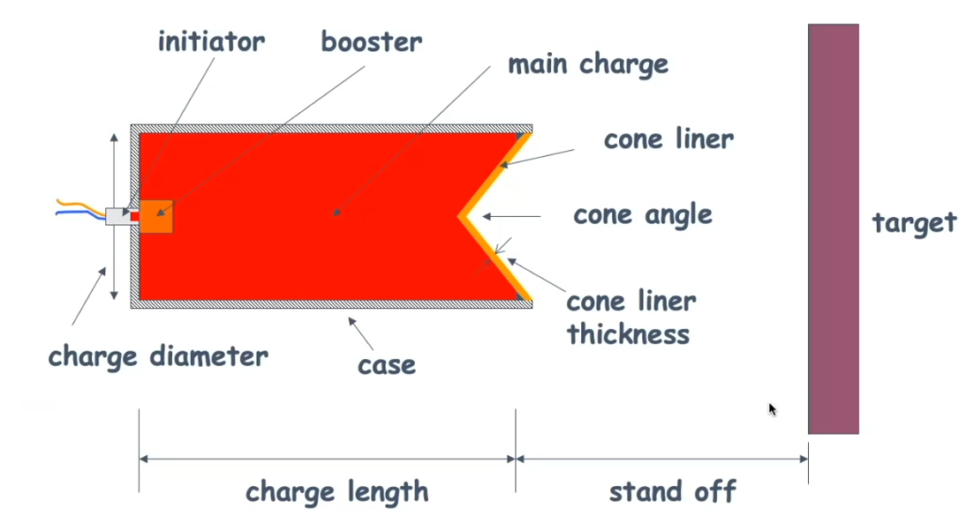
Figure 1-Labelled diagram of a shaped charge [1].

Traditionally, to test the performance of these weapons, trials would be conducted in an approved range or testing facility. Instrumentation such as pressure gauges, high-speed cameras or flash x-ray would then assess the success of each firing. Unfortunately, this method can be costly, requires a high amount of workforce, and could pose safety concerns, due to the risks associated with live explosives. Modelling offers a detailed insight into what is occurring inside the weapon, and, if done correctly, can provide data representative of a real-life trial.
Finite element analysis is a mathematical method for solving problems related to engineering and mathematical physics. To solve problems, it divides systems into smaller simpler parts called finite elements. Together, these finite elements combine to create a larger mesh that can be altered to represent a material through changing specific properties or shapes [2]. These meshes are then used to model simulations such as the detonation of a shaped charge. The interaction of these meshes then creates data that when compared to experimental results, is somewhat comparable. The below report aims to select the most appropriate analysis methodology, then use that to compare the results from three separate experiments where the explosive fill was changed.

Method

Altering the Explosive

The type of explosive used was altered because the initial jet formation relies on its explosive power. A more powerful explosive will accelerate the lining walls faster, causing them to reach higher pressures and velocities, thus resulting in a more effective jet formation, and thus target penetration [3].
PBX, TNT and RDX were chosen because these were well documented explosives, with a lot of information on their material properties. PBX and RDX are also used in shaped charge applications, so this was to be more representative of shaped charges than traditional TNT [3]. This literature will also serve as a comparison point between the information gathered from modelling and the information from real life trials.
Name | Density (kg/m³) | Detonation Wave Speed (ms-1) | A | B | Omega | R1 | R2 | Detonation Energy Density | Dynamic Viscosity
PBX | 1840 | 8800 | 852400 | 1802000 | 0.8867 | 14.1 | 1.41 | 5500000 | 10
RDX | 1836 | 8913 | 201000 | 5200000 | 0.8867 | 12.4 | 1.24 | 6300000 | 10
TNT | 1630 | 6930 | 373800 | 3737 | 0.35 | 4.15 | 0.9 | 3680000 | 10
Figure 2- Material properties for the explosives [4] [5] [6]
In Abaqus, the high explosive mesh was edited to display the Jones-Wilkins-Lee (JWL) properties shown in figure 2. The JWL equation of state is a mathematical expression often used in reactive hydrosimulations to describe the thermodynamics of detonation products and unreacted high explosive [7]. It calculates pressure by using the energy and volume relationships associated with the chemical detonation products [8]. This equation therefore allows the explosives properties and behaviour upon detonation to be modelled accurately.

Modelling Approach

As mentioned above, shaped charges exhibit fluidlike properties after being put under huge number of pressures by the high explosive. Therefore, to be able to accurately describe its flow during the simulation, Lagrangian and Eulerian methods need to be considered. Each algorithm uses different techniques to observe small pieces of fluid (fluid elements) over time to gain results.
In the Lagrangian method, a fluids element position is a function of time. Its considerers the volume flow in terms of the individual characteristics attributed to these particles. This means the particles response to the environment and movements can be observed over a time period. When there is lots of particles to track however, it becomes far harder to observe the positions and behaviours of these particles. The fluid elements can also deform, mix with other fluid elements, and split into new fluid elements as they move through space, causing mesh distortion. This can cause errors during calculation due to element failure, where due to the mathematics being too complex for the system to handle, the node gets deleted by the system.
In the Eulerian method, the fluid properties are observed at fixed points in space. The description uses scaler and vector fields such as temperature, velocity, and pressure to describe fluid properties. From this perspective, it is harder to calculate how the fluid particles will behave in respect to this fixed viewpoint, thus reducing the resolution of the flow details. [9]. It also means the viewpoint itself must cover all parts in space that could be reached by the fluid during calculations. In this instance, shaped charge jets can increase from initial length by 150-250%, making the number of viewports large and therefore time consuming in data analysis. The Eulerian method also makes it harder to follow material boundaries, meaning results may not truly reflect the material being used [10].
The Lagrangian formulation was chosen to model the shaped charge because it allowed all three materials to remain separate, give a higher resolution of data and allow a shorter calculation time. To try and reduce its distortion, the mesh was resized at different areas of the charge depending on how critical the information from that region is. A smaller mesh means more nodes, and therefore more data points are inside an area. For the simulation below, the explosive mesh is far larger than the one for the liner. This is because data is being collected on the liner and not the explosive, as the velocity of the liner ultimately decides on the explosive power, not its deformation.

Experimental Settings
The simulation run for 75 microseconds, allowing for the jet to reach its terminal velocity. These factors would give the best indication of its jet formation, whilst ensuring a low experiment run time. Velocity data was recorded based upon the furthest node of the jet at the cut-off time. Photographs were taken of the liner every 25 microseconds, to observe the stresses and strains it was being put under by the explosive.

Results

Velocity
Velocity data for the three explosive types can be seen in figure 3. RDX is shown to have the highest maximum velocity.

Figure 3- Graph showing the velocities reached by all three explosive types over run time

Stress and Strain
Figures 4-6 demonstrate the differences in stress and strain measured across 25 microsecond intervals. Negative values (where the material is under compression) is represented by blue nodes and positive vales (where the material is under tension) is represented by red nodes.
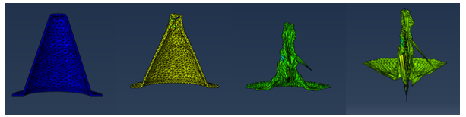
Figure 4-Screenshots taken at 25 microsecond intervals of the stresses and strains experienced by TNT.
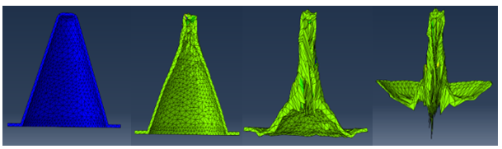
Figure 5-Screenshots taken at 25 microsecond intervals of the stresses and strains experienced by PBX.
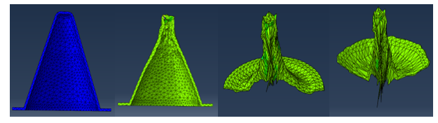
Figure 6-Screenshots taken at 25 microsecond intervals of the stresses and strains experienced by RDX.

Discussion

Velocity
All three models undergo huge amounts of acceleration in the first 40 microseconds, as shown in figure 3. At around 45 microseconds, they then reach their terminal velocity, then gently decelerate to reach a somewhat constant velocity until the end of simulation.
As shown, RDX has the highest maximum velocity of the three explosives used. This is because it has the highest detonation wave speed of the three. This meant that it had a higher energy content per unit mass, so therefore was able to exert more energy into the liner, thus increasing its velocity [11].
Compared to common literature, shaped charge liners often achieve much higher velocities when used with the same explosives. For example, in an experiment by Hicham Kemmoukhe et al. the maximum velocity of RDX was found to be $6520ms^{-1}$ experimentally, and $6301ms^{-1}$ when simulated using Autodyne [12]. This is over double the velocity measured for RDX in figure 3. This could be due to the model mesh not fully being able to replicate real life forces.
Additionally, during firing, the outer casing flexes upon detonation for all three explosive types, meaning not all the explosive energy is directed towards the liner. The young’s modulus is calculated as the ratio between the tensile stress and strain. A material with a higher young’s modulus will experience a lower value of plastic deformation. This deformation causes energy losses within the system as the material undergoes non-recoverable plastic deformation. The young’s modulus of the steel casing used was found to be $2×{10}^{11 }$ Pa, which is significantly lower than steels typically used in military applications. Using a tempered steel with a higher carbon content would increase the young’s modulus, therefore reducing the amount of plastic deformation that occurs [13]. This may have led to a higher velocity of casing, as the material wouldn’t have flexed.

After 60 microseconds, both PBX and RDX exbibit lower velocities when compared to TNT, despite their material properties demonstrating higher energies. When looking at figures 5 and 6, the meshes are seen to be heavily distorted, with certain nodes experiencing high number of stresses compared to the rest of the mesh. Lagrangian element failure is when, due to large deformations, the mesh becomes significantly malformed. Solving the various velocity, stress etc. calculations therefore require higher amount of computer power, which then increases the time spent on solving the simulation. The erosion algorithm is therefore used to delete these elements to allow further calculations to continue. It deletes nodes that have undergone a specific element failure strain, the amount of which is specified by the user. As the basic model of this design was replicated, the value for this figure is not known. However, the maximum stress recorded for TNT was $2.37×{10}^{9}$Pa, which is significantly lower than those for RDX ($1.054×{10}^{10}$Pa) and PBX ($2.371×{10}^{10}$Pa) at 75 microseconds. If the erosion algorithm was therefore set to be around the PBX/RDX stress figures, then many nodes would have been deleted due to this element failure. Such nodes may have contained higher velocities than those used in figure 3, but due to the erosion algorithm, may have been deleted [14].

Stress and Strain
All three models exhibit similar amounts of stress and strain during the simulation, as demonstrated by figures 4-6. Initially, the liner is placed under huge amounts of compressive strain as the explosive shockwave acts to deform it towards the central axis. As the liner material accelerates, the internal shear strains cause the casing to invert and form a high-speed jet.

Mesh Analysis
Figure 4 shows some nodes are travelling in an irregular fashion by travelling diagonally instead of towards the central axis. This yet again highlights the mesh irregularities, as the mesh should be symmetrical, with the liner forced towards the centre due to explosive. Such irregularities could be due to the large mesh size being unable to centre into one axis without a high number of collisions occurring. A smaller mesh would result in more nodes interacting with each other, and therefore be more representative of a real-life firing. However, this requires significantly greater computer power and time, as each node collision, speed, strain etc. would have to be calculated at each step.

Limitations
The aforementioned mesh irregularities, as a result of the Lagrangian methodology, severely impacted the data from this experiment. New modelling techniques combine the benefits of both the meshing techniques to create the Arbitrary Lagrangian–Eulerian method. It features the high resolution found from the Lagrangian method, as well as being able to handle high mesh distortions like the Eulerian. This adaptive meshing reduces the total number of elements necessary for simulation by allowing multiple scales in the solution. When the mesh is severely deformed, elements are sub-divided, and a new defined mesh is created. This ensured adequate element aspect ratios are maintained throughout mesh deformation. Using this method may have therefore resulted in a less distorted mesh, and hence produce results more representative of other experimental data [15].

It is, however, worth nothing that modelling often displays the results of a “best case scenario” explosive charge, where real-life limitations such as manufacturing defects, wind and temperature are just too small to be accounted for. Therefore, it could be argued that regardless of properties such as mesh size, real life experimental data cannot simply be replicated, or repeated through the use of modelling techniques.

Conclusion
The explosives within the shaped charge have been altered and modelled using Lagrangian mechanics. RDX was found to have the highest maximum velocity due to its higher detonation wave speed. However, velocities of all three charges were found to be significantly lower than those highlighted in the original literature review. Upon further analysis, all three models produced poor jet formation due to experiencing high levels of mesh distortion and asymmetrical behaviour, which likely caused these reduced velocities. In future studies, the use of the Arbitrary Lagrangian-Eulerian formulation has been recommended to reduce these effects, whilst maintaining the high resolution of results.

Table of Figures
Figure 1-Labelled diagram of a shaped charge [1]. 2
Figure 2- Material properties for the explosives [4] [5] [6] 3
Figure 3- Graph showing the velocities reached by all three explosive types over run time 5
Figure 4-Screenshots taken at 25 microsecond intervals of the stresses and strains experienced by TNT. 5
Figure 5-Screenshots taken at 25 microsecond intervals of the stresses and strains experienced by PBX. 6
Figure 6-Screenshots taken at 25 microsecond intervals of the stresses and strains experienced by RDX. 6

References

[1] | G. J. Appleby-Thomas, “Directed Explosive Energy,” Cranfield Defence and Security, Cranfield, 2021.
[2] | S. Rao, “FINITE ELEMENT METHODS,” in Encyclopedia of Vibration, Miami, University of Miami.
[3] | U. R. N. G. M. G. R. K. S. A. K. S. N. A. Samson S. Samudre, “Studies on an Improved Plastic Bonded Explosive (PBX) for Shaped Charges,” Propellants Explos. Pyrotechnics, vol. 34, pp. 145-150, 2009.
[4] | G. B. X. Z. Z. W. J. Y. Yakun Liu, “The EFP Formation and Penetration Capability of Double-Layer Shaped Charge with Wave Shaper,” Materials , vol. 4519, pp. 13-20, 2020.
[5] | S. J. D. M. Predrag Elek, “Modeling of the Metal Cylinder Acceleration Under Explosive Loading,” Scientific Technical Review, vol. 63, no. 2, pp. 39-46, 2013.
[6] | H. F. Karim Elsharkawy, “Synthesis and Characterization of Advanced PBXs Materials Based on GAP and HTPB,” International Journal of Advanced Materials and Production, vol. 1, no. 1, pp. 41-48, 2016.
[7] | G. B. a. R. Serradeil, “Review of Jones-Wilkins-Lee equation of state,” The European Physical Journal Conferences, vol. 10, no. 1, 2011.
[8] | Devon Downes, Amal Bouamoul, M. N. Ensan and Y. Baillargeon, “Development of an efficient numerical model for shaped charge analysis,” Journal of defense modeling and simulation, vol. 13, no. 3, pp. 355-362, 2016.
[9] | B. Smyth, “5.1: Lagrangian and Eulerian descriptions,” in All Things Flow - Fluid Mechanics for the Natural Sciences (Smyth), Oregon, Oregon State University, 2021.
[10] | G. Luttwak, “NUMERICAL SIMULATION OF WATER JET PENETRATION,” in Shock Waves in Condensed Matter 1983, New Mexico , 1984.
[11] | K. Lóránd, “EXPERIMENTS WITH SMALL SIZE SHAPED CHARGES,” Hadmérnök, vol. 14, no. 2, pp. 99-110, 2019.
[12] | Z. B. S. S. S. T. D. S. M. L. Hicham KEMMOUKHE, “Improvement of Shaped Charge Penetration Capability and Disturbation of the Jet by,” Tehnički vjesnik, vol. 26, no. 6, pp. 1658-1663, 2019.
[13] | W. Callister, Material Science and Engineering, John Wiley and Sons, 2020.
[14] | R. H. K. W. A. &. T. E. A. Vignjevic, “Overcoming element erosion limitations within Lagrangian finite element codes,” in Proceedings of the Third European Conference on Space Debris, Darmstadt,, 2001.
[15] | A. H. J.-P. P. a. A. R.-F. Jean Donea, “Arbitrary Lagrangian–Eulerian Methods,” in The Encyclopedia of Computational Mechanics, Wiley, 2004, pp. 413-436.
[16] | A. H. S. A. Khalid Naeem, “A Review of Shaped Charge Variables for its Optimum Performance,” Engineering, Technology & Applied Science Research, vol. 9, no. 6, pp. 4917-4924, 2019.
[17] | D. M. K. Oğuzhan AYISIT, “DETERMINATION OF SHAPED CHARGE JET CHARACTERISTICS USING,” in 10th ANKARA INTERNATIONAL AEROSPACE CONFERENCE, Ankara, 2019.

