

Assessment 1 – Shekofteh Afrasiabi 2612542
PART 1
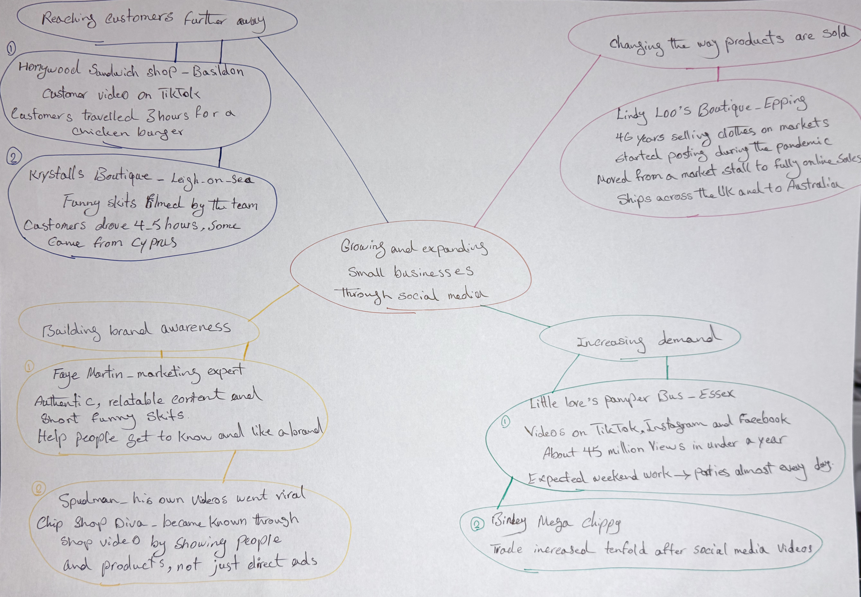

PART 2:

- What is the main idea of the whole text?

Social media platforms are powerful and useful tools to help small businesses grow and expand.

- What is one key point that supports the main idea, and which specific example from the text shows this?
One key point is that social media help businesses reach customers further away. For example, videos posted by customers on TikTok helped Honeywood Sandwich Shop attract people who travelled three hours to try its chicken burger.

- What is a different key point that supports the main idea, and which specific example from the text shows this?

Another key point is that social media can change the way products are sold. For example, Lindy Loo’s Boutique moved from a market stall to a fully online business and now ships clothes across the UK and to Australia.

- Which part of the text do you think is most important, and why?

In my opinion, reaching customers further away is the most important point because it helps businesses introduce themselves to new people and makes their brands better known.

Reflection:
- What did you find difficult in this task (including in-class components), and why was it difficult?

Finding short phrases for the key point was a little difficult for me because I wanted to use my own word instead of copying sentences from the text.

- What helped you with this difficulty, and how did it help you?

Reading the text carefully twice helped me. My classmates and my programme manager explained the task instructions and structure. Overall, all of this helped me understand the task better and organise the key points.

