Distributing the Workload – Part 2

After assembling the team and deciding on the topic of our project we went to the drawing board to break down the project into smaller, more manageable tasks and give ourselves a timeframe for completion. But it was mot all words drafted ideas. We have utilized two of the best project management tools out there (for small-scale projects mind you) – the Gantt Chart and WBS – and here’s how they could improve your project management skills (Ramos, 2021).

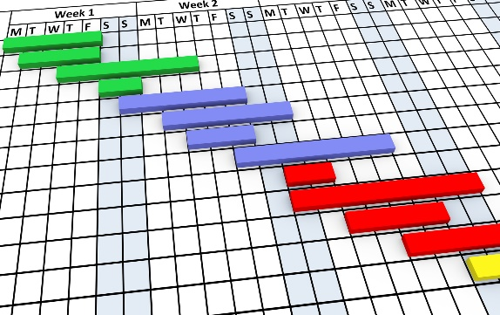
The Gantt Chart (Fig. 1) – the project is a series of smaller tasks that need doing – before the deadline! But who can be bothered remembering loads of tasks and their due dates? A bit taxing, isn’t it? This is where this powerful tool comes in! It allows for a graphic depiction of team members’ tasks, their deadlines, and a completion bar that keeps track of your progress. You can easily make one yourself by downloading a free MS Excel template or if your project in on a larger scale, you can purchase some software (like Asana (Asana.com, 2023)) that pretty much does it all for you.
Fig1 – Example Gantt Chart | Google stock images

The WBS (Fig. 2) – lets say that someone asks you to build a house… Quite intimidating, right? Where do you even begin? Wouldn’t it be so much easier and convenient if someone (or something) could give you a step-by-step guide? This is where the WBS steps in! It breaks down that complex task into smaller, easy-to-understand steps. You just need a PC/Laptop or a pen and piece of paper to get started.

Reference list
Fig. 2 – Example WBS | greensystem.vn
- Asana (2018). Asana. [online] Asana. Available at: https://asana.com/.
- Ramos, D. (2021). Gantt Charts & Work Breakdown Structures I Smartsheet. [online] www.smartsheet.com. Available at: https://www.smartsheet.com/content/wbs-gantt.

