BSC HND COMPUTIING INTRODUCTION TO WEB AND DATABASE CONCEPTS

David Julian Rapado RAP11801722
21 January 2023

Contents
Contents 1
Introduction 1
Requirements 2
Validation 2
Implementation 2
Evaluation 6
Usability 6
Accessibility 7
Search engine optimisation (SEO) 8
Conclusion 9
References 9

Introduction

This website will give a small glimpse into the world of Chinese Martial Arts and how religion, geography and politics have influenced and shaped it over the generations. Starting with a little history. Leading into the influence of Taoism and the internal arts. Then probably the most well known with the “World famous” Shaolin Buddhist Monastery, with their kung fu. This is where geography started to influence with the northern and southern styles and finally Communism and it’s ban on religion, so it replaced it with a more sport and gymnastic element in Wushu .

Requirements

This site is about Chinese Martial arts. The aim of this site is to give people who have little to no knowledge about Chinese Martial arts, beyond the Orange robed guys you See on Television or on YouTube videos. Also by highlighting some of the softer arts ( the three internal arts) it might appeal to someone who already does a martial art and wants to try something different. Or someone that is looking to take up a more gentle from of exercise after an illness or injury.

Validation

During the Validation phase I had problems with my images and some of the videos not being in the centre of the page. I used the centre tag to overcome this problem for the images but could not get all the videos to centre. Also,on my contact page I wanted to have the text in the centre with an Icons showing the e-mail ,Telephone and address but I couldn’t get that to work.

Implementation

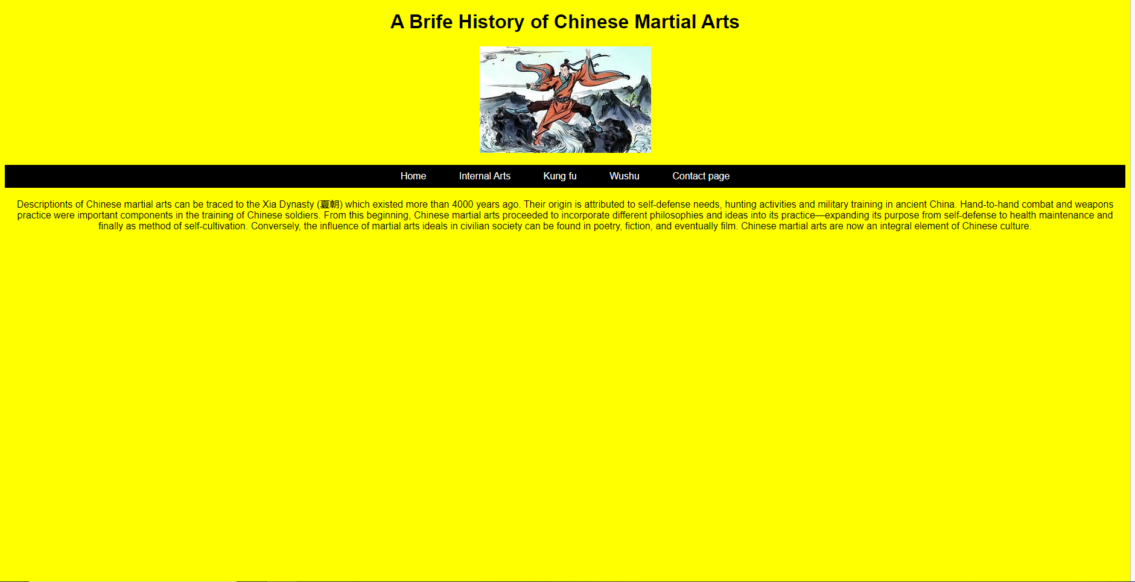
Internal Arts 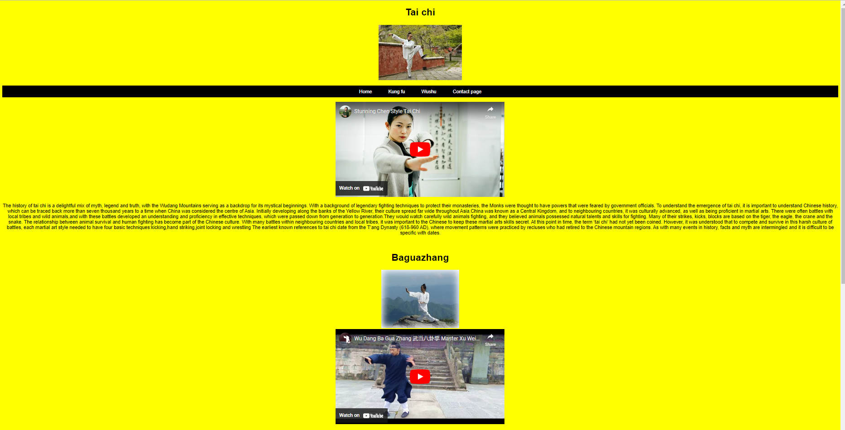

Internal arts
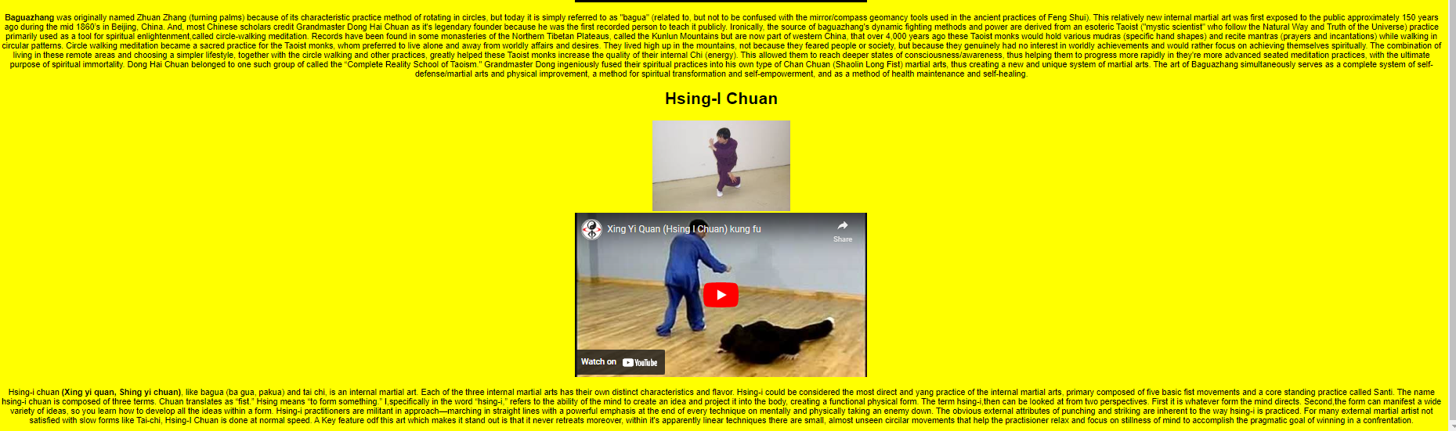
Kung fu
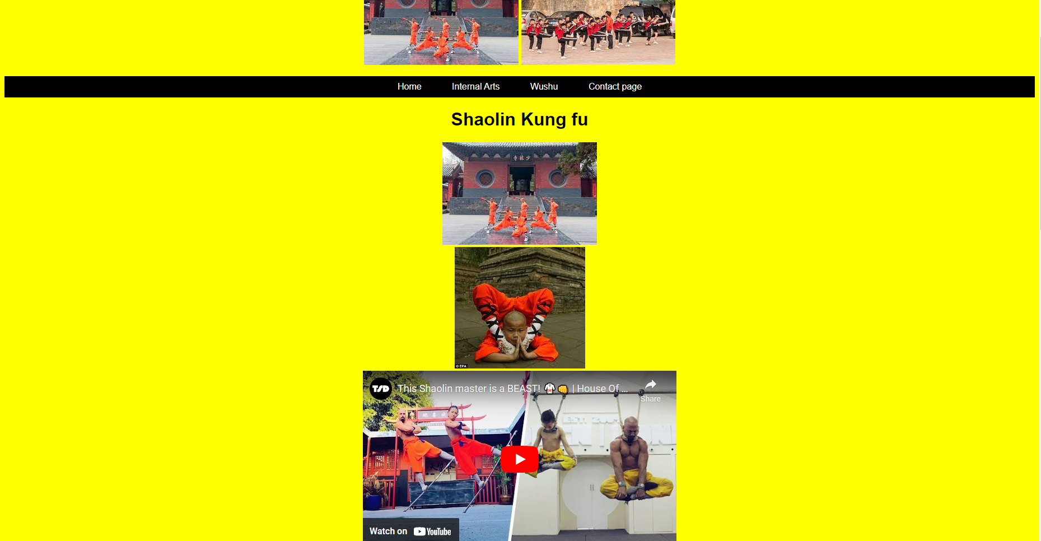
WuShu
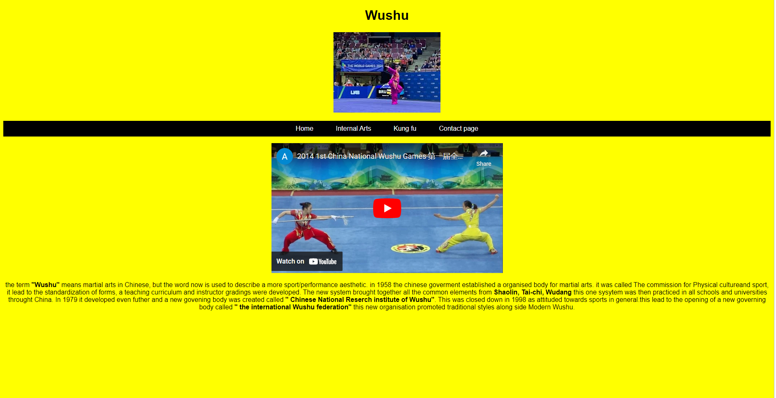
Contact page
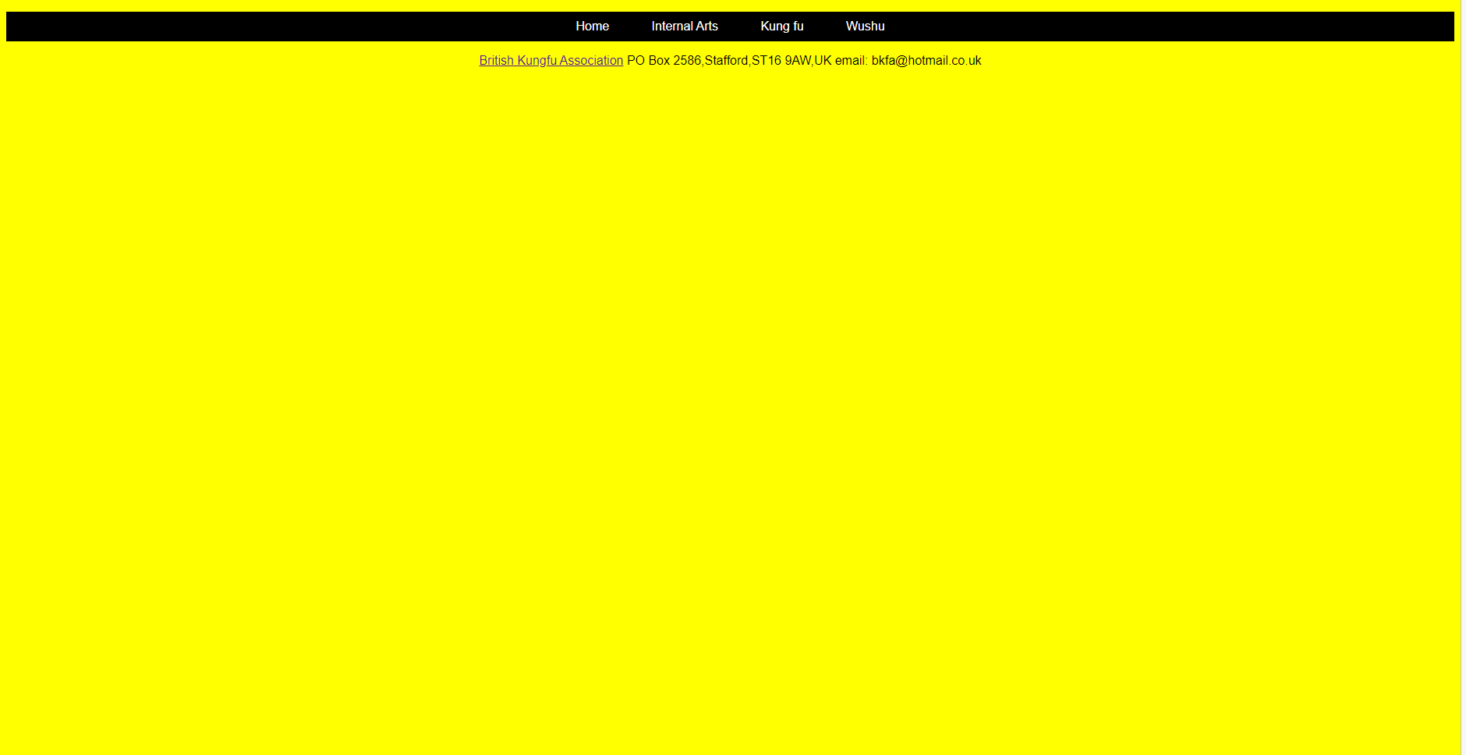

Evaluation

Usability

Usability is an important aspect when designing a website. As it ensures that the website users have a positive experience interacting and navigating the site. A website that has good usability increases the chances of the user staying on the site longer, completing their desired actions on the site that and possibly returning in the future.
There are several key elements to a website being user friendly [1] the first one is navigation; the navigation menu should be clear consistent and easy to use. After the navigation another aspect to look at is the layout and design. This should be clean, and uncluttered and easy to read keeping the font size and colour scheme consistent across the whole website to improve readability.
Content also plays a crucial part in the usability of a site. Content should be well-written, easy to understand and relevant to the users. Using headings, bullet points, images and videos can help to break up the text making it more visually appealing. The site should be optimised for different screen sizes and devices so the site can be accessed easily on any device.
Another important part of usability is the sites load time. If this takes to long it can be frustrating to a potential user and may cause them to leave the site prematurely, resulting in the site not being accessed. To speed the load time up keep the amount of elements on the page to minimum optimise images and compress files.
When designing a website, it is important to know your target audience. Different types of users may have different needs and expectations when it comes to website usability. For example a website that is selling a product should be designed with the goal of making it easy for a customer to find and purchase a product. On the other hand a Blog site should be designed to make it easy for a user to find and read content. Usability testing can be used to evaluate the usability of the site .
This involves getting a group of users and see how they interact with the site and how well they are able to find and use the features. This will help to identify any areas to improve and ensure the website meets the needs of the users. It is important to consider the technical aspect of usability. This includes making sure that the website is easy to use on different devices and using technologies that are accessible to users with disabilities. In addition, the site should be optimized for search engines to ensure that potential customers can easily find the website

Accessibility

Accessibility is NOT! to be confused with usability. Accessibility is essential to ensure that everyone has equal access to digital products such as websites. Accessibility refers to the design process of a website for people with disabilities. This includes individuals with visual, audio, moto and cognitive impairments. Accessibility is an important for creating an inclusive online experience and to reach a wider audience.This not only promotes inclusion and diversity, but has legal and ethical implications, as individuals with disabilities are protected by laws. The World Wide Web Consortium (W3C) has established the Web Content Accessibility Guidelines (WCAG) 2.1 to ensure that all websites are accessible to all users regardless of their ability. This section of the report will talk about the importance of accessibility and how WCAG 2.1 can help.

According to Humanity-inclusions web site, there more than 1 billion People worldwide have a disability [2], so it’s important to ensure websites are accessible to everyone. There are several ways this can be achieved. Offering keyboard-only for people who can not use a mouse, ensuring that the site is easy to navigate. Content robust enough to be able to be interpreted reliably by a wide variety of agents and assistive technologies. To do this there are a number of tools and techniques that can be used. Provide alternative text for non-text content, use headings and labels to clearly organise the site and make it easier to understand. Contrasting text, use high text make it easier to read. Use ARIA (Accessible Rich Internet Applications) such as screen readers and other assistive technologies. Alt text to describe images and other non-text content for users that are visually impaired.

WCAG 2.1 are a set of international standard guidelines to make websites easier to access by disabled people. These guidelines cover wide range of topics, including most of the ones mentioned above. WCAG 2.1 [3] is not a legal requirement, but it is important best practice for website design. Abiding by these guidelines can help make your site more accessible to all users, regardless of their abilities.

It is important to note that making a website accessible is an ongoing process that can be a dauting task, as it requires regular monitoring to ensure all users can access and interact with the website effectively. Thankfully there are tools out there to help automate this. Such as testing tools that scan your site and identify any issues. Additionally, there are some links that can help with Accessibility

http://contrastchecker.com/
http://juicystudio.com/services/luminositycontrastratio.php

Above are two links that can be used to check the contrast of the colours in your website to see if they meet the Guidelines laid down WCAG set by W3C. For this site I used juicystudio.com and the results came back for my site were a AAA. So that’s a pass within the guidelines, laid out by the W3C and WCAG.

Search engine optimisation (SEO)

Search engine optimisation (SEO) is the process of improving the visibility of a website or web page in a search engine’s results. This means the higher up the search engine results page the site is and how frequently the site appears in search results lists, the more visitors it will receive.Theses visitors can then potentially be turned into customers. SEO may target different Kinds of search, including image search, local search, video search, academic search, news search and industry specific vertical search engines.

To improve a websites visibility and rankings SEO like to use on-page and off page optimization techniques. One key On-page optimization technique is the use of relevant keywords and phrases. Theses Keywords and phrases when typed into a search engine, the search engine will send out a crawler program to read it’s content and look for theses keywords and phrases indexing them as it goes. The more of theses key words and phrases these “crawlers” index the higher up the search result the site will appear. Another commonly on-page optimization technique that is used are regular updates making sure the sites lay out is well structured and the content is well organised and is up to date high quality content and is well and well structured and consistent layout.

Off-page techniques involve building “backlinks”, theses are links to your site via other more established websites. They can act as a “quality assurance” indicating to the search engine that your sight is of higher value and worthy of having a higher rank. Creating theses backlinks can be achieved via several methods, like blogging about your site , talking on a podcast about your site, posting a link to your site on all the social media platforms such as Instagram, Facebook, Twitter and Linkedin. Also you could promote in local directories such as google my business.

Creating a website that is accessible is not only an ethical and legal obligation but it is good business practice. It can help to reach a wider audience and increase customer satisfaction, as well as improve overall user experience. There are many different tools and techniques that can help you improve your websites ranking by using a combination of on-page and off-page optimization. Also there websites that offer tips and tools to help get the most out of your site. It’s important to understand the basics of SEO, and use the right tools and techniques to ensure that your website is optimized for success. By doing this you can ensure your site is visible in the search results, and over time it will attract more visitors and customers.

Here are some tools and tips to help improve your site. Visit https://www.semrush.com for a list of tips and tools to help improve your site.

Conclusion

In conclusion, accessibility, usability and SEOs are essential to ensure that everyone has equal access to digital products, such as websites. It is a legal requirement, good for business, and a moral imperative. By following web accessibility guidelines and using the appropriate tools and techniques, you can ensure that your website is accessible to people with disabilities. The importance of accessibility cannot be overstated and it's crucial for website creators, developers, and managers to make accessibility a top priority in their work.

References
[1] Techopedia (2022, Dec), What Does Usability Mean?
https://www.techopedia.com/definition/4919/usability
[2] W3C (2022, Dec), Introduction to web accessibility
https://www.w3.org/WAI/fundamentals/accessibility-intro/#:~:text=Web%20accessibility%20depends%20on%20several%20components%20working%20together%2C,techniques%2C%20and%20supporting%20resources%20that%20describe%20accessibility%20solutions.
[3] Gov.uk (2022, Dec) Understanding WCAG 2.1
https://www.gov.uk/service-manual/helping-people-to-use-your-service/understanding-wcag

