BMIH6007
International Meetings Management for the Hotel Industry
Technology and Innovation

Name: Ionut Alexandru Andruta
Student ID number: 2133015
Lecturer: Jemma Smith
Contents
1.0 Introduction 3
2.0 Market Factors 4
2.1 Target Market Analysis 4
2.2 Demand Analysis 5
2.3 Supply Analysis 5
2.4 Competition Analysis 5
3.0 Operational Factors 6
3.1 Venue Selection 6
3.2 Logistics and Infrastructure 6
3.3 Staffing and Personnel 7
4.0 Financial Factors 7
4.1 Costs Analysis 8
4.2 Predicted Revenues 9
4.3 Funding Sources 10
5.0 Conclusion 11
6.0 References 12

Introduction

The 2026 FIFA World Cup, marketed as FIFA World Cup 26, will be the 23rd Fifa World Cup, the quadrennial international men's football championship contested by the national teams of the member associations of Fifa. The tournament will take place from June 11 to July 19, 2026. It will be jointly hosted by 16 cities in three North American countries: Canada, Mexico, and the United States. The tournament will be the first hosted by three nations. FIFA World Cup remains a watershed moment in international sports (Emerald Insight, 2019). The World Cup has a spectacle of epic grandeur. It has also captured the world's football imagination. It serves as a platform for showing the prevailing sentiment of friendship in society. This scenario reflects the strategic thinking necessary to ensure the event's success. Hosting the FIFA World Cup presents a logistical difficulty (Emerald Insight, 2014). At the same time, it is a complex undertaking. This encompasses everything from finding an appropriate site to obtaining money. A successful World Cup organization involves strategic planning. Central to this effort is the critical examination of probability factors (Journal of Convention & Event Tourism, 2023). These aspects will be explored with a discerning eye. This assignment will explore the intricacies of organizing the FIFA World Cup. The event's target audience, demand, supply, etc. will be analyzed in this report. Market elements influencing the competitive landscape will be investigated. Operational issues include allocating resources and managing the skills necessary to orchestrate a smooth tournament experience. Assessing these components will shed light on the strategic pre-planning research necessary to host the FIFA World Cup (Getz, 2008).

Format and expansion.
Starting with this edition, the FIFA World Cup expanded to 48 teams, an increase of 16 from the previous tournaments. The teams will be split into 12 groups of 4 teams, with the top 2 of each group and the eight best third-placed teams progressing to a new round of 32, as approved by the FIFA. This is set to be the first expansion and format change since 1998.
The total number of games played will increase from 64 to 104, and the number of games played by teams reaching the final four will increase from seven to eight. The tournament will last 39 days, an increase from 32 days of the 2014 and 2018 editions.
Market Factors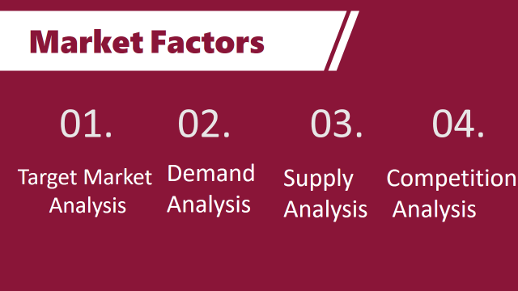
The FIFA World Cup is one of the most significant sporting events globally (Ahmad and Daud, 2016). It needs analysis to understand market dynamics. Market factors encompass various elements. It includes the target market, demand, supply, and competition. All of which play pivotal roles in shaping the strategic planning of the tournament.
Target Analysis
The FIFA World Cup has a very broad target market (Emerald Insight, 2024). It comprises people of various ages, genders, socio-economic backgrounds, etc. Other athletic events target certain groups. The World Cup draws a genuinely global audience. It transcends national bounds. Its target market is football fans. These range from ardent national team supporters to casual viewers who tune in to enjoy the spectacle of the competition. These supporters comprise the core of the World Cup audience. They provide a substantial contribution to economic success, as the target demographic has grown beyond conventional football supporters. It encompasses a large portion of the people who are drawn to cultural importance. People who aren't very interested in sports may be drawn to the World Cup because of the celebratory mood (Chuah and Latip, 2018).
Demand Analysis
The demand for the FIFA World Cup is understandably great. This led to its reputation as a big international athletic event. Football is commonly referred to as "the world's game." It is widely popular across the continent. This makes the World Cup a highly anticipated event for people throughout the world (Jamal and Robinson, 2009). The competition has typically drawn significant TV viewers. Billions of people utilize various media outlets to watch the game live. Fans anxiously anticipate the crowning of a new champion. A variety of reasons contribute to the FIFA World Cup's popularity. The World Cup provides a great chance for sponsors.
Supply Analysis
The supply side of the FIFA World Cup encompasses some factors (Smith, 2012). It includes the availability of infrastructure. The provision of necessary services is important to ensure the smooth functioning of the tournament. Stadiums serve as focal points for the World Cup. They serve as prominent monuments that represent the host country's culture. The availability of appropriate stadiums with cutting-edge facilities is critical to providing the finest watching experience for the audience (Bouchon et al., 2015). Apart from the stadium, housing choices are critical to satisfying the demands of supporters throughout the event. The provision of permanent accommodations is critical to assuring tourist arrivals. Transportation infrastructure contributes to greater general accessibility. The availability of qualified workers, notably hospitality personnel, is critical to the success of the World Cup.
Competition Analysis
Understanding the competitive landscape is essential to effectively distinguishing the World Cup from rival events. It faces competition from other major sporting events. It competes for disposable income from consumers (Crowther et al., 2015). The World Cup competes with other international tournaments such as the UEFA European Championship, Copa America, etc. These events attract similar sponsors (Contextualising phenomenology in event management research: Deciphering the meaning of event experiences | Emerald Insight, 2014). They create competition for media coverage. Despite these challenges, the FIFA World Cup maintains a unique position in the world sporting calendar.

Operational Factors
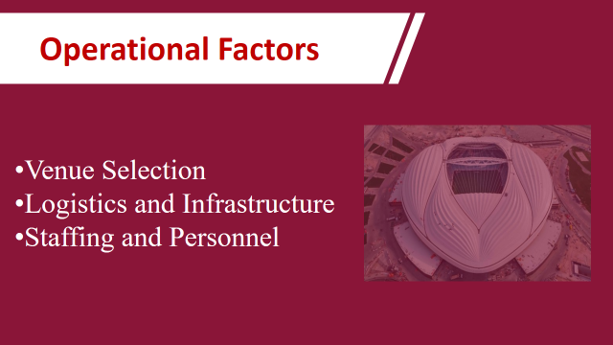
The FIFA World Cup's success depends on operational aspects (Smith et al., 1994). It includes a wide variety of managerial factors. From site selection to personnel requirements, competent operational administration is critical to the tournament's success.
Venue Selections
The most important component of hosting the FIFA World Cup is choosing the right venue (Reid and Ritchie, 2011). The stadiums serve as the tournament's hub. When deciding on a site, organisers must consider a number of things. Stadium improves the whole visiting experience. Its distinctive architectural elements reflect the city's cultural legacy. There will be sixteen host cities Vancouver, Seattle, San Francisco, Los Angeles, Guadalajara, Kansas City, Dallas, Houston, Atlanta, Monterrey, Mexico City, Toronto, Boston, New York City, Philadelphia, and Miami. Eight of the sixteen chosen stadiums have permanent artificial turf surfaces that are planned to be replaced with grass under the direction of FIFA. Four venues (Dallas, Houston, Atlanta, and Vancouver) are indoor stadiums that use retractable roof systems, all equipped with climate control while a fifth, Los Angeles, is open-air but has a translucent roof and no climate control. The host of the final match is MetLife Stadium, in New York with a capacity of 82,500 seats.
Logistics and Infrastructure
Logistics plays several important roles in ensuring the smooth running of the FIFA World Cup (Meredith, 2022). Security protocols facilitate the seamless flow of visitors from accommodation options. A strong infrastructure is essential for this. Efforts are underway to upgrade the existing infrastructure to meet the demands of hosting World Cup matches. Transport networks are strengthened through improved connectivity. Specialized shuttle services are also implemented to transport fans. Vigilance by law enforcement personnel is intensified to ensure the safety of visitors. Medical facilities will be provided to deal with any emergency during the tournament.
Staffing and Personnel
The success of the FIFA World Cup largely depends on the skills of the personnel involved (Fox et al., 2014). Fifa is looking for personnel that can handle a variety of customer service tasks. The hospitality staff works to ensure the smooth running of the tournament. Training programs are implemented to equip employees with knowledge. Volunteers play a vital role in facilitating the flow of support for the smooth running of the World Cup. The hosts of the Fifa World Cup can provide a world-class experience for players during the competition. These can enhance the overall experience for participants.

Football Technologies & Innovations at the FIFA World Cup 2026
  - VAR (Video Assistant Referee) - Throughout a match, the video assistant referee team constantly checks for clear and obvious errors related to these four match-changing situations. The VAR team communicates with the referee only for clear and obvious mistakes or serious missed incidents.
  - Goal-line Technology - Goal-line technology was first implemented in 2014. The technology must provide a clearly indicate whether the ball has fully crossed the line. This information will serve to assist the referee in taking their final decision. The information is transmitted within one second which ensures an immediate response from the referee. Only the match officials receive the signal on their watches.

Financial Factors

Successful hosting of the FIFA World Cup requires a comprehensive understanding of financial factors. As well as identifying appropriate funding sources to support the event. Here, the financial aspects of exploring potential funding sources will be discussed to ensure the financial viability of the event.
Costs Analysis
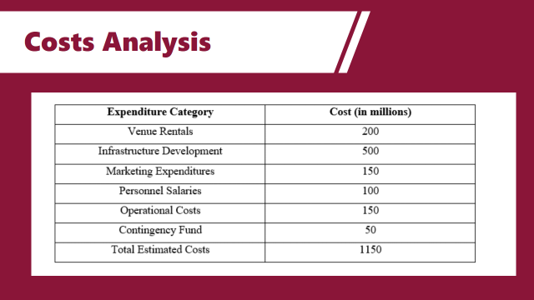
Cost analysis is very important for every event (O’Toole, 2011). Hosting the FIFA World Cup incurs a wide range of expenses. It includes infrastructure development, venue management, marketing and promotion, operational logistics, etc.
Expenditure Category | Cost (in millions)
Venue Rentals | 200
Infrastructure Development | 500
Marketing Expenditures | 150
Personnel Salaries | 100
Operational Costs | 150
Contingency Fund | 50
Total Estimated Costs | 1150
Predicted Revenues
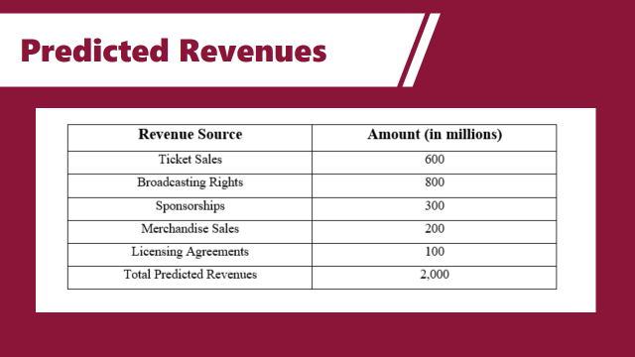
Hosting the FIFA World Cup involves significant expenditure (Getz and Page, 2019). It also presents opportunities to generate income through various channels. Revenue forecasting helps organisers assess the financial viability of tournaments.
Revenue Source | Amount (in millions)
Ticket Sales | 600
Broadcasting Rights | 800
Sponsorships | 300
Merchandise Sales | 200
Licensing Agreements | 100
Total Predicted Revenues | 2,000

Funding Sources
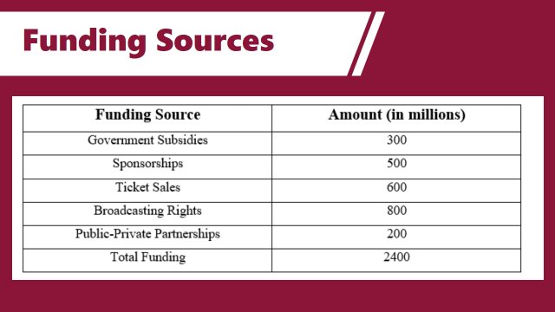
Securing funding is essential for hosting the FIFA World Cup (Rogers and Wynn, 2022). It can comes from various sources such as government subsidies, sponsorships, ticket sales, broadcasting rights, and public-private partnerships.
Funding Source | Amount (in millions)
Government Subsidies | 300
Sponsorships | 500
Ticket Sales | 600
Broadcasting Rights | 800
Public-Private Partnerships | 200
Total Funding | 2400

Conclusion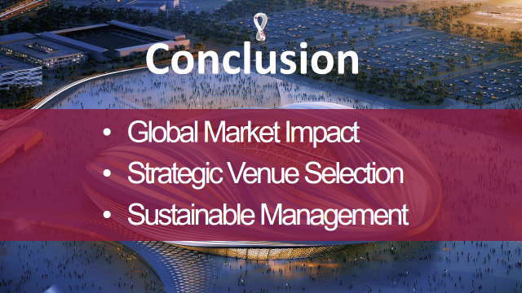
Hosting the FIFA World Cup is an important undertaking. This requires meticulous planning. Pre-planning to host a prestigious event is discussed here. Here is an examination of market factors affecting the FIFA World Cup, including competition. The FIFA World Cup aims to include football lovers from all over the world. Soccer's worldwide appeal places the World Cup well. Finally, the operational requirements for hosting the FIFA World Cup are addressed. The correct venue is critical to providing the best experience for the audience. Staff management is crucial to providing excellent service during the event. Hosting the FIFA World Cup represents a unique opportunity for cities to showcase their capabilities on the world stage. Providing an unforgettable experience for stakeholders alike. Organisers can ensure long-term sustainability by managing finances. A celebration of football's universal appeal. It brings people from all walks of life together to share in the excitement.

References 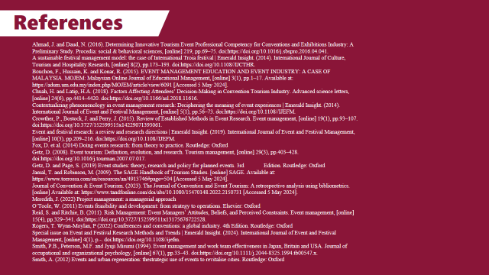
Ahmad, J. and Daud, N. (2016). Determining Innovative Tourism Event Professional Competency for Conventions and Exhibitions Industry: A Preliminary Study. Procedia: social & behavioral sciences, [online] 219, pp.69–75. doi:https://doi.org/10.1016/j.sbspro.2016.04.041.
A sustainable festival management model: the case of International Troia festival | Emerald Insight. (2014). International Journal of Culture, Tourism and Hospitality Research, [online] 8(2), pp.173–193. doi:https://doi.org/10.1108//IJCTHR.
Bouchon, F., Hussain, K. and Konar, R. (2015). EVENT MANAGEMENT EDUCATION AND EVENT INDUSTRY: A CASE OF MALAYSIA. MOJEM: Malaysian Online Journal of Educational Management, [online] 3(1), pp.1–17. Available at: https://adum.um.edu.my/index.php/MOJEM/article/view/6091 [Accessed 5 May 2024].
Chuah, H. and Latip, H.A. (2018). Factors Affecting Attendees’ Decision-Making in Convention Tourism Industry. Advanced science letters, [online] 24(6), pp.4414–4420. doi:https://doi.org/10.1166/asl.2018.11616.
Contextualizing phenomenology in event management research: Deciphering the meaning of event experiences | Emerald Insight. (2014). International Journal of Event and Festival Management, [online] 5(1), pp.56–73. doi:https://doi.org/10.1108//IJEFM.
Crowther, P., Bostock, J. and Perry, J. (2015). Review of Established Methods in Event Research. Event management, [online] 19(1), pp.93–107. doi:https://doi.org/10.3727/152599515x14229071393061.
Event and festival research: a review and research directions | Emerald Insight. (2019). International Journal of Event and Festival Management, [online] 10(3), pp.209–216. doi:https://doi.org/10.1108//IJEFM.
Fox, D. et al. (2014) Doing events research: from theory to practice. Routledge: Oxford
Getz, D. (2008). Event tourism: Definition, evolution, and research. Tourism management, [online] 29(3), pp.403–428. doi:https://doi.org/10.1016/j.tourman.2007.07.017.
Getz, D. and Page, S. (2019) Event studies: theory, research and policy for planned events. 3rd Edition. Routledge: Oxford
Jamal, T. and Robinson, M. (2009). The SAGE Handbook of Tourism Studies. [online] SAGE. Available at: https://www.torrossa.com/en/resources/an/4913746#page=504 [Accessed 5 May 2024].
Journal of Convention & Event Tourism. (2023). The Journal of Convention and Event Tourism: A retrospective analysis using bibliometrics. [online] Available at: https://www.tandfonline.com/doi/abs/10.1080/15470148.2022.2150731 [Accessed 5 May 2024].
Meredith, J. (2022) Project management: a managerial approach
O’Toole, W. (2011) Events feasibility and development: from strategy to operations. Elsevier: Oxford
Reid, S. and Ritchie, B. (2011). Risk Management: Event Managers’ Attitudes, Beliefs, and Perceived Constraints. Event management, [online] 15(4), pp.329–341. doi:https://doi.org/10.3727/152599511x13175676722528.
Rogers, T. Wynn-Moylan, P (2022) Conferences and conventions: a global industry. 4th Edition. Routledge: Oxford
Special issue on Event and Festival Research Methods and Trends | Emerald Insight. (2024). International Journal of Event and Festival Management, [online] 4(1), p.-. doi:https://doi.org/10.1108//ijefm.
Smith, P.B., Peterson, M.F. and Jyuji Misumi (1994). Event management and work team effectiveness in Japan, Britain and USA. Journal of occupational and organizational psychology, [online] 67(1), pp.33–43. doi:https://doi.org/10.1111/j.2044-8325.1994.tb00547.x.
Smith, A. (2012) Events and urban regeneration: thestrategic use of events to revitalise cities. Routledge: Oxford


