Nathaniel C Raynes
M4X01975
Architecture in your hometown

Context and historical background
Cyfarthfa castle was built by Richard Crawshay in 1825 for a price of £30,000 and it sits in Cyfarthfa park in Merthyr Tydful. The Architect was Robert Lugar and the building was originally a house for the Crawshay family that were extremely wealthy and owned the Cyfarthfa iron works which had changed the surrounding area, “the grounds around Cyfarthfa Castle shew successful cultivation” (Clarke, 1996) . Though it resembled a castle with its towers and stone the building itself was essentially a mansion that looked like a castle this was mainly to show the families power due to their hugely successful iron works. After the council bought the castle in 1909 it was turned into a school and museum for the public and now resides solely as a museum with countless pieces of Merthyr’s long history.
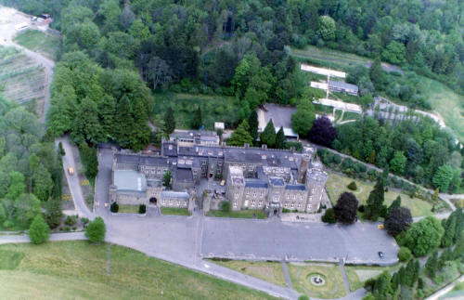
(Alangeorge.co.uk, 2019)
The Red House
The Red House was built between 1896 and 1898 and was the used as a court house and the home of the council. The Architect for the old town hall was E.A.Johnson and the building was a late Victorian building with a “Solid masonry construction - red brick & terracotta - with stained glass windows & terracotta parapet adornments.” (Cewales.org.uk, 2019). It is now used for public use and it is the monument to the new small festival known as Merthyr rising which takes its name from the riots that occurred in the 1830’s.

Plan and section
Cyfarthfa Castle
I have run into some trouble with getting plans of Cyfarthfa castle so I have had to use google earth to show its size. The mansion in length is roughly 100 meters long and is around 45 meters wide.

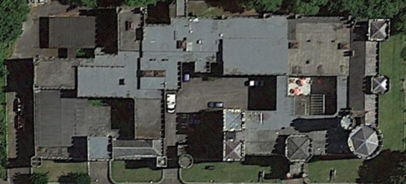(Google Earth)
As you can see it shows its castle like features with its circular and square towers and also the gate entrances leading to two courtyards. The building itself is asymmetrical with the majority of the towers and castle like structure to protrude on the side of the building not on the front. The building is a very odd construction with what seems to be half a castle and half a mansion.

The Red House
Below are the original plans for the Red house;

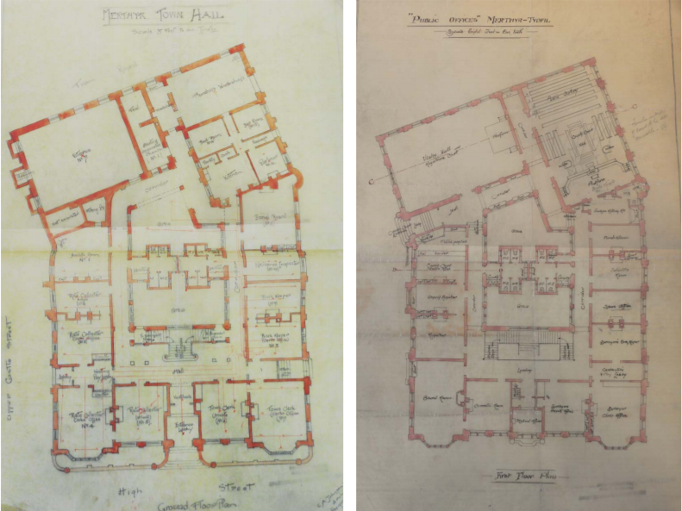 (Cewales.org.uk, 2019)
As you can see in the plans the building itself is of rectangular form that sweeps off to the side towards the rear and consists of many windows and rooms. The building from the front is quite symmetrical before branching off into the rear with a huge room right at the back of the building itself. The building has many rooms which were mainly used for the local government and the local council for their various meetings.

Materials and Lighting
Cyfathfa castle
Cyfarthfa was mainly built out of Pennant sandstone and had “crenelated parapets with false machicolation to the towers and weathered string courses to the other walls” (Coflein.gov.uk, 2019) .The interior still has its many rooms and they include a “baronial-style entrance hall” and a “neo-classical library ,drawing room and dining room” (Coflein.gov.uk, 2019) . The inside is very well lit due to the buildings various large windows, the architect clearly wanted to make the most of natural light and succeeded in doing this and the building is perfect for the now museum section in the house.
The Red House
The Red House was primarily built out of red terracotta and red bricks, it had a clock at the top of the spire and had various large windows along the building. The windows of the building made good use of natural light and the rooms are very tall with sound carrying throughout the huge spaces. The courtyard which is now indoor is vast and open space with a sky light and the use of light wooden flooring and the skylight complement each other well to make the room even brighter.

Use
Cyfarthfa castle
Cyfarthfa castle once belonged to Richard Crawshay and was a part of the Crawshay family from 1825-1909 when the local council bought the building and turned it into a museum and school for the public. A member of my family once went to the school and described the building as being “ aesthetically pleasing”(M.March, 2019) and she also commented on how well the building flowed as a school as she was later on a school cook in neighbouring schools. Though as good as it is a school it is also very good as a museum as it has very spacious and tall rooms that can house the various exhibits and also has the amount of rooms that can be utilised for various different sized exhibits. The large windows are also good at letting plenty of natural light in which would be ideal as a house in which the Crawshays used and also as the museum that it now is.

The Red House
The red house once served as Merthyr’s old town hall and was left derelict in recent years until it got refurbished and is now a public building and is mainly used for arts and creative industries and can also be booked out for various events. The building has a new café that sells fresh local produce keeping the local businesses happy. As I have been there before the Red House has a vast amount of space and also many rooms inside which are ideal for people looking to book out rooms for their events.

Conclusion
After studying both of these historic buildings of my hometown I have come to the conclusion that they are very different buildings but function in a similar way as they are now publically used. Cyfarthfa castle was an earlier build that had castle characteristics and was primarily made of stone, this was obviously used as a symbol to the locals that the family had a huge amount of power. Whereas the old town hall was a red brick and terracotta build that was a symbol of the leaders of our town and also the monument for the riots that went against people and families like the Crawshays who monopolised the towns that the workers lived in.
If I was tasked to do this again I would make sure to back up my work more often as I damaged my laptop and had to go without copies of the plans of the castle that I had requested from the national archives. I also would have wanted to spend much more time than I did in the buildings to really see how people interact with the buildings every day as both buildings are of public use.
I would say it has made me think of buildings more differently and has made me realise that access to plans and basic information about historic buildings should have easier access to the public as you can really appreciate a building when you can see all of its components and information all laid out.

Reference list
Cewales.org.uk. (2019). [online] Available at: http://www.cewales.org.uk/files/5214/4343/8708/Ashleigh-Presentation-Merthyr-Town-Hall1.pdf [Accessed 9 Jan. 2019].
Clarke, T. (1996). A guide to Merthyr-Tydfil. Cardiff [Wales]: Cardiff Academic Press, p.16.
Alangeorge.co.uk. (2019). Cyfarthfa Castle and the Park: Page - 1. [online] Available at: http://www.alangeorge.co.uk/cyfarthfa_and_the_Park.htm [Accessed 13 Jan. 2019].
Coflein.gov.uk. (2019). CYFARTHFA CASTLE, MERTHYR TYDFIL | Coflein. [online] Available at: https://www.coflein.gov.uk/en/site/18504/details/cyfarthfa-castle-merthyr-tydfil [Accessed 17 Jan. 2019].
Earth.google.com. (2019). Google Earth. [online] Available at: https://earth.google.com/web/@51.75684767,-3.39039889,222.9459062a,270.52302944d,35y,32.26706829h,0t,0r [Accessed 15 Jan. 2019].
Margaret March. Interviewed 4th of January 2019.
Polyflor.com. (2019). Redhouse arts and cultural centre, JOL’s caf� & gallery | Case Study | Polyflor. [online] Available at: https://www.polyflor.com/jh/web.nsf/c267d15b1f5db3e080257f3700461755/f0d5f21c54be723580257fa1003c4898!OpenDocument#/0 [Accessed 14 Jan. 2019].
Cynonculture.co.uk. (2019). William Crawshay II 1788 – 1867 – Cynon Culture. [online] Available at: http://cynonculture.co.uk/wordpress/merthyr-tydfil/william-crawshay-ii-1788-1867/ [Accessed 16 Jan. 2019].

