University of Wales Trinity Saint David
School of Engineering

Analysis and Simulation of a Centrifugal Clutch
Stress Analysis and Dynamics ACMA5010

Heather Came
2208198
11/11/2024
Contents

Task A
1 Introduction 1
2 Historical Development of the Centrifugal Clutch 2
3 Design and Mechanics of Centrifugal Clutches 3
3.1 Operating Principle 3
3.2 Typical Components and Their Functions 3
3.3 Diagram of a Centrifugal Clutch 4
4 Choice of Materials for Centrifugal Clutches 5
5 Applications of Centrifugal Clutches 6
6 Operating Conditions of a Centrifugal Clutch 7
7 Advantages and Disadvantages of Centrifugal Clutches 8
8 Introduction to Electromagnetic Clutches 9
9 Advantages and Disadvantages in Automation 10
10 Applications of Electromagnetic Clutches in Modern Automation 11
11 Conclusion 12
Task B
12 Question 1 14
13 Question 2 15
14 Question 3 17
15 Question 4 18
16 Question 5 19
17 Question 6 21
18 Question 7 23
19 Question 8 25
20 References 26
21 Appendix 32

Figure 1 – Physics of a centrifugal clutch (PlanMED, 2021) 3
Figure 2 - Diagram of a centrifugal clutch (Kholil and Dwiyati, 2021) 4
Figure 3 - Diagram of an Electromagnetic Clutch (Jaber, 2024). 9
Figure 4 - Graph displaying the transmitted torque against the driving shaft speed when the coefficient is 0.35 20
Figure 5 - Graph displaying the transmitted torque against the driving shaft speed with varying coefficients 21
Figure 6 - Task B 32

Task A

Introduction

Centrifugal clutches are vital for small, motorised equipment due to their simplicity and automatic engagement. They offer a practical solution for tools and small machinery, with ongoing advancements improving their efficiency. This report explores the materials, applications, and advantages of centrifugal clutches, alongside the role of electromagnetic clutches in automated manufacturing.

Historical Development of the Centrifugal Clutch

Early concepts and initial development of the centrifugal clutch appeared during the 19th century within the locomotive industry (Sirajeddine, 2023). It was developed through the contributions of various engineers. By the 1900s, centrifugal clutches were gaining popularity and being utilised in equipment such as lawn mowers and light industrial machinery.
The post-war era marked a shift from organic composites to high-performance friction materials that could handle higher speeds and temperatures, improving the longevity of the clutch. As technology progressed into the late 1900s, centrifugal clutches began to incorporate lightweight alloys like aluminium and titanium (Khan et al., 2024). These materials reduced clutch weight while maintaining durability, making them particularly effective in high-speed applications like chainsaws and other small engine machinery.

Design and Mechanics of Centrifugal Clutches

Operating Principle

The operation of a centrifugal clutch relies on centrifugal force to engage/disengage the clutch. The centrifugal force increases as the engine speed increases. The shoes within the clutch are forced outward, pressing against the drum and transmitting torque to the driven shaft. When the engine speed decreases, the force drops, causing the clutch to disengage and stop power transmission (Sirajeddine, 2023).

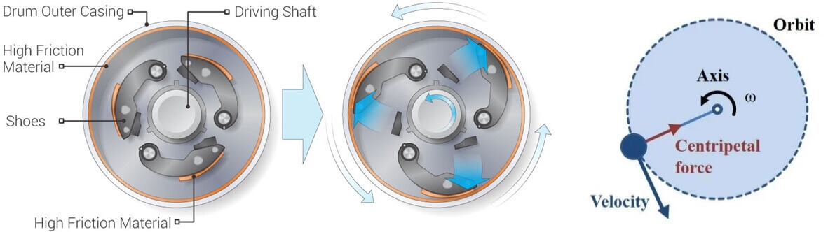
Figure 1 – Physics of a centrifugal clutch (PlanMED, 2021)

Typical Components and Their Functions

Centrifugal clutches key components:
- Friction Lining: this is located on the outer surface of the shoes and is used to contact the drum. The lining helps hold the drum in place and prevent slipping, enabling efficient torque transfer.
- Shoes: these components move outward with centrifugal force as the engine speed increases. They slide along guideways and initiate contact with the drum.
- Springs: springs keep the shoes in place at low speeds, ensuring the clutch remains disengaged. As the centrifugal force increases it eventually exceeds the tension force of the spring, allowing the shoes to engage with the drum.
- Drum: the drum houses the clutch shoes. It is connected to the driven shaft and begins to rotate once the clutch shoes make sufficient contact with its inner surface, typically when a specific RPM is reached. This contact allows the drum to transfer torque from the engine to the driven shaft, effectively engaging the transmission system.
- Hub: The hub holds the clutch assembly together and serves as a mounting point. It is critical for proper alignment.
- Spiders/Guides: These are mounted on the motor/drive shaft and are distributed evenly to keep the shoes aligned, ensuring smooth movement (Shivansh Sabhadiya, 2024).

Diagram of a Centrifugal Clutch

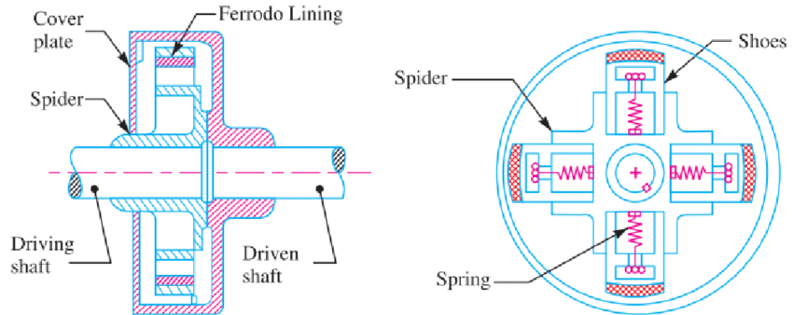
Figure 2 - Diagram of a centrifugal clutch (Kholil and Dwiyati, 2021)

Choice of Materials for Centrifugal Clutches

Centrifugal clutches are made with carefully selected materials, these include:
- Friction linings: use materials such as ceramic or sintered metal for high performance, and Kevlar for durability and heat tolerance (Phoenix Friction, 2022). Higher-performance linings improve torque transfer and reduce wear under extreme conditions. Recent studies are exploring the use of wood powder and coconut fibres as an environmentally friendly alternative (Kholil et al, 2021).
- Shoes: are often aluminium for lightweight applications. For higher stress applications cast iron and steel are used due to their durability. Lightweight alloys, such as titanium-aluminium, reduce weight without sacrificing strength (Science Direct, 2023).
- Springs: typically use high-carbon or stainless steel for elasticity and corrosion resistance (TEVEMA Marketing, 2024).
- Drums: use cast iron or steel for strength, or composite drums for lightweight applications.
- Hubs and Spiders/Guides: steel hubs provide the necessary strength and durability to withstand the stress of high RPMs. Guides often use lightweight metals or fibre composites in to reduce wear and improve performance.

Advancements in materials, such as high-strength alloys and carbon-fibre-reinforced polymers, have considerably enhanced the durability and performance of centrifugal clutches by reducing wear and improving heat resistance. Sintered composites, with additives like graphite or copper, now provide better heat dissipation, extending the lifespan of clutches in high-stress applications (Padmanabhan et al., 2023).

Applications of Centrifugal Clutches

Centrifugal clutches are widely used in small, motorised equipment. Common applications include:
- Garden Equipment: lawnmowers, chainsaws, and leaf blowers benefit from centrifugal clutches as they enable smooth operation without manual intervention.
- Small Vehicles: go-karts, mopeds and scooters use centrifugal clutches for smooth power transmission without requiring a manual clutch, making these vehicles easier to operate (Sehgal, Pratap and Kuhar, 2017).
- Industrial Machinery: low-power industrial machines, such as concrete mixers, use centrifugal clutches for automatic power control, making them efficient for tasks with variable loads and speeds (Testbook, 2023).

Operating Conditions of a Centrifugal Clutch

Centrifugal clutches operate under varying conditions, which include:
- Temperature: centrifugal clutches must cope with heat generated by friction, especially in high-speed applications; therefore, requiring heat-resistant materials to prevent wear or failure.
- Speed: centrifugal clutches typically engage at engine speeds between 1,500–3,000 RPM, though this can vary (GKG, 2021). The clutch must engage smoothly as speed increases, ensuring reliable torque transfer without slipping.
- Load variations: centrifugal clutches are designed to handle intermittent loads by engaging and disengaging as needed, based on speed rather than directly responding to load fluctuations.

Advantages and Disadvantages of Centrifugal Clutches

Centrifugal clutches offer several distinct advantages suitable for small engine applications:
- Automatic Engagement: they require no manual control, automatically engaging as engine speed increases.
- Safety and Simplicity: by disengaging at low speeds, they provide an additional safety feature, reducing power transmission when the engine is idle.
- Low Maintenance: they are simpler to maintain than alternative clutches. With fewer components and simpler mechanics, they require only routine adjustments and repairs.
- Cost-Effectiveness: compared to electromagnetic clutches, centrifugal clutches are relatively affordable, both in initial cost and ongoing maintenance.
Unlike fluid clutches, which use hydraulic fluid for smooth engagement, centrifugal clutches are more straightforward and economical. This simplicity makes them particularly well-suited for small engines where automatic engagement and low maintenance are priorities (BLM Team, 2019).

However, centrifugal clutches also have disadvantages:
- Limited torque capacity: centrifugal clutches may not be appropriate for applications requiring high torque as they have a limited capacity.
- Slipping: slipping is common with centrifugal clutches and can damage parts of the clutch such as the friction lining and drum (Peterson, 2023).
- Lack of control over engagement: in high-performance applications that require precise control over engagement, centrifugal clutches may not be suitable. They are designed to engage automatically at a specific RPM threshold, limiting the operator’s ability to adjust/control engagement points according to varying needs.

Introduction to Electromagnetic Clutches

Electromagnetic clutches use an electromagnet to engage and disengage, using an electric current. When current flows through the electromagnet, it creates a magnetic field that pulls an armature, which engages the clutch and transfers torque from the driving shaft to the driven shaft. This allows for precise control over clutch operation, making them ideal for applications requiring accurate engagement/disengagement (Jaber, 2024).

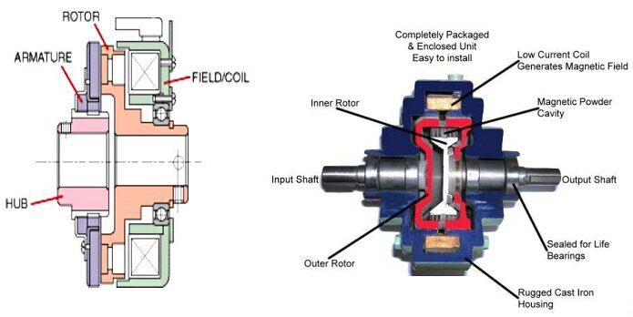
Figure 3 - Diagram of an Electromagnetic Clutch (Jaber, 2024).

Advantages and Disadvantages in Automation

Electromagnetic clutches provide several benefits for automated manufacturing:
- High Precision and Speed: they engage/disengage quickly and accurately, making them suitable for high-speed applications, such as robotics and assembly lines, where timing is critical (KTSales, 2024).
- Infrequent Maintenance: as the clutch does not mechanically wear, maintenance occurrences are minimal which results in lower costs and less down-time.
- Reliability and Durability: as they do not rely on mechanical contact for engagement but instead engage magnetically, less wear occurs over time lengthening their lifespan.
- Remote and Automated Control: these clutches can be controlled remotely, making them highly suitable for integration with computerised and automated systems.
- Energy Efficient: electromagnetic clutches consume power only when engaged.
- Control: electromagnetic clutches allow for precise control over power transmission and rapid response time which results in swift engagement/disengagement.
- Torque: electromagnetic clutches can transmit high torque efficiently, making them suitable for heavy-duty applications. Torque transmission can be adjusted by controlling the current supplied (OGURA, 2024).
In automated manufacturing, where processes must be repeated with exact timing and precision, electromagnetic clutches are invaluable (Dr Solenoid, 2024).

However, electromagnetic clutches also come with drawbacks:
- Power dependent: electromagnetic clutches rely on a power source and therefore are vulnerable to electrical issues. In the event of a power failure, the clutch will cease to function, as it relies on engine speed to engage.
- Upfront cost: the materials and technology used within the clutch makes it expensive initially, especially compared to centrifugal clutches.
- Maintenance needs: when maintenance is required, the complexity of the clutch assembly and the specialised materials used can make maintenance and replacement parts costly and time-consuming; often resulting in increased downtime and higher overall operating costs (Somani, 2023).

Applications of Electromagnetic Clutches in Modern Automation

Electromagnetic clutches are used for environments where timing, efficiency, and precision are vital. They are utilised in modern automation for various applications such as:
- Robotics: electromagnetic clutches allow for precise movement control. This enables robots to carry out detailed tasks with high accuracy (SG Transmission, 2021).
- Conveyor Belts: electromagnetic clutches are widely used in automated conveyor systems to manage start/stop sequences smoothly, optimising the flow of materials (Morgan, 2023). Control over engagement/disengagement is essential in manufacturing plants.
- Automotive: electromagnetic clutches are used for power steering as well as air conditioning systems where controlled engagement enhances performance and safety (Jaber, 2024).
- Aerospace: due to their ability to accurately transmit torque, electromagnetic clutches are employed in aviation to manage precise control of power transfer on an aircraft (SEPAC, 2024).

Conclusion

Centrifugal and electromagnetic clutches illustrate how clutch technology has adapted to meet the diverse needs of modern engineering. Centrifugal clutches have provided a reliable, low-cost solution for small, motorised equipment requiring automatic engagement, with material advancements enhancing their durability and performance. In contrast, electromagnetic clutches have enabled precise and efficient power transmission in automated manufacturing processes, where timing and control are paramount. Together, these technologies showcase the adaptability of clutch designs to meet both traditional and advanced industrial requirements.

Task B

Please see the Appendix for Task B questions.

Known values converted to SI units:
Mass of each shoe m = 275grams = 0.275kg
Stiffness of the spring k = 7.5kN/m = 7500N/m
Coefficient of friction μ = 0.35
Centre of mass radius (of each shoe from the shaft centres at rest position) r = 95mm = 0.095m
Clearance distance/gap between the shoes and inner drum c = 9 mm = 0.009 m
Outer drum wall thickness t = 4mm = 0.004 m
Number of shoes: 4

Question 1

The outer drum's inner radius r_{inner} ​ is given by the sum of the centre of mass radius and the clearance distance:
$$r_{inner} = r + c = 0.095m + 0.009m= 0.104m$$
$$Diameter = r_{inner}*2$$
$$D = 0.208m$$
Include the wall thickness on either side:
$$0.208 + (2*0.04) = 0.216m = 216mm$$

Question 2

The engagement speed is the speed at which the shoes contact the outer drum, overcoming the force of the spring. The force exerted by the spring is given by Hooke's Law:
$$F = kΔx$$
$$Δx=c$$
$$F = kc$$
k = 7500N/m
c = 0.009m

$$F = 7500 * 0.009=67.5N$$
Therefore 67.5N is the tension force of the spring ($F_{spring}$) when its extension is 9mm. This means that for the shoes to contact the drum the centrifugal force must be equivalent. To calculate the speed at which the forces are equal, use the formula $F=mω^{2}r$
The formula can be arranged to find angular velocity: $ω=\sqrt{\frac{F}{mr}}$
F = 67.5N
m = 0.275kg
r = 0.104m
$$ω=\sqrt{\frac{67.5}{0.275*0.104}}$$
$$ω=\sqrt{\frac{67.5}{0.0286}}$$
$$\sqrt{\frac{67.5}{0.0286}}=48.58127067 rad/s$$
$$RPM = (rad/s) * (60/2π)$$
$$48.58127067 * (60/2π) = 463.9169622$$
$$ω = 464RPM$$

Question 3

Driving shaft speed = 550RPM
rad/s = RPM/ ($\frac{60}{2π}$)
550($\frac{60}{2π}$) = 57.596rad/s
Substituted into the equation $F=mω^{2}r$ to work out radial force:
ω = 57.596rad/s
r = 0.095m
m = 0.275kg
$$F=0.275*{57.596}^{2}*0.104$$
$$F=94.875$$
Given the force of the spring was 67.5N, this must be subtracted this from 94.875N.
$$94.875 – 67.5 = 27.375$$
As 27.375 is for one shoe, it must be multiplied by the number of shoes in the clutch.
$$27.375 * 4 = 109.5$$
The radial force acting on the clutch when the driving shaft is rotating at 550RPM = 109.5N

Question 4

Driving shaft is rotating at speed = 550RPM
$$rad/s = RPM/(\frac{60}{2π})$$
$$\frac{550}{\frac{60}{2π}}= 57.596$$
$$ω = 57.596 rad/s$$
Using the known information; to calculate the torque transmitted, use the formula:
$$T = F * r * μ$$
F = 109.5N
r = 0.104m
µ = 0.35
$$T = 109.5 * 0.104 * 0.35 = 3.9858$$
$$T = 3.99Nm$$

Question 5

Mass of each shoe m = 275grams = 0.275kg
Coefficient of friction μ=0.35
r = 0.104m
F_{spring} = 67.5N
No. of shoes = 4

To calculate the transmitted torque at the driven shaft against driving shaft speed and create a graph, MATLAB can be utilised. To mathematically calculate each torque, follow these steps:
- Firstly, RPM must be converted to radians using $ω= RPM*\frac{2π}{60}$
- Use ω to find $F_{centrifugal}$ using the formula $F_{centrifugal}​= m*ω^{2}*r$
- To work out the total force per shoe ($F_{net}$) substitute into $F_{net}= F_{centrifugal}-F_{spring}$
- As $F_{net}$ is per shoe, multiply $F_{net}$ per number of shoes to get $F_{total}$ e.g. $F_{total}= F_{net} *4$
- Use $F_{total}$, $r$ and $μ$ to calculate the transmitted torque $T$ using ${T=F}_{total}* r* μ$
Repeat this process for each RPM value in the given range, in increments of 25RPM.

Example using 450RPM:
Firstly, convert to radians.
$$ω=RPM ×\frac{2π}{60}$$
$$450 ×\frac{2π}{60}=47.12rad/s$$
$$F_{centrifugal}​= m*ω^{2}*r$$
$$0.275*{\left(47.12\right)}^{2}*0.104=63.804N$$
$$F_{net}= F_{centrifugal}-F_{spring}$$
$$63.804-67.5= -3.696$$
As the net force is negative, this indicates that there is no engagement.
$$F_{total}= F_{net} per shoe*4$$
$$-3.696*4= -14.784$$
$${T=F}_{total}* r* μ$$
$$-14.784* 0.104* 0.35= -0.54Nm$$
As displayed at 450RPM on the graph below the transmitted torque is roughly 0.5Nm, supporting the calculation.

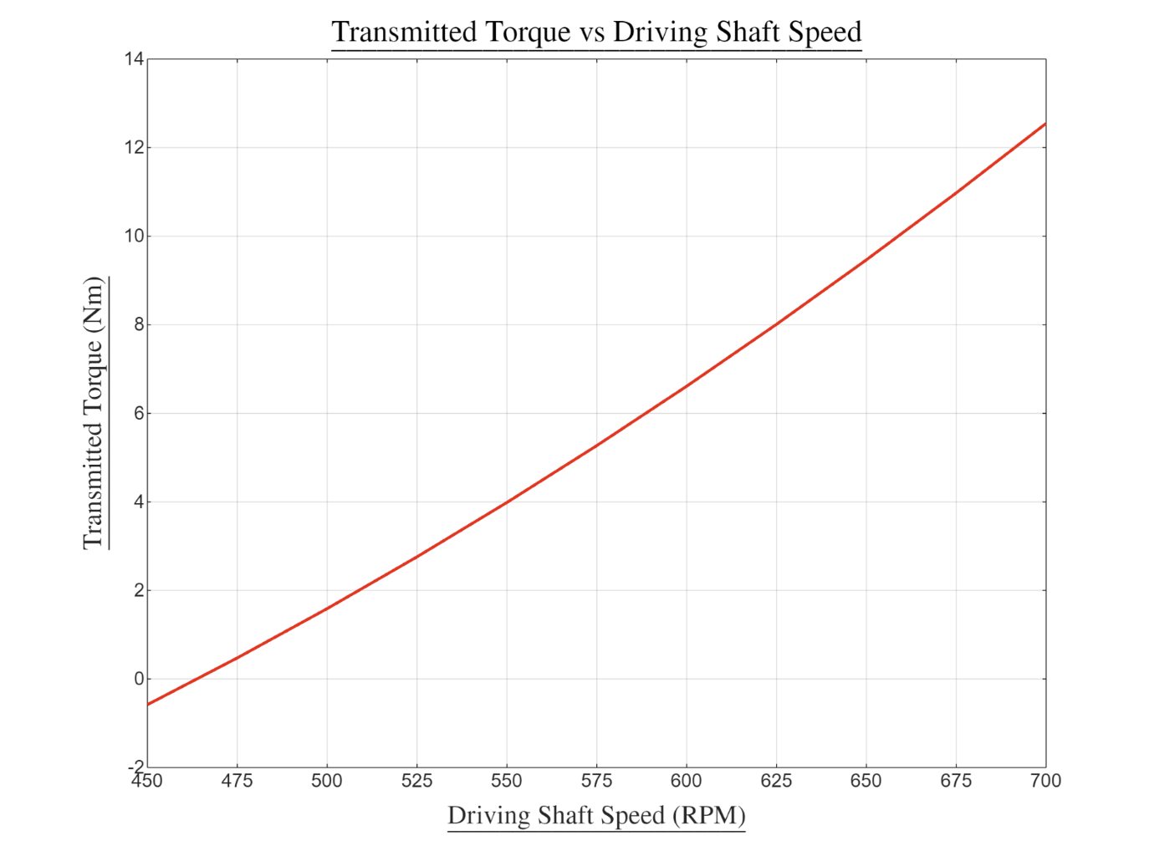
Figure 4 - Graph displaying the transmitted torque against the driving shaft speed when the coefficient is 0.35

Question 6

To calculate the torque transmitted at various speeds when the coefficient of friction changes, one can repeat the calculations stated above but replace $μ$ with the adopted coefficient.
$μ=0.3$
$${T=F}_{total}* r* μ$$
$$-14.784* 0.104* 0.3= -0.46Nm$$
$μ=0.4$
$$-14.784* 0.104* 0.4= -0.62Nm$$
This value is consistent with the graph.

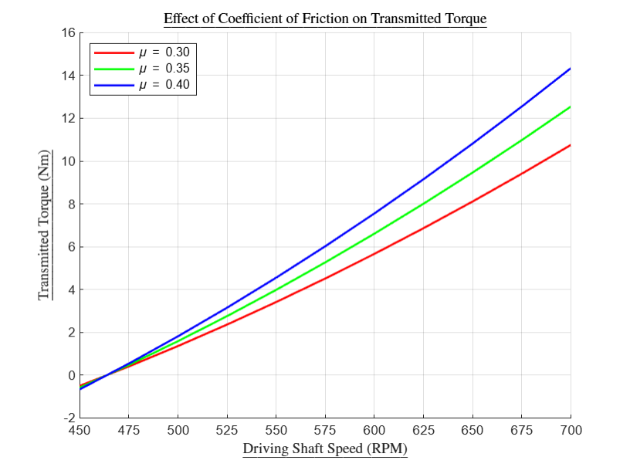
Figure 5 - Graph displaying the transmitted torque against the driving shaft speed with varying coefficients

At low speeds e.g., 450 RPM, where centrifugal force F_{centrifugal} ​ is too weak to overcome the spring force F_{spring}, changing the coefficient μ has no effect on torque, as the shoes do not engage. At higher speeds, when F_{centrifugal} is greater than F_{spring} and the shoes engage, a higher μ e.g., 0.4 significantly increases the transmitted torque; whereas a lower μ e.g., 0.3, results in lower torque transmission. This is because, the higher the coefficient the greater the grip the shoe friction lining has on the drum resulting in less slipping. This increased grip allows more torque to be transferred from the clutch to the driven shaft, as there’s less relative movement. Choosing μ requires balancing torque needs with material durability. It’s important to note, the graph does not consider external factors acting on the clutch such as oil, wear or swarf that could affect the performance of the clutch.

Question 7

I will determine the maximum torque from question 5, using the coefficient of 0.35.

k = 7500N/m
d (clearance) = 0.009m
r = 0.108m (radius + wall thickness = 0.104 + 0.04)
Maximum RPM: 700RPM
m (mass of drum) = 750grams = 0.75kg
maximum possible transmitted torque: 700RPM
μ = 0.35 (as used in question 5)
F_{net} = total force per shoe

$$ω=700*\frac{2π}{60}=73.304$$
$$F_{centrifugal}​= m*ω^{2}*r$$
$$0.275*{\left(73.304\right)}^{2}*0.104=153.68$$
$$F_{net}= F_{centrifugal}-F_{spring}$$
$$153.68-67.5=86.18$$
$$F_{total}= F_{net} *4$$
$$86.18*4=344.72N$$
$${T=F}_{total}* r* μ$$
$$344.72* 0.104* 0.35=12.548$$
$$T = 12.55Nm$$
Now to work out angular acceleration:
$$α=\frac{T}{I}$$
As the drum is considered a solid disc, to work out the moment of inertia I this equation can be used:
$$I =\frac{1}{2} * m * r^{2}$$
$$I =\frac{1}{2} * 0.75 *{\left(0.108\right)}^{2}$$
$$I =0.004374kgm^{2}$$
Now substitute into the formula:
$$α=\frac{T}{I}$$
$$α=\frac{12.55}{0.004374}$$
$$α=2869.23rad/s^{2}$$

Question 8

D_{shaft} (diameter of the driven shaft) = 17.5mm = 0.0175m
$$r =\frac{0.0175}{2}$$
r_{shaft} = 0.00875m
F_{brakimg} (tangential braking force applied to the driven shaft) = 500N
T_{max} = 12.55Nm
I = 0.004374kgm²
Using the equation for torque
$$T_{braking}=F*r_{shaft}$$
$$500*0.00875=4.375Nm$$
$$T_{total}=T_{max}-T_{braking}$$
$$12.55-4.375=8.175Nm$$
$$α=\frac{T_{total}}{I}$$
$$\frac{8.175}{0.004374}=1868.9986$$
$$=1869rad/s^{2}$$

References

Anand, M. and Das, A.K. (2021). Issues in Fabrication of 3D Components through DMLS Technique: a Review. Optics & Laser Technology, 139(1), p.106914. doi:https://doi.org/10.1016/j.optlastec.2021.106914.
BBC Bitesize (2019). Design Briefs and Specifications - Investigating - AQA - GCSE Design and Technology Revision - AQA. [online] BBC Bitesize. Available at: https://www.bbc.co.uk/bitesize/guides/zbn6pbk/revision/3 [Accessed 20 May 2024].
Bitonti, F. (2019). 3D Printing Design. Bloomsbury Visual Arts.
BLM Team (2019). Advantages and Disadvantages of Centrifugal Clutches. [online] BLM Automatic Clutch. Available at: https://www.centrifugalclutches.com[Accessed 20 Oct. 2024].
Boyer, R.R. (1995). Titanium for aerospace: Rationale and Applications. Advanced Performance Materials, 2(4), pp.349–368. doi:https://doi.org/10.1007/bf00705316.
BOYI (2024). Mechanical Manufacturing and Its Lifecycle - BOYICNC Mechanical Parts. [online] BOYICNC Mechanical Parts - BOYICNC Mechanical Parts. Available at: https://boyicnc.com/2024/03/13/understanding-die-casting-methodology-material-selection-and-variants/ [Accessed 7 Jun. 2024].
BPF (2019). Plastics in Electrical and Electronic Applications. [online] Bpf.co.uk. Available at: https://www.bpf.co.uk/innovation/plastics_in_electrical_and_electronic_applications.aspx [Accessed 15 Jun. 2024].
Broadbent, T. (1950). The Broadbent Automatic Centrifugal Clutch, Pulleys, Couplings, and Brakes.
BSA Mouldings (2017). Injection Moulding Process - the Art of Injection Moulding. [online] BSA Mouldings - Plastic Injection Moulding. Available at: https://www.bsamouldings.co.uk/injection-moulding-process [Accessed 11 Jun. 2024].
California Metals (2024). The Titanium Revolution: Unveiling the Strength, Versatility, and Sustainability of a Metal Marvel. [online] Sustainable Metal Technologies. Available at: https://www.californiametals.com/sustainability/the-titanium-revolution-unveiling-the-strength-versatility-and-sustainability-of-a-metal-marvel/ [Accessed 7 Apr. 2024].
Campbell, J. (2015). Complete Casting Handbook: Metal Casting processes, metallurgy, Techniques and Design. 2nd ed. Amsterdam: Elsevier: Butterworth-Heinemann.
Chanda, M. and Roy, S.K. (2008). Plastics Fundamentals, Properties, and Testing. Boca Raton: CRC Press.
Chen, J. (2023). How CNC Machining and Injection Molding Used for Manufacturing Auto parts? [online] www.linkedin.com. Available at: https://www.linkedin.com/pulse/how-cnc-machining-injection-molding-used-auto-parts-johnny-chen-rnw6c [Accessed 11 May 2024].
Conger Industries (2022). How to Reduce Lead Times: 11 Tips for Manufacturers & Warehouses. [online] Conger Industries Inc. Available at: https://www.conger.com/reduce-lead-time/ [Accessed 7 Jun. 2024].
Dr Solenoid (2024). AS-0417 DC 12V C Type Flame Pull Push Solenoid. [online] AS-0417 DC 12V C Type Flame Pull Push Solenoid. Available at: https://www.drsolenoid.com[Accessed 6 Nov. 2024].
Essentra (2023). Design for Sustainability: Optimising Plastic Injection Moulding Processes. [online] www.essentracomponents.com. Available at: https://www.essentracomponents.com[Accessed 7 Jun. 2024].
Formlabs (2021). Additive Manufacturing: Industry Trends and Outlook. [online] Formlabs. Available at: https://formlabs.com/uk/blog/additive-manufacturing/ [Accessed 8 Jun. 2024].
Gayette, M. (2022). Top 10 Advantages of Additive Manufacturing. [online] www.ptc.com. Available at: https://www.ptc.com/en/blogs/cad/10-additive-manufacturing-advantages [Accessed 8 Jun. 2024].
Gebhardt, A. (2011). Understanding Additive Manufacturing. Hanser Fachbuchverlag.
GKG (2021). Go-Kart Guru - Go Kart Clutches: Which Kind Should I Use? [online] Go-Kart Guru. Available at: https://gokartguru.com/go-kart-clutches-which-kind-should-i-use/ [Accessed 1 Nov. 2024].
Groover, M.P. (2016). Principles of Modern Manufacturing. 4th ed. Singapore ; Hoboken, New Jersey: John Wiley & Sons, Inc.
Guevara, P. (2023). A Guide to Quality Function Deployment. [online] SafetyCulture. Available at: https://safetyculture.com/topics/qfd/ [Accessed 3 Jun. 2024].
Hatch, M. (2022). Advantages and Disadvantages of Injection Moulding | Protolabs. [online] www.protolabs.com. Available at: https://www.protolabs.com/en-gb/resources/blog/injection-moulding-what-are-the-advantages/#:~:text=It%20minimises%20moulding%20costs%20and [Accessed 7 Jun. 2024].
Haworth Castings (2021). Machining versus Casting – What Is Right for My requirements? [online] Haworth Castings. Available at: https://haworthcastings.co.uk[Accessed 15 Jun. 2024].
Injection Moulders (2023). Why Injection Moulding Is Ideal for High-Volume Manufacturing. [online] injectionmoulders.co.uk. Available at: https://injectionmoulders.co.uk/[Accessed 3 Jun. 2024].
Jaber, S. (2024). Electromagnetic Clutch Design: Simulate and Optimize. [online] SimScale. Available at: https://www.simscale.com/blog/electromagnetic-clutch-design-simulate-and-optimize/ [Accessed 1 Nov. 2024].
Jung, S., Kara, L.B., Nie, Z., Simpson, T.W. and Whitefoot, K.S. (2023). Is Additive Manufacturing an Environmentally and Economically Preferred Alternative for Mass Production? Environmental Science & Technology, [online] 57(16), pp.6373–6386. doi:https://doi.org/10.1021/acs.est.2c04927.
Khan, F., Hossain, N., Mim, J.J., Rahman, S.M.M., Iqbal, Md.J., Billah, M. and Chowdhury, M.A. (2024). Advances of Composite Materials in Automobile Applications – A Review. Journal of Engineering Research, [online] 2. doi:https://doi.org/10.1016/j.jer.2024.02.017.
Kholil, A., Dwiyati, S.T., Riyadi, R., Siregar, J.P., Yoga, N.G. and Aji, A.I. (2021). Characteristics of Wood powder, Coconut Fiber, and Green Mussel Shell Composite for Motorcycle Centrifugal Clutch Pads. IOP Conference Series: Materials Science and Engineering, 1098(6), p.062034. doi:https://doi.org/10.1088/1757-899x/1098/6/062034.
Kolman, R. (2020). Residual Stress Analysis of Additive Manufacturing of Metallic Parts Using Ultrasonic waves: State of the Art Review. Journal of Materials Research and Technology, [online] 9(4), pp.9457–9477. doi:https://doi.org/10.1016/j.jmrt.2020.05.092.
KTSales (2024). The Role of Industrial Electromagnets in Automation and Robotics - Ningbo Ketian Magnet CO.,LTD. [online] Ningbo Ketian Magnet CO.,LTD. Available at: https://www.ktmagnet.com/the-role-of-industrial-electromagnets-in-automation-and-robotics.html [Accessed 15 Oct. 2024].
Locke, R.M. and Wellhausen, R. (2014). Production in the Innovation Economy. MIT Press.
Loughborough University (2024). Powder Bed Fusion | Additive Manufacturing Research Group | Loughborough University. [online] www.lboro.ac.uk. Available at: https://www.lboro.ac.uk/research/amrg/about/the7categoriesofadditivemanufacturing/powderbedfusion/#:~:text=Direct%20metal%20laser%20sintering%20(DMLS)%20is%20the%20same%20as%20SLS [Accessed 7 Jun. 2024].
Madhavadas, V., Srivastava, D., Sakthivel, A. and Chadha, U. (2022). A Review on Metal Additive Manufacturing for Intricately Shaped Aerospace Components. [online] Available at: https://www.researchgate.net/publication/362269138_A_review_on_metal_additive_manufacturing_for_intricately_shaped_aerospace_components [Accessed 3 Jul. 2024].
Milewski, J.O. (2017). Additive Manufacturing of Metals : From Fundamental Technology to Rocket Nozzles, Medical Implants, and Custom Jewelry. Cham: Springer International Publishing.
Morgan, D. (2023). Electromagnetic Clutches & Brakes Are Revolutionizing Material Handling. Unleash the Precision and Efficiency. [online] Multidimensions.co.in. Available at: https://multidimensions.co.in/blogs/precision-and-efficiency-electromagnetic-clutches-and-brakes-in-material-handling-systems?srsltid=AfmBOoqIJ0QwA1ckKnclSaNbKTTTUgvCUER4IsteFuxzoFvs7UAJx3KD [Accessed 22 Oct. 2024].
OGURA (2024). Electromagnetic Clutches and Brakes Available from Jbj Techniques Limited. [online] Jbj.co.uk. Available at: https://www.Electromagnetic_clutches-from-jbj [Accessed 18 Oct. 2024].
Orthwein, W.C. (2004). Clutches and Brakes. CRC Press.
Padasak, Z. (2022). Advantages & Disadvantages of Additive Manufacturing. [online] www.alphaprecisionpm.com. Available at: https://www.additive-manufacturing [Accessed 8 Jun. 2024].
Padmanabhan, S., Vinod Kumar, T., Sendil Kumar, D., Velmurugan, G., Akshay Kumar, B. and Hitesh Sri Subramanyam, K. (2023). Investigation of structural and thermal analysis of clutch facings with different friction materials. Materials Today: Proceedings, [online] 92, pp.98–105. doi:https://doi.org/10.1016/j.matpr.2023.03.757.
Peterson, J. (2023). How to Tell If Centrifugal Clutch Is Bad. [online] Go Karting Buddy. Available at: https://gokartingbuddy.com/how-to-tell-if-centrifugal-clutch-is-bad/ [Accessed 7 Oct. 2024].
Protolabs (2019). 6 Reasons Why Aluminium Is Great for Your CNC Machined Parts. [online] www.protolabs.com. Available at: https://advantages-of-aluminium-for-cnc/ [Accessed 12 Jun. 2024].
Pugh, S. (1991). Total Design. Prentice Hall.
Science Direct (2023). Aluminum Alloys - an Overview | ScienceDirect Topics. [online] www.sciencedirect.com. Available at: https://materials-science/aluminum-alloys [Accessed 7 Jun. 2024].
Sehgal, K., Pratap, A. and Kuhar, R. (2017). Centrifugal Clutch Design for Various Applications. [online] pp.22–28. doi:https://www.ijrdo.org/index.php/mce/article/download/668/621/.
SEPAC (2024). Aerospace. [online] SEPAC, Inc. Available at: https://sepac.com/industries/aerospace/ [Accessed 6 Nov. 2024].
SG Transmission (2021). Robotics | SG Transmission. [online] SG Transmission. Available at: https://www.sgtransmission.com/sectors/robotics [Accessed 1 Nov. 2024].
Sha, W. (2013). Steels. Springer Science & Business Media.
Shaver, R. (1996). Manual Transmission Clutch Systems. SAE International.
Sims, J. (2023). An Overview of Titanium Anodizing and Its Applications in Aerospace. [online] Valence Surface Technologies. Available at: https://www.valencesurfacetech.com/the-news/titanium-anodizing/ [Accessed 28 Jun. 2024].
Sirajeddine, Y. (2023). Centrifugal Clutch - How It Works. [online] www.linkedin.com. Available at: https://www.linkedin.com/pulse/centrifugal-clutch-how-works-youness-sirajeddine [Accessed 5 Nov. 2024].
Smith, N. (2020). History in the Making – the single-plate Dry Clutch. [online] autotechnician.co.uk. Available at: https://autotechnician.co.uk/history-in-the-making-the-single-plate-dry-clutch/ [Accessed 9 Oct. 2024].
Somani, A. (2023). Tips for Maintaining and Servicing Electromagnetic Clutches. [online] Shree Krishna Sales. Available at: https://www.shreekrishnasales.com/post[Accessed 3 Nov. 2024].
Sunny, T.H., Shalvin (2014). Design for X (DFX). [online] Six Sigma Study Guide. Available at: https://sixsigmastudyguide.com/design-for-x-dfx/#:~:text=This%20approach%20entails%20early%20consideration [Accessed 11 Jun. 2024].
Tarlengco, J. (2024). DFMEA: Design Failure Mode and Effects Analysis. [online] SafetyCulture. Available at: https://safetyculture.com/topics/dfmea-design-failure-mode-and-effects-analysis/ [Accessed 4 Jul. 2024].
Testbook (2023). Centrifugal Clutch- Diagram, Working, Advantages and Applications. [online] Testbook. Available at: https://testbook.com/mechanical-engineering/centrifugal-clutch [Accessed 26 Oct. 2024].
TEVEMA Marketing (2024). The Influence of Carbon Fiber, Superconductors on Springs -. [online] Technische Veren Specialist | Tevema.com. Available at: https://www.tevema.com[Accessed 6 Oct. 2024].
Thomas, D.S. and Gilbert, S.W. (2014). Costs and Cost Effectiveness of Additive Manufacturing. Costs and Cost Effectiveness of Additive Manufacturing, [online] 2(1). doi:https://doi.org/10.6028/nist.sp.1176.
Vorob’Yeva, T.M. and Blunn, O.M. (2013). Electromagnetic Clutches and Couplings. Elsevier.
Xiaozhong, R. (2020). Fundamentals of Manufacturing Technology. Alpha Science International, Limited.
Ye, R. (2024). Injection Molding Vs CNC machining: Differences and 14 Comparison Points. [online] Rapid Prototyping & Low Volume Production. Available at: https://www.3erp.com/blog/injection-molding-vs-cnc-machining/ [Accessed 11 Jun. 2024].

Appendix

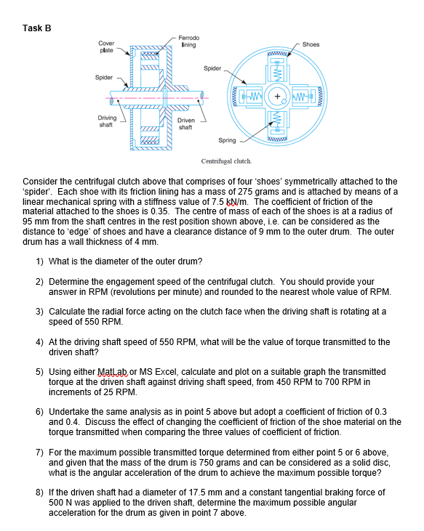
Figure 6 - Task B

