Morgan’s Hotel
Georgina Watt- General Manager
georgina@morganshotel.co.uk
Consultancy Project Final Report
Morgan’s Hotel
Staff Motivation & Work Effectiveness

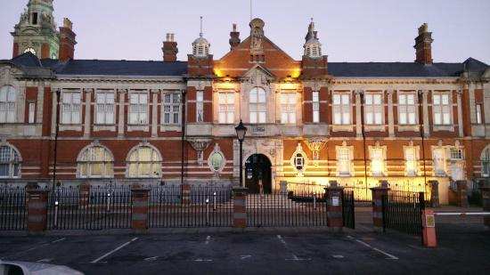
Content Page

1.1 Acknowledgement………………………………………………………………………………………….Page.3
1.2 Executive Summery…………………………………………………………………………………………Page.3
1.3 Introduction……………………………………………………………………………………………………Page.3
1.4 Aims and Objectives……………………………………………………………………………………….Page.3-4

1.5 Situational Details…………………………………………………………………………………………..Page.4
1.6 Statement of Problem…………………………………………………………………………………….Page.4
1.7 Information Collection…………………………………………………………………………………….Page.4
1.8 Form of the project…………………………………………………………………………………………Page.5

1.9 Observation Research…………………………………………………………………………………….Page.5-6
1.10 Focus Groups Research…………………………………………………………………………………Page.6-7
1.11 Discussion & Analysis…………………………………………………………………………………Page.7-10
1.12 SWOT………………………………………………………………………………………………………Page.10-11

1.13 Conclusion……………………………………………………………………………………………………Page.11
1.14 Summary of Aims & Objectives…………………………………………………………………….Page.11
1.15 Recommendations……………………………………………………………………………………….Page.12
1.16 References and Bibliography………………………………………………………………………..Page.13

1.1 Acknowledgement.
Higher success rates in small business ventures, however, correlate with specific planning, professional advice and resources (Lussier, 1995). At some point every business needs advice and solutions to make improvements, there for this project to help out privately owned organisation Morgan’s Hotel.
1.2 Executive Summery.
Specific definitions have included ideas of the consultant’s specialization, training and qualification; the role of the consultant as assistant, bridge, architect, physician and expert; and common actions of the consultant to identify, analyse, steer, design, solve, monitor, recommend, assist and implement (Ajmal et al., 2009; Leong and Huang, 2008; Old, 1995). There consultant choose Morgan’s Hotel, the Hotel was opened since 2002, and through the years several staff came in and left the organisation. In past 2 years the hotel has faced several management changes and drops in staffing members. For this project the consultant chooses to work with Morgan’s Hotel as the organisation, where worked for a long period of time and knows the inside issues, there for there will be 2 ways of research and a number of solutions to help the organisation to stay balanced and be able to motivate the staff and improve work effectiveness.
1.3 Introduction.
This project and consultancy work will be based in Morgan’s Hotel, the organisation as the hotel was opened since 2002 and curries a good reputation and known as 5-star hotel, however it is 4. For the number of years, the hotel was running under different management and to the consumer from the outside it looks great, where on the other hand the Hotel is straggling due to the lack of staff and no system. The reason for choosing this organisation is the organisation loses a lot of F&B members and managers and consultant have worked in the organisation for almost 2 years and have a good knowledge of how staff is managed and how hotel is run. So, there for this project will be focused on this organisation and close work with managers of the hotel. Motivation is a key to every organisation, Unsatisfied needs create tension and disequilibrium, to restore the balance a goal is identified which will satisfy the need (Maslow, A 1954). There for consultant’s aim is to make the difference to the staff, to help organisation be a happy place for the staff.
1.4 Aims and Objectives
The aims and objectives of consultant stayed the same throughout the work with the organisation and by working with the Hotel the issues and research showed that those aims, and objectives are necessary to achieve and to provide help and advise to the organisation.
As mentioned in PID Report the aim and objectives are:
Aim of this consultancy project is to improve staff motivations and work effectiveness in Morgan’s Hotel. Due to the staff and managers leaving and no stability in place. The hotel itself is popular and has good reputation, however the major problem is lack of unmotivated staff which effects service and customers experience.
Consultancy project will carry out 3 objectives which are:
- To work close with F&B staff and Managers
- Analyze the issue and reflect collected information to managers
- Come up with effective plan on how to make improvements

1.5 Situational details
When choosing the organisation consultant thought of the organisation which will be needing it the most, Morgan’s Hotel was the right choice for a number of reasons. Their situation is clear, being the most luxury and popular hotel in Swansea, Morgan’s however has issues which are not noticeable for customers. First their situation started to be noticed 2 years ago, when the first general manager Mark Gallagher has left the organisation and after that period Morgan’s hotel started to suffer with keeping their staff. On the other hand, change of management can be a good thing, but sometimes it doesn’t work. As the consultant the issue and the situation were identified, that is where the consultant has met with new general manager Georgina Watt and agree on terms and conditions on how to solve their problem.
1.6 Statement of Problem
Morgan’s Hotel as mentioned before is popular hotel with good reputation, however every organisation faces problems. In case of Morgan’s Hotel, it is staff motivations and work effectiveness. The consultant worked in the organisation for almost 2 years and identified those problems, with in 2 years a lot of members of staff came in into organisation and never stayed there for long including managers, within 2 years 5 main mangers left and changed in the organisation. For every organisation stability is a key, however it is hard to say that about Morgan’s Hotel. There for consultant identified the issues and worked close with recent managers team to help the organisation to bring stability and improve motivations and work effectiveness in the hotel.
1.7 Information collection
For this project the consultant met face to face with general manager of the Hotel and got the confirmation for this project, manager Georgina Watt also confirmed that organisation is facing this sort of issue, the fore the information collection started with face to face conversation with a manager, followed on by research methods such as focus groups and observation. The hotel is busy always due to the number of functions that happen there. There for consultant thought of the most time-consuming methods to be able to collect all the information and to not take time of the organisation. When doing consultancy and giving advice and solutions to organisation it is important to consider the needs of the client, in case of consultant it was to come with most less time-consuming methods which also would be effective and help the consultant to analyse the information and come up with best solutions for the client. Most available consulting tools are limited because they fall into one of three categories: based on research, with an ability to generalize but not action oriented (quantitative, prediction-oriented models); based on research but with unknown ability to generalize and varying degree of action orientation (qualitative or understanding-or action oriented research); or, not research based but action oriented (e.g., how-to literature) (Davidsson and Klofsten, 2003).

1.8 Form of the project
Before the project start to get into the form, the consultant had to set out aims and objectives, what should be achieved and how. By working with organisation and the client, thorough the work the consultant stayed with the same aims and objectives only with slight changes were made. PID was there for to help the consultant to create a plan for the project, however some things didn’t go as planed for example meetings with a client, however consultant manged to achieve objectives, and carry out the information through the research and furthermore to come up with best solutions for the organisation. Time scale sometimes was an issue, however the time line was meat and the research was complete.
The table above was demonstrated before in PID report, this timescale plan was the original plan, however there were some changes due to the time limitations and the time that client could provide, for example observation research and focused groups were done in one day, for the reason of time. On the other hand, it helped the consultant give more feedback to the client and gave a clear idea of the issue and the solutions that can solve the problem. The client was happy with all feedback and with the solutions that consultant came up with.
1.9 Data collection methods
For this project consultant used qualitative research methods such as observation and focus groups. According to Juliet Corbin & Anselm Strauss 3rd edition p 12 “Qualitative research allows researchers to get at the inner experience of participants, to determine how meanings are formed through and in culture, and to discover rather than test variables”. On the other hand, observation and focus groups were chosen due to the client’s time limitation, as mentioned before Morgan’s Hotel is busy organisation and doesn’t have a lot of time, there for observation and focus groups were the best solution for the client and consultant. Observation worked well for this project, the consultant used this method during the busy time in the hotel it gave the opportunity to the consultant to identify all the inner issues of the organisation. Gorman and Clayton define observation studies as those that “involve the systematic recording of observable phenomena or behaviour in a natural setting” (2005, p. 40). Focus group method was done on the same day as observation, as mentioned before it was a busy function during that day and client didn’t have a lot of time to spare, how ever focus group was helpful du to it was done straight after the event. A focus group is generally more useful when outcomes of research are very unpredictable, and the researcher is looking for more open feedback, as opposed to comparisons of potential results as in a quantified research method, (Neil Kokemuller; Updated April 13, 2018).
1.10 Observation Research
For this project the consultant used observation research method as mentioned before. For this particular research the consultant came up with key headings that consultant was looking for while doing research. As well as said before the aim of this consultancy project is to improve staff motivations and work effectiveness in Morgan’s Hotel. Due to the staff and managers leaving and no stability in place. For the observation the consultant created a list with headlines off all the key areas that consultant though were necessary to look at.
Observation Morgan’s Hotel
Staff Motivations & Work Effectiveness
Organisation
Communication
Stress Management
Motivation
Customer Service
Manager/ Team leader approach
Appearance/ Friendliness
Above is demonstrated the list that consultant used during the research. The research took more than an hour, due to the busy event that was happening on the day of research. The aim of this research was to observe how staff behaves before busy service, during the service, and in the end of service. On the other hand, for consultant as well as behaviour side looked at work effectiveness and how managers team and team leaders deal with certain situations.
1.11 Focus Groups Research
Focus group meeting was held on the same day as observation research. The consultant had a number of reasons why to do both research methods on the same day. First of all, management team is busy at all times, secondly consultant thought it would be a good idea to hold a focus group straight after busy event. The aim of the focus group, was to hear out opinions of management team of what they think the team is lacking and would could be improved for future functions and services. There for the consultant came up with a number of questions for the group, focus groups is another from of interview, it is just more than with one person. In consultant’s case the focus group had 4 people and for the consultant it was important to see how the management team is getting along together, does the team share same opinions, is there trust between management team or on the other hand they are all separate members of the team and have different ideas, opinions and visions.

Focus Group meeting
Morgan’s Hotel
Staff Motivations and Work Effectiveness
- As Management team, do you think you have a system in place? If so, do you think it is working?
- Do you think your members of staff are motivated enough?

- As Management team, do you think you need improve you staff motivations to improve work effectiveness of members of staff?

- If so what would you do different to keep you staff motivated and effective?

- As the hotel, do you think you are stable and sustainable?

Above is demonstrated a number of questions that consultant used for focus group meeting, as, mentioned before consultant done two research methods on the same day. According to PID document consultant planned to do research in different days, however due to the management team and organisations time, the time was limited so consultant had to come up with best solution to complete the research. Focus group meeting was long enough for the consultant to understand the issue and observe at the same time how management team is working together.

Both research methods are qualitative research methods, qualitative research methods are based on opinions and behaviours of participants. There for consultant will pick up the key issues that been noticed, key areas that seemed lacking and poor, and will be basing on the evidence that been collected or said or mentioned by participants of the research to be able to discuss and analyse the issue of the organisation.
1.12 Discussion & Analysis
Observation research showed that Morgan’s front of house team and strong and supportive towards each other. The consultant while observation noticed that before big function the team is well organised and know what they are doing, in the beginning of every shift management team provides staff plan where everyone is allocated a task and position for a day.
The list below demonstrates organisational structure of the day for members of staff. In the opinion of consultant is a good method of organising members of staff for the day, however as the research went on and the consultant noticed that manager itself does not stick to the original plan that been made in the morning, as service went on general manager Georgina assigned different tasks to members of staff, through observation consultant noticed that stress management gone up and front of house members lost their track, however general manger seemed approachable but not enough motivative.
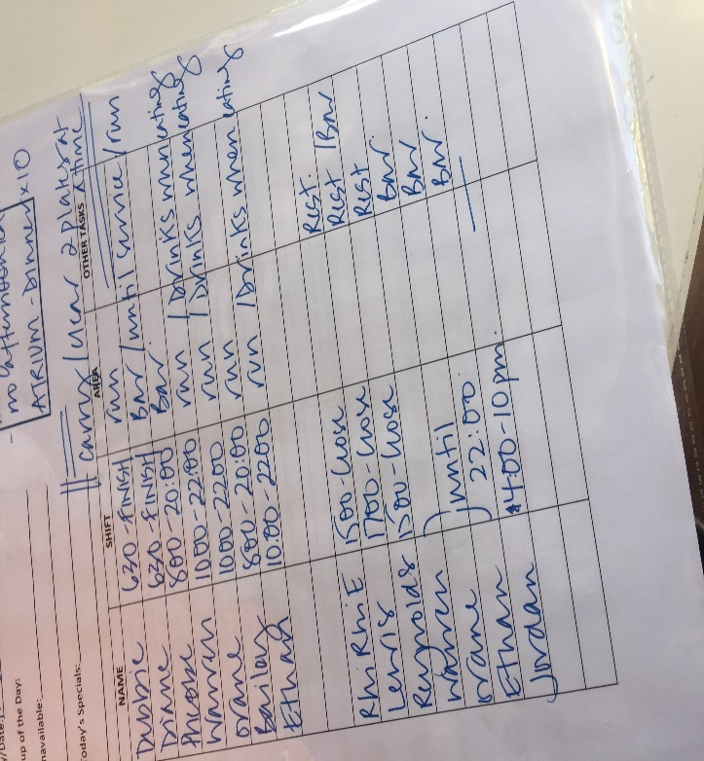
Communication between members of staff Is outstanding through the service all members of staff communicate with each through the phones around the hotel and face to was, as was mentioned before general manager seemed to ask a lot of from members of staff and half way service front of house team seemed run out. In consultant’s opinion motivation is a key in such organisation and small reward would seem appropriate in the of the day, on the other hand through the service manager and team leaders ask members of staff if they are ok and how they are getting on, it is important to feel that you belong and you been cared about, however in terms of motivation and work effectiveness it seemed not enough, more than just a question (you are ok?) should be done, for example all members of staff should know what they are working for and it is important to feel apparition. Pictures below demonstrate event which was happening on the day of research, it was a busy event with almost over 100 customers and 7 members of staff on for such a huge event, which is not enough, due to such busyness it is hard to provide any good service. As research showed as event went on customer service gone down, some customers were ignored and not served, during the research consultant spoken to one of the team leaders, according to Emma Waren Bar& Restaurant team leader she said, “It is defiantly harder to provide good customer service when it is busy, but we still try our best”.
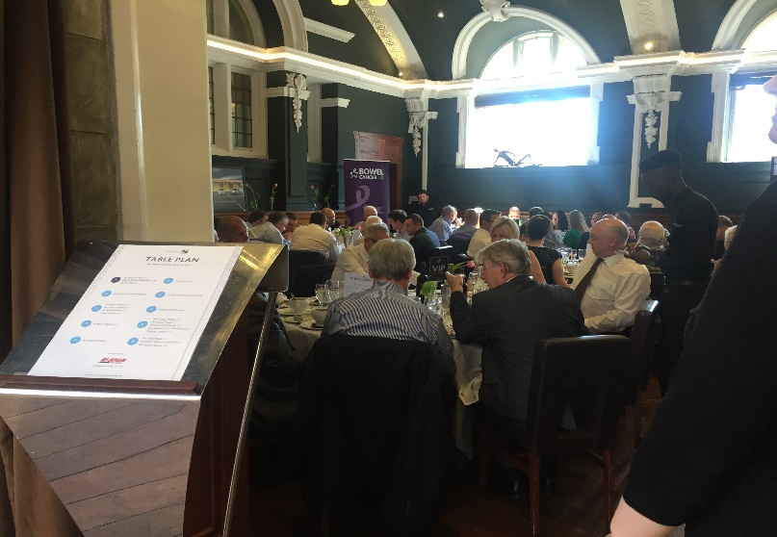
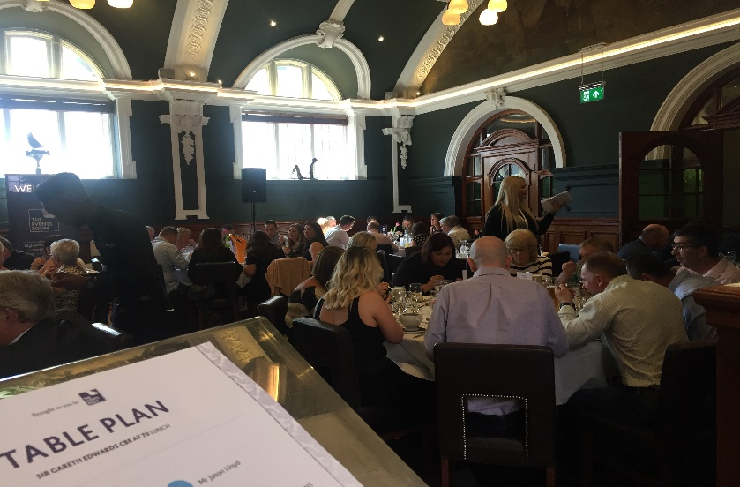

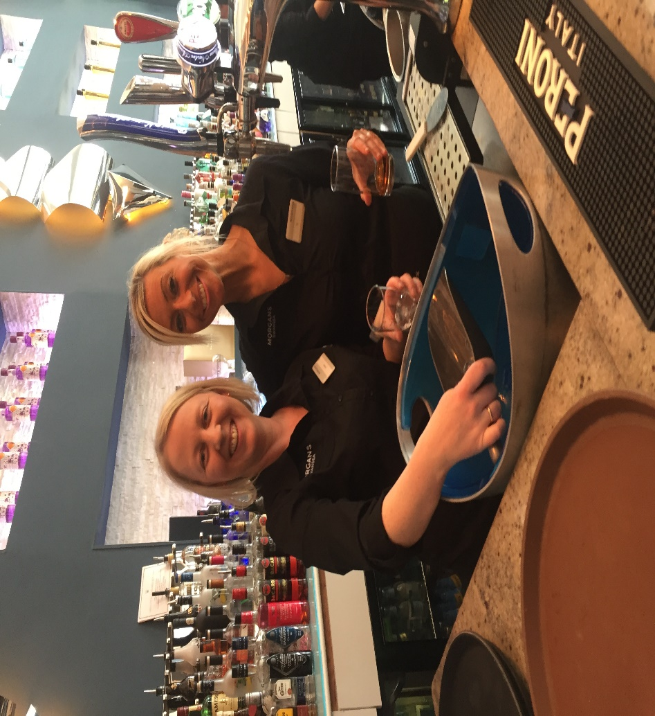
Observation research showed that there is no system In place, there is organisation, however through the service it fades away, members of staff get stressed and not motivated enough, and as noticed, on the day plan mentions when staff starts and when they finish their shifts, some of them work 10-12 hour a day, which runs them down and their work effectiveness is not good as it should be if they had enough rest, that is defiantly something to look at and to improve in future for Morgan’s Hotel. However, team members are still trying their best and keep smiling.

In focus group meeting consultant met with management team after a busy function, the aim was to do a group interview and observe at the same time. As mentioned before and in PID report, focus group meeting was there for consultant to understand the relationship between management team and to understand their options and issues which were brought up.
Below is demonstrate a table of questions that consultant asked in focus group meeting. Qualitative data collection can be complicated to analyse because it doesn’t have numbers and percentages to look at, however this table is there for to give an overall answer of participants of the focus group and give an idea of what been discussed and to which conclusions participants came up with.

Focus group Questions | Answers
- As Management team, do you think you have a system in place? If so, do you think it is working? | Majority of the group agreed that there is a system in place however not all of them were sure if it works all the time as all managers seemed to have different approach and different ways they want things done
- Do you think your members of staff are motivated enough? | All 4 managers that attended focus group agreed that motivation Is a key issue, and that more things needs to be done to keep staff motivated at all times
3. As Management team, do you think you need improve you staff motivations to improve work effectiveness of members of staff? | Due to the question number 2 all 4 managers agreed with consultant that motivation needs improvement, however their reaction to work effectiveness was not as positive as expected, all the managers thought that their front of house team is effective enough
4. If so what would you do different to keep you staff motivated and effective? | Discussion about motivation improvements was separated into 2 different opinions, 2 members of management team Emma Waren and Gemma said “there should be done more team activities which will bring team together and build stronger relation and trust in the team”
5. As the hotel, do you think you are stable and sustainable? | All member of the management team agreed, that the hotel as the organisation are sustainable however not stable at all times and as they team they wish to bring stability in place and give the organisation not just a good reputation but also a happy place to work at

in group discussion there were agreements and disagreements, but on the other hand the team managed to come to the same opinion and that as management team they need to do more on motivating their staff and eventually it will lead them to better work effectiveness and performance. According to Vroom “Motivation is likely only when a clearly perceived and usable relationship exists between performance and outcome and the outcome is seen as a means of satisfying needs” (Vroom, V (1964) Work and Motivation.
1.13 SWOT
Strength of Morgan’s Hotel as they are a privately-owned organisation and they can have and they do have their own system in place unlike the other chained hotels and organisations which are run under the same system, which means Morgan’s hotel is capable of making difference. On the other hand, by working close with management team, this project showed that Morgan’s staff is friendly and willing to make changes and was more than happy to participate in consultant’s project.
Weakness on the other hand, the research showed that Morgan’s Hotel is unbalanced and management team has different opinion and most of the time they disagree. However it is about to change . Main weakness of the organisation is lack of staff and long hours shifts which effect on front of house team, and soon or late Morgan’s can lose important members of staff.
Opportunities for this organisation are promising, there Is so much they can do, as the Hotel Morgan’s does a lot of, and stands out from all the Hotels around Swansea. The main opportunity that Morgan’s Hotel can have at the moment is to stick to consultancy recommendations and solutions and start making improvements and become more sustainable and stable then they already are.
Every hotel organisation has same threat, competition, Morgan’s Hotel has great location, however surrounded by other hotels in that area. But on the other hand, hotel is unique and has great reputation and popularity. All though according to the research consultant has done for the organisation, at the moment the biggest threat to the hotel is another change of management and staff leaving if recommended solutions will not be taken into consideration.
1.14 Conclusion
Overall consultancy project worked well, consultant worked with organisation analysed issues and was able to come up with best solutions for Morgan’s Hotel. At the begging it was hard to understand the importance o consultancy work and for what is it needed, however as the project went on and consultant worked closely with organisation that main picture and understanding came alone. The Project it self was hard at the start, client was busy all the time and didn’t have so much time to meet with consultant, however as said before project went good overall, and consultant believes this project helped organisation such Morgan’s Hotel and further organisation will soon start to make changes and will fell the difference. Consultancy the fore to help organisations like Morgan’s Hotel.
1.15 Summary of Aims & Objectives
Before starting this project and work with organisation, consultant had to come up with a set of aims and objectives. PID report explained in detail what they are and why they were important. Through this project the aim stayed the same and hopefully was achieved, the aim was to improve staff motivations and work effectiveness in Morgan’s Hotel. Due to the staff and managers leaving and no stability in place. In opinion of consultant the has been achieved or mainly is in progress as recommendations were given to organisation and hopefully soon will come in place. In terms of objectives, also stayed the same but not all of them worked for example objective number one “to work close with F&B and management team, as mentioned before management team didn’t have some much time, which shifted some things like research dates. But on the other hand, project worked well, aim has been achieved with small changes to objectives. However, consultancy is not type of job that author would come back to, as it is a lot of responsibility to make changes in organisations which been running in business for long, but on the other hand it has been great experience and pleasure to help organisation like Morgan’s Hotel

1.16 Recommendations
The research has been done and meetings been held with organisation and consultant came up with good recommendations and solutions for organisation on things that can be improved. First of all, consultant would recommend organisation to be more flexible with their F&B team, as they are key team members in organisation and require appreciation for their hard work. Consultant also recommended to management team to hold weekly meetings with their F&B team, hearing them out will help the team to understand their issues and it will also work for F&B team, as they will feel more respected. As mentioned before the issue was clear and consultant done it’s best to help organisation to move forward and keep their team together, hotels organisations are always hard to work for, that is why it is important to keep staff together and keep motivating them, according to Maslow’s Hierarchy of needs, feel of belonging is important, team members of Morgan’s Hotel needs that feeling, that they are there and management team needs them. To start to make improvements Morgan’s Hotel needs to hold a meeting with their F&B team to hear them out, to hear their issues, and further it will help management team to understand their team. However, the key solution for Morgan’s Hotel would be is to build trust between each other and do some team activities to build team spirit which will help them to feel stronger as one-hole team and it will lead to great work effectiveness.

References and Bibliography
(Lussier, 1995).
(Ajmal et al., 2009; Leong and Huang, 2008; Old, 1995).
(Maslow, A 1954). Employee reward management and practice (Michael Armstrong, Tina Stephens, Page.83)
(Davidsson and Klofsten, 2003).
Gorman and Clayton (2005, page.40)
(Neil Kokemuller; Updated April 13, 2018).
(Vroom, V (1964) Work and Motivation. Employee reward management and practice (Michael Armstrong, Tina Stephens, Page.83)
http://caaab.org/wordpress/wp-content/uploads/2012/04/CAAAB-Consulting-Research-Report.pdf (CAAAB Consulting Report, Dean, Hegel, McLaughlin, Wright)

http://smallbusiness.chron.com/focus-group-research-method-17464.html (The Focus Group Research Method)

