finance for business managers
BMMB7005

Lokesh Reddy Karangula
2513500

Executive Summary
The purpose of this report is to assess Westward Plc's financial health and consider upcoming investment options. Apparently, the Board is planning to decide on the basis of accurate and solid data. The report’s main parts are two in number. The Part 1 is dedicated to an in-depth assessment of the company’s recent financial performance, through ratio analysis, taking into consideration the following areas: profitability, liquidity, efficiency, gearing, and investor ratios. The company’s present financial position is looked into, so that it becomes possible to consider its potential for further investment.
In Part 2, three investment strategies are evaluated, retail extension, internet trading, and branching into the wooden and Roman blind markets. The analyses were done through the Net Present Value (NPV) and the Internal Rate of Return (IRR) methods. All projects are financially feasible; nevertheless, the internet sales alternative produces the largest NPV and increases the value for the shareholders to the maximum. If capital rationing is practiced, then the most efficient projects mix-ups will add up to the total NPV – right for the company. By and large, the main argument of the document was that Westward Plc's financial situation was at the point for its exploring subject to careful financing and strategic factors.

Table of Contents
Executive Summary 1
Introduction 3
Part 1 3
1.1 Introduction 3
1.2 Ratio Analysis 3
1.2.1 Profitability Analysis 3
1.2.2 Liquidity Analysis 6
1.2.3 Efficiency Ratios 7
1.2.4 Solvency Ratios 8
1.2.5 Investor Ratios 9
1.3 Recommendations 9
Part 2 11
2.1 Introduction 11
2.2 Net Present Value (NPV) 11
2.3 Internal rate of return (IRR) 13
2.4 Interpretation of results 15
2.4.1 Net present value as the best method 15
2.4.2 Non-discounting methods of investment appraisal 16
2.4.3 Other factors in investment decision 16
2.5 Optimal investment policy 17
2.6 Sources of finance 18
Conclusion 20
References 21
Appendices 24
Appendix 1: Income statement of AstraZeneca 24
Appendix 2: Balance Sheet of AstraZeneca 25
Appendix 3: Calculation of Ratios 26

Introduction
This business report concerns itself with an assessment of the four-year investment plan that the Westward Plc company, a firm that deals with the production of high-quality curtains, has put forward. The Board is looking at three strategic investment areas which include expanding the current retail outlet, creating an online sales avenue, and jumping into the wooden and Roman blinds business. All these investments will need quite a lot of initial capital but will then result in different cash flow, risk, and strategic profiles.
The report uses Net Present Value (NPV) and Internal Rate of Return (IRR) techniques while taking taxation and capital allowances into account to evaluate each option's financial feasibility and assure the owner of the money a consistent, time-adjusted basis for comparing the projects. The report also examines the effects of capital rationing in the situation where the funds are restricted and offers a valuation of how the best combination of investments can benefit the shareholders. The report is expected to make clear, financially sound recommendations that would significantly influence the investment choices of the Directors.

Part 1

1.1 Introduction
AstraZeneca is a global player in the pharmaceutical industry, which is known for a big chunk of money being continuously pumped into research and development, the creation of products taking a long time, strict regulatory governance, and solid capital expenses. Therefore, it is essential to evaluate the variations in financial ratios in the context of, but not limited to, sales mix, R&D spending, working capital management, and financial terms and conditions (AstraZeneca PLC, 2024). This section will therefore not only contain the ratio calculations for 2023 and 2024, but also have a detailed analysis of the root causes of the changes noticed in the stated period.

1.2 Ratio Analysis

1.2.1 Profitability Analysis
Profitability ratios are the metrics that measure how much a company will earn in relation to sales, assets, and equities (Sharma and Mittal, 2023). AstraZeneca's basic reason for gaining profit is that there are many fixed costs they need to cover for their research and development (R&D) decisions, regulatory requirements, and maintenance of modern manufacturing plants.
Marginal Ratios

(Source: Appendix 3)
The gross profit margin went down a little bit from 81.95% in 2023 to 81.16% in 2024, with the revenue increasing greatly from $45,811 million to $54,073 million at the same time. The slight decrease is due to the fact that the cost of sales went up more than the revenue, increasing from $8,268 million to $10,207 million. A higher number of products produced, inflationary expenses for inputs and a shift in revenue structure, with alliance and collaboration revenues increasing as very likely having different cost structures in comparison to core patented medicines, were the main reasons for the growth in the cost of sales (AstraZeneca Plc, 2024). Yet, the gross margin stays at an outstanding level, showing that the firm still has pricing power and a very valuable product portfolio.
On the other hand, the operating profit margin increased from 17.88% to 18.50%, clearly showing enhanced operational efficiency. This change took place even though the R&D spending went up significantly, from $10,935 million in 2023 to $13,583 million in 2024. The increase in the company's operating margin expanding, together with the rise in R&D investment, is a sign of the company experiencing excellent revenue growth and strong cost absorption. Besides, it is also a hint that the firm is moving towards operating leverage, wherein fixed and semi-fixed costs are evenly distributed over the increased revenue base of the business.
Net profit margin remained stable at around 13.0%, moving up marginally from 13.01% to 13.02%. This stable behavior showed good financial control since the money from higher sales revenue was enough to cover the upsurge in finance costs and tax. It is remarkable that the company could keep its net profit margins even while investing more in R&D, which would, in turn, help the company grow through innovation in the long run.
Return Ratios
Return ratios are used to understand the efficiency of AstraZeneca when it comes to generating profits with capital.

(Source: Appendix 3)
The ROE made a gain of 15.22% in 2023 to 17.23% in the next year, indicating that shareholders were served better. Net profit was the major factor responsible for the growth rather than the company taking on additional debts -- since equity saw a modest increase from $39,166 million to only $40,871 million. The reason for the growth in ROE was that the company made more profit per each dollar of invested capital, but the total financial risk was not increased.
In the same way, return on assets (ROA) rose 5.90% - 6.77%. Total assets somewhat increased within that period, mainly because there were more intangible assets and property, plant and equipment related to the R&D and production facility expansion process. Nevertheless, compare to the growth of assets profits rose on a higher rate, which means that the company is using its assets more efficiently. Consequently, one may conclude that the company’s investments are for the most part becoming more and more productive, and its continued investment in R&D and manufacturing capacity is yielding higher economic returns.
The return on equity (ROE) increased by nearly 13.13%, reflecting improved long-term capital efficiency – an almost 2% jump in ROCE would be clearly rather significant. The higher operating profit had a noticeable influence on this figure, thus proving a more effective management of capital and more efficient production activities. Another factor contributing to this result is the firm’s increased ability to obtain credit, not to mention its being more cost-aware than before.

1.2.2 Liquidity Analysis
Liquidity ratios evaluate the company’s ability to meet short-term obligations as they fall due (Sharma, 2021).

(Source: Appendix 3)
The liquidity was 1.22% more in 2024 than in 2023. For the quick liquidity, there was 0.10 change from 0.64 to 0.74. The main reason for these ratios' positive change was the decrease in current liabilities, which went down from $30,542 million to $27,866 million, and not so much the rise in current assets. This represents a boost in the short-term money availability and alleviation of the need for immediate cash funds.
Nevertheless, both indexes are still situated under the typical 1.0 mark which implies that AstraZeneca keeps relying on the steady inflow of money from operations instead of using a significant chunk of its money in liquid form. The liquidity ratio stayed small and constant at the level of 0.19-0.20, which shows there wasn't much use of cash on the company's part to cover short-term debt. This is a strategy that is both aggressive as well as conservative, which affects the cash flow statement directly. Use of this strategy might achieve a long-term goal but it will also bring the company to a critical position if any trouble shows up in the short-term.

1.2.3 Efficiency Ratios
Efficiency ratios assess how effectively AstraZeneca manages its working capital and assets.

(Sources: Appendix 3)
One of the most prominent deteriorations took place in inventory days as they rose sharply from 108.37 days in the year 2023 to 189.10 days in 2024. Despite the slight decrease in inventory levels, the sale's costs have decreased more than the inventory levels leaving a slower inventory turnover. This might be either stockpiling, regulators taking time or the therapeutic segment moving at a slow pace. The pharmaceutical sector is the one that will be badly hit hardest by prolonged inventory holdings due to increased storage costs and the risk of obsolescence, which in consequence of all this will become a major concern over the operations.
On the other hand, debtor days got better from 96.61 to 87.56, which told the story that cash management was smoother. Turnover growth exceeded the rise in trade receivables, meaning better credit control or more positive customer payment conducts. As a consequence, this change positively affects both cash flow and liquidity.
The increase in creditor days was significant, going up from 447.04 to 803.34 days, which now shows a very aggressive cash-out working capital policy. AstraZeneca was able to enhance money flow and short-term liquidity by letting their suppliers wait a bit longer. Nevertheless, the elongated periods of repayments, which are integral components of this financing strategy, may lead to conflicts with suppliers and, once they require stricter terms, the situation might be impossible to maintain. In such a case, the strategy might have a very positive effect on the liquidity ratios but still result in a high operational risk in the long term.
Increase of assets turned over (from 0.45 to 0.52) and fixed assets turned over (from 0.60 to 0.69) evidence that AstraZeneca can make more money per unit of its assets in 2024. This means that the company was more productive in using both total and fixed assets which is also in line with the recorded growth in ROA and ROCE.

1.2.4 Solvency Ratios
The long-term financial stability and risk profile of the company can be evaluated through the gearing ratios (Petty et al., 2015).

(Source: Appendix 3)
The company has maintained a debt ratio of 0.61, and the equity ratio was steady at 0.39, suggesting a balanced capital structure. The debt-to-equity ratio has also fallen a bit from 1.58 down to 1.55, thus showing that the company is very slightly deleveraging, and the financial risk has also been reduced.
The increase in the interest coverage ratio from 5.04 to 5.74 mainly attributed to the higher operating profits and lower effective interest rates on borrowings in the year 2024. The betterment shows a greater capability of paying off loans from earnings and strengthens AstraZeneca's solvency position in the long run.

1.2.5 Investor Ratios
Investor ratios are the market's perceptions and the company's shareholders' returns (McNair-Connolly & Merchant, 2020).

(Source: Appendix 3)
The company was able to increase its earnings per share (EPS) from $3.85 to $4.54 mainly due to the higher net profit and the slight change in the number of shares outstanding. Thus, such an improvement is a manifestation of the real earnings growth rather than the effects of dilution.
The dividend cover ratio has undergone a change of 1.33 to 1.53, implying dividend payments to be more and more backed up by its earnings, hence increasing dividend sustainability. Yet, on the other hand, the dividend yield decreased from 5.81% to 3.35%, mainly because of the significant rise of the stock price and not of the decrease of dividends.
This interpretation is further supported by the fact that the price-to-earnings (P/E) ratio has risen from 12.95 to 19.52, signaling that the investors have more trust in AstraZeneca's prospects for future earnings, the quality of its pharmaceutical portfolio, and possible growth over the long term.

1.3 Recommendations
Using the financial ratio analysis as basis and the comprehensive study of the variations that were noticed between 2023 and 2024 as main drivers, the analysis team comes up with several recommended actions that are specifically aimed at the financial management, operational efficiency, and long-term sustainability of AstraZeneca.
1. Strengthen Inventory Planning and Control Mechanisms
The drastic jump in inventory days from 108.37 days to 189.10 days denotes a serious decline in inventory efficiency. It is suggested that AstraZeneca direct its efforts towards the improvement of inventory planning, forecasting accuracy, and stock rotation practices. This may entail more of the use of demand forecasting tools combined with sales and regulatory approval processes, especially for products with intricate supply chains or limited shelf lives (Ahmed et al., 2021). Shrinking the amount of inventory in a warehouse would result in reduced storage and obsolescence risks, better working capital efficiency, and increased liquidity without affecting the quality of service offered (Munyaka and Yadavalli, 2022). Furthermore, better inventory management would have a positive impact on asset turnover and overall operational efficiency ratios (Panigrahi et al., 2024).
2. Rebalance Working Capital Strategy to Reduce Supplier Risk
Extending accounts payable days from 447.04 to 803.34 days has restored the short-term liquidity to be much stronger. However, this move may exert pressure on relations with suppliers and result in future disruptions in the supply chain. AstraZeneca is recommended to revise its payment conditions so that the company can adopt a working capital strategy that is more balanced and, at the same time, can maintain the cash quality and the sustainability of the suppliers (Panigrahi et al., 2024). An option to consider in this case would be payment schedules with a slow or long-term pace while the suppliers can use supplier financing programs. Early payment discounts are another tool that could be used for this purpose (Munyaka and Yadavalli, 2022). In other words, the company would draw the liquidity from the cash and accounts payable side rather than the latter becoming a bigger source.
3. Enhance Liquidity Resilience Through Selective Buffer Creation
In 2024, both the current and quick ratios showed improvements although still being inferior to the typical benchmarks, making the company still heavily reliant on operational cash inflows. AstraZeneca must possibly create some safety nets for liquidity taking into consideration the uncertain environment of regulatory changes, patent expiries, and global supply chain fluctuations. This does not mean parking an excessive amount of cash in the company's vault but instead the business must be able to have access to liquid resources through the use of short-term investments and/or credit facilities being it on the basis of a commitment (Akgün and Karataş, 2020). The strengthening of liquidity resilience would not only lower the level of financial risk but also make the company better positioned to suffer from unexpected setbacks without affecting the core operations or the investment in R&D (Alvarez et al., 2021).
4. Continue Disciplined Capital Allocation and ROCE Optimization
An increase in the return on capital employed (ROCE) from 11.61% to 13.13% expresses the fact that the company is making better use of its long-term funds. AstraZeneca ought to strictly implement capital allocation strategies when investing in research and development, acquisitions, and expanding production capacity to continue progressing in this area. Post-investment reviews need to be more diligent so as to make sure the capital invested is performing as expected. It would also be beneficial to concentrate on projects that give back high returns and to divest from low-performing assets when necessary for the purpose of achieving higher capital efficiency and also to create long term shareholder value (Siziba and Hall, 2019).
5. Maintain Prudent Gearing While Leveraging Low-Cost Financing
AstraZeneca has a well-managed capital structure because debt and equity ratios are stable and interest coverage is improving. It is advisable for AstraZeneca to keep up the good work in having a well-managed capital structure, but it may also borrow funds strategically to support growth while at the same time keeping a strong interest coverage ratio and having financial flexibility.

Part 2

2.1 Introduction
This section aims to assess the triplicate of suggested investment alternatives that Westward Plc can choose from in relation to its planned four-year expansion scheme. For the purpose of an informed decision, this report has utilized the Net Present Value (NPV) and Internal Rate of Return (IRR) methods while assuming a 6% cost of capital, 25% corporate tax, and 20% capital allowances per year on a straight-line basis.

2.2 Net Present Value (NPV)
Option A: Retail Expansion
Annual allowance = Initial Cost x 20%
Annual allowance = ₤600,000 x 0.20 = |  |  |  | £120,000
Tax saving = Annual allowance x 25%
Tax saving = 120,000 x 0.25 = |  |  |  | £30,000
Calculation of Cash inflows (£'000)
Year | Cash inflow | Less: Tax @ 25% | After-tax Cash inflow | Add: Tax Shield | Net Cash inflow
1 | 200 | 50 | 150 | 30 | 180
2 | 400 | 100 | 300 | 30 | 330
3 | 500 | 125 | 375 | 30 | 405
4 | 700 | 175 | 525 | 30 | 555

Calculation of Net present Value (NPV)
Year | Cash inflow | DF @ 6% | DCF
0 | (600) | 1.000 | (600)
1 | 180 | 0.943 | 170
2 | 330 | 0.890 | 294
3 | 405 | 0.840 | 340
4 | 555 | 0.792 | 440
NPV = ΣDCF |  |  | 643

Option B: Internet Sales
Annual allowance = Initial Cost x 20%
Annual allowance = ₤1,000,000 x 0.20 = |  |  |  | £200,000
Tax saving = Annual allowance x 25%
Tax saving = 200,000 x 0.25 = |  |  |  | £50,000
Calculation of Cash inflows (£'000)
Year | Cash inflow | Less: Tax @ 25% | After-tax Cash inflow | Add: Tax Shield | Net Cash inflow
1 | 400 | 100 | 300 | 50 | 350
2 | 450 | 113 | 338 | 50 | 388
3 | 720 | 180 | 540 | 50 | 590
4 | 980 | 245 | 735 | 50 | 785

Calculation of Net present Value (NPV)
Year | Cash inflow | DF @ 6% | DCF
0 | (1,000) | 1.000 | (1,000)
1 | 350 | 0.943 | 330
2 | 388 | 0.890 | 345
3 | 590 | 0.840 | 496
4 | 785 | 0.792 | 622
NPV = ΣDCF |  |  | 792

Option C: New Product Lines
Annual allowance = Initial Cost x 20%
Annual allowance = ₤1,600,000 x 0.20 = |  |  |  | £320,000
Tax saving = Annual allowance x 25%
Tax saving = 320,000 x 0.25 = |  |  |  | £80,000
Calculation of Cash inflows (£'000)
Year | Cash inflow | Less: Tax @ 25% | After-tax Cash inflow | Add: Tax Shield | Net Cash inflow
1 | 450 | 113 | 338 | 80 | 418
2 | 700 | 175 | 525 | 80 | 605
3 | 900 | 225 | 675 | 80 | 755
4 | 1,200 | 300 | 900 | 80 | 980

Calculation of Net present Value (NPV)
Year | Cash inflow | DF @ 6% | DCF
0 | (1,600) | 1.000 | (1,600)
1 | 418 | 0.943 | 394
2 | 605 | 0.890 | 538
3 | 755 | 0.840 | 634
4 | 980 | 0.792 | 776
NPV = ΣDCF |  |  | 743

2.3 Internal rate of return (IRR)
Option A
Calculation of Internal rate of return (IRR)
Year | Cash inflow | DF @ 38% | DCF | DF @ 39% | DCF
0 | (600) | 1.000 | (600.00) | 1 | (600)
1 | 180 | 0.725 | 130.50 | 0.719 | 129
2 | 330 | 0.525 | 173.25 | 0.517 | 171
3 | 405 | 0.380 | 153.90 | 0.372 | 151
4 | 555 | 0.275 | 152.63 | 0.268 | 149
NPV = ΣDCF |  |  | 10.28 |  | (0.57)
IRR = 38% + [10.28 / (10.28 + 0.57)] x (39% - 38%) = |  |  |  | 38.95%

Option B
Calculation of Internal rate of return (IRR)
Year | Cash inflow | DF @ 32% | DCF | DF @ 33% | DCF
0 | (1,000) | 1.000 | (1,000.00) | 1.000 | (1,000)
1 | 350 | 0.758 | 265.30 | 0.752 | 263
2 | 388 | 0.574 | 222.43 | 0.565 | 219
3 | 590 | 0.435 | 256.65 | 0.425 | 251
4 | 785 | 0.330 | 259.05 | 0.320 | 251
NPV = ΣDCF |  |  | 3.42 |  | (15.91)
IRR = 32% + [3.42 / (3.42 + 15.91)] x (33% - 32%) = |  |  |  | 32.18%

Option C
Calculation of Internal rate of return (IRR)
Year | Cash inflow | DF @ 22% | DCF | DF @ 23% | DCF
0 | (1,600) | 1.000 | (1,600.00) | 1.000 | (1,600)
1 | 418 | 0.820 | 342.35 | 0.813 | 339
2 | 605 | 0.672 | 406.56 | 0.661 | 400
3 | 755 | 0.551 | 416.01 | 0.537 | 405
4 | 980 | 0.452 | 442.96 | 0.437 | 428
NPV = ΣDCF |  |  | 7.87 |  | (26.97)
IRR = 22% + [7.87 / (7.87 + 26.97)] x (23% - 22%) = |  |  |  | 22.23%

2.4 Interpretation of results
The investment appraisal results for Westward Plc have shown that all three proposed projects produce positive Net Present Values (NPVs) and Internal Rates of Return (IRRs) that far exceed the company’s cost of capital of 6%. This implies that all projects are economically viable and would contribute financially to the firm if implemented. Despite this, there are different levels of value creation in all projects. This is why careful interpretation of the results to make wise decisions is necessary.
According to the Net Present Value (NPV) analysis, the most attractive option is Option B (Internet Sales) with £792,000 of NPV, Option C (New Product Lines) and finally Option A (Retail Expansion) with £743,000 and £643,000 respectively. Since NPV is the measure of shareholders' absolute wealth increase, this finding indicates that Option B would bring the largest financial value to the company. The IRR also indicates the same; here the B option gives an IRR of 32.18% which is very much higher than the capital cost even though it is lower than the A option’s IRR. It should be clear, however, that when projects are mutually exclusive, the decision should be made on the basis of NPV not IRR, with the reason being that NPV measures value directly while IRR is only a percentage return indicator.

2.4.1 Net present value as the best method
Net Present Value is considered to be the most theoretically robust method of investment evaluation by many authors. One of NPV’s major advantages is that it takes into account the time value of money completely, acknowledging that the money one receives today has more value than the money he/she will get in the future because of opportunity cost and risk (Bierman and Smidt, 2014). NPV transforms all future gains into present value terms via the firm’s cost of capital indicating that the management is ready to accept these benefits if only equal to the initial outlay (Bennouna et al., 2010).
Another benefit of NPV is that it takes into account all the significant cash flows for the project's whole duration, vice versa methods like payback period, which exclude cash flows after the stipulated time limit (Shaheen et al., 2025). This factor is crucial for long-term strategic investments, like the introduction of an online sales channel or a new product line, as the main advantages might emerge in the years to come.
It is of primary importance that NPV is in line with the goal of maximizing shareholder wealth, which is the financial objective for most companies in their internal policies. When a project has a positive NPV, it tells that the firm is expecting to pay back the capital with a little extra profit, so the market value of the firm will go up (Putri et al., 2024). If a project shows negative NPV, it means that the company's capital will not be fully repaid, and the shareholders will lose money, so the project should be abandoned. This theoretical guidance makes NPV a go-to method over other techniques for evaluating investments and making the right strategic decisions.

2.4.2 Non-discounting methods of investment appraisal
Despite the fact that a discounted cash flow method like NPV is generally regarded as the most superior, methods that do not consider the discount factor, specifically payback and ARR, are still the most accepted ones among the decision makers (Gitman et al., 2015). The major factors contributing to this trend, according to Fanta et al. (2023), are the methods' simplicity and the fact that they are easily understood. These methods are likely to be more intuitive and quicker to apply for the managers who are not very proficient in financial matters.
Payback period is considered as useful because of its focus on liquidity and risk, and it tells us how quickly the first investment can be rejuvenated (Gitman, 2013). In such an unstable business condition, the managers can opt to invest in such projects that provide them with cash in the least period of time, though the projects' long-run profitability may not be the utmost (Gitman, 2013). It is particularly relevant to small firms and cash-stricken ones.
Nonetheless, the different methods have their own flaws. Firstly, they are unaware of the time value of money and very probably do not deal with money flows coming after the time of return. So, if one mainly relies on non-discounting methods, then at that point one is subject to making an investment-related mistake with the greatest of ease, particularly when such projects are dissimilar in size, timing of returns or life length. In this regard, the non-discounting tools may be helpful as further due diligence or prescreening methods but the NPV they should be no one's primary method.

2.4.3 Other factors in investment decision
While the financial valuation may give good quantitative answers, investment calls must not be totally taken on financial measures alone. Several qualitative and strategic factors must also be considered:
1. Strategic alignment: With the option of Internet Sales (Option B), the company may receive strategic advantages in the long run as a consequence of the market enlargement, clientele being served better and enhanced overall digital retail competitiveness.
2. Operational capability and expertise: There is a need to find out the company's operational capability and expertise. That is to say, the company and its new staff might need to have upgraded skills, technology, and cybersecurity for the online sales platforms; where else, the making of wooden and Roman blinds would demand a higher level of expertise in manufacturing and also supplier connections.
3. Risk considerations: The company must assess the liabilities. The reason is actual results might be greatly influenced by market demand uncertainty, technological risk, competitive response, and execution risk.
4. Financial flexibility: It is a crucial factor to consider, especially with the limit imposed by the capital rationing. Projects with high NPV might still put a strain on the cash reserves or even increase the financial risk when not managed well (Maheshwari, 2019).

2.5 Optimal investment policy
Profitability Index = PV of inflows / Initial Investment
Options | PV | Initial Investment | PI | Rank
A | 1,243 | 600 | 2.07 | 1
B | 1,792 | 1,000 | 1.79 | 2
C | 2,343 | 1,600 | 1.46 | 3

Optimum NPV
Options | Fund Allocated | Proportion of Investment | NPV | Weighted PV
A | 600 | 100% | 1,243 | 1,243
B | 1,000 | 100% | 1,792 | 1,792
C | 900 | 56% | 2,343 | 1,318
Total | 2,500 |  |  | 4,353
Note: It is assumed that change in value of initial investment for option C will also change the NPV in same proportion.
NPV = Sum of weighted PV - Initial investment
NPV = 4,353 - 2,500 = | 1,853
With a budget of £2.5 million, it is the best to select projects that have the best performance index (PI) ranking, which means money well spent and money well earned. First, Option A is chosen as it has the most concentrated PI (2.07), then Option B (PI = 1.79) is selected. The left-over funds are then split among Option C, which is the one with the lowest PI (1.46). This mix consumes all the capital and the NPV generated is the highest among all the perfectly utilised combinations, with the maximum being £1.853 million, thus supporting shareholders' wealth to the maximum degree when funds are limited. It can be concluded from the study that investing partly in divisible projects can positively affect the overall creation of value when capital is a constraint.

2.6 Sources of finance
Once Westward Plc has pinpointed the best investment program, the company is to choose a financing strategy that suits growth and keeps the financial situation steady. The main financing sources are internal finance, debt finance, and equity finance. Each of these has its own merits and demerits, so they all need to be weighted diligently before the ultimate choice is made.
1. Internal Finance (Retained Earnings)
Generally, retained earnings is the most favored among other options for internal finance and source of funding (Seal et al., 2018).
Advantages:
Internal finance is frequently considered the best financing option, mainly because it does not necessitate interest payments and repayment of the principal debt (Hillier, 2021). It is a suitable method to prevent the dilution of ownership and enable the firm to maintain full control over the decisive power. Furthermore, the utilization of retained earnings can be a way to avoid issuing costs and the company side-stepping external scrutiny (Vernimmen et al., 2017).
Disadvantages:
One of the major limitations of internal financing is its limited accessibility. The profits kept aside for the future may not always constitute a large enough chunk to finance investment projects worth pushing for. At the same time, using internal funds involves an opportunity cost since shareholders may like to be paid dividends or may have other investment preferences. Besides, the dependence on retained earnings can lead to a reduction in available prospects for growth in future (Schlegel, 2015).
2. Debt Finance (Bank Loans or Long-term Borrowing)
Bank loans or long-term borrowing as evidence by a debt finance are one of the major choices for start-up and established businesses alike (Ross et al., 2010).
Advantages:
Debt finance costs less than equity in most cases because of the tax deductibility of interest payments. It preserves the ownership of the then-existing shareholders and can possibly make the equity investment more profitable when it yields a return on investment higher than the borrowing cost (Chiu et al., 2017). In conclusion, debt can be a very effective means of funding profitable growth.
Disadvantages:
Debt requires a fixed repayment which, in turn, would add financial risk and increase pressures on cash flows. High amounts of borrowing can reduce their financial flexibility and the breach of loan covenants may become a reality or the exposure to financial distress risk might rise, should the expected cash inflows of a project fail to meet the target of break-even point (Aziz and Abbas, 2019).
3. Equity Finance (Issue of Shares)
Equity financing, which involves the sale of new shares, is a long-term source of funds with no mandatory payments, and it can boost the financial position of the company (Ross, 2017).
Advantages:
The equity financing brings a permanent cash flow without any specific payback plan that helps in lowering the risk of liquidating the company. It enhances the company’s financial position and is most likely suitable for projects that are riskier or have a longer duration (Aggarwal and Acharya, 2020).
Disadvantages:
Equity finance is generally the most expensive way to raise capital, in addition to it causing dilution of existing shareholders’ ownership share and control. Another problem is that issuing shares could be a lengthy procedure and be postponed due to conditions that are not so beneficial in the market (Mwende et al., 2019).

Conclusion
In part 1, AstraZeneca showed its financial conditions significantly increased and improved for the period of 2023-2024. The company's return on investment, capital turnover, liquidity, and the confidence of market participants all showed a rise, which was accompanied by a strong rise in revenue and good control of costs, even though the company had to increase its R&D budget. At the same time, poor inventory management together with a significant dependence on supplier credit relations could, however, become a challenge that would need managerial action. Thus, it can be argued that AstraZeneca is in good financial shape, and it is in a strong position to improve financial sustainability and create long-term shareholder value by overcoming weaknesses in operations with the help of its innovation-driven strategy.
In part 2, the investment evaluation has expressed that each of the trio of projects is indeed economically appropriate, but the selection of Project B should be done in consideration of the NPV principles. Nonetheless, the ultimate verdict should be a merge of both the quantitative facts and the qualitative strategic aspects to assure the continual growth and the creation of sustainable value for Westward Plc.
On the other hand, Westward Plc should employ a mixture of different financing options with a considerable amount of retained earnings being dominant. Additionally, it should consider having a conservative amount of long-term loans. This will decrease the cost of capital, maintain control, and give the company adequate financial flexibility to finance its investment plans.

References
Aggarwal, A. and Acharya, S.R. (2020) 'CHOOSING EQUITY AS a SOURCE OF FINANCE: PERCEPTION OF SME PROMOTERS,' RePEc: Research Papers in Economics [Preprint]. https://doi.org/10.12775/cjfa.2019.016.
Ahmed, E.R. et al. (2021) 'The inventory control system’s weaknesses based on the accounting postgraduate students’ perspectives,' JABE (Journal of Accounting and Business Education), 5(2), p. 1. https://doi.org/10.26675/jabe.v5i2.19312.
Akgün, A.İ. and Karataş, A.M. (2020) 'Investigating the relationship between working capital management and business performance: evidence from the 2008 financial crisis of EU-28,' International Journal of Managerial Finance, 17(4), pp. 545–567. https://doi.org/10.1108/ijmf-08-2019-0294.
Alvarez, T., Sensini, L. and Vazquez, M. (2021) 'Working Capital Management and Profitability: Evidence from an Emergent Economy,' IJAME, pp. 32–39. https://www.managementjournal.info/index.php/IJAME/article/view/689.
AstraZeneca PLC (2024) Annual Report 2024, AstraZeneca Annual Report and Form 20-F Information 2024. https://www.annualreports.com/HostedData/AnnualReports/PDF/LSE_AZN_2024.pdf (Accessed: December 26, 2025).
Aziz, S. and Abbas, U. (2019) 'Effect of debt financing on firm performance: A Study on Non-Financial Sector of Pakistan,' Open Journal of Economics and Commerce, 2(1), pp. 8–15. https://doi.org/10.22259/2638-549x.0201003.
Bennouna, K., Meredith, G.G. and Marchant, T. (2010) 'Improved capital budgeting decision making: evidence from Canada,' Management Decision, 48(2), pp. 225–247. https://doi.org/10.1108/00251741011022590.
Bierman, H., Jr and Smidt, S. (2014) Advanced capital budgeting: Refinements in the Economic Analysis of Investment Projects. Routledge.
Brealey, R.A., Myers, S.C. and Allen, F. (2016) Principles of corporate finance.
Chiu, W., Wang, C. and Peña, J.I. (2017) 'Does the source of debt financing affect default risk?,' Review of Financial Economics, 36(3), pp. 232–251. https://doi.org/10.1016/j.rfe.2017.03.006.
Fanta, A. et al. (2023) Principles of Managerial Finance Global & Southern African Perspectives. Pearson Higher Ed.
Farooq, M. et al. (2022) 'Ownership structure and financial constraints – Evidence from an emerging market,' Managerial Finance, 48(7), pp. 1007–1028. https://doi.org/10.1108/mf-12-2021-0620.
Gitman, L.J. (2013) Principles of Managerial Finance: Global Edition. Pearson Higher Ed.
Gitman, L.J., Juchau, R. and Flanagan, J. (2015) Principles of managerial finance. Pearson Higher Education AU.
Hillier, D. (2021) EBook Fundamentals of Corporate Finance 4E. McGraw Hill.
Maheshwari, S.N. (2019) Financial Management: Principles & Practice. Sultan Chand & Sons.
McNair-Connolly, C.J. and Merchant, K.A. (2020) Management Accounting: An Integrative Approach. John Wiley & Sons.
Munyaka, J.B. and Yadavalli, V.S.S. (2022) 'INVENTORY MANAGEMENT CONCEPTS AND IMPLEMENTATIONS: A SYSTEMATIC REVIEW,' South African Journal of Industrial Engineering, 33(2), pp. 15–36. http://www.scielo.org.za/pdf/sajie/v33n2/03.pdf.
Mwende, M.J., Muturi, W. and Njeru, A. (2019) 'Effect of equity finance on financial performance of small and medium enterprises in Kenya,' International Journal of Business and Social Science, 10(5). https://doi.org/10.30845/ijbss.v10n5p7.
Panigrahi, R.R., Shrivastava, A.K. and Kapur, P.K. (2024) 'Impact of inventory management practices on the operational performances of SMEs: review and future research directions,' International Journal of Systems Assurance Engineering and Management, 15(5), pp. 1934–1955. https://doi.org/10.1007/s13198-023-02216-4.
Parrino, R. et al. (2020) Fundamentals of Corporate Finance.
Petty, J.W. et al. (2015) Financial Management: Principles and applications. Pearson Higher Education AU.
Putri, M., Ramadanty, J. and Uddin, M. (2024) 'Analyzing the Development of capital Budgeting Methods in Investment Decision Making: A Systematic Literature review,' IFR Journal of Economics and Business Management., 1(2), pp. 27–33. https://doi.org/10.70146/ebmv01i02.004.
Ross, S. (2017) Essentials of corporate finance. McGraw-Hill.
Ross, S., Westerfield, R. and Jordan, B. (2010) Essentials of corporate finance. McGraw-Hill/Irwin.
Schlegel, D. (2015) Cost-of-Capital in managerial finance, Contributions to management science. https://doi.org/10.1007/978-3-319-15135-9.
Seal, W. et al. (2018) Management Accounting, 6e. McGraw-Hill Education (UK).
Shaheen, W.A. et al. (2025) 'Systematic Literature Review on Capital Budgeting Techniques,' UCP Journal of Business Perspectives, 2(2), pp. 17–29. https://doi.org/10.24312/ucp-jbp.02.02.378.
Sharma, F.C. (2021) Financial Management - SBPD Publications. SBPD Publications.
Sharma, F.C. and Mittal, R. (2023) Financial Management. SBPD Publications.
Siziba, S. and Hall, J.H. (2019) 'The evolution of the application of capital budgeting techniques in enterprises,' Global Finance Journal, 47, p. 100504. https://doi.org/10.1016/j.gfj.2019.100504.
Vernimmen, P. et al. (2017) Corporate Finance: Theory and Practice. John Wiley & Sons.
Yahoo finance (2025) AstraZeneca PLC (AZN). https://finance.yahoo.com/quote/AZN/history/?frequency=1mo&period1=1608981485&period2=1766747876 (Accessed: December 26, 2025).

Appendices

Appendix 1: Income statement of AstraZeneca
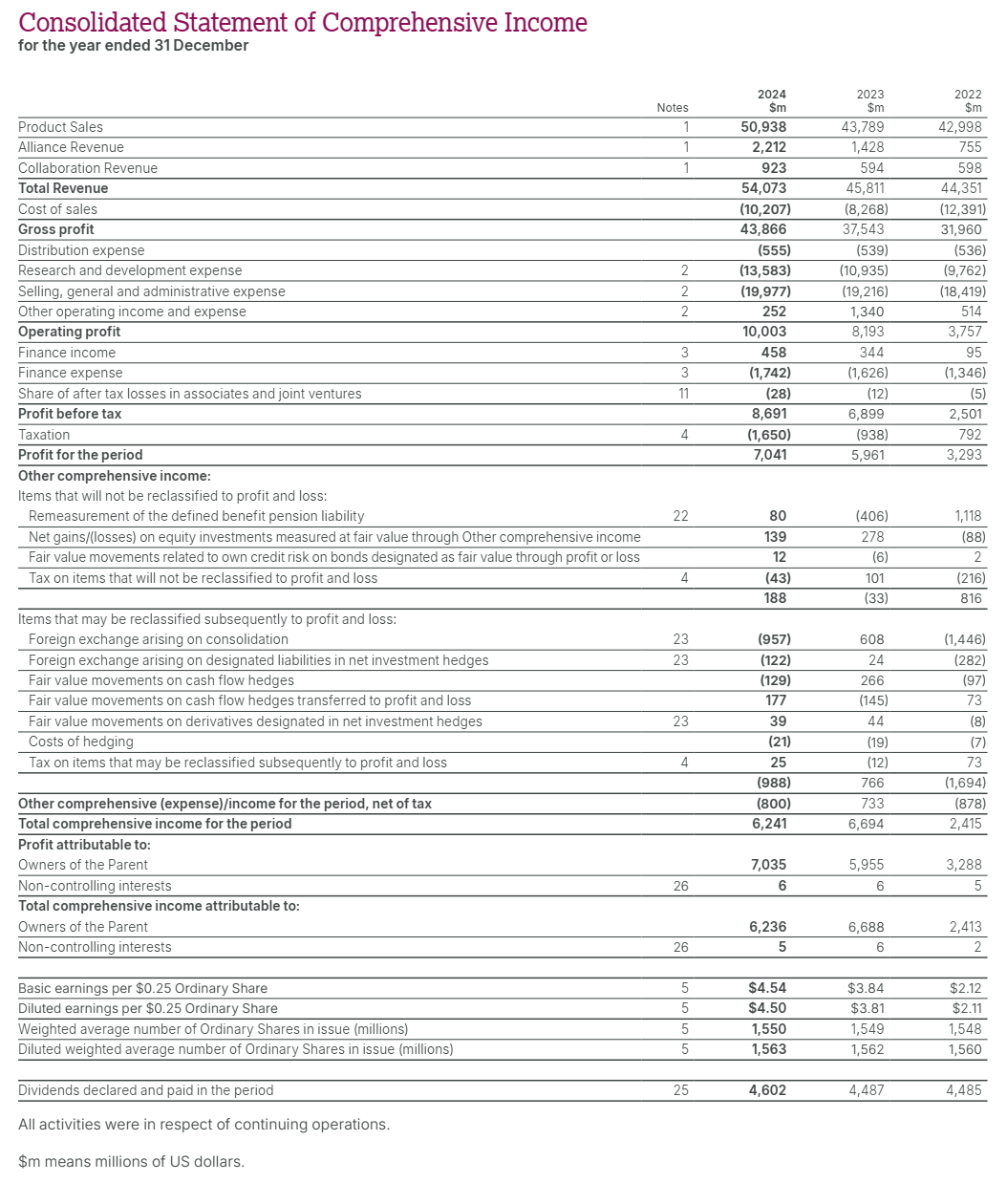

Appendix 2: Balance Sheet of AstraZeneca
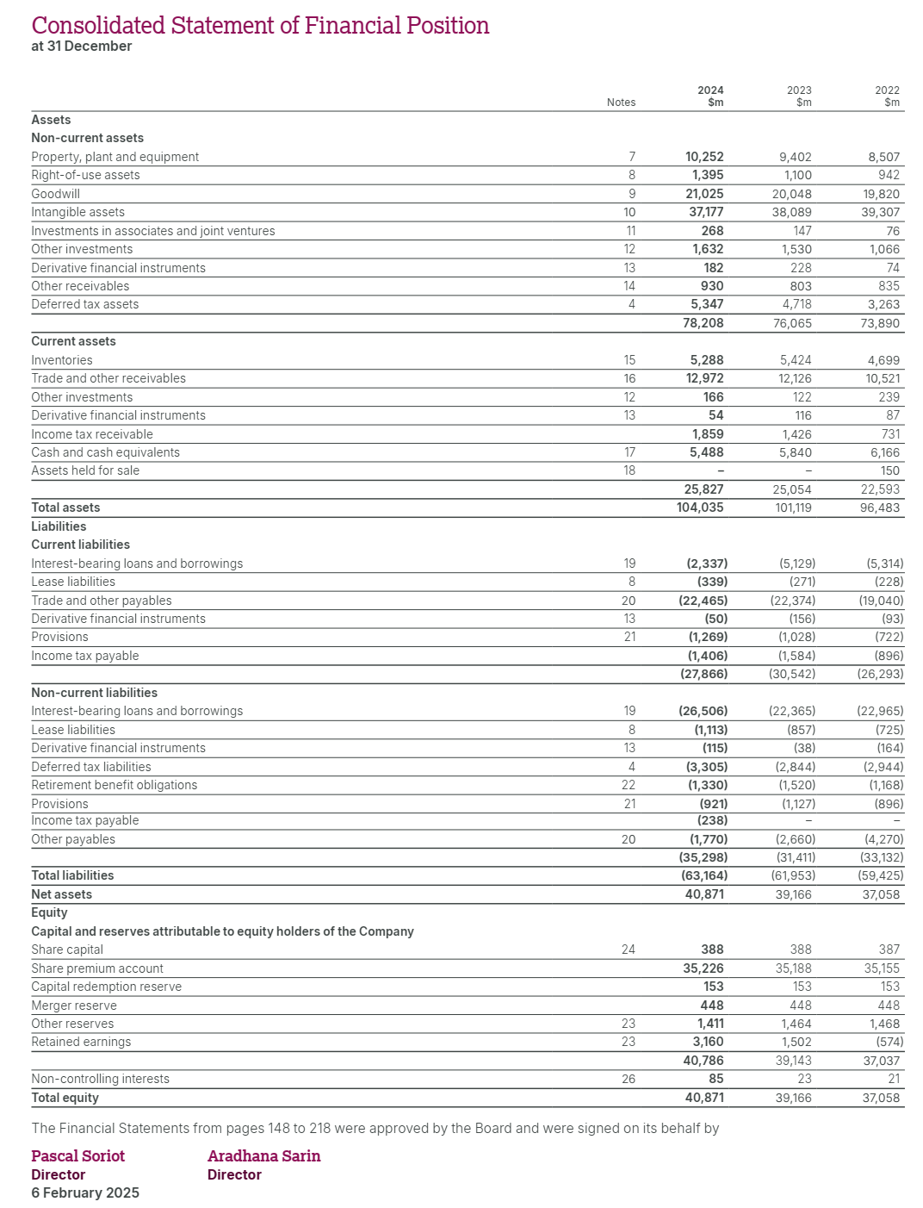

Appendix 3: Calculation of Ratios
 | Profitability
1 | Gross profit margin
 | Formula = Gross profit / Sales x 100
 |  | 2023 | 2024
 | Gross profit | 37,543 | 43,886
 | Sales | 45,811 | 54,073
 | Gross profit margin | 81.95% | 81.16%
2 | Net profit margin
 | Formula = Net profit / Sales x 100
 |  | 2023 | 2024
 | Net profit | 5,961 | 7,041
 | Sales | 45,811 | 54,073
 | Net profit ratio | 13.01% | 13.02%
3 | Operating profit margin
 | Formula = Operating profit / Sales x 100
 |  | 2023 | 2024
 | Operating Profit | 8,193 | 10,003
 | Sales | 45,811 | 54,073
 | Operating profit margin | 17.88% | 18.50%
4 | Return on equity
 | Formula = Net profit / Total equity x 100
 |  | 2023 | 2024
 | Net profit | 5,961 | 7,041
 | Shareholder Equity | 39,166 | 40,871
 | ROE | 15.22% | 17.23%
5 | Return on assets
 | Formula = Net profit / Total assets x 100
 |  | 2023 | 2024
 | Net profit | 5,961 | 7,041
 | Total assets | 101,119 | 104,035
 | ROA | 5.90% | 6.77%
6 | Return on capital employed (ROCE)
 | Formula = Operating profit / (Total Assets - Current liabilities) x 100
 |  | 2023 | 2024
 | Operating profit | 8,193 | 10,003
 | Total Assets | 101,119 | 104,035
 | Current Liabilities | 30,542 | 27,866
 | ROCE | 11.61% | 13.13%
 | Liquidity
1 | Current ratio
 | Formula = Current assets / Current liabilities
 |  | 2023 | 2024
 | Current assets | 25,054 | 25,827
 | Current liabilities | 30,542 | 27,866
 | Current ratio | 0.82 | 0.93
2 | Quick ratio
 | Formula = (Current assets - Inventories) / Current liabilities
 |  | 2023 | 2024
 | Current assets | 25,054 | 25,827
 | (-) Inventories | 5,424 | 5,288
 | Quick assets | 19,630 | 20,539
 | Current liabilities | 30,542 | 27,866
 | Quick Ratio | 0.64 | 0.74
3 | Cash Ratio
 | Formula = (Cash + Cash Equivalents) / Total Current Liabilities
 |  | 2023 | 2024
 | Cash and Cash Equivalents | 5,840 | 5,488
 | Current liabilities | 30,542 | 27,866
 | Cash Ratio | 0.19 | 0.20
 | Efficiency Ratios
1 | Stock Days
 | Formula = Stock / Cost of sales x 365
 |  | 2023 | 2024
 | Stock | 5,424 | 5,288
 | Cost of sales | 18,268 | 10,207
 | Stock Days | 108 | 189
2 | Debtor Days
 | Formula = Debtors / Net sales x 365
 |  | 2023 | 2024
 | Debtors | 12,126 | 12,972
 | Net sales | 45,811 | 54,073
 | Debtors | 97 | 88
3 | Creditor Days
 | Formula = Creditors / Cost of sales x 365
 |  | 2023 | 2024
 | Creditors | 22,374 | 22,465
 | Cost of sales | 18,268 | 10,207
 | Creditors Days | 447 | 803
4 | Asset Turnover
 | Formula = Revenue / Total Assets
 |  | 2023 | 2024
 | Revenue | 45,811 | 54,073
 | Total Assets | 101,119 | 104,035
 | Asset Turnover | 0.45 | 0.52
5 | Fixed Asset Turnover
 | Formula = Revenue / Fixed Assets
 |  | 2023 | 2024
 | Revenue | 45,811 | 54,073
 | Fixed Assets | 76,065 | 78,208
 | Fixed Asset Turnover | 0.60 | 0.69
 | Solvency Ratio
1 | Debt Ratio
 | Formula = Total Liabilities / Total Assets
 |  | 2023 | 2024
 | Total Liabilities | 61,953 | 63,164
 | Total Assets | 101,119 | 104,035
 | Debt Ratio | 0.613 | 0.607
2 | Equity Ratio
 | Formula = Total Equity / Total Assets
 |  | 2023 | 2024
 | Total Equity | 39,166 | 40,871
 | Total Assets | 101,119 | 104,035
 | Equity Ratio | 0.387 | 0.393
3 | Debt-to-Equity Ratio
 | Formula = Total Liabilities / Total Equity
 |  | 2023 | 2024
 | Total Liabilities | 61,953 | 63,164
 | Total Equity | 39,166 | 40,871
 | Debt-to-Equity Ratio | 1.58 | 1.55
4 | Interest coverage ratio
 | Formula = Operating profit / Interest expense
 |  | 2023 | 2024
 | Operating profit | 8,193 | 10,003
 | Interest expense | 1,626 | 1,742
 | ICR | 5.04 | 5.74
 | Investor Ratio
1 | Earnings Per Share ($)
 | Formula = Profit / No. of ordinary shares
 |  | 2023 | 2024
 | Net profit | 5,961 | 7,041
 | No of ordinary shares | 1,549 | 1,550
 | EPS | 3.85 | 4.54
2 | Dividend Cover Ratio
 | Formula = EPS / DPS
 |  | 2023 | 2024
 | EPS | 3.85 | 4.54
 | DPS | 2.90 | 2.97
 | Dividend Cover Ratio | 1.33 | 1.53
3 | Dividend yield
 | Formula = DPS / Share price x 100
 |  | 2023 | 2024
 | DPS | 2.90 | 2.97
 | Share price | 67.35 | 65.62
 | Dividend yield | 4.30% | 4.52%
4 | Price-to-earnings ratio
 | Formula = Share price / EPS
 |  | 2023 | 2024
 | Share price | 67.35 | 65.62
 | EPS | 3.85 | 4.54
 | P/E ratio | 17.50 | 14.45
(Source: AstraZeneca PLC, 2024; Yahoo finance, 2025)

