Server Room System Specifications
Name Mohammed Abdulla
P152058
Implementation project
Computer network and cyber security

Server Room System Specifications
Content
4. Amendment Index………………………………………………………………………………2
5. System Description……………………………………………………………………………………..2-13
5.1 System implication…………………………………………………………………………….14-15
5.2 training and awareness…………………………………………………………………………16
5.3 Maintenance……………………………………………………………………………………16
6. Hardware and equipment’s………………………………………………………………………17
7. Costs………………………………………………………………………………………………18
8. Benefits of the new system……………………………………………………………………….19-20
9. Output Specification ……………………………………………………………………………………....20, 26
10. Input Specification……………………………………………………………………………………….20
11. Files specification………………………………………………………………………………………....20
12. Implementation Plan……………………………………………………………………………………….21-23
13. User policy………………………………………………………………………………………………....24-25
14 Reference’s………………………………………………………………………………………………….27

4. Amendment Index
N/A

5. System Description

The followings are the description benefits of the new system
Server Room Air-Conditioning
The server room requires 24-hour air-conditioning. In this case, supplementary conditioning will be provided whereby controlled air is supplied to the floor void and disseminated through IT cabinets and other equipment, via adjustable transfer grills. The system which will be distributing air will be dynamically controlled to eradicate areas of high heat as well as maintaining constant temperatures within the server room [1]. Effects of changing the heat loads in the server room are predicted at the design stage by performing the fluid dynamic study. This study is used to control the rate of heat elimination which is required to achieve any desired air conditions throughout. According to the given design, two separate cooling circuits in down blow unit will be installed from diverse ends of the technical space to achieve different routing.Besides, 3 N0 fans are to be inverter configured. One of the fans will be served from a power-driven service supply system and the other two fans will be substituting for standby. However, the standby fans are to be generator backed.
The server room’s air conditioning plant and the required equipment will be located off floor within access corridor. This will enable easy maintenance, repairs, and monitoring. Besides, the plant, pumps, and condensers are configured with routed pipes such that they can work with reticulation. Also, they are backed by alternative power supply system to safeguard continuous operation. Buffer vessels which provide chilled water in the distributed system during main electricity failure will be installed. In addition, the environmental conditions within and outside server room will be controlled through a Building Energy Management System. The system will be located in the appropriate zone, and temper proof sensors will be mounted within the return airways at a high level. The server room relative humidity should be regulated, and installation of stand-alone air humidifiers will achieve this. The humidifiers will be deployed in the selected plant areas to deliver moisture injection right to the designed server room airspace.
- Supplementary Cooling Systems
A supplementary cooling system which provides conditioned air to the server room shall be provided. It should be noted that a cooling system depends on thermal flow so that it can condition the air within server room [2]. Due to the cooling system’s critical nature, it is normally separated from the main building plant, and it can be mini-circuited of the main system. In this case, the system depends on evaporative cooling barbicans for heat rejection. Twelve hours raw water storage tank should then be installed to maintain supply whenever the mains water supply fails. However, if separate chillers are connected, then the plant should have N+1 configurations, and the advantages of providing a dry, cool water system are considered. It should be noted that chilled water storage pitcher shall be situated in the distribution system.

- Dx Systems
Air conditions within server room and its surrounding environment need to be regulated and maintained. To maintain the required air conditions, Dx air-conditioning units that are alternative to a discrete chiller plant shall be deliberated for critical areas. It should be noted that DX systems use refrigerant and screw compressors to produce cooling conditions [3]. Besides, the units shall be in N + 1 configuration, and it is advisable that Dx systems to be of split package units incorporated with R410 gas as well as inverted compressors. The two features of the units are used to reduce energy consumption. A control system such as trip auto change-over shall be provided. This system automatically switches over to an alternative redundant unit whenever one of the dynamic units trips. For notification purpose, forewarn system shall be provided to produce a signal for the technical crew of the trip. Moreover, the forewarn system should be developed such that work on a weekly basis, where it alternates the redundant and active units.

- Power Supply
Power supply for the designed sever room can be structured in a variety of ways. This depends on the level of reliability of network services required by the university. For instance, the university’s server room will be equipped with network infrastructure servers which need robust setup. The setup will include redundancy in power circuits that are backed up by UPS as well as a diesel power [4]. Besides, it should be noted that the quality of power supplied to the server room will be checked during power system installation. Power strips which are usually attached to power hips will be used to supply power to server racks. Each of the three servers will be provided with at least three reliable power connections. Two of the three power connections will be used for redundant power supplies while the remaining one will be used for remote management card. Color coding shall be used in network calling as well as both power supplies will not be connected to the same circuit to avoid overloading. Therefore, black, white, and grey whips and power cords will be used for the purpose of maintaining power redundancy.
- Power Utility (50Hz)
Server systems require SA standard voltages to operate. Therefore, the voltage must not be supplied beyond the limits which are specified in the Eskom standard 400V plus or minus 10%. All equipment to be connected must be in the three-phase 415V nominal limits, and transient voltage condition should not exceed +15% or -18% of single phase 240V nominal limits. Besides, voltage and frequency monitoring systems shall be installed to notify operating staff through an alarm whenever the power supply forbearances are exceeded. However, the alarm circuits should not disconnect power source to the equipment systems. Each server room system will be fed with dedicated power cable.
- Power Distribution Unit (PDU)
PDU is defined as an electrical distribution board. It supplies power through circuit breakers to the outlet linkage point next to the servers. A dedicated electrical service shall be directly provided from incoming LV distribution to the power distribution unit. It should be noted that no other device should be linked to this supply. Besides, the three-phase cable which is connected to servers PDU consists of three phase conductors. These conductors include a full neutral as well as an insulated high integrity earth conductor which are sized with SANS0142-1 compliance. Each outbound power from the PDU shall be incorporated with circuit isolation and protection, and circuit breakers shall be used where single phasing might cause damage. Convenience outlets, air conditioning plant, and lighting system shall be powered from other power source but, not from the board that supply power to the servers.
- Cables
A radial cable system is preferred. It must be provided to supply power from the PDU. Also, the cable should follow clear escape routes and server room perimeters to keep areas within the room clear of signal and interconnection of cables. The cable requirements include 16A single phase sockets which shall supply dual power below the floor. Different sizes of 16A single phase are required and are terminated in different industrial sockets. For instance, 16A to 32A single phase and three phase with 6sqmm 3c XLPE/SWA/LSF and 6sqmm 5c XLPE/SWA/LSF respectively are terminated in industrial socket outlets.
- Emergency Power Off (EPO) Systems
The server room should be installed with EPO circuits for life safety purpose. It should be noted that emergency power off standards requires EPO switches to situated near the major exit in the server areas. Moreover, the operation of the EPO system must detach power to all devices and electrical outlets except lighting in the server room. The EPOs shall be easily located and accessible to prevent accidents. The type of EPO system shall be determined by performing an assessment of the integral risk of the operation. The buttons of EPO shall be red in color as well as appropriately identified. Furthermore, adequate warning signage should be provided at the button to identify its position in the server room. EPOs shall frequently be tested to ensure that they properly isolate power [4].

- Uninterruptable Power Supply
The university’s server room should always be in operation and consistency state. In order to avoid any undesired feature which might affect the operation of the devices in the server room, Uninterruptible Power Supply (UPSs) are installed. These undesired features can include surges, bad harmonics, and outages. The UPSs are connected to mains and server devices, and they carry on supplying power to hardware systems in the server room during mains outage. In addition, UPSs is used to clean out noisy power as well as restarting equipment after power outage resolution [5]. However, larger numbers of units UPS system increases heat load which has to regulated by the air cooling system. In this respect, every server cabinet will be installed with UPS to avoid the establishment of one point of power failure. Moreover, UPS are classified into three types, off-line UPS which is the least costly as well as the simplest one, the second type is Line Interactive which cost a bit higher than Off-line one, and finally Double Conversion On-Line which it delivers the best results although it costs the highest price. Nevertheless, it should be noted that any of the three types can be used in the server room.

- Fire Suppression Systems
Fire suppression systems are very important to the server room. The systems are configured in a way that automatically extinguishes a fire that may occur in the server room without the need of human intervention. Typical causes of fires in the server room may include overheated electronics, electrical failure in the server equipment, subfloor wiring malfunctions as well as fires dissemination from other rooms in the university building. Also, due to the critical mission systems and vulnerable nature of the university server room, installing suppression systems over sprinkler is vital. Sprinkler systems have demerits of causing expensive water damage, and they might put the university business at risk with extreme downtime. Besides, the design standards for the suppression systems will have strict strategies in regards to the institution fire suppression agents. It should be noted that all IT personnel and users have to be trained on how to react in case of fire or smoke in the server room. Fire can be inhibited in two different ways, mainly by use of inert gas fire suppression systems or by synthetic gas suppression. Inert Gas suppression IG55 shall be installed, which its working standards reduces oxygen level below 15% by displacing it with noble gas such as Argon or Nitrogen. Moreover, the design can keep the oxygen levels above 12% for the safety of personnel working in the server room.
- Smoke Detectors
The smoke detector will be installed in the server room to detect smoke in the individual cabinet and some identified zones. In the designed server room, high sensitivity air sampling EF-FT15 detection system shall be installed. This detector is capable of sampling up to fifteen individual cabinets or zones simultaneously. Besides, the system utilizes unobtrusive 6mm small tubing to deliver smoke to the detector to enhance installation time. In comparison to predictable air sampling pipes, the detector system uses a vacuum drive to draw air from the secured areas. It should be noted that smoke detection is the most common method used to detect fire [4]. Besides, the system is beneficial since it has a dynamic range of inner laser detectors which can allow it to be configured and be used in wide range of environments, at different levels of sensitivity.

- Environment monitoring system
A server Environment monitoring system helps prevent the damages caused by environmental threats by monitoring critical conditions (such as temperature, humidity, and water leakage) that could destroy network components in a server room. It uses sensors to track environmental conditions around servers, workstations. When the system detects an abnormality, such as a temperature increase over the recommended limit, it sends an alert. Alerts can be flashing lights, buzzers, and messages via SNMP traps, email, and the system's Web-based administrative interface. After IT administrators receive the alert, they can investigate and resolve the issue. Many systems log environmental data, which administrators can use to investigate problems.

- IP Cameras
IP Cameras are network security cameras which are directly connected to IP network. The IP network cameras will be deployed in and out of the server room by Ethernet calling or via the wireless access point. Power over Ethernet (PoE) feature is used in the installation of the IP network camera recorders. The PoE feature reduces maintenance and installation cost as well as improves consistency in IP video surveillance systems. Besides, it essential to determine the type of IP camera the server room areas need since different IP cameras have different power requirements. In this case, pan-tile zoom (PTZ) IP cameras will be installed. These type of cameras are characterized to detect motion, turns, as well as zooms in for movements. 20 to 30W of power is required to operate each camera. Also, a PoE plus with a new standard that is able to provide up to 30W shall be used. It should be noted that cameras in the server room will use LAN network to transmit video signals to the IT switches and monitoring equipment [3].
The senior security personnel and university stakeholders will be trained on how they may access to view images from some specific cameras. The IP camera system will have categories of users, those authorized to view camera images from specific video cameras and those who have operator level access. It should be noted that IP cameras can be configured to generate event messages as captured images [3]. An added advantage of the IP cameras is that they may offer AES encryption which secures any video streaming. This is achieved through IP address filtering which either gives or refuses access rights to the defined IP addresses. In the server room, three cameras will be installed, and they shall be at the points from where they capture all the equipment in the server room. Another one will be set at a point outside the server room to take care of entry. For security reason, it is best practice to put the server room IP cameras in isolated network that is controlled by video recording system . By putting the IP cameras in isolated network, it will save some bandwidth on the general network and prevent any outside connection to the cameras. The cameras should be secured by locking the ports to Mac sticky. Also Antivirus software should also be used to protect the IP cameras

- Motion Detection Systems
Motion detection system consists of devices which function by sensing physical movement based on variation in speed or vector of a body or an object within an identified area. The detection system will be used in monitoring the physical security of the server room’s critical assets. This will ensure that unauthorized access is unsuccessful which could jeopardize data and mission-critical systems in the server room. In this case, smart sensors with the capability of providing twenty-four hours monitoring and activity logging services will be required for the server room security purpose. The detection sensors shall be constituted to record time and date of motion activities automatically. Furthermore, the sensors can be configured to trigger other systems such as security IP cameras, lights, or alarms for unauthorized access. Four SKU: SH-MD-00 motion detection smart sensors shall be installed in the server room. They shall be mounted to the ceiling to record server room entries dates and time automatically.
Entry systems are considered during server room design for security reasons. The server room security is essential because it is equipped with expensive devices and mission operation critical systems. For physical security, server room shall have steel doors and window which should remain locked when authorized IT personnel are not working from within. The server room door will be incorporated into access control system. This will protect the room against unauthorized access. Besides, it should be noted that to access the server room access control cards should be used. The system will be full-featured and integrated into server room design to grant or refute a set of rights to each access control card. This system will offer the best benefit to the university since it will be allowing server facilities to handle some special situations, such as when changing IT personnel.
5.1 System implication
There are many risks that should be considered when relocating and upgrading to a new system:
- Server room Relocation
Because of the fund constrain, the UWTSD have to move the valuable equipment’s from the old server room to the new location. Moving high value infrastructure is not that simple, so proper planning for the move and appointing the right mover is so important, a company who have the knowledge of moving such sensitive equipment’s. The move have to be on schedule and within the budget and with minimal downtime.

- Down Time
A proper planning is required to reduce the impact when relocating as much as possible.
The big question is how much down time can UWTSD afford? , because of budget constrain, we cannot duplicate the infrastructure in order to smooth the transition, the move have to be scheduled for over the summer time when the system in less in use. The shutdown of the servers should be on Friday afternoon and would be down until Monday morning with full weekend is sufficient time to relocate equipment’s that need to be relocated. In that way the UWTSD will have the benefits of being able to reuse most of the old equipment’s.
In case the UWTSD can’t afford to be offline or at least some of the service’s need to be online during the transition, the cloud is an option for the services that need to be online continuously during the move.

- Security
It’s very important to make sure that there is an IT security plan is in place to make sure that all hardware’s, applications, data and documents are kept in safe place when the new system is up and running.
- System Usage
When upgrading to a new system the risk is that the employees don’t easily adopt to the new system quickly. There should be a training plan put in place to teach the users how to use the new system in most sufficient and correct way.
- Untested Technology
It’s important to carry a research before implementing a new system, IT infrastructure is major step , so it’s important to fiend the most reliable company that can provide what we need.

5.2 Training and Awareness
All the relevant users have to be fully trained on how to use the access card .Therefore, after the installation of all server equipment, training will be planned to ensure that all the users are aware of all the necessary requirements. The policies on handling and assigning of the access cards will be given alongside the training events.
5.3 Maintenance
To ensure the server room is maintained in optimum working order and continue to meet UWTSD security needs, a third party service maintenance contractor should be appointed. The level of cover and response time should be decided before choosing the contractor.
The contractor should provide support and routine maintenance for air-condition, UPS system, generator unite, water leak detection and the fire suppression system.

6. Hardware and Equipment’s

IP Cameras (ACTi Fisheye Camera)[6]
With 180/360 degree viewing capability, it can monitor wider areas and reduce any blind spot. It is also has 5 megapixel CMOS image sensor which produce excellent visual.
- Motion Detection(SKU:SH-MD-00)[6]
The smart motion detection sensor’s detect motion or movements and can be mounted on wall or ceiling. It can be viewed from any browser, receive email and alert notification and support SNMP polling.
- Entry System (CDVI ATRIUM) door access control[7]
Built in web server and built up battery charger.
Metal cased for security
230Vac input
7. Cost
Item | Costs
Hardware
IP Cameras | £140*3
Entry system
Access control | £1200
Motion detection systems installation | £120 * 4
Training | £2500
Designing and developing server room is not an easy task. It costs a lot in the process of designing planning and construction a server room. For the university to achieve its objectives on networking mission, it must construct reliable server room. The installation of IP cameras will cost the university about £ 1000 whereby it will cost £140 per camera. The cost of cameras, involved software, and equipment to installation will total up to around £1500. Besides, entry systems including access control systems and their cards will cost the university approximately £1200 including installation charges. Furthermore, training and awareness event will cost the university some amount of money. The training of IT personnel and users is estimated to cost up to £2500 whereby the estimation covers the cost of food and snacks during training events.

8. Benefits of the new system.
The new server room will have the benefit theEnvironment monitoring system helps prevent the damages caused by environmental threats by monitoring critical conditions such as temperature, humidity, and water leakage that could destroy network components in a server room.
The environment can damage equipment, slow performance, and cause hardware to shut down. Unplanned costs can soar if servers or any communication equipmenst stop working while employees are on the clock. For example, the cost of 5 employees during a server failure of just two hours. If the average rate of pay was £20.00 per hour, a single two hour outage would cost the University £200.00. How many server failures will a University tolerate each year? The system can minimize the University exposure to unplanned costs related to server equipment failure.

The University will also have the benefit from the new system which include motion detection system that will improve the security of the university and the server room at large. The smart sensor can be configured with alarms and IP cameras to provide all time security against any unauthorized access to university server room. Besides, the installation of the motion detection system will eliminate the budgeting of security personnel to guard the server room. Fire suppression systems are the most reliable and the highest quality clean agent for suppressing fire in any emergency. Besides, the Inert Gas system which is to be installed cannot damage any server equipment when there is fire emergency. Therefore, the IT management department will not need to regularly repurchase equipment after fire emergency incident. Moreover, the entry monitoring systems have major benefits to the university especially the IT department. These include simplifying the management of access to the server room for the authorized personnel. There will be no budget for making copies of keys and distributing them to employees since temporary or permanent credentials will be issued. As such, the system eliminates the risk of misplacing essential gadgets and the cost of replacing them. It will also eliminate manual lock and unlock the server room door.

9. Output Specification
Refer to page 28

10. Input Specification

N/A
11. Files specification
N/A

12.0 Implementation Plan
After the university stakeholders accept the projection quotation, implementation plan will be strictly followed in the construction and installation processes of the server room. The installation of electrical power supply from main and backups, fire suppression system, cooling system, motion detectors, smoke detectors and IP cameras are given an estimation of two weeks. Testing and implementation are also given estimation of four days. Finally, training for the users will take approximately 5 days to ensure competency.

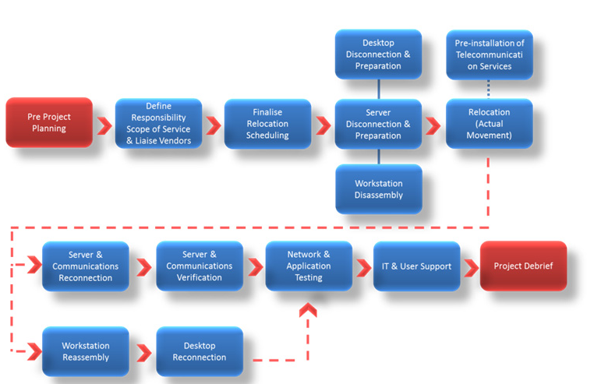

Figure 1 illustrate project flow chart

Figure 2 illustrate the project plan

13. Server Room Access Policy
Purpose
This policy establishes rules and procedures for accessing the UWTSD server room.
Scope
The UWTSD server room is a limited access area. Only personnel requiring constant access to the server room will be supplied with an access card. All requests for access to UWTSD server room area must be approved by Head of computing school or senior IT manager.
Policy Statement
There are three types of server room access, IT staffs contractors and visitors. The card access will be restricted to IT staff who require constant access to the server room to perform their job, or UWTSD emergency personnel for site emergencies only. Visitor access is restricted to non-IT departmental staff, vendors, or service personnel that are listed on the approved IT server room sign-in access list. Procedures regarding access requests, viewing, or touring the IT server room are provided below:
. Card Access: Individuals with card access to the server room are responsible for ensuring the area remains secure upon entering or exiting. This includes deactivating and activating server room alarms when production operations staff is not on-site. Individuals without server room card access must follow one of the appropriate procedures below.
Visitor sign-in access: any person on the UWTSD server room sign-in access list may be granted monitored access permission to the server room area. These individuals can enter the server room area with supervision and accompanied with one of IT staff. They are required to record the following in the UWTSD server room log book: date, name, company or department, reason for entry, in time, and out time for each access. The individual will be given a dated visitor badge from IT senior manager or any authorized staff in the IT department. The badge must be worn at all times while in the server room, and returned to The IT manager or one of the IT authorized staff when the individual leaves the server room.
Access requests: Any person without an access card or visitor access must request via the IT manager stating the reason for an access to the server room, and if approved they will granted an escorted access to the server room. IT staff will contact the Head of computing school or senior IT manager for access authorization every time access is requested. If the Head of IT is not available, IT staff will contact senior IT manager to obtain access authorization. If the access request is approved, the contractor or visitor must follow the visitor sign-in access rules and procedure and will be escorted at all times by one of the IT staff with card access while in the server room.
Server room tours: Any requests for viewing the server room area must be approved by the Head of IT or senior IT manager. Any requests for tours of the server room area must be in writing and presented at least one week prior to the requested tour. Tour requests will be presented to the Head of the IT for approval prior to scheduling a tour.
Enforcements
Any relevant individual requiring access to the server room or tour the server room, shall follow the rules and guidance of the UWTSD policy. Any person found to be in violation of this policy, will be subject to the set disciplinary action as outlined by current University policy.

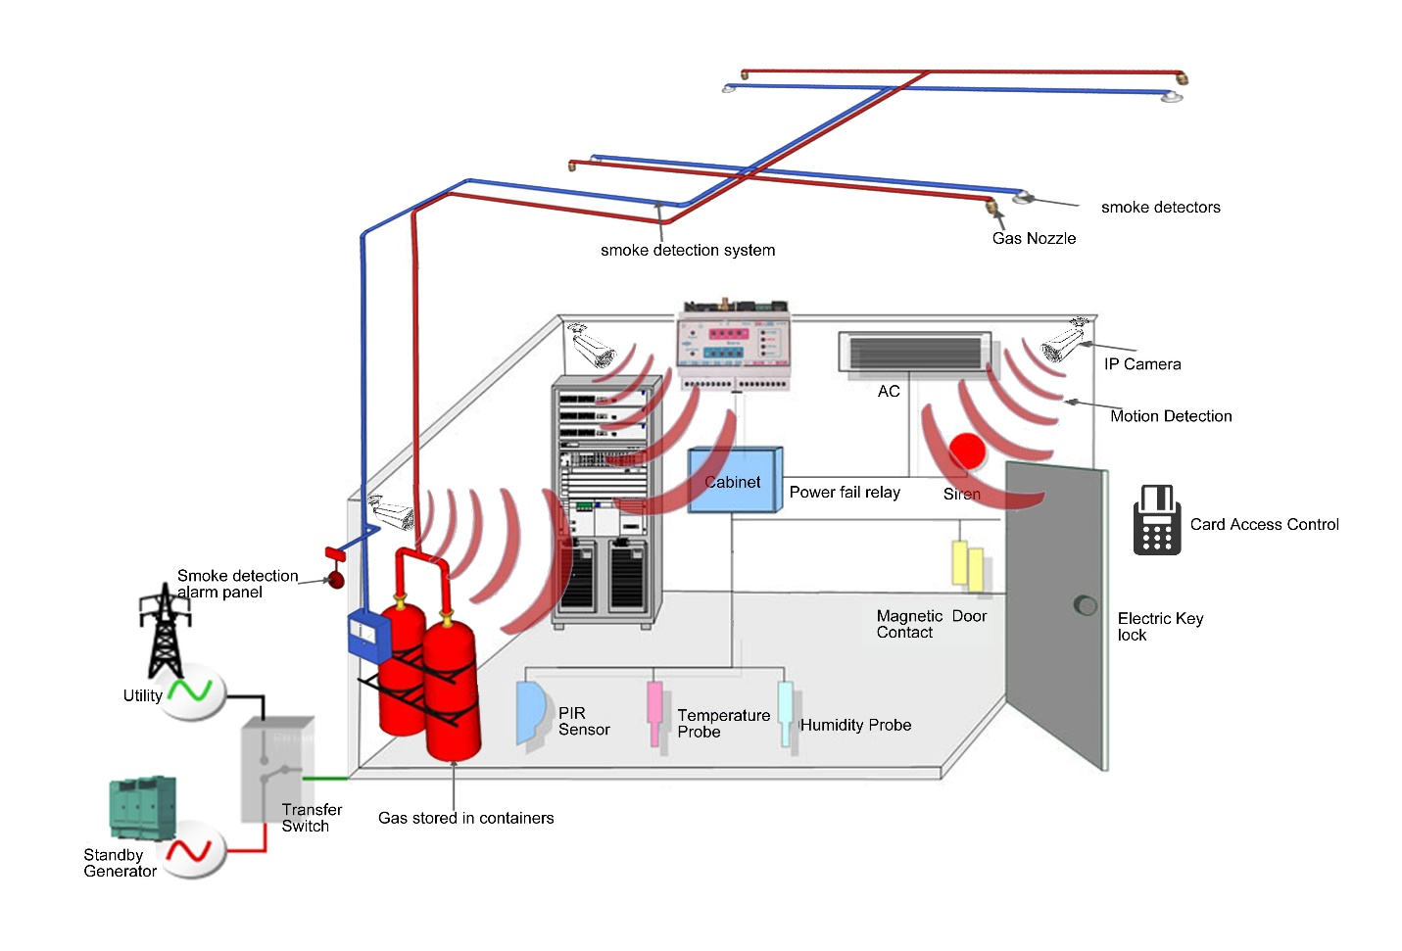
Figure 3 Illustration project output

14. References
1.Bassler, B. L., & American Institute of Architects. (2008). Architectural graphic standards: Student edition. Hoboken, N.J: John Wiley & Sons.
2.Curtis, P. M., & Wiley InterScience (Online service). (2011). Maintaining Mission Critical Systems in a 24/7 Environment. Hoboken, N.J: Wiley-IEEE Press.
3. McDowall, R. (2008). Fundamentals of HVAC control systems. Oxford: Elsevier Science.
Sterling, D. (2011). Dancing on a cloud: A framework for increasing business agility. Bloomington, Ind.: Xlibris Corp.
4. Marx, G. J., Mora, M., Raisinghani, M. S., Nebel, W., & O'Connor, R. V. (2017). Engineering and management of data centers: An IT service management approach. Cham: Springer.
5. Sterling, D. (2011). Dancing on a cloud: A framework for increasing business agility. Bloomington, Ind.: Xlibris Corp.
6. https://www.enviromon.net/monitoring-physical-security-server-room/
7. https://www.directaccessautomation.co.uk

