
ACCA4026
Software Solutions for Business
Component 1- Coursework: Portfolio
Name: Rezaul Mowla
ID: 2543079
Lecturer: Rajeev Nath
Submission Date: 11/08/2026

Table of Contents
Introduction 3
Task 1. e-Commerce Website Builders/Software Solutions 4
1.1 Wix 4
1.2 Shopify 4
Task 2. Mind-map of Contemporary Software Applications 6
2.1 Concept of Mind Mapping 6
2.2 Mind Map of Contemporary Software Applications 7
Task 3. Office Applications 8
3.1 Four office software solutions for business operations 8
MS Word 8
MS Excel 9
MS PowerPoint 10
MS Access 11
3.2 Testing Features Using Dataset 12
Mail Merge (Microsoft word) 12
IF Function (Microsoft Excel) 16
Task 4. Communication and Collaboration applications 19
4.1 One contemporary Communication and one Online Collaboration 19
4.2 Testing Features of Communication and Collaboration Applications 20
Conclusion 24
Bibliography 25

Introduction
Modern organisations are extremely reliant on digital software to facilitate operations in an efficient and competitive manner. e-Commerce platforms, office software, and communications allow organisations to have smooth workflows and make better decisions. On-line presence and sales are supported by online builders. Mind mapping enhances planning and problem solving. Office applications aid in data processing and record keeping. Team communication and team collaboration tools enhance connectivity. The knowledge of these technologies enhances organisational performance and effectiveness of operation in dynamic business environments. This discussion is an assessment of some important software solutions in the contemporary business environment.

Task 1. e-Commerce Website Builders/Software Solutions

1.1 Wix
Wix is a web hosting platform that allows users lacking advanced technical skills to create a website. It offers drag-and-drop interface making the process of creating web pages and designing easier [1]. Layouts, fonts, colours and images are easily customised by the user. Wix has plenty of templates, which are applicable to various industries and business requirements. It has integrated e-Commerce features that enable it to list its products, manage its stock and make secure payments. The site has features of marketing like email campaigns and search engine optimisation. These tools will assist in enhancing online presence and interaction with the customers. Wix also enables mobile optimisation, so that websites can operate well across the devices [2]. It comes with hosting and security service which minimises technical maintenance needs.
There are however limitations in terms of scalability to large businesses with a complex requirement. The customisation can be advanced and needs to be coded or external applications. Depending on the plan of choice, transaction charges might be charged [3]. Irrespective of these limitations, Wix is still an appropriate solution for small to medium-sized businesses that seek affordable digital solutions. On the whole, Wix is a convenient and adaptable option that can be used by companies, which want to create an online presence within a short period of time. Its desktop-friendly nature and inbuilt features make it more efficient in terms of its operations.

1.2 Shopify
Shopify is one of the most popular e-Commerce sites that are tailored to online retail-based businesses. It allows organisations to develop, operate and expand online stores effectively. The site has a huge variety of professional templates suitable to retail operations [1]. Customers have the option to design the store with in-built tools or with sophisticated codes. Shopify offers an all-encompassing inventory control, order handling and integrated secure payments. It also supports various payment gateways, making it more convenient to the customers and worldwide. Developed analytics systems help companies to track sales performance and customer behaviour.
The site has the marketing capabilities of discount code, integration of email marketing and social media connectivity. The characteristics facilitate retention and acquisition of customers. Shopify also provides integrations of apps, which allows adding new features like shipping automation and customer care systems [2]. Nevertheless, there is the possibility of increased operation costs due to subscription charges and transaction charges. Specialisation of non-standard templates might need technical skill. Irrespective of these shortcomings, Shopify is very scalable, and reliable in expanding businesses. In sum, Shopify is a powerful and holistic e-Commerce system that provides effective business development and business management.

Task 2. Mind-map of Contemporary Software Applications

2.1 Concept of Mind Mapping
Description of Mind Mapping
Mind mapping is a visual tool that is applied to arrange concepts around a main concept. It represents interrelationships between information using branches, keywords and connection [4]. One central idea is positioned in the centre and the ideas related to the central idea are shown as branches. Sub-branches give more detail and organisation. This style is similar to the way people think in nature and makes knowledge more understandable as it delivers information in a well-structured visual form in a logical way.
Benefits of Mind Mapping in Business Operations
Improved Clarity and Organisation: Mind mapping makes things easier and clearer; by displaying complex information in a structured visual manner. The thoughts are arranged in a logical manner and it is easier to comprehend the relationships amongst concepts [5]. The work processes and strategies become more employee friendly. This minimises the confusion and facilitates effective execution of tasks.
Enhanced Creativity and Innovation: Mind mapping promotes creative thinking in that one is allowed to think freely without strict organisation. The brainstorming can allow employees to consider various points of view. This results to creative solutions and better problem-solving results [6]. New ideas and strategic enhancements are beneficial to organisations.
Better Decision-Making: Mind mapping facilitates decision making by describing the major factors, risks and potential consequences. The visual representations help managers to analyse situations in a clear manner. This assists in determining strengths and weaknesses with business strategies. This leads to better informed and effective decisions.
Improved Collaboration and Communication: Mind mapping enhances teamwork since it allows teams to display ideas through a visual representation in the process of discussion. Communication and understanding of information within different departments becomes simplified [4]. This encourages group work and solving of problems. Clearly visual structures will make sure that every participant is on track with organisational objectives.

2.2 Mind Map of Contemporary Software Applications
The below mind map shows a mind map in details on the modern software applications in business settings. An organisational software system is seen as a central node and several branch structures run outwards. These divisions consist of communication solutions, teamwork applications, office solutions, and data management solutions. The branches have sub-branches that recognise particular tools and functions that are utilised in day-to-day activities. Mechanisms used in communication, such as email and messaging services, and those used in collaboration such as shared workspaces and project tools can be exemplified. The office programs are document creation, spreadsheets and presentations. The layout depicts the relationship between categories with the help of colours and connectors. Such set of visual illustration enhances knowledge of the integration of software application to enable efficiency, coordination and productivity within organisations.
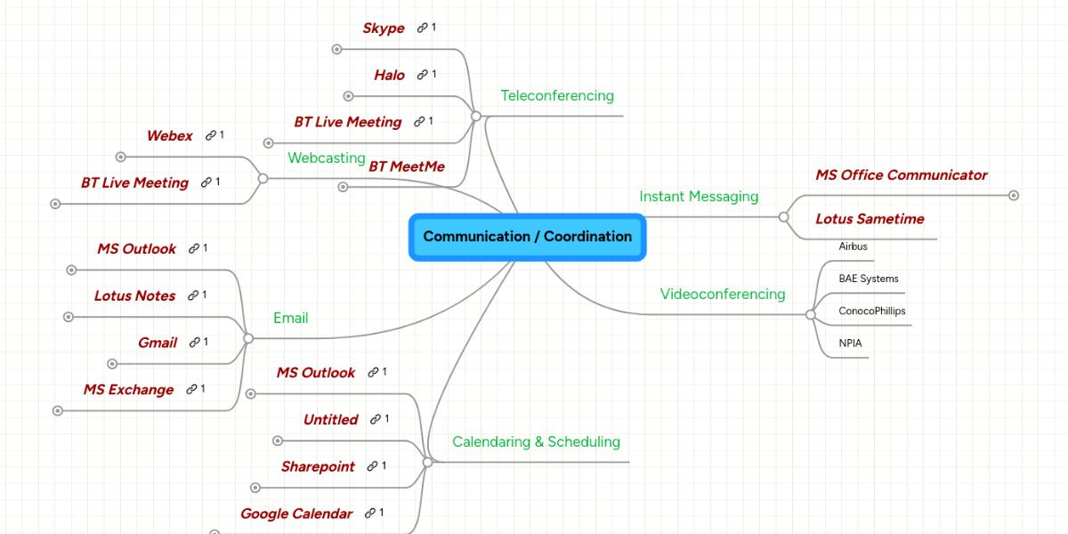
Figure 1: Mind Map
Source: Author

Task 3. Office Applications

3.1 Four office software solutions for business operations

MS Word
Overview: Microsoft word is a popular word processing program that is used to create, edit and format documents used in the business world [7]. It accommodates different types of documents such as reports, letter, proposal and contracts. The interface is easy to use and navigate; documents can be easily managed.
Key Features: Microsoft word has advanced features of text formatting, such as fonts, styles and layout features. Templates give pre-designed document templates to use in practice. Writing is accurate with spell checking and grammar tools [8]. It facilitates the addition of tables, pictures, charts and references. The collaboration aspects are tracking changes, comments, and real time co-authoring.
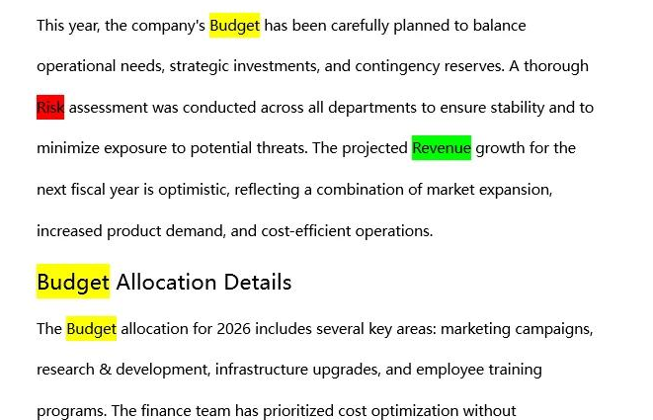
Figure 2: Key Features of MS Word
Source: Author
Benefits in Business Operations: The Microsoft Word enhances productivity by making it easier to create documents and edit them. Standard templates bring about uniformity and professionalism in documents. Teamwork and efficiency in document review is improved through collaboration tools [9]. Automated functionalities minimise mistakes and enhance the quality of documents. It helps in communication of business information effectively by well-structured documents.
Limitations: When advanced formatting options are employed in Microsoft Word, it can be complicated. Documents that are huge in size, highly formatted can slow down the system. There are a few features that are subscribe thereby raising expenses [10]. Interoperability between software versions can be a problem when using files created with other versions. There are few features to work with highly structured data in comparison with specialised tools. In conclusion, Microsoft Word is still a necessity when it comes to business documentation and it possesses flexibility, efficiency and professional output to meet organisational communication requirements.

MS Excel
Overview: Microsoft Excel is an efficient spreadsheet software that is applicable in organising, analysing and management of data in business operation [11]. It is widely used in performance tracking, accounting and finance. Rows and columns make up the interface to create the structured datasets.
Key Features: Microsoft Excel has a great variety of calculations and data analysis formulas and functions. Pivot tables are useful in summarising huge data. Charts and graphs are used to visually depict the data. Conditional formatting is used to point out significant information [8]. Repetitive tasks can be automated by use of macros. Sorting and filtering of data improves organisation.
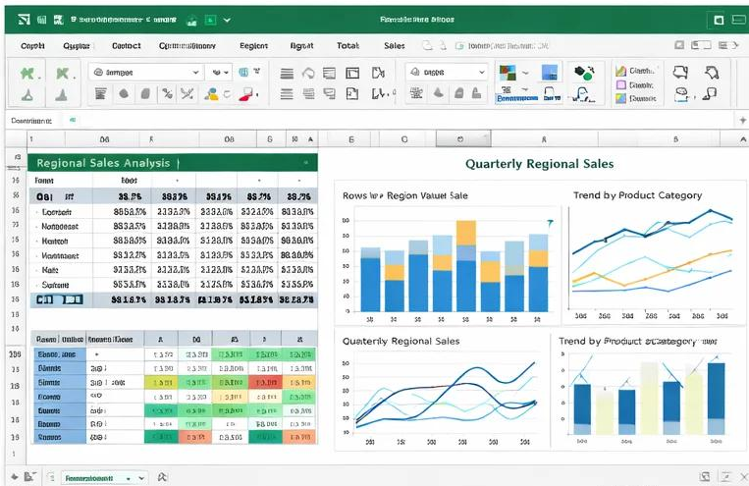
Figure 3: Microsoft Excel Features
Source: Author
Benefits in Business Operations: Microsoft Excel helps in proper data analysis and making decisions. It facilitates effective budgeting, predicting and financial control. With complex datasets, visual tools are used to simplify the data to make it easier to comprehend [9]. Automation properties save time and minimise the work. It aids in monitoring performance and strategic planning.
Limitations: Microsoft Excel can prove to be challenging to users who lack technical skills on formulas and functions. Big data can slow down the processing speed and make it longer. The inaccuracy of results can be caused by errors in formulas [10]. Complex functionalities need training to be used. Cooperation might not be as much as with cloud-based tools. Altogether, Microsoft Excel is a key to data-driven business processes, as it offers the ability to analyse and offers a wide range of data management solutions.

MS PowerPoint
Overview: Microsoft PowerPoint is a presentation program that can be used to prepare images in the form of slideshows in business communication [11]. It is popular in terms of meetings, training sessions as well as strategic presentations. The interface enables one to create slides in text, image and multimedia.
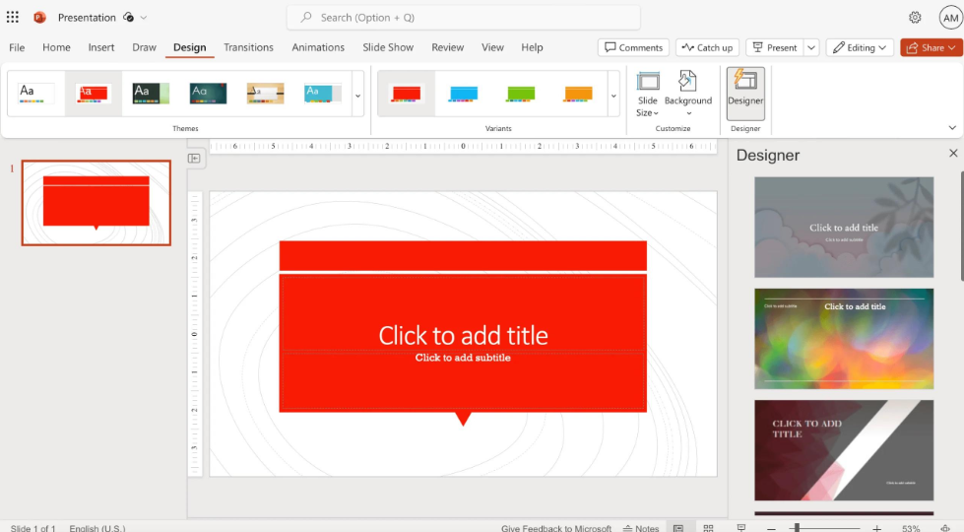
Figure 4: MS PowerPoint
Source: Author
Key Features: Microsoft PowerPoint offers templates, themes, as well as layouts of slides in order to design professional presentations. It helps to use transitions and animations in order to be more visual. Data can be presented by the use of charts, graphs and diagrams [8]. Multimedia can be integrated to enable the use of audio and video. Shared editing and feedback are supported by collaboration tools.
Benefits in Business Operations: Presentation of information using Microsoft PowerPoint enhances communication because it is presented in a manner that is easy to understand and follow. Images aid comprehension and memory of the audience [9]. It aids successful presentation of complicated concepts and business plans. Training, marketing and reporting purposes are helpful. It enhances the professionalism and influence in presentation.
Limitations: Microsoft PowerPoint can promote excessive use of visuals, minimising the attention to the quality of the content. The design of slides may have an impact on audience engagement. Multimedia files can consume a lot of memory and slow down performance [7]. Depending on the level of design needed, more competencies might be required. The use of slides could lead to a lack of interactive communication. Finally, Microsoft PowerPoint is a critical tool to be used in order to make business presentation structured and appealing to the eye.

MS Access
Overview: Microsoft Access is a database management system which is used to store, arrange and manipulate structured data. It is appropriate in small to medium business operation that needs efficient data management [10]. The system allows the generation of databases, tables, queries, forms and reports.
Key Features: Microsoft access also has relational database features, which enable the ability of connecting the data in more than one table. Data analysis and retrieval is made possible through query tools. Forms make data entries easy [11]. Reports build positional outputs to decision making. It can be integrated with other Microsoft applications to increase functionality.
Benefits in Business Operations: Microsoft Access enhances the efficiency in organising and managing data. It enables information to be stored and retrieved easily [7]. Questions assist in analysis of data and reporting. It can improve decision making with the help of structured data retrieval. It is integrated with other tools, which facilitates workflow. It is affordable to smaller database needs.
Limitations: Microsoft Access might not be applicable in large enterprise database system. Performance may decrease with very large datasets. It involves technical skills in designing an advanced database. It might be restricted to multi-user access as compared to enterprise solutions [8]. Scalability can be a problem with an increase in business data. In conclusion, Microsoft access is a great tool to deal with structured data in a small and medium business setting.
Application | Key Features | Benefits | Limitations
MS Word | Document formatting, templates, collaboration tools | Improves document quality and communication | Complex features and compatibility issues
MS Excel | Formulas, charts, pivot tables, automation | Enhances data analysis and decision-making | Difficult for beginners, error-prone formulas
MS PowerPoint | Slides, animations, multimedia integration | Improves presentations and audience engagement | Overuse of visuals, design skill required
MS Access | Database management, queries, reports | Efficient data storage and retrieval | Limited scalability and technical complexity
Table 1: Office Applications

3.2 Testing Features Using Dataset

Mail Merge (Microsoft word)
Step 1 Save Excel File: The steps include preparation and saving of the Excel dataset. The columns in the file are to be clearly labelled like Name, Marks and City. The records are represented by each row. By saving the file, it is possible to get it in the future when linking. It is important to format properly at this stage since any mistake in the data will have an impact on the output of the merge.

Figure 5: Save Excel File
Source: Author
Step 2 Open Word: Microsoft Word is launched to make the main document. The user clicks on the Mailings tab on the ribbon. This tab has all the tools needed to conduct the mail merge process. When the appropriate tab is opened, one will be able to access the required features.
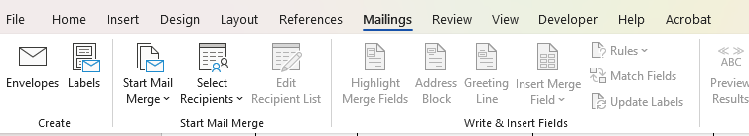
Figure 6: Open Word (Maillings)
Source: Author
Step 3 Start Mail Merge: Start Mail Merge option is selected and the type of document is selected as Letters. This is what determines the structure of the output document. It prepares the Word in a manner that it is ready to merge a standard letter with the variable data in the dataset.
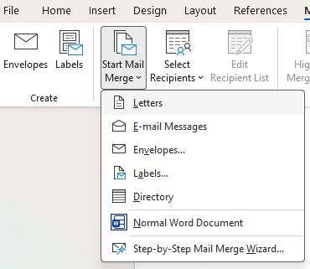
Figure 7: Start Mail Merge
Source: Author
Step 4 Link Excel File: The ‘Select Recipients’ option is used to connect the Excel file. By choosing ‘Use Existing List’, the saved dataset is selected. This creates a relationship between Word document and Excel data source.

Figure 8: Link Excel File
Source: Author
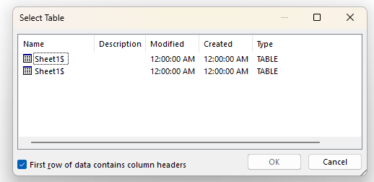
Figure 9: Select Table
Source: Author
Step 5 Writing Letter: The usual message is typed, with blank areas to fill in with customised information. This is to be used as a template which will be used with every record.

Figure 10: Writing Letter
Source: Author
Step 6 Insert Merge Fields: Name, Marks, and City are inserted in the document by clicking the option, which is called, Insert Merge Field. These areas are used as data store holders of Excel data.
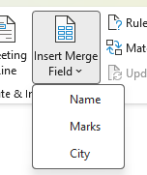
Figure 11: Insert Merge Fields
Source: Author
Step 7 Preview Results: The preview Results option is provided to enable users to preview the appearance of each letter. Navigation arrows facilitate going through all records and ensuring that they are correct.

Figure 12: Preview Results
Source: Author
Step 8 Finish Merge: Lastly, it is chosen as Finish and Merge to produce single documents. This generates numerous personalised letters in an efficient way, conserving time and decreasing manual labour.
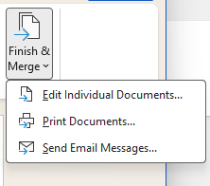
Figure 13: Finish Merge
Source: Author

IF Function (Microsoft Excel)
Step 1 Enter the Dataset: The data are entered into Microsoft Excel where the name, marks and the city are the columns. Records are represented by each row. Proper results are necessary as a result of the correct data entry.

Figure 14: Dataset
Source: Author
Step 2 Add a New Column: Result is a new column that is formed. The result of the IF function will be saved in this column. It assists in separating the results of calculations with the original data.
Step 3 Enter IF Formula: The result column has the first cell where the IF formula is to be entered. To test the conformity to the required condition, the formula =IF(B2>=50,"Pass","Fail") is used. Passing and failing It gives Back Pass and Fail respectively.

Figure 15: IF Formula
Source: Author
Step 4 Apply to All Rows: Once the Enter button has been pressed, the fill handle is pulled down to duplicate the formula to all rows. This will automatically apply the logic to the whole dataset. All records are rated in a similar manner.

Figure 16: Apply to All Rows (Results)
Source: Author
In conclusion, the IF function can be used to simplify the decision-making process, as it will automatise logical comparisons. It enhances accuracy, efficiency and productivity in working with a huge amount of data.

Task 4. Communication and Collaboration applications

4.1 One contemporary Communication and one Online Collaboration
Gmail (Contemporary Communication Tool): The Gmail communication application is one of the most common communications applications in the contemporary business world, offering quick, dependable, and professional emails. It enables people to receive and send messages in real time, which is crucial in both internal and external communication with clients and other stakeholders in organisations [12]. Its uncomplicated and easy-to-use interface makes sure that users can easily write, respond, forward and categorise email messages without any problem. Their powerful organisation system is one of the main distinguishing features of Gmail. Users are able to label, create folders and use filters to automatically sort the incoming messages. This assists in prioritising crucial emails and handle huge amounts of communication effectively [13]. An example of this is the auto-labelling and storing of emails of particular clients in special folders, saving time and effort.
Another powerful feature of Gmail is the search option, which allows the user to search emails by keywords, date or attachment easily. This comes in handy especially in business world where speed in retrieving information is of essence [14]. Moreover, Gmail is compatible with other products such as Google Drive and Google Calendar to enable the exchange of files, organize meetings, and work within the same ecosystem. Another great benefit of Gmail is security. It also includes spam filters, phishing, and two-factor authentication to ensure the safety of the sensitive information. These attributes make business communication safe and unharmed by cyber threats [12]. In most cases, Gmail enhances the efficiency of communication, increases efficiency, and enhances organised and secure communication in modern organisations.
Zoom (Online Collaboration Tool): One of the most popular online collaboration tools that companies use to communicate and collaborate virtually is Zoom. It may be utilized to conduct video conferencing, webinars, and online meetings in any place and thus the most appropriate in remote and hybrid workplaces [13]. It also allows real-time communication and hence, the teams can keep in touch with one another, although the geographical distance. A key aspect of Zoom is its quality video and audio conferencing. It helps a few people to view a single meeting, which allows working together and arguing. The gallery view option puts all the participants on the screen, making meetings more interactive and engaging.
Screen sharing is also provided by Zoom; it enables the users to share documents, slides and applications during meetings. This aspect is of great benefit especially when making business presentations, conducting training sessions, and discussing projects. Moreover, breakout rooms can help the host to separate participants into smaller groups to facilitate focused discussions or teamwork activities [15]. The built-in chat feature is another essential characteristic that enables the participants to transmit the messages, links and files within the meetings. Recording and storing meetings can also be referred to in future which is advantageous in terms of training, documentation and recapping on discussions.
One of the features of Zoom is security. Meeting passwords, waiting rooms and host controls are some of the features that ensure that meetings cannot be accessed by unauthorised personnel [12]. All in all, Zoom enhances teamwork and productivity in the contemporary business setting through promoting real-time communication, supporting teamwork, and ensuring that it promotes collaboration.

4.2 Testing Features of Communication and Collaboration Applications
Gmail (Feature Tested: Sending an Email): The feature that was used to test Gmail was through the sending of an email. The first step was to open the Gmail application and then a new message was to be created by clicking on the Compose button. This had the email address of the recipient typed in the “to” section and a subject line was also included that was pertinent. The email content was then professionally and clearly written.

Figure 17: Compose
Source: Author
Then, the attachment feature was tested with the addition of a file to the email with help of the attachment icon. This proved the easiness with which documents can be exchanged in business communication. Once the message was finished, the “Send button was clicked to send the email.
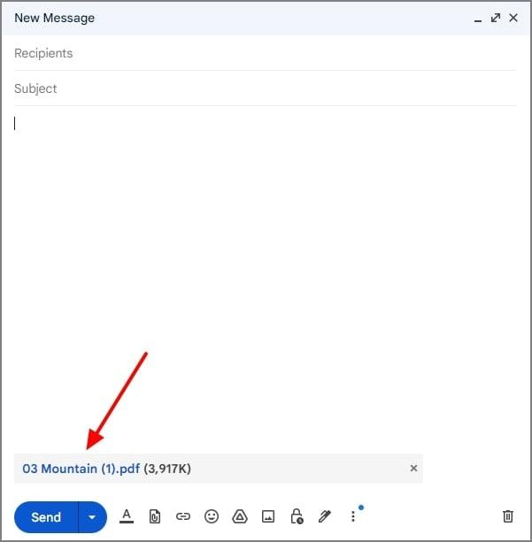
Figure 18: Attachment
Source: Author
Lastly, the email that has been sent was checked in the sent mails indicating successful delivery. This aspect demonstrates that Gmail aids fast, effective, and dependable communication in the workplace.
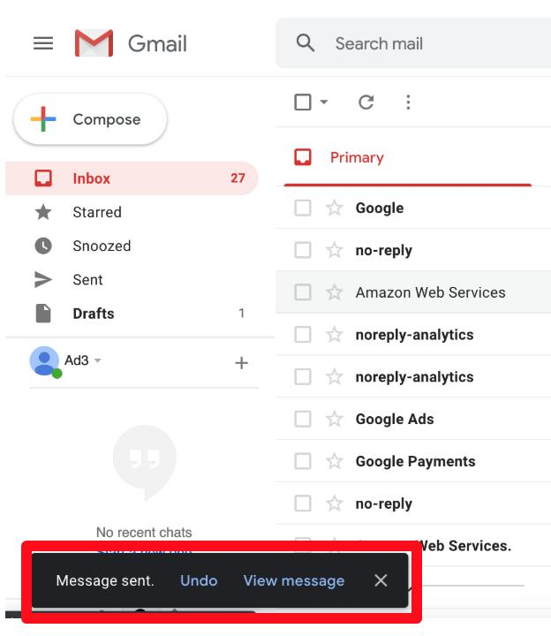
Figure 19: Checking Message Sent
Source: Author
Zoom (Feature Tested: Screen Sharing in a Meeting): The Zoom was also experimented with the screen sharing feature in a virtual meeting. To begin with, Zoom application was launched and a new meeting was initiated. The participants have been invited to participate in the session via a meeting link.

Figure 20: Share Screen in Zoom
Source: Author
When the meeting started, the control panel was used to select the Share Screen button. To all participants, a particular window, e.g. a presentation or a document, was selected and shown. This enabled all members of the meeting to watch the same stuff at the same time.
The participants could collaborate and understand during the session by sharing the screen, which enhanced understanding and interaction. It was also possible to record the meeting to use in the future. This aspect indicates that Zoom allows successful interaction and collaboration in real-time business scenarios.

Conclusion
The portfolio carried out gave an in-depth insight into the effective usage of digital tools and applications in the business world. Tasks 1 and 2 have emphasised the value of working with data, organising, and presenting it with the help of productivity software, where the structured data is useful in decision-making. Task 3 was dedicated to practical testing of such features like Mail Merge and IF functions and demonstrated how automation increases efficiency, accuracy and minimises manual repetitive work. Task 4 was about communication and collaboration tools such as Gmail and Zoom and their importance in facilitating rapid communication and working with a group in real-time. These tools were tested and their usefulness and applicability in real-life situations were established. On the whole, these exercises indicate that the introduction of digital applications increases productivity, facilitates working together, and provides efficient business processes.

References:-
[1] J. Ponce, H. Litardo, A. Vicuña, and O. Erazo, “Towards a Dashboard for E-Commerce Analytics in a Wix-Based Website,” Lecture Notes in Networks and Systems, pp. 56–71, 2026, doi: 10.1007/978-3-032-19852-5_5.
[2] P. J. P. F. Azeredo, “Shopify Equity Research - Staying Ahead of the Market,” Run.unl.pt, Jan. 14, 2022. https://run.unl.pt/entities/publication/6be7614f-92b7-4829-ad99-38d491dec203 (accessed July 21, 2026).
[3] M. Neri, “Fashion E-Commerce: A Study of the Elements Determining the Profitability of an Online Sale Channel Within the Fashion Industry,” Unive.it, Dec. 2024, Accessed: July 21, 2026. [Online]. Available: https://unitesi.unive.it/handle/20.500.14247/10925
[4] D. Anderson, Creative Thinking Enhancement Skills Using Mind Mapping Techniques. Estalontech, 2020.
[5] M. Jamshidi et al., “Investigation of Secondary Hyperparathyroidism and Its Contributing Factors in Hemodialysis Patients: A Cross-Sectional Study,” Journal of Education and Health Promotion, vol. 15, no. 1, June 2026, doi: 10.4103/jehp.jehp_2225_24.
[6] Y. Shi, H. Yang, Y. Dou, and Y. Zeng, “Effects of Mind Mapping-Based Instruction on Student Cognitive Learning Outcomes: A Meta-Analysis,” Asia Pacific Education Review, vol. 24, Mar. 2022, doi: 10.1007/s12564-022-09746-9.
[7] J. Reed, Microsoft 365. Hoboken, Nj: John Wiley & Sons, Inc, 2022.
[8] H. Ackmann, B. Kulterman, and R. Arora, Microsoft 365 Word Tips and Tricks Discover Top Features and Expert Techniques for Creating, Editing, Customizing, and Troubleshooting Documents. Birmingham: Packt Publishing, Limited, 2021.
[9] Wattimena, None Reni Koibur, and None Andrijanni, “Office Aplication Training ( Ms Office ) for the Community of Holtekamp Village,” International Journal of Community Service, vol. 2, no. 1, pp. 9–16, Dec. 2021, doi: 10.51601/ijcs.v2i1.62.
[10] K. Cao, “Predicting the Behavior Intention of Intelligent Office Software,” SHS Web of Conferences, vol. 181, pp. 01009–01009, Jan. 2024, doi: 10.1051/shsconf/202418101009.
[11] B. Jelen and T. Syrstad, Microsoft Excel 2019 VBA and Macros. Redmond: Microsoft Press, 2019.
[12] T. A. Hilal, A. A. Hilal, and H. A. Hilal, “Social Networking Applications: A Comparative Analysis for a Collaborative Learning Through Google Classroom and Zoom,” Procedia Computer Science, vol. 210, pp. 61–69, 2022, doi: 10.1016/j.procs.2022.10.120.
[13] V. Gudzinskiene and D. Mačiuikienė, “Using Distance Communication and Collaboration Tools for General Social Services,” Society. Integration. Education. Proceedings of the International Scientific Conference, vol. 1, pp. 767–781, May 2022, doi: 10.17770/sie2022vol1.6819.
[14] A. Bhardwaj and V. Kumar, “Challenges in Online Collaboration to Augment Industry 4.0,” International Journal of Technology, Policy and Management, vol. 24, no. 1, pp. 71–92, Jan. 2024, doi: 10.1504/ijtpm.2024.135977.
[15] T. Connolly and C. Begg, Database Systems: A Practical Approach to Design, Implementation, and Management, Global Edition, 6th ed. Pearson Higher Ed, 2015.

