

Introduction to Physiology (BMHP5023_LON)
ASSIGNMENT 1
Student Name: Marcia Thomas
Student ID: 2314277
Lecturer’s Name: Shaila Hussain

Case Study Report: Supporting Patients with Type 2 Diabetes

Table of Contents

1. Introduction

2. What This Report Will Cover

3. How Blood Sugar is Controlled

4. How Energy is Made in the Body

5. Lifestyle Changes to Manage Diabetes

6. Conclusion

7. References

Title: Understanding Type 2 Diabetes and Its Management

Introduction

Diabetes mellitus is a long-term metabolic condition characterized by high blood glucose (sugar). This happens because the body either does not produce enough insulin or cannot use the insulin it does produce properly. Insulin is an essential hormone made by the pancreas, and its main job is to move glucose from the bloodstream into the body’s cells, where it can be used as a source of energy. When this system does not function correctly, glucose remains in the blood instead of entering the cells. As a result, blood sugar levels rise, leading to hyperglycemia.

If hyperglycemia persists over a long period, it can cause significant damage to various parts of the body. Long-term complications of poorly managed diabetes include nerve damage (neuropathy), kidney disease (nephropathy), eye problems that can lead to blindness (retinopathy), slow wound healing, and an increased risk of heart attacks and strokes. These complications can seriously affect a person’s quality of life and overall health, which is why understanding and managing diabetes properly is so important.

There are several types of diabetes, but Type 2 diabetes is the most common, accounting for most cases worldwide. Type 2 diabetes usually develops in adulthood, although it is increasingly being seen in younger people due to rising obesity levels. In this form of the condition, the pancreas still produces insulin, but the body’s cells become insulin-resistant, so the insulin cannot work effectively. Over time, the pancreas may also become unable to produce enough insulin to meet the body’s needs.

Type 2 diabetes is strongly linked to lifestyle factors. These include eating an unhealthy diet that is high in sugar, fats, or processed foods; not getting enough exercise; being overweight or obese; smoking; and having an overall sedentary lifestyle. Other risk factors include getting older, having a family history of diabetes, and belonging to specific ethnic backgrounds where the condition is more common. Because many of these risk factors are related to behaviour and lifestyle, Type 2 diabetes is often considered a preventable condition.

What This Report Will Cover

In this report, I will explore several key areas related to the understanding and management of Type 2 diabetes. First, I will explain how the body normally regulates blood sugar levels through a balance of hormones, mainly insulin and glucagon. This section will describe how insulin lowers blood glucose levels and how glucagon raises them, helping the body maintain a stable, healthy range. Understanding this natural process is essential because it highlights what goes wrong in Type 2 diabetes and why patients experience high blood sugar levels.

I will then describe how the body uses glucose and oxygen to create energy through a process called cellular respiration. This part of the report will look at how glucose enters the cells, how it is broken down, and how oxygen is used to produce ATP, which is the primary source of energy for the body. This section is essential because diabetes directly affects how effectively glucose can enter body cells, which can lead to tiredness, weakness, and other symptoms when energy levels are low.

Another primary focus of this report will be the importance of monitoring and recording blood sugar levels, particularly for people living with Type 2 diabetes. Regular monitoring can help patients understand how different foods, physical activity, stress, medication, and illness affect their blood glucose levels. By tracking these patterns, patients can make informed decisions and work with healthcare professionals to adjust their treatment or lifestyle. This section will highlight how tracking blood sugar can help prevent complications and support safer self-management.

Finally, I will outline evidence-based lifestyle changes that can help patients manage their diabetes more effectively. These changes include quitting smoking, improving diet, increasing physical activity, and maintaining a healthy weight. Lifestyle modifications are an essential part of diabetes management because they can enhance the body’s ability to use insulin, lower blood sugar levels, and reduce the risk of developing serious complications such as heart disease or kidney damage. In this section, I will explain how each lifestyle factor contributes to better health and why healthcare professionals play a key role in supporting patients’ behaviour change.

How Blood Sugar Levels Are Maintained

The body keeps blood sugar levels within a healthy and stable range because both very high and very low levels can be dangerous. This balance is maintained through a complex system involving several organs and hormones, with the pancreas playing the most critical role. The pancreas releases two key hormones, insulin and glucagon, which work together to regulate blood glucose.

After a person eats a meal, especially one containing carbohydrates, the food is broken down in the digestive system into simple sugars, mainly glucose. This glucose is then absorbed into the bloodstream, raising blood sugar levels. In response to this increase, the pancreas releases insulin. Insulin acts like a “key” that unlocks the body’s cells, allowing glucose to enter. Once inside the cells, glucose can be used immediately to produce energy or stored for later use, mainly in the liver and muscles as glycogen. This process lowers blood glucose levels back to a normal range.

When blood sugar levels fall too low, for example, between meals or during physical activity, the pancreas releases another hormone called glucagon. Glucagon does the opposite of insulin: it signals the liver to break down the stored glycogen into glucose and release it back into the bloodstream. This raises blood sugar levels to make sure the body has enough energy to function. This system of insulin and glucagon working in opposite ways keeps blood sugar levels steady throughout the day.

However, in people with Type 2 diabetes, this regulatory system does not work as it should. The main issue is insulin resistance, which means the body’s cells do not respond appropriately to insulin. Although the pancreas still produces insulin, it is not used effectively, so glucose cannot enter the cells easily. As a result, glucose remains in the bloodstream, causing high blood sugar levels. Over time, the pancreas may struggle to produce enough insulin to overcome this resistance, worsening the problem.

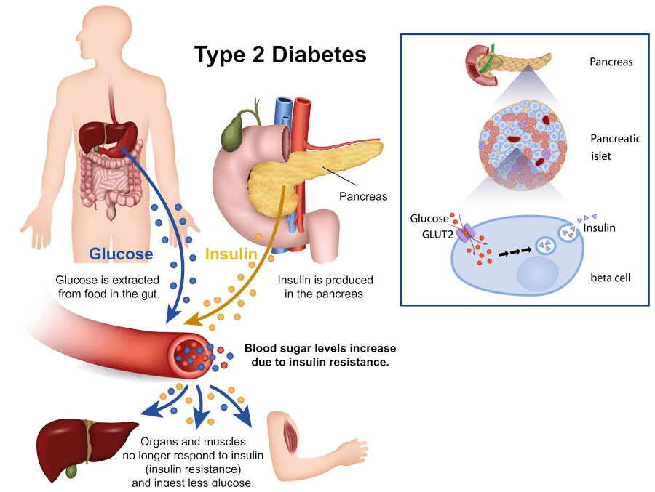
This Photo by Unknown Author is licensed under CC BY-NC-ND

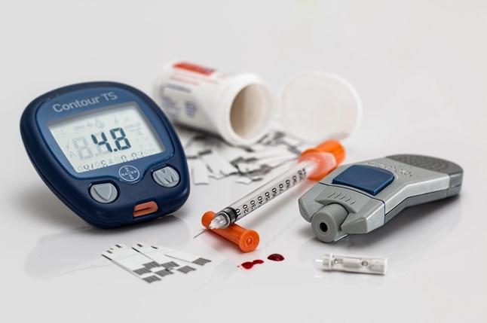

The Role of Oxygen and Glucose in Producing Energy

The body needs a constant supply of energy to perform everyday functions such as walking, thinking, breathing, digesting food, and repairing damaged tissues. This energy comes mainly from glucose, a type of sugar absorbed from the food we eat. However, glucose cannot release energy on its own; it must be combined with oxygen inside the body’s cells through a process called cellular respiration.

Cellular respiration takes place mainly in the mitochondria, which are often referred to as the “powerhouses” of the cell because they produce most of the body’s energy. In this process, glucose molecules are broken down in a series of chemical reactions. Oxygen plays a crucial role because it helps fully break down glucose, allowing the body to extract the maximum amount of energy. The result of this process is the production of ATP (adenosine triphosphate). ATP is like the body’s “energy currency” that powers muscle movement, nerve signals, cell growth, and many other essential functions.

If there is not enough glucose or oxygen available, the body cannot make enough ATP. This can cause fatigue, muscle weakness, shortness of breath, and slow wound healing. In people with diabetes, this problem occurs because glucose remains in the bloodstream rather than entering cells. Since insulin is needed to move glucose into the cells, insulin resistance prevents cells from receiving the glucose they need. As a result, even though the blood sugar level is high, the cells behave as if the body is low on energy.

Over time, poor energy production can contribute to complications such as nerve damage, infections, and reduced circulation. This is why effective diabetes management is essential not only to control blood sugar levels but also to ensure that the body’s cells can produce enough energy to function correctly.

Why Recording and Tracking Blood Sugar Levels Is Important

For people with Type 2 diabetes, regularly checking and recording blood sugar levels is a vital part of managing the condition. Blood glucose can fluctuate throughout the day for many reasons, including food choices, portion sizes, physical activity, stress, illness, and timing of medications. Without regular monitoring, these changes may go unnoticed, increasing the risk of complications.

By recording blood sugar readings, patients can clearly see how their lifestyle affects their glucose levels. For example, they may notice that certain foods spike blood sugar or that their levels drop after exercise. This knowledge helps them make better decisions about meals, activities, and medication use.

Healthcare professionals also rely on these records to adjust treatment plans. Accurate blood sugar logs allow nurses, doctors, and diabetes specialists to determine whether the current medication is effective or needs to be changed. Without this information, it is harder for healthcare teams to prevent dangerous situations such as:
Hypoglycemia, when blood sugar falls too low, can cause dizziness, shaking, sweating, and confusion.
Hyperglycemia, when blood sugar becomes too high, can cause dehydration, blurred vision, and long-term organ damage.

Regular monitoring also builds confidence and encourages patients to take an active role in managing their health. It turns diabetes care into a partnership between patients and healthcare providers, improving communication, treatment success, and long-term well-being.

Lifestyle Changes That Improve Diabetes Management
Smoking

Smoking is especially harmful for people with diabetes because it increases insulin resistance, makes blood vessels narrower, and raises blood pressure. These effects increase the risk of serious complications such as heart attack, stroke, kidney damage, and poor circulation. Smoking also reduces the amount of oxygen that reaches the body’s tissues, which slows healing and increases the risk of infections, which are already common in diabetes.
Quitting smoking can significantly improve overall health, enhance blood flow, reduce inflammation, and help the body use insulin more effectively.

Diet
Eating a healthy, balanced diet is one of the most effective ways to control blood sugar. A good diabetes-friendly diet includes:
Plenty of vegetables and high-fibre foods
Whole grains instead of refined carbohydrates
Lean sources of protein
Limited sugary foods and drinks
Smaller portion sizes
Regular mealtimes to prevent blood sugar spikes and dips

Making gradual changes, such as replacing sugary snacks with fruit or switching to wholegrain bread, can make blood sugar easier to control. Working with a dietitian can also help patients plan meals that suit their lifestyle and medical needs.

Exercise
Physical activity helps the body use insulin more effectively, allowing glucose to enter cells more easily. Regular exercise can lower blood sugar levels, reduce body weight, strengthen the heart, and improve mood and energy levels.
Patients do not need to join a gym; daily activities such as brisk walking, cycling, swimming, or even gardening can make a difference. Aim for at least 30 minutes of moderate exercise most days of the week.
Exercise also reduces stress, which is vital because stress hormones can raise blood sugar

l
Conclusion

In conclusion, Type 2 diabetes is a long-term and potentially serious health condition that affects the way the body regulates and uses blood sugar. A clear understanding of how insulin works, how energy is produced within the cells, and how daily activities influence blood glucose levels is essential for anyone living with this condition. When patients understand these processes, they are better able to recognize symptoms, make informed decisions, and take active steps to maintain their health.

Regular monitoring of blood glucose is essential for effective diabetes control. By checking and recording levels throughout the day, patients can identify trends, understand how different foods, activities, and medications affect their blood sugar, and take corrective action when necessary. This not only helps prevent short-term complications such as hypoglycemia and hyperglycemia but also reduces the risk of long-term problems, including heart disease, nerve damage, kidney failure, and vision loss. Consistent monitoring empowers patients and allows healthcare professionals to provide more accurate and personalised advice.

Lifestyle changes remain a central part of diabetes management. Quitting smoking helps improve circulation, reduces inflammation, and lowers the risk of cardiovascular complications, which are already higher in people with diabetes. Adopting a healthier diet, rich in vegetables, whole grains, and lean proteins, helps stabilise blood sugar and provides the nutrients needed for overall health. Regular physical activity improves insulin sensitivity, enhances energy levels, supports weight control, and promotes better mental well-being. These lifestyle adjustments may seem challenging at first, but even small, gradual changes can significantly improve a patient’s long-term health.

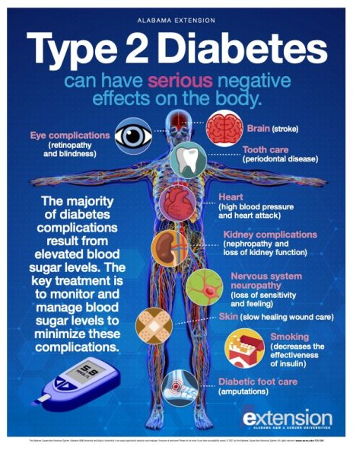

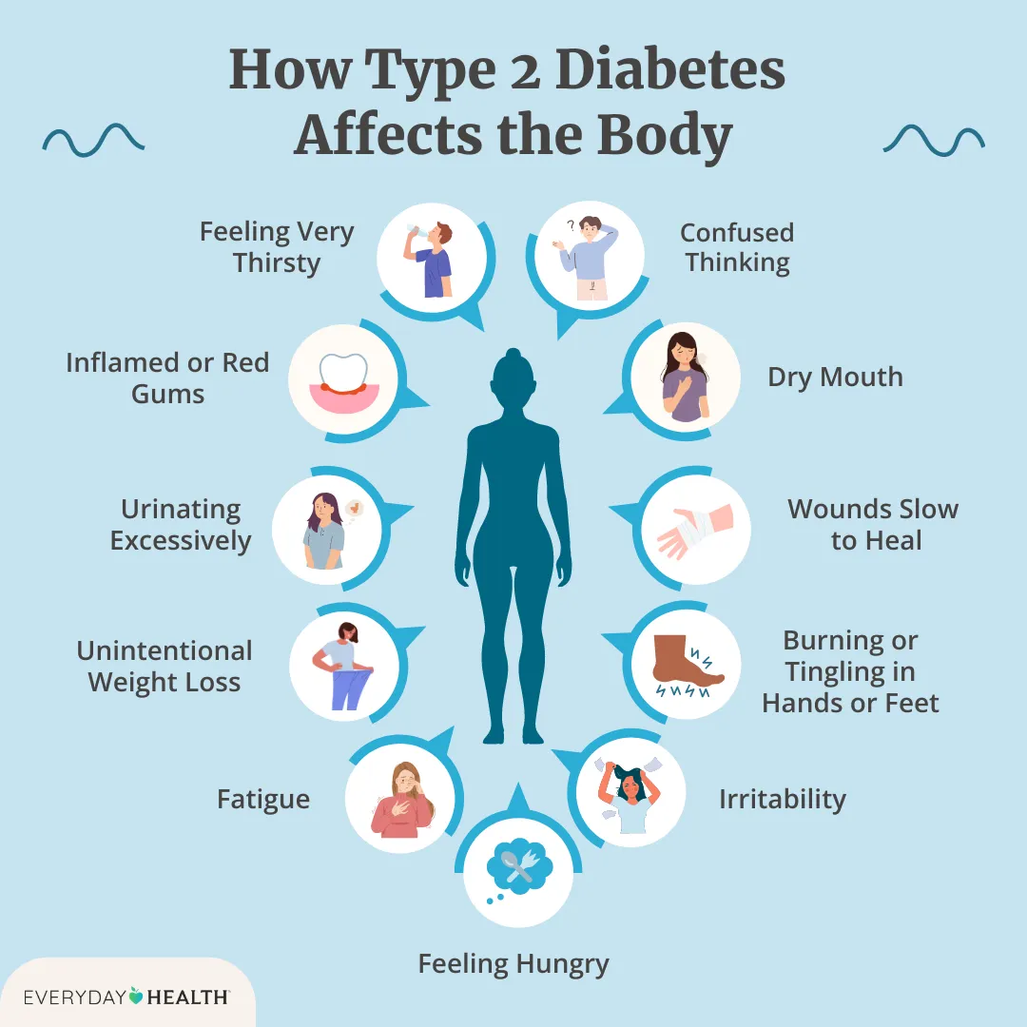

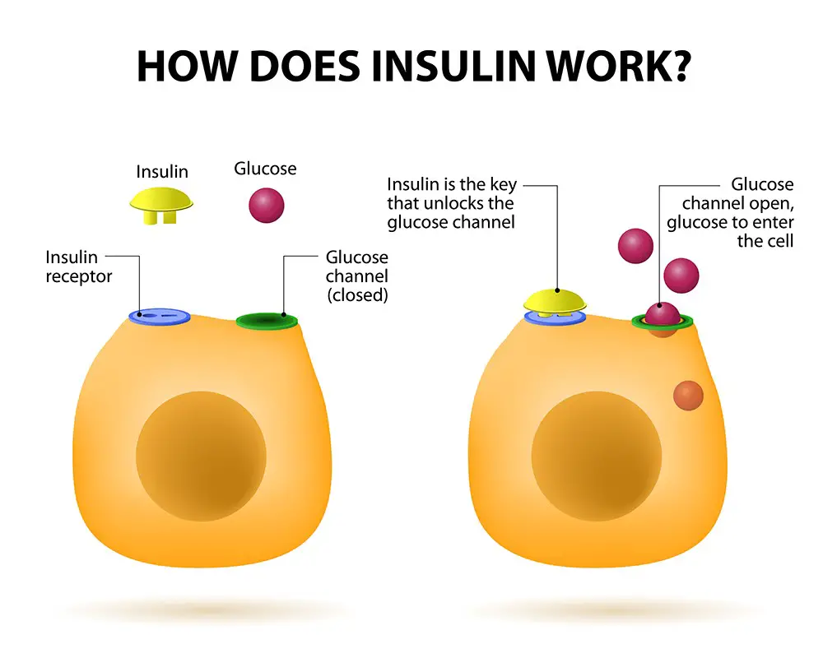

References
American Diabetes Association (2023). American diabetes association releases 2023 standards of care in diabetes to guide prevention, diagnosis, and treatment for people living with diabetes | ADA. [online] diabetes.org. Available at: https://diabetes.org/newsroom/american-diabetes-association-2023-standards-care-diabetes-guide-for-prevention-diagnosis-treatment-people-living-with-diabetes.

Atkinson, M.A., Eisenbarth, G.S. and Michels, A.W. (2014). Type 1 Diabetes. The Lancet, [online] 383(9911), pp.69–82. Available at: https://www.thelancet.com/journals/lancet/article/PIIS0140-6736(13)60591-7/fulltext.

Carracher, A.M., Marathe, P.H. and Close, K.L. (2017). European Association for the Study of Diabetes 2017. Journal of Diabetes, 10(2), pp.90–93. doi:https://doi.org/10.1111/1753-0407.12617.

Fujimoto, W.Y. (2000). The importance of insulin resistance in the pathogenesis of type 2 diabetes mellitus. The American Journal of Medicine, 108(6), pp.9–14. doi:https://doi.org/10.1016/s0002-9343(00)00337-5.

Hyderabad Diabetes Centre (2025). Reducing Diabetes Risk Factors - Health blog from Hyderabad Diabetes Centre. [online] Health blog from Hyderabad Diabetes Centre. Available at: https://hyderabaddiabetes.com/articles/prevention-of-diabetes/reducing-diabetes-risk-factors/ [Accessed 10 Dec. 2025].

Idris, I. (2019). News and Views September 2019: American Diabetes Association (ADA) 79th scientific session Highlights. Diabetes, Obesity and Metabolism, 21(9), pp.2183–2186. doi:https://doi.org/10.1111/dom.13834.

Kahn, S.E., Cooper, M.E. and Del Prato, S. (2014). Pathophysiology and Treatment of Type 2 diabetes: Perspectives on the past, present, and Future. The Lancet, [online] 383(9922), pp.1068–1083. doi:https://doi.org/10.1016/s0140-6736(13)62154-6.

Saini, V. (2010). Molecular mechanisms of insulin resistance in type 2 diabetes mellitus. World Journal of Diabetes, [online] 1(3), p.68. doi:https://doi.org/10.4239/wjd.v1.i3.68.

Sesti, G., Federici, M., Lauro, D., Sbraccia, P. and Lauro, R. (2001). Molecular mechanism of insulin resistance in type 2 diabetes mellitus: role of the insulin receptor variant forms. Diabetes/Metabolism Research and Reviews, 17(5), pp.363–373. doi:https://doi.org/10.1002/dmrr.225.

Stumvoll, M., Goldstein, B.J. and van Haeften, T.W. (2005). Type 2 diabetes: principles of pathogenesis and therapy. The Lancet, 365(9467), pp.1333–1346. doi:https://doi.org/10.1016/s0140-6736(05)61032-x.

Stumvoll, M., Goldstein, B.J. and van Haeften, T.W. (2008). Type 2 diabetes: pathogenesis and treatment. The Lancet, 371(9631), pp.2153–2156. doi:https://doi.org/10.1016/s0140-6736(08)60932-0.

Tahrani, A.A., Bailey, C.J., Del Prato, S. and Barnett, A.H. (2011). Management of type 2 diabetes: new and future developments in treatment. The Lancet, 378(9786), pp.182–197. doi:https://doi.org/10.1016/s0140-6736(11)60207-9.

Thelancet.com. (2025). Welcome To Zscaler Directory Authentication. [online] Available at: https://www.thelancet.com/journals/lancet/article/PIIS0140673601054150/abstract.

Yee, G. (2017). Bright Spots & Landmines: The Diabetes Guide I Wish Someone Had Handed Me. Clinical Diabetes, 35(5), pp.356–357. doi:https://doi.org/10.2337/cd17-0107.

Zierath, J.R. (2019). Major Advances and Discoveries in Diabetes - 2019 in Review. Current Diabetes Reports, [online] 19(11). doi:https://doi.org/10.1007/s11892-019-1255-

