

Master of Business Administration

Strategic Management - LCMB7003

Student Name -Harshkumar Manojkumar Patel

Student ID - 2503790

Lecturer Name – Dr. Hoang Dang Nguyen

Company – Burberry

Word Count – 5469
Critical Analysis of the Strategic Management Practices of Burberry

Table of Contents
Section 1: Strategic Analysis of Burberry 4
1.0 Introduction 4
2.0 Organisational Context and Overview 4
2.1 Organisational Historical Perspectives 4
2.2 Industry Analysis and Market Position 6
3.0 External and Internal Environment Analysis 7
3.1 External Environment Analysis: PESTEL Impact on Burberry’s Strategic Decisions 7
3.2 Critical Success Factors and Strategic Challenges in the External Environment 9
3.3 Internal Environment Analysis: Resources, Capabilities and VRIO Analysis 10
3.4 Contribution of Internal Strengths to Competitive Advantage 12
4.0 CSR and Sustainability Objectives 13
5.0 Comprehensive and Holistic View of the Organisation 15
6.0 Strategic Choices and Implementation 17
6.1 Strategic Choices at Business and Corporate Levels 17
6.2 Managing Change and Strategic Implementation 18
7.0 Strategic Evaluation and Recommendations 19
7.1 Strategic Evaluation of Burberry Using SWOT Analysis 19
7.2 Recommendations to Enhance Competitive Advantage 21
8.0 Conclusion 22
Section 2: Reflective Account 23
1.0 Overview 23
2.0 Reflection using Gibbs' Reflective Cycle 23
2.1 Description 23
2.2 Feelings 24
2.3 Evaluation 24
2.4 Analysis 25
2.5. Conclusion 25
2.6 Action Plan 25
3.0 Summary 26
Reference List 27

Section 1: Strategic Analysis of Burberry

1.0 Introduction
The report discusses Burberry's performance management methods as well as organizational environment, strategic position and sustainability efforts. It does assess internal and external factors, but with the use of recognised strategic frameworks. This can affect business success as well as looking at strategic decisions which can help to achieve competitive advantages and long-term growth.
Strategic management refers to process of analysis organisation’s external environment and internal capabilities to support decision-making for long-term competitive advantages (Teixeira et al., 2023). The use of PESTEL, VRIO and SWOT enables Burberry’s external pressures, internal capabilities and strategic position to be evaluated.

2.0 Organisational Context and Overview

2.1 Organisational Historical Perspectives
Burberry was founded by Thomas Burberry in Hampshire, England, in 1856 (Yan, 2023). The business has grown from an outdoor apparel company to one of the top luxury fashion firms in the world (Yan, 2023). However, the company has been known for the invention of gabardine fabrics along with the introduction of the iconic trench coat worn during the First World War.

Figure 1: Trench coat wearing during the First World War
(Source: Claire, 2020)
Burberry’s Mission and vision statements are strategically relevant since they reinforce Burberry’s British heritage, innovation and luxury positioning. Figure 1 shows the trench coat of Burberry, which is associated with its British heritage.
Mission
The mission of Burberry is to create products which represent modern British luxury while providing inspiration for creativity and responsible business practices (Lim, 2023).
Vision
The strategy of Burberry has been to reinforce their global identity as a top British luxury brand by sustainability, innovation and craftsmanship (Lim, 2023).
Business model
Burberry has operations in a vertically integrated business model along with controlling design, retail activities, manufacturing and marketing process for maintaining brand quality and exclusivity. As per Lim (2023), the company has generation of the revenue through direct retain stores, licensing agreements, wholesale partnerships and e-commerce platforms. It has been seen that Burberry has operated over 400 stores in the global marketplace, along with employing approximately 8,700 people, with the generation of revenue exceeding £2.4 billion in 2025 (Phau et al., 2022).
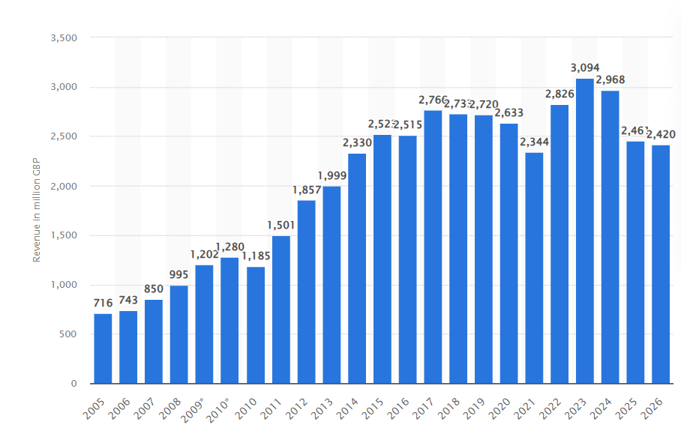
Figure 2: Revenue of Burberry
(Source: Rocco, 2026)
Figure 2 highlights the revenue of the brand from 2005 to 2026. It is linked with the strategic initiatives of the company, including having Burberry Forward, which aims to enhance customer engagement along with encouraging long-term growth with the focus on core products such as scarves and outerwear. Therefore, the heritage, digital innovation and commitment of Burberry have strengthened its reputation as a premium luxury brand in the global market. As per Baran and Khammash (2024), its distinctive check pattern has been among the most recognisable symbols in fashion in the international market. The mentioned company has continual investment in sustainable sourcing and technology to maintain relevance among younger luxury consumers. Therefore, the recent initiatives include reduction of environmental impacts throughout its global supply chain and expanding the digital retail experience in the global market.

2.2 Industry Analysis and Market Position
Burberry has operations within the global luxury fashion industry, which has a valuation of €360 billion and is expected to grow to $106.1 billion in 2030 for luxury apparel, the brand positioned in the accessible to mod-high luxury segment (Burberry, 2026). It is characterised by premium pricing, brand equity and exclusivity, while the industry includes beauty products, accessories, leather goods and apparel. According to Lee and Choi (2022), the demand is growing in the Asian region among the middle-class population, while Burberry has competition with Louis Vuitton, Hermès, Prada and Gucci in the global market.\
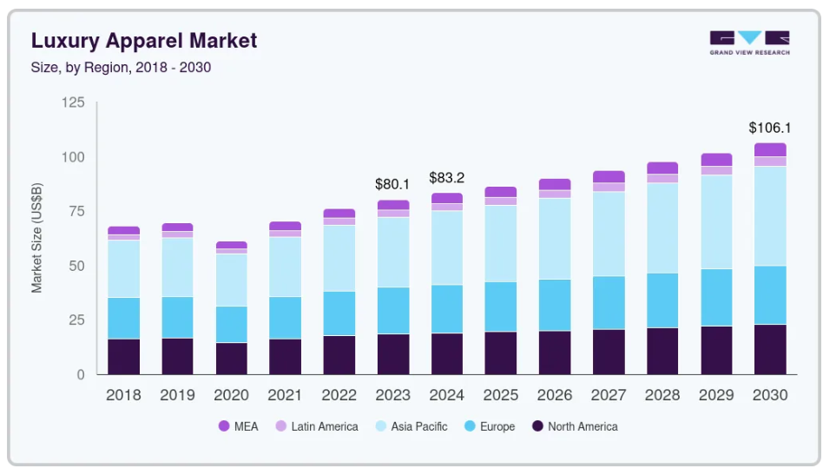
Figure 3: Luxury apparel market
(Source: Grand View Research, 2026)
Figure 3 highlights the luxury apparel market growth from 2018 to 2030. The company is a leading British luxury company with its mid-to-high luxury positions to grow exclusivity and luxury with below positioning of Louis Vuitton and Hermès (Zhang et al., 2022). Burberry differentiate itself through British heritage, digital innovation and iconic outerwear, which helped to improve profitability.

3.0 External and Internal Environment Analysis

3.1 External Environment Analysis: PESTEL Impact on Burberry’s Strategic Decisions
PESTEL is a framework used for analysing external environment for the organisation (Franzè et al., 2024). It is relevant to Burberry since its international luxury operations expose the organisation to changing conditions.
Table 1: PESTLE analysis
Factor | Impact on Burberry | Opportunity/Threat
Political | Brexit increased trade costs and customs complexities across Europe (Burberry, 2026). | Threat
Economic | Inflation and currency fluctuations has impact on luxury spending globally. | Threat
Social | Younger consumers prefer sustainable and digital luxury experiences. | Opportunity
Technological | AI, e-commerce and digital marketing enhance customer engagement. | Opportunity
Environmental | Net-zero targets pressure firms to adopt sustainable sourcing (Gupta et al., 2024). | Opportunity
Legal | Strict regulations on labour rights and data privacy increase compliance requirements. | Threat
Table 1 highlights the detailed PESTLE analysis of the brand. The strategic decisions of Burberry have been shaped primarily by the external factors. However, the political approach indicates that Brexit created barriers in customs, along with increased operation costs for the UK-based luxury brands. This influences the company to diversify supply chains, along with having strong international operations.
As per Sgibneva (2023), in the economic approach, slow luxury demand in China and global inflation has negative impact on the patterns of the consumer spending process, which indicates a compelling focus on high-margin products such as outerwear by the company. It has been seen that Burberry has revenue of approximately £2.4 billion in 2025, which reflects the challenging market conditions in the global marketplace.
As per McKelvey (2025), the social approach includes the increasing rate of sustainability along with personalised experiences, which promote the company’s investment in circular fashion initiatives, along with the digital engagement process. For example, the company has launched carbon-neutral collections and resale programs, which lead to the attraction of environmentally conscious customers.
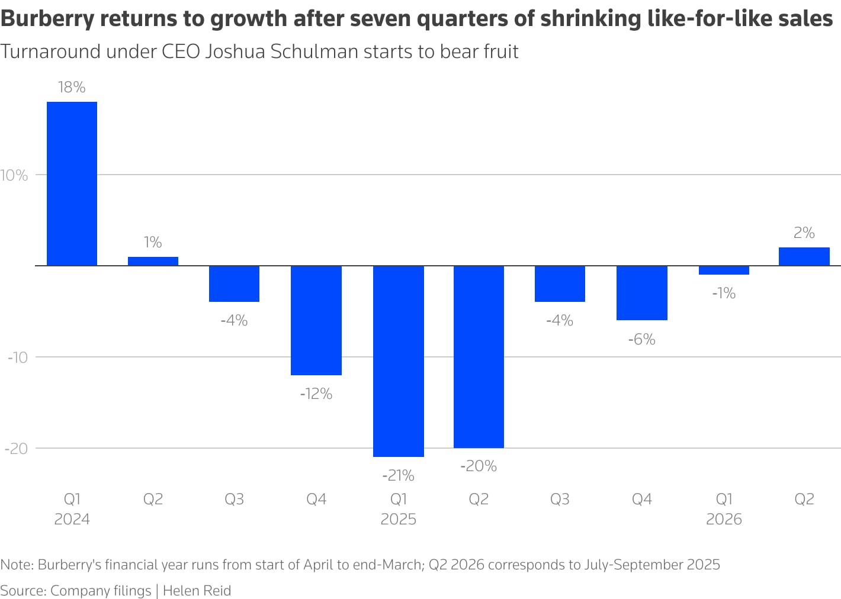
Figure 4: Burberry’s return to growth
(Source: Reid and Shabong, 2025)
Figure 4 highlights the financial year returns in years of 2024 to 2026. The technological approach includes development with the association of AI and data analytics, which support the strategies of omnichannel retail process and personalised marketing (Franzè et al., 2024). It can be said that Burberry was among the first luxury brand which livestream fashion shows along with integrating digital experience in the associated sector. Therefore, the environmental pressures have been linked to carbon emissions and climate change, which have encouraged sustainable sourcing and commitment to net-zero emissions by 2040.
As per Dominguez and Bhatti (2022), the legal factors include having strict data protection laws, such as labour regulation and GDPR, which indicate an increase in the compliance costs while strengthening consumer trust. It is essential to say that these external factors together shape the strategic priorities of Burberry, along with encouraging innovation, resilience, sustainability and global market adaptation to maintain competitiveness and luxury brand prestige in the international market.
PESTEL create threats and opportunities for Burberry which indicates technological development for increasing demand for sustainable luxury as an opportunity. The political complexity and regulatory requirements create threats.

3.2 Critical Success Factors and Strategic Challenges in the External Environment
Critical Success Factors (CSFs) ae the key areas in which an organisation needs to perform effectively to succeed within the industry (Avdalyan, 2024). For Burberry, global market present, sustainability, digital innovation and brand heritage can be considered as CSFs since they directly support competitiveness, market reach and customer engagement in the luxury fashion industry.
The success of Burberry within the luxury fashion industry has dependence on the important critical success factors. According to Kim et al. (2026), the strong brand heritage is the main advantage, which includes the iconic trench coat of the company with signature check patterns globally recognisable. It can be said that innovation and digital capabilities have a high contribution to the competitiveness of the business. Therefore, the leading digital luxury marketing by the company associated with the proper digital approach indicates having the first fashion brands to run live streaming for the runway events. As per Avdalyan (2024), the global market has a presence across 400 stores, which enables access to the high-growth region, specifically in the Asian region.
The sustainability effort has increased customer loyalty, particularly among younger consumers who prioritise making ethical purchases. However, the business confronts serious strategic challenges, including fierce competition from high-end brands in the local and global marketplace. Therefore, this indicates sustaining in the highly competitive marketplace for the company in the fashion sector. As per Di Leo et al., (2023), this indicates providing pressure on the differential and prices in this. The economic uncertainty, along with currency volatility and inflation, can reduce the discretionary spending on luxury goods.
Additionally, rapidly changing consumer preferences need to have continuous innovation in the retail and product experiences (Banerjee, 2023). But the supply chain can cause cost and complexity issues, especially due to geopolitical tensions and tough environmental legislation. Hence, the need for Burberry to create a balance between preserving the heritage and innovating to continue to grow in the global market. The company has to strategically operation the changing dynamics of the global market and also stay at the premium levels in the increasingly competitive luxury markets for the related business.

3.3 Internal Environment Analysis: Resources, Capabilities and VRIO Analysis
Table 2: VRIO Analysis
Capability | Value | Rare | Imitable | Organization | Competitive advantage
Brand Heritage | Yes | Yes | Yes | Yes | Sustainable competitive advantage
Digital Innovation | Yes | Yes | Yes | Yes | Temporary competitive advantage
Global Retail Network | Yes | No | No | Yes | Competitive advantage
Sustainable Practices | Yes | No | No | Yes | Competitive advantage
Table 2 highlights the VRIO analysis of Burberry. The brnad has valuable resources along with capabilities that provide support for the strategic objectives and market performance. However, the strongest asset includes having the globally recognised British heritage brand, which has been developed over 170 years and is associated with the luxury craftsmanship (Zhou, 2025). The intangible resources provide opportunities for customer loyalty and premium pricing, while the extensive retail network of Burberry provides strong market presence and customer engagement opportunities in the international marketplace. It can be said that digital capabilities provide representation of another important competency. As per Phau et al. (2024), the company has heavy investment in the e-commerce, AI and omnichannel experiences, which enhance the operational efficiency and customer personalisation approach. It has been seen that the sustainability capabilities, which include responsible sourcing along with carbon reduction initiatives, provide opportunities for the strengthening of brand reputation among environmentally conscious customers.
Although Burberry’s digital capabilities create value and differentiation, similar technologies can be adopted by competitors. Therefore, their provide a temporary rather than sustainable competitive advantage (Masè¹ et al., 2025). While scaling benefits is not uncommon in the luxury fashion industry, the entire global retail network of the company does. It is essential to address that the organisational structure of Burberry provides support for the effective utilisation of these resources through strategic leadership, along with integrated operations. According to Singh et al., (2025), the company’s combination of sustainability, heritage and innovation creates strategic capabilities which enhance the competitiveness and resilience process.
The VRIO analyses highlight that brand heritage, digital strength and vertically integrated business model, sustainability commitments are the key resources for competitive advantage. Therefore, these core competencies are associated with providing opportunities for Burberry to maintain market relevance by adapting to changing industry dynamics and consumer preferences. The following section highlights capabilities and resources to translates the brand to sustainable brand.

3.4 Contribution of Internal Strengths to Competitive Advantage
The internal strength of Burberry is crucial in maintaining their competitive benefits in the international luxury fashion market. The most important advantage of the company is its brand strength, which has been established over its heritage and is recognised globally due to its iconic products such as trench coats, as mentioned by Twamley and Mazzarella (2022).
It is essential to say that the entire integration process provides help for the maintain of product quality along with exclusivity while providing assurances of the consistent brand experiences throughout the entire marketplace, as per Mogno et al., (2025). The mentioned company’s advanced digital capabilities have a significant contribution to the competitive advantage. Therefore, the early adoption of the company includes e-commerce, social media marketing and livestreamed fashion shows, which strengthen the customer engagement process. This also helps the company to position itself as an innovative luxury brand in the global marketplace.
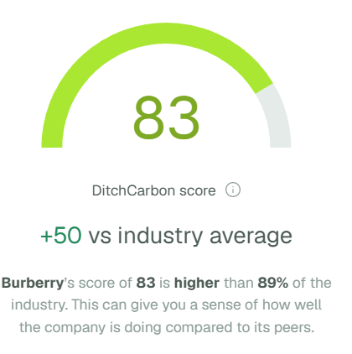
Figure 5: Carbon emission score of Burberry
(Source: Ditchcarbon, 2026)
Furthermore, Lin et al., (2025), found that sustainability programs, such as the net zero emissions by 2040 and the score of 83, are elements that add to the reputation among environmentally conscious customers highlights in figure 5. Therefore, the huge global retail network of Burberry over 400 stores increases availability, accessibility and reinforcement of the brand's visibility in the international marketplace. In order to maintain competitive advantages, continuous innovation is necessary because the competitors are able to imitate retail strategies and technology in the related market, as stated by Ahmed et al., (2022). Thus, Burberry's heritage, sustainability, operational integration and innovation are unique capabilities that are hard to replicate. This will allow the company to continue to differentiate and consolidate its market value in the highly competitive luxury fashion industry.
These internal strengths contribute to competitive advantages by enabling Burberry to differentiate its products, support premium pricing and maintain customer loyalty. The VRIO analysis indicates that brand heritage is specifically important since it is valuable, rare, difficult to imitate and supported by organisation. Therefore, competitive advantages results of Burberry not simply from processing resources but from effectively converting these sources into customer value and distinctive capabilities.

4.0 CSR and Sustainability Objectives
The Corporate Social Responsibility (CSR) strategy has been integrated with its business objectives, which support the long-term growth along with brand value and risk management process. As per Peng (2025), the company has a target for the net-zero greenhouse gas emission throughout its value chain by 2040 through its Burberry Beyond program and the achievement of carbon neutrality in its own operations. However, the using of the Triple Bottom Line framework enables Burberry to balance people, planet and profit approaches seen in figure 6.
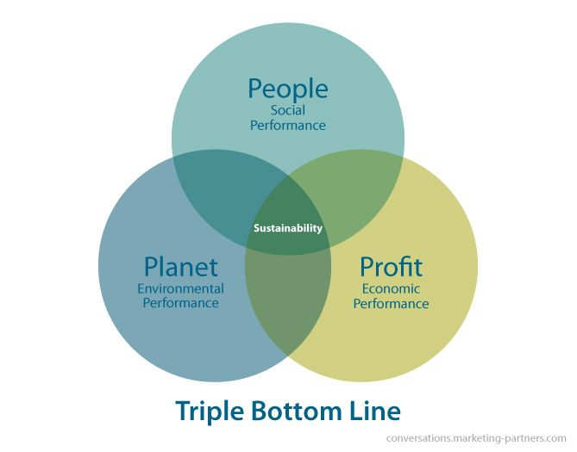
Figure 6: Triple Bottom Line
(Source: Inachainge, 2022)
People: In the aspect of people, Burberry invests in employee's wellbeing besides carrying out community interventions and provides support to more than 8,700 employees in the global marketplace (Coşkun, 2025).
Planet: Regarding the planet dimension, Burberry provides a promotional approach of sustainable sourcing along with circular fashion and a renewable energy adoption process. For example, it has a commitment to the ethical sourcing of 100% certified key raw materials (Turunen and Henninger, 2022).
Profit: From a profit point of view sustainability offers an improvement in customer loyalty and an enhancement in competitiveness in the luxury market worth more than €360 billion.
The CSR strategy of Burberry has alignment with the business objectives, with the differentiations of the brand among environmentally conscious consumers, specifically in the generation Z. However, there are several challenges that remains in this case, which include to have transparency in the supply chain along with balancing the sustainability investments with profitability during the time of economic uncertainty in the global aspect. As per Yu and He (2025), continual progress in ethical practices can be associated with the strengthening of stakeholder trust, along with the improvement of resilience and securing sustainable competitive advantages in the global marketplace, among the rapidly changing luxury marketplace.

5.0 Comprehensive and Holistic View of the Organisation
The balanced scoreboard developed by Kaplan and Norton provides opportunities for organisations to measure non-financial and financial performance in a comprehensive manner seen in figure 7. For Burberry, this framework has alignment with the operational activities with its mission of delivering modern British luxury products while providing promotions for the sustainable growth in the fashion industry.
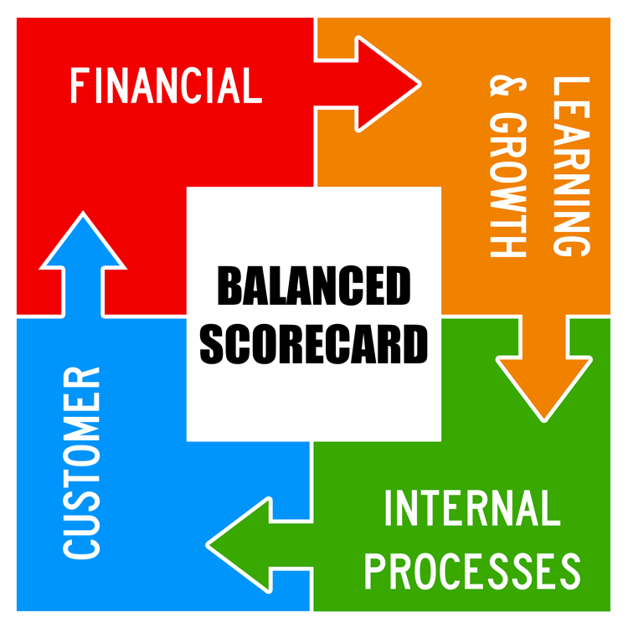
Figure 7: Balanced Scoreboard
(Source: Stanke, 2023)
Financial: Under the financial perspectives, several objectives are included to have revenue growth along with the improvement of the profitability approach. However, the key performance indicator (KPI) includes revenue, operating margin and return on capital employed in the entire marketplace. It can be said that the company has an approximate revenue of £2.4 billion in 2025, while it has a target for sustainable profitability growth through several initiatives, including the "Burberry Forward" strategy, along with proper expansion of the high-margin categories like outerwear products (Hoang et al., 2023).
Customer: Customer perspectives have focused on the objectives of adequately strengthening brand loyalty along with enhancing the customer experience process. As per Mathew et al. (2025), the relevant KPIs include repeat purchase behaviour, digital engagement rates and customer satisfaction process. It can be said that Burberry has aimed to attract younger customers who prefer luxury products through personalised digital experiences. The company can focus on the omnichannel retail services and social media campaigns to attract young consumers.
Internal business process: From the perspective of internal business process, the objectives include to have inclusion of the improvement of supply chain efficiency along with sustainability performance and product innovation process. According to López et al. (2023), the entire process indicates KPIs' involvement in the inventory turnover, along with the reduction of carbon emissions and the product development cycles for the entire business process.
Learning and growth: The learning and growth perspectives have been associated with the focus on objectives of employee capability, along with innovation and organisational culture aspects. However, the KPIs for this include innovation outcomes along with the employee management process and training hours. It can be said that Burberry provides support for approximately 8,700 employees in the global marketplace through digital skill development, leadership programs and diversity initiatives (Qin et al., 2023). Therefore, the continuous investment in the workforce capabilities and technology provides strengths for adaptability in this rapidly changing luxury market.
The entire aspect of Burberry through the balanced scoreboard provides the company with an integrated management system which connects strategy, sustainability objectives and performance measurement approach. As mentioned by DiVito et al., (2023), the company can sustain competitive advantages along with have achievement of the long-term growth in the global luxury industry by balancing of few specific objectives.

6.0 Strategic Choices and Implementation

6.1 Strategic Choices at Business and Corporate Levels
Burberry has several strategic choices available at the business and corporate levels. From the internal and external analyses Burberry highlights several strategic strengths in business level as well as corporate level. The brand utilise brand strength to sustain long-term competitive advantage by addressing challenges.
Business level
At the business level, Burberry can pursue cost leadership or differentiation. As per Liu and Bai (2023), the cost leadership has been less suitable since most luxury brands have a heavy reliance on the exclusively rather than low prices. It can be said that difference remains the strongest option, which leverages Burberry's craftsmanship, heritage and iconic trench coat for the justification of premium pricing.
But all of the strategies offer avenues to offer distinctive customer value and ensure high brand loyalty in the international market. According to Asfaw and Menon (2025), the continual investment in sustainability initiatives, along with product innovation and digital experiences, can further strengthen differentiation. This means that Burberry will be protected from competition based on price and improve the profitability in this relatively competitive market. Therefore, at the business level, Burberry can retain its product differentiation policy and not cost leadership.
Corporate level
At the corporate level, strategic choices include the diversification into the adjacent luxury categories along with the international expansion process. For example, Burberry has expanded its beauty and accessories segments while it strengthens its presence in the Asian region. As per Lin and Yu (2023), this region has been responsible for a major share of the global luxury demands in the international marketplace. The company has revenue of £2.4 billion in 202 which indicates further growth opportunities for the existing business in the emerging luxury markets such as Southeast Asia and India. However, the recommended strategy has been associated with the combination of selective international expansion and a differentiation approach. As per Cheah et al. (2023), this initiative has alignment with the luxury positioning of Burberry, which indicates strengthening its brand equity, increasing market reach and supporting sustainable long-term profitability without reducing the exclusivity aspect of the products.

6.2 Managing Change and Strategic Implementation
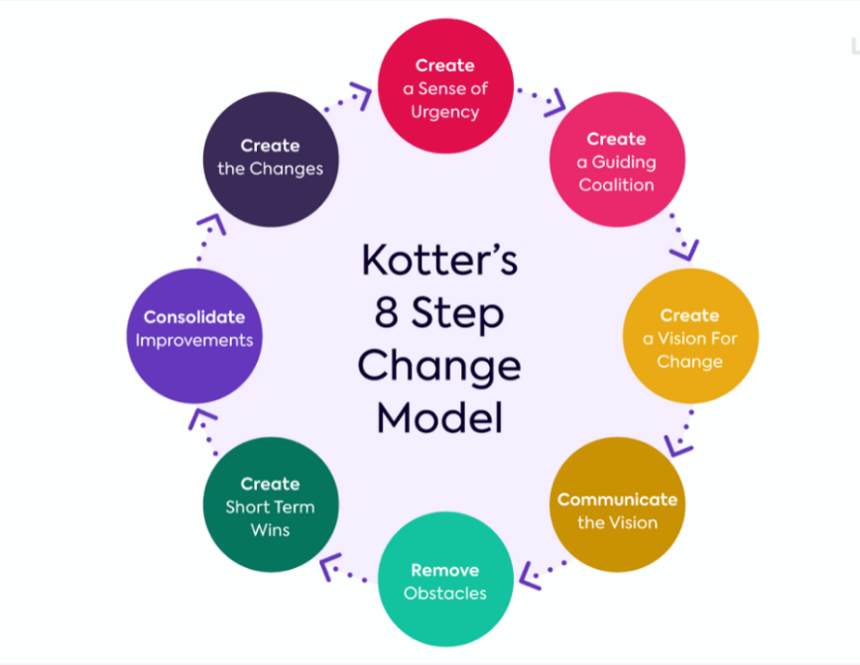
Figure 8: Kotter’s 8-step change model
(Source: Ozero, 2023)
To create a sense of urgency, Burberry has shown a reasonable ability for the management of organisational change, which indicates that this has variations throughout the different periods. However, using Kotter’s 8-step model, the company have created urgency by providing responses to the declining luxury demand along with changing consumer preferences in the global market. Figure 8 shows the Kotter’s change management framework. A guiding coalition has been established through the initiatives of strategic restructuring, along with the changes in executive leadership in the organisation. To develop a vision and strategy, it is essential to note that the company have communicated its vision through the operational transformation programs along with the global branding campaigns process (Brambilla et al., 2022).
The vision sharing approach includes having a process that Burberry has increased digital innovation by expanding e-commerce capabilities, along with enhancing the omnichannel retail experiences (Zaidi and Gandhi, 2025). Therefore, these changes support operational efficiency along with the customer engagement process within the global marketplace. Remove barriers to change adoption through the implementation challenges appeared from the intense competition from luxury rivals, weaker demand in China and uncertainty in the economic approach. The brand generates short-term wins while control pressure didn't stop Burberry from having high revenue generation while working on quick wins and advanced sustainability goals such as becoming a net zero business by 2040. (Sanz-Lopez et al., 2024). The company sustains change as a continuous process where continually changes implementation process in the supply chain and overall business process.

7.0 Strategic Evaluation and Recommendations

7.1 Strategic Evaluation of Burberry Using SWOT Analysis
SWOT analyses the findings from the previous internal and external analysis. However, the strengths and weaknesses are informed mainly by the internal analysis and VRIO while the threats and opportunities are fetched from the PESTEL and external industry analysis. Therefore, the SWOT analysis provides an integrated view of Burberry’s strategic position.
Strengths: The brand legacy of having been in operation for over 170 years, the global branding and the well-established use of digital capabilities are strengths. According to Teixeira et al., (2023), these assets directly help achieve high prices and customer loyalty. It also has a presence in more than 400 stores worldwide and is a leader in sustainability in the worldwide marketplace seen in figure 9.
Weaknesses: The weaknesses incudes the size of its revenue of nearly £2.4 billion is considerably smaller than rivals like Louis Vuitton and Gucci. According to Yan (2023), they will have an economy of scale and marketing influence that is far greater in the market. Therefore, the trade in outerwear and some product categories can be a barrier to growth.
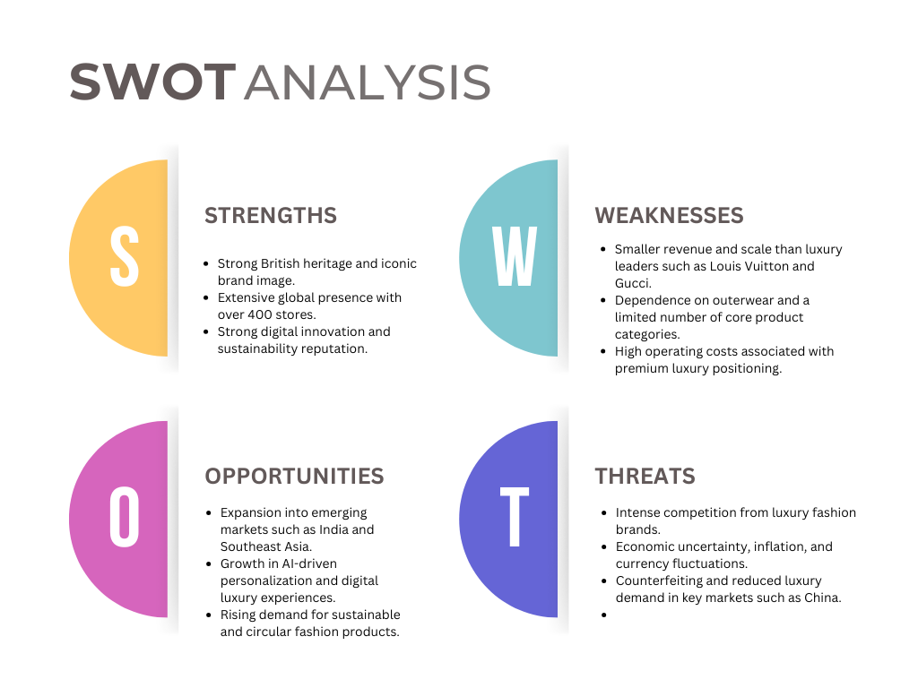
Figure 9: SWOT analysis of Burberry
(Source: Self-created)
The opportunities identified below arise primarily from the external opportunities identified through PESTEL.
Opportunities: The emergence of new luxury markets like India and the Southeast Asia is another opportunity given the fast growth of high-paying consumer segments. Additionally, the adoption of AI technology, personalised shopping experiences, and sustainable luxury products can help further engage consumers and differentiate the offering (Phau et al., 2022). The increasing demand for circular fashion has the potential to create innovations as well in the market. The threats identified below reflect the external risks identified through PESTEL and the competitive environment.
Threats: Economic instability, inflation, geopolitical concerns, counterfeiting, and intense competition from established luxury brands are all threats to Burberry. Another risk is the relatively low level of luxury consumption in China, as a large market of luxury consumption is the backbone of the luxury market (Baran and Khammash, 2024). In general, Burberry's strategy is competitive, but it needs to continue to innovate and diversify its markets if it has the intention of growth and maintain its business sustainability over time.

7.2 Recommendations to Enhance Competitive Advantage
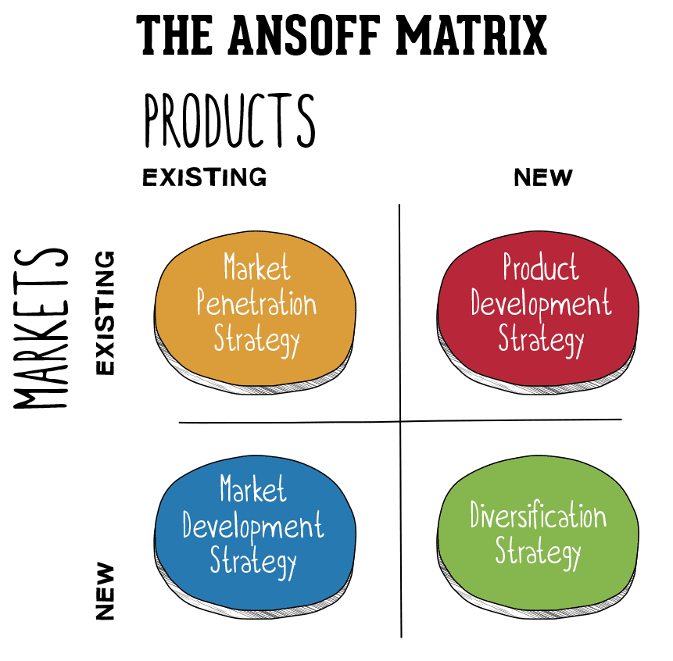
Figure 10: Ansoff Matrix
(Source: Hanlon, 2021)
- Burberry needs to take several strategic steps to reinforce and maintain its competitive advantages. The implication of the Ansoff matrix is that the firm should grow faster in new markets or sales that offer growth opportunities like India, Middle East & Southeast Asia (Lee and Choi, 2022). Ansoff's market development strategy involves an organisation's expansion of revenue from new markets with its current products. These are all large long-term prospects for Burberry to explore, as incomes increase and more people are buying luxury goods seen in figure 10.
- Burberry should continue to innovate and be sustainable to further differentiate itself. This could enable firms to increase prices and reduce direct price competition, the product development of the above-mentioned framework. As per Zhang et al., (2022), by offering limited edition collections, customised services, and digital luxury experiences, Burberry can further reinforce its exclusivity. Speciality brands such as Louis Vuitton, for example, have been able to generate demand by establishing exclusive partnerships, and even gain prestige.
- The company should invest more in AI and data analytics to enhance customer personalisation. The theory is that the sustainable competitive advantage is due to unique capabilities which possess value and are difficult to imitate. According to Gupta et al., (2024), leveraging experienced customer data and insights can result in improved product recommendations, stock management, and customer retention.
- There is a need to extend the efforts of Burberry to circular fashion practices, such as repair, resale and recycling programs. This suggestion has been matched with the market penetration where customer, community and environment value has been created. According to Sgibneva (2023), the decision-making process is becoming more and more influenced by sustainability, especially by younger consumers. Enhanced environmental commitments can enhance reputation and promote long-term profitability.
- Burberry must spread its narrow range of products such as beauty products, jewellery and lifestyle across a wider range so as to reduce its dependence on a few product lines. Diversification can help to distribute risk and generate extra income. All of these recommendations aim to sustain growth and create resilience to external factors along with improving Burberry's competitive position in the rapidly changing luxury market in the long run.

8.0 Conclusion
The key strengths of Burberry are its strong heritage, differentiation strategy, digital focus and sustainability. However, the continual market expansion, along with customer-oriented innovation and strategic diversification, can provide opportunities for the strengthening of resilience. This can improve the performance of the organisation, as well as facilitate sustainable development in the dynamic luxury market.

Section 2: Reflective Account

1.0 Overview
This section of the research widely showcases a reflective account of my processes and experiences during the research. The reflective account has been constructed based on the ideas and the principles of the Gibb’s reflective cycle. Thus, providing a greater and staged understanding of my analysis and preparation during the overall research seen in figure 11.

2.0 Reflection using Gibbs' Reflective Cycle
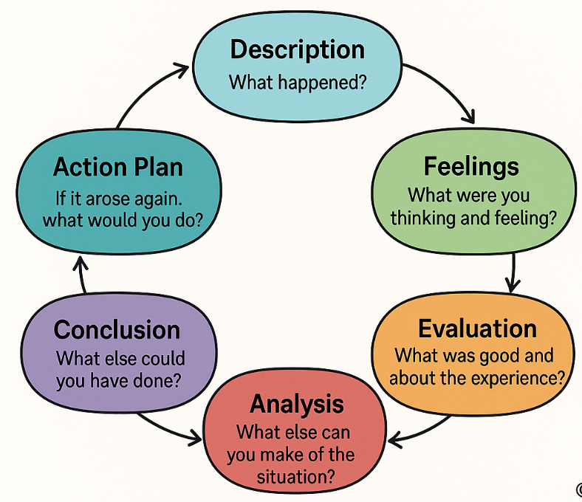
Figure 11: Gibbs' reflective cycle
(Source: Athal, 2025)

2.1 Description
During this stage, I would refer to the strategies and processes I adapted during the research completion. While the research has been specifically designed to explore the positioning of Burberry in the global luxury industry, I had to complete the assignment through multiple steps. For example, I initially collected general information about Burberry's history and products, but I realized that this was insufficient for strategic analysis, therefore includes information and data from the academic sources. This primarily included gathering information on Burberry's operations and market position and analysing them for the assignment. This allowed me to implement a strategic management framework such as PESTLE and VRIO. I was also able to explore certain concepts related to organisational sustainability, including the Triple Bottom Line, to assess the external and internal capabilities of Burberry. However, this also allowed me to understand the social responsibility of an organisation. The overall research process included identifying and gathering suitable data based on market research or a similar research area. Apart from the mentioned, I also invested some time in understanding how external and internal environmental factors may influence the organisational strategic decisions while operating in a specific market.

2.2 Feelings
My feeling throughout the research process has been rather confident. This is mostly because I know that Burberry is a globally recognised brand, and gathering information on their business would be quite easy compared to other organisations. However, while going through with my research, my confidence faltered for a moment when I was supposed to complete a strategic analysis for Burberry. At this stage, I understood that it takes more than just data gathering, and I had to distinguish between descriptive and analytical information. This forced me to invest more time in this specific segment of the research. While I was stubborn enough not to lose my confidence during this stage, I faced a challenge to identify specific frameworks that needed to be applied to amplify suitable research outcomes (McKelvey, 2025). It is needless to state that after completing every section of the research, I gained a sense of achievement that strengthened my confidence.

2.3 Evaluation
The research went smoothly and generated fruitful results while evaluating the outcomes. It is safe to state that this allowed me to use suitable frameworks according to the research work. I was successfully able to use the PESTLE framework. This allowed me to identify critical external factors for Burberry that affect its business. The same could be mentioned for the implementation of the VRIO framework. This framework allowed me to identify all the important resources for Burberry and their capabilities to either pose as a market advantage or something that may not be unique for Burberry (Franzè et al., 2024). For instance, I found it difficult to distinguish between descriptive information and analytical discussion when completing the PESTEL and VRIO analyses. However, I did face some challenges while completing this assignment, as the identification of essential data was rather hard. Initially, I focused on collecting descriptive data. However, later within the assignment, I understood the importance of using analytical data for Burberry.

2.4 Analysis
This research helped me massively to understand the importance of certain frameworks, such as PESTLE, for organisational environmental analysis. In this case, I understood that Burberry's business is widely based on the market scenario and the market scenario is governed by factors such as political, economic, social, environmental, technological and legal aspects. This helped me understand the limitations of the proposed business and its process of strategic planning based on the current factors (Kim et al., 2026). This research also allowed me to reflect upon the sustainability initiatives undertaken by Burberry to reach a better market advantage. This further included actions, including digital transformation for Burberry.
Additionally, I was also able to use the VRIO framework to gain a better understanding of Burberry's market positioning. It is important to state that this reflective segment allowed me to look back on the strategic planning and evidence-based decisions undertaken by Burberry. This assignment aided my capability to collect, analyse and interpret complex business information.

2.5. Conclusion
Through this reflection, I have been able to deduce that this research was an important learning experience. This assignment also allowed me to understand and implement the strategic management framework and theories with practical implementation. This shall be further related to the core theories and information regarding the global luxury fashion industry. It is needless to state that I had encountered multiple challenges while undertaking this research, yet I was able to overcome them.

2.6 Action Plan
I intend to adopt a more systematic approach when undertaking similar research to enhance planning and overall research outcomes. I also hope to improve my analytical skills with better academic writing capabilities to produce articles or pieces of research that could be read by other researchers. I hope to enhance these skills within the next 3-4 months, which would further allow me to focus on analytical interpretation skills. While a significant part of my research has been based on interpreting analytical data, in future I would like to collect primary data to produce analytical data (García-Sánchez and Carnicero-Martínez, 2026). This would provide significant credibility towards the research for better comparative information and reliability. Therefore, I hope to become more efficient while conducting future research. It is also essential to note that I will enhance my capabilities to combine information from multiple sources into a single research project for better dynamics.

3.0 Summary
Finally, it can be mentioned that this research has been a great learning experience for me and has allowed me to understand various concepts related to strategic management. This experience allowed me to strengthen my capabilities in research, decision-making, analysis and strategic planning.

Reference List
Ahmed, A. A. A., Agarwal, S., Kurniawan, I. G. A., Anantadjaya, S. P., and Krishnan, C. (2022). Business boosting through sentiment analysis using Artificial Intelligence approach. International Journal of System Assurance Engineering and Management, 13(Suppl 1), 699-709. https://repository.ipmi.ac.id/2086/1/38b0b726-4611-Business%20Boosting-Springer.pdf
Asfaw, B. W., and Menon, F. (2025). Exploring the impact of virtual reality on consumer purchase decisions: A strategic perspective on immersive digital marketing in the luxury fashion industry. The Business & Management Review, 16(1), 144-149. https://cberuk.com/cdn/publications/2025-05-29-00-16-46-AM.pdf#page=142
Athal, D. K. (2025) Gibbs Reflective Cycle Explained: A Framework for Structured Self-Reflection - Dr Krishna Athal, Dr Krishna Athal - Life & Executive Coach in India & Mauritius ✨. Available at: https://drkrishnaathal.com/blog/gibbs-reflective-cycle-explained-a-framework-for-structured-self-reflection/ (Accessed: 19 June 2026).
Avdalyan, L. (2024). Corporate Discourse in Building Corporate Identity: on Some Pragmalinguistic Features of Annual Reports. Foreign Languages in Higher Education, 28(1 (36)), 3-23. https://journals.ysu.am/index.php/foreign-lang/article/download/vol28_no1_2024_pp003_023/pdf
Banerjee, A. (2023). Risk Return Analysis of FTSE Listed Select Stocks with FTSE100 Index. Journal of Accounting, Business and Management (JABM), 30(2), 59-69. https://journal.stie-mce.ac.id/index.php/jabminternational/article/download/962/458
Baran, S., and Khammash, M. (2024). The social media marketing strategies of luxury fashion brands-impact on brand equity. International Social Sciences Studies Journal, 10(6), 871-878. https://sssjournal.com/files/sssjournal/8ea76081-c1c6-4254-9929-e25714973aed.pdf
Brambilla, M., Badrizadeh, H., Malek Mohammadi, N., and Javadian Sabet, A. (2022). Analyzing brand awareness strategies on social media in the luxury market: the case of Italian fashion on instagram. Digital, 3(1), 1-17. https://www.mdpi.com/2673-6470/3/1/1
Burberry (2026). Burberry Annual Report 2025/2026. 2026, https://www.burberryplc.com/content/dam/burberryplc/corporate/oar/oar-2025-2026/annual-report-2025-26.pdf. Accessed 7 Aug. 2026.
Cheah, I., Shimul, A. S., and Teah, M. (2023). Sustainability claim, environmental misconduct and perceived hypocrisy in luxury branding. Spanish Journal of Marketing-ESIC, 27(3), 306-323. https://www.emerald.com/sjme/article-pdf/27/3/306/2251415/sjme-02-2022-0012.pdf
Claire, S. (2020) History Of The Trench Coat: Military Necessity To Fashion Accessory, Contrado Blog. Available at: https://www.contrado.co.uk/blog/history-of-the-trench-coat/ (Accessed: 19 June 2026).
Coşkun, M. (2025). Metaverse and the Future of Fashion: A Comparative Analysis of Fast-Fashion and Luxury Fashion Brands. Sosyal Mucit Academic Review, 6(3), 392-418. https://dergipark.org.tr/en/download/article-file/4726005
Di Leo, A., Sfodera, F., Cucari, N., Mattia, G., and Dezi, L. (2023). Sustainability reporting practices: an explorative analysis of luxury fashion brands. Management decision, 61(5), 1274-1297. https://iris.uniroma1.it/bitstream/11573/1673489/1/Di%20Leo_Sustainability-reporting-practices_2023.pdf
Ditchcarbon (2026). Available at: https://ditchcarbon.com/organizations/burberry (Accessed: 19 June 2026).
DiVito, L., Leitheiser, E., and Piller, C. (2023). Circular Moonshot: Understanding shifts in organizational field logics and business model innovation. Organization & Environment, 36(2), 349-377. https://research.cbs.dk/files/93402297/lori_divito_et_al_circular_moonshot_acceptedversion.pdf
Dominguez, M. F. O., and Bhatti, Y. A. (2022). From waste to luxury fashion at Elvis & Kresse: A business model for sustainable and social innovation in the circular economy. Sustainability, 14(19), 11805. https://www.mdpi.com/2071-1050/14/19/11805
Franzè, C., Paolucci, E., and Ravetti, C. (2024). A dynamic view of strategic innovation for sustainability: A longitudinal case study of a luxury fashion engineering company. Creativity and Innovation Management, 33(4), 603-619. https://onlinelibrary.wiley.com/doi/pdf/10.1111/caim.12609
García-Sánchez, I. M., and Carnicero-Martínez, M. (2026). Sustainability in Fashion Industry: A View Through the Top Ten Multinational Strategies. Administrative Sciences, 16(2), 90. https://www.mdpi.com/2076-3387/16/2/90
Grand view research (2026). Luxury Apparel Market (2024 - 2030). Available at: https://www.grandviewresearch.com/industry-analysis/luxury-apparel-market (Accessed: 19 June 2026).
Gupta, V., Hushain, J., and Mathur, A. (2024). The future of luxury brand management: A study on the impact of new technology and relationship marketing. In AI in Business: Opportunities and Limitations: Volume 1 (pp. 57-68). Cham: Springer Nature Switzerland. http://repository.psa.edu.my/bitstream/123456789/4905/1/67.%20AI%20in%20Business%20Opportunities%20and%20Limitations%20.pdf#page=66
Hanlon, A. (2021). The Ansoff Model is a matrix that helps marketing leaders identify business growth opportunities for their marketing strategies in a challenging market. Available at: https://www.smartinsights.com/marketing-planning/create-a-marketing-plan/ansoff-model/ (Accessed: 19 June 2026).
Hoang, D., Kousi, S., and Martinez, L. F. (2023). Online customer engagement in the post-pandemic scenario: a hybrid thematic analysis of the luxury fashion industry: D. Hoang. Electronic Commerce Research, 23(3), 1401-1428. https://link.springer.com/content/pdf/10.1007/s10660-022-09635-8.pdf
Inachainge (2022) What do we know about the Triple Bottom Line?, Inchainge. Available at: https://inchainge.com/knowledge/sustainability/what-do-we-know-about-the-triple-bottom-line/ (Accessed: 19 June 2026).
Kim, Y., Kim, Y., Lee, M. J., and Roh, T. (2026). Strategic sustainability in the digital era: signaling theory and consumer responses in luxury fashion. Industrial Management & Data Systems, 1-33. https://www.researchgate.net/profile/Taewoo-Roh/publication/403883833_Strategic_sustainability_in_the_digital_era_Signaling_theory_and_consumer_responses_in_luxury_fashion/links/69e0dcaed2ec9a706ec00a65/Strategic-sustainability-in-the-digital-era-Signaling-theory-and-consumer-responses-in-luxury-fashion.pdf
Lee, M., and Choi, S. Y. (2022). How does Burberry Infuse'Freshness' into Classic Trench Coats?. International Journal of Costume and Fashion, 22(1), 63-79. https://ijcf.ksc.or.kr/xml/33546/33546.pdf
Lim, M. (2023). ‘Net Zero’Luxury: Guy Debord, Burberry and the Spectacle of (Hypo) Crisis. Luxury, 10(1-2), 23-40. https://www.tandfonline.com/doi/pdf/10.1080/20511817.2023.2316516
Lin, L., Abdelkafi, N., and Pero, M. (2025). How Do Digital Platforms Support Sustainable Business Models in the Fashion Industry?-A literature-based analysis. In Proceedings of the Summer School Francesco Turco (pp. 1-7). https://re.public.polimi.it/bitstream/11311/1303706/1/XXX-Summer-school-Paper-Template_FULL%20Lin%20Lin%2030-06-2025.pdf
Lin, Y., and Yu, J. (2023). Study on the modernization of supply chain management of the luxury industry in the context of the digital economy. Academic Journal of Management and Social Sciences, 4(1), 5-11. https://pdfs.semanticscholar.org/0995/df6d30b8ce8b04ed4a767c7f932c2278c5ef.pdf
Liu, H., and Bai, H. (2023, June). Luxury fashion retailers’ internationalisation: A mixed-methods study of dynamic process in China. In Proceeds of the 8th Colloquium on European Research in Retailing (CERR) (pp. 139-146). http://researchonline.ljmu.ac.uk/id/eprint/19958/1/Luxury%20Fashion%20Retailers%E2%80%99%20Internationalisation%20A%20Mixed-Methods%20Study%20of%20Dynamic%20Process%20in%20China.pdf
López, B., Rangel-Pérez, C., and Fernández, M. (2023). Sustainable strategies in the luxury business to increase efficiency in reducing carbon footprint. Journal of Business Research, 157, 113607. https://www.sciencedirect.com/science/article/pii/S0148296322010724
Masè¹, S., Giovannetti, M., Colapinto, C., and Cedrola, E. (2025, November). Luxury Fashion Brands Communication on Gender Issues and Corporate Activism: Action or Hype?. In XXII SIM Conference 2025 (p. 1055). https://www.iris.unina.it/retrieve/8292e17a-88de-45c0-9ab1-1d3798297515/SIM-2025-proceedings-final.pdf#page=1056
Mathew, S. K., Rathee, S., and Burns, M. (2025). Reinventing Fashion Business: Big Data Analytics. In Fashion Marketing: The Contemporary Marketing Mix (pp. 325-358). Cham: Springer Nature Switzerland. https://www.researchgate.net/profile/Neetu-Singh-3/publication/393405358_Brand_Experience_and_Its_Role_in_Fashion_Retailing/links/68ee5fd2e7f5f867e6df9f8e/Brand-Experience-and-Its-Role-in-Fashion-Retailing.pdf#page=340
McKelvey, G. (2025). Is the Metaverse a Strategic Marketing Channel for Fashion? Opportunities and Challenges for Marketing Fashion Within the Metaverse. Fashion Practice, 1-20. https://www.tandfonline.com/doi/pdf/10.1080/17569370.2025.2605996
Mogno, S., Nuccio, M., and Bellio, E. (2025). Building a customer experience strategy in phygital retail: the role of digital platforms. SINERGIE, 43(3), 137-160. https://iris.unive.it/bitstream/10278/5108368/5/mogno%2Bet%2Bal%202025%20sinergiepdf.pdf
Ozero, T. (2023) The Kotter model: an 8-step model to manage change , Ink Strategy. Available at: https://www.inkstrategy.com/post/the-kotter-model-8-steps-for-managing-change/ (Accessed: 19 June 2026).
Peng, H. P. (2025, June). Classic Brands and Global Culture: A Symbolic Shift Toward Sustainability Inspired by Barthes. In International Conference on Fashion communication: between tradition and future digital developments (pp. 269-282). Cham: Springer Nature Switzerland. https://link.springer.com/content/pdf/10.1007/978-3-031-99481-4_20.pdf
Phau, I., Akintimehin, O. O., and Lee, S. (2022). Investigating consumers' brand desirability for upcycled luxury brands. Strategic Change, 31(5), 523-531. https://onlinelibrary.wiley.com/doi/pdfdirect/10.1002/jsc.2523
Phau, I., Akintimehin, O., and Lee, S. (2024). Investigating consumers' brand desirability of “upcycled” luxury: the many faces of designer facemasks. Journal of Fashion Marketing and Management: An International Journal, 28(4), 635-652. https://oro.open.ac.uk/83940/1/83940AAM.pdf
Qin, Y., Song, L., Hui Shi, L., and Tan, K. (2023). A global perspective on combating Shanzhai products: Cross‐cultural solutions. Thunderbird International Business Review, 65(4), 409-421. https://onlinelibrary.wiley.com/doi/pdfdirect/10.1002/tie.22343
Reid, H. and Shabong, Y. (2025). Burberry returns to growth as turnaround effort starts to bear fruit. Available at: https://www.reuters.com/business/burberry-returns-growth-with-first-quarterly-sales-increase-two-years-2025-11-13 / (Accessed: 19 June 2026).
Rocco, B. (2026) Burberry’s revenue 2026, Statista. Available at: https://www.statista.com/statistics/263885/burberrys-worldwide-revenue/?srsltid=AfmBOoqXLlHFWW5DML6Iuvlm6n4T-1M2rOXkLwk_N72nAPp73qpwRwbS (Accessed: 19 June 2026).
Sanz-Lopez, F., Gallego-Losada, R., Montero-Navarro, A., and García-Abajo, E. (2024). Is the digitalisation the future of the luxury industry?. Heliyon, 10(21). https://www.cell.com/heliyon/pdf/S2405-8440(24)16060-4.pdf
Sgibneva, N. (2023). A Functional Typology by Christiane Nord in Corporate Newsletters’ Translation (English to Spanish). Translation Studies: Theory аnd Practice, 3(1), 110-120. https://cyberleninka.ru/article/n/a-functional-typology-by-christiane-nord-in-corporate-newsletters-translation-english-to-spanish
Singh, N., Sim, D., Khan, H., Khan, Z., and Ascencio, C. (2025). Nature: The Silent Architect of Firm Performance Through Biodiversity Management Strategies. Business Strategy and the Environment, 34(7), 8742-8758. https://aura.abdn.ac.uk/bitstreams/82b5e268-8741-4fdb-aabd-1e28acce8d3b/download
Stanke, B. (2023) The Balanced Scorecard: Balancing Financial and Non-Financial Performance - Bob Stanke: Executive Leadership Team Coach, BOB STANKE. BOB STANKE. Available at: https://www.bobstanke.com/blog/the-balanced-scorecard (Accessed: 19 June 2026).
Teixeira, S., Reis, J. L., Barbosa, B., and Ferreira, S. (2023). Online strategies of brands: A case of Portuguese luxury fashion designers. Innovative Marketing, 19(1), 72. https://www.academia.edu/download/110617319/IM_2023_01_Teixeira.pdf
Turunen, L. L. M., and Henninger, C. E. (2022). The hidden value of second-hand luxury: Exploring the levels of second-hand integration as part of a luxury brand’s strategy. In Sustainable luxury: An international perspective (pp. 13-33). Cham: Springer International Publishing. https://research.aalto.fi/files/87555047/Turunen_Henninger_accepted_2022.pdf
Twamley, G., and Mazzarella, F. (2022). The benevolent future of fashion: A framework for business partnerships with a social purpose. DISCERN: International Journal of Design for Social Change, Sustainable Innovation and Entrepreneurship, 3(2), 38-57. https://designforsocialchange.org/journal/index.php/DISCERN-J/article/download/91/55
Yan, Y. (2023, September). Comparative Analysis of Luxury Brands-Take Louis Vuitton and Burberry as Examples. In Proceedings of the 3rd International Conference on Economic Development and Business Culture (ICEDBC 2023) (p. 285). Springer Nature. https://www.atlantis-press.com/article/125991308.pdf
Yu, K., and He, Z. (2025). Beyond adaptation: consumer-driven glocalization and the negotiation of luxury brand meaning in China. Marketing Intelligence & Planning, 1-18. https://www.researchgate.net/profile/Kaidong-Yu-2/publication/398066656_Beyond_adaptation_consumer-driven_glocalization_and_the_negotiation_of_luxury_brand_meaning_in_China/links/696a17fbc906f117f2a5d25f/Beyond-adaptation-consumer-driven-glocalization-and-the-negotiation-of-luxury-brand-meaning-in-China.pdf
Zaidi, A. A., and Gandhi, A. (2025). Green or green washing? A review paper on the current state of sustainability of fashion brands. International Journal of Sustainable Society, 17(4), 334-354. https://www.researchgate.net/profile/Ahmed-Zaidi-6/publication/399508733_Green_or_green_washing_A_review_paper_on_the_current_state_of_sustainability_of_fashion_brands/links/697f0b10ca66ef6ab98f2c77/Green-or-green-washing-A-review-paper-on-the-current-state-of-sustainability-of-fashion-brands.pdf
Zhang, Y., Liu, C., and Lang, C. (2022, December). What makes luxury brands win the hearts of Gen Z on TikTok? An exploratory study. In International textile and apparel association annual conference proceedings (Vol. 79, No. 1). Iowa State University Digital Press. https://www.iastatedigitalpress.com/itaa/article/15836/galley/14591/download/
Zhou, D. (2025, July). Sweaty Betty’s Attractiveness of New Market Spaces in Growth Prospects and Strategic Sustainability. In 2025 International Conference on Financial Risk and Investment Management (ICFRIM 2025) (pp. 329-337). Atlantis Press. https://www.atlantis-press.com/article/126013061.pdf

