Customer Relationship Management Emerging Themes

By
Nargas Ahmadzai 2106756
Understanding and engaging in the customer experience (BMSW 5103)
Lectures by BUDDHI PATHAK

CONTENTS

- Executive summary
Part A
- Introduction
- Customer touchpoints
- Customer experience and brand experience
- Impacts of touchpoints and customer and brand experience themes on CRM
- Recommendations
Part B
- A critical literature review on the customer experience
- Customer experience firms’ perspective and co-creation perspectives
- The impact of understanding these perspectives to shape the customer experience for information and technology firms
- Summary
- References

Executive summary

This report aims to introduce one of the information technology industries in the United Kingdom and discuss the company specifications and guidelines dealing with customer experience. The report contains a brief overview of the company, the understanding of customer experience and the CRM using touchpoints and customer and brand experience themes and discusses the impacts of these themes related to CRM on the organisation. This includes the company touchpoints, a company’s customer experience, and brand experiences. The second part of the report focuses on the literature review of the customer experience from both perspectives the customer and the firm perspectives and the impact of these perspectives on shaping the customer experience for the organisation. How Marketing ethics and sustainability are important for any business. At the end of the report, there are some recommendations to improve the customer experience for chosen company.

Introduction



The Softcat company is an IT infrastructure provider founded in 1993 by Kelly and it has UK offices in different cities (Kelly, 2022). This company is a provider of technology solutions and services to both private and public companies. The Softcat company assets management software licensing and IT services. It commoditises sourcing data centres and computing mobility and networking security. The company focus and advises across three key IT determinants, Hybrid Infrastructure, Digital workplace, and cyber security (Softcat plc, 2022).

Customer touchpoints

Before starting the main concept of this report this is better to understand the explanation of customer experience and the importance of this knowledge for any organisation. Customer experience encircles every feature of the organisation’s subscription and contribution. The quality of customer care, the advertisement and the packaging of products, availability and reliability and other service features. The customer experience of any company is the responsibility of certain people, their opinions and decisions shape and achieve the best customer experience for their organisation (Meyer and Schwager, 2007).
The customer experiences of an organisation depend on the quality of touchpoint services they carried while engaging with customers. (Eichner and Gruber, 2017) have suggested in their article that not all existing touchpoint services are important or applicable, they added that human interaction is the highest-ranked satisfied customer touchpoint service to date.
The Softcat company is different and runs a very promising touchpoint service. This company have highly experienced consultants and designers, expert support and dedicated customers with professional managers that work team based to supply and deliver distinctive service (Softcat, 2022).
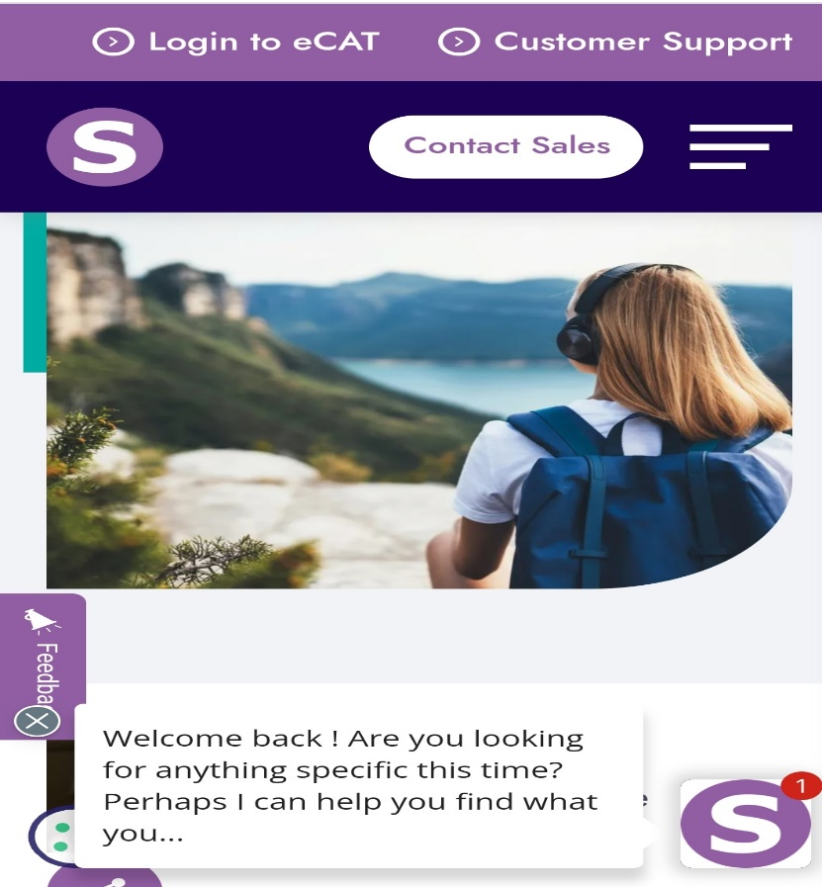
Softcat never fails to engage with their customer at any query. The company embraces the hybrid method of working so this able staff to interact with their customers from home or office and provide their support to their customers 24/7 at any location or time. As the figure below shows one of the methods of interactions between a company and the customer.

The organisation believes to work effectively in a secure environment. As this is a well-known fact that better touchpoint service leads to a successful customer experience. (Robertson, 2022) has argued in his article that most industries rely on the four p’s (product, price, place, promotion) but he suggested that the five consumer touchpoints include change or alteration, brand story, promises of brands to people, purchase moment and customer experience are the foremost effective touchpoints that can keep customers engagement longer.
Softcat company knows that balancing culture is vital for fulfilling the company’s and its customers’ needs. For this act, they need to keep different communication channels open. The company uses regular surveys and one-to-one calls to attain feedback and improve their performance in future. Employees in Softcat know that effective communication, the feeling of self-respect and strong management are the key points of successful touchpoints. To keep their values and achieve customers’ desires.

As we know the world has changed after the pandemic 2019 and now the requirements are carried into both ways in-person or remotely in every organisation.
Softcat company embraces this very well and they think that giving people value at home is reaching more steps ahead. This can link to outstanding customer satisfaction and the industry’s overall success.

Customer experience and brand experience

The customer experience is every aspect of interactions carried out between the business and the consumer. Satisfying experience from both parties describes a successful customer experience. A company will never be successful without acknowledging its strength and weaknesses. Softcat runs annual experience surveys to recognise what they are doing better and what they need to do best. By communicating with customers to listen to their opinions and thoughts about their brand, they achieve valuable experience and suggestions that can help a company to change business according to their needs and to support them better on their journeys with the industry.
The perfect survey returns a huge platform for the company to discuss future improvement plans and actions. To build a strong relationship between customers and the brand, it is important to know customers' values and the bonding of trust that could lead employees to work more effectively.
Motivation and rewarding staff for the best performance and focusing on the negative feedback to identify the causes of problems are important. Whatever good things we build end up building us (Rohn,2017) this lightened some important facts that if a company keep their employees happy and satisfied, they will keep customers more contented.
(Hellawell, 2012) wrote that if the staff perceive that the company is unfair to them this can be resulted in doing the same to the customers. Softcat has a record of a super customer experience because the employees’ satisfaction surveys have a huge impact on the business growth. A joyful workplace can lead a business to a successful industry. The author’s experience as a managing director of Softcat explained that customer experience depends on three major aspects: design, process, and method of approach. He explained that professional managers can engage employees by increasing their satisfaction and retention. They need to arrange consistent meetings to know their needs. Offer rewards, provide training, build cultural teamwork, and provide the opportunity to share their views and opinions. Considers little things to achieve a bigger image (Hellawell,2012).

As Softcat is the provider of IT solutions to other companies and as a customer of Softcat these companies are very confident to keep their engagement at any level of marketing. The customers are happy with their support services including price range, solutions and customer needs. However, every organisation has some disappointing reviews about their service. Softcat has also experienced that some of its customers are not happy with its services. Some have complained that the staff was rude and unprofessional, and they did not provide the right support they need.

Impacts of touchpoints and customer and brand experience themes on CRM
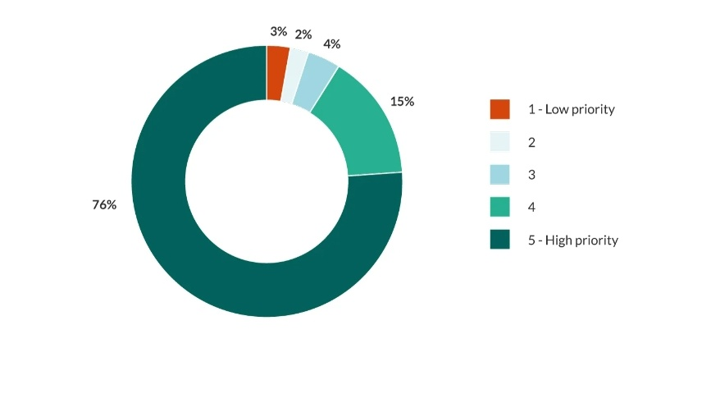
CRM is a software system that helps the organisation to monitor or track customer data and manage every interaction between business and customer for example sales, customer experience, marketing, support etc. The data collected below shows the CRM of a company.

(SuperOffice, 2021)
Customer relationship management is highly dependent on the quality of touchpoint data because touchpoint processes every important thing that customers and organisations do not acknowledge before. Touchpoint details improve and support the CRM database and provide opportunities that could lead the company to know their strength and weaknesses and the gaps of improvements they require for strong customer relationships. However, it is very important to use the details of touchpoint data in the right manner to improve. For example, while using any message or email the sender should know to whom they send and what content this has and does the customer is interested in these messages or not. (Jennings, 2021)
The other benefit of touchpoint data is that it provides an opportunity for a company to realise during the transaction process, the interest of a customer so this can allow the company to reach them before they try another company to buy.
Customer relationship management implementation in an effective manner can influence and hold on to the customer’s loyalty to the company.
Softcat has announced its new software related to data management for better CRM for companies. (Softcat, 2016) It is Microsoft cloud in the UK that will supply Office 365 and Azure from data centres with strong CRM. Businesses can take advantage of this new service to increase communication and security during processing data. This service will have a huge impact on the CRM of the company to increase their production and support storage solutions.

Recommendations
Softcat is one of the companies that achieved more success in recent years and the competition around this company led them to face more challenges to secure their position and reputation. This company has a strong customer experience which makes them different and unique from the rest. Some of the recommendations are to keep their reputation and progress.

- The company needs to set goals and objectives that could help them to overcome their challenges and keep progressing.
- The company needs to focus more on the collected data and the usage process. Use fewer layers of pages to make it easy for understanding the customer easily.
- Design more channels for customer engagement and provide more support to customers.
- Merge CRM for new enquiries and customers’ needs.
- Use more strategies to enlarge and improve the SEO system.
- The very important thing is to improve data and insight. (Softcat 2022)

A critical literature review on the customer experience
The very important fact of understanding customer experience is the ability to manage, measure and observe customer reactions to industry or business offers, especially customer attitudes and perceptions. The business has to assess its customer’s responses towards their products and delivery to attain their expectations (Lemon & Verhoef, 2016).
The journey between customer and company has 4 stages shown below;

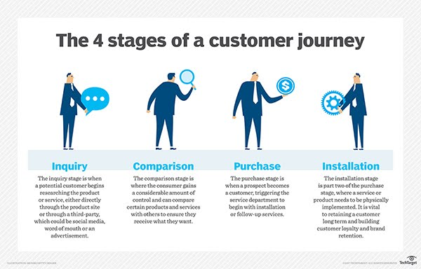
The article explains that customer experience is about designing, managing, and monitoring each interaction with customers. Data collection of the customer journey, marketing strategies, CEM and CRM and all the touchpoints that can deliver a healthy customer experience. Many companies believe that customer experience management is the base of customer relationship management. All customer’s demands and interests are different, and they value different aspects. For example, some customers are satisfied with the price value or purchase intentions or advertisement strategies.
Understanding the customer’s value is another topic that is mainly focused on customer experience. This can be described as what service or product is worth to a customer for example the benefit, they received is worth the money they paid. V=B/S means the value is what they benefitted from the service. The values can be found as the value in use, value in experience and this can be value in exchange too (Buttle and Maklan,2015).
The knowledge of marketing ethics and setting sustainability goals are very vital features of a successful business. Businesses can achieve their sustainability goals through ethical marketing direction and management. Ethical marketing is the cornerstone of sustainable marketing (Kotler, et al, 2017)
Marketing ethics follows all the rules that respect consumers' rights, interests, needs and expectations. This helps a business set its goals and implement them through the best management strategies. The section below discusses the customer perspectives on the customer experience concept.

Customer experience firms’ perspective and co-creation perspectives

CX or customer experience are based on two different perspectives the firms and co-creation perspectives because customer experience is not just marketing or selling and buying processes, it is a connection, trust and a relationship that carries two different parties and their opinions to one agreement of approval or disapproval.
For consumers, it is important to connect to the product and understand the vision of the company so this can make a stronger relationship between customers and the organisation (Geljon,2020).
For example, Apple charge a big amount for their products and people are happily buying those products because they build that connection and trust to keep sustainability in marketing and people are happy to be part of the product because it values them.
Here values are different for customers according to their interests and affordability some customers value the product because of its features or maybe the price and even some value the brand.
This is very important for a successful brand or organisation to always offer value to its customer in any aspect such as establishing a good price or offering strong brand support at any time to make customers engage and satisfied (Geljon,2020).
However, CX will not be enough to just offer values it needs a better experience too.
Therefore, every interaction between both parties decides the results of the customer experience. As the expectations of customers are increasing so companies try to design more approachable channels such as friendly websites, Apps, and customer contact centres.
As hybrid is a more demanding need of the modern world so the business focuses on designs of touchpoints direct or indirect for better customer experience and for this big achievement all the boxes of customer experience need to be ticked any small section can rise an issue.

Co-creation is another opportunity for businesses to progress because working with customers and enhancing their ideas and opinions fills the gaps to achieve their goals and take more steps towards success (Gardner, 2022). This is also challenging for some businesses to adopt ideas from customers in case of failure and limitations. Some well-known brands collaborate with customers to make a product more useful according to the people’s needs for example LEGO ideas where there is a link where fans or consumers submit their ideas for new LEGO kits.

Muji a Japanese company (which makes household items) also collaborate with customers because they believe that co-creation item is more successful, and customers can tell us more about the product efficiency than the company itself.

As the value in co-creation increases loyalty in customers because they demand products, they value, and if the co-creation fails due to any aspect of communication or mistake., that will lead to value in co-destruction that shows disagreement of product between the company and customers.

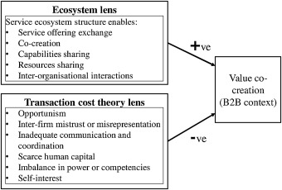 (Pathak et al., 2020)
The above figure from the article shows two different lenses for the positive and negative sides of value in co-creation. It suggests that ecosystem elements are attempting to increase talent, skills, and knowledge of demonstrating leadership in business and technology. To reduce unreliability and overcome upcoming business challenges that lead to co-destruction. (Pathak et al., 2020)

The impact of understanding these perspectives to shape the customer experience for information and technology firms

Technology has a big impact on customer experience because consumers have a variety of access to information regarding organisations and products. They have channels of communication with organisations to enquire about products and share their views. Companies need to train and educate their staff to embrace new technology to engage with customers’ queries successfully.
Information and technology able customers to be more connected to businesses and brands from any location. For example, a survey by the Centre of Economics and Business shows that in the UK people spend over £22.8 billion per year online shopping while using public transport (Alexa, 2022).
As the Softcat industry is covering cyber security for businesses and every company needs to protect their programmes so it is important to invest in Softcat to overcome all the challenges however, if the company fails to implement the plan correctly it will result in a waste of money. So Softcat focuses mainly on internal partners that run the program. The company needs to use trusted and expert staff for these plans. The company need to invest in training and educating staff and promoting more strategies that shape a better customer experience and block the road for competitors to move forwards.
Softcat promotes collaboration and the company believes that teamwork productivity is best. A flexible approach to customers and understanding their needs is the best way to achieve goals and deliver a great customer experience.

Summary
The fact is that no customer no business and without a satisfying customer experience there is no successful organisation. Great customer experience needs more strategies to make a company or brand successful. Increasing customer values and following marketing ethics are ways to sustainability in brands. Make every customer experience an opportunity to catch the ball of success. Respect, appreciate, and value customers. Pay attention shows empathy and understanding to each section of feedback so the business can follow up with the issues that need to be solved. Businesses need to respect and value their employees because every action reacts. If a company is supportive enough of employees, this can affect the customer experience because employees will do their best in engaging with the customer. In the modern world changes in the brand, can be seen every day so companies must upgrade all their capabilities and strategies to reach the highest level of success and make it harder for their competitors.

REFERENCES

- Alexa (2022) The impact of technology on consumer behaviour -: Keensights, Keenfolks. Available at: https://thekeenfolks.com/the-impact-of-technology-on-consumer-behaviour/ (Accessed: October 27, 2022).
- Buttle and Maklan,2015: understanding customer value, lecture notes, understanding and engaging in the customer experience BMSW5103_BIRM, UWTSD, delivered 15 OCT 2022
- Eichner, t. and gruber, B., 2017. Managing customer touchpoints and customer satisfaction in b2b mass customization: A case study. 8th ed. international journal of industrial engineering and management, pp.131-140.
- Gardner, D. (2022) 6 key areas for customer co-creation and Brand Collaboration, Chaordix. chaordix inc. Available at: https://chaordix.com/resources/6-key-areas-for-customer-co-creation-and-brand-collaboration (Accessed: October 26, 2022).
- Geljon, M. (2020) The 3 perspectives of customer experience, Medium. Better Marketing. Available at: https://bettermarketing.pub/a-new-view-on-customer-experience-3-perspectives-5b84cc5f4621 (Accessed: October 26, 2022).
- Hellawell, M., 2012. How to create a thriving workplace: Reaping employee satisfaction benefits | Emerald Insight. [online] Emerald.com. Available at: <https://www.emerald.com/insight/content/doi/10.1108/02580541211222915/full/html> [Accessed 19 October 2022].
- Jennings, J. (2021) Why touchpoint data is invaluable to your CRM and driving sales, ClickZ. clickz.com. Available at: https://www.clickz.com/why-touchpoint-data-is-invaluable-to-your-crm-and-driving-sales/ (Accessed: October 21, 2022).
- Kelly, P., 2022. Peter Kelly. [online] Forbes. Available at: <https://www.forbes.com/profile/peter-kelly/> [Accessed 14 October 2022].
- Lemon, K.N. and Verhoef, P.C. (2016) “Understanding customer experience throughout the customer journey,” Journal of Marketing, 80(6), pp. 69–96. Available at: https://doi.org/10.1509/jm.15.0420.
- Linked In. 2022. Softcat plc. [online] Available at: <https://www.linkedin.com/company/softcat> [Accessed 14 October 2022].
- Meyer, c. and schwager, a., 2007. Harvard business review. 85th ed. [eBook] Switzerland: ZURICH, p.116. Available at: <http://[PDF] idcexed.com> [Accessed 18 October 2022].
- Pathak, B., Ashok, M. and Tan, Y.L. (2020) “Value co-destruction: Exploring the role of actors’ opportunism in the B2B context,” International Journal of Information Management, 52, p. 102093. Available at: https://doi.org/10.1016/j.ijinfomgt.2020.102093.
- Robertson, G., 2022. Forget the 4 P's. Try our 5 consumer touchpoints. [online] beloved brands. Available at: <https://beloved-brands.com/consumer-touchpoints/> [Accessed 19 October 2022].
- Softcat (2016) New UK-based cloud from Microsoft, Softcat. Softcat. Available at: https://www.softcat.com/news/new-UK-based-cloud-from-microsoft (Accessed: October 21, 2022).
- Softcat (2022) Rawnet. rawnet.com. Available at: https://www.rawnet.com/our-work/softcat (Accessed: October 21, 2022).
- SuperOffice (2021) 7 reasons why CRM improves the customer experience, 7 Reasons Why CRM Improves the Customer Experience. Available at: https://www.superoffice.com/blog/crm-customer-experience/ (Accessed: October 31, 2022).
- Softcat. 2022. About Us: Softcat. [online] Available at: <https://www.softcat.com/about-us> [Accessed 16 October 2022].

