

Project submitted as part of the requirements for the award of MSc Computer Networks & Cyber Security.

School of Applied Computing
ACFA7003

An evaluation of the current cyber security processes & their adaptation by Small & Medium Enterprises.

By
Gareth Cox

P014666
September 2022

Supervisor
Dr Kapilan Radhakrishnan
2nd Marker
Dr Carlene Campbell

Declaration of Originality

I, Gareth Cox declare that I am the sole author of this Project; that all references cited have been consulted; that I have conducted all work of which this is a record, and that the finished work lies within the prescribed word limits.

This work has not previously been accepted as part of any other degree submission.

Signed: Gareth Cox.

Date: 01 / 09 / 2022

Form of Consent

I Gareth Cox hereby consent that my Project, submitted as part of the requirement for the award of MSc Computer Networks & Cyber Security, if successful, with the author’s permission may be made available for inter-library loan or photocopying (subject to the law of copyright), and that the title and abstract may be made available to outside organizations.

Signed: Gareth Cox

Date: 01 / 09 / 2022

Abstract
This Project is a study of the current cyber security processes, their suitability and how this application is managed by an organisation, by carrying out the evaluation through the lens of a small company, that’s production process includes automated machinery (operational technology), To help understand the problems and then effectivly protect those with the least resources.

Acknowledgements
I would like to thank everyone who has encouraged, guided and helped me over the time I have completed this course, although this Final project is now the last stage it has been a long road.
I would especially like to thank my wife for putting up with me these last few years even with a new addition to my family turning everything upside down she has given me the support I needed to complete this study.

I would also like to thank all the staff at the UWTSD who have helped me especially Cherry Crew & David Williams who has helped me understand and adapt the way I tackle academic study although I know they would both agree I have a long way to go yet.

And my Project Supervisor Dr Kapilan Radhakrishna
has been dedicated to helping guide and advise me while I completed this project. Ensuring I stayed on the correct trajectory whilst completing my project.

Thank you

Contents
Declaration of Originality iv
Form of Consent iv
Abstract v
Acknowledgements v
List of Figures & Tables viii
Chapter 1: Introduction 1
Project Background 1
Project Aim 3
Project Objectives 3
Project Summary 4
Chapter 2: Literature Review 5
Cyber Security 5
Management Theory 13
Manufacturing 30
Operational Technology 35
Chapter 3: Research Methodology 42
Problem 42
Theory 42
Philosophy 42
Methods 42
Data Collection 43
Research Validity 51
Chapter 4: Analysis of Research 53
Analysis of Primary Data 53
Analysis of Secondary Data 82
Chapter 5: Conclusion & Recommendations 84
Conclusion 84
Chapter 6: References 87
Appendix I
ONS Report Welsh Manufacturing I
Research Method selection I
Project Plan II
Bibliography III
E I

List of Figures & Tables
Figure 1 Cyber security standards Usage 7
Figure 2 the 16 Critical Infrastructure sectors in the US 10
Figure 3 the 13 Critical Infrastructure sectors in the UK 11
Figure 4 Operations Strategy 13
Figure 5 Policy Development Process 15
Figure 6 Crichton’s Risk Triangle 17
Figure 7 APMBOK Project Life Cycle 18
Figure 8 PMBOK Project Life Cycle 18
Figure 9 DMAIC Life Cycle 19
Figure 10 The 5 Whys 20
Figure 11 Deming Wheel 22
Figure 12 Product Life Cycle 23
Figure 13 TDQM Cycle 26
Figure 14 UK SME Definition 31
Figure 15 Welsh Business Statistics 2021 31
Figure 16 Industrial Revolution Timeline. 32
Figure 17 9 Pillars of I4.0 33
Figure 18 PERA Model 36
Figure 19 Automation Pyramid 37
Figure 20 Purdue Levels 37
Figure 21 OT Vs IT CIA Triangle 40
Figure 22 OT Vs IT CIA Priorities 40
Figure 23 Data collection flowchart (Cox) 49
Figure 24 Data Quality Categories and Dimensions 52
Figure 25 Selection of recipients 53
Figure 27 Survey Q1 54
Figure 28 Analysis of Survey Q1 55
Figure 30 Survey Q2 56
Figure 32 Survey Q3 57
Figure 33 Survey Q4 58
Figure 34 Analysis of Survey Q4 58
Figure 35 Survey Q5 59
Figure 36 Analysis of Survey Q5 59
Figure 37 Survey Q6 60
Figure 38 Analysis of Q6 60
Figure 39 Analysis of Q6 61
Figure 40 Survey Q7 62
Figure 42 Survey Q8 63
Figure 43 Analysis Survey Q8 64
Figure 45 Survey Q9 65
Figure 47 Survey Q10 66
Figure 49 Survey Q11 67
Figure 51 Survey Q13 68
Figure 53 Survey Q13 69
Figure 55 Survey Q14 70
Figure 57 Survey Q15 71
Figure 58 Interview Q1 72
Figure 60 Interview Q2 73
Figure 62 Interview Q3 74
Figure 63 Interview Q4 75
Figure 65 Interview Q5 76
Figure 67 Interview Q6 77
Figure 69 Interview Q7 78
Figure 71 Interview Q8 79
Figure 73 Interview Q9 80
Figure 75 Interview Q10 81
Figure 76 Literature Review 82
Figure 77 Simple Internet Search 83

Chapter 1: Introduction

Project Background
Operational Technology Security (OT Sec) has recently gained a lot of visibility due mainly to several high-profile incidents that have made headlines around the world [1] [2] in which the media’s increased reporting in the Last 12 months created a shift, OT Security has moved from a small niche community to being front and centre in the public eye and turn becoming one of the hottest topics in the cyber security space, and this has only been increased by the current political climate and the war in Ukraine, these factors highlighting the reality of dependence on operational technology has allowed for a broad public concern.
In the private sector OT cyber security considerations have often been overlooked, too often a stance has been taken that cyber security is the domain of IT, if OT was ever a consideration within policies, they have either been focused on the enterprise systems so attempted enforcing enterprise standards onto the OT environment often with negative results [3].
As seen first by the author whilst working as a control engineer within one of the major global automotive companies, as most large organizations there is a standard or policy for every aspect, when the company policy dictated the IT Personnel were solely responsible for the cyber security (and the management) of both IT & OT systems and then created procedures around this, however, this created several major issues that should have been avoidable, IT personnel did not have the skills or knowledge to enact these policies, when they attempted to enforce these policy’s, the result was a direct impact to production.
It is important to understand in a manufacturing environment production is everything, any impact on it is considered almost sacrilege, so as a result even though there was a clear policy in place, its application was to a minimum, and this then created a disconnect between what management & the board believed the state of cyber security to be to the actual reality on the shop floor.
Two things became apparent to me whilst working for this company
- OT Security was of little or no concern and given to the IT dept to manage
- Data from the shop floor was considered nothing more than a by-product of the manufacturing process and not a product in its own right.
The idea for this project formed over the course of several conversations between local small manufacturers and myself,
when the topic of cyber security was discussed and their company’s application, it became quickly apparent that their cyber security boiled down to 2 things
- I have got x anti-virus on my PC's
- why do I need to bother with cyber security
from these conversations, I wanted to take investigate the application of cyber security within small & medium enterprises (SMEs).
These conversations have led to the initial theory that
“A lack of education (Cyber awareness) is the inhibiting factor for the adoption of established cyber security processes”.
However, to understand this an understanding of the specific conditions surrounding these processes
This Project will primarily focus on those with the least resources at the bottom of the ladder. Micro & Small enterprises ideally target those with 1 to 15 employees.

Project Aim
This project will be split into multiple parts with the understanding that the context of cyber security in this project is, not focused on the traditional, enterprise of (IT) cyber security practices as these are well established and have been employed by companies for many years rather this project will be on the cyber security considerations through the lens of Operational technology asset owners and operators.
With that now established this project aims to answer the following question: -
“Are the current practices/processes concerning cyber security for SMEs fit for purpose”

Project Objectives
To be able to answer the research question a benchmark of current practices needs to be established this will be done in 2 parts
Part 1 By conducting a critical review of publicly available publications
- What are the current best practices for Cyber Security?
  - Gain a high-level understanding of the best practices with regards to cyber security currently being employed by organizations of all sizes
- How are these practices managed in an organisation?
  - Gain a high-level understanding of how these practices are applied to an organisation with a specific interest in a Manufacturing organisation
- How do these apply to an SME
  - Gain an understanding of how these practices, are applied to small manufacturing companies. (SMEs)
Part 2 Carrying out surveys to understand the practical implications and applications of achieving these benchmarks
- Established & respected Cyber Security personnel
- Small & Medium Companies to understand
This will allow for ether the potential improvement or Development of processes currently in place, by using appropriate methods and techniques, and guidelines to establish operational technology cyber security requirements for these companies.

Project Summary
This project is essentially an evaluation and critical review of the theoretical & practical practises established which are currently being employed and conducting research relating to cyber security approaches of Operational Security by local companies.
An application of the research material to create an Operational technology cyber security program for a local company
The project is laid out in the following way
- Chapter 1.
  - Overview of the project. Its background, aim and objectives
- Chapter 2.
  - Review of publicly available research & literature to establish benchmarks
- Chapter 3.
  - Research methodologies the selection and application of research methods & data collection employed in this project
- Chapter 4.
  - Analysis of data collected through research
- Chapter 5.
  - Conclusions & Recommendations
- Chapter 6.
  - References

Chapter 2: Literature Review

Cyber Security

Information Security
Information security often referred to as InfoSec, refers to the processes and tools designed and deployed to protect sensitive business information from modification, disruption, destruction, and inspection [4].

Cyber Security
Cybersecurity is the practice of protecting systems, networks, and programs from digital attacks. These cyberattacks are usually aimed at accessing, changing, or destroying sensitive information, extorting money from users, or interrupting normal business processes. [5]
Both infosec & Cyber security can be considered practices used to reduce the exposure of risk which can be defined simply as “The possibility of something bad happening” [6]
Whitman and Mattord define Security as ‘Security is the quality or state of being secure—being free from danger. To be secure is to be protected from the risk of loss, damage, unwanted modification, or other hazards’ [7]

Cyber Security Standards
So, in essence, the goal of a security policy is to protect something that is of value to the organisation.
The earliest collected design for security controls we developed by Saltzer & Schroeder [8] , who created 8 principles in 1974 and has become the foundation for Security Standards,
NIST has incorporated and extended these principles [9], and are categorised in 3 broad family cores that cover
- Security Architecture and Design
- Security Capability and Intrinsic Behaviours
- Security Life Cycle
Although the cores stay the same the principles within them are constantly evolving. Modern systems are becoming increasingly interconnected and as such require new principles developed on how to secure them.
work summarises, that the application of any framework's philosophy & principles only provides guidance & should never have its application be considered as an absolute law to the point that they must be followed to the letter. [10]
Security framework principles should never be applied if it is uneconomical to do so or if there is the possibility that its application will degrade the performance of a system any more than necessary or be unacceptable to its users. So, the level of application must apply to the level of risk

UK Regulation
In January 2022 the UK Government released its first strategy specifically relating to Cyber Security of the country known as the National Cyber Strategy 2022 [37], however, this did not just focus on CNI but rather on the cyber security of the county as a whole.
This shows OT Sec is not just a recent concern, the reason CNI had traditionally been considered the primary threat is that the attack landscape potential targets would require vast resources & Knowledge which should only be accessible to State-sponsored actors or potentially terrorist groups making this domain a potential cyber warfare battle field
NIST notes that vulnerabilities in ICS are often exploited due to inadequate policies or the lack of specific policies for control system security.

Current Standards / Frame Works
Organisations look to Standards & frameworks to develop structured security systems
Standard
Is accepted as the best practice, or level required to achieve this. (specific)
Framework
Is a set of beliefs, rules or ideas that guide planning and discissions, considered a support structure to build the standard. (generalised)
Using the Sans report [11] as a starting guide, the following are the identified as the leading standards & frameworks employed by organisations
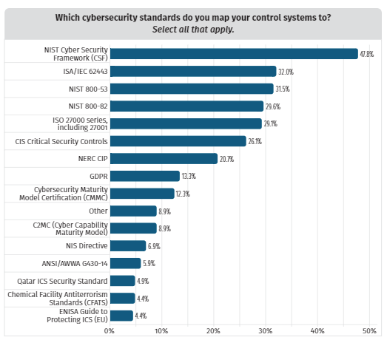
Figure 1 Cyber security standards Usage

NIST CSF
The “cybersecurity framework” was established by NIST after the executive order was signed by President Obama in 2014 [12].
This Executive Order calls for the development of a voluntary Cybersecurity Framework (“Framework”) that provides a “prioritized, flexible, repeatable, performance-based, and cost-effective approach” to manage cybersecurity risk for those processes, information, and systems directly involved in the delivery of critical infrastructure services. The Framework, developed in collaboration with industry, provides guidance to an organization on managing cybersecurity risk. [13] they outline 5 distinct phases
- Identify
- Protect
- Detect
- Response
- Recovery

IEC62443
IEC 62443 is an international series of standards in cybersecurity that is for the cybersecurity requirements for operating technology (OT) in systems used for industrial automation and control purposes.
The ISA/IEC 62443 series of standards, developed by the ISA99 committee and adopted by the International Electrotechnical Commission (IEC), provides a flexible framework to address and mitigate current and future security vulnerabilities in industrial automation and control systems (IACSs). The committee draws on the input and knowledge of IACS security experts from across the globe to develop consensus standards that are applicable to all industry sectors and critical infrastructure [14]
So, in essence ISA 95 -> ISA 99 -> IEC 62443

NIST 800-53
This standard mainly concentrates on privacy and controls in information systems and organizations aiming to secure assets, individuals, and operations in organizations from different cyber threats, including human error, hostile attacks, failures in structure, natural disasters, privacy risks, and threats from foreign intelligence entities [15]

NIST 800-82
This standard provides guidance on how to secure operational technology (OT), while addressing their unique performance, reliability, and safety requirements. OT encompasses a broad range of programmable systems and devices that interact with the physical environment [16]

ISO 2700 Series
ISO/IEC 27001 is widely known, providing requirements for an information security management system (ISMS), though there are more than a dozen standards in the ISO/IEC 27000 family. Using them enables organizations of any kind to manage the security of assets such as financial information, intellectual property, employee details or information entrusted by third parties. [17]
It is however important to note since its release in 2019 the MITRE ATT&CK ICS framework its reported use in parallel to existing frameworks has

MITRE ATT&CK
MITRE ATT&CK (MITRE Adversarial Tactics, Techniques, and Common Knowledge)
“Is a globally-accessible knowledge base of adversary tactics and techniques based on real-world observations. The ATT&CK knowledge base is used as a foundation for the development of specific threat models and methodologies in the private sector, in government, and in the cybersecurity product and service community”. [18]

Critical National Infrastructure (CNI)
Governmental strategies and regulations of Cyber Security within the OT environment are not new, traditional these have been focused on what the government determine CNI which are assets deemed Strategically important in the functioning of the country.
In the United States, this was initiated when in 1996 President Clinton issued Executive order 13010
“Certain national infrastructures are so vital that their incapacity or destruction would have a debilitating impact on the defence or economic security of the United States.” [19]
this was the first publicly documented time of government addressed strategically concerns in which the inclusion of cyber threat elements was considered alongside the traditional physical threat towards CNI. However, since 1996 there have been many revisions currently The Department of Homeland Security (DHS) is tasked by legislation to protect the 16 critical infrastructure sectors described in Presidential Policy Directive (PPD)-21 (Presidential Policy Directive-21, 2013 [20]A shown in Figure 1 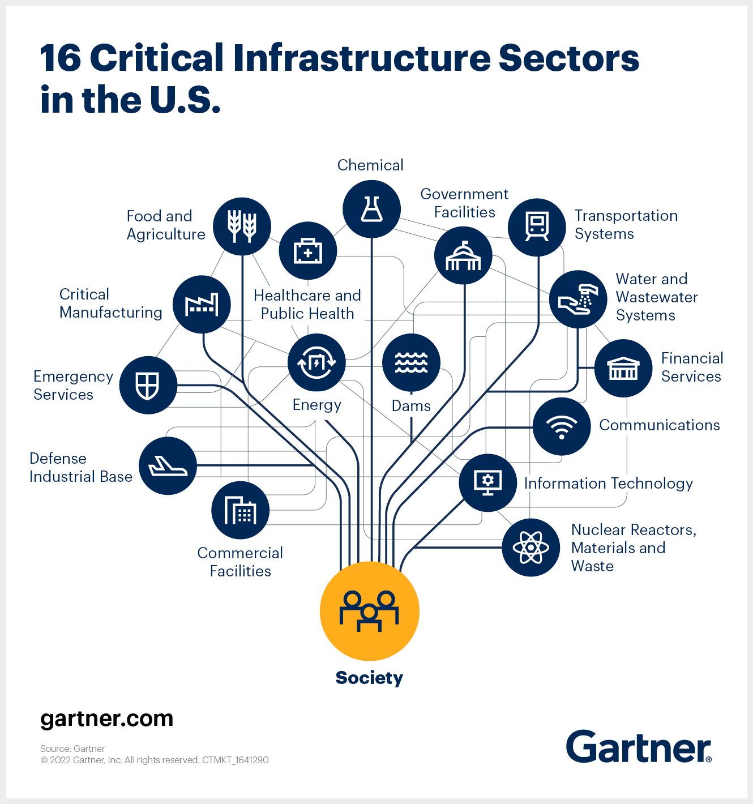
Figure 2 the 16 Critical Infrastructure sectors in the US

The UK has categorized 13 sectors as CNI as shown in Figure 2
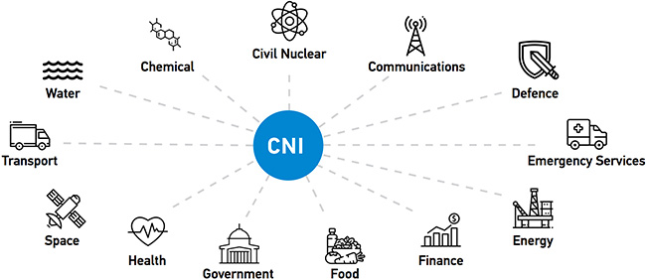
Figure 3 the 13 Critical Infrastructure sectors in the UK

The UK government's official definition of CNI is
‘Those critical elements of infrastructure (namely assets, facilities, systems, networks or processes and the essential workers that operate and facilitate them), the loss or compromise of which could result in:
a) Major detrimental impact on the availability, integrity or delivery of essential services – including those services whose integrity, if compromised, could result in significant loss of life or casualties – taking into account significant economic or social impacts; and/or
b) Significant impact on national security, national defence, or the functioning of the state.’ [16]
Fred Cohen [21] sums this up pretty well with the simplified definition that
“Critical infrastructure is something that people depend on, either directly or indirectly, for their lives and wellbeing, in any time frame “
Because of the importance of CNI, and the impact severity of any disruption in these sectors can cause its simple to see why governments consider them strategically important, and the focus of regulation & legislation concerning cyber security.

However, CNI sectors all require the use of OT systems to function. So, the indiscriminate application of IT cyber security principles potentially may inadvertently cause more harm than good to an OT environment
Murray states that this is “primarily due to the nature of control systems being designed before IT networking technology and due to the use of proprietary hardware and software from manufacturers” [22]

Management Theory
“While competitors can surely be threats, the right competitors can strengthen rather than weaken a firm’s competitive position.” [23]
Although there are many forms of businesses and thinking within each is varied it is critical for a company that wishes to prosper to have a strategy in place
“A good strategy recognizes the nature of the challenge and offers a way of surmounting it. Simply being ambitious is not a strategy.” [24]
It is important to know what a strategy is and how it is applied to the business Porter argues [25]that a company’s only aim is to produce and sell a product or service to a customer via a series of activities, however, to be a successful business these activities have to be done as efficiently as possible and more importantly, more efficiently than your competitors, as with all things when a successful strategy is devised competitors are soon to follow as can be seen with Toyota and their lean manufacturing strategies of the ’90s [26] therefore to maintain a competitive advantage a constant improvement in operational effectiveness is required.
However, “a brilliant strategy, blockbuster product or breakthrough technology can put you on the competitive map, but only a solid execution can keep you there” [25]
Slack defines strategy as “Operations strategy concerns the pattern of strategic decisions and actions which set the role, objectives and activities of the operation” [27]
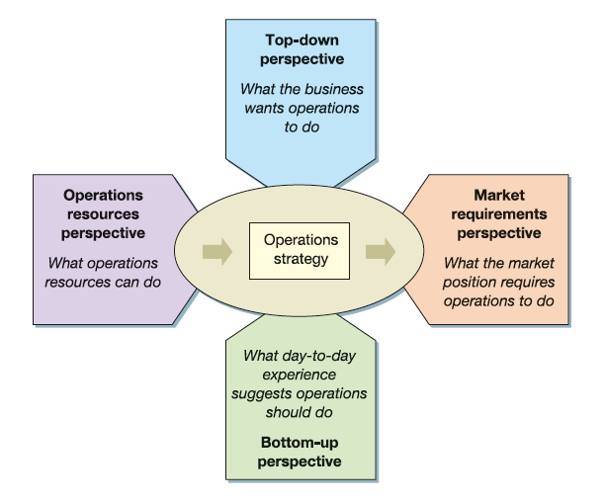
Figure 4 Operations Strategy
Johnson and Scholes define strategy as “the direction and scope of an organisation over the long-term: which achieves advantage for the organisation through its configuration of resources within a challenging environment, to meet the needs of markets and to fulfil stakeholder expectations". [28]
This can then be broken down further by considering strategy as a means to answer the following questions: -
- Direction - What is the business objective
- Market and Scope - What markets can it compete in and what kind of activities are involved in these markets?
- Competitive Advantage - How can the business outperform the competition?
- Resources Available - What resources does the business have that allow it to be competitive?
- Environment - What external factors affect the business’s ability to be competitive?
- Stakeholder objectives - What are the expectations of the business?

Policy Development
A policy is a guideline for organisational action and the implementation of goals and
objectives [29].
A policy is the organisation's statement of intent for the rules, plans and procedures it expects to be upheld for all activities of the organisation to achieve its objective, Policies give clear definitions of the main functions of the organisation, allowing for standardised practices. By clarifying the roles and responsibilities of managers and other members of staff and providing guidelines for employee behaviour. Policy creation is directly influenced by external factors such as government legislation as shown in Figure 4 [30]
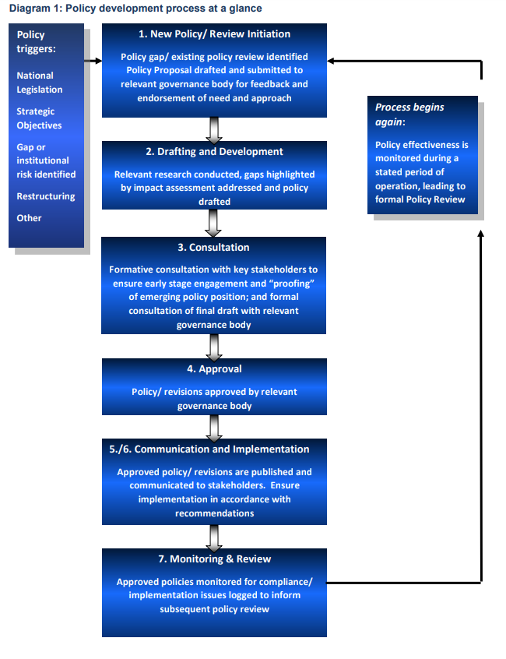
Figure 5 Policy Development Process

Why have a security policy
There are only three policies that are a requirement under British law [31].
- Health & safety policy (if you have more than five employees).
- Disciplinary and dismissal policies.
- Grievance policy.
Although there is no current legal requirement [32] for an SME in the UK to have a security policy having a robust policy in place reduces potential risk exposure to the organisation.
When considering the fact technology advancements have allowed for computers to be linked globally & easily accessible the vulnerability to digital information to theft, manipulation, and destruction will always be present then security breaches are inevitable.
Establishing a security policy that can be used to guide what must be done to protect any information stored digitally, without this and there is the probability the organisation would be found to have been in non-compliance with legal requirements such as the Data Protection Act [33] or General Data Protection Regulations (GDPR) [34].

Risk Management
Risk management is a process that allows individual risk events and overall risk to be understood and managed proactively, optimising success by minimising threats and maximising opportunities and outcomes. [35]
There are 4 main categories to define business risk [36]
- Strategic
- Operational
- Reputational
- Compliance

Risk Triangle
Known as Crichton’s risk triangle [37] its purpose is to depict the fact risk depends on 3 factors if any of the 3 increases, then the overall risk also increases.
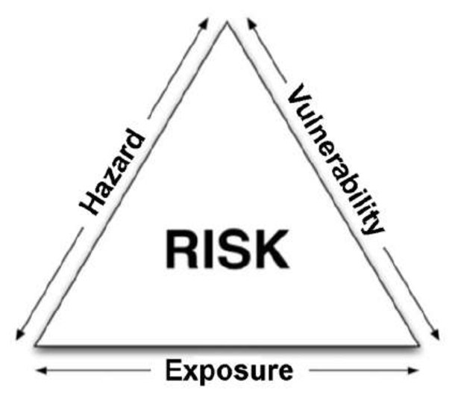
Figure 6 Crichton’s Risk Triangle

Cyber Security Risk Management
There for the application Cybersecurity risk management can be considered the process of working through the following steps allowing for a pre-emptive approach to reduce the expose of risk and to understanding and establishing the context (in this case cyber security), and the potential threats and its implication currently faced
- identifying the risk
- analyses the risk
- evaluating the impact
- put in place measures to address and mitigate the risk

Project Management
“The project management system is the set of tools, techniques, methodologies, resources and procedures used to manage a project. It can be formal or informal and aids a project manager in effectively guiding a project to completion.
“Project management is the application of knowledge, skills, tools and techniques to project activities to meet project requirements.” [38] [39]
A project is defined by very specific criteria it is something that must have a start and end date; it follows a recognizable working procedure. Any project goes through identifiable phases known as the project life cycle, each requiring different tools and techniques to achieve the outcome.
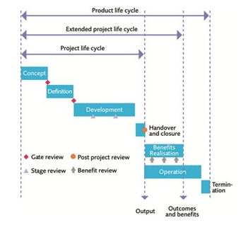
Figure 7 APMBOK Project Life Cycle
However, this is divided by the PMBOK into five distinct steps
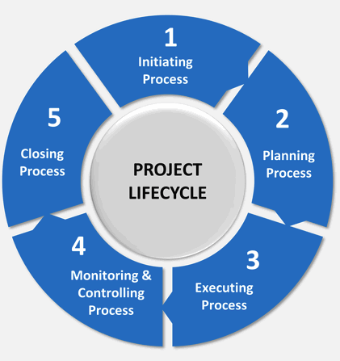
Figure 8 PMBOK Project Life Cycle

Management Tools

Six Sigma DMAIC
“In Six Sigma, processes are where the action is. Whether designing products and services, measuring performance, improving efficiency and customer satisfaction - or even running the business - Six Sigma positions the process as the key vehicle of success.” [40]
Using the Six Sigma Methodology, a company can strategize its plan of action and gain a competitive advantage through the improvements of the processes in all parts of the company.
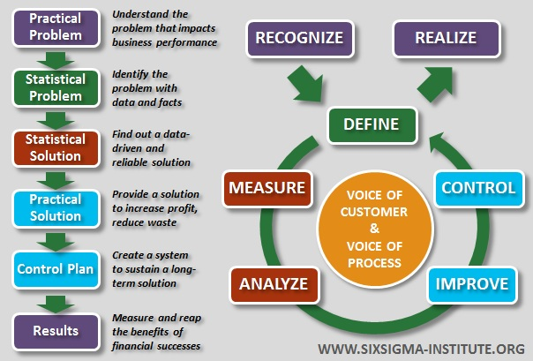
Figure 9 DMAIC Life Cycle
A brief description of the process
- DEFINE
  - The purpose of the Define Phase is to define who the customers are and to define their needs and expectations, it sets the foundation for the success of any 6-Sigma project.
- MEASURE
  - The purpose of the Measure Phase is to establish techniques for collecting data about current performance and then highlight the opportunities for possible improvements it will also provide a structure for monitoring these subsequent improvements.
- ANALYSE
  - The purpose of the Analyse Phase is to allow the Project to further target and narrow the focus of the improvement opportunities by taking a closer look at the data and identifying the best improvements to make.
- IMPROVE
  - The purpose of the Improve Phase is to generate ideas about ways to improve the process design from the data that has been measured and analysed, then a pilot can be initiated and implement these improvements and finally validate these improvements
- CONTROL
  - The purpose of the Control Phase is to ensure the improvements that are carried out are successful and then to monitor their ongoing performance.

Five Whys (5y’s)
Is a problem-solving tool originally developed by Sakichi Toyoda [41] it is a simple tool that allows by asking why 5 times to discover the root cause of any problem
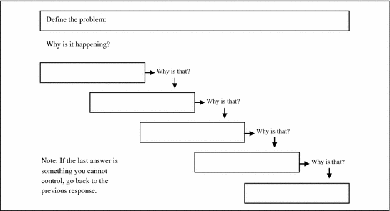
Figure 10 The 5 Whys

FMEA
Failure Mode effects analysis (FMEA) is a tool used to examine any process or product and find all they potential ways for it to fail [42].
- Failure mode – ways something can fail
- Effects analysis – potential effect and risks relating to it (consequences)
Once this is established the process or product can be prioritised by the calculation of the Risk Priority Number (RPN) this is done by calculation from predetermined values for the 3 following
- Severity (S) the consequence should failure occur
  - Rated on a scale from 1 to 10, where 1 is insignificant and 10 is catastrophic
- Occurrence (O) is the probability of a failure occurring
  - Rated on a scale from 1 to 10, where 1 is extremely unlikely and 10 is inevitable
- Detection (D) the probability of a failure being detected before the effect
  - rated on a scale from 1 to 10, where 1 means the control is certain to detect the problem and 10 means the control is certain not to detect the problem
RPN = S x O x D

PDSA
Deming [43] introduced the Plan - Do – Study – Act (PDSA) model known as the Deming cycle of the wheel. It is used as a model to improve any product or process. The PDSA cycle gives you a roadmap for moving forward and methodically introducing improvements and modifications to any system.
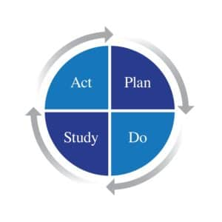
Figure 11 Deming Wheel
- Plan
  - Form ideas to improve a process.
- Do
  - Test idea.
- Study
  - Examine results
- Act
  - Accept idea or restart

Product Life Cycle
At the very basic level, a cyber security frame work is a product and as with every product it only has a limited shelf life, known as a life cycle four district stages can be identified, these are: -
- Introduction
- Growth
- Maturity
- Decline

With the possibility of product extension if it is still fit for purpose.

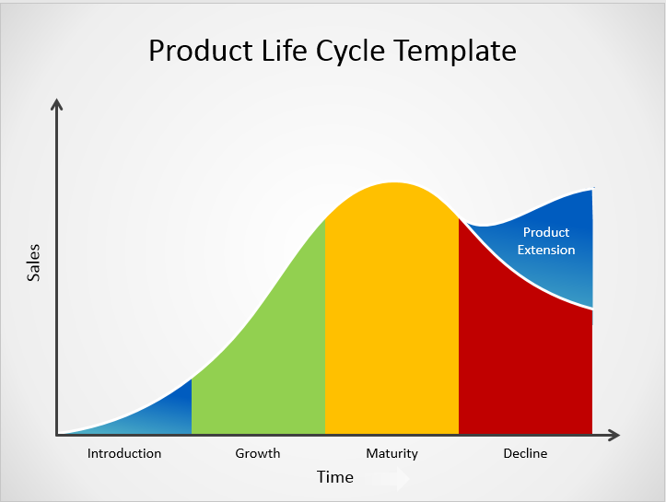
Figure 12 Product Life Cycle

Using this model, it is possible to identify where a product is in its life cycle. When identified a choice between 2 strategic decisions must be made as to which plan of action needs to be followed,
• Make a better product
• Make the product better

Kotter’s 8 Steps Change Model
Kotter’s model [44] is a more detailed model than that of Lewin’s [45] but embodies similar principles. In summary, the eight steps are:
Step 1 Create Urgency
The creation of a sense of urgency (but not panic) within the workforce to achieve change is necessary, otherwise, impetus can be lost. It is useful to undertake SWOT analyses (Strengths, Weaknesses, Opportunities and Threats) with employees to emphasise the need for change.
Step 2 Establish a Powerful Coalition
Bring together influential people preferably from within (but, if necessary, outside) the organisation who by working together can provide the expertise and knowledge encompassing major areas of the organisation. These should not necessarily be confined to any hierarchical structure.
Step 3. Create a Vision for Change
From ideas generated by the coalition, it is necessary to formulate a vision for the organisation, which everyone can understand and is succinct in the form of a Vision or Mission statement. Equally a strategy needs to be devised which will execute that vision.
Step 4. Communicate the Vision
Whenever an opportunity arises, the vision needs to be reinforced within the workforce and applied to all aspects of the organisation’s activities. It is important in doing this that concerns that arise are addressed openly so that the credibility in delivering the vision can be maintained.
Step 5. Remove obstacles
Any processes, structures or individuals that prevent delivering the necessary changes need to be identified. Equally, it is important to reward those individuals who are seen to be supporting change, not necessarily by financial means but in terms of awards and standing within the workforce.
Step 6. Create Short-term Targets
So that progress can be seen to be made short-term targets must be specified within the overall vision. The achievement of such targets provides concrete evidence to the workforce of the progress being made.
Step 7. Build on Change
Constant monitoring of progress is essential together with an analysis of what is good and what needs improving. In this way, it is possible to focus on the necessary improvements, whilst consolidating and building on the positive achievements.
Step 8. Anchor the Changes in the Corporate Culture
It is necessary to continuously emphasise success stories and reinforce in all staff the vision that is at the root of the organisation. This is particularly important in the recruitment of new staff. It is equally important to recognise the contributions of long-standing staff as it recognises the commitment of those staff who are particularly supportive of the company’s vision [46].
In considering the two models outlined above, it might be considered for larger companies, Kotter’s 8-step process is perhaps more suitable for its emphasis on corporate thinking. It highlights issues such as removing obstacles and setting short-term goals, which are fundamental to successfully delivering in a large organisation [47]Lewin’s reference in the Phase 3 model can instead be seen as being counterproductive to any organisation that needs that strives to effect continuous improvement mind-set as it implies that Phase 3 in an “end” which in any dynamic organisation should not be the case [46].

Data Quality
Total Data Quality Management (TDQM)
Total data quality management (TDQM) is based on the traditional Total Quality Management (TQM) discipline and adapts the widely used Deming Quality Cycle [43],
- define
- measure
- analyse
- improve
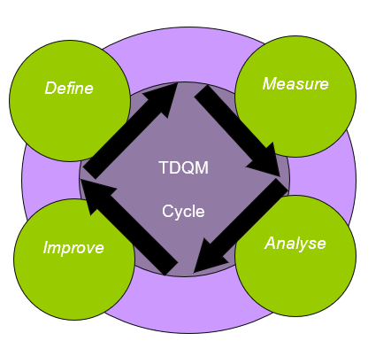
Figure 13 TDQM Cycle
The definition component of the TDQM cycle identifies important data quality dimensions and the corresponding data quality requirements. Defining and measuring data quality should include both objective (quantitative) and subjective (qualitative). The measurement component produces data quality metrics. The analysis component identifies root causes for data quality problems and calculates the impact of poor-quality data. The improvement component provides techniques for improving data quality. These are then applied to data quality dimensions according to requirements specified by the customer.
TDQM is particularly effective in improving information management in organisations where top management has a strong commitment to a data quality policy [48].
Defining what data quality means to an organisation and the level of data quality required by those who use the information can be a difficult task.
Define the functionalities of the information product. This is what the data is needed by the data customer.
Define the characteristics of the information product. Information product mapping shows us the ‘critical path’ that data takes as it develops into an information product and helps define the information product.
Define the basic unit, components and their relationships for the information product through an entity-relationship (ER) model. The ER model outlines the relationships between different data entities.
Define the data requirements from the perspectives of information product suppliers, manufacturers, consumers and managers.
Prioritise the data quality dimensions for the information product. So, you can decide what dimensions are of the highest priority for an individual or group of information products.
Fundamental to the TDQM process is that data are seen as a product, a valuable asset that should be produced as part of a well-defined production process rather than the traditional view of data as a by-product [49]. A process is ‘a structured, measured set of activities designed to produce a specified output for a particular customer.
TDQM looks at the processes that data flows through before ending in an information product
To manage data as a product, organisations should:
- know the customers of the data and their data needs
- manage the data as if it were the product (rather than a by-product) of a well-defined data process, which includes considering the technology and the organisational culture;
- manage the entire life cycle of their information products;
- make management accountable for managing their data processes and resulting products [49]
The data and data quality requirements mean that TDQM uses the existing practices of ‘find and fix’ and adds to this the dimension of prevention. Whilst prevention of all errors is the target, no system is 100% guaranteed so the error may occur however the same as using a 5’s technique any abnormality can be easily identified if everything else is in order.
TQM practices encourage building on existing practices and knowledge, rather than a complete change [50]

The Impact of Poor Data Quality
As noted earlier, it has been estimated that around 1-5% of data found in organisations are of poor quality [51]. The average perceived cost of poor data quality can be as high as 30% of organisations’ revenue. It is believed by 2025, Organisations will have lost more money in operational inefficiency due to data quality issues than they will spend on data warehouse and customer relationship management initiatives’ [52].
The cost to private organisations is also far more than merely financial. Trust is lost from valuable customers potential customers and sales are missed, operational costs increased, workers lose motivation, long-term business strategy is hindered and business re-engineering is impeded [53]. Redman also details how poor data quality affects operational, tactical and strategic decisions [51].
Organisations generally struggle with the issue of estimating the actual cost of poor data quality and the return on investment (ROI) of data quality initiatives [53], [54]. There is no formal structure that would apply to all organisations; priorities for improvement differ from one organisation to the next. The literature suggests that the cost of poor quality is often underestimated as not all impacting factors are considered [55]. In calculating the cost of poor data quality companies need to not only identify all 8 types of waste but also
- assess the business problems that create ‘data scrap and rework’;
- calculate direct (lost and missed opportunity) versus indirect costs (soft measures);
- identify the organisation’s key performance indicators (KPIs) and business drivers;
- identify critical data that has a significant impact on the business;
- meet with subject matter experts to assess the impact of poor quality [56]
The increase in technology has only increased the problem through the ability to collect huge amounts of data quickly and easily. Companies are only now starting to realise the implications of not addressing poor data quality systematically [57]. An example is a progress in e-business, where businesses need to change their methods of delivering products and services. Where web services have become the foundation of service delivery new and improved ways to manage data quality are required. This method of business has increased the complexity of data quality management due to the increase in a company’s interaction with its environment and new levels of data integration [51]. Web-based companies will have to establish trust with their customers. Those who provide high-quality data have a better chance of doing so and can expect to achieve competitive advantages [51].

Manufacturing
To understand the unique cybersecurity challenges being faced by a modern manufacturing organization, it is important to understand the principles of manufacturing, there are 2 recognised classifications for manufacturing.
Traditional manufacturing is defined “as the process of turning raw materials or parts into finished goods through the use of tools, human labour, machinery, and chemical processing” [58].
Advanced manufacturing which is defined “Advanced manufacturing is the use of innovative technologies and methodologies for improved competitiveness in the manufacturing sectors” [59].

UK Manufacturing
The UK is the 9th largest manufacturing nation in the world [60] of that SMEs (0-49 employees) make up 99.2% with 5.5 million businesses in the UK. [61]
In 2021, the manufacturing sector accounted for 9.7% of total UK economic output and accounts for 7.3% of jobs. [62]

Small medium enterprise
The UK defines SMEs as the following [63]
Turnover or balance sheet total | Headcount | Business size
less than or equal to €50 million or €43 million | less than 250 | Medium-sized
less than or equal to €10 million or €10 million | less than 50 | Small
less than or equal to €2 million or €2 million | less than 10 | Micro
Figure 14 UK SME Definition
Currently, there are estimated to be 262,800 enterprises in Wales, [64] [65]
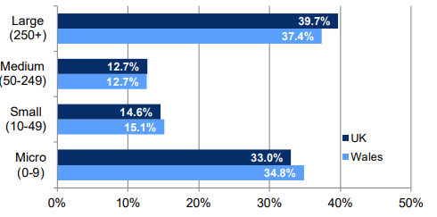
Figure 15 Welsh Business Statistics 2021
As the focus will be on small & micro enterprises
- Small = 15.1%
- Micro = 34.8%
Making a Combined 49.9% of all Welsh Enterprises or 113,138 the Business population estimates for the UK & Regions report [62] manufacturing makes up 9% of SMEs or 11,802 manufacturing Small or micro-enterprises in Wales.

Current State of Manufacturing & industrial Revolution
We are currently within what has been classified as the 4th industrial revolution as shown in Figure 15 [66]
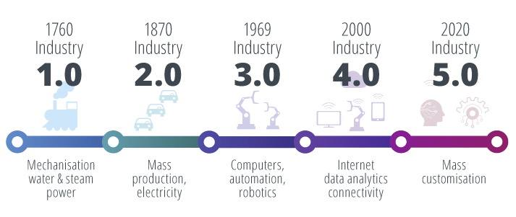
Figure 16 Industrial Revolution Timeline.
There have been many proposed definitions of what industry 4.0 is, but to date, no exact definition has been agreed upon.
However, Jacobi and Landherr [67] as cited in [68] offered one of the simplest descriptions, stating that Industry 4.0 “will be an (r)evolution towards digitalization”.
Hofmann and Rüsch [69] define Industry 4.0 as
“a shift in the manufacturing logic towards an increasingly decentralised, self-regulating approach of value creation, enabled by concepts and technologies such as CPS, IoT, cloud computing or additive manufacturing and smart factories, to help companies meet future production requirements”.

9 Pillars of Industry 4.0
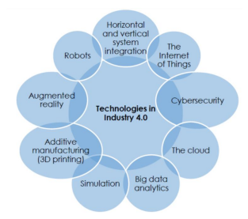
Figure 17 9 Pillars of I4.0

Description of 9 Pillars [70]
Big Data and Analytics
- Analysing and management of large amounts of data to provide an increase in performance by allowing faster decision-making and allowing data-driven optimization of industrial processes.
Robotics
- Using robots in Industrial environments allows for an increase in performance by assigning repetitive tasks to these robots
Simulation
- In industry 4.0, computer simulation is used in industrial analyse of production data in real-time, bringing the physical and virtual worlds closer together such as by the use of a Digital twin.
Horizontal & Vertical Integration
- By integrating all systems between, the organisation & the customer to allow better harmonisation across the entire supply chain

Internet of Things
- The internet of things (IoT) is the connection of physical objects to the network these objects include environments, machines and vehicles which allows for faster and more effective collection and exchange of data
Cybersecurity
- With the increase in connected objects, organisations must have robust cybersecurity systems to protect systems and information from possible threats and failures that could potentially disrupt production.
Could Computing
- With the increase in data being generated and the increasing requirement to access and analyse this data the resources required are often un economical however outsourcing these to the Cloud (someone else’s computer) allows for a considerable reduction in costs
Additive Manufacturing
- Or 3D printing is the manufacture of components by building the product, instead of the traditional method of removing it by machining. This allows the rapid production of prototypes or highly customized products with designs of complexity unobtainable by traditional methods.
Augmented Reality
- Employing augmented (AR) technologies allows for the digital images to be integrated (overlapped) into the physical world

Operational Technology
NIST recently released an updated Special Publication 800-82 to Rev. 3, renaming it: "Guide to Operational Technology (OT) Security." [16] from “Guide to industrial control systems (ICS) Security” is the reflection of the increased scope resulting from the evolution of ICS technology and its applications in many more environments such systems as: -
- Medical Systems
- Transport Systems
- Building Automation Systems

The National Cyber Security Centre (NCSC) is the UK government agency responsible for bridging government & Industry both private & public sector organisations providing a single unified source for guidance support & advice relating to cyber security & incident management, it defines Operational Technology (OT)
“Technology that interfaces with the physical world” [71]
Gartner an Information Technology (IT) is a research & technology company’s definition of Operational technology has become a standard definition used often and will be the response to many searches for ‘what is OT’.
“Operational technology (OT) is hardware and software that detects or causes a change, through the direct monitoring and/or control of industrial equipment, assets, processes and events” [72]
And define Information Technology as
"IT is the common term for the entire spectrum of technologies for information processing, including software, hardware, communications technologies and related services”. [73]
However, Robert M Lee CEO of Dragos a specialist OT Cyber security company defines operational technology simply as
“OT is Everything, not IT”. [74]
This simplistic definition clearly shows a similar understanding yet also division within the two IT and OT security communities.
For this project, the following definitions will be used when referring to these technologies although not to be confused with the original definition of operational technology as outlined by Hickson when considering operations management [75],
• Information Technology (IT) as an umbrella term for technologies that enable the processing, storage and transportation of data
• Operational Technology (OT) as an umbrella term for technologies that enable the interaction and control of the physical world.

Control Systems
A control system is simply a system that uses a control loop to monitor and correct the behaviour of a device, control systems are not new, the first recorded use of a control system was by the Greek inventor Ctesibius in around the time of 250BC when he created the Clepsydra (water clock) using a simple control loop to ensure a constant movement of water allowing for accurate time keeping [76]

Purdue Model
In the 1990s, Theodore Williams with a team from Purdue University Consortium for Computer Integrated Manufacturing developed a model known as the Purdue enterprise reference architecture (PERA), as shown in the below figure. PERA was assembled specifically for the manufacturing industry to address the human and organizational aspects of an enterprise, from planning [77]
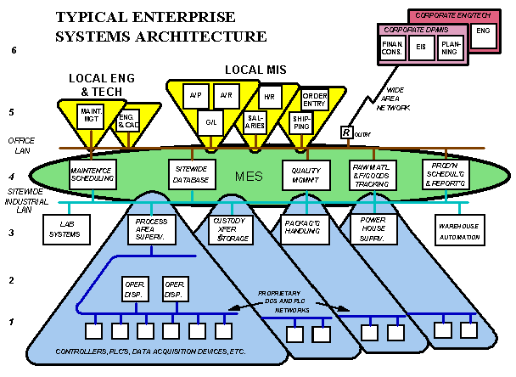
Figure 18 PERA Model
This has been used as the basis for many of the OT standards however it is more recognisable in its simplified form known as the Automation Pyramid as seen in Figure 18, The automation pyramid visualises the integrated layers of industrial control systems used in manufacturing or industry levels within of automation [78]
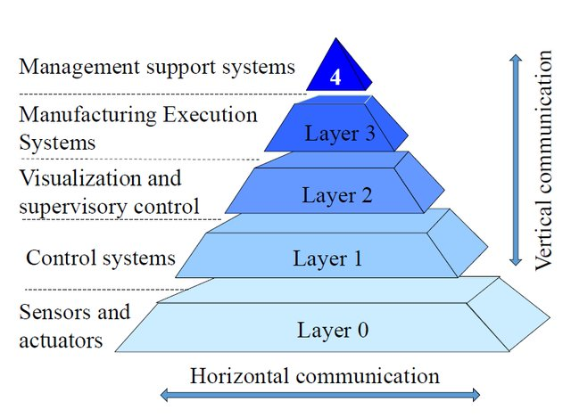
Figure 19 Automation Pyramid
Level / Layer | Function | Example | Location
4 | Site Business Planning | MES | Enterprise Network
3 | Site Operations | ERP | Enterprise Network
2 | Supervisory Control | SCADA | OT Network
1 | Basic Control | PLC | OT Network
0 | Process | Sensor | OT Network
Figure 20 Purdue Levels
The Standard ISA-95 (IEC 62264) is a 6-part model that was developed from the PERA Model, and used for the developing of automated interfaces between enterprise and control systems. By reducing risk and errors associated with the systems integration by giving a hierarchal model for both function & data flow.
The ISA 95 created the ground work for the creation of the ISA 99 (IEC 62443) Security for Industrial Automation and Control Systems. which will be discussed later.

The current state of OT?
OT and IT convergence, OT & IT systems if anything converged many years ago with many OT systems already running on common operating systems and communicating over ethernet structures with protocols such as Modbus-TCP which allows the connection of devices using serial communications, so the repeated use and misuse of the term are causing a lot of confusion, the term as it is perceived similarly to the network convergence, where Data, Voice & Video systems that were historically separate converged using the same protocols (IP) however these were already closely related systems, Technology has always been the driving the factor as organisations sought to gain competitive advantage through its processes.
OT systems of the past were not only air-gapped but also individual systems that ran on proprietary protocols [79] this allowed most systems to be secure by design secure by obscurity, but now systems are moving away from proprietary protocols and towards the Common Industrial Protocol (CIP), which the most common of these is Ethernet / IP (ethernet industrial protocol) which is an application layer protocol that uses the ethernet structure to manage the connections is a large driving force in the publications is these protocols that are converging, however, the systems are still two very separate and distinct universes and need to be considered so.
“OT / IT collaboration should be a more suitable term to describe the current state entwinement” [80]
OT has not suddenly been revolutionised; it has evolved the expected life span of an OT system is much greater than that of IT” The lifespan of an OT system can exceed twenty years” [16] so leap into a connected environment with the advent of the internet and now the convergence of IT / OT, has left many legacy systems which could have been installed venerable to potential attack and this is a long way from the original design and function of many of these systems, the first generation of SCADA were monolithic systems based on mainframes developed in the 1940’s when the Visicode supervisory control was developed by Westinghouse and the North Electric Company to control electric utility systems [81] evolving from simple automation that was isolated and not connected to external networks through the 1980s to controlling complex and sophisticated processes across dispersed, inter-connected processes [82]

simple automation that is isolated and not connected to external networks through the 1980s, to controlling complex and sophisticated processes across dispersed, inter-connected processes [82]
However, with the increase in OT connecting to the Internet their historic security by obscurity become susceptible to attack, The convergence of OT with IT created vulnerabilities cyber-attackers can use to exploit and enter ICSs [83]
With the convergence of OT and IT environments and the adoption and implementation of IIoT, the need to ensure the corporate and operational networks remain separate and segmented is of utmost importance, Common practices in the IT world, such as certification and accreditation of network segments, potentially may not be applicable in the OT environment [84]
ICS cyber-attacks may traverse IT networks to OT systems showing the susceptibility of ICS to cyber-attack because of the OT to IT convergence since the creation of the Internet [85]
The need for, and the ability to, administer control via remote and secure means continue to grow, as ICSs become geographically dispersed [84]
As technology advances, distributed automation provides improved reliability, including efficiency, while extending the system’s life for ICS owners and operators [86].
As the OT environment evolves to encompass IT systems, network architectures require logical separation and segmentation within the networking structure to lessen the risk of cyber-attacks The fourth generation of ICSs began implementation in the 2010s and are web-based [87]
However, it is also important to note that the convergence of OT /IT systems is the catalyst that has propelled us into the 4th Industrial revolution by enabling the ability to conduct autonomous interconnected & intelligent manufacturing by integrating IT technologies such as data analytics & this Cloud, this digitalisation of manufacturing is known as digital transformation.

OT Considerations
OT can take on different forms depending on the design requirements and the approach of the system integrator who is designing and building the solution. While there may be different design approaches, the majority of OT has the same core components. To understand the opportunities for improvement related to cybersecurity, it is important to understand these core components. The primary difference between these systems OT and IT is their functions discussed previously
- Information Technology (IT) as an umbrella term for technologies that enable the processing, storage and transportation of data
- Operational Technology (OT) as an umbrella term for technologies that enable the interaction and control of the physical world.
However, by using the CIA Triad below figure it is possible to see that the Security Priorities are also different.
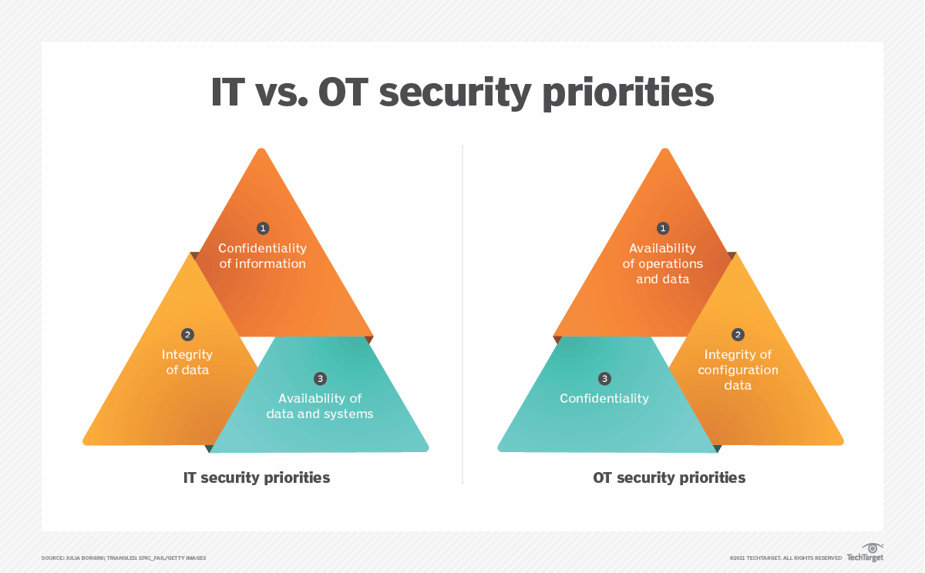
Figure 21 OT Vs IT CIA Triangle
Priority | Operational Technology Security | Information Technology Security
1 | Availability | Confidentiality
2 | Integrity | Integrity
3 | Confidentiality | Confidentiality

Figure 22 OT Vs IT CIA Priorities
OT and IT are different environments in terms of networking and functionality of the systems OT environments were static with little to no configuration changes spanning years, or decades. For example, in the nuclear sector, OT configurations are the same for decades in closed networks due to the inherent risks associated with connecting to networks and regulatory requirements [88]
IT environments, in contrast, are dynamic and change due to the nature of the architectures and potentially may cause conflicts between the OT staff and culture and the IT staff and culture [89].
Firewalls and other preventative measures used in a control systems environment are required to enable the safe operation of the ICS and need to ensure the safety of the people and processes a control system oversees [88].
Therefore, the evolving IT environment adoption of approaches away from intrusion detection systems (IDS) to intrusion prevention systems (IPS), by searching for abnormal traffic would create havoc in an OT environment.
Abnormal traffic in an OT environment could well be an atypical action on the part of an OT such as an event on the safety system, triggered to prevent a physical hazard.
So, the introduction of any automated applications reacting to abnormalities will introduce operational risk and with it a potential disruption to the industrial environment.
If an emergency occurs, the ICS technician must be able to control the process to ensure the safety and integrity of the systems and the process [90]
As safety and reliability are important elements for an ICS, the need to understand the attack vectors and threat landscape, including emerging threats, is necessary to ensure the continued safety and security of control systems [91].
So, while the use of some IT techniques can address some security issues in industrial environments they cannot be used as a one size fits without disastrous consequences, as with IPS systems the cure may be worse than the cold.

Chapter 3: Research Methodology

Problem
Cyber security is an essential component for every modern company is it neglected by SMEs?

Theory
“A lack of education (Cyber awareness) is the inhibiting factor for the adoption of established cyber security processes”

Philosophy
A research philosophy refers to the set of beliefs concerning the nature of the reality being investigated [92]

Methods
Using the Flow charts set out by Edgar 2017 [92] and the Research onion [93] as a guide the following base lines have been met
- I have a research Question
- The question is about how well a system solves a problem
- I have a theory
As the objective is to understand how in the real world how cyber security processes are applied, an Observational research method is required, this will take the form of an exploratory study to gain a greater understanding of the processes & descriptive study to gain a better understanding of its real-world interactions

Data Collection
Research objective – Gain a greater understanding of how Cyber Security processes are applied in a Manufacturing SME

Primary Data Collection
Data collection method – Observational research by conducting a survey and interviews to establish an understanding of the system's real-world application (Behaviour) through Quantitive & Qualitative analysis to enable deductive reasoning.

Survey Design
The initial question for this project’s data collection is not which methodology I need to follow to gather data but rather what I need to know and why.
Therefore, by using the simple product life cycle analogy as a starting point I have two options to follow [94]
• Improve the Current Process
• Create a new Process
To do this several questions first needed to be formed & answered
- What are the current best practices for Cyber Security?
- How are these practices managed in an organisation?
- How do these apply to a Manufacturing organisation?
- How do these apply to SMEs
Therefore, the proposed Research question for this project is.
“Are the current practices/processes concerning cyber security SMEs fit for purpose”
Now a question is set it is important to establish the best way to collect data to answer it.
To answer this, it is important to gather data from as many sources as possible however, the end user is the final customer, so it is important to gather data about how cyber security is employed by Local SMEs.
As this can be extremely objective, to be able to catalogue and analyse the customer’s responses to a targeted questionnaire, it first needs to be created and issued
On the assumption that there are 11,802 Small & Micro manufacturing enterprises in Wales even though the use of qualitative & exploratory research to achieve a high confidence level in the results the sample size would still be far outside the ability of this project therefore a requirement to drill down into local SME’s is required
Swansea has 20,200 SMEs using the statistics established in chapter 2
49.9% - 10,080
9% - 908 Small or micro manufacturers in the Swansea (Local) area
Ideally, 100% survey would be issued but due to limitations in time because the total population is und 1000 a 10% sample will be selected as suggested by Suskie [95].

Survey Questions
The following survey was designed using micro soft Forms and distributed
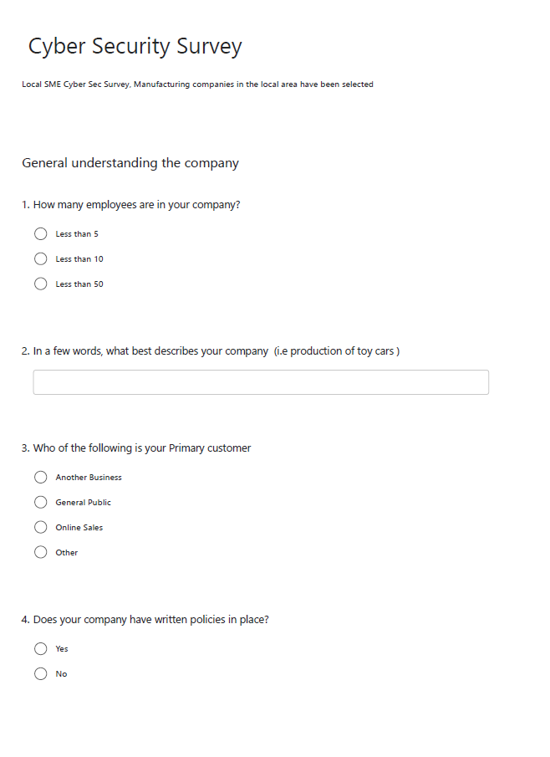
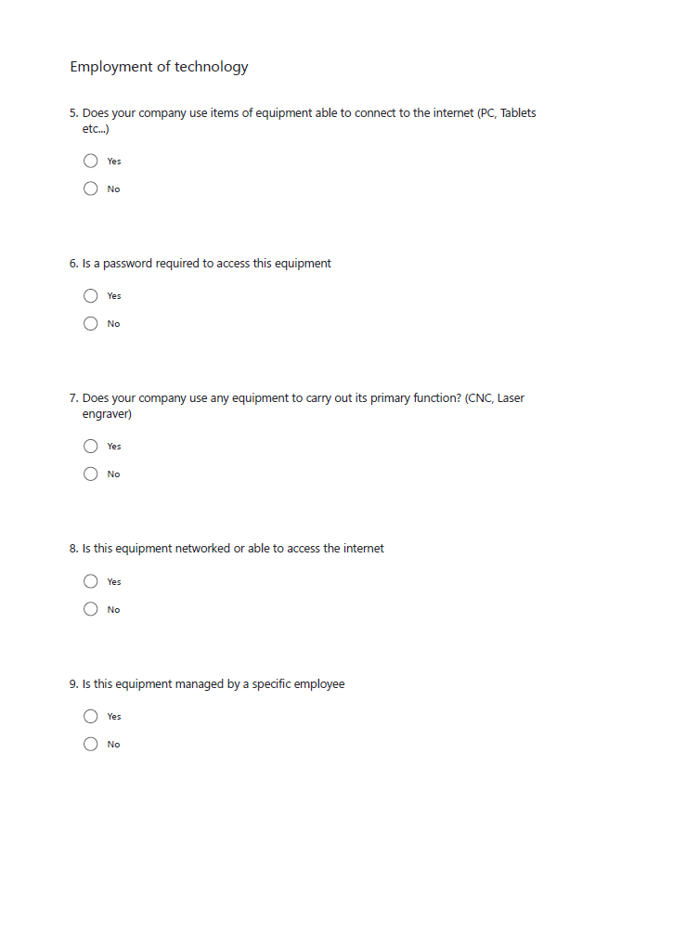
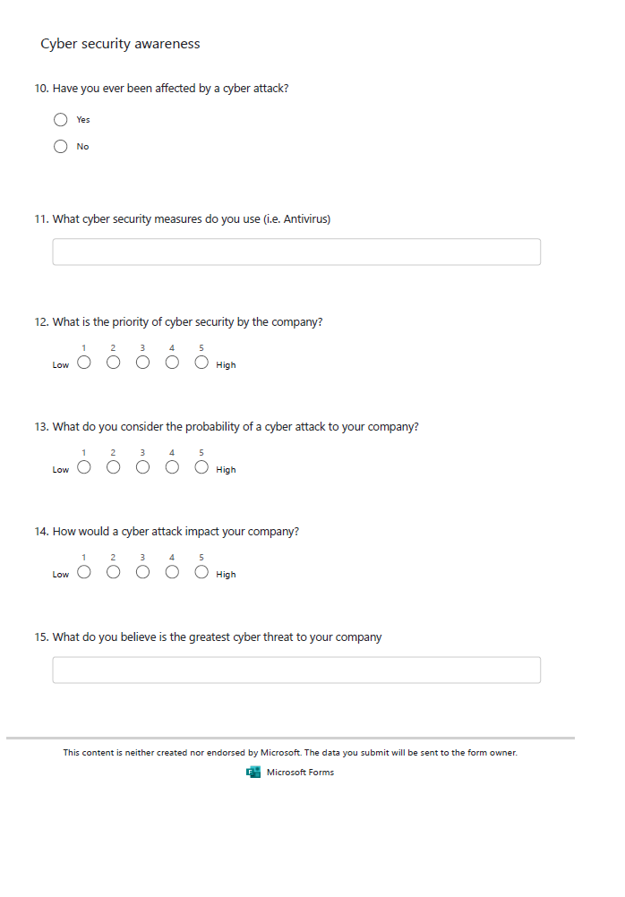

Interview Design
Conducting an interview of 10% of the survey’s population allowed for the closing of gaps in understanding of the surveys and to better understand the needs & desires of the organisations, as suggested by [92] [95] [96].

Interview Questions
- How many employees do you have?
- You indicated in the survey you have policies in place why?
- You indicated in the survey you’re the survey what do you use the equipment for the following?
- Are any of your manufacturing processes automated?
- What Is this equipment used for?
- Are your production machines & office connected (networked i.e., can you send files, start machines etc.)?
- Do you consider these machines when thinking about cyber security?
- What do you believe is the greatest cyber threat to your company?
- What do you see as the restricting factor in your cyber security development/adoption?
- What would encourage your company to Develop its Cyber security adoption?

Secondary Data collection
Data collection method – Observational research to establish a greater understanding of the systems in place and how they should be used (real-world application behaviour) through a semi – systematic literature review.
The semi-systematic or narrative review approach is designed for topics that have been conceptualized differently and studied by various groups of researchers within diverse disciplines and that hinder a full systematic review process [97]
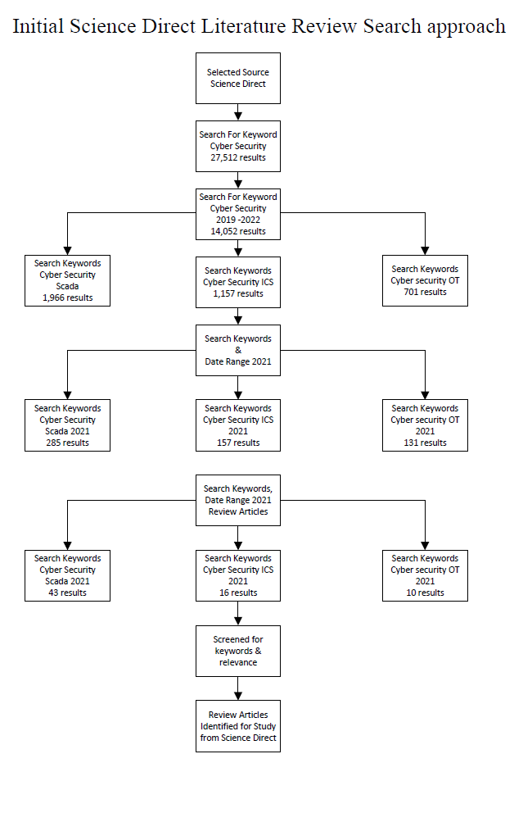
Figure 23 Data collection flowchart (Cox)

“A literature review can broadly be described as a systematic way of collecting and synthesizing previous research” [98],
An effective review for research can create a firm foundation for gaining a further understanding and allowing for theory development [99].
By gaining an understanding of the background of the system a literature review together with the survey & interviews can help with addressing my research question, it can also help to provide an overview of areas in which my research is sparse and requires more in-depth focused understanding. In addition, this literature review is an opportunity for my research findings to show corroborating evidence or to uncover areas which need more research,
“Traditional ways of describing and portraying the literature often lack thoroughness and are not undertaken systematically” [98]
“For a number of research questions, a literature review may be the best methodological tool to provide answers. For example, reviews are useful when the researcher wants to evaluate theory or evidence in a certain area or to examine the validity or accuracy of a certain theory or competing theories” [98]
Literature reviews are useful when the aim is to provide an overview of a certain issue or research problem. Typically, this type of literature review is conducted to evaluate the state of knowledge on a particular topic. It can be used, for example, to create research agendas, identify research gaps, or simply discuss a particular matter. Literature reviews can also be useful if the aim is to engage in theory development [100]
In these cases, a literature review provides the basis for building a new conceptual model or theory, and it can be valuable when aiming to map the development of a particular research field over time. However, it is important to note that depending on the goal of the literature review, the method that should be used will vary.
“As with all research, the value of an academic review depends on what was done, what was found, and the clarity of reporting” [101]

Research Validity
The concept of data quality is defined by a set of dimensions, usually considered in data quality literature as quality properties or characteristics of data. A data quality dimension is defined by
‘a set of data quality attributes that most data consumers react to in a fairly consistent way’. [48].
“This treatment of dimension is consistent with previous empirical research”. [102].
Modern definitions of data quality have a wider scope and many more attributes than the traditional characteristics of accuracy, going on to identify four dimensions of data quality as being accuracy, completeness, consistency, and timeliness [103] there is however still no general agreement on data quality dimensions. However, research is beginning to show consistency, but data accessibility is becoming increasingly important to organisations. [48] [102]. An analysis is needed to determine the dimensions of data quality appropriate to the organisation and to be able to put a value on that data.
“Dimensions employed by data quality practitioners are driven by the context in which they are delivering data quality, more so than academic research”. [53]
Dimensions break down data quality into practical constructs that can be defined and measured. In defining appropriate dimensions for the context of their use, the developer must take care to include all relevant dimensions of data quality to ensure subsequent appropriate measurements of data quality. For example, measuring timeliness is often considered important, as is completeness. By measuring both and prioritising their importance the organisation has appropriate data quality information on which to base decisions around timeliness versus completeness trade-off. Trade-offs are sometimes required where, for example, complete data are not available in a timeframe acceptable to the data user, and therefore the user could decide to use the incomplete data set. Data consumers may need to decide which is more important for the context in which they use the data.
These dimensions need to be clearly understood by everyone as having the same meaning to be effective [49].
Without consistent definitions for the naming of dimensions, it will be difficult to develop generic data quality frameworks. Wang summed this up with the statement
“At present, there are no consistent definitions used and further research is required in this area to develop these definitions [49]”
Noting further analysis of the various attributes of data quality from the perspective of data consumers. Dimensions were then grouped into four broad categories: intrinsic, contextual, representational and accessibility. These dimensions and categories are detailed in Table 4. Intrinsic data quality captures the fact that data has quality in its own right. Contextual data quality highlights the requirement that data quality must be considered within the context of the task at hand. Representational and accessibility data quality emphasises the importance of the role of information systems [48] and reveal the need for ease of use and convenience if ‘quality’ data are to be of value.
Data Quality Dimensions

Category | Dimension
Intrinsic | Accuracy
Intrinsic | Objective
Intrinsic | Believability
Intrinsic | Reputation
Accessibility | Accessibility
Accessibility | Access Security
Contextual | Relevancy
Contextual | Value Added
Contextual | Timeliness
Contextual | Completeness
Contextual | Amount of Data
Representational | Interoperability
Representational | Ease of understanding
Representational | Concise Representation
Representational | Consistent Representation

Figure 24 Data Quality Categories and Dimensions

Chapter 4: Analysis of Research

Analysis of Primary Data

Survey Results
Surveys will undergo statistical analysis
Recipients | Issued | Returned
90 | 89 | 47
Figure 25 Selection of recipients
Unfortunately, of the 89 surveys issued only 47 were completed and returned it meaning 53% (52.81%)
Analysis was carried out on each Question to establish relationships, in excel the relationships were identified and summarised for each question (example shown in Q6)

Q1. How many employees are in your company
Using the employee figures set out by the UK Government for SME sizes [63]
- Less than 10
- Less than 50
These allowed the identification of Small and Micro enterprises I also added the choice
- Less than 5
From the survey, the following results were achieved

Figure 27 Survey Q1
Although in hindsight during the analysis I believe the question should have been to ask the size and request a value in return. (This was altered for the interview questions)
However, the data captured was still extremely valuable when analysed

Less than 5
- 82% rated Q12 High,
- 100% rated Q13 Low
Less than 10
- 100% replied Yes to Q4
- 100% replied Yes to Q7
- 90% replied No to Q8
- 80% replied No to Q9
- 80% replied No to Q10
- 65% rated Q14 Low
Less than 50
- 100% replied Yes to Q6
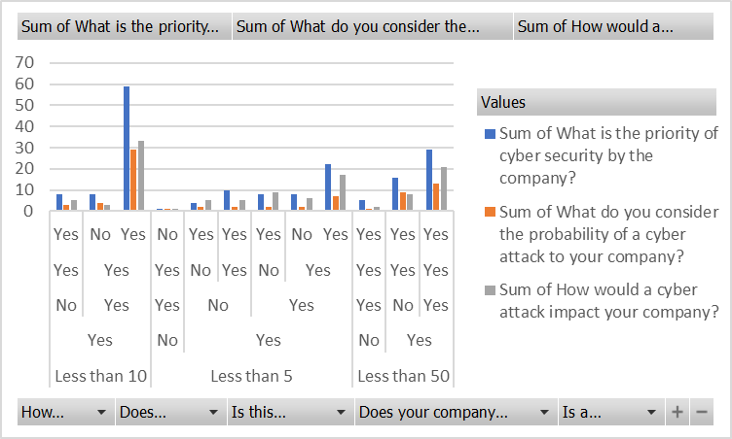
Figure 28 Analysis of Survey Q1

Q2. In a few words, what best describes your company's
This question was asked to get an understanding of what these organisations considered themself to be.
This guided the Literature searches in understanding the accessibility to resources
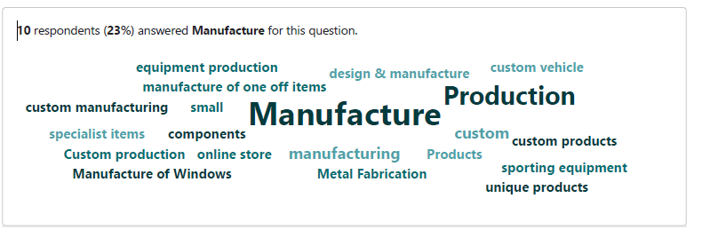
Figure 30 Survey Q2

Q3. Which of the following is your Primary customer
This question was asked to get an understanding of the organisation's customers it also allowed me to understand if potential customer data was being recorded which would make a company susceptible to prosecution if no compliance can be proven with the Data Protection Act [33] or General Data Protection Regulations (GDPR) [34].

Figure 32 Survey Q3

Q4. Does your company have written policies in place
This allowed for the understanding of current management procedures in place
After investigation the 2 that stated no were corrected to Yes
- Theory “Small Companies won’t even know what a policy is”
The replies completely disproved my initial theory
Only 2 companies replied no, when followed up they do have written policies in place,
96% answered Yes
- 100% of those that replied Yes to Q4 Replied Yes in Q10
- 67% of those that replied Yes to Q4 Rated Q12 high
- 81% of those that replied Yes to Q4 Rated Q13 Low
- 100% that answer that replied no in Q4 Rated Q14 Low
Figure 33 Survey Q4
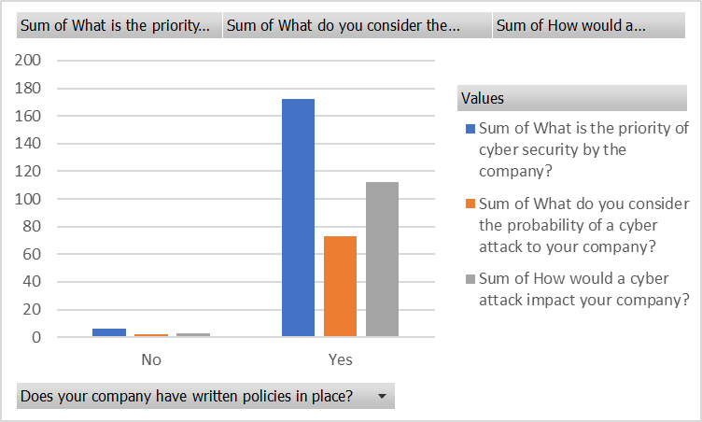
Figure 34 Analysis of Survey Q4

Q5. Does your company use IT equipment that connects to the internet
100% answered Yes
Figure 35 Survey Q5

- 75% of those that replied Yes to Q5 replied No to Q10
- 66% of those that replied Yes to Q5 rated Q12 High
- 82% of those that replied Yes to Q5 rated Q13 Low
- 55% of those that replied Yes to Q5 rated Q14 Low

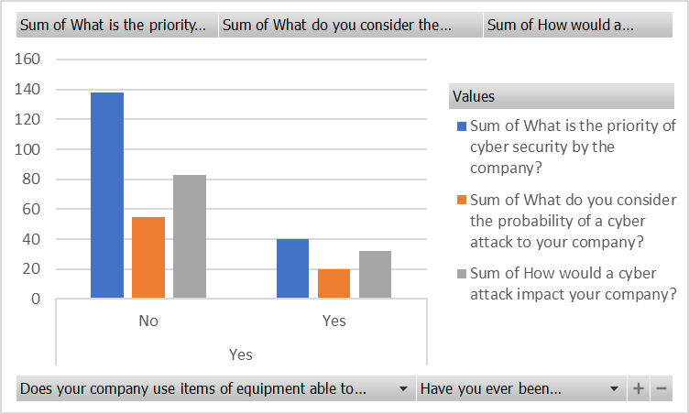
Figure 36 Analysis of Survey Q5

Q6. Do you require the use of a password to access this equipment
This Question Let me understand the level of basic password protection used by small companies, 90% answered Yes

Figure 37 Survey Q6

- 93% of those that replied Yes to Q6 replied Yes to Q7
- 75% of those that replied Yes to Q6 replied No to Q10
- 68% of those that replied Yes to Q6 rated Q12 High
- 83% of those that replied Yes to Q6 rated Q13 Low
- 100% of those that replied No to Q6 rated Q14 Low

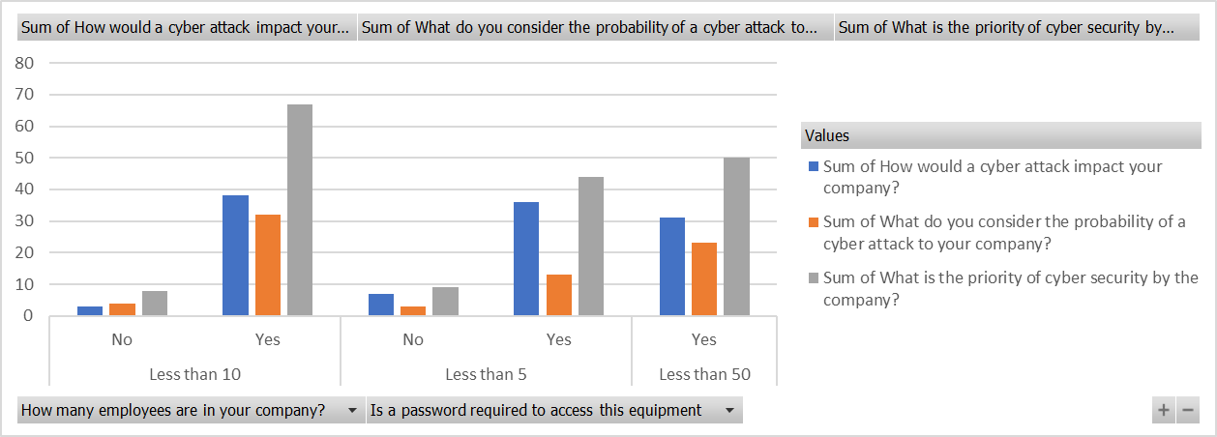
Figure 38 Analysis of Q6

Figure 39 Analysis of Q6

Of the 5 replies that no to Q6.
- 60% were less than 5 employees (Q1)
- 40% were less than 10 employees (Q1)
- 80% customer was online sales (Q3)
  - 1 (20%) had no policies in place (Q1 - Less than 5)
    - Also, the only 1 from these to reply yes to Q10
    - Rated Q12 Low
    - Rated Q13 Low
    - Rated Q14 Low

Q7. Do you use any machines to manufacture your product
This question was asked to understand how the companies perceived their manufacturing equipment each company was selected because of their use of machines in manufacturing, 94% answered Yes 6% answered No
Figure 40 Survey Q7

- 96% of those that replied Yes to Q7 replied Yes to Q4
- 76% of those that replied Yes to Q7 replied No for Q10
- 100% of those replying No to Q7 rated Q12 High
- 81% of those that replied Yes to Q7 rated Q13 Low
- All those that replied No to Q7 rated Q14 High

Q8. Is this equipment networked or able to access the internet
This question allowed the understanding of company’s understanding of connected devices 81% answered Yes

Figure 42 Survey Q8

- 95% of those that replied Yes to Q8 replied Yes to Q4
- 89% of those that replied Yes to Q8 replied Yes to Q6
- 95% of those that replied Yes to Q8 replied Yes to Q7
- 80% of those that replied Yes to Q8 replied No for Q10
- 89% of those that replied No to Q8 rated Q12 High
- 83% of those that replied Yes to Q8 rated Q13 Low
- 55% of those that replied Yes to Q8 rated Q14 Low

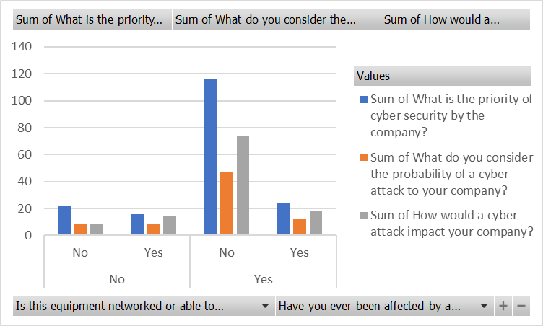
Figure 43 Analysis Survey Q8

Q9. Is this equipment managed by a specific employee
To understand if there was a dedicated employee for the IT systems, in hindsight this question was miss understood as of those that replied yes would later elaborate this by saying “Bob is the go-to guy for the IT” so not a dedicated employee but an employee who takes on the task. 75% answered No

Figure 45 Survey Q9
- 97% of those that replied Yes to Q9 Replied Yes Q4
- 100% of those that replied Yes to Q9 Replied Yes Q6
- 94% of those that replied No to Q9 Replied Yes to Q7
- 100% of those that replied Yes to Q9 Replied Yes Q8
- 75% of those that replied No to Q9 Replied No Q10
- 82% of those that replied Yes to Q9 Rated Q12 High
- 100% of this that replied Yes to Q9 Rated Q13 Low
- 58% of those that replied No to Q9 Rated Q14 Low

Q10. Have you ever been affected by a cyber-attack
Simple Yes or no Question here to understand if there was a relationship between this and the rating asked in later questions. 77% answered No

Figure 47 Survey Q10

- 82% those that replied Yes to Q10 Rated Q13 Low

Q11. What cyber security measures do you use
To gain an understanding what cyber security measures companies currently employ
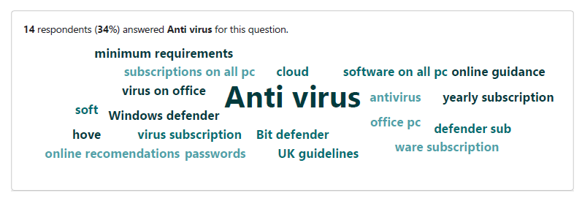
Figure 49 Survey Q11

Q12. What is the priority of cyber security by the company
To gauge companies’ perception. 11% Low (1-2), 66% High (4-5)

- 76% of those that Rated Q12 High, Replied No Q10
- 100% of those that Rated Q12 Low, Rated Q13 Low
- 100% of those that Rated Q12 Low, Rated Q14 Low

Figure 51 Survey Q13

Q13. What do you consider the probability of a cyber-attack on your company
To gauge companies’ perception. 83% Low,

Figure 53 Survey Q13

Q14 How would a cyber-attack impact your company
To gauge companies’ perception. 51% answered Low

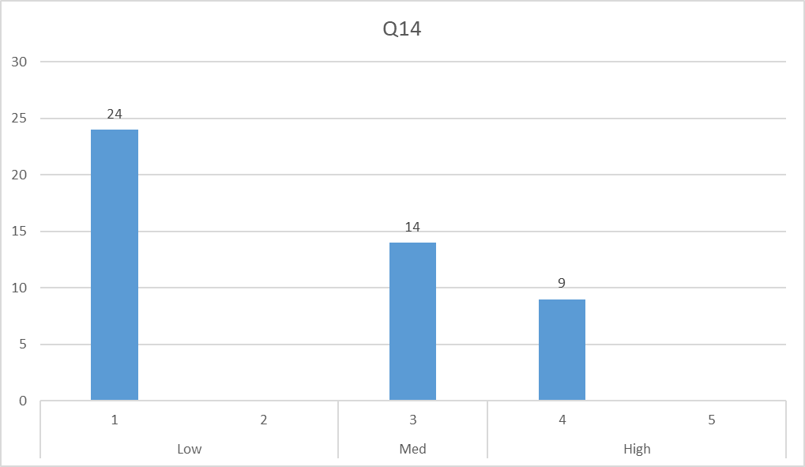

- 84% of those that Rated Q14 Low, Replied No Q10
- 84% of those that Rated Q14 Low, Rated No Q13 Low

Figure 55 Survey Q14

Q15. What do you believe is the greatest cyber threat to your company
To gain an understanding what cyber threats companies’ priorities. - Malware & Phishing
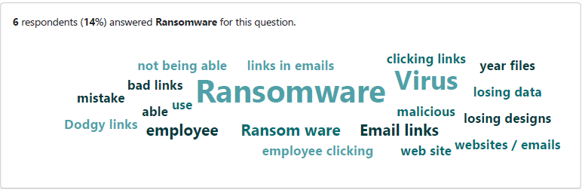

Figure 57 Survey Q15

This has allowed me to understand how the perceived threats are managed and delt with by companies

Interview Results

Q1. How many employees do you have

Figure 58 Interview Q1
This has allowed me to target the ideal focus group for this project

Q2. You indicated in the survey you have policies in place why

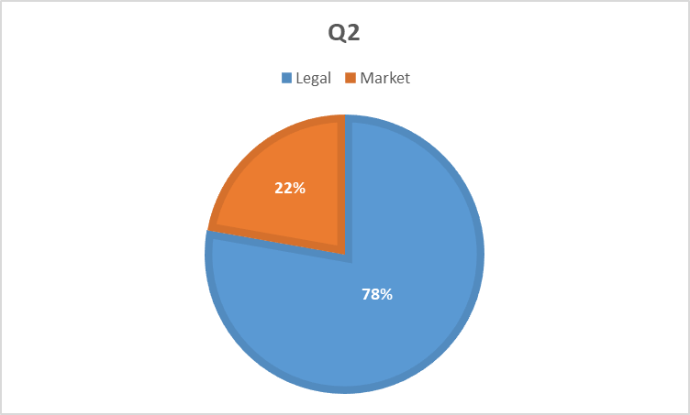
Figure 60 Interview Q2

From, this an understanding was gained of the company’s policy development

Q3. You indicated in the survey you’re the survey what you use the equipment for the following
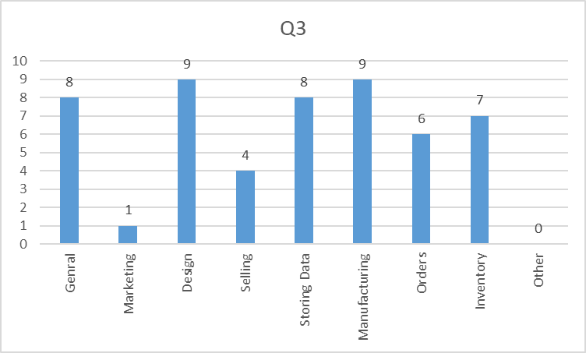
Figure 62 Interview Q3

Q4. Are any of your manufacturing processes automated

Figure 63 Interview Q4

Q5. What Is this equipment used for

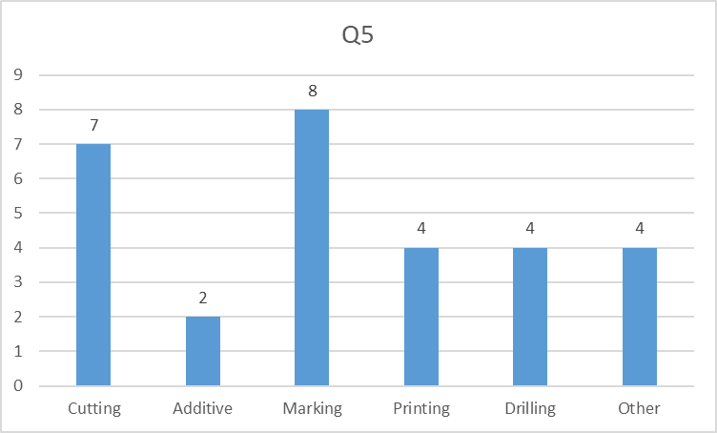

Figure 65 Interview Q5

Q6. Are your production machines & office connected

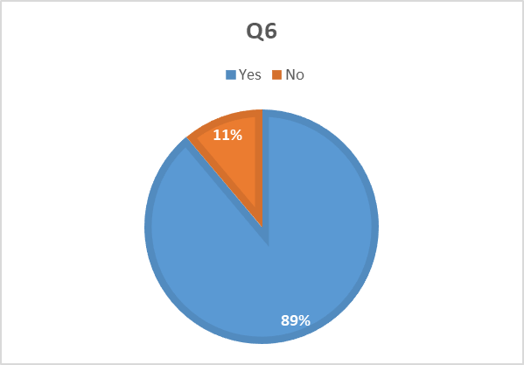

Figure 67 Interview Q6

Q7. Do you consider these machines when thinking about cyber security

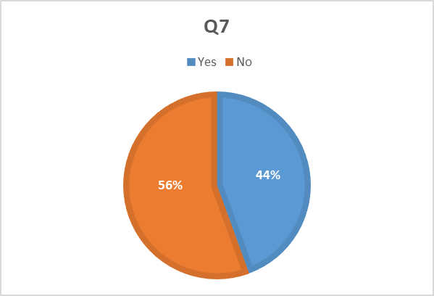

Figure 69 Interview Q7

Q8. What do you believe is the greatest cyber threat to your company

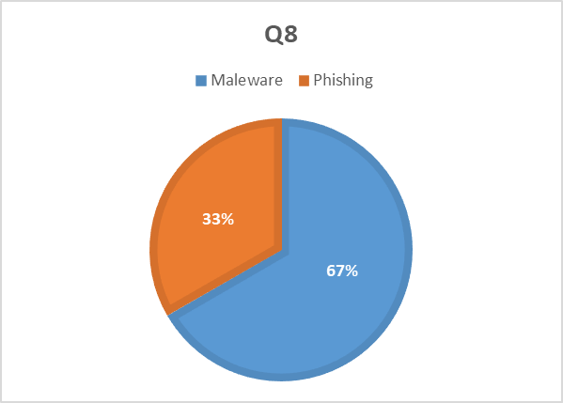

Figure 71 Interview Q8

Q9. What do you see as the restricting factor in your cyber security development/adoption

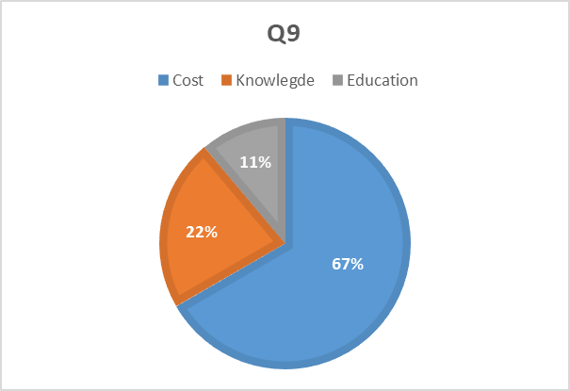

Figure 73 Interview Q9

Q10. What would encourage your company to Develop its Cyber security adoption

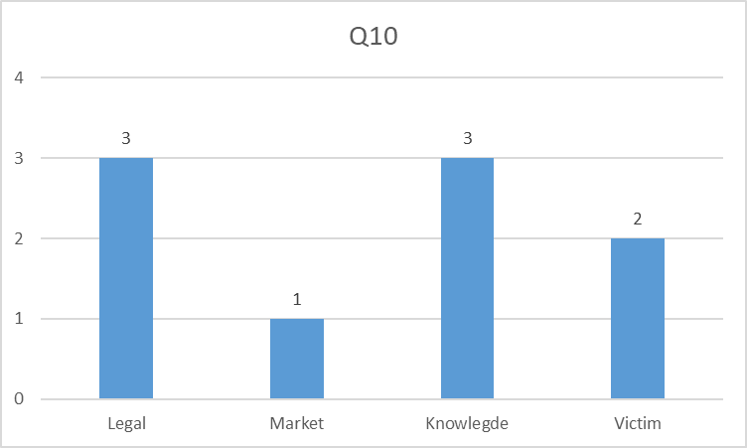

Figure 75 Interview Q10

Analysis of Secondary Data

Literature review
A literature review will undergo content analysis
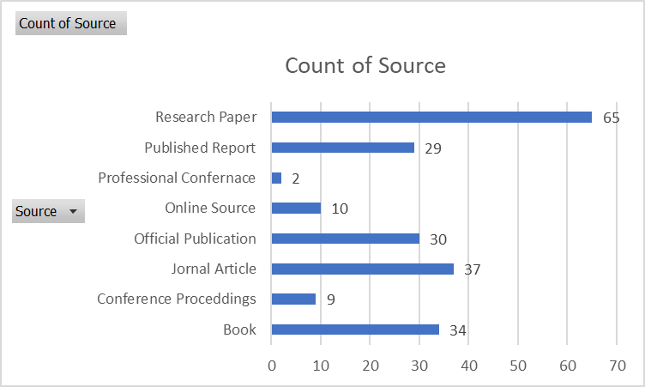
Figure 76 Literature Review
Throughout this Literature review the realisations that these systems are designed for large organisations, this greatly affected availability and suitability of guidelines in the form of standards to an SME, the documentation that was reviewed either had generic information such as creating a backup or required the implementation of steps such as employ an information security officer and instructions on how their segregation of duties need to be applied, some of the most popular standards such as ISO 27001 describe the steps for carrying out the
- design
- implementation
- operation
- control
- Improvement
Implementation of an Information Security Management System, which due to the complexity would require outsourcing carry out.

It was also found the official guidance in the form of guidelines for implementing cybersecurity in an organisation is publicly available,
Accessing these guides in its self is a considerable task, carrying out a simple internet search as shown in the table below returns a daunting number of results.
Search | Results
Cyber Security | 1,250,000,000
Small business cyber security | 205,000,000
Small manufacturer cyber security | 116,000,000
Cyber security for a small manufacturing company | 386,000,000
SME Cyber Security | 13,600,000
Engineering company cyber security | 168,000,000
Workshop cyber security | 29,100,000
Figure 77 Simple Internet Search
These search terms were generated with the help of the survey results, even when publications were found they were often outdated & written more to focus on the current theories behind cybersecurity without providing any practical guidelines.

Chapter 5: Conclusion & Recommendations

Conclusion
My initial theory
- “A lack of education is the main inhibiting factor for the adoption of known cyber security processes in small companies”,
has been proven to be true however, it is one of many factors affecting the adoption of a comprehensive cyber security process.
For an SME the entire procedure of selecting the most suitable process and then tailoring it to suit your organisation and managing its application, is this complexity is the primary reasoning that these processes need to be outsourced however, in the current environment climate where overheads are spiralling upwards, coupled with the lack of understanding the potential risks to the company the cost of outsourcing is either not viable or perceived as not needed.
So, although education is a key factor it is now my believe that the principal reason for lack of adoption is more a factor of the level of complexity required by these systems, which for the constraints on SMEs discourages or even prohibits the acquisition of education. [104]
The fact that every company surveyed and interviewed had policies in place & although the companies with greater than 5 employees Require it by UK Law [31], most policy creation was carried out before these companies reached 5 employees the development of policies was initiated often by the requirements to trade on the online market place, most of these companies have developed comprehensive and thoughtful policies mainly intending to protect the market place of being found in noncompliance such as data management agreements & behavioural guidelines, however, on reviewing these polices often the smaller company’s requirements such as security & procedure are lacking as although they agree to minimum requirements for access to the market place often the application of this minimum requirements is ad hoc.

.Again though this was proven to be more an effect of the level of cyber awareness, the priority company’s gave to cyber security was often decreased because the relationships between the perceived probability & perceived severity were not understood leading to a feeling of it wont happen to us, however those that had been the victim of a cyber incident , realised the impact to every aspect of the company from administrative tasks to manufacturing unfortunately this could only inspired reactive measure, it is my belief that should companies be armed with the knowledge & educated enough to understand the risks removing these barriers then the uptake in cyber security by smaller companies would be greatly increased.
In general, most people wanted to be secure the smaller companies have a personal interest in they’re own companies but the main stumbling block is they don’t know how to, and are more unable to justify the cost of outsourcing rather than the assumption they were unwilling.
However, the beginning of this project was 2020, during the pandemic and national lock downs many companies were forced into digital transformation, to accommodate the work force having to stay at home, this brought about a shift in thinking & the sudden realisation that cyber security is a critical component of the current manufacturing environment, this has seen a increased demand for cyber security specialists & has spurned a new wave of publications of government publications & private company reports that are beginning be availible online, to help SMEs however to find these often takes a lot of trawling through irrelevant and outdated information.
Therefore, the recommendation stage of this project, will focus now on the simplification of the cyber security guidelines, allowing SMEs to use a holistic approach when considering cyber security, this is to allow an increase in adoption by removing several barriers and the simplified application for some of the basic tools & practices readily availible with minimum cost & knowledge.
However, these are only to be considered basic guidelines to increase a company’s cyber resilience, so at least they can be given a fighting chance & hopefully encourage a proactive rather than reactive approach to cyber security. The analysed results confirmed in this project with Mishra et al [105]. “Cyber security awareness is a critical component of their effective cybersecurity strategy.”
DEFENSE-IN-DEPTH
An organization’s cybersecurity goal should protect the assets that it considers critical to success.
There is no easy solution, or “silver bullet” application of cybersecurity tools and practices that address vulnerabilities.
It requires the layered approach of Defence in Depth. It employs a holistic approach to protect all assets, their connections both up and down stream, by using an organization’s available resources to provide effective layers of protection based on the company’s exposure to cybersecurity risks, and the levels that are deemed acceptable
In order to successfully apply a strategy of Defence in Depth, a company must understand the relationship between the cyber threats and the company’s own cyber vulnerabilities to be able to appropriately apply the required controls to put in place.
Cyber Security Awareness
Creating awareness about security issues is imperative for an organization’s overall objective to establish a cyber security Mishra [105] recognised that training and education as effective methods to create cyber awareness and understanding of vulnerabilities made employees aware of the risks and what their responsibilities were to protect against them.
Knowledge of protection. Hayes [106] stressed SME owners must be more aware of cyber security if they are going to avoid becoming victims.

Chapter 6: References

[1] | BBC News, “US fuel pipeline hackers 'didn't mean to create problems,” BBC News, may 2021. [Online]. Available: https://www.bbc.co.uk/news/business-57050690. [Accessed 2022].
[2] | D. Sanger, “Cyberattack Forces a Shutdown of a Top U.S. Pipeline,” NY Times, 2020. [Online]. Available: https://www.nytimes.com/2021/05/08/us/politics/cyberattack-colonial-pipeline.html. [Accessed 2022].
[3] | Deloitte, “Managing the successful convergence of IT and OT,” Deloitte LLP, 2020.
[4] | Cisco, “What is Information Security,” 2018. [Online]. Available: https://www.cisco.com/c/en/us/products/security/what-is-information-security-infosec.html. [Accessed 2020].
[5] | Cisco, “What is Cybersecurity,” Cisco, [Online]. Available: https://www.cisco.com/c/en_uk/products/security/what-is-cybersecurity.html. [Accessed 2022].
[6] | Cambridge Dictionary, “Risk,” in Cambridge Dictonary , Cambridge University Press.
[7] | H. Whitman, Management of Information Security 6th Edition, CENGAGE Learning Custom, 2018.
[8] | S. Saltzer, “The protection of information in computer,” in IEEE , 1974.
[9] | M. M. a. J. C. O. R. Ross, “NIST SP 800-160 Systems security engineering considerations for a multidisciplinary approach in the engineering of trustworthy secure system,” NIST , 2016.
[10] | CYBOK, “The Cyber Security Body Of Knowledge,” CYBOK.Org, 2019.
[11] | Sans, “SANS 2021 Survey: OT/ICS Cybersecurity,” Sans, 2021.
[12] | B. Obama, “Presidential Policy Directive (PPD)-21,” White House, 2013.
[13] | NIST, “Develop a Cybersecurity Framework to Protect Critical Infrastructure (CSF),” NIST, 2018.
[14] | ISA, “ISA/IEC 62443 standard specifies security capabilities for control system components,” ISA, 2022. [Online]. [Accessed 2022].
[15] | NIST, “SP 800-53 Rev. 5 Security and Privacy Controls for Information Systems and Organizations,” NIST, 2020.
[16] | NIST, NIST SP 800-82, Revision 3, Guide to Operational Technology (OT) Security,, The National Institute of Standards and Technology (NIST), 2022.
[17] | ISO, “ISO/IEC 27001 Information security management,” ISO, 2022. [Online]. Available: https://www.iso.org/isoiec-27001-information-security.html. [Accessed 2022].
[18] | MITRE ATT&CK, “MITRE ATT&CK,” 2022. [Online]. Available: http://attack.mitre.org/. [Accessed 2022].
[19] | Cabinet Office, “National Cyber Strategy,” HM Goverment, 2022.
[20] | C. J. Bower, “Disruptive Technologies: Catching the Wave,” Harvard Business Review, no. Jan - Feb, 1995.
[21] | F. Cohen, “What makes critical infrastructures Critical?,” International Journal of Critical Infrastructure Protection, vol. 3, no. 2, pp. 53-54, 2010.
[22] | D. S. Lane Thames, 4.0, Cyber Security For Industry, Springer, 2017.
[23] | Porter, Competitive Advantage: Creating and Sustaining Superior Performance, Free Press, 2004.
[24] | Centre for the protection of National Infrastructure (CPNI), “Critical National Infrastructure,” HM Goverment, 2021. [Online]. Available: https://www.cpni.gov.uk/critical-national-infrastructure-0. [Accessed 2022].
[25] | Porter, HBR's 10 Must Reads on Strategy, Harvard Business Review Press, 2011.
[26] | Womack, The Machine that changed the world, Simon & Schuster UK, 1990.
[27] | N. Slack, Operations Management, Pearson, 2013.
[28] | Johnson, Exploring Strategy, Pearson, 2014.
[29] | Mullins, “Management & Organisational Behaviour,” Pretice, 2010.
[30] | HM Goverment, “Guide to governance and management frameworks,” HM Goverment, 2021.
[31] | “Companies Act 2006,” 2006. [Online]. Available: https://www.legislation.gov.uk/ukpga/2006/46/contents. [Accessed 2022].
[32] | Department for Digital, Culture, Media & Sport , “Proposal for legislation to improve the UK’s cyber resilience,” HM Goverment, 2022.
[33] | “Data Protection Act 2018,” HM Goverment, 2018.
[34] | “General Data Protection Regulation (GDPR),” European Union, 2016.
[35] | Association for Project Management, APM Body of Knowledge, Association for Project Management, 2019.
[36] | Hopkin, Fundamentals of Risk Management: Understanding, Evaluating and Implementing Effective Risk Management, Kogan Page, 2014.
[37] | Crichton, “The Risk Triangle,” United Nations, 1999.
[38] | APMBok, APM Body of Knowlege, association for project managers, 2006.
[39] | Project Management Institute, PMBOK, PMI, 2017.
[40] | R. P. N. a. R. R. C. Peter S. Pande, The Six Sigma Way, McGraw-Hill, 2000.
[41] | J. Liker, The Toyota Way, McGraw-Hill , 2004.
[42] | Mikulak, The Basics of FMEA, Routledge, 2008.
[43] | Deming, Out of Crisis, MIT Press, 1982.
[44] | Kotter, Leading Change, HBR, 2012.
[45] | Lewin, Understanding the three stages of change, 1947.
[46] | B. Burnes, “Kurt Lewin and the Planned Approach to Change: A Re-appraisal,” Journal of Management Studies, vol. 41, no. 6, pp. 1467-6486, 2004.
[47] | A. V. Horenbeek, “A dynamic predictive maintenance policy for complex multi-component systems,” Reliability Engineering & System Safety, vol. 120, pp. 39-50, 2013.
[48] | Wang, “Beyond accuracy : what data quality means to data consumers,” Journal of MAnagement of information systems, vol. 12, pp. 5-33, 2001.
[49] | Wang, “Manage your information as a product,” Sloan Management., 1998.
[50] | Greenhalgh, “The challenge of complexity in health care,” BMJ : British Medical Journal, 2001.
[51] | Redman, Data Quality for the Information Age, Artech House, 1996.
[52] | H. Goverment, “Hidden costs of poor data quality,” HM Goverment, 2021.
[53] | Loshin, Enterprise Knowledge Management. The Data Quality Approach., California: Academic Press., 2001.
[54] | Tayi, “Examining data quality,” Communications of the ACM, vol. 41, pp. 54-57, 1998.
[55] | Loshin, Master Data Management, Elsevier, 2010.
[56] | English, “Improving Data Warehouse and Business Information Quality: Methods for Reducing Costs and Increasing Profits,” Business, Computer Science, 2011.
[57] | Stackpole, Big Data Big Problems, Springer, 2014.
[58] | W. KENTON, “investopedia,” 2021. [Online]. Available: https://www.investopedia.com/terms/m/manufacturing.asp. [Accessed 2022].
[59] | W. B. Heginbotham, “The future and scope of AMT,” The International Journal of Advanced Manufacturing Technology, vol. 1, pp. 7-8, 1985.
[60] | Make UK, “Uk Manufacturing , The facts 2022,” Make UK, 2022.
[61] | House of Commons Library, “Economic Indicators,” HM Goverment, 2022.
[62] | Department for Business, Energy & Industial Stratagy, “BUSINESS POPULATION ESTIMATES FOR THE UK AND THE REGIONS 2021,” HM Goverment, 2021.
[63] | Foreign Commonwealth & Development Office, “Small to medium sized enterprise (SME) action plan,” HM Goverment, 2022.
[64] | Statistics for Wales, “Size Analysis of Active Businesses,” Welsh Goverment, 2022.
[65] | Office of National Statisics, “Analysis of enterprises in the UK for Section C - Manufacturing in Wales 2021,” ONS, 2022.
[66] | R. Matheson, “Customising the future – The next industrial revolution,” Nickel Institute, 2020. [Online]. Available: https://nickelinstitute.org/en/blog/2020/november/customising-the-future-the-next-industrial-revolution/. [Accessed 2022].
[67] | H. L. M. Jacobi, “Bedeutung des Treibers Informations- und Kommunikationstechnik für die Wettbewerbsfähigkeit industrieller Produktion,” Digitale Produktion , vol. 1, 2013.
[68] | P. Ghadimi, “The successful implementation of industry 4.0 in manufacturing: An analysis and prioritization of risks in Irish industry,” Technological Forecasting and Social Change, vol. 175, 2022.
[69] | E. H. &. M. Rüsch, “Industry 4.0 and the current status as well as future prospects on logistics,” Computers in Industry, vol. 89, pp. 23-34, 2017.
[70] | Leong, The Nine Pillars of Technologies for Industry 4.0, IET, 2020.
[71] | NCSC, “Operational technologies,” 2017. [Online]. Available: https://www.ncsc.gov.uk/guidance/operational-technologies. [Accessed 2022].
[72] | Gartner, “Gartner Glossary,” 2022. [Online]. Available: https://www.gartner.com/en/information-technology/glossary/operational-technology-ot. [Accessed 2022].
[73] | Gartner, “Gartner Glossery,” 2022. [Online]. Available: https://www.gartner.com/en/information-technology/glossary/it-information-technology. [Accessed 2022].
[74] | Dragos Industrial Security Conference 2020, Dragos, 2020.
[75] | D. S. P. a. D. C. P. David J. Hickson, “Operations Technology and Organization Structure: An Empirical Reappraisal,” Administrative Science Quarterly, vol. 14, no. 3, pp. 378-397, 1969.
[76] | Britannica, “Ctesibius Of Alexandria,” Encyclopedia Britannica, 2028. [Online]. Available: https://www.britannica.com/biography/Ctesibius-of-Alexandria. [Accessed 2022].
[77] | G. Rathwel, “DESIGN OF ENTERPRISE ARCHITECTURES,” Enterprise Consultants, 2009. [Online]. Available: http://www.pera.net/Levels.html. [Accessed 2022].
[78] | Cupek, “Digital Twins for Highly Customized Electronic Devices,” IEEE Access, 2019.
[79] | Ackerman, Industrial Cyber Security, Packt, 2017.
[80] | Dragos Industrial Security Confernace (DISC) 2021, 2021.
[81] | Thakur, “Leveraging Information and Communication Technologies for Development (ICTD) in the Caribbean,” Geography Compass, vol. 6, no. 1, pp. 1-18, 2012.
[82] | Ackerman, Industrial Cyber Security, Packt, 2021.
[83] | Ginter, SCADA Security What's Broken and How To Fix It, Abterra Technologies Inc, 2016.
[84] | Ginter, Secure Operations Technology, Abterra Technologies Inc, 2018.
[85] | G. J. M. &. V. C. Murray, “The convergence of IT and OT in critical infrastructure,” in 15th Australian Information Security Management Conference, 2017.
[86] | Northcote, Control and Automation of Electrical Power Distribution Systems, CRC Press, 2006.
[87] | Kovaliuk, “Development of SCADA System based on Web Technologies,” International Journal of Information Engineering and Electronic Business, vol. 10, pp. 25-35, 2018.
[88] | Litherland, “Cyber security of operational technology: understanding differences and achieving balance between nuclear safety and nuclear security,” in 11th International Conference on System Safety and Cyber-Security (SSCS 2016), 2016.
[89] | Perelman, “The Future of Industrial Security - IT and OT Convergence,” Security Week, 2017. [Online]. Available: https://www.securityweek.com/future-industrial-security-it-and-ot-convergence. [Accessed 2022].
[90] | Lee, “Paper Cyber-to-Physical or Process Effects,” Sans, 2014.
[91] | Hayden, “Paper An abbreviated history of automation & industrial controls systems and cybersecurity,” Sans, 2014.
[92] | Edgar, Research Methods for Cyber Security, Elsevier, 2017.
[93] | Saunders, Understanding research philosophies and approaches, Pearson, 2009.
[94] | K. Dhargalkar, “A universal new product development and upgradation framework,” Journal of Innovation and Entrepreneurship, no. 27, 2016.
[95] | Siskie, Questionnaire survey research : what works, Association for Institutional Research, 1996.
[96] | Harris, “Mixing interview and questionnaire methods: Practical problems,” Practical Assessment, Research, and Evaluation, vol. 15, 2010.
[97] | Wong, “Probabilistic Local Walks for detecting protein complexes from protein interaction networks.,” BMC Genomics, vol. 14, 2013.
[98] | Tranfield, “Towards a Methodology for Developing Evidence-Informed Management Knowledge by Means of Systematic Review,” British Mangement Journal, 2003.
[99] | Webster, “Analysing the Past to Prepare for the Future: Writing a Literature Review,,” MIS Quartlery, 2002.
[100] | Bauemeister, “Writing Narrative Literature Reviews,” American Psychological Association, 1997.
[101] | Moher, “Preferred Reporting Items for Systematic Reviews and Meta-Analyses: The PRISMA Statement,” Annals of Internal Medicine, 2009.
[102] | ZMud, “Information Technology Implementation Research: A Technological Diffusion Approach,” Management Science, no. 36, pp. 123-139, 1990.
[103] | Wang, “A framework for analysis of data quality research.,” IEE Transactions on Knowledge and Data Engineering, 1995.
[104] | Snyder, “The Simple, the Complicated, and the Complex: Educational Reform Through the Lens of Complexity Theory,” Education Working Papers, no. 96, 2013.
[105] | Mishra, Modern Cybersecurity Strategies for Enterprises, BPB, 2021.
[106] | J. H. Bodhani, “Cyber security: small firms under fire [InformatIon Technology Professionalism],” Engineering & Technology, vol. 8, pp. 80-83, 2013.
[107] | Rumelt, Good Strategy Bad Strategy: The difference and why it matters, Profile Books, 2017.
[108] | Wong, “RAMESES publication standards: meta-narrative reviews,” BMC Medicine, 2013.

Appendix

ONS Report Welsh Manufacturing

Research Method selection

Project Plan
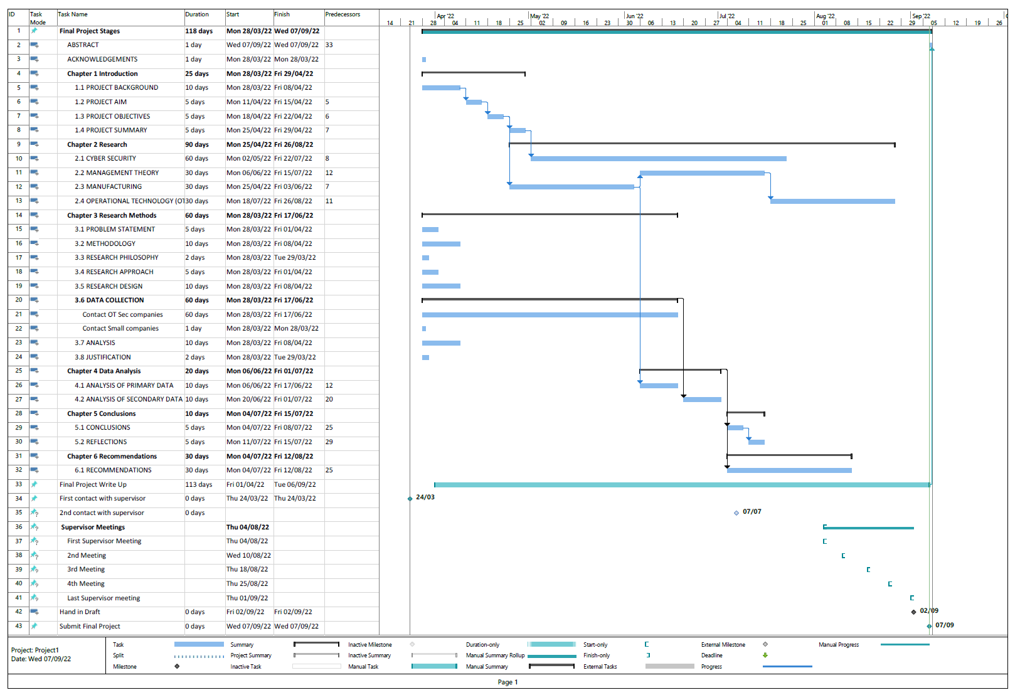

Bibliography

E

