Assignment feedback

Student Name: Mathew Bennett
Student University Email: 1600138@student.uwtsd.ac.uk
Module code: AHAC5008  Module title: Palaeoenvironmental Archaeology | Student ID number:  1600138 |  | Educational support needs:  No
Assignment title: Assignment 1

Assignment due date: 12th December 2017
Assignment Number: 1
(i.e. 1,2,3)
Marker’s signature: |  | Date:
Provisional.
NB. All marks are provisional until confirmed by the final examination board.

Multi-disciplinary practices in Palaeoenvironmental Archaeology

Palaeoenvironmental archaeology, indeed archaeology in general, can be considered to be a multi-disciplinary practice. This is to say that many different aspects that make up Palaeoenvironmental archaeology come from other scientific backgrounds, such as Biology or Geology etc. In this essay I will be looking at two urban archaeological sites, Çatalhöyük and the excavation of Swinegate in York, as I believe that the way these sites have been excavated can show us a multitude of different disciplines that are involved in the archaeological process. I will give a brief explanation of each site which can give us some context as to why some of these techniques have been used. Throughout this essay I will be looking at certain aspects and specific disciplines and how they individually apply, and how they can be used as a group, in Palaeoenvironmental Archaeology.

First of all, we must say what an Urban site actually is, as these sites will form the basis of the essay. An Urban Site is an area in which there is a higher population of humans, typically associated with areas such as cities, towns conurbations and suburbs (Urban 2017). This term applies not only to modern life, but can also be applied to ancient areas of higher populations, and thus we can consider sites like Uruk or Çatalhöyük to be Urban centres. However, this isn’t the only type of Urban archaeology as smaller sites that are situated within modern urban areas are also called Urban sites and consist as part of Urban archaeology, this includes such sites as the excavation at Swinegate, an excavation in a much smaller area than that of Çatalhöyük. I believe that both of these sites, that are vastly different in content, will provide an excellent backdrop as to why Palaeoenvironmental archaeology is a multi-disciplinary subject.

Çatalhöyük is a site situated in Central Anatolia (modern turkey) that dates back to around 7400 BCE to around 5700 BCE (Cressford 2001) and is considered to be one of the earliest continuously inhabited areas. First excavated by James Mellaart in 1958, it is currently being headed by Ian Hodder (et al. 2017), one of the forbears for the theory of past-processional archaeology (Johnson 2010, and Cipolla and Harris 2017). The site itself is split into two mounds, East and West, each with an independent settlement, with the West site being settled during/after the East site was originally settled (Mellaart, 1962). The site is made up of dwellings, both fauna and floral remains, human remains and culture pieces (Mellaart 1962) (such as figurines and art), making the site very rich in archaeological material and a gem in the archaeological community. This differs from the excavation at Swinegate, a site that dates from the roman occupation of Britain up until the modern era (McCormish 2015). The site has remains from the main periods of settlement, and itself is situated in York [Figure 1], from roman artefacts to full skeletal remains in wooden coffins. This contrast in material and use of scientific methods provides good context as to why Palaeoenvironmental archaeology is multi-disciplinary in nature.

Due to the massive amount of material at Çatalhöyük, it is obvious that many different aspects of science are needed to be able to fully analyse this still ongoing site. First, I will discuss the matter of actually dating the site and thus establishing it as one of the earliest urban sites. Cressford (2001) used 10 samples from different layers of the site [Figure 2] (though he does state these are only from the Eastern site) with [Figure 3] showing the dated calibrations of these samples in a graph. As stated in Cressford’s article these where obtained using “accelerator mass spectrometry at the Oxford Radiocarbon Accelerator Unit of the Research Laboratory for Archaeology and the History of Art” and “They were calibrated using the OxCal program (v.3.5) (Brook Ramsey 2000) using atmospheric data from Stuiver et al. (1998)”. This already demonstrates how Palaeoenvironmental archaeology is drawing on other disciplines, as this technique is based on physical and chemical notions, using calibration curves lending from mathematics and computer programming (Ramsey 2000 cited in Cressford 2001) to make the software and atmospheric data from dendrochronology (Stuiver et al. 1998). These dates show us that the range of results for these samples falls under the broad range of 7480 cal BCE to 6690 cal BCE (all samples calibrated at 95% probability). Though this does not show the age of the whole site it does show us the range for Level XII, an area in which Mellaart’s general system for dating the site could not be applied due to no buildings being present (Cressford 2001). Thus, the use of radiocarbon dating for the pre-XII Level would provide accurate (at this time) points which can we can then use a these to create an intra-site chronology for dating in years to come (Cressford 2001: 717). In comparison, the Swinegate excavations had many different portions that needed to be dated, but for this section I will be focusing on trench 3 and the coffins that lay within (McCormish 2015:13). In McCormish’s report it has been stated that the burials from Trench 3 date from the end of the 9th century to the start of the 11th century (Bagwell and Tyres 2001, cited in McCormish 2015:13). He later on states that one of the burials was also dated using C14 dating to “with a 95% degree of probability to the period 1076-1154” though he doesn’t establish what curve and system he used. These are some of the many ways in which Palaeoenvironmental archaeology can be considered to be multi-disciplinary in nature, showing us how different types of dating can be used to create an idea of how old individuals or a whole site is based on the dates calibrated from either radio carbon dating or dendrochronology, tree ring dating.

Osteoarchaeology can also tell us about sites and individuals, and it a great asset to the field of Palaeoenvironmental archaeology. Though there are human remains at Çatalhöyük, I will be focusing on Swinegate for this section of the essay, but I will touch on Çatalhöyük later. Osteoarchaeology can contribute much to a site, indeed it can not only tell us about an individual(s), if there are enough skeletal remains, but also diet at the time, problems such as degenerative diseases etc. The osteoarchaeological report for Swinegate was done by York Osteoarchaeology Ltd, for the seven skeletons from St Benet’s, Churchyard (Keefe and Holst 2015). This report tells us some interesting points about the individuals buried at the site, for instance we can see from their bones that there is evidence in all 5 adults at the site of joint degeneration, but it was more prolific in the more mature adults (Keefe and Holst 2015:22) and that there was trauma to the spine. This suggests to us that they were more than likely to have contributed to hard physical labour, possibly from a young age (lesser spinal damage in the 2 adolescents) which tells us about the working conditions in this area of Britain during the time period. This can indicate some idea about the society and how it functioned. The individuals also seem to all have some health problems which could have been caused by stress in childhood (Keefe and Holst 2015:27). This osteoarchaeological report is useful to us as it provides excellent detail of these citizens and how they fit into the wider picture, it also adds another discipline to that of Palaeoenvironmental archaeology as to suggest the multi-disciplinary nature of the subject.

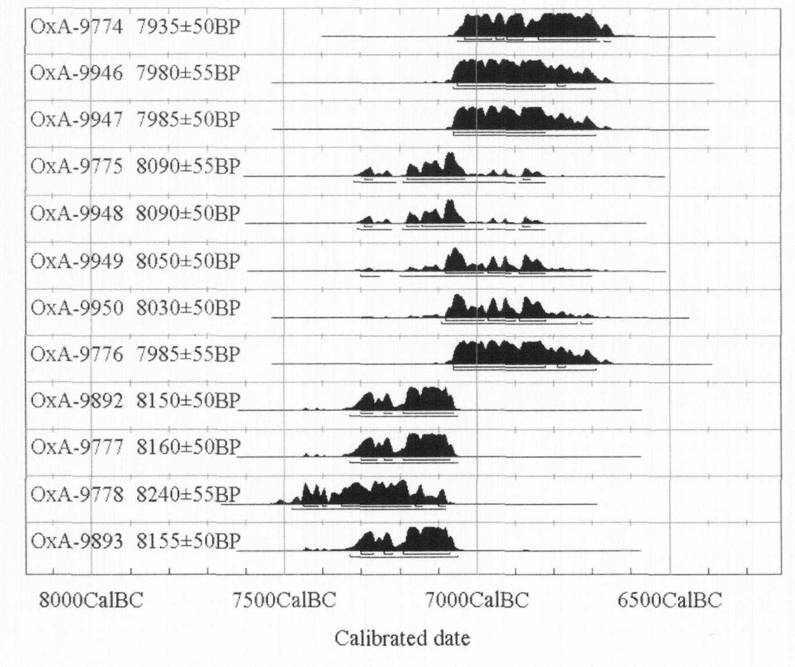
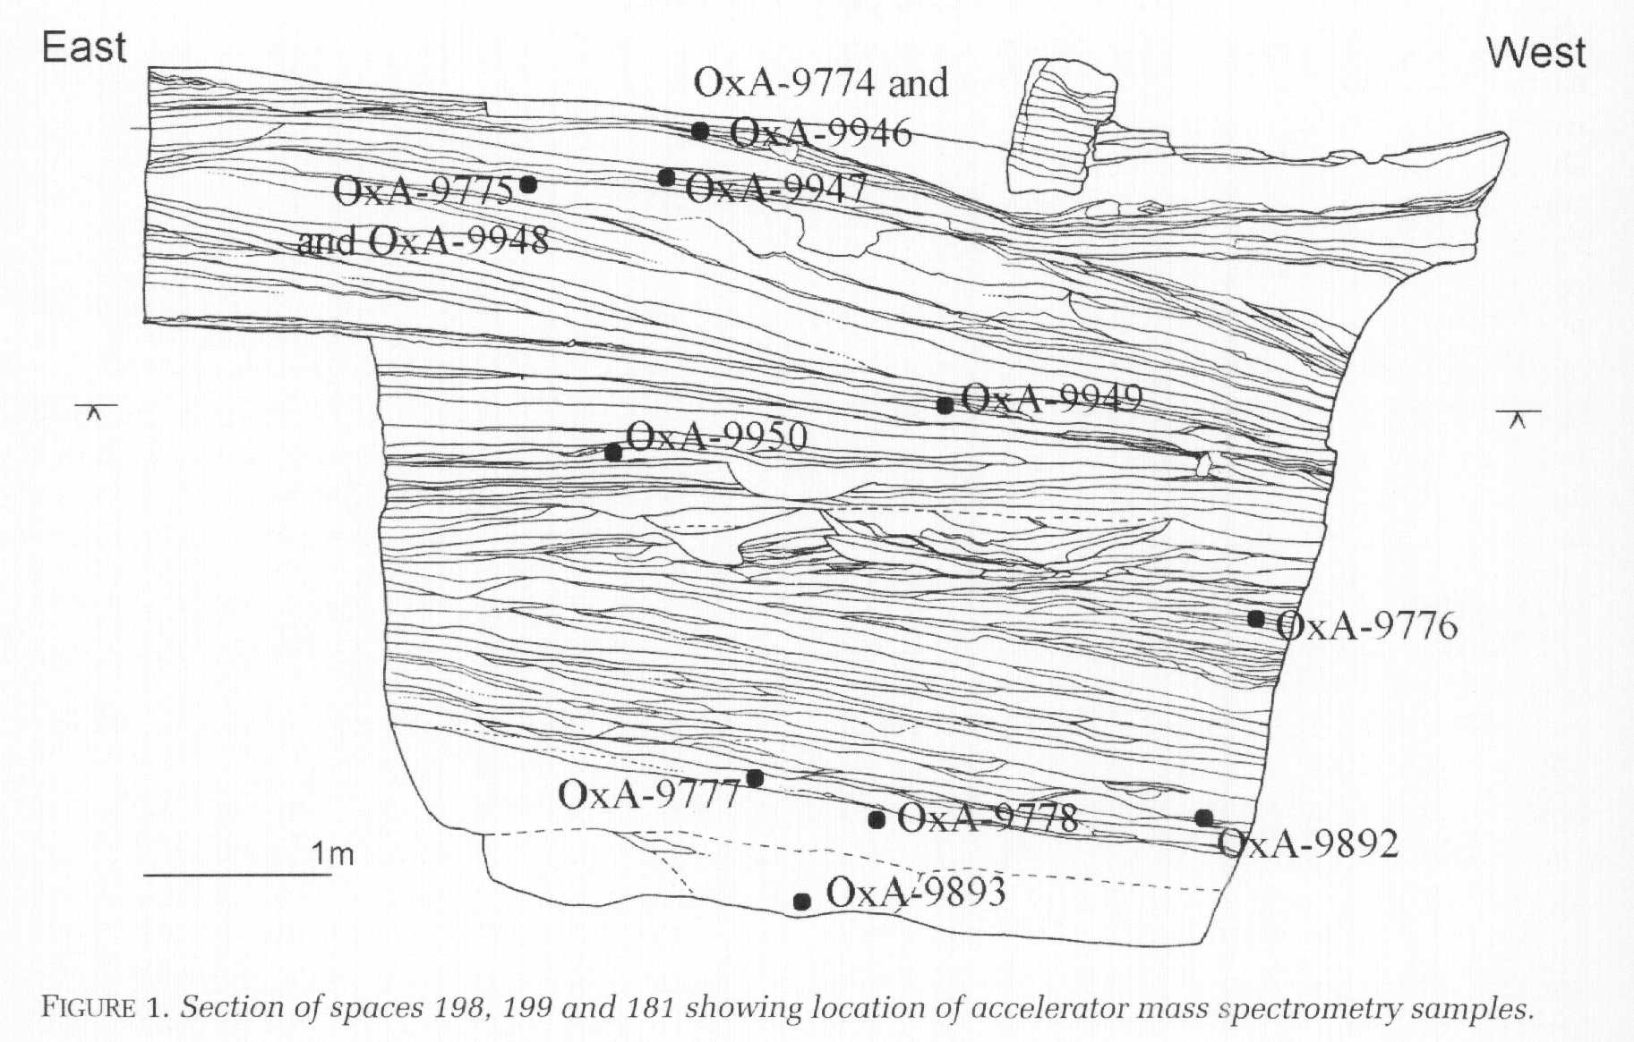
Figure 3: Calibrated radiocarbon dates from the 10 samples
Figure 2: Sample area cross section at Çatalhöyük

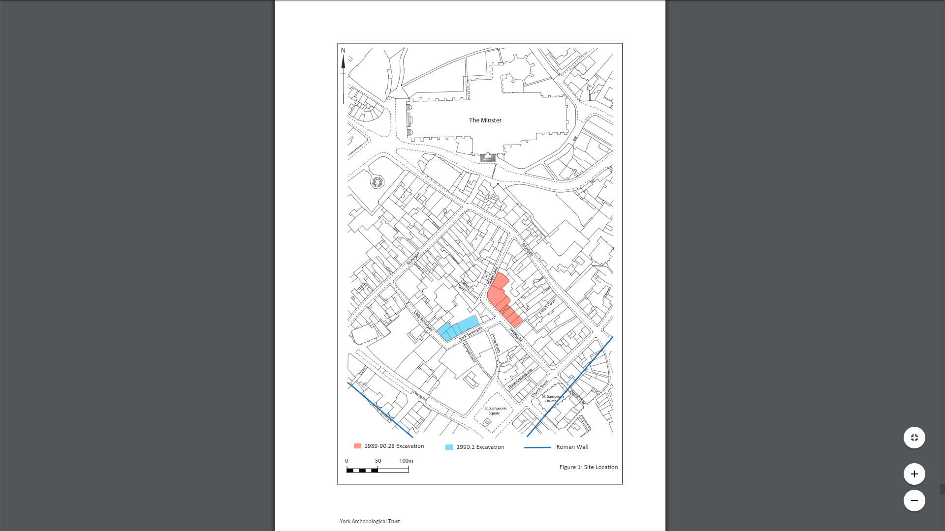
Figure 1: Swinegate site location in York

When looking at sites it is important to take into account the surrounding area, or at least what the area would have been like when the site was in use, as often the surround area influences how a site was used. Due to limitations when looking at the site during the excavation phase it can be difficult to establish what the area around the site may have looked like, thus we need to use techniques such as archaeobotany to create an accurate picture. At Çatalhöyük (East) Asouti and Hather (2001) use charcoal analysis of charcoal assemblages in the archaeological record, the results of which can be seen in [Table 1], taken from material in the 1996/97 seasons from roughly levels V-VIII. Though this graph contains a lot of information, it is crucial to developing an idea of the surrounding environment. This graph tells us of the multitude of different plant remains present in levels V-VIII which could be present for a multitude of reasons. We do see an abundance of tree types and shrubbery, from this we can infer that the area surrounding Çatalhöyük at this time seems to be woodland. From this we can gleam what kind of lifestyle the inhabitants led, possibly a substance lifestyle with little game meat? Or a sedimentary lifestyle which relied heavily on hunting? It is hard to say based on just this data, but when combined with data gathered from other sources we can gain a better idea of what it may be like. This use of archaeobotany only furthers and expand upon the concept that Palaeoenvironmental archaeology is multi-disciplinary in its nature.

In conclusion I believe that it can be suggested that Palaeoenvironmental archaeology is multi-disciplinary in nature. Using our two case study sites, Çatalhöyük and Swinegate, as examples of Palaeoenvironmental archaeology in the field we can say to what extent Palaeoenvironmental archaeology is multi-disciplinary. Due to the multitude of different aspects and fields that are used when analysing a site; such as radiocarbon dating, osteoarchaeology, archaeobotany etc. all these different disciplines are required when analysing a site, both during excavation and in post-excavation, and if we only relied on archaeology many of the different pieces of information that make up a site would not be available to us, preventing us from seeing the ‘whole’ of the site (including the natural area that may have once surrounded and influenced said site). Thus, Palaeoenvironmental archaeology is multi-disciplinary in nature.

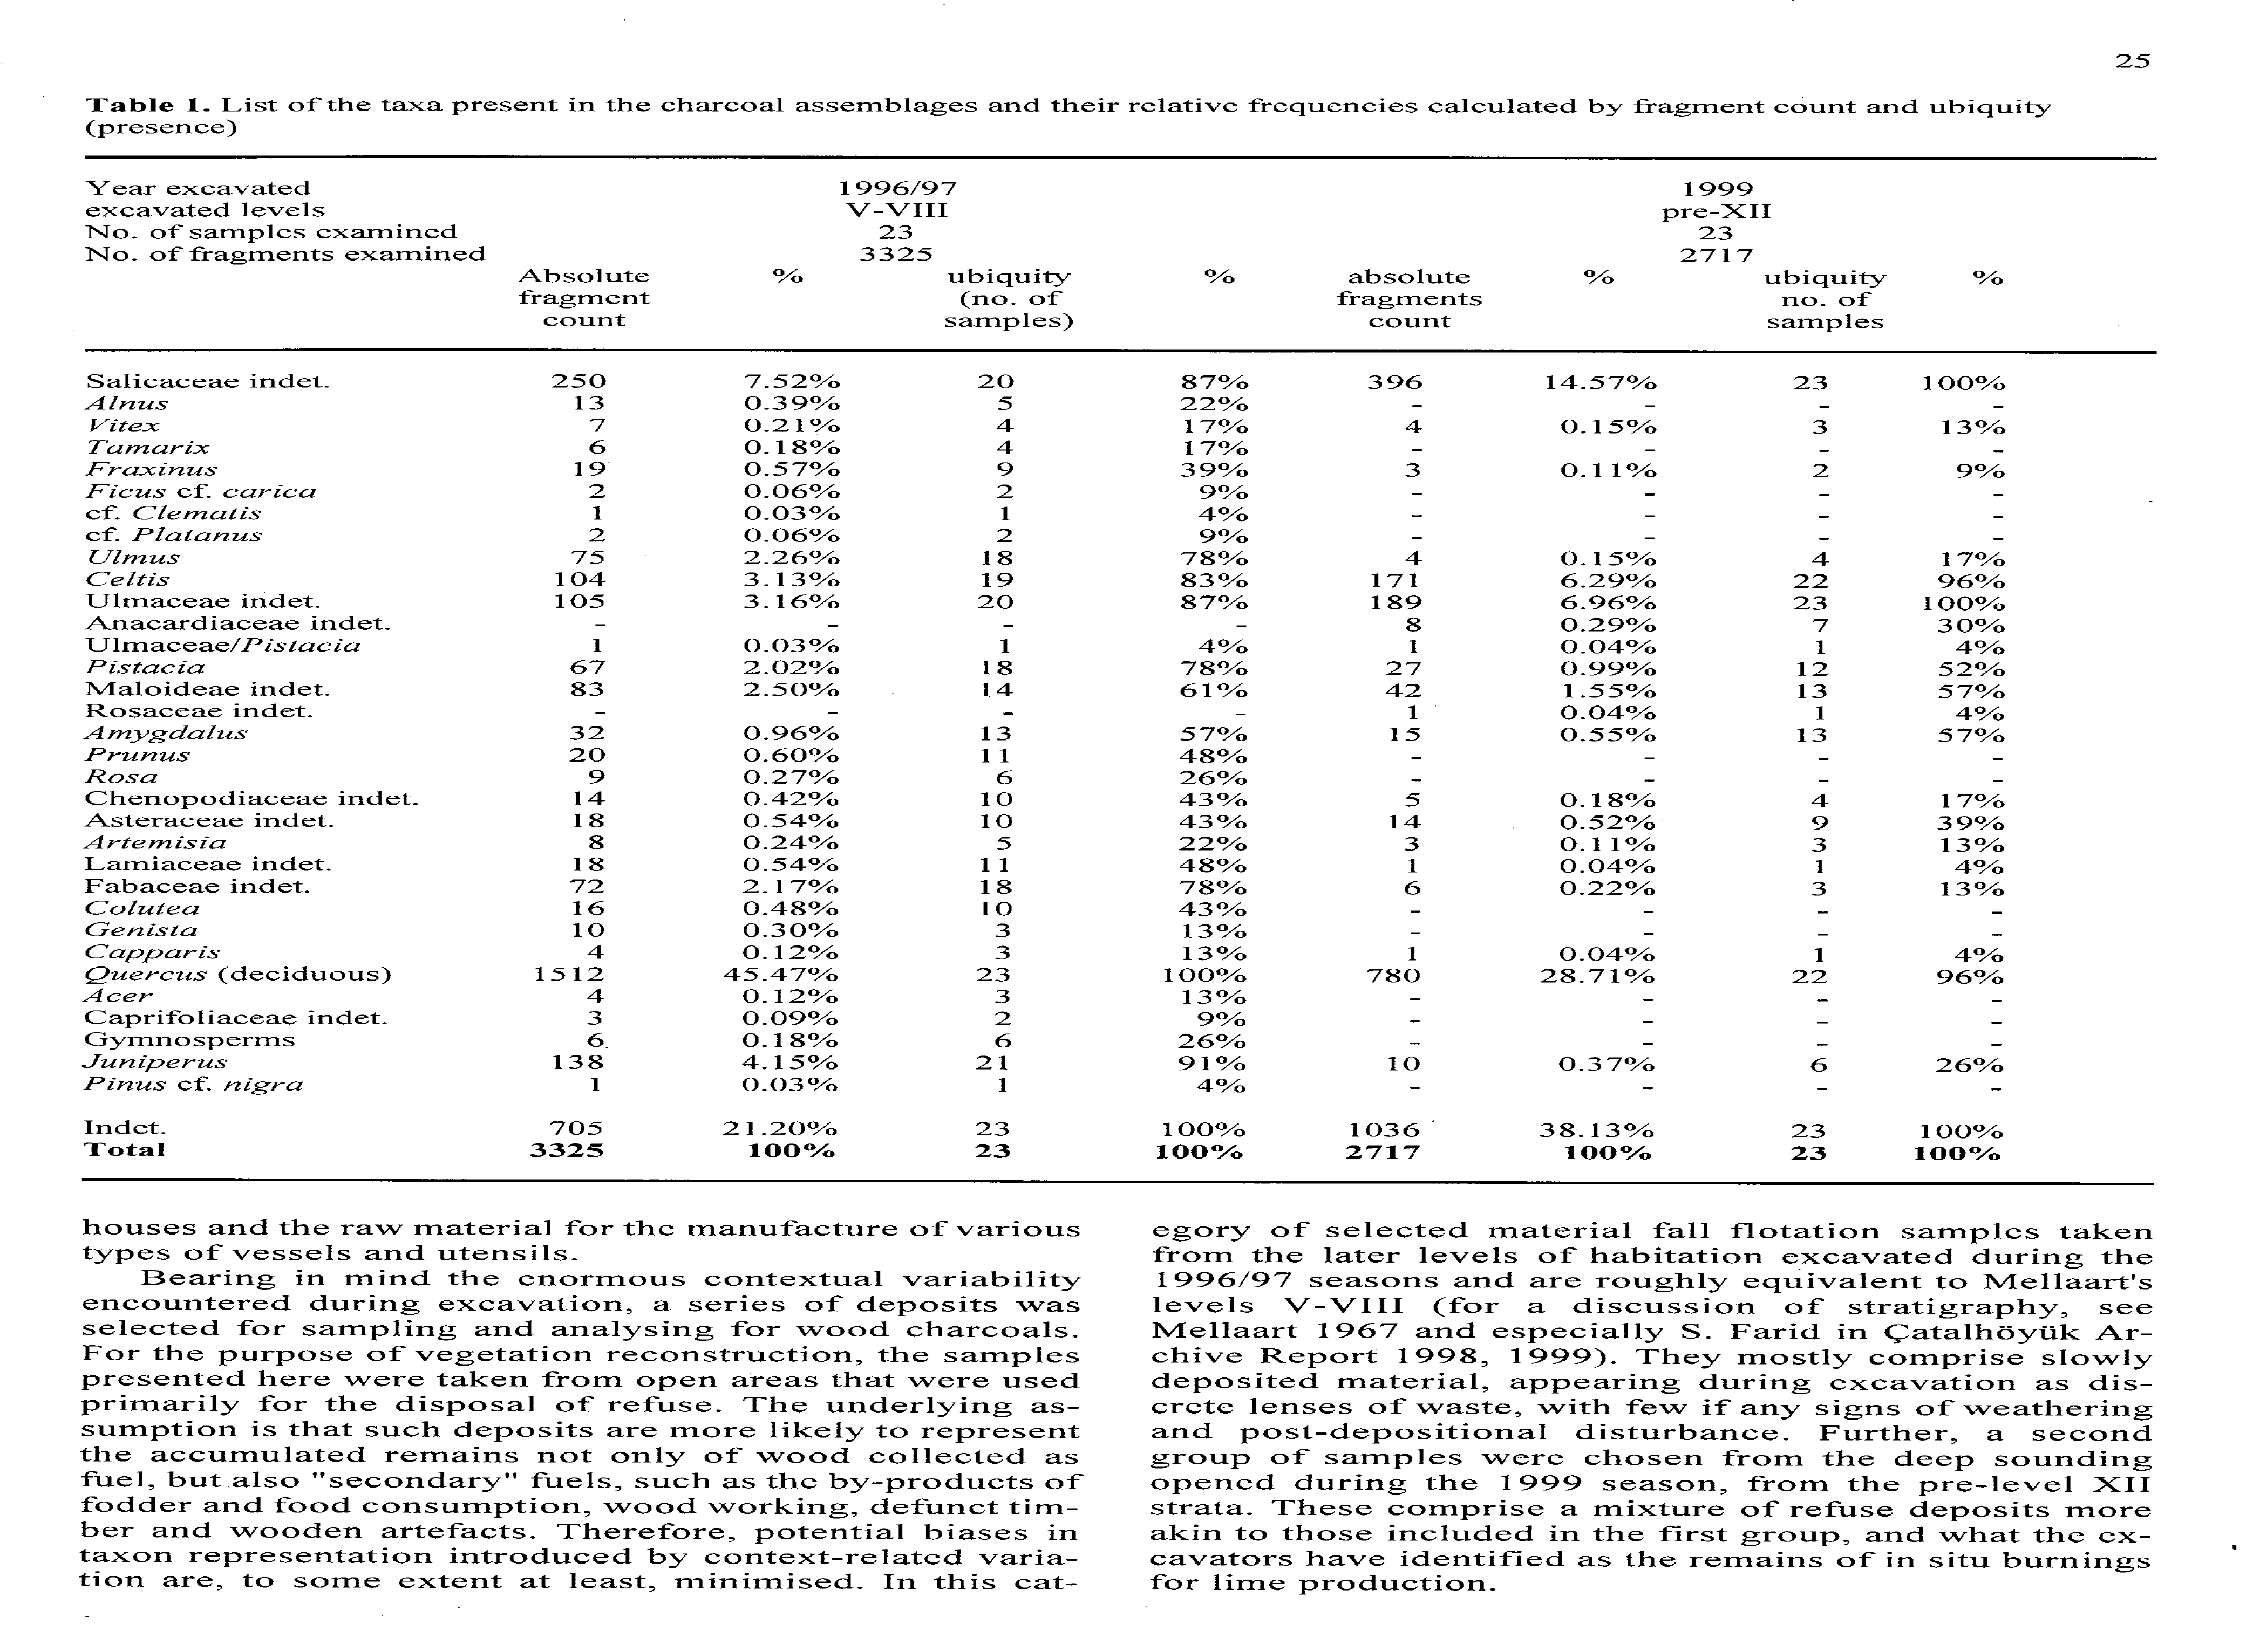
Table 1: List of taxa present in the assemblages, and their relative frequencies

References

Asouti, E. and Hather, J. (2001). Charcoal analysis and the reconstruction of ancient woodland vegetation in the Konya Basin, south-central Anatolia, Turkey: results from the Neolithic site of Çatalhöyük East. Vegetation History and Archaeobotany, [online] 10(1), pp.23-32. Available at: https://link-springer-com.ezproxy.uwtsd.ac.uk/article/10.1007/PL00013369 [Accessed 9 Dec. 2017].

Buckley, R., Morris, M., Appleby, J., King, T., O'Sullivan, D. and Foxhall, L. (2013). ‘The king in the car park’: new light on the death and burial of Richard III in the Grey Friars church, Leicester, in 1485. Antiquity, [online] 87(336), pp.519-538. Available at: https://www.cambridge.org/core/journals/antiquity/article/king-in-the-car-park-new-light-on-the-death-and-burial-of-richard-iii-in-the-grey-friars-church-leicester-in-1485/EB678293FE20EF21D246D149766A95F4 [Accessed 8 Dec. 2017].

Cessford, C. (2001). A new dating sequence for Çatalhöyük. Antiquity, [online] 75(290), pp.717-725. Available at: https://search-proquest-com.ezproxy.uwtsd.ac.uk/docview/217561434/fulltext/1F7C9B8D368E415APQ/1?accountid=130472 [Accessed 8 Dec. 2017].

Cipolla, C. and Harris, O. (2017). Archaeological theory in the new millennium. Oxon: Routledge, pp.22-26.

Hodder, I. (2017). Çatalhöyük 2017 Archive Report, by members of the Çatalhöyük Research Project. Çatalhöyük Archive Report. [online] Available at: http://www.catalhoyuk.com/research/archive_reports [Accessed 6 Dec. 2017].

Johnson, M. (2010). Archaeological Theory: An intoduction. 2nd ed. Singapore: Wiley-Blackwell, pp.102-121.

Keefe, K. and Holst, M. (2015). Osteological Analysis 12-18 Swinegate, 14 Little Stonegate & 18 Back Swinegate, York, North Yorkshire. [online] York Archaeological Trust for Excavation& Research Ltd. Available at: http://www.yorkarchaeology.co.uk/wp-content/uploads/2015/08/St-Benets-Swinegate-Osteological-Analysis-December-2015-2.pdf [Accessed 8 Dec. 2017].

King, T., Fortes, G., Balaresque, P., Thomas, M., Balding, D., Delser, P., Neumann, R., Parson, W., Knapp, M., Walsh, S., Tonasso, L., Holt, J., Kayser, M., Appleby, J., Forster, P., Ekserdjian, D., Hofreiter, M. and Schürer, K. (2014). Identification of the remains of King Richard III. Nature Communications, [online] 5, p.5631. Available at: https://www.nature.com/articles/ncomms6631?message-global=remove&hc_location=ufi [Accessed 8 Dec. 2017].

McCormish, M. (2015). ARCHAEOLOGICAL INVESTIGATIONS AT 12-18 SWINEGATE, 14 LITTLESTONEGATE AND18 BACKSWINEGATE. [online] York. Available at: http://www.yorkarchaeology.co.uk/wp-content/uploads/2015/08/Swinegate-Final-text-with-Figures.pdf [Accessed 8 Dec. 2017].

Mellaart, J. (1962). Excavations at Çatal Hüyük: First Preliminary Report, 1961. Anatolian Studies, [online] 12, pp.41-65. Available at: http://www.jstor.org.ezproxy.uwtsd.ac.uk/stable/3642517?sid=primo&origin=crossref&seq=2#page_scan_tab_contents [Accessed 8 Dec. 2017].

Stuiver, M., Reimer, P. and Braziunas, T. (1998). High-Precision Radiocarbon Age Calibration for Terrestrial and Marine Samples. Radiocarbon, [online] 40(03), pp.1127-1151. Available at: https://journals.uair.arizona.edu/index.php/radiocarbon/article/viewFile/3786/3211 [Accessed 9 Dec. 2017].

Urban. (2017). In: Oxford Dictionary. [online] Oxford University Press. Available at: https://en.oxforddictionaries.com/definition/urban [Accessed 8 Dec. 2017].

