

THE ROLE OF TRANSFORMATIONAL LEADERSHIP STYLE IN MANAGING MULTICULTURAL TEAMS IN INTERNATIONAL BUSINESSES
Name: Tanya Eftimova
Student ID: 2317898
Abstract
This dissertation critically assesses the influence of transformational leadership on the management of multicultural teams in the context of international business. In an era of escalating global integration, firms increasingly leverage diverse workforces, which can be a source of numerous advantages as well as potential impediments. Though multicultural teams are recognised for their capacity to foster creativity, innovation, and a broader range of problem-solving approaches, they frequently face substantial impediments, including language differences, cross-cultural misunderstandings, barriers to effective communication, trust deficits, and friction among team members.
The study is qualitative secondary research, where a thematic review of academic literature, peer-reviewed journal papers, and reliable corporate papers is applied in exploring ways that transformational leadership can address such problems. An interpretivist philosophy of research along with the application of deductive approach will be used in the research, where relevant leadership and intercultural management theories will be used. The findings of the study show that transformational leadership traits, including idealized influence, inspirational motivation, intellectual stimulation, and individualized consideration, can be effective in improving communication, building up teamwork, as well as raising employee performance in culturally diverse situations. Transformational leaders are capable of creating a psychologically safe environment, inspiring a common vision, encouraging participation, and providing personal guidance based on diverse cultures.
However, various limitations were established, among them the cultural variance in the leadership effectiveness, a potential exaggeration of individual personality of a leader, and the requirement for culturally intelligent strategies. The results contribute to the current body of literature by bringing together the theories of transformational leadership and multicultural team management, and giving practical recommendations to multinational corporations in order to effectively use workforce diversity. Such recommendations include the development of leadership, cultural intelligence training, and establishment of effective communication channels. This study generates important understandings for managers and organisational executives dealing with the challenges of multicultural teams in the prevailing globalized commercial climate.
Keywords: Transformational leadership, multicultural teams, international business, cultural diversity, team cohesion, employee engagement, cross-cultural management

Acknowledgements
I would like to take this opportunity to thank everyone who helped me in this research process. My heartfelt thanks go to my advisor who has immensely helped me through his/her guidance, feedback, and encouragement. Their contributions have made a significant impact on this dissertation and have improved the quality of this research. I also thank the teaching faculty and librarians for providing me access to important databases and information sources. Moreover, I thank my family members and friends who have helped me in this difficult period. Their encouragement is a constant source of motivation for me.

Declaration
In this regard, I hereby certify that the above-mentioned dissertation entitled “The Role of Transformational Leadership Style in Managing Multicultural Teams in International Business” is my own original work and that all sources used in this study have been duly quoted and acknowledged as per the standards of academic referencing. I further certify that this work has not been previously submitted for any other degree or professional qualification at any other institute. It is to be understood that any form of plagiarism and/or academic dishonesty is strictly prohibited and I have followed all ethical norms in conducting this research.
Table of Contents
Chapter 1: Introduction 8
1.1 Background of the Study 9
1.2 Problem Statement 9
1.3 Research Aim 10
1.4 Research Objectives 10
1.5 Research Questions 10
1.6 Research Rationale and Significance 10
1.7 Structure of the Dissertation 11
1.8 Chapter Summary 12
Chapter 2: Literature review 13
2.1 Introduction 13
2.2 Definition of transformational leadership 13
2.3 Evaluating the main characteristics of transformational leadership. 15
2.4 The benefits of transformational leadership 16
2.5 The limitations of transformational leadership 18
2.6 Literature gap 19
2.7 Chapter Summary 19
Chapter 3: Research Methodology 20
3.1 Introduction 20
3.2 Research Philosophy 20
3.3 Research Approach 20
3.4 Research Design 21
3.5 Data Collection Method 21
3.6 Sampling Strategy 22
3.8 Ethical Considerations 23
3.9 Limitations of the Methodology 24
3.10 Chapter Summary 24
Chapter 4: Findings and Analysis 25
4.1 Introduction 25
4.2 Key Challenges Faced by Multicultural Teams 25
4.3 Role of Transformational Leadership in Improving Communication 27
4.4 Role of Transformational Leadership in Building Team Cohesion 29
4.5 Role of Transformational Leadership in Improving Motivation and Performance 31
4.6 Critical Analysis of Transformational Leadership in Multicultural Teams 32
4.7 Chapter Summary 34
Chapter 5: Conclusion, Limitations and Recommendations 35
5.1 Introduction 35
5.2 Achievement of Research Aim, Objectives and Questions 35
5.3 Summary of Research findings and outcomes 36
5.4 Original Contribution of the Research 36
5.5 Recommendations 36
5.6 Limitations and Further Research 37
5.7 Chapter Summary 37
References 38

List of Figures
Figure 1.1: Structure of the dissertation 11
Figure 2.1: Key Components of Transformational Leadership 14
Figure 2.2: Influence of Transformational Leadership on organisation 15
Figure 2.3: Benefits of Transformational Leadership 17
Figure 4.1: Key factors to consider for multicultural teams 26
Figure 4.2: Overview of Transformational Leadership 28
Figure 4.3: Key trends in employee engagement factors 30
Figure 4.4: Influence of Transformational Leadership on Teams 33

Chapter 1: Introduction

1.1 Background of the Study
Globalisation has accelerated at an alarming rate, changing the nature of today's organisations and allowing companies to operate internationally and hire people from different cultures (Lazarova et al., 2023). Multicultural teams are a crucial part of an organization's success as multinationals expand their business operations overseas. Multicultural teams are groups of employees from various countries, languages, values, beliefs and working methods who work together towards shared working goals.
It has long been accepted that workplace diversity offers a competitive edge. Research shows that diverse teams in organisations are more creative, innovative and adept at problem-solving. Businesses with strong ethnic and cultural diversity are, on average, 39% more likely to perform better financially than those with less diversity, and diverse teams are, on average, 33% more likely to perform better than less diverse teams (McKinsey & Company, 2023). The results underscore the increasing relevance of the field of diversity management within international companies.
Multiculturalism, while a potential strength in the workplace, can also lead to many issues. The challenges are due to language barriers and different communication styles, working values and working styles and can all lead to conflict within teams. Research has identified that 42 percent of employees working within global teams find themselves struggling with communication due to language and a further 33% cite cultural differences as a barrier to effective team collaboration (Carucci, 2024). These factors could all prove problematic and negatively impact employee motivation, team cohesion, and the organisation's performance.

1.2 Problem Statement
Multicultural teams are becoming increasingly common in businesses around the globe, especially where they interact with international partners, leading to new management challenges for organisations. Although cultural diversity is positive as it allows new innovative ways of doing business or of making decision, it may lead to communication gap, interpersonal conflicts, lack of coordination, and make managing teamwork more complicated. Evidence suggests that 42% of employees in global teams experience language-related communication challenges, while 33% encounter cultural misunderstandings that negatively affect collaboration and workplace relationships (Arman et al., 2024). These issues can reduce productivity and limit the potential benefits of workforce diversity when not managed effectively.
This is also reflected in trends in the global workforce. In 2025, Gallup reported that employee engagement in the workplace is in a crisis, with only one in five employees globally engaged, meaning that the cost of the lost productivity is estimated to cost $10 trillion in the United States alone (Gallup, 2025). Employees' expectations of workplace communication, motivation and support are likely to vary, and leadership effectiveness has a significant impact on employee engagement, especially in diverse work environments.
Research on workplace diversity and on leadership, including transformational leadership, has been conducted independently, but little research considers transformational leadership in the context of multicultural teams and international business environments. While the benefits of diversity are emphasised in current literature, less attention is paid to mechanisms for addressing cultural differences and reinforcing team cohesion in the context of leadership (Arman et al., 2024). Hence, additional research is needed to explore the role of transformational leadership in addressing multicultural team issues in organisations, employee engagement, and team performance in international business settings.

1.3 Research Aim
Aim
The primary aim of this research is to examine the role of transformational leadership in properly managing multicultural working teams in international business processes.

1.4 Research Objectives
- To evaluate the main characteristics of transformational leadership.
- To explore significant challenges in multicultural working teams.
- To analyse the working capabilities of transformational leadership.

1.5 Research Questions
a. What are multicultural working teams?
b. What is transformational leadership?
c. How can transformational leadership improve team management and cohesion?

1.6 Research Rationale and Significance
Multicultural teams are increasingly a part of international organisations due to the globalisation of business operations. Workforce diversity has its advantages, including more creative and innovative thinking, a wider perspective, and other benefits, but it can also be difficult to communicate, trust, handle conflict and manage cultural differences (Taras et al., 2021). Many organisations are expanding their operations internationally and the effectiveness of managing culturally diverse employees is a key factor that can affect the success of many organisations.
This study arises from the need to understand how leadership can tackle issues in multicultural teams. The transformational leadership has been extensively acknowledged for its impact on inspiring employees, fostering cooperation and developing an organizational vision (Arman et al., 2024). Nevertheless, it is essential to explore the positive impact this leadership style can have on multicultural team management in international business settings specifically.
The academic and practical importance of this research are of great importance. Academically, it contributes to the existing literature by bringing together research on transformational leadership and multicultural team management. The findings have implications for managers and organizational leaders wishing to facilitate team cohesion, employees' engagement and improve overall performance for culturally diverse teams. (Lazarova et al. 2023) Moreover it provides direction for organization practices in regard to leadership styles that foster cross cultural collaboration and create inclusive environment.

1.7 Structure of the Dissertation
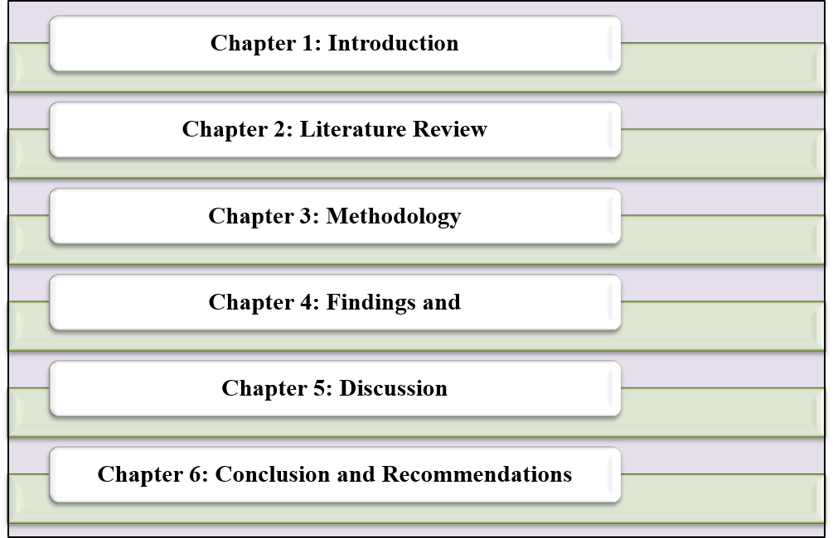

Figure 1.1: Structure of the dissertation

This dissertation has five chapters. The research topic, background, problem statement, aim, objectives, research questions, rationale and significance of the study are introduced in Chapter 1. The relevant literature on the topic of transformational leadership is discussed in Chapter 2 as well as the literature related to multicultural teams and international business. The research methodology is explained in chapter 3 which explains the research design, data collection method and ethical consideration. The research findings are presented and analysed in Chapter 4, in relation to the research objectives. Finally, Chapter 5 presents a summary of the main results, further recommendations, restrictions and future research.

1.8 Chapter Summary
This chapter introduced the research and included the background and significance of transformational leadership in multicultural team management. It outlined the research problem, objective, aim, and research questions, as well as the study's rationale and significance. The chapter also included a general introduction to the dissertation's structure. The next chapter reviews literature about the existing literature on transformational leadership and multicultural team management as a basis for the research.

Chapter 2: Literature review

2.1 Introduction
The chapter summarises the current literature on transformational leadership and its impact on multicultural team management in international businesses. The aim of a literature review is to consider important theories, concepts and debates that underpin the research topic. It sets the groundwork for understanding the relationship between transformational leadership and employee motivation, communication, teamwork and work performance in culturally diverse work contexts.
The chapter first defines what transformational leadership is and outlines its primary characteristics. It addresses the advantages and disadvantages of transformational leadership, particularly in the international business context. The chapter also explores what is meant by multicultural teams and the challenges that they encounter such as language barriers, cultural differences, communication and conflict. The chapter also pinpoints the limitations of the current literature and discusses the implications of the current study for understanding transformational leadership in the context of multicultural team management.

2.2 Definition of transformational leadership
Transformational leadership is a leadership style that inspires, motivates, and empowers people to work together for the organisation's success (Bakker et al., 2023). This style differs from traditional leadership approaches that mainly focus on control, supervision, and task completion. Transformational leadership emphasises vision, motivation, trust, employee development, and positive organisational change (Suryadi, Trisnawati and Al-Amin, 2024). A transformational leader challenges members of the workforce to go beyond their job descriptions and do something that will benefit the organisation's broader goals. This means that employees are not only expected to complete assigned tasks, but are also encouraged to participate, share ideas and develop their skills (Notarnicola et al., 2024). The role of the leader is important in developing confidence, establishing commitment, and communicating to team members about their contribution to the overall success of the organisation.
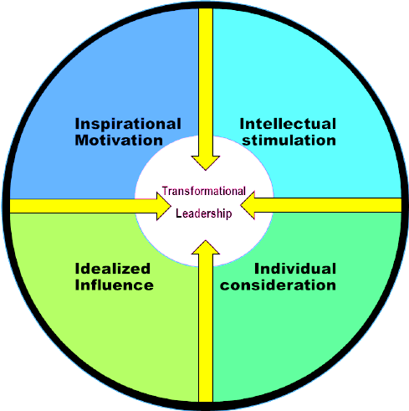

Figure 2.1: Key Components of Transformational Leadership
(Source: Susilo, 2019)
Transformational leadership is usually connected with four main elements: idealised influence, inspirational motivation, intellectual stimulation and individualised consideration (Susilo, 2019). Idealised influence: the leader becomes a positive role model and is respected by employees. Inspirational Motivation is the leader's ability to communicate a vision that is clear and meaningful. Intellectual stimulation means stimulating employees' thinking in new ways and challenging them to think creatively and solve problems in new ways (Karimi et al., 2023). Individualised consideration provides support tailored to the various needs, abilities, and development objectives of employees.

In international businesses, transformational leadership is particularly significant as workers can have various cultural backgrounds (Poturak et al., 2020). One way a transformational leader can assist multicultural teams is by establishing a shared vision that unites the staff, irrespective of their cultural backgrounds. This leadership style can also help to foster trust, inclusion, and communication, all of which are essential for culturally diverse teams. Thus, transformational leadership is defined as a people-oriented leadership strategy that emphasizes motivation, vision, development and positive change.

2.3 Evaluating the main characteristics of transformational leadership.
There are four widespread characteristics of transformational leadership: idealised influence, inspirational motivation, intellectual stimulation and individualised consideration. These elements are the reasons why transformational leaders can motivate employees, foster commitment and excel at improving team performance (Hassan, Bogale and Kunle, 2025). These are particularly relevant in multicultural teams, as team members might have diverse values and expectations of leadership and communication styles.
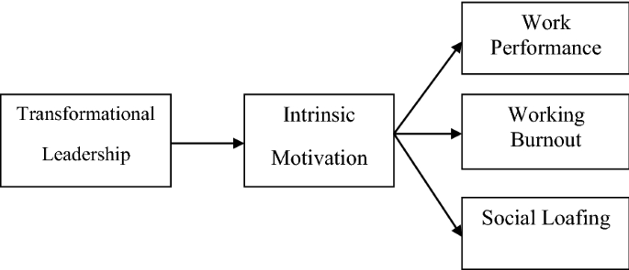

Figure 2.2: Influence of Transformational Leadership on organisation
(Source: Khan et al., 2020)

Idealised influence means that the leader acts as a positive role model for employees. A transformational leader is honest, fair, confident and has professional conduct. This aids staff in building trust and respect with the leader (Khan et al., 2020). Trust forms an integral part in multicultural teams, as each employee may come from different backgrounds, and have varying assumptions about the nature of authority, teamwork and communication. When the leader behaves consistently and fairly, employees are more likely to feel respected and included.
Inspirational motivation is the leader's capacity to develop and share a vision. Transformational leaders motivate workers by communicating shared objectives and why their work is important (Kim and Yoon, 2025). This is significant in international business because a multicultural team may include people with different personal objectives and expectations for the work environment. A clear shared vision can help bring the team together and reduce confusion. It also promotes the need to attend to common organizational goals instead of cultural differences among employees.
Intellectual stimulation involves stimulating employees to think outside the box and to question their current methods of working (Ligombi, Msomba and Pesha, 2023). Transformational leaders promote new ideas, problem-solving and innovation. This is important in multicultural teams as cultural diversity can offer a different perspective and experience. Leaders can foster an environment that allows for the free exchange of ideas, which can lead to more open sharing among employees. A transformational leader gives support, feedback and guidance based on the individual employee (Li et al., 2019). This is particularly relevant in multicultural teams because employees may need different types of support depending on their language ability, cultural background or working style. Knowing the employee from an individual level can enhance the motivation, sense of belonging and cohesiveness of teams.

2.4 The benefits of transformational leadership
Organisations, particularly those performing in international and multicultural business, may enjoy the following benefits from transformational leadership. The key advantage is increased employee motivation. Transformational leaders encourage their staffs to follow them by articulating a vision and demonstrating how their tasks fit into the larger picture of the organisation's success (Abdul-Azeez, Ihechere and Idemudia, 2024). This can help to increase employee value and commitment.
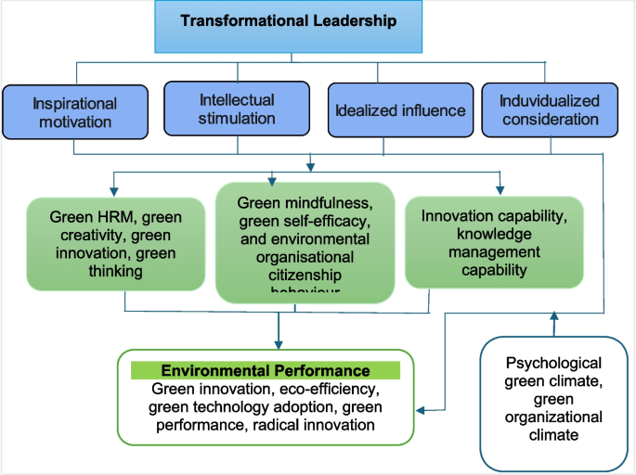

Figure 2.3: Benefits of Transformational Leadership
(Source: Gaybullaev and Strode, 2026)
One of the other advantages is improved team unity. Within multicultural teams, employees may communicate differently, work differently and have different cultural expectations. By fostering shared goals, mutual respect, and cooperation, transformational leadership can help build unity (Gaybullaev and Strode, 2026). When employees understand the team's purpose and feel included, they are more likely to work together effectively. Transformational leadership can also help enhance team communication. Openness and trust in the leader can lead to employees raising concerns, questioning and giving ideas. Important to multicultural team, as it can contribute to miscommunication as a result of cultural beliefs or barriers on the language (Motsamai and Onyenankeya, 2025). There are some ways of mitigating such barriers, such as to have a supportive leader that create a safe and respectful work space.
Another great advantage is creativity and innovation. Multicultural teams can bring a great deal of experience, knowledge and perspectives (Eyiah et al., 2025). This diversity can be harnessed by transformational leaders who can inspire employees to think critically, propose new ideas and solve problems creatively. This can enable international businesses to be more agile in responding to market changes and customer requirements. Employee development is also enhanced by transformational leadership. Transformational leaders can help employees gain confidence and develop skills by recognising those unique strengths and needs (Bakker et al., 2023). It can be helpful to staff and to organisations as it can result in increased job satisfaction, performance, and commitment.

2.5 The limitations of transformational leadership
Transformational leadership possesses significant benefits, but there are drawbacks. It has its drawbacks and shortcomings, one of which is that it can rely on the personality and communication abilities of the leader (Ugochukwu, 2025). A transformational leader is supposed to inspire, motivate and lead employees with vision. However, not every leader has the confidence, emotional intelligence or communication ability to apply this style effectively.
There are also a few drawbacks, such as making vision and motivation the sole focus of transformational leadership and neglecting practical matters. Staff should have clear expectations, timescales, resources and expectations of their performance (Salameh-Ayanian et al., 2025). Excessive emphasis on inspiration and not enough on structure can cause confusion about responsibilities and priorities among team members.
Another challenge with applying transformational leadership in a multicultural team is that members of the team may have different cultural backgrounds, meaning that they might have different responses to leadership. Some staff members may prefer empowerment, open discussion and creativity, while others may prefer to have clear authority, direct guidance and formal decision making (Salameh-Ayanian et al., 2025). Therefore, a leadership style that motivates one group of employees may not work equally well for another group.
Another danger is that transformational leadership puts excessive demands on the leader. The dependence on the leader's vision and motivation can also affect the employees' independence in decision-making. This may present problems when leader is not around or during times the organisation demand workers take up more accountability. More than this transformational leadership will never have solutions for all concerns the organisation faced with its multinational teams. To surmount such issues language difference, culture clashes, job discrimination and organisational policies call for organisation as a whole assistance. Leadership matters but organisation support with training, inclusive organisational practices, and sound communication frameworks is all that is needed

2.6 Literature gap
In literature, transformational leadership has been well explored as a leadership style that can enhance employee motivation, commitment, communication and performance. Research on multicultural teams and the difficulties involved in multicultural teams in international business settings also has been conducted (Bakker et al., 2023). These difficulties are: language barriers, cultural differences, conflict, trust and working style.
However, there remains a gap in understanding of how transformational leadership specifically supports the management of multicultural teams in international businesses (Eyiah et al., 2025). While many studies have examined leadership, few explicitly connect transformational leadership with the ability to overcome the cultural challenges of working in diverse teams.
One limitation is that the effectiveness of transformational leadership may vary by culture. Staff from different cultures may have different reactions to vision, empowerment, feedback, and participation (Khan et al., 2020). Hence, there is a need for further research to understand how transformational leaders can adjust their behaviour in multicultural teams. Thus, this dissertation explores this gap by focusing on the role of transformational leadership in managing multicultural teams in international business (Li et al., 2019). It highlights the potential of this leadership style to promote communication, inclusion, employee motivation and team performance.

2.7 Chapter Summary
The literature was reviewed on transformational leadership and its relationship to managing multicultural teams in international businesses. It originally defined transformational leadership as “a people-centred leadership style focussed on motivation, vision, trust, human development and positive change.” The chapter then examined the key features of transformational leadership: idealised influence, inspirational motivation, intellectual stimulation and individualised consideration. The advantages of transformational leadership were also shared, including increased employee development, motivation, communication, inclusion, team performance, and creativity. It also noted drawbacks, such as excessive reliance on the leader, a lack of structure, and difficulties applying the style in other cultural settings.

Chapter 3: Research Methodology

3.1 Introduction
The research methodology to study the role of transformational leadership in managing multicultural teams in international businesses is described in this chapter. The research methodology is essential as it reveals the manner in which the research will be done and the aim and objectives of the research will be dealt with. A clear methodology also helps to make the research more reliable, organised and academically valid. The chapter discusses the research philosophy, research approach, research design, data collection method, sampling strategy and data analysis method. It also provides an ethical consideration and limitation of the selected methodology.

3.2 Research Philosophy
The interpretivist research philosophy is used in this study. Interpretivism is appropriate for this research because it is a study of leadership, culture, communication, motivation and relationships within the team (Alawamleh et al., 2023). These areas are related to human behaviour and the social meaning, which are difficult to be understood only with numbers. The research is focused on the increased communication, trust, cohesion and performance of multicultural teams with the support of transformational leadership.
An interpretivist view provides the researcher with the opportunity to consider other interpretations and meanings which are to be found in the literature (Nickerson, 2024). This is significant as there will be differences in understanding of leadership, and culture, between countries, organisations, and employees. For instance, leaders and managers from various cultures might react differently to a leadership style, feedback, motivation and decision-making. Hence, the interpretivism approach would be suitable because it would allow the research to explore other deeper meanings and interpretations beyond measuring set variables. In this research, Interpretivism helps to develop a detailed understanding of the transformational leadership in multicultural business settings (Jo and Shin, 2025). It enables the research to take into account various views from existing research on leadership behaviour and see how this can impact on different teams.

3.3 Research Approach
A deductive approach is used in this study. The deductive approach is the method that starts with the theories or concepts, and then is applied to a particular topic of study (Robinson and Bailey-Rodriguez, 2025). This method is appropriate because of the study's foundation on the theories on transformational leadership and multicultural teams and international business management.
The dissertation explores theories of leadership and cross-cultural management, and explores how transformational leadership can be used to manage multicultural teams. The research is not intended to develop a totally new theory (Susilo, 2019). Rather, it draws upon the existing knowledge and synthesizes these in the unique setting of international businesses. For instance, transformational leadership traits like inspirational motivation, intellectual stimulation and individualised consideration have been studied as facilitating communication and cohesion in multicultural teams. Deductive approach is also appropriate due to the high level of specificity of the research aim and objectives from the outset. The study already concentrates on the evaluation of the transformational leadership, research of multicultural team problems, and analysis of the influence of the transformational leadership on team management (Robinson and Bailey-Rodriguez, 2025). Hence, the deductive method gives a definite and systematic study of the research topic.

3.4 Research Design
The research method used is a qualitative research. A qualitative approach is appropriate as the study deals with concepts, meanings, themes and relationships, rather than numerical measurement (Susilo, 2019). The research does not use surveys, statistical testing or experiments. Instead, it delves into literature to gain an understanding of the published discussion on the topic of transformational leadership and multicultural team management.
Leadership and cultural diversity are complex human and organisational issues, and as such are suitable for qualitative research. This type of research design will allow the study to investigate the impact of transformational leadership on multicultural teams in international businesses (Agag et al., 2025). It also provides the scholar to compare with the different perspectives from the available academic resources. This allows a qualitative design to better grasp the topic and to determine the important themes within the literature.

3.5 Data Collection Method
In this study, secondary data collection methods are used. Secondary data are data that have been already published by other researchers, organisations or institutions (Wickham, 2020). No new data will be gathered from individuals through interviews, questionnaires or focus groups as part of this study. Rather, it will draw upon current academic and professional materials on the topic of transformational leadership and multicultural teams in international business. Primary sources will be academic books, peer reviewed journal articles and credible organisational reports from online academic databases. Secondary sources were identified using a structured search strategy. Information from academic literature was gathered using academic databases including Google Scholar, ScienceDirect, Emerald Insight and Taylor and Francis. The keywords used were transformational leadership, multicultural teams, international business leadership, cross cultural management, cultural diversity, team cohesion, employee motivation and team performance. The terms chosen were those that are directly related to the research aim and objectives.
Appropriate for this study is the use of secondary data because a vast amount of literature exists on the subject of leadership and multicultural team management (Wickham, 2020). It allows the researcher to review existing knowledge, compare different arguments and identify gaps in the literature. This approach is also suitable since there is no direct contact with subjects involved in the research, and it does not involve any risk.

3.6 Sampling Strategy
The study employs purposive sampling technique for the selection of secondary sources of data. Purposive sampling is where sources are chosen based on having a direct link to the aim, objectives and questions of the research (Tajik, Golzar and Noor, 2024). Peer-reviewed journal articles, academic books and reputable organisational reports, primarily published from 2020 to 2026, were included. Sources were selected where they mentioned the concepts of transformational leadership, multicultural teams, cultural diversity, international business, communication, cohesion, motivation, or performance. Sources that offered clear academic evidence were prioritized, as were more recent sources and direct relevance to the dissertation topic.
The exclusion criteria were also used to enhance the quality of the research. Sources were removed if they were dated, not relevant to the research goals, not scholarly or did not include any evidence for their content and only opinion. Unsupported websites, blogs without clear identification of a connection to leadership or a multicultural team were not used as key evidence. This contributed to keeping the focus and increase the reliability of the chosen literature.
3.7 Data Analysis Method
The study will use thematic analysis to analyse the collected secondary data. The thematic analysis method was employed, as it assisted in identifying the repeated ideas, patterns and themes from the existing literature (Ahmed et al., 2025). This approach enables the researcher to categorise the literature into relevant themes related to the research goals.
The first step will be to read and analyze carefully selected sources. The next step will be to identify key concepts of transformational leadership and multicultural team management. In the third step, similar ideas will be clustered into themes. Themes could be communication, cultural barriers, trust, motivation, inclusion, leadership behaviour, engagement and team performance. Thematic analysis is useful because it enables the researcher to make comparisons across a number of sources and look for common themes (Agag et al., 2025). For instance, some will have literature indicating that transformational leadership enhances employee motivation, and other literature will show the disadvantages of transformational leadership in other cultural settings.

3.7.1 Validity and Reliability of Secondary Research
The validity of this research was also supported by the selection of the sources from which the research was conducted which was directly related to the research aim, objectives and research questions. Relevant and trustworthy peer-reviewed journal articles and academic books and credible organisational reports were prioritised to ensure this. The search strategy was clearly formulated and inclusion and exclusion criteria were used, which helped to strengthen reliability. The study also looked at the comparison of various sources rather than relying on one author or perspective. This has minimized researcher bias and ensured a balanced analysis of the relationship between transformational leadership and multicultural team management.

3.8 Ethical Considerations
This study is a secondary data study and does not entail human participants, however, ethical considerations are still salient. All sources will be used responsibly and accurately as a result of the research. The dissertation will use proper citation and referencing throughout to ensure that there is no plagiarism and no academic dishonesty. Credible academic sources and reliable organisational reports will be used in the study. This is crucial as it can result in flawed or misleading conclusions. The researcher will also refrain from distorting the words of other writers. Caution will be used in interpreting information from sources and discussion will be done in an honest manner.

There will be no collection of personal data, consent forms, interviews or questionnaires, as there are no participants involved. This diminishes the moral danger from the study. Confidentiality and anonymity do not apply either, as the study does not gather information on people. However, academic integrity remains important. All information is to be kept in password protected files and will be kept for academic purposes only.

3.9 Limitations of the Methodology
There is a limitation that the methodology relies on secondary sources, which are already available. This means that the research is not able to gather people's experiences from managers or employees in multicultural teams face-to-face. Consequently, the study might not reflect the latest experiences of particular international companies in the workplace.
Another constraint is that the literature available might be drawn from diverse countries, industry and organisational contexts (Nalmpanti, Wong and Oghazi, 2024). Thus, the results may not be necessarily relevant for all the international companies. For instance, what works in one cultural context may not work in another context when it comes to leadership practice. The selection of literature and its interpretation are also prone to researcher bias. The researcher may focus more on sources that convey a specific perspective (Agag et al., 2025). To minimise this risk the study will draw on a variety of authoritative sources and evaluate various arguments. The advantages and disadvantages of a transformational leader will also be examined.

3.10 Chapter Summary
In this chapter, the research methodology adopted in the study was explained. The research has an interpretivist philosophy as it involves human behaviour, culture, leadership and social meaning. Uses a deductive approach as it works from existing theories and literature to the research topic. The study is also qualitative in nature as it investigates themes, concepts and relationships as opposed to numerical data.

Chapter 4: Findings and Analysis

4.1 Introduction
The results and analysis resulting from the secondary qualitative sources are presented in this chapter. This dissertation is based on secondary research, with results drawn from academic literature, business reports, and reliable business evidence, and not from interviews or questionnaires. The chapter ties the research goals to the themes in the literature, particularly the challenges of working with multicultural teams and how transformational leadership can overcome them. The analysis reveals that multicultural teams are becoming increasingly relevant in international businesses as organisations operate in a multifaceted environment, spanning borders, markets and cultures. Diversity can lead to broader access to knowledge, creativity, and innovation. This indicates that with the proper organizational practices, cultural diversity potentially correlates with improved business results.

4.2 Key Challenges Faced by Multicultural Teams
The first significant discovery is that multicultural teams have communication issues. Along with language difficulty, differences in meaning, tone, nonverbal communication and expectations of employees' speech in the workplace contribute to these challenges. In international teams, employees can speak a common business language (e.g., English) but read messages differently due to cultural assumptions (Ivanova-Gongne et al., 2023). This can lead to misunderstandings at meetings, in writing, in feedback and when making decisions.
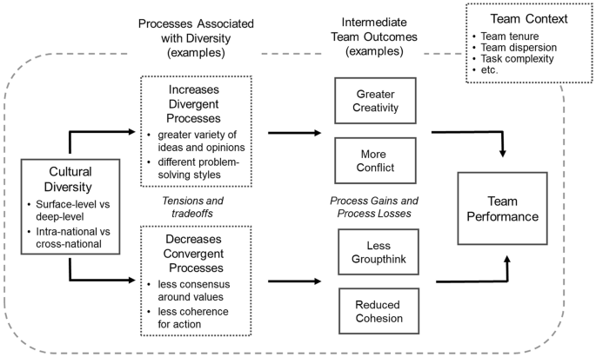

Figure 4.1: Key factors to consider for multicultural teams
(Source: Stahl and Maznevski, 2021)
One of the key traits of multicultural teams is cultural diversity. This can be a good thing since everyone has a different set of values, experiences, and ways of solving problems. McKinsey & Company (2023) reveals that diverse companies are likely to perform better financially. This finding should be taken with a pinch of salt, however. Diversity can generate potential value but not assure performance. In addition, Taras et al. (2021) suggest that cultural differences can also have an impact on collaboration, trust and communication in international teams. This implies that the use of multicultural teams is of only value if the organisation has the leadership practices to manage difference constructively.
Linguistic diversity is another of its features. A common language for business e.g. English can be used by employees but this does not eliminate all communication barriers. Ivanova-Gongne et al. (2023) explain that language in intercultural business interactions is connected with power, confidence and participation. That means that those who have a better command of the language might be dominating the conversation while others who do not, may not be contributing much even if they have some valuable information. So language diversity has the potential to enhance the team, but it can also lead to unequal participation if not managed well. Research on software teams around the world has discovered that lack of awareness of culture can lead to a lack of trust and potential loss of opportunity for collaboration. The third challenge is trust building. However, in multicultural teams, trust can be more challenging because employees' conceptions of time, responsibility, teamwork, and authority sometimes differ (Wengel, 2023). Likewise, one worker might want to see quick decisions made by the leader, another might want to see consultation and group discussion.
The fourth challenge is conflict in the team. Cultural diversity can benefit in problem solving as it presents different perspectives. The differences, however, could also cause disagreement. Differences in values about work or roles, communication styles or expectations of accountability can cause conflict (Iddrisu, 2025). It is acceptable in certain cultures to raise objections during a meeting to a concept. In others, there can be a lack of agreement, but it is kept quiet to maintain harmony. Thus, conflicts can be either obvious or obscure, depending on the team members' cultural context (Ugochukwu, 2025). Equality of participation is another difficulty. Some of the staff might be more dominant in the discussion in a multicultural team, due to his or her confidence or fluency with the communication style of the organization (Sahadevan and Sumangala, 2021).

4.3 Role of Transformational Leadership in Improving Communication
The results indicate that transformational leadership can facilitate communication within multicultural teams by establishing a common vision, fostering trust and enabling open involvement. Communication is a key problem in multicultural team management as many problems within teams start with a misunderstanding (Eyiah et al., 2025). Transformational leadership is relevant because of its emphasis on inspiration, support, shared objectives, and positive change, as opposed to just control and supervision.
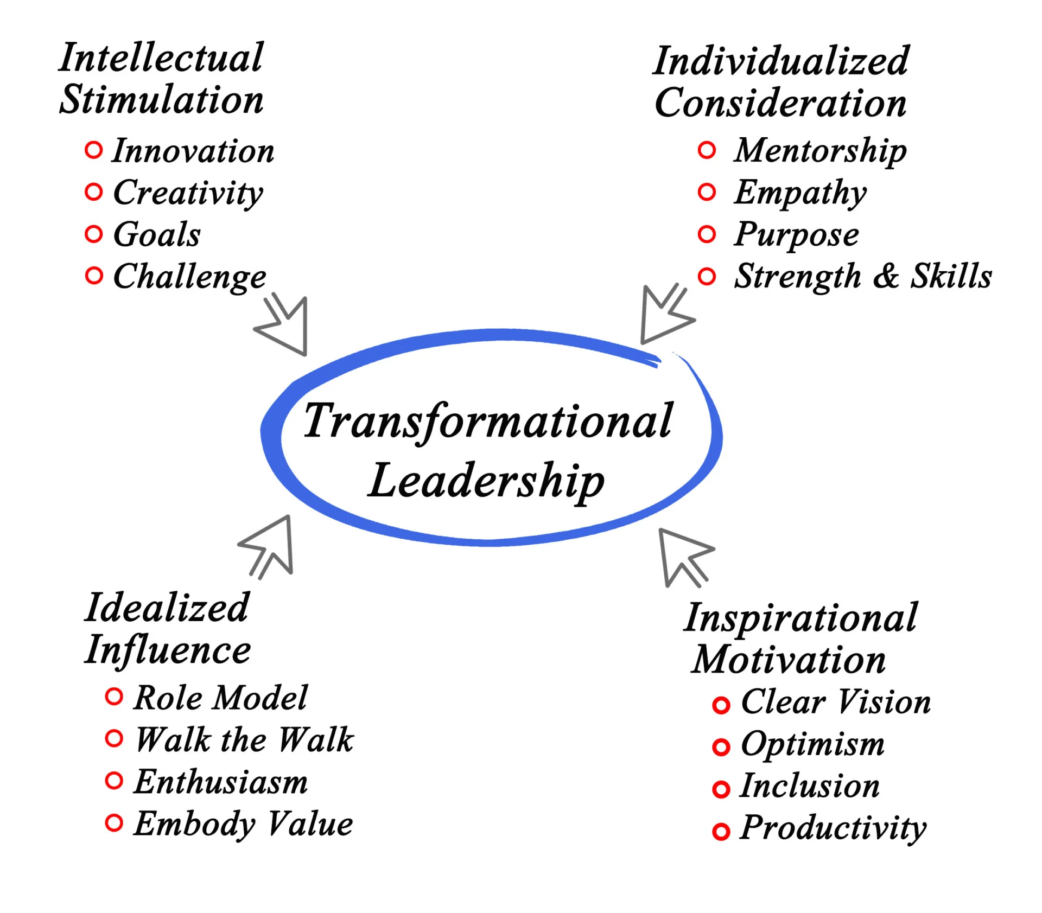

Figure 4.2: Overview of Transformational Leadership
(Source: Ugochukwu, 2025)
There is one area of opportunity and that is innovation. Cross-cultural teams of employees may think differently about a problem and come up with solutions not present in culturally similar teams. Arman et al (2024) state that diversity of culture may affect employee performance due to the inclusion of various perspectives in the workplace. This reinforces the idea that multicultural teams have the potential to enhance decision making. But this opportunity is subject to the condition. Eyiah et al. (2025) point out that effective management practices are essential to project teams with diverse cultures to achieve the advantages of diversity. Thus, diversity can only be beneficial when team members can freely share and respectfully consider knowledge.
Furthermore, transformational leadership ensures “psychological safety” to improve communication. An employee will feel comfortable enough to communicate when he or she feels appreciated and supported. This is even more true about those people who speak another language or come from a different culture and, thus, might not be confident to do so (Nadolna, 2020). The transformational leader will be able to create an environment where receiving questions, comments, and new ideas becomes possible. This way the silence will be reduced and more responses will become available.
Active listening is yet another important element. Transformational leadership should involve understanding of what employees need and helping them to grow as people (Yang et al., 2025). This strategy can help to make people equally involved. Moreover, transformational leadership is able to improve communication through using cultural diversity as a learning tool. This is crucial as multicultural teams can generate more original and creative solutions when members feel free to share. In the fields of science and technology, large-scale studies of teams with different mixes revealed that teams with diverse expertise are more likely to produce original work and achieve high impact (Meirinhos et al., 2022). This evidence comes from science and technology teams, but serves the broader case that with good knowledge sharing, diversity can lead to better outcomes.

4.4 Role of Transformational Leadership in Building Team Cohesion
According to Bakker et al. (2023), transformational leadership has the potential to motivate the performance of follower by establishing motivation and meaning. This shared understanding can minimize confusion and enable employees to understand the value of their contribution within multicultural teams. Team cohesion is how united team members are, how committed and willing to collaborate they are in order to achieve a common goal (Riisla et al., 2021).
Team cohesion is developed in the underpinnings of one way transformational leadership, in the form of a shared vision (Intan, 2025). Multicultural teams may contain workers who have various expectations regarding communication, teamwork, authority and work. A transformational leader can diminish these gaps by articulating a shared team vision and connecting individual jobs to the larger organisational mission. This ensures that employees know that they are collaborating towards the same end, even if they come from different cultural backgrounds (Grossman et al., 2021). This is significant as the evidence indicates that employees' engagement and connection with the workplace is still a great problem in the world today.
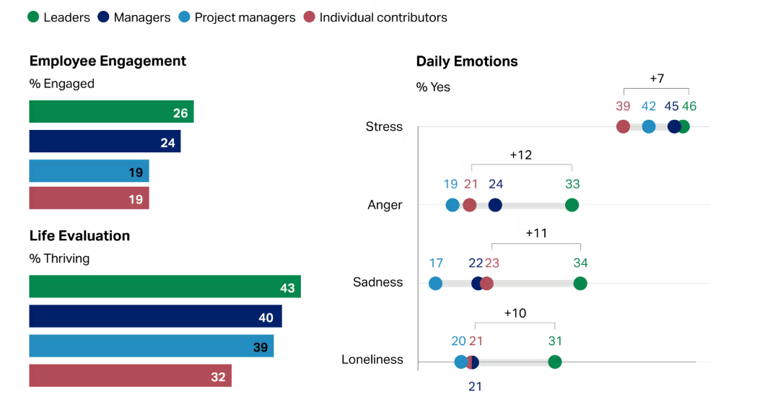

Figure 4.3: Key trends in employee engagement factors
(Source: Gallup, 2025)
The figures from Gallup's 2025 workplace evidence show that employee engagement in 2024 dropped to 21%, and manager engagement dropped to 27%, compared to 23% and 30%, respectively, in 2023 (Gallup, 2025). This drop in engagement was estimated by the same report to cost the world economy approximately $438 billion in lost productivity this fall. This demonstrates how a lack of engagement and leadership support can negatively impact organisations' performance (Gallup, 2025).
Regarding cohesion, transformational leadership can foster a culture of trust and psychological safety. Employees might not feel comfortable discussing things openly due to language barriers or cultural norms in multicultural teams, or because they are afraid of being misunderstood (Gašpar, Podrug and Aleksić, 2023). Transformational leadership, however, needs to be used judiciously. An inspiring vision can be delivered by a leader but may be different for employees of different cultures. According to Poturak et al. (2020), the effectiveness of transformational leadership may be different across different cultures.
The process of transformational leadership also ensures the development of cohesiveness through the process of fostering intellectual stimulation (Notarnicola et al., 2024). It implies that the employees are allowed to use different views and different approaches in dealing with issues of problem-solving. Diversity may be a benefit in multicultural teams as they possess different experience and different knowledge. But this happens only when team members will listen to one another. A transformational leader can contribute by framing diversity as a resource, not a hindrance (Mishra et al., 2024). The results, however, indicate that there are certain aspects of transformational leadership that must be used with caution. Having a common vision can enhance cooperation, but cannot overlook cultural differences (Iddrisu, 2025). When a leader attempts to make everyone fit into one predominant culture, some employees may feel left out. Thus, transformational leadership must foster unity by inclusion, not uniformity.

4.5 Role of Transformational Leadership in Improving Motivation and Performance
The results indicate that transformational leadership can also enhance employee motivation and team performance in multicultural teams. Motivation is crucial because workers will be more likely to give their best when they feel appreciated, supported and aligned with company objectives (Uka and Prendi, 2021). Grossman et al. (2021) identified a positive correlation between team cohesion and team performance, highlighting that team cohesion is not only a social phenomenon but also a performance related phenomenon. However, cohesion must not mean forcing employees to follow one dominant cultural style. According to the authors of Korkmaz et al. (2022), inclusion is not only about belonging, it's also about uniqueness.
Motivation is important and this is backed up by data that is derived from the global workplace. The 2025 Gallup workplace results revealed that just one-quarter (21%) of workers overall were engaged in 2024 (Gallup, 2025). This indicates that the majority of all workers in the world are not very engaged or motivated to work. Also of note is that manager engagement dipped in the report as managers are a huge influence on team engagement. This evidence helps to support the argument that leadership style impacts significantly on motivation and work performance. Individualised consideration is another element that helps in improving motivation in transformational leadership (Pischel, Felfe and Klebe, 2022). Based on the research of Bakker et al. (2023), transformational leadership is a source of inspiration for followers' performance. This is consistent with the study that says transformational leaders can help to boost motivation by providing employees with purpose. This sense of purpose can make employees feel more connected to the organisation among multicultural teams, even when they are different cultures and different countries.
However, motivation and performance cannot be improved by leadership style alone. Gallup (2025) states that employee engagement is low at the global level, indicating that there are still plenty of organisations where employees are not motivated.
One way transformational leadership enhances performance is by fostering innovation and problem solving (Pischel, Felfe and Klebe, 2022). Employees from multicultural teams may also have the benefit of a broader perspective on ideas, as these are influenced by their cultural and professional backgrounds. This diversity can be utilized by transformational leaders who can motivate employees to question the status quo and propose new solutions. Studies on knowledge sharing in diverse teams in science and technology indicate that such teams have the potential to generate more original content and create a more lasting impact by effectively sharing their knowledge (Soomro et al., 2024). This evidence is not exclusive to business teams, but indeed is a supporting argument to the wider argument that with effective collaboration and leadership diversity can improve outcomes.

4.6 Critical Analysis of Transformational Leadership in Multicultural Teams
The results indicate that transformational leadership may be helpful in a multicultural team, but there needs to be a measure of caution in accepting the effectiveness of such leadership without question. The leadership style can be beneficial for communication, cohesion, motivation and performance but has its limitations in various cultural contexts (Colgate, 2025). Thus, Transformational Leadership is a valuable tool to be used, but not as a panacea for every multicultural team problem.
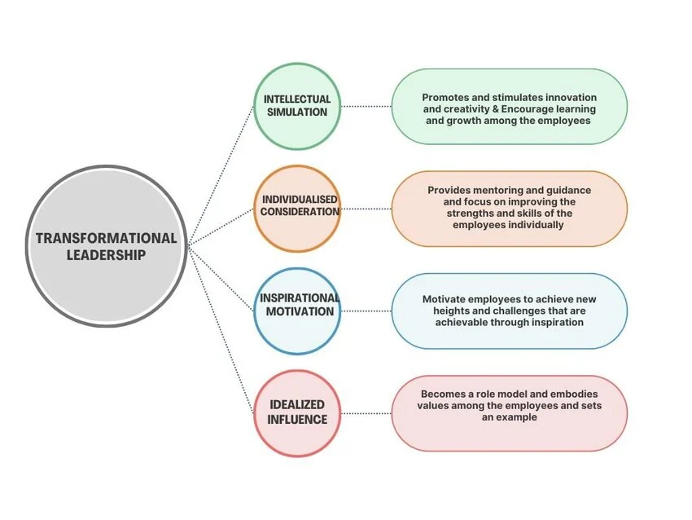

Figure 4.4: Influence of Transformational Leadership on Teams
(Source: Estherita, Vasantha and Sudha, 2023)
One of the advantages of transformational leadership is that it provides a direction for multicultural teams. In international businesses, staff could have different cultural backgrounds, different languages and may have different expectations regarding work (Colgate, 2025). To help minimize confusion, a transformational leader can set a clear vision and connect people to shared objectives. This is significant because multicultural teams have the potential to be split when employees are only concerned with their own cultural perceptions or department interests (Khan and Jin, 2024). A vision can thus make it easier for employees to grasp the bigger picture of teamwork.
Another advantage is the transformational leadership's positive relationship with inclusion. Another advantage is the positive relationship between transformational leadership and inclusion. Multicultural teams need more than diversity; they need employees to feel respected, heard and valued. Individuals considering employees, treating them according to their needs, abilities and development goals is a way for transformational leaders to support this (Agag et al., 2025). This is especially crucial since workers from various cultures could not react to the same leadership actions.
The importance of effective leadership is also supported by workplace engagement data. Global employee engagement has remained low, with recent evidence showing that only around one-fifth of employees are engaged at work (Goyal et al., 2025). This suggests that many organisations are having problems motivating, engaging, and fostering employees' emotional attachment. This challenge may be intensified in multicultural teams for its employees may also experience language barriers, misunderstanding of culture, and low belonging (Khan and Jin, 2024). This can be addressed with transformational leadership, which can be used to build purpose and recognition and increase relationships.

4.7 Chapter Summary
The secondary literature survey presented and analysed key findings in this chapter. The results indicated that multicultural teams are useful to the international companies due to their ability to assist creativity, innovation and broad market knowledge. On the other hand, the chapter also revealed some problems with multicultural teams: language barriers, cultural misunderstanding, communication issues, conflicts, low trust and unequal participation. The chapter discussed the transformational leadership to enhance communication through vision creating, open discussion, trust building and recognizing the person's communication needs.

Chapter 5: Conclusion, Limitations and Recommendations

5.1 Introduction
This chapter summarizes the findings of the research, explains how the research aim, objectives and questions were met and offers recommendations. It also points out the study's limitations and indicates areas for further study.

5.2 Achievement of Research Aim, Objectives and Questions
This study sought to evaluate the transformational leadership's contribution to the management of multicultural teams in international companies. This was accomplished using secondary qualitative research and literature analysis on the concepts of leadership, cultural diversity, communication, cohesion and performance (Khan and Jin, 2024). First, the principle traits of transformational leadership were examined. This was done through talking about idealised influence, inspirational motivation, intellectual stimulation and intellectual individualisation. These attributes reveal the ways in which transformational leaders inspire trust, vision, creativity, and individual support.
The second objective was to examine the essential issues for multicultural groups. The study identified that language and cultural issues, miscommunication, varying communication styles, trust problems, conflict, and unequal participation are some of the issues that may arise among multicultural teams. These challenges can have a negative impact on team working and stop organisations from maximising the benefit of diversity.
The third objective was to examine the effect of transformational leadership on the improvement of multicultural team management. The results revealed that transformational leadership increases communication by fostering open discussion, active listening and mutual understanding. It is also able to build cohesion through establishing a shared vision and fostering inclusion.
The fourth objective was to provide recommendations for enhancing multicultural team effectiveness through transformational leadership. This aim was made by recognizing feasible actions for the international businesses, such as the training on cultural intelligence, inclusive communication systems, and clearer conflict-resolution procedures.
Answers were also provided to the research questions. The study revealed communication, cultural and trust problems of multicultural teams. It also concluded that transformational leadership can help these teams in three ways: vision, motivation, and inclusion and individual support (Ivanova-Gongne et al., 2023). Lastly, the study indicated that transformational leadership has the potential to enhance communication, cohesion and performance but only if the leader is culturally aware and flexible.

5.3 Summary of Research findings and outcomes
The primary finding is that transformational leadership can be very important in leading multicultural teams in international businesses. Multi-cultural teams can be helpful for creativity and innovation and even for gaining market knowledge. However, not everything mentioned above will necessarily happen. It depends on proper leadership and participatory management. According to this study, one of the biggest barriers of the multi-cultural team is Communication. There may be differences between language, tone, ways of giving feedback, etc., which can result in misunderstanding. Transformational leaders can do their best to avoid such a situation.
The study also determined that team cohesiveness is critical for the success of multicultural teams. People should feel part of the team, valued and have a sense of common purpose. Transformational leadership can help with this as it fosters trust and values difference. The results also indicated limitations of transformational leadership. It may not be as effective across all cultures as employees' expectations for leadership, authority and feedback vary. Thus, transformational leadership needs to be tailored to the team culture.

5.4 Original Contribution of the Research
The originality of this research consists in its links between transformational leadership and multicultural team management in international businesses. The study demonstrates that having diverse members does not lead to better performance. The organisations require leaders to build inclusion, trust and shared purpose. The study is also a balanced study, as it presents the strengths and weaknesses of transformational leadership.

5.5 Recommendations
International businesses need to foster training in leadership with transformational leadership and cultural intelligence (Yuwono et al., 2026). Managers must be familiar with various communication styles, cultural expectations and motivational requirements. Organisations also need to establish clear communication systems, including: meeting rules, written summaries, and inclusive meeting techniques. These will help limit miscommunication and ensure more participation. Managers should apply individualised consideration by adjusting feedback, support and recognition based on the individual employee (Uka and Prendi, 2021). Additionally, companies should foster a culture of psychological safety, where workers are encouraged to voice their views and ideas without the worry of being attacked.

5.6 Limitations and Further Research
This study is limited because of the secondary qualitative data used. It does not contain first-hand accounts from managers and/or employees on multicultural teams. The results might not be necessarily applicable to all countries, industry or organisation. Primary data could be obtained from interviews or questionnaires in future research. Other studies may also examine the relationship between transformational leadership and other leadership styles in multicultural team environments, such as inclusive leadership or servant leadership.

5.7 Chapter Summary
This chapter has found that transformational leadership is effective in achieving international businesses' multicultural team management goals, which include communication improvement, team cohesion, motivation and team performance improvement. Best used in combination with culture, inclusive policies and clear organisational systems.

References
Abdul-Azeez, O., Ihechere, A.O. and Idemudia, C. (2024). Transformational leadership in SMEs: Driving innovation, employee engagement, and business success. World Journal of Advanced Research and Reviews, 22(3), pp.1894–1905. doi:https://doi.org/10.30574/wjarr.2024.22.3.1888.
Agag, G., Abdelmoety, Z.H., Aboul-Dahab, S., Daher, M., Sharkasi, N., Taha, E., Yousaf, A. and Abdelwahab, M. (2025). A cross-cultural meta-analysis of transformational leadership- performance outcomes relationship. International Studies of Management and Organization, pp.1–41. doi:https://doi.org/10.1080/00208825.2025.2566556.
Agag, G., Ziad Hassan Abdelmoety, Sameh Aboul-Dahab, Daher, M., Sharkasi, N., Taha, E., Yousaf, A. and Abdelwahab, M. (2025). A cross-cultural meta-analysis of transformational leadership- performance outcomes relationship. International Studies of Management and Organization, pp.1–41. doi:https://doi.org/10.1080/00208825.2025.2566556.
Ahmed, S.K., Mohammed, R.A., Nashwan, A.J., Ibrahim, R.H., Abdalla, A.Q., Ameen, B.M.M. and Khidhir, R.M. (2025). Using Thematic Analysis in Qualitative Research. Journal of Medicine, Surgery, and Public Health, [online] 6(6), p.100198. doi:https://doi.org/10.1016/j.glmedi.2025.100198.
Alawamleh, M., Al-Twal, A., Lahlouh, L. and Jame, R.O. (2023). Interpretive structural modelling of organizational innovation factors: An emerging market perspective. Journal of Open Innovation: Technology, Market, and Complexity, [online] 9(2), p.100067. doi:https://doi.org/10.1016/j.joitmc.2023.100067.
Arman, A., Sohaib, O., Begum, V. and Alkharman, A.A. (2024). Impact of Cultural Diversity on Employee Performance. International Journal of Service science, management, Engineering and Technology, [online] 15(1), pp.1–14. doi:https://doi.org/10.4018/ijssmet.342614.
Bakker, A.B., Hetland, J., Olsen, O.K. and Espevik, R. (2023). Daily transformational leadership: a source of inspiration for follower performance? European Management Journal, [online] 41(5), pp.700–708. doi:https://doi.org/10.1016/j.emj.2022.04.004.
Carucci, R. (2024). One More Time: Why Diversity Leads To Better Team Performance. [online] Forbes. Available at: https://www.forbes.com/sites/roncarucci/2024/01/24/one-more-time-why-diversity-leads-to-better-team-performance/ [Accessed 18 Jun. 2026].
Colgate, M. (2025). The Importance and Application of a Coaching Leadership Style in Businesses. Businesses, [online] 5(3), p.32. doi:https://doi.org/10.3390/businesses5030032.
Deloitte (2023). Working in multicultural teams |Deloitte Australia | Diversity, Inclusion and Leadership consulting case study. [online] www.deloitte.com. Available at: https://www.deloitte.com/au/en/services/consulting/perspectives/working-multicultural-teams.html [Accessed 2 Jul. 2026].
Erfan, M. (2024). The Impact of Cross-Cultural Management on Global Collaboration and Performance. Advances in Human Resource Management Research, 2(2), pp.102–112. doi:https://doi.org/10.60079/ahrmr.v2i2.261.
Estherita, S.A., Vasantha, S. and Sudha, S. (2023). Influence Of Transformational Leadership on Organisational Culture with a Mediating Effect of Innovative Work Behaviour: A Systematic Review. Journal of Law and Sustainable Development, 11(12), pp.e2699–e2699. doi:https://doi.org/10.55908/sdgs.v11i12.2699.
Eyiah, A.K., Bondinuba, F.K., Adu-Gyamfi, L. and Liphadzi, M. (2025). Promoting effective management of cultural diversity in multinational construction project teams. Buildings, 15(5), pp.659–659. doi:https://doi.org/10.3390/buildings15050659.
Gallup (2025). State of the Global Workplace Report. [online] Gallup. Available at: https://www.gallup.com/workplace/349484/state-of-the-global-workplace.aspx [Accessed 18 Jun. 2026].
Gašpar, M., Podrug, N. and Aleksić, A. (2023). The significance of cross-cultural barriers in organizational communication. Zbornik Veleučilišta u Rijeci, [online] 11(1), pp.235–246. doi:https://doi.org/10.31784/zvr.11.1.13.
Gaybullaev, O. and Strode, J.P. (2026). Transformational leadership and organizational sustainability performance: A systematic literature review of global evidence. Environment, Development and Sustainability. doi:https://doi.org/10.1007/s10668-026-07319-z.
Goyal, K., Lim, W.M., Nigam, A. and Goyal, N. (2025). How to promote employee engagement? A comparison of top-down versus bottom-up approaches. Asia-Pacific Journal of Business Administration. doi:https://doi.org/10.1108/apjba-10-2024-0551.
Grossman, R., Nolan, K., Rosch, Z., Mazer, D. and Salas, E. (2021). The Team Cohesion-Performance Relationship: A Meta-Analysis Exploring Measurement Approaches and the Changing Team Landscape. Organizational Psychology Review, 12(2), pp.181–238. doi:https://journals.sagepub.com/doi/10.1177/20413866211041157.
Hassan, A.F., Bogale, M. and Kunle, M.A. (2025). Transformational Leadership and Employee Motivation: A Systematic Literature Review. [online] ResearchGate. Available at: https://www.researchgate.net/publication/390822593_Transformational_Leadership_and_Employee_Motivation_A_Systematic_Literature_Review [Accessed 26 Jun. 2026].
Iddrisu, I. (2025). Understanding the Nexus Between Organizational Culture and Trust: The Mediating Roles of Communication, Leadership, and Employee Relationships. Sustainable Futures, 9, p.100555. doi:https://doi.org/10.1016/j.sftr.2025.100555.
Intan, R. (2025). The Role of Shared Leadership and Team Cohesion in Shaping the Effectiveness of Multidisciplinary Research Teams in Indonesia. Journal Research of Social Science, Economics, and Management, 5(5), pp.5249–5261. doi:https://doi.org/10.59141/jrssem.v5i5.1229.
Ivanova-Gongne, M., Barner‐Rasmussen, W., Torkkeli, L. and Elo, M. (2023). Language in intercultural business interactions: A self-perceived power perspective. Industrial Marketing Management, 115, pp.312–326. doi:https://doi.org/10.1016/j.indmarman.2023.10.004.
Jo, H. and Shin, D. (2025). The impact of recognition, fairness, and leadership on employee outcomes: A large-scale multi-group analysis. PLOS ONE, [online] 20(1), p.e0312951. doi:https://doi.org/10.1371/journal.pone.0312951.
Karimi, S., Malek, F.A., Farani, A.Y. and Liobikienė, G. (2023). The Role of Transformational Leadership in Developing Innovative Work behaviors: the Mediating Role of Employees’ Psychological Capital. Sustainability, [online] 15(2), p.1267. doi:https://doi.org/10.3390/su15021267.
Khan, H., Rehmat, M., Butt, T.H., Farooqi, S. and Asim, J. (2020). Impact of transformational leadership on work performance, burnout and social loafing: A mediation model. Future Business Journal, [online] 6(1), pp.1–13. doi:https://doi.org/10.1186/s43093-020-00043-8.
Khan, M.H. and Jin, J. (2024). The relationship between ethnocentric behaviour and workforce localisation success: The mediating role of knowledge sharing tendency. European Research on Management and Business Economics, 30(2). doi:https://doi.org/10.1016/j.iedeen.2024.100245.
Kim, J.Y. and Yoon, D.-Y. (2025). How transformational leadership of managers affects employee innovative behavior in IT corporations. Frontiers in Psychology, 16. doi:https://doi.org/10.3389/fpsyg.2025.1565307.
Korkmaz, A.V., van Engen, M.L., Knappert, L. and Schalk, R. (2022). About and beyond Leading Uniqueness and belongingness: a Systematic Review of Inclusive Leadership Research. Human Resource Management Review, [online] 32(4), p.100894. doi:https://doi.org/10.1016/j.hrmr.2022.100894.
Lazarova, M., Caligiuri, P., Collings, D.G. and De Cieri, H. (2023). Global Work in a Rapidly Changing world: Implications for MNEs and Individuals. Journal of World Business, [online] 58(1). doi:https://doi.org/10.1016/j.jwb.2022.101365.
Li, H., Sajjad, N., Wang, Q., Ali, A.M., Khaqan, Z. and Amina, S. (2019). Influence of transformational leadership on employees’ innovative work behavior in sustainable organizations: Test of mediation and moderation processes. Sustainability, 11(6), p.1594. doi:https://doi.org/10.3390/su11061594.
Ligombi, N.C., Msomba, G. and Pesha, J. (2023). The Influence of Intellectual Stimulation as an Aspect of Transformational Leadership in Enhancing Employee’s Performance towards Successful Management of Water Supply Services at Iringa Urban Water Supply and Sanitation Authority. South Asian Journal of Social Studies and Economics. [online] doi:https://doi.org/10.9734/sajsse/2023/v20i3736.
McKinsey & Company (2023). Diversity Matters Even more: the Case for Holistic Impact. [online] McKinsey & Company. Available at: https://www.mckinsey.com/featured-insights/diversity-and-inclusion/diversity-matters-even-more-the-case-for-holistic-impact [Accessed 18 Jun. 2026].
Meirinhos, G., Cardoso, A., Silva, R., Rêgo, R. and Oliveira, M. (2022). Employee Involvement and Commitment in Internal Communication. Social Sciences, [online] 11(9), p.423. doi:https://doi.org/10.3390/socsci11090423.
Mishra, K., Goyal, R., Sharma, M. and Raj, S. (2024). The Influence of Transformational Leadership on Enhancing Performance in the IT Sector. pp.1–9. doi:https://doi.org/10.1145/3745812.3745848.
Motsamai, P.F.T. and Onyenankeya, K. (2025). Employee perceptions of internal communication in culturally diverse workplaces in South Africa: A systematic literature review. Social Sciences & Humanities Open, 11, p.101589. doi:https://doi.org/10.1016/j.ssaho.2025.101589.
Nadolna, K.K. (2020). The role of a leader in stimulating innovation in an organization. Administrative Sciences (2076-3387), [online] 10(3), pp.1–18. doi:https://doi.org/10.3390/admsci10030059.
Nalmpanti, A.D., Wong, C.Y. and Oghazi, P. (2024). Collaborating for innovation: The inhibiting role of constraints. Journal of Innovation & Knowledge, 9(3), pp.100504–100504. doi:https://doi.org/10.1016/j.jik.2024.100504.
Nickerson, C. (2024). Interpretivism Paradigm & Research Philosophy. [online] Simply Psychology. Available at: https://www.simplypsychology.org/interpretivism-paradigm.html [Accessed 26 Jun. 2026].
Notarnicola, I., Duka, B., Lommi, M., Grosha, E., Maria, D., Iacorossi, L., Mastroianni, C., Ivziku, D., Rocco, G. and Stievano, A. (2024). Transformational Leadership and Its Impact on Job Satisfaction and Personal Mastery for Nursing Leaders in Healthcare Organizations. Nursing Reports, [online] 14(4), pp.3561–3574. doi:https://doi.org/10.3390/nursrep14040260.
Notarnicola, I., Duka, B., Lommi, M., Grosha, E., Maria, D., Iacorossi, L., Mastroianni, C., Ivziku, D., Rocco, G. and Stievano, A. (2024). Transformational Leadership and Its Impact on Job Satisfaction and Personal Mastery for Nursing Leaders in Healthcare Organizations. Nursing Reports, [online] 14(4), pp.3561–3574. doi:https://doi.org/10.3390/nursrep14040260.
Pischel, S., Felfe, J. and Klebe, L. (2022). ‘Should I Further Engage in Staff Care?’: Employees’ Disclosure, Leaders’ Skills and Goal Conflict as Antecedents of Health-Oriented Leadership. International Journal of Environmental Research and Public Health, 20(1), p.162. doi:https://doi.org/10.3390/ijerph20010162.
Poturak, M., Mekić, E., Hadžiahmetović, N. and Budur, T. (2020). Effectiveness of Transformational Leadership among Different Cultures. International Journal of Social Sciences and Educational Studies, 7(3), pp.119–129. doi:https://doi.org/10.23918/ijsses.v7i3p119.
Riisla, K., Wendt, H., Babalola, M.T. and Euwema, M. (2021). Building cohesive teams—the role of leaders’ bottom-line mentality and behavior. Sustainability, 13(14). doi:https://doi.org/10.3390/su13148047.
Robinson, O.C. and Bailey-Rodriguez, D. (2025). Deductive qualitative research: an integrative approach to designing studies. Qualitative Research in Psychology, pp.1–16. doi:https://doi.org/10.1080/14780887.2025.2604773.
Sahadevan, P. and Sumangala, M. (2021). Effective Cross-Cultural Communication for International Business. [online] ResearchGate. Available at: https://www.researchgate.net/publication/350728276_Effective_Cross-Cultural_Communication_for_International_Business [Accessed 2 Jul. 2026].
Salameh-Ayanian, M., Lakkis, P., Jabbour, N. and Makki, M. (2025). Leading Through Uncertainty: How Transformational and Transactional Leadership Shape Employee Satisfaction and Performance in Lebanese NGOs. Administrative Sciences, [online] 15(5), p.172. doi:https://doi.org/10.3390/admsci15050172.
Soomro, M.A., Ali, A., Memon, A.H., Khahro, S.H. and Memon, Z.A. (2024). Improving innovation in construction projects: Knowledge-sharing, open-mindedness and shared leadership. Journal of Innovation & Knowledge, [online] 9(4), p.100629. doi:https://doi.org/10.1016/j.jik.2024.100629.
Stahl, G.K. and Maznevski, M.L. (2021). Unraveling the effects of cultural diversity in teams: A retrospective of research on multicultural work groups and an agenda for future research. Journal of International Business Studies, 52(1), pp.4–22. doi:https://pmc.ncbi.nlm.nih.gov/articles/PMC7812115/.
Suryadi, Y., Trisnawati, T. and Al-Amin, A.-A. (2024). The Impact Of Transformational Leadership On Organizational Performance And Employee Motivation. Transforma Jurnal Manajemen, 2(2), pp.65–76. doi:https://doi.org/10.56457/tjm.v2i2.129.
Susilo, D. (2019). Transformational Leadership: A Style of Motivating Employees. Management and Economics Journal (MEC-J), 3(1), p.124. doi:https://doi.org/10.18860/mec-j.v0i1.5222.
Tajik, O., Golzar, J. and Noor, S. (2024). Purposive Sampling. Purposive Sampling, [online] 2(2), pp.1–9. doi:https://doi.org/10.22034/ijels.2025.490681.1029.
Taras, V., Baack, D., Caprar, D., Jimenez, A. and Froese, F. (2021). Research: How Cultural Differences Can Impact Global Teams. [online] Harvard Business Review. Available at: https://hbr.org/2021/06/research-how-cultural-differences-can-impact-global-teams [Accessed 18 Jun. 2026].
Theron, L., Shopo, K.D. and Ngami, O. (2024). Exploring perceptions of communication among culturally diverse nurses in Saudi Arabia. Journal of Transcultural Nursing, 36(2). doi:https://doi.org/10.1177/10436596241291839.
Ugochukwu, C. (2025). Transformational Leadership Style: How to Inspire and Motivate. [online] Simply Psychology. Available at: https://www.simplypsychology.org/what-is-transformational-leadership.html [Accessed 26 Jun. 2026].
Uka, A. and Prendi, A. (2021). Motivation as an Indicator of Performance and Productivity from the Perspective of Employees. Management & Marketing. Challenges for the Knowledge Society, 16(3), pp.268–285. doi:http://dx.doi.org/10.2478/mmcks-2021-0016.
Wengel, J. (2023). Cultural Intelligence and Trust in Global Virtual Teams. Business and Professional Communication Quarterly, 88(1). doi:https://doi.org/10.1177/23294906231179915.
Wickham, R. (2020). Secondary Analysis research. Journal of the Advanced Practitioner in Oncology, [online] 10(4), pp.395–400. doi:https://doi.org/10.6004/jadpro.2019.10.4.7.
Yang, J., Zheng, G., Peng, M.Y.-P., Hrdinová, N. and Alasmrai, M.A. (2025). From silence to spark: How transformational leadership empowers employee innovation and voice in SMEs. Acta Psychologica, [online] 261, p.105761. doi:https://doi.org/10.1016/j.actpsy.2025.105761.
Yuwono, W., Mohd, T., Leona, M. and Muchsinati, E.S. (2026). The Impact of Transformational Leadership and Training Program on Innovation: A Moderation Analysis of... Quality - Access to Success, [online] 27(211), pp.368–377. Available at: https://www.researchgate.net/publication/401726365_The_Impact_of_Transformational_Leadership_and_Training_Program_on_Innovation_A_Moderation_Analysis_of_Cultural_Intelligence.

