

Heat Exchanger Laboratory Report
Thermofluid Mechanics
M5X00406

Wesley Patrick
1701708

BEng Motorcycle Engineering

12th April 2020

Contents
1.0 Introduction 4
2.0 Methodology 6
3.0 Results 8
3.1 useful equations 8
3.2 Experiment 1 12
3.3 Experiment 2 12
3.4 Experiment 3 13
4.0 Analysis 14
5.0 Conclusion 18
6.0 References 18

Figure 1 Left Parallel flow heat exchanger 4
Figure 2 Right Counterflow heat exchanger 4
Figure 3 Left Finned crossflow heat exchanger 4
Figure 4 Right Unfinned heat exchanger 4
Figure 5 Left heat exchanger (TecQuipment ltd, 2014) 5
Figure 6 Right heat exchanger flow path (TecQuipment ltd, 2014) 5
Figure 7 Experiment setup (TecQuipment ltd, 2014) 6
Figure 8 Specific Heat Capacity of Water at Constant Pressure 8
Figure 9 Air density plotted against air temperature 9
Figure 10 Water density plotted against water temperature 10
Figure 11 Experiment 1 air heat transfer plotted against water mass flow 14
Figure 12 Experiment 1 η plotted against water mass flow 15
Figure 13 Experiment 1 heat transfer coefficient plotted against water mass flow 15
Figure 14 Experiment 2 and 3 water heat transfer plotted against air mass flow 16
Figure 15 Experiment 2 and 3 heat transfer efficiency plotted against air mass flow 17

Equation 1 Specific Heat Capacity of Water 8
Equation 2 Air Density 9
Equation 3 Water density 9
Equation 4 Water heat transfer 10
Equation 5 Air heat transfer 10
Equation 6 Perfect heat exchanger heat transfer 10
Equation 7 coefficient of energy balance 10
Equation 8 Realistic energy balance 11
Equation 9 Temperature efficiency of hot water 11
Equation 10 Temperature efficiency of cold air 11
Equation 11 Mean temperature efficiency 11
Equation 12 Logarithmic mean temperature difference (LMTD) 11
Equation 13 Heat transfer coefficient 12

Table 1 Experiment 1 example results table (TecQuipment ltd, 2014) 6
Table 2 Experiment 2 and 3 example results table (TecQuipment ltd, 2014) 7
Table 3 Experiment 1 results 12
Table 4 Experiment 2 results 12
Table 5 Experiment 3 results 13

Introduction
A cross flow heat exchanger works by transferring heat from one fluid or gas to another. The process off this transfer happens by one fluid or gas flowing through a tube and the other fluid or gas flowing over this tube. There a three heat transfers that happen in this system those being: convective heat transfer from the fluid or gas to the inner wall of the tube; conductive heat transfer through the wall of the tube; and convective heat transfer from the outside wall of the tube to the external fluid or gas (Spakovszky, 2006).
Heat exchangers are classified by their flow arrangement some examples of these are: parallel flow where the fluids or gasses flow in the same direction in a concentric pipe (figure 1); counterflow where the fluid or gasses flow in a similar concentric pipe system but in opposite directions (Figure 2); finned cross flow where one fluid or gas flows through a tube and another fluid or gas flows perpendicular to the tube which is housed inside fins (Figure 3); and unfinned cross flow similar to the finned cross flow minus the fins (Figure 4) (Spakovszky, 2006).
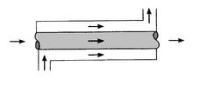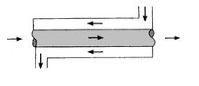
Figure 1 Left Parallel flow heat exchanger
Figure 2 Right Counterflow heat exchanger
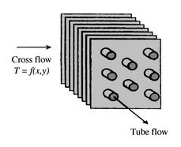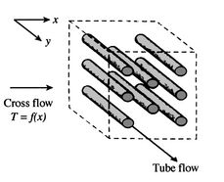
Figure 3 Left Finned crossflow heat exchanger
Figure 4 Right Unfinned heat exchanger
The heat exchanger at UWTSD (Figure 5) uses a fan to accelerate air that has flowed down the inlet duct over the 32 tube heat exchanger and out the outlet duct (Figure 6). A calibrated orifice sits atop the inlet duct and works with an air pressure gauge to determine the air flow rate through the system. A sliding valve at the exit of the outlet duct to control the air flow rate of the system. Thermocouples along the ducting measure the ambient air temperature as well as before and after the heat exchanger. The flow and initial temperature is controlled via the water temperature and flow display.
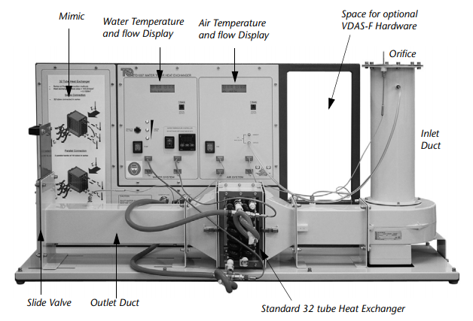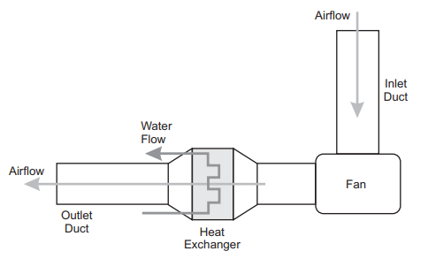
Figure 5 Left heat exchanger (TecQuipment ltd, 2014)
Figure 6 Right heat exchanger flow path (TecQuipment ltd, 2014)
Three experiments have been performed one looking at various water flow rates at 60°C from 2 L/min to 0.75 L/minute in increments of 0.25 L/minute and two looking at various different air pressures from 250 Pa to 50 Pa in 50 Pa increments and another measurement at 25 Pa. the first of the air pressure experiments is carried out with a fixed inlet water temperature of 60°C and the second experiment at a fixed inlet water temperature of 50°C, as the initial water temperature is controlled by a heater module on the rear of the apparatus the initial temperature varies slightly but not enough to effect the results in these small experiments. As the air pressure in the system is controlled manually via the slide valve on the outlet duct the experiments involving variable air pressures are taken as close to the recorded value as possible.

Methodology
The equipment was set up as shown in Figure 7 and switched on prior to arrival so that the water had enough time to heat to 60°C. upon arrival the equipment was inspected to check all the temperature sensors and controls are working correctly.
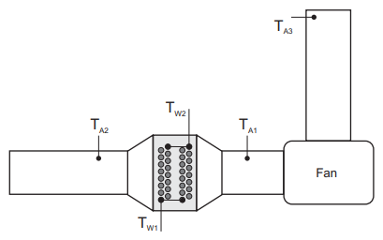
Figure 7 Experiment setup (TecQuipment ltd, 2014)
Secondly the results table was created with reference to table 1 for experiment 1 or table 2 for experiment 2 and 3 pictured below and changed accordingly for this experiment to list the temperature and other results could be noted. Things that should be made note of are: the ambient air pressure; the ambient air temperature; the orifice diameter; the initial water temperature if not at the specified temperature; and air or water leaks in the system.
Table 1 Experiment 1 example results table (TecQuipment ltd, 2014)
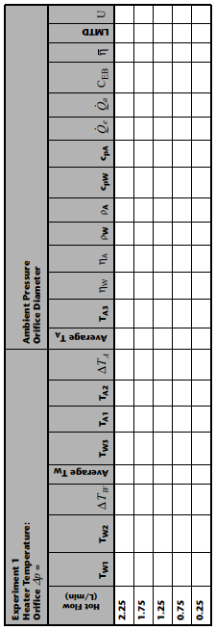
Table 2 Experiment 2 and 3 example results table (TecQuipment ltd, 2014)
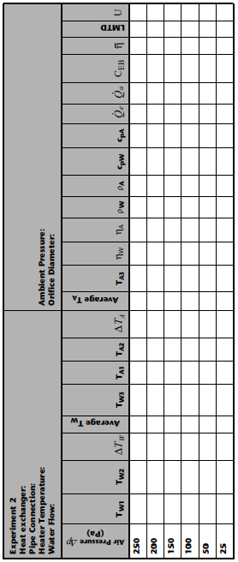
Using the slide valve, the drop in air pressure from the orifice to the fan needs to be set at 250 Pa with a tolerance of plus or minus 5 Pa by sliding the valve up and down.
Setting the required water flow rate is accomplished via the hand operated water supply valve and should be set to 2.25 L/minute, with a tolerance of 0.01 L/minute.
Once the parameters for the experiment are set a timer should be started for 5 minutes to allow the heat exchanger temperatures to stabilise. Note that during this time period some parameters may fluctuate slightly so constant attention is required, these parameters include: the inlet water temperature; the drop in air pressure; the water flow rate; and the air flow rate. After the 5 minute period has concluded results should be noted in the results table.
The experiment should be repeated with the parameters changed by adjusting the hand controlled water flow valve to the next water flow rate in the table.
By following the above instructions the experiment can altered in accordance with experiment 2 and 3 by adjusting the sliding valve to adjust the drop in air pressure and adjusting the inlet water temperature on the main control panel for experiment 3 to 45°C.

Results

useful equations
the specific heat capacity of water can be calculated via equations 1 and the results can be validated by looking at figure 8 which shows specific heat capacity measured in kJ.kg⁻¹.K⁻¹ plotted against temperature measured in Celsius.
Equation 1 Specific Heat Capacity of Water
$${cp}_{w}=0.996185+0.0002874{\left(\frac{T+100}{100}\right)}^{5.26}+0.011160∙{10}^{-0.036T}$$
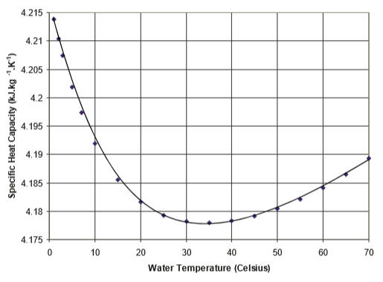
Figure 8 Specific Heat Capacity of Water at Constant Pressure
The operational manual provided by TecQuipment Ltd states that the specific heat capacity of water remains reasonably around 1005 J.kg⁻¹.K⁻¹ at normal atmospheric pressure and for the temperature ranges used in heat exchangers (TecQuipment ltd, 2014).
Looking at density, air has a maximum density at absolute zero (0K or -273.15°c) and decreases as the temperature rises. Air density can be calculated by using equation 2 and validated against figure 9 which shows air density measured in kg.m⁻³ plotted against air temperature measured in Celsius.
Equation 2 Air Density
$$ρ_{a}=\frac{p}{RT}$$
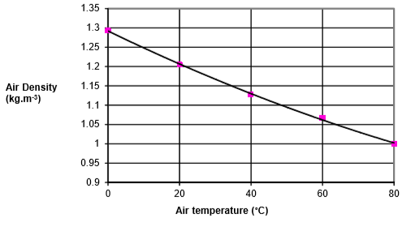
Figure 9 Air density plotted against air temperature
Water density has a maximum density at around 4°c and decreases as temperature increases, the calculation needed to calculate this is shown as equation 3 where is the average recorded temperature and verified by referencing figure 10 which shows water density measured in kg.m⁻³ plotted against water temperature measured in Celsius.
Equation 3 Water density
$$ρ_{w}=\frac{\left(999.839+16.952T-7.99∙{10}^{-3}T^{2}-46.241∙{10}^{-6}T^{3}+105.846∙{10}^{-9}T^{4}-281.03∙{10}^{-12}T^{5}\right)}{(1+16.887∙{10}^{-3}T)}$$
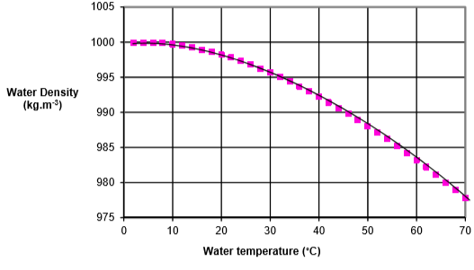
Figure 10 Water density plotted against water temperature
In heat exchanger systems heat transfer happens from the colder fluid or gas to the hotter colder fluid or gas and is measured in power (Watts) as the rate of transfer. The heat transfer emitted by the water is calculated by equation 4 and the rate of heat transfer by the air is calculated by using equation 5 respectively.
Equation 4 Water heat transfer
$$Q_{w}=m_{w}∙{cp}_{w}∙∆T$$
Equation 5 Air heat transfer
$$Q_{a}=m_{a}∙{cp}_{a}∙∆T$$
When considering the perfect heat exchanger system that doesn’t lose or absorb any thermal energy both equation 4 and 5 should be equal as all the heat energy transferred from the cooled liquid or gas (Qt) will be absorbed by the hotter liquid or gas meaning equation 6 would be true.
Equation 6 Perfect heat exchanger heat transfer
$$Q_{t}=Q_{w}=Q_{a}=m_{w}∙{cp}_{w}∙∆T=m_{a}∙{cp}_{a}∙∆T$$
C_{eb} describes the energy balance coefficient and shows the relationship the energy absorbed and the energy emitted, this is calculated by using equation 7 below.
Equation 7 coefficient of energy balance
$$C_{eb}=\frac{Q_{a}}{Q_{w}}$$
As stated above the heat exchanger may lose some energy that is absorbed by the surroundings or leak from the system so the C_{eb} may give results greater than 1 so equation 7 will only give an guided estimate on the actual result. Equation 8 shows the realistic equation for energy balance.
Equation 8 Realistic energy balance
$$Q_{w}=Q_{a}±losses or gains from surroundings$$
The temperature efficiency of the water can be calculated by using equation 9.
Equation 9 Temperature efficiency of hot water
$$η_{w}=\left(\frac{T_{w1}-T_{w2}}{T_{w1}-T_{a1}}\right)∙100$$
The temperature efficiency of the cold air can be worked out using equation 10 below.
Equation 10 Temperature efficiency of cold air
$$η_{a}=\left(\frac{T_{a2}-T_{a1}}{T_{w1}-T_{a1}}\right)∙100$$
Using the results from equations 9 and 10 the mean temperature efficiency can be calculated by putting the results into equation 11 which is an average of the two values.
Equation 11 Mean temperature efficiency
$$η_{t}=\frac{η_{w}+η_{a}}{2}$$
The logarithmic mean temperature difference (LMTD) is a measure of the heat driving force that creates the heat transfer. It’s a logarithmic average of the temperature difference between the hot and cold circuits at each end of the heat exchanger (TecQuipment ltd, 2014). The equation for LMTD is shown below as equation 12
Equation 12 Logarithmic mean temperature difference (LMTD)
$$LMTD=\frac{\left(T_{w2}-T_{a2}\right)-(T_{w1}-T_{a1})}{\ln\left(\frac{T_{w2}-T_{a2}}{T_{w1}-T_{a1}}\right)}$$
Lastly the heat transfer coefficient (U) is a measure of how well the heat exchanger works by calculating the coefficient of heat transfer for the wall and boundary layers. The higher the value for this, the better as this shows how good the heat exchanger is. This is calculated by using equation 13.
Equation 13 Heat transfer coefficient
$$U=\frac{Q_{w}}{A∙LMTD}$$

Experiment 1
Experiment 1 looks at the change in heat exchanger efficiency whilst changing the hot water flow rate. With the experiment apparatus set to 60°c as the hot water temperature and air flow rate set at 250pa will remain as the constants, the hot flow rate measured in litres per minute will be changed in 5 minute increments from 2 to 0.75 in 0.25 increments. The results that were recorded during the experiment are displayed in table 3 below.
Table 3 Experiment 1 results

Experiment 2
Experiment 2 looks at heat exchanger efficiency when altering the air pressure in the system. Whilst keeping the hot water temperature set at 60°c and the hot water flow rate at 0.25 L/min as the constant parameters for this experiment, the air pressure will be changed from 250Pa to 50Pa in 50Pa increments with the addition of 25Pa as well. The result from the experiment were recorded into table 4 shown below.
Table 4 Experiment 2 results

Experiment 3
Similarly, as above experiment 3 looks at the heat exchanger efficiency with the hot water flow rate set at 0.25 L/min and the hot water temperature set at 45°c as constant parameters. The variable parameter in this experiment, as above, will be the air pressure in the system which will be set at the start of the experiment at 250Pa and decrease in 50Pa increments down to 50Pa with the addition of 25Pa.
Table 5 Experiment 3 results

4.0 Analysis
Looking at experiment 1, although this experiment differs to experiments 2 and 3 the results can still be compared against the range of variables with the different water mass flow rates. Figure 11 below shows the air heat transfer (Qw) measured in watts plotted against water mass flow measured in kilograms per second. Figure 11 shows a positive correlation between the two fields until the water mass flow rate reaches around 0.028kg/s where the air heat transfer reduces suggesting a peak in the amount of heat that can be transferred occurs at around 1.75L/min.

Figure 11 Experiment 1 air heat transfer plotted against water mass flow
Looking at overall temperature efficiency plotted against water mass flow in experiment 1 displayed in figure 12. There is a very clear negative correlation from the lower test point of 0.75L/min down to the higher test point of 2L/min, this shows that the peak temperature efficiency is higher when the hot water flow rate is lower which contradicts the statement made above that more energy is transferred when the water flow rate is at 0.28kg/s.

Figure 12 Experiment 1 η plotted against water mass flow
Looking at U in experiment 1 is the main variable that engineers look at as this value describes how well the heat exchanger works, the higher the value the better the system. Figure 13 shows the heat transfer coefficient plotted against the water flow rate. Apart from a small negative correlation between 0.016kg/s to 0.02kg/s the graph clearly indicates a positive correlation that support the suggestion that as the water flow rate increases the better the heat exchanger works.

Figure 13 Experiment 1 heat transfer coefficient plotted against water mass flow
When looking at experiments 2 and 3 they can be directly compared as the same variables are changed with a change in the constant, being the hot water temperature from 60°c in experiment 2 to 45°c in experiment 3. With that said, looking at the relationship between heat transfer in the water (Qe) measured in watts and the air mass flow measured in kilograms per second is displayed in figure 14. Both curves follow a positive correlation in a similar pattern, as expected the curve for experiment 2 shows higher values than that of experiment 3 suggesting there is more heat transfer when the hot water is at a higher temperature but also when there is a higher air mass flow.

Figure 14 Experiment 2 and 3 water heat transfer plotted against air mass flow
When comparing the results for the heat transfer coefficient plotted against the air mass flow in experiments 2 and 3 displayed in figure 15. A clear positive correlation can be noted from the lower test point of 250Pa to the lower test point of 25Pa, as stated above the curves follow a similar pattern although for the majority of the curve the results from experiment 3 are slightly higher than those recorded in experiment 2. With a higher heat transfer coefficient at lower air mass flow this would suggest that the heat exchanger works better at the lower temperature of 45°c although the difference in results becomes negligible at an air mass flow value of 0.11kg/s. Towards the end of the curves the results for experiment 2 are slightly higher than that of experiment 3 which may suggest that as the air flow mass continues off the graph beyond the testing range that the higher temperature of 60°c may improve the performance of the heat exchanger.

Figure 15 Experiment 2 and 3 heat transfer efficiency plotted against air mass flow

5.0 Conclusion
In conclusion there was a good range of data that was gathered from experiments 1 through 3 with many variables such as: hot flow water temperature; hot water flow rate; and cold air flow rate. From looking at the analysis of the results an argument could be made to say that the heat exchanger works best when the hot water flow temperature is at 60°c with a water flow rate of 2L/min and an air pressure of 250Pa, this test produced a heat exchange coefficient value of 136.921 which was the peak of all tests completed. On the other end of the scale the test that produced the lowest heat transfer coefficient value of 79.757 was when the hot water temperature was set at 60°c with a water mass flow rate of 0.004kg/s and an air pressure of 25Pa when completing experiment 2.
If more experiments were to be undertaken it would be interesting to see the effect of changing the constant hot water flow temperature in experiment 1 to 45°c to see how these results would compare to those recorded in experiment 1. It is no surprise to see that when: the hot water temperature; hot water flow rate; and air pressure are set at their highest for this set of equipment that the heat exchanger works at its best. It would however be interesting to compile more data to see if graphs created from university testing matches those supplied by TecQuipment ltd for air and water density and specific heat capacity. Finally more research could be completed at different times of the year to see the effect of ambient air temperature and also if at all possible at different altitudes to see the effect of ambient air pressure.

6.0 References
Spakovszky, P. Z. S., 2006. 16. Unified: Thermodynamics and Propulsion, s.l.: s.n.
TecQuipment ltd, 2014. TD1007 Water to Air Heat Exchangers. Nottingham: s.n.

