Ethan Reed
A Report into The Effectiveness of the Current Structure of NHS Wales
Tania Davies
Abstract
This report explores the effectiveness of the current structure of the National health service in Wales by evaluating data, graphs and statistics surrounding the structure. These included; government publications on the hierarchical structure of the NHS, publications on how health and social care funding is allocated throughout the UK and how local health boards and their hospitals are distributed throughout Wales. It described how NHS Wales allocates responsibility and 6.3 million pounds of funding between seven local health boards. During the evaluation of the current structure it was shown that the NHS has several flaws; a potential mess of communications should it ever hire too many managers, severe bed shortages from elderly persons needing longer hospital stays that may cause some patients to be discharged early, and a culture of bullies and general negativity that is found to ignore its shortcomings and make up for them.

Table of contents
- Abstract………………………………………………………………………………..……………………….pg. 1
- Introduction……………………………………………………………………………..……………………pg. 3
- Information, Statistics and Guides…………………………………………………..………………pg. 4-7
- Evaluation of Current Structure…………………………………………………………..………….pg. 7-8
- Conclusion……………………………………………………………………………………………..………pg. 8
- Recommendations……………………………………………………………………………………..…..pg. 8-9
- Reference list…………………………………………………………………………………………………pg. 10-12

Introduction
According to Full Fact (2017), The National Health Service, abbreviated as NHS. Is a publicly funded medical and healthcare service provider in the United Kingdom. It provides essential medical treatments to all residents of the UK, with a few exemptions such as certain dental treatments (National Health Service, 2017) and prescriptions in England (politics.co.uk, 2019). NHS Wales, also known as Public Health Wales (NHS Wales, 2018) describes itself as the government funded health provider for Wales, working to improve general health and quash health inequality for Welsh people. It achieves this through working with its partners in a multitude of medical, research, political and care provision sectors, including; screening and early detection services, safeguarding services for children and other vulnerable persons, and global research contribution efforts. It also works within itself at a local in order to strategize and prioritise care and community support within Wales. Simpson (2016) wrote that in Wales, the NHS is managed by seven local health boards each led by a Director of public Health (NHS Wales, 2018) with the goal of providing, planning and developing treatment and healthcare services for each of their geographical areas, these health boards oversee delivery in four sectors (GPOne, 2019): Primary care through GP surgeries, secondary care through hospitals and ambulance providers, Tertiary care through specialist centres and hospitals, and community care through cooperation with local services, normally within patient home settings. Simpson (2016) continues, stating that the boards are assisted by three trusts; the Welsh ambulance service, Public Health and Velindre health trusts. Public Health Wales (2017) states that its purpose is to work within communities to develop services and improve local health, whereas Velindre University trust is made of two divisions focusing on developing and delivering care surrounding blood donation and cancer care provision (MediWales, 2015).

Information, Statistics and Guides
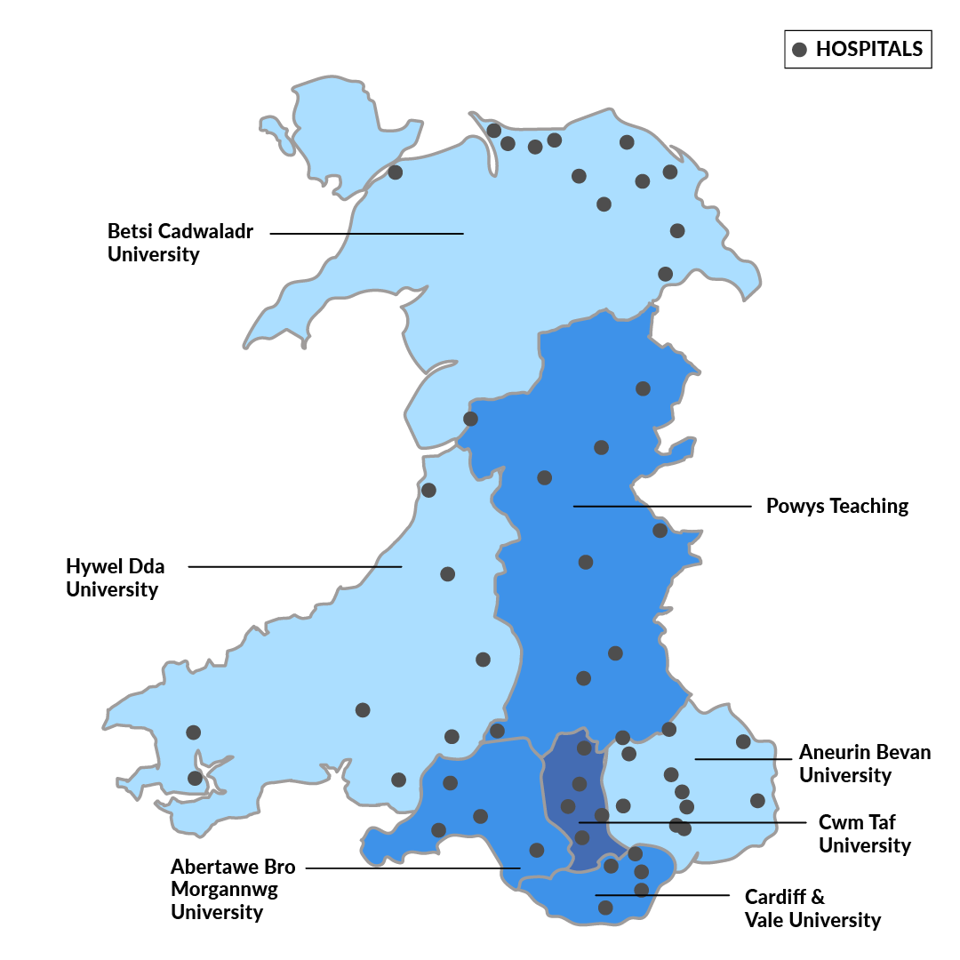
Diagram of Health board jurisdictions and hospitals within Wales (Richmond Nursing, 2019).
According to StatsWales (2018) the highest populations of the health boards is estimated to be nearly 700,000 in the Betsi Cadwaladr University health board, within this health board, the largest demographic belongs to those between the ages of 45 to 64. This demographic may have affected the services provided within the board, according to Betsi Cadwaladr University Health Board (2016) there are a number of services that seem to be targeted for middle-aged to elderly service users, for example there exist services which provide artificial limbs and prosthetic eyes, stroke care units, arthritic clinics and a mental health network for the deaf. Another example of targeted service provision within health boards is within Cwm Taf Morgannwg University Health Board (2019), which states that it also provides a large array of services for its elderly and aging population (StatsWales, 2018), such services include a Parkinson’s Disease nurse specialist service, Home Oxygen therapy services, a Stroke service and a veterans mental health service.
As the Welsh Ambulance Services NHS Trust (2019) reasoning behind ‘targeted service provision’ is that it allows health boards to spread the cost of specialised equipment and staff. Instead of each health board providing services for every type of patient or condition, each health board will specialise in fewer services which are more tailored to their population’s needs. This in turn allows them to provide better funded and staffed services at the detriment of allowing other services to minority demographics.

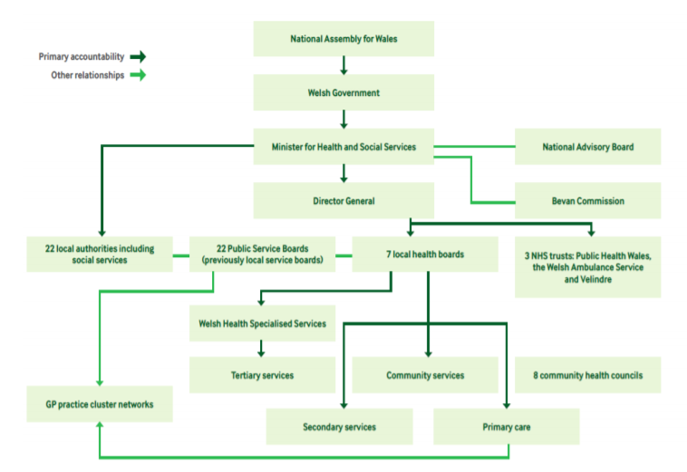

Organisation of Health and social care provision within Wales (Simpson, 2016)
As shown in the diagram above, primary accountability for the NHS in Wales stems from the National Assembly for Wales and is distributed downwards through various trusts, organisations and government bodies. In this case, accountability is handed down to the Welsh government and by extension the Minister for Health and Social services, who oversees service provision on a national scale. They will then allocate responsibility for service provision to the 22 local authorities and the Director General. The Director general allocates regional and local responsibility to the 7 Health Boards as well as the 3 Trusts, the Health Boards then allocate care provision at a local and hospital-wide scale to specialised services, community care services, primary, secondary and tertiary care services.
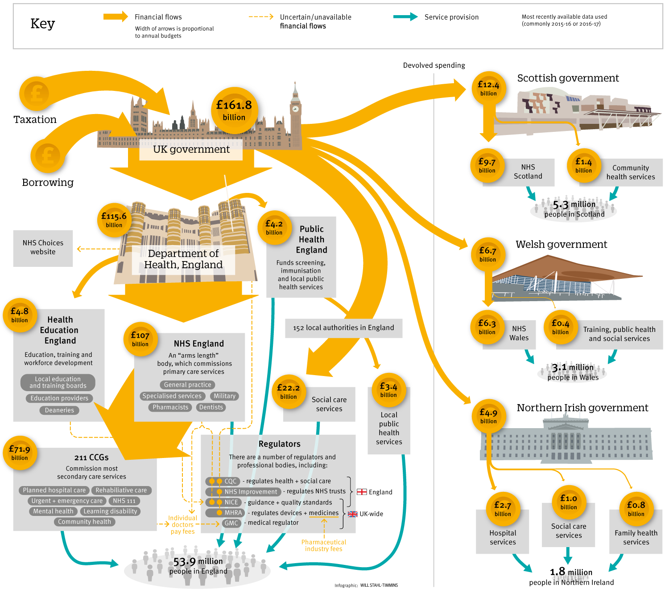
Allocation of funding within the NHS (Iacobucci, 2017).
Funding allocation in NHS Wales follows a similar structure and process as the allocation of responsibility. Funding flows directly from the sitting government and is split and allocated to the various organisations, regulators, devolved governments and departments. Funding within Wales is then further distributed between the NHS itself and the respective training programs, public health and social care services.
Funding allocation at the present is affected by several factors, according to Triggle (2018) the NHS at large has been facing enormous pressure from overcrowding, a lack of staff, long waiting times for treatments and ambulance shortcomings. Triggle states that the budget for the NHS has steadily been on the increase since its inception during the late 1940’s, resting at around 150 billion pounds in 2017 when adjusted for inflation. This has in turn caused a much larger percentage of the public spending budget to be funnelled into the NHS. Triggle also identifies that patient targets are being missed by increasing margins every year, reaching their worst at the end of the year. As stated previously in StatsWales (2018), the population of the UK is living to be older, with Triggle predicting the ageing population to reach a demographic of 25% by 2044, this means that through cause and effect, people will live longer with conditions that require hospital stays, long-term treatment and higher rates of recurrent stays.

Evaluation of current structure
According to Morton (2019), a hierarchical structure tends to have a single manager or management body at the top with responsibilities and power being passed down through lower levels of management down to the workers. Morton (2019) continues stating that the NHS is structured in this manner and provides the organisation with several benefits, including a reporting structure which allows for doctors, nurses and other staff to easily report issues or receive instructions. This also provides clear communication lines between different types of staff as most information can be passed through managers of different sections. There should not be any confusion on who is higher or lower within this structure although this can still occur if there are too many managers, potentially causing miscommunication and increasing the risk of errors being made.
Though not so much an organisational issue as much an overcrowding issue. As medical technology improves and people’s lifestyles become healthier, we begin to see the population live to older ages and see this at a more frequent rate (Office for National Statistics, 2018). While this is a great improvement for patients overall, it can become an issue for hospitals. Older people are at greater risk of becoming ill and require longer stays at hospital in order to become well again. This causes beds to be used up for much longer periods and puts pressure on hospitals to discharge other patients as soon as possible, perhaps leading to improper attention and care being provided as well as a myriad of other issues (British Medical Association, 2017).
According to the Nursing Times (2008), despite there being a rise in nurses who suffer from work-related stress and mental health issues, almost two-thirds of NHS nurses feel happy in their occupation. This is further enforced by the Nursing Times finding that nurses take less sick leave for reasons of work-related stress. Although, despite this, Pope, (2015) finds that there exists severe organisational negligence and other negative behaviour. Based upon an apparent model of dysfunction, several interviews and focus groups, they have identified that the NHS, harbours a culture of; ignorance, bullying and avoidance of any sort of responsibility for its own actions. Pope continues, stating the NHS has lost sight of its original purpose as a health and care institution and needs to re-emerge as an organisation that is open and honest with its service users and is not afraid to learn from its mistakes.
The NHS is free to the point of use (Labour, 2019) and provides a vital service which many living in the UK could not afford otherwise. The NHS is able to remain free largely due to taxation, national insurance contributions and a small amount of patient charges such as for dental services and prescriptions (Full Fact, 2018). However, in recent years it has come to light that there is a present issue surrounding the waste of funding. There are several examples of NHS resources being wasted, including: over prescription of painkillers such as ibuprofen and paracetamol for relatively minor conditions which do not warrant medication, inappropriate usage of accident and emergency services and inappropriate redirection of patients through the 111 helpline (Proprietary Association of Great Britain, 2016).

Conclusion
This report has looked at the National Health Service, the division supporting Wales in particular. It has described the aims of the NHS as a body for health and social care service provision and its underlying purpose of providing free healthcare to the population of the UK. It discussed briefly how the organisation is structured in Wales, allocating responsibilities and funding to seven health boards, each with their own specialisations. It also mentioned the three health trusts in Wales and how they assist boards in fulfilling their duties. The report then provided diagrams and statistics which delved deeper into the organisational structure of the Welsh NHS and how responsibilities are divided from parliament down to the local level. It also brought in figures for the allocation of funding, how much is provided to different bodies and organisations, and which bodies are in charge of allocation. It also spoke of how the seven health boards overcome the issues stemming from limited funding, spreading out their services and putting more into services which benefit the largest demographics. Lastly, this report discussed the various strengths and weaknesses of the NHS from both a general and organisational standpoint, it found that there are inherent issues with its hierarchical structure in that communication could suffer from a large amount of managers, which in turn could cause issues regarding the care of patients. It also saw it reported that the NHS harbours a culture that is apparently unwilling to admit mistakes and negative all-round for its staff. Severe wasting and misuse of NHS resources and services was also found, particularly in the over-prescription of painkillers, and misdiagnosis of patients over the 111 hotline causing them to seek A&E help.

Recommendations
After compiling this report, it is obvious that the NHS is in need of major improvements in order to bring itself back as an organisation capable of its original goal. Some ideas for recommendations are listed below:
- Reallocate funds from taxes on certain health detrimental products such as cigarettes. O’Brien and O’Leary (2015) state that estimates of the cost the NHS endures from treating those who smoke lie between three to six billion pounds, they continue, stating that the government takes around twelve billion from VAT and duties so it makes a certain degree of sense that the NHS could cover the costs of treatments with the earnings made from tobacco products.
- Provide the public with basic diagnostic education, perhaps through television advertisements or a much larger campaign. The NHS has a number of public health campaigns running at present, such as Adverse Childhood Experiences (ACES), Beat Flu and Help Me Quit (Public Health Wales, 2018). So it would not be inconceivable for it to perform a campaign to reduce unnecessary hospital visits.
- Supporting whistleblowing within the organisation and try and nurse a much more positive working environment.

Reference list
Betsi Cadwaladr University Health Board (2016) A-Z of Services. Available at: http://www.wales.nhs.uk/sitesplus/861/page/52125#top (Date accessed: 20/04/2019)
British Medical Association (2017) Bed shortage crisis reaches point of no return. Available at: https://www.bma.org.uk/news/2017/december/bed-shortage-crisis-reaches-point-of-no-return (Date accessed: 22/04/2019)
Business Case Studies (2019) Organisational structure in an innovative environment A Capco case study. Available at: http://businesscasestudies.co.uk/capco/organisational-structure-in-an-innovative-environment/organisational-structures-and-cultures.html (Date accessed: 21/04/2019)
Cwm Taf Morgannwg University Health Board (2019) Services. Available at: https://cwmtaf.wales/services/ (Date accessed: 20/04/2019)
Full Fact (2017) What is the NHS? Available at: https://fullfact.org/health/what-is-the-nhs/ (Date accessed: 03/04/2019)
Full Fact (2018) How is the NHS funded? Available at: https://fullfact.org/health/how-nhs-funded/ (Date accessed: 22/04/2019)
GPOne (2019) NHS Wales Structure. Available at: http://www.gpone.wales.nhs.uk/nhs-wales-structure (Date accessed: 04/04/2019)
Iacobucci, G. (2017) ‘NHS in 2017: the long arm of government’, BMJ. 356 (8088) pp. 1-5 (Date accessed: 19/04/2019) DOI: https://doi.org/10.1136/bmj.j41
Labour (2019) Healthcare for all. Available at: https://labour.org.uk/manifesto/healthcare-for-all/ (Date accessed: 22/04/2019)
MediWales (2015) Velindre University NHS Trust. Available at: https://www.mediwales.com/members/velindre-nhs-trust/ (Date accessed: 04/04/2019)
Morton, P. (2019) The middle manager: pros and cons of hierarchy in a small business. Available at: https://www.turbinehq.com/blog/pros-cons-hierarchy-small-business (Date accessed: 21/04/2019)
National Health Service (2017) Which dental treatments are available on the NHS? Available at: https://www.nhs.uk/common-health-questions/dental-health/which-dental-treatments-are-available-on-the-nhs/ (Date accessed: 04/04/2019)
National Health Service (2018) Principles and values that guide the NHS. Available at: https://www.nhs.uk/using-the-nhs/about-the-nhs/principles-and-values/ (Date accessed: 20/04/2019)
Nursing Times (2008) How happy and healthy are nurses? Available at: https://www.nursingtimes.net/how-happy-and-healthy-are-nurses/1902473.article (Date accessed: 21/04/2019)
Office for National Statistics (2018) Estimates of the very old, including centenarians, UK: 2002 to 2017. Available at: https://www.ons.gov.uk/peoplepopulationandcommunity/birthsdeathsandmarriages/ageing/bulletins/estimatesoftheveryoldincludingcentenarians/2002to2017 (Date accessed 21/04/2019)
O’Brien, L. and O’Leary, J. (2015) Does smoking cost as much as it makes for the Treasury? Available at: https://fullfact.org/economy/does-smoking-cost-much-it-makes-treasury/ (Date accessed: 22/04/2019)
politics.co.uk (2019) NHS Prescription Charges. Available at: https://www.politics.co.uk/reference/nhs-prescription-charges (Date accessed: 04/04/2019)
Pope, R. (2015) ‘The NHS: Sticking Fingers in Its Ears, Humming Loudly’, Journal of Business Ethics. 145 (3), pp. 577-598. (Date accessed: 21/04/2019) DOI: https://doi-org.ezproxy.uwtsd.ac.uk/10.1007/s10551-015-2861-4
Proprietary Association of Great Britain (2016) Report: Five examples of waste in the NHS. Available at: https://www.pagb.co.uk/latest-news/report-five-examples-waste-nhs/ (Date accessed: 22/04/2019)
Public Health Wales (2017) About Public Health Wales. Available at: http://www.wales.nhs.uk/sitesplus/888/page/88654 (Date accessed:04/04/2019)
Public Health Wales (2018) Campaigns and Collaborations. Available at: http://www.wales.nhs.uk/sitesplus/888/page/44945 (Date accessed: 22/04/2019)
Richmond Nursing (2019) Health Boards and Hospitals in Wales. Available at: https://www.richmondnursing.co.uk/2018/12/27/health-boards-hospitals-in-wales/ (Date accessed: 19/04/2019)
Simpson, M. (2016) How is healthcare in Wales structured? Available at: https://www.bma.org.uk/-/media/files/pdfs/working%20for%20change/doctors%20in%20nhs/brief%20how%20is%20healthcare%20in%20wales%20structured.pdf?la=en (Date accessed: 04/04/2019)
StatsWales (2018) Mid-year population estimates (2009 onwards), by Welsh health boards, for single year of age and gender. Available at: https://statswales.gov.wales/Catalogue/Population-and-Migration/Population/Estimates/Local-Health-Boards/populationestimates-by-lhb-age (Date accessed: 20/04/2019)
Triggle, N. (2018) 10 charts that show why the NHS is in trouble. Available at: https://www.bbc.co.uk/news/health-42572110 (Date accessed: 20/04/2019)
Welsh Ambulance Service NHS Trust (2019) Health Boards. Available at: https://www.nhsdirect.wales.nhs.uk/localservices/localhealthboards/ (Date accessed: 20/04/2019)

