Alina Mariutac
Digital skills
Username: alinamariutac73@gmail.com
Password: Dob27.11.91
What are your dietary requirements?
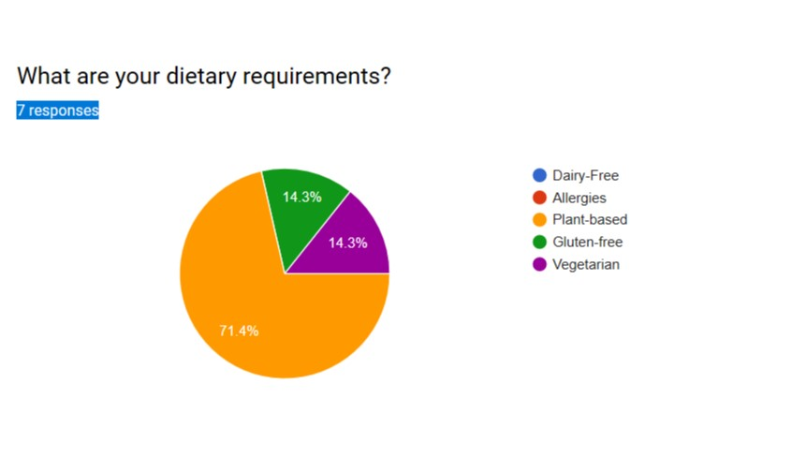
Survey data analysis are the results of seven responses to the question of dietary requirements, we collect the statistical survey results and we have a data analysis plan, 71.4% of the responses are Plant-based, followed by 14.3% gluten free and vegetarian with 14.3%.
Based on those results we are planning to focused our marketing on people with food allergies restrictions and to target the people in Newport that are looking for a restaurant with a plant based meal and completely meat free.
Our strategy to increase the sells for customers with gluten free restrictions are:
- Customers can feel confident that their food will be prepared by our chef who is fully trained in Coeliac Awareness catering module

- In our restaurant awe offer a Gluten Intolerance menu and Allergies lots of options for vegetarians’ customers as well as vegan menu.

- Our recopies had been careful created by our qualified head chef and they have selected and modified recipes which are as close as possible to the original great test to help people with food intolerance and people with wheat and allergies.

From the marketing point of view, we will implement the follow strategies:
- Website, readers can check our recipes online on the section “my gluten-free vegan meal plan”.
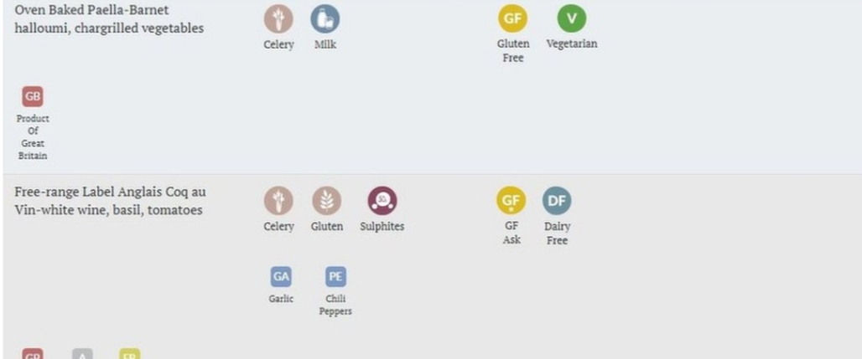
- Customers can get a “food testing box” delivered to their door where they can try our gluten free meals.
- The online tool allows customers with food intolerance to view the menus 24/7 and filter out dishes according to their allergies and dietary needs.

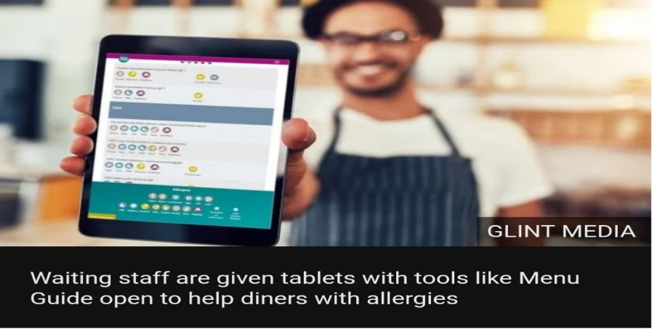

- our manager will help you to order/create a special meal design special for you, where he will oversee the order to monitore its preparation in the kitchen and delivery of the food.

Those days Food-Intolerance is a big part in our community and our goal is to make sure that customers are safe in a friendly environment, with fresh, high quality vegan products for this reason customers who have allergies or gluten intolerance are encouraged to look through a food allergy and information book with a manager before ordering.
Our aim is to give the change to people that live in Newport and to recognise the many benefits of Vegan food, and the changes that this bring to customers.

Why it is important having a website?
We create a light weight and responsive website, content it is simple and exact, where our customers can find information’s about our restaurant. The most significant reason which is behind the requirement of a website for our Vegan only restaurant is to attract lot of people. By establishing a website for Heaven Vegan that will attract people from all over the place.

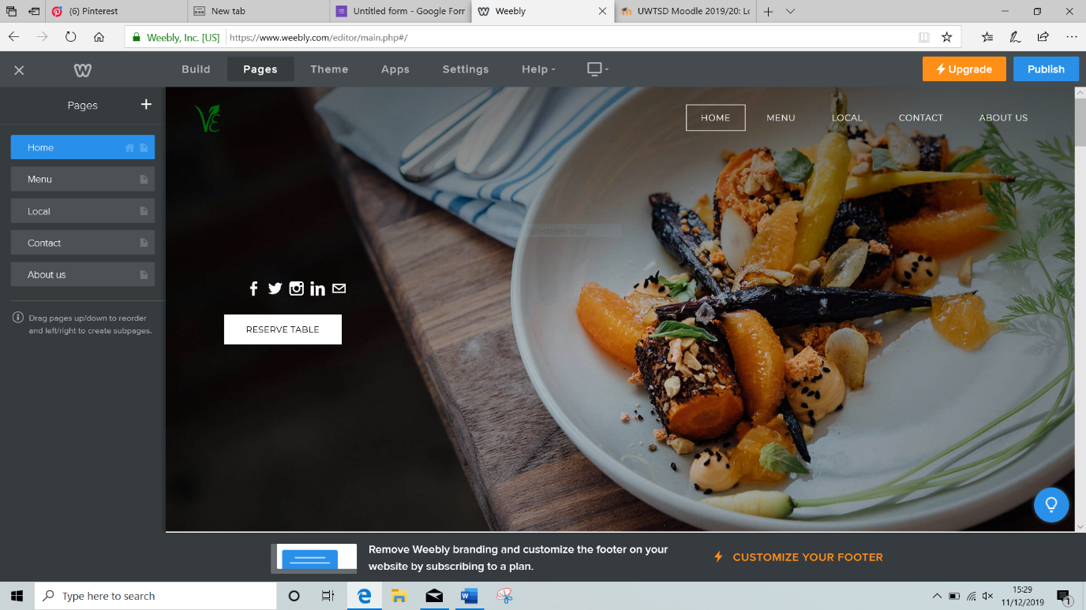

Our web design is created to match with the atmosphere of our restaurant as well as giving visitors the information needed so they know what to expect when visiting Heaven Vegan in Newport and how to get to our restaurant.
The Quality of the images and videos
Prints ads, commercial, phone book listings are all very expensive and are reaching less and less potential customers. Quality images and videos will help us to promote faster at a low cost, offer more information through out the images and it is avaible 24/7 and even to anyone’s reach with a smartphone.

Keywords are important for our website because we target the right people, close to the restaurant location such as Newport, Vegan, for customers that their diet is based on plant-based but not only Vegan population also to everyone who like fruits and vegetable, seeds, nuts, and want to try our meals, we offer the optimal nutrients for a healthy lifestyle. We target our marketing to everyone who is meat free, people chose to become vegan or vegetarian from different reasons, some for animals, ecosystem, and many for health reasons.

Social media
Will help us to build relationship with customers, a website is a great place for capturing customers feedback through comments and surveys and to promote vegan products. Using the social media, visitors to either call or fill out a contact form, the goal is to get people to visit our Vegan Restaurant.

Blog
It is becoming increasingly important for business to develop a strong web to engage and communicate with our customers.
We decided to use our blog, because our customers what to find more information’s about ourselves and we create one on the website so readers can ask questions. Blogging is an inexpensive way for small business to dive traffic to our website, enhance inbound marketing efforts and attract more perspective customers.

Maps and contact
On our page customers can find basic information’s such as hours of operation, payment methods, location and direction, go a long way to helping customers come to our restaurant.

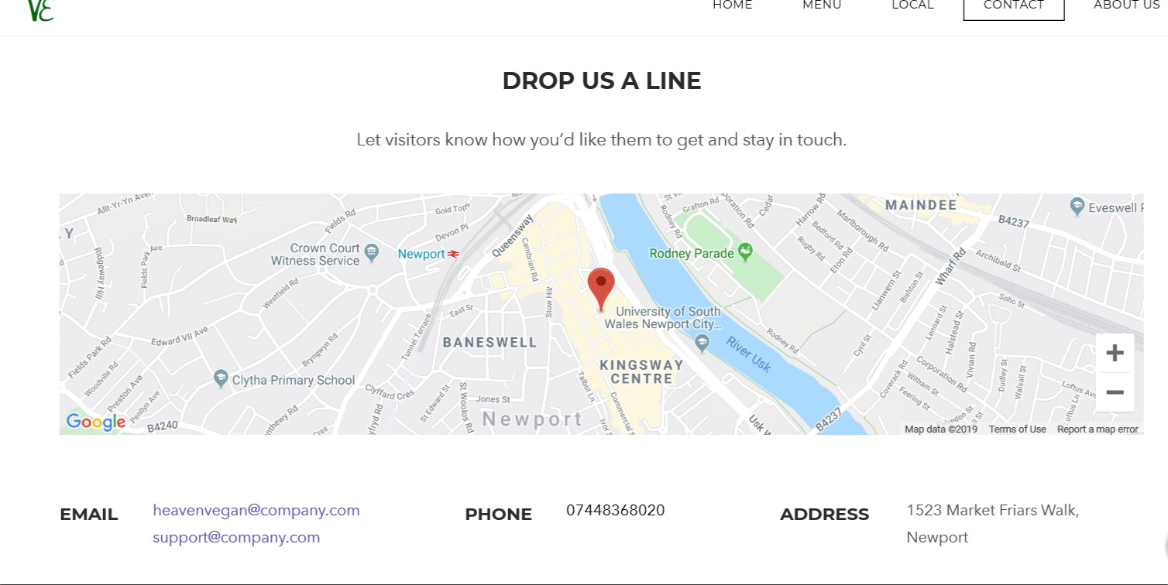

What it is SEO?
SEO stands for “search engine optimization” it is the process of getting traffic from the free search results on search engines. A huge aspect of SEO revolves around competitor analysis and determination the exact ranking factors behind any given keywords, in order to found on the internet, we must build a website, SEO is the way which search engines find our website.
Why we need SEO?
People search all day, SEO help us to put our website in front to people when they search, help our business for the follow reasons, give us the opportunity to answer peoples questions, many check our products and services before ordering, they want to know about quality, prices, location and also want to know if the service or products satisfy their needs, SEO help us to turn our potential customers into real customers.
Another reason to use SEO in our business is to help us to show our restaurant first on Google when customers search, we need to make sure we stay on the first page of the search engine, our website needs to stay first before our competitor. SEO is the quickest form of direct Marketing, our website is ready to serve our customers.

SEO will help our Business to get up in google rank, points to consider:
Speed of loading quality of the images | Images/video
Website \blog | Social media
Keywords search | Internal linking

The reasons why we Optimize our website frequently is to make our site more effective, to make sure we target the right audience, grow our organic traffic, help our website to work faster and to give our audience what thy want and what they expect from our service in order to do that we analyse all our website data, conduct through out keywords research, optimize the website for mobile.

