

Professional career development report and role play (interviewee and interviewer) (Task-1 And Task-2)

Student’s Name: Rasel Khan
Student’s ID: 2011485
Module Code: BMSW4005
Lecturer: Anita Nan
University of Wales Trinity Saint David

Table of content
Introduction ------------------------------------------------------ 1
Mainbody(Lifeline)----------------------------------------------------------- 2
VAK Learning style------------------------------------------------2-3
My learning style------------------------------------------------------3
Self-motivation---------------------------------------------------------3
SWOT Analysis--------------------------------------------------------3-4
What employer want------------------------------------------------4
Employment Goals-------------------------------------------------4
Personal development plan-----------------------------------------5
Conclusion--------------------------------------------------------------6
Appendix---------------------------------------------------------------7

Task 2- Report

Introduction
It will be discussed in this essay what I have learn from this module and how it will impact on my further study and career . The module professional career development is one of the most important module for me where I gained more knowledge that will help me to build a beautiful career.
I will discussed about them in this essay, such as, what employer want, self-motivation, learning style , SWOT analysis, employment goals, personal development plan , employment goals etc .
On the appendix I will upload the job application from and the questions I have asked my partner as an interviewer .

Mainbody
----------------------------------------------------------------------------

Lifeline: lifeline indicates a clear future plan for a person to achieve the goals what should do the next . it gives a clear direction to go ahead successfully .
I will describe about my future plan and what should I do to reach my destination. Currently I am studying CertHE skills for the work place the course will take one year . as it is Level4 so it needs another two years to get a degree. I have decided after completion level4 I will go for further study means level5 and 6 . I am currently working at primark as a retail assistant and living with my family . as a matured student it is a challenge to continue study with a lots of family and social commitments. but for a better future I can sacrificed and I decide that I will reduce working hours 40 hours to 30 hours in a week , which will help me to get some times for study , if I can complete my degree I will apply for a manager at my current employer or any other reputed company . alongside I will try my best to complete my M.A . although I want to be a manager but my dream is to be lecturer in a university in the future.
The university of Wales Trinity saint David gives a better opportunity for students those are studying after a long gaps . I would like to take this advantage for a bright future .
I believe that the dream will come true if I can make a better plan to make it happen .. I will research on myself to find the challenges and will work on it .this will help me to enhance my potential for future development in the personal and professional context.

What employers want: achieve their goals easily. Every organizations have a certain works to be completed in a certain time period if it fails to do that it will badly affect on it internally and externally . To pay wages, pay bills, building rend and all cost it is really need for a organization to make profit without making profit no person or organization can run the business . and hard work is one of the most important thing to do that .
Punctuality is a one of the important things for a staff. every employer want people who is on time and able to complete task on time . tardiness is the main reason for a business to be loser. there are a lot of examples many of world-famous organization sack employees because of staff tardiness and poor performance What employers Want: employer want people like, hardworking, punctual, reliable, self-motivated and good communication skills . every organization has a target to reach the goals by doing hard work. without hard work it is not possible to be succeed. people who working hard can help an organization.
Self-Motivation: Motivation is pushing yourself to do something. To achieve any goals push yourself in the right direction. people can be motivated in their life by seeing or hearing someone achievement. self-motivation is an important part that helps an employee to employ themselves in a confident manner that helps to enhance the capacity to endure the flexibility of the communication.

for example , someone works two or three days in a week and struggling to pay bill end of the month, on the other hand , someone works five days in a week and leads a happy life with family without struggling .it can motivated the person who is working less then three days in a week and end of the month facing problem to pay bills, buying food which badly affect on his family life .
I believe I am well motivated and able to motivate people around me . when I started studying last year my family member and friends said that this is not a right time to go back to the study again as nowadays I have a family with two kids and lot of commitments to them .as well as now I am 38 years old it was supposed to finish study before get married but I was able to show them some example a good number of people could not complete their study when they supposed to but after a long gap when they realised to achieve the goal it is rather important to be highly educated and some of them complete their graduation when they are over aged of fifty .
The example I showed was helped them to understand they were wrong and there is no age limit to learn something .

VAK Learning Style
The VAK learning style assessment assesses a person's dominant or preferred style of learning using the three primary sources responsible for a range for the Vision, Auditory, and Kinesthetic (Gholami and Bagheri, 2013).
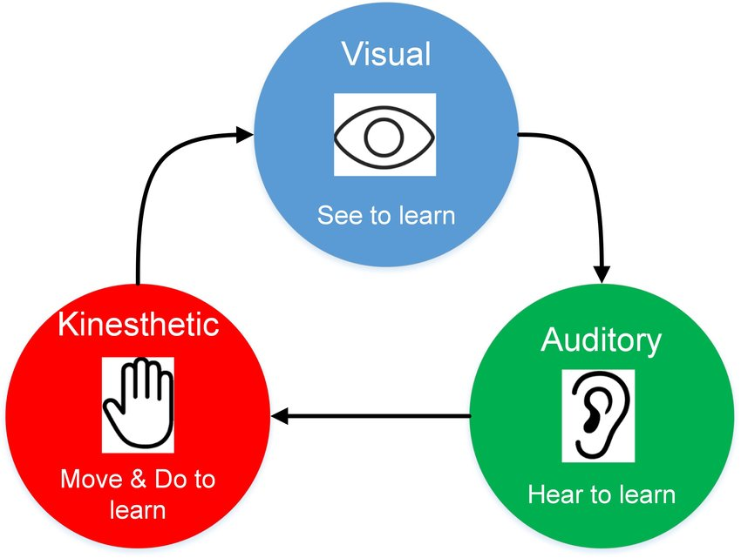
Figure 2: VAK Learning Style
(Source: Gholami and Bagheri, 2013)
Visual: they enjoy analysing and observing things like, pictures, diagrams,and charts that shows a clear information of the task they are doing .
This is based on how a person is able to understand any kind of source through visualization.
Auditory: Auditory learners prefer listening to information that is presented to them vocally. these learner work well in class or group study where presenting information vocally and may enjoy reading too.
This factor is based on the capacity of someone who is capable of acquiring something through hearing.
kinaesthetic: kinaesthetic learners prefer to physically act put when learning . always use all of their sens while learning . they need frequent breaks during heavy studying periods.This particular one is a mixed combination of visual and audible things.

My Learning style: I Believed I am a auditory learner. it best suits me and through this, I am easily able to learn and evaluate any kind of problematic sources based on any kind of subject. I also like to take note in class. I am able to learn while lecturer presenting something vocally in class. Reading and writing also help me to understand the main aspect of the information I need to collect. during this term the assignments I completed is mostly by taking note, reading journals/articles, and watching the relevant video clips. which is prove that I am a auditory learner.

. Personal SWOT Analysis
The tool of personal SWOT Analysis performs a vital role that will be analysing and evaluating my own personality and qualities along with my strength and weakness. Regarding this matter, the personal SWOT will be going to represented in the below (Rangkuti, 2015):
Strength | Weakness
According to what I previously stated, I believe I have a limited set of talents, which I also consider to be my strengths. In my professional life, I consider myself to be dependable, confident, attentive, and careful in everything I do. I can work effectively under time restraints and have unique issue abilities. | According to the overall rating, I have poor communication abilities. This is a significant difference from myself, who had a difficult time during the interview. On the other side, I am lacking in patience. I am not capable of maintaining my patience when listening to and learning something for an extended amount of time. And, based on the interview assessment, another issue I discovered is that I occasionally have a feeling of anxiety, which leads to an insecure attitude.
Opportunities | Threats
Opportunities exist exclusively in a person's potential capacity. In such a situation, my opportunities are represented as my strengths. As a result of the examination, it has been determined that I am capable of managing my affairs more effectively. Self-confidence will be really beneficial to me since I believe in my general ability to succeed and am not afraid about becoming a loser. It is a concept that assists individuals in dealing with stress, anxiety, rejection, failure, and basic convictions, among other things. Self-esteem and confidence are the belief in one's own ability to flourish in specific situations or finish a task. | According to the evaluation, I have deficits in communication skills and patience. Even a lack of effective communication skills may build a barrier between the transmitter and a receiver, resulting in irritation on both sides. When you are unable to explain your views to others, it causes a serious problem between them. A lack of it, whether in one's personal or professional life, may lead many relationships to fail.

Employment Goals: employment goals means make a plan to take yourself to desired destination . research on yourself to find actually what should we need to go there . every individual has different ambition . for me , I want to be a manager in any reputed company and I found that I need more knowledge about this position . by reading newspaper, journal , article watching relevant video I can gain knowledge . alongside I need to continue my study to get a degree on management. which will enable me to right fit for this position .
A good writing skills, reading and vocal skills are primary step to be a manager . every industry want a qualified manager who will be able to achieve their goals. a manager should have a good communication skill as they need to maintain a group of employees
From deafferent diversity different culture .
I believed if I can continue my study in uwtsd and get a degree I will be able to achieve my goals .

Gibbs Reflective Cycle Model
The overall experience from the interview session has clearly been described below through the reflective model of Gibbs.
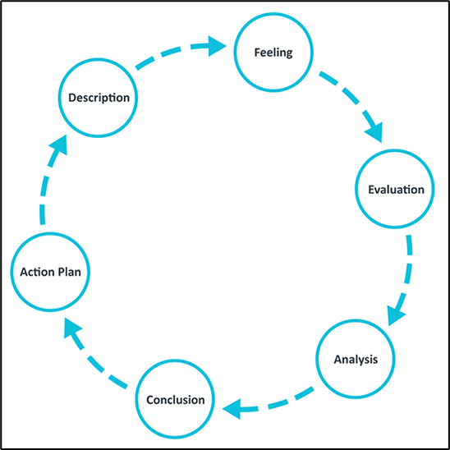
Figure 2: Gibbs Reflective Cycle(Source: Adeani, Febriani and Syafryadin)

, This time, I did the interview for the supervisor of a restaurant, I felt secure and safe in my responses to all of my questions during the brief duration of this interview, and even during the question-and-answer session, I must confess that I maintained a composed demeanour, which I can also say for my interview partner. The interview finishes within the lecturer's stipulated time range. I felt good while they supported me enough to express my own thoughts about the data analysis as well as my all experiences on that. The questions were also very good and they helped me to express my thoughts in a proper way. In that case, my workers also helped me to complete the situation and constantly motivated me all the time.

Analysis:
I believe that both I and my colleague were rather confident, and also that we complied with the instructor's time constraints, allowing us to complete our piece before the allocated time limit. In order to get the position as a data analysis manager, I want to improvise many more things. Alongside, whatever I have faced during the interview session will resolve through a single trigger when I will be capable of adjusting myself to all kinds of criteria that have to be needed as an interviewee.
Conclusion:
Now, from the overall evaluation of the analysis, it has been seen that the interview session was going in a good manner. But there are some aspects of mine that need to be improved for the further development of my personality in both personal and professional. And from this overall process it has been seen that, I have enough confidence and I am very attentive and careful which is very fit for my job. On the other hand, the nervousness and lack of communication skills are the weaknesses that are considered by me as a threat to my job.
Action Plan:
An action plan is based on some actions that will help me to enhance the qualities which are still considered as the gaps as my qualities. The action plan is required for me for the further development of my qualities that will help to improve the perception and qualities helpful for the personal and pr4. Personal Development Plan professional context.
Personal Development Plan:
Skills | How to improve | Timescale
Communication Skills | In order to improve my communication skill, Active listening is the first step toward effective communication. Nonverbal communication abilities: good communication depends on visual clues in relation to language information. The communication and presenting abilities will improve as I become more conscious of their body language and tone of voice. Developing the capacity to actively participate in team-building activities and to continuously interact with co-workers is a critical component of developing corporate communication skills. When I develop great relationships and camaraderie with people in the workplace, I am better able to assist someone in communicating successfully with them, which will improve my abilities as a result of those relationships and camaraderie. | 4 to 6 months
Listening skills | Good communication necessitates the development of both listening and speaking abilities. Every employment, in every industry, places a premium on effective communication. Therefore, to enhance my listening skill I have to listen to all the words of the speaker with effort. I have not to create any kind of disruption while someone wishes to discuss with me. | 3 to 5 Months
Skill of patients | From the overall evaluation of the report, it has been seen that I have a great lack in my patients. Maintaining a standard level of patients is a very important thing. Patience is a key part of achieving goals and developing a good rapport. When things will not go their way, there's always that one teammate who refuses to follow the rules and ideas of the rest of the group, becoming irritated when things don't go their way. Take a moment to consider how much more efficiently duties would be performed if every single employee was patient and trusted in what their teammates were saying. Therefore, I have to enhance my capabilities to learn and hear about anything with great patience. | 5 to 6 Months

5. Conclusion
Professional career development is one of the most important module for a student to develop the skills and analyse every single factor to achieve goals. the discussion on this report has given me such knowledge what I did not have just a year ago .especially personal SWOT helped me to find an accurate calculation on myself . the personal SWOT is also helpful for me to identify my potential qualities and weaknesses. From this critical evaluation, I have to consider taking some steps that will help me to overcome the fragile aspects in the professional context. In order to remove such incapability, this report has arranged the Personal Development plan.

References
Adeani, S. and Febriani, R.(2020) using Gibes reflective cycle in making reflection of literary analysis: Indonesian EFL Journal, 6(2), pp.139-148.
Gholami, S.and Bagheri, M. (2013) Relationship between VAK learning styles and problem-solving styles regarding gender and students' fields of study. Journal of language teaching and research, 4(4), p.700.
Rangkuti, F.(2015) Personal SWOT analysis,Gramedia Pustaka Utama.

APPENDIX

I have attached a copy of my job application that I prepared for my role play .me and my partner Natasha was presented our role play an interviewer and interviewee.
The questions I asked
- Could you please tell me about yourself?
- What is your strength and weakness?
- what makes you right fit for this job?
- What was your most challenging Data analysis project?
- How do you deal with missing data, outliers duplicate data?

Job application form

Application for [job title] - Supervisor

Your details

Name: Rasel khan

Education and training
Please give details:

Higher secondary certificate HSC(Bangladesh) equivalent O; Level
Esol B1 (London college)

Qualifications
Please give details:

I am very organised and punctual. able to work under pressure. Had been working in a busy shop past five years . well-motivated and able to motivate people around me.

Employment history

Your current or most recent employer

Name of employer: Alauddin Sweets and Cakes

Job title: Supervisor

Length of time with employer: Five years

Reason for leaving: continue study

Duties:

I was responsible to receive product from supplier, check expiry date and pay supplier. As a supervisor I used to set up a meeting every morning with all staff to explain their duties and confirm sign up and sign out .

Previous employers
Please tell us about other jobs you have done and about the skills you used or learned in those jobs.

I used to work with a five-star hotel named ‘HOTEL MAYFER:
Duties were checking rooms if its occupied or departure. Sending staff to every departure room to make it ready for upcoming guest

Supporting statement
Please tell us why you applied for this job and why you think you are the best person for the job.

The reasons of applying this job is my previous study and experiences is related to this job .
As I had been working as a supervisor past five years, I believe the experience I gained will help to do this job successfully.

Right to work in the UK
Do you need a work permit to work in the UK? Yes / No

References
Please give the names and contact details of 2 people who we can ask to give you a reference. We may ask them before an employment offer is made. We will not ask your current employer until we get your permission.

Declaration
I confirm that to the best of my knowledge the information I have provided on this form is correct and I accept that providing deliberately false information could result in my dismissal.

Name: Rasel Khan

Signature:
Date: 13/11/2021

