

Student name: Mariana Pandele
Student number :1914599
Module code and title:BMSW5103- Understanding And Engaging in The Costumer Experience
Lecturer name: Mary March

Organisations quality systems and costumer relationship management

Table of contents

Introduction
Company background
Costumers relationship management theorys

How do internal and external factors including COVID-19 affect or influence organisations quality systems and controls for costumers?
How the organisation can deal the new situation and achieve its business objectives by developing and maintaining good costumers relationships?

Introduction
At the beginning of 2020 the world suffer drastic measurements, in December 2019 China announce the Corona virus outbreak, that starts in Wuhan, China. World health Organisation decide to declare the outbreak into global pandemic in March 2020, and after that the panic install in every single country . As many others UK declare national lockdown, school were closed , borders was closed. The lockdown affects majority of business, small and large businesses.
People all over the country became to panic and start to buy essential and non essential products from supermarkets. Every were we go , the selves were empty. The humanity had been affected not only economic or politic, had been mental and psychical affected, social and environmental.
The aim of this report is to understand how Covid affects organisations, and how the organisation deal with costumers on pandemic times.
In this report we will debate the Costa Coffee situation since pandemic starts and how they deal with their costumers.

Company Background

Costa Coffee was born in London UK in 1971, that means 50 years of existence and experience. Costa brothers Sergio and Bruno arrived in London and open a small roastery in London, where start to test more then 100 coffee variants. Their favorite taste was named ‘’Mocha Italia’ which remain their signature coffee to this day.
According to Costa website , Sergio and Bruno, keep their coffee under the railway arches in Lambeth to keep the coffee fresh and flavorful.
In 1981 Sergio and Bruno open the first COST COFFEE shop in Vauxhall Bridge Road, and became the first coffee shop in London that serve Cappuccino and espresso, soon Costa brothers open more shops in London , and easy become destination for fashionable Londoners.
In 1995 costa brothers sell Costa to Whitbread for £19m when only have 39 shops.. According to ‘’The Guardian.com’’ in 2019 Alison Brittain, is the owner of Whitbread, and the Costa Chief Executive, sell Costa Coffe to Coca Cola for £3.9bn
Today Costa Coffee is owned by american company Coca-Cola.

Costa coffe culture.
‘’At Costa Coffee ,we advocate passionately for inclusion and diversity and believe that everyone should be able to bring their whole selves to work’’ (www.costacareers.co.uk)
Values
Costa coffee values are
- Passion
- Warmth
- courage
- trust.
Beliefs
Costa believe that a quality coffee is more than a drink, it is a felling , an experience , a passion that keep them connected to their costumers.

Costumer relationship management
Costumer relationship management or CRM, can be defined as different things to different peoples.CRM is used for relationship between customers and their supplier.
CRM can be strategic ,operational and analitycal.(Francis Buttle 2004).
In this report we will use the CRM theory and Service QUALITY GAP MODEL
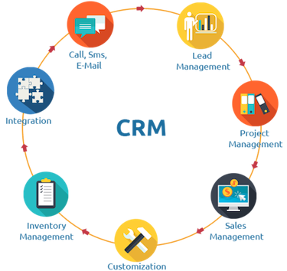
CRM model.
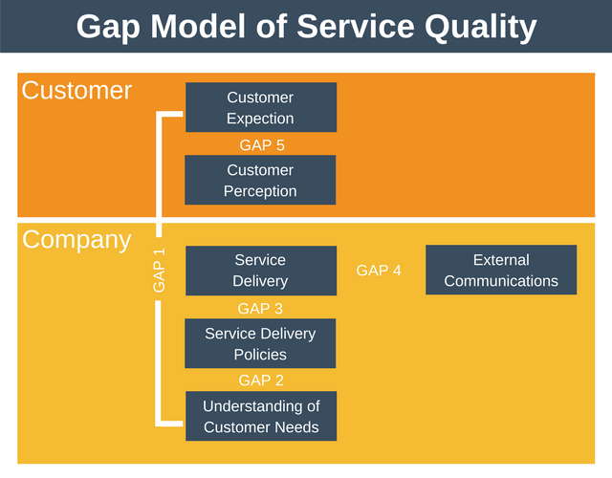
GAP MODEL.

REFERENCES

SCN,EDUCATION, B.V (2001) Costumer relationship management-the ultimate guide to the efficient us of crm.,vieweg,(p22).
francis Buttle(2004), costumer relationship management-concept and tools,elsevier butterworth,oxford, p 1-6.
www.costacoffe.co.uk accesed on 23 july 2021
www.costacarres.co.uk accesed on 23 july 2021

