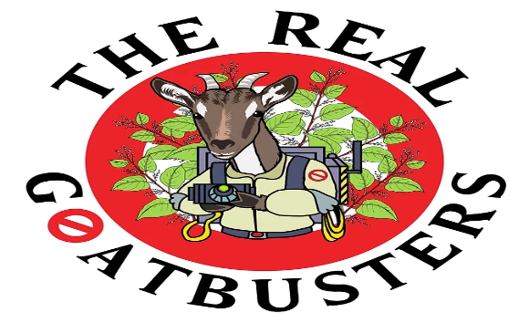
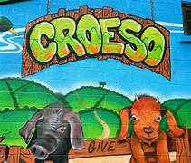

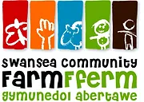
Conclusion
Swansea Community Farm illustrates how local action can foster sustainable community growth. Through its dedication to inclusivity, environmental stewardship, and community education, the farm has created a replicable model for community resilience. In a world facing both environmental and social challenges, initiatives like Swansea Community Farm are essential for building healthy, sustainable, and cohesive communities.
Challenges and Future Directions Key Challenges: Funding Constraints: Limited funding impacts the farm’s ability to expand programs. Demographic Diversity: Tailoring programs to suit all age groups and cultural backgrounds is essential for inclusivity. Safety and Resource Management: Managing a working farm with public involvement requires careful planning and volunteer support. Future Goals: Increase funding through community partnerships. Expand educational and environmental programs. Strengthen community engagement by enhancing inclusivity and volunteer support
introduction
Swansea Community Farm
Swansea Community Farm, founded in 1992, is Wales’s sole city farm, situated on a 3.5-acre property in Swansea. This community effort seeks to unite individuals of all ages and backgrounds via activities centred on sustainable farming, well-being, and community development.
Mission: To provide a location for community people to connect with nature, learn sustainable habits, and build resilience. The farm provides hands-on experiences, skill-building programs, and environmental education to develop a friendly, inclusive community.

Key Approaches for Community Development
1. Visual Engagement and Imagery
The farm employs compelling pictures to engage the community. Photos and media depicting a varied range of people, animals, and activities promote a welcoming image and generate a sense of community.
"Visual storytelling builds connections and a shared identity in communities" (Gronemann et al., 2019).
2. Cultural and Social Engagement
Swansea Community Farm organises cultural events, seasonal festivals, and intergenerational activities to promote unity and cultural exchange. These events increase social capital, which is critical for community resilience.
"Social capital is the glue that holds communities together" (Putnam 2000).
3. Economic Empowerment.
Participants in skill development programs for sustainable agriculture get practical knowledge that improves their employability. The farm's produce sales, which include eggs, honey, and beef, provide cash while also promoting local food security.
"Economic empowerment enhances social cohesion and personal agency" (Bourdieu, 1986).
4. Civic and Political Engagement.
Workshops on local environmental policy and sustainable practices increase civic understanding and active engagement in community planning.
"Civic engagement empowers communities to address local challenges" Dahlgren, 2005.
5. Environmental sustainability.
The farm uses organic practices, including the Geifr Gwŷr (Gower Goats) project, which promotes biodiversity through conservation grazing. This model decreases chemical consumption while protecting natural environments.
"Local environmental action strengthens community resilience" Klein (2014).

Encouraging Behaviour Change
Modelling and Peer Influence: Leaders and long-term members set a good example by participating in recycling, gardening, and conservation, inspiring others to do the same.
"People are more likely to adopt behaviours they see modelled by peers" (Bandura, 1977, p. 2).
Educational Workshops: The farm conducts workshops on sustainable practices that provide participants with practical knowledge for eco-friendly living.
"Knowledge increases perceived control and intention to act sustainably" (Ajzen, 1991).
Community Ownership: Initiatives like as the Gower Goats initiative are driven by the community, promoting a sense of shared purpose and ownership.
"Community-led initiatives build stronger commitment to sustainability" (Oström, 1990).

https://www.gov.uk/government/publications/community-development-handbook/community-development-handbook
https://www.swanseacommunityfarm.org.uk/
https://www.swanseacommunityfarm.org.uk/about-us
https://www.swanseacommunityfarm.org.uk/get-involved
https://www.swanseacommunityfarm.org.uk/professional-services
https://www.swanseacommunityfarm.org.uk/goatproject

Personal Involvement and Potential Impact
Volunteering in workshops, assisting with animal care, and participating in event planning can all help to further the farm's goal and impact. You can help Swansea Community Farm maintain its status as a community cornerstone by actively participating.
Expected Advantages:
Gaining practical experience in sustainable farming.
Making links within the local community.
Supporting an initiative that encourages environmental sustainability and community resilience.

