PREPARED BY
MICHELE CHIARELLO [1805745]

PREPARED FOR
DR. Joy Botu
AN INVESTIGARION INTO THE CURRENT ALARM SYSTEMS TECHNOLOGIES FOR THE DEVELOPMENT OF A USER- FRIENDLY, VENDOR-INDIPENDENT HOME SECURITY SYSTEM

ACCC5006 RESEARCH METHODS
May 14, 2020

TABLE OF CONTENT

TABLE OF FIGURES 2
ABSTRACT 3
INTRODUCTION 3
AIM OF THE RESEARCH 4
OBJECTIVES 4
LICTERATURE REVIEW 5
CLOUD COMPUTING CONCEPTS 5
CLOUD SERVICE MODELS 6
PAAS 6
HARDWARE DEVELOPMENT 7
SOFTWARE DEVELOPMENT 7
RESEARCH AND METHODOLOGY 8
ACTION RESEARCH 9
DEVELOPMENT METHODOLOGY 10
RISK ASSESSMENT 10
PROJECT TIMETABLE AND RESOURCES 11
CONCLUSION 13
REFERENCES 13

TABLE OF FIGURES

Figure 1. Cloud Computing Technologies [1] 5
Figure 2. Prototyping model [3] 7
Figure 3. Risks assessment table 11
Figure 4. Three-Point Estimation formula 11
Figure 5. Time Estimate Table 12
Figure 6. Gantt Chart 12
Figure 7. Resources 12

ABSTRACT

The following paper has been written with the purpose to bring to the reader a better knowledge about Cloud Computing Technologies and how they can be used to develop alarm security systems that can take advantage of them.
The research has been conducted making use of academic journals and reports that have been carefully analysed and reviewed to understand how better home security systems can be developed, leveraging the various ideas and knowledge that the various authors have expressed in their studies.
The document is focused on the research approaches that will be used by the author to develop a home security system that will rely on the Cloud and will be innovative compared to the ones in commerce, by delivering the outcomes expressed in the aim and objective paragraphs.

INTRODUCTION

The Security Systems Industry plays an important role in nowadays life.
The security market has grown exponentially since manufacturing processes have evolved, becoming cheaper, and more vendors started to be interested in the field, which has always been fruitful.
Alarm systems are everywhere, from companies to institutions to domestic environments and with the continuous implementation of new technologies they allow to be always more integrated into an increasingly internet-dependant society.
But they always have a few drawbacks.
They are expensive and in most cases vendor-locked. Vendors do not give the consumers the possibility to have the complete control over the hardware and software they buy, by making these systems only compatible with proprietary expansion boards and enforcing them to buy additional modules to extend the product functionalities.
Moreover, it is possible to add that, since the average user is not tech-savvy and requires the intervention of a specialist to set up the system, the overall cost is subjected to increase, bringing frustration to the user who, in order to get a good product, is forced to invest a big capital.
Another important aspect is related to the data collection that vendors put in place against the consumer to grant themselves a secure income, attracting the interest of technicians with the control over the systems they work on, sharing customer’s implants data in real-time, to allow prompt repair proposal to the customers who need repairs.
These are the reasons why the research aims towards the development of a new type of home security system.

AIM OF THE RESEARCH

The research aims to investigate the different technologies behind home alarm systems for the development of an innovative, cost-effective device that does not require the involvement of third parties for the installation and takes advantage of cloud computing technologies to offer the consumer all the functionalities that vendors sell as a surplus on a pay-as-you-need basis.

OBJECTIVES

The objectives of the research are:
- To examine the gap in the field and find out where actual security systems design lacks on
- To find out how to take advantage of Cloud Computing Technologies to implement the infrastructure for the working of the system
- To find out the manufacture processes involved in the realisation of the product hardware
- To find out the best practices to develop the software ecosystem sold with the product

LICTERATURE REVIEW

This section is dedicated to discussion of the analysed documents used by the author to better understand the topics that will be involved in the realisation of the project.

CLOUD COMPUTING CONCEPTS

Cloud computing technologies have brought new potential to the development of smart systems, giving organisations the opportunity to develop solutions based on complex network environments, without the need to invest big capitals or maintain the used infrastructures.
According to the NIST, that defined the main model for Cloud Computing, it is possible to highlight three Service typologies that, as visible in the picture below, can be deployed under different forms, such as Public Cloud, Private Cloud etc.

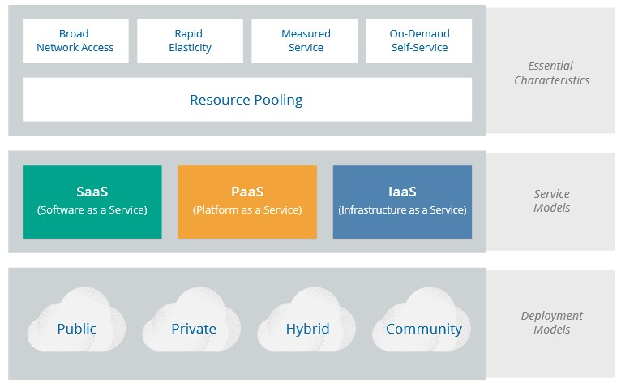
Figure 1. Cloud Computing Technologies [1]

CLOUD SERVICE MODELS

These Service Models that can be respectively identified as:
- IaaS
- PaaS
- SaaS
They are classified based on a common stack in which all the components of the used environment are defined.
The following list, introduce these components and provides a brief explanation for them:
Physical hardware, that is composed of servers, storage devices and network components.
Virtualisation layer, composed of software for the virtualisation and the distribution of the resources.
OS, that is the environment on which all the services and applications, needed to run, are located.
Middleware, that is defined by the runtime environments used by organisation for the development of custom applications.
Software, defined by the application used by the final user that runs it as SaaS.

PAAS

The service model that allows companies to develop custom software to run their services is defined by PaaS.
This model, in fact, allows companies to focus only on the software development, freeing them from the hassle to manage the underlying infrastructure [2].
Benefits that this typology of service offers are:
- Fast release
- Lower costs

HARDWARE DEVELOPMENT

A key aspect of the research is the understanding of the manufacturing field, that must be utilised for the production of the device.
This part of the development process is out of the scope of this research because the manufacturing of the hardware will be outsourced to a third-party organisation.

SOFTWARE DEVELOPMENT

In order to accomplish the development of the system, it is required to implement a software solution that is not only related to the cloud environment utilised by the internet service, but also to the device represented by the central unit.
A systematic approach that involves different phases must be used to design and deploy the system but, at the same time, it should give the possibility to adapt and improve the code development if there are changes on the project.
The Prototyping model is a good example of this approach and, as visible in the next figure, it is composed by different phases. This allows to support the full software development life cycle, more commonly known as SDLC [3].
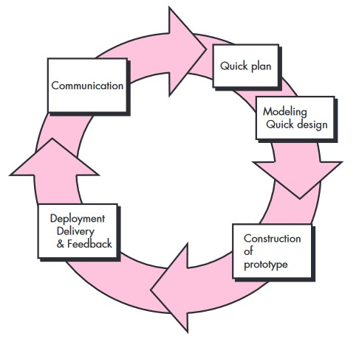
Figure 2. Prototyping model [3]

RESEARCH AND METHODOLOGY

The literature review reveals important aspects of the development of the research. The treated topics represent important milestones for the study. However, in order to carry out the project and complete the objectives, it is compulsory to set the boundaries of the research.
A more in-dept study must be implemented and a methodology that allows the data to be collected and analysed must be adopted.
The following paragraphs explain the used approach and methodology and the reasons behind them.
Being a necessity for the research the collection of data from customers, in order to determine the gaps and the functionalities they would like to improve in actual security systems, the author has chosen to make use of a phenomenological philosophy instead of positivistic one.
Phenomenology focuses on the analysis of experiences and events (different phenomena) and gives a subjective overview on the results.
The philosophy just described, has been paired to an inductive approach, due to the fact that the phenomena must be observed and a certain amount of qualitative data must be collected and analysed, in order to identify the common patterns in the analysed samples. This allows the formulation of the theory that will be used to produce a solution to overcome the issues set out by the literature review.
It is important to specify that, during the research process, this theory could change depending on the results of the analysed data.
Moreover, one of the main reasons why the author has chosen this type of approach is related to the fact that he observed the phenomena in his previous work environment, maturing knowledge on the common issues and gaps that must be analysed.
Due to use of an inductive approach, the author found out that an appropriate research methodology is needed to collect data.
In this case has been undertaken the use of Action Research, this because of the need of cooperation with the research participants.

ACTION RESEARCH

Action research is a flexible and reliable methodology, based on four main phases that take the name of:
- Planning
- Acting
- Observing
- Reflecting
The use of this approach will be characterised by the collection of both primary and secondary data since research of literature, interviews and surveys are involved in the accomplishment of the objectives.
The collection of primary source data, will see the use of surveys that will be administered to the participants in order to understand the characteristics that a home security system should have out-of-the-box and how the cloud service implementation could bring improvements to the actual and existing services.
The target population will be represented by the actual users of security alarm systems since they would have the experience with similar products. This would allow to get valuable and functional suggestions that can be ensure the validity of the data.
For the completion of the objectives related to developing the software and hardware components of the system, secondary data will be collected. Hardware manufacturing industries organisation will be approached in order to choose the appropriate one for the project.

DEVELOPMENT METHODOLOGY

The development methodology for the accomplishment of tasks in which the project will be divided can be compared to the inductive approach used for the research.
This because it relies on adaptability, a characteristic needed due to the fact that the requirements could change following the results generated by the gathered data.
Prototyping offers a set of characteristics that would allow to reduce the risks of failure, since potential risks can be identified and corrected in early stages. According to [3] , this methodology helps to better understand what must be developed when requirements are confused.
Since the project will see the implementation of different typologies of software, in particular:
- Embedded software for the central unit
- Cloud hosted application
- Application software for mobile devices
the used practices will be implemented all of them.

RISK ASSESSMENT

Since during the development of the project, would be possible to incur in issues that could delay its delivery, it is always needed to understand and provide some measures to prevent that external these to interfere with it.
In the picture below it is possible to find a table containing the possible risks that the author assessed for this project, highlighting the severity and the impact probability these could have on the development process.

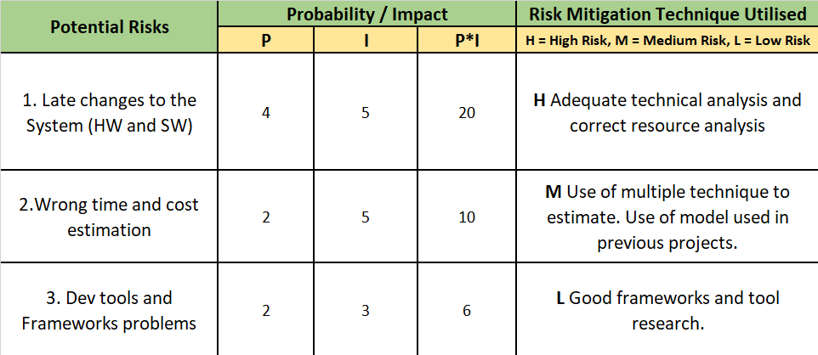
Figure 3. Risks assessment table

PROJECT TIMETABLE AND RESOURCES
To define the timetable for the development of the research, a method for the calculation of the time that relies on a mathematical formula has been utilised.
The method takes the name of Three-Point Estimation and takes in consideration three variables defined by the Optimistic Time, defined by the estimation of the fastest time possible to accomplish a task, the Pessimistic Time, represented by the longest time possible for the accomplishment and the Most Probable Time, that is the average time period between the previous two.
The following three figures represent the formula used to calculate these timings, the time estimate table and the Gantt Chart used to represent the data.

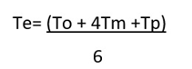
Figure 4. Three-Point Estimation formula

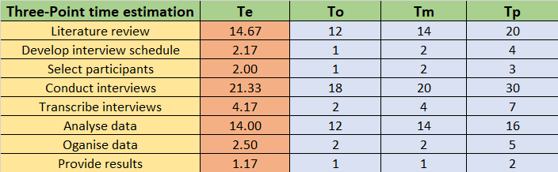
Figure 5. Time Estimate Table

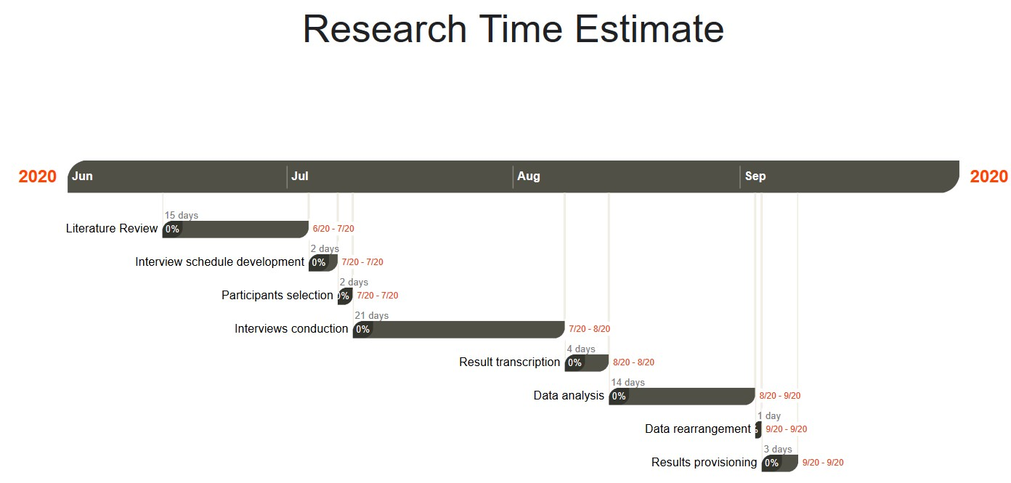
Figure 6. Gantt Chart

In the following table, it is possible to find all the resources and software that will be used to the accomplishment of the interviews and the analysis of the data.
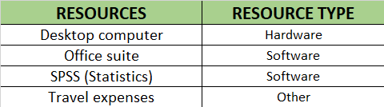
Figure 7. Resources

CONCLUSION

The chosen topic and the research processes analysed in the paper, aim towards the development of a reliable, affordable and complete home security solution that differs from the ones currently available on the market, by respecting the criteria listed in the objectives of the research.
The accomplishment of the project and the meeting of the deadlines, as well as the knowledge acquired during its course, will be seen as outcomes of this research proposal.
This can be seen just as a starting point, because the project will be reviewed and further developed, since some of the core aspects such as the manufacturing process are not handled at the current stage.

REFERENCES

[1] | J. A. F. G. A. L. D. M. G. P. M. R. Rich Mogull, “Security Guidance for Critical Areas of Focus in Cloud Computing v4.0,” Cloud Security Alliance, 2017.
[2] | X. L. X. Z. M. F. S. V. D. W. X. R. Z. A. Vu Viet Hoang Pham, “PaaS - Black or White: An Investigation into Software Development Model for Building Retail Industry SaaS,” School of Information Technology, Deakin University, Melbourne, 2017.
[3] | R. S. Pressman, Software EngineeringA Practitioner’s Approach 7th edition, Raghothaman Srinivasan, 2010.
[4] | F. Rosa, “Analysis of requirementsand technologies to migrate software development to the PaaS model,” 11 2018. [Online]. Available: https://run.unl.pt/bitstream/10362/57147/1/TGI0178.pdf. [Accessed 17 05 2020].

