Quality Tools & Root Cause Analysis
  - Name: Rhys Vincent
  - Student number: 2020212
  - L4 – Quality & Business Improvements
  - Module code: ACMA4004
  - Assignment 2

Contents
Introduction/problem statement 3
Main Body 3
Data collection 3
Data analysis 5
Root Cause Analysis 5
What is Root Cause Analysis? 5
Action plan 7

Introduction/problem statement
The purpose of this report is to create an improvement plan for a certain process within our workplace which needs to be data driven and informed.
FSG has many customers and one of them is BIOMET who are frequent customers, and a lot of work goes through the factory for them. One of those jobs are test buttons which are either made from titanium or cobalt chrome. These parts are high volume which means there are several thousand per batch and every single one must be measured. When these parts come off the machine, the machine operator usually checks one every ten parts to make sure if the tools are wearing or not. After the batch is machined, they all get etch-engraved and sent to QA. As mentioned before each part must be checked to ensure they meet the specified dimensions and respecting tolerances. There are a few ways of checking the buttons but the main way that is used is using dial test indicators calibrated by slip gauges to check the thickness and diameter. The setup time is not really the problem with the method as it is simple, but it is the actual measuring which is the time consumer. Management usually say they want five hundred buttons out at the end of the day therefore 500 need to be manually measured plus the defective ones. This usually takes around 2-3 hours depending on who does it. This process can be improved by a great amount which can give employees more time to do other work.
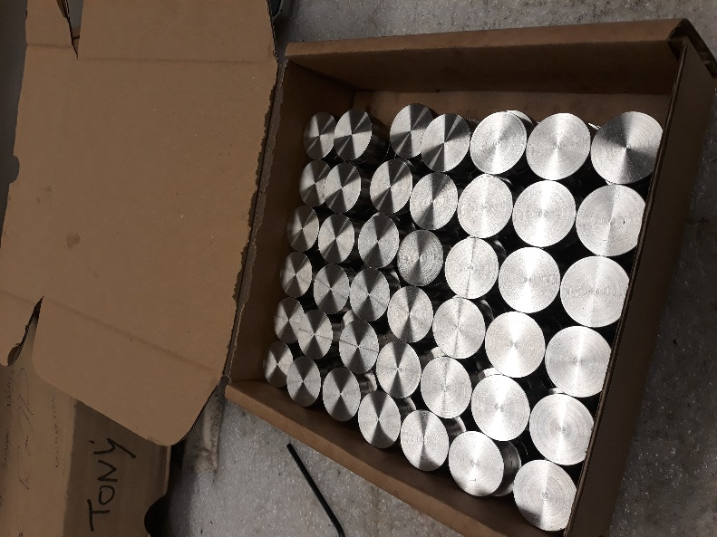
Figure 1 Image of test buttons after machining

Main Body
From my own experience in Quality Assurance is does take an exceedingly long time to measure these parts. Because of this it can get very boring for the employee, and this can lead to the process taking even longer and leaves them with less time to do other jobs which may need doing as soon as possible. To help combat this problem I will need to do some data collecting to analyse the performance of this procedure. I will use a line graph to demonstrate the correlation between the amount of part to measure and the time taken to measure them.

Data collection
To look at the data associated with this process I will need to express it by using one of the 7 Quality Tools. I will use a line graph to show how long it usually takes to measure the test buttons for part of the batch.

Figure 2 Graph showing results after measuring buttons
The data taken here was from my own time measuring these test buttons. I measured how many buttons were done within a length of time and took an average rate and extended it to the time it took me to finish the complete set.
I will also create a check sheet to identify the defects in the buttons that were found during measuring. The table will identify which defects occur on each test button.
 | Defects
Buttons | Surface finish | Out of tolerance Ø | Out of tolerance thickness
Button 1 |  | x
Button 2 |  |  | x
Button 3 | x |  | x
Button 4 |  | x
Button 5 | x | x

Data analysis
If it takes 2 hours to measure 500 parts plus defective parts, which totalled at around 5 parts last time, so it comes to an average of around 252 parts an hour, which is about 4 parts a minute if the employee is going non-stop. The incline of the line, also referred to as the gradient, is quite shallow compared to the time taken which shows how inefficient the process is and can be improved drastically. By finding a new process I believe that the slope of the graph can be much steeper than it is now, or the gradient could be larger. By making the slope steeper it will show us how much the process has improved.

The table above shows the defective buttons and what the defects were on those buttons in particular. The manufacturing efficiency is about 99% which is somewhere in-between 2-3σ. The defects for measurements were quite hard to determine whether they were within tolerance or not. The ones specified above were distinctively out of tolerance by a large margin of about 0.025mm below the tolerances bottom limit and therefore would not be accepted. Some however were around 0.002mm over the top limit which I double checked with the QA manager, and they said that it was acceptable. These are the defects that need to be monitored with the new method.

Root Cause Analysis

What is Root Cause Analysis?
To find the cause of the problem I will be using a form or two of Root Cause Analysing. Root Cause Analysis (RCA) is one of the terms that refers to the range of tools and techniques which can be used to identify the cause or causes of a problem. They are used within engineering to assist with the identification of problems within the workplace that need to be changed whether that change be high impacting or low impacting just as long as there is improvement. Overall, its key goal is to eliminate the problem. It also establishes what control measures will need to be implemented to prevent the problem from reoccurring.
There are 2 types of RCAs which can be used in my scenario, and they are the 5 Why’s and the 6 M’s.

5 Why’s
This RCA helps you think of a structured way of analysing the problem. What this means is that you should keep asking yourself the same question until you find the main root of the problem, in other words keep asking yourself ‘why?’
Why is the process inefficient? Because it takes too long.
Why? Because the current method is time consuming.
Why? Because each part needs to be measured one by one.
Why? Because there is no other method available at the current time.
Why? Because a new method has not been introduced yet.
From using the 5 Why’s method I have found a possible root cause to the problem. If we did some research and found an alternative faster method this could potentially eliminate the problem. However, there are some problems when using the 5 Why’s approach. If other employees were to repeat this RCA, they could end up with completely different answers because they may have asked different ‘why’ questions. Another problem is that the real root cause may not have been found and that would mean that the problem could resurface the same way or in a different form.

Ishikawa / fishbone diagram (6M’s)
The Ishikawa/fishbone diagram is a visual RCA tool which helps identify and organise the problem of a process. It is referred to the fishbone diagram because the problem forms the backbone or head of the ‘fish,’ the spine acts as the causes that provide to the problem which stems off the sub-causes like ribs which are the 6M’s. The 6M’s stand for Man, Machine, Materials, Method, Measurement, and Mother nature (but easier to refer it to as Environment).
Measuring process for BIOMET test buttons is taking too long.
Environment
Machine
Method
Material
Measure
Man
Using DTI’s and slip gauges.
Measuring 1 part at a time feels boring and no-one wants to do them.
Titanium or cobalt chrome
Employee can get tired and fatigued from doing repetitive work
Measuring the same dimensions get tiresome and potentially frustrating.
Temperature usually kept around room temperature.
The green boxes are more likely to be the causes of the problem and they all seem to revolve around the fact that the measuring of 500 test buttons is repetitive manual work which tires out employees and lowers morale. If the measuring process was fast and automated, then employees would be happier to measure parts. However, this RCA has limitations. The brainstorming of causes can produce irrelevant points which can be seen above, for example the Method and Material points do not affect the process problems.
From this RCA I have discovered that the root cause is the fact that the process has to be manual, and the previous experience of measuring parts reminds them that the job is repetitive, tiring and time consuming. Workers would rather do more interesting jobs which keeps their morale up. So, what if the process eliminated the repetitiveness and fatigue of the job and became fast and automated but also be done in the background so other jobs can be done during the measuring of the buttons.

Action plan
After going through my analysis of data and RCAs, I have produced a potential solution for the problem. The idea I had in mind was a machine that would be fed the buttons and would then measure the parts one by one then it would sort the good parts from the bad parts. The idea of it came from a coin sorter which would ‘look’ at the coins and assort them into their corresponding places, but the difference with the test buttons and coins is that coin categories have all different shapes, sizes, and materials whereas the test buttons are going to be one material, either titanium or cobalt chrome but material doesn’t matter in this aspect, and the sizes are fairly similar.
A model of an initial idea has been made.
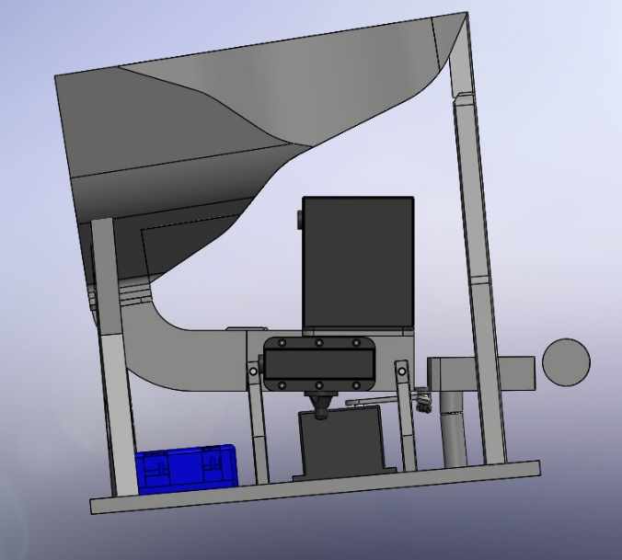
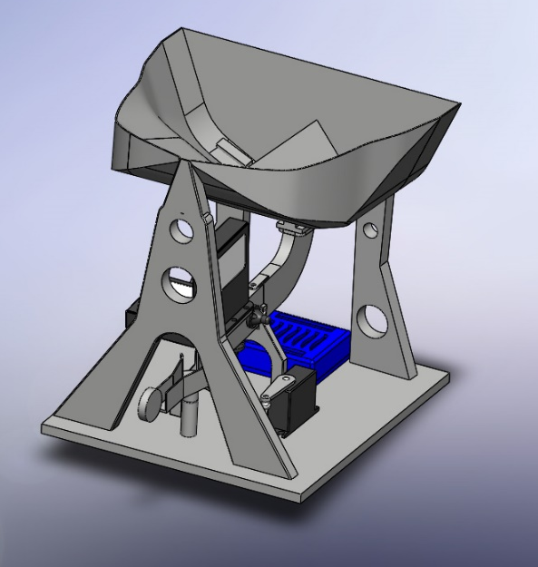
Figure 3 Side view of idea
Figure 4 Image of isometric view of proposed idea
The main idea was that the buttons would be put into the top funnel, and they would fall into the track down to be scanned. Then they would be sorted dependant on if the sizes were correct or not. Then the parts can easily be checked by eye for surface finish.
One of the ideas on how it was going to work was to use lasers to measure the parts and a programmable Arduino electronic board would be used to determine if the sizes were correct, but it was hard to find lasers that were accurate at measuring sizes so another idea was that at the end of the track it could be a gap gauge at the end and if the part went through good it would pass a laser which detects if it has passed or not. The Arduino could still be used with the laser here as it would be especially useful. If a button got stuck in the gap gauge, meaning it was over size, then the laser would not detect the part passing through within a given amount of time so it could then send a signal to a piston to push the button into another pile separated from the good pile.
The Arduino can be programmed through different programming languages such as C++, Java, Python and even MATLAB which could come in useful as I have access to MATLAB because of one of my university modules and could use it to program what is needed. I also have had some experience with Python from GCSE, but it would be much easier if I used a programming language that I am currently familiar with and studying.

Figure 5 Graph showing comparison of results
The graph above shows the comparison between the time taken to measure the set of test buttons manually (Before) and the estimated time taken with the new method (After). It is clearly evident that the new process is much more efficient that the current method, about 4 to 5 times more effective. The gradient of the graph is much higher than the previous gradient proving that it is the better method to use. The solution aims to measure 20 parts a minute compared to a measly 4 parts a minute which totals to about 500 parts within half an hour, a massive increase from 2 hours which runs in line with the improvement being around 4 times.

