Environmental Analysis of an industry

Assessment 1

Name: Cezar Bodnariu
Student Number: 1914623
Module Title: Global Business Environment
Assignment Title: Environmental Analysis of an Industry
Module Lecturer’s Name: Nadeem Mirza

Contents
Introduction 3
Explaining the major forces shaping the business environment of the car manufacturing industry showing how the industry changed in the last few years 4
PESTEL analysis 4
Product Life Cycle 8
Assessing the opportunities and challenges of a company presented by different forces and demonstrating the ways of gaining competitive advantages 9
SWOT analysis 9
Porter’s Value Chain 10
Porter’s five forces 13
Conclusion 15
References 16

List of figures
Figure 1: PESTEL analysis (CAR industry, UK) 4
Figure 2: Automobile market of the UK 5
Figure 3: Coronal impact on car sales 6
Figure 4: Demand for electric cars in the UK 7
Figure 5: Product Life Cycle 8
Figure 6: SWOT analysis (Car industry, UK) 9
Figure 7: Porter’s Value Chain 11
Figure 8: PESTEL analysis (Car industry, UK) 13

Introduction
The business environment is the collection of several factors that have an impact on the business operation. The business environment includes two major categories like internal environment and external environment. Internal environment refers to the environmental factors that have a direct impact on company performance. And external environment comprises the factors within which the company operates and cannot be controlled. Understanding the business environment effectively can derive success for an organization.
Several elements help to construct the business environment. Reportedly, the major forces of shaping a business environment are economic, socio-cultural, legal, competitive, technological, and political (Yuksel, 2012). So, the process of forming a business environment is empirically analysed below relating relevant theories concerning the car industry:

PESTEL analysis
PESTEL analysis is a tool to analyse the factors of the external environment of a company or an industry. It helps to understand the trends of the external forces (Guy, 2016). An industry cannot manipulate the external environment. The forces of PESTEL analysis are demonstrated below concerning the car industry of the UK:

Figure 1: PESTEL analysis (CAR industry, UK)
Political forces: This factor shows how a business is associated with government policies, political stabilities or instabilities, foreign trade policies, environmental laws, labour laws, tax policies, etc. In the UK, the car industry has been affected by the BREXIT issue that had given result in political instability. Reportedly, the car sell has been fallen by 6.6% following the issue
Economic factors: Economic factor is concerned with the economic situation of a company, interest rates, inflation, exchange rates, incomes of the customers, etc. The car industry of the UK had a contribution of £18.6bn to the UK economy in 2019 from a turnover of approximately £82bn (Haynes, 2016). Eight cars out of 10 produced in the UK are exported to 160 markets across the world.
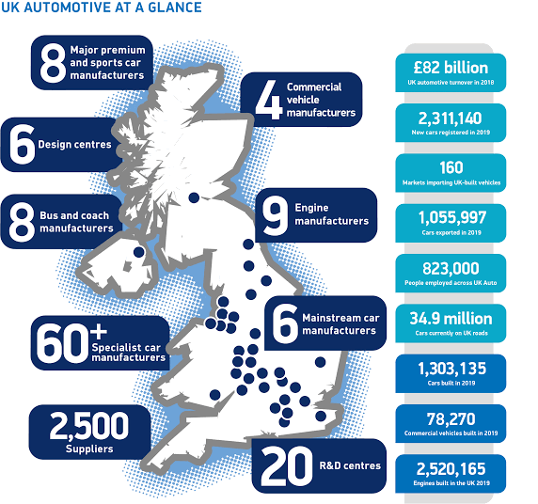
Figure 2: Automobile market of the UK
But the coronavirus has hit the sales of cars downward by 37.6% in 2020. This can affect the UK economy as well.
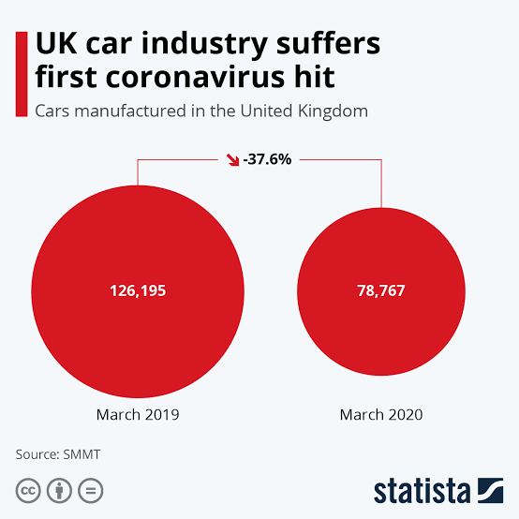
Figure 3: Coronal impact on car sales
Social factors: Social factor refers to the beliefs, attitudes, behaviours of a certain community. These factors often form the customers' demands and preferences for certain products. In the present situation, the demand for eco-friendly cars like electric cars and hybrid cars is on the rise in the UK, as the people are concerned with the pollution derived from the burn of diesel.
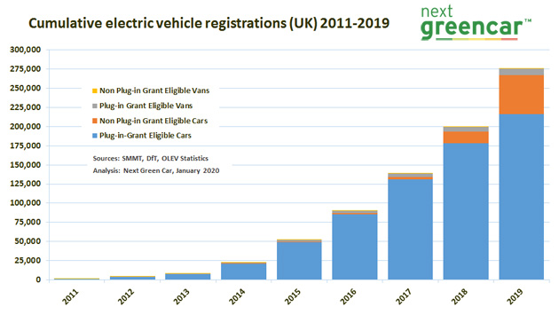
Figure 4: Demand for electric cars in the UK
Technological factors: Technological factors put a light on the innovation of products, newer ways to produce products, newer ways of allocating products, etc. Nowadays, in the UK, the automobile industry is holding the importance of how to develop new and stylish cars that can attract customers worldwide (Simsekoglu, 2018). As part of technological advancement, electric cars and sports cars of latest trend have been developed and updated.
Environmental factors: This factor points out the factors like pollution targets, carbon emission targets, and different environmental laws and regulations imposed by the government. To conduct business in the UK, the car industry must comply with the Control of Pollution Act 1974, issued to control pollutions, and the Environmental Protection Act 1974, enforced to control waste management and emission. Concerning these issues, the car industry has been working on the development of eco-friendly cars.
Legal factors: This factor includes different business laws like working environment, health and safety, labour and employee right, consumer right, etc. The car companies of the UK have been found well-compliant of the concerning laws and regulation that shows the corporate ethics in the industry.

Product Life Cycle
Product life cycle is a process that indicates the duration in which a product is introduced to the market and withdrawn after it gets replaced by new products (Fujimoto, 2013). There are 4 stages of a product life cycle. Those stages are stated below concerning the car industry of the UK
Introduction: In this stage, a new product is launched in the market. Self-driving cars are being introduced to the market but yet to prove their effectiveness.
Growth: In this stage, sales of the product hit upward because of promotional programs. In the UK, the sales of electric cars are on the rise due to concurrent campaigns of eco-friendly cars showing the facilities and advantages of using an electric car.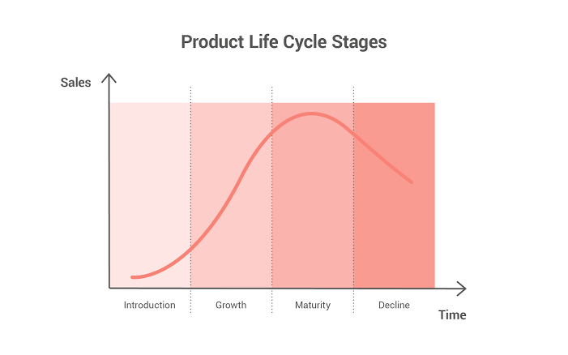
Figure 5: Product Life Cycle
Maturity: This stage provides the product with the peak sales of its lifeline. In the UK, Ford Fiesta has experienced the most sales in 2019 (Autoexpress, 2020).
Decline: In this stage, the product is replaced by new products. As the UK government is patronizing the scrapping of diesel cars, the sales of diesel cars have drastically fallen.

Assessing the opportunities and challenges of a company presented by different forces and demonstrating the ways of gaining competitive advantages
There are several factors that describe the opportunities and challenges for a company. Internal factors of a company are the major sources of strength and weakness. Effective handling of such forces can often decide the competitive position of a company. To understand these things well, an extended analysis is conducted in the following part with respect to different theories concerning the car industry of the UK:

SWOT analysis
SWOT analysis is an effective tool to evaluate the internal factors affecting the competitive efficiency of a company and design effective strategic plans. The components of SWOT analysis are discussed below based on the car industry:

Figure 6: SWOT analysis (Car industry, UK)
Strength: Strengths of a company refer to the positive brand image, latest technology, loyal customers, etc. of a company. The automobile industry of the UK is projecting a great significance to the Research and Development (R&D) that is providing the industry with the latest innovative product ideas (Zhikang, 2017). Else this, the cost per mile will drop because of alternative energy sources, longer vehicle lives, technological updates, etc. These will get the companies new customers.
Weakness: It refers to the variables that cause the lower performance of a company. The growth in the demand for electric and hybrid cars has made it difficult for companies producing diesel cars to cope up with technological advancement. This also has affected the traditional aftermarket. It is estimated that by 2030 the traditional aftermarket will fall to 25%.
Opportunities: This refers to external factors that can assist a company to gain competitive advantages. A survey shows that 87% of people in England think that they should own a car. Moreover, several pieces of research show that by 2025, 15% of cars will be electric. So, if a company can accommodate the changing pattern of the automobile industry, then it is likely to get competitive efficiency.
Threats: This can bar a company to attain its goals. In the automobile sector of the UK, it has been identified that a number of new entrants are catching up with the industry with less hassle. Besides, several environmental guidelines are putting significance in eco-friendly car developments. So, if a company fails to adapt to these changes, then the company will face complicacy with survival and growth (Zhikang, 2017).

Porter’s Value Chain
Porter's value chain is an effective framework designed to break a company's activities down into measurable pieces in order to analyze them and make changes in any area if required (Porter, 2016). Elements of Porter's value chain is described below concerning the car industry of the UK:
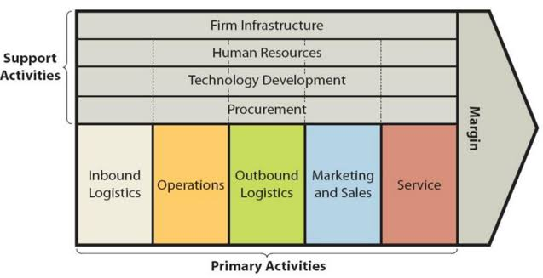
Figure 7: Porter’s Value Chain
Primary activities
Primary activities refer to the tasks that are directly associated with the manufacturing and marketing of a product. Primary activities of a company are as follows:
Inbound logistics: These relate to the operations of collecting, warehousing, and distributing raw materials within the organization. In the automobile industry, collecting parts of automobiles and distributing them to the assembly departments need to be done effectively to gain timeliness and quality output.
Operations: These include the conversion process of raw-materials into final products (Al-Shammari and Al-Faqir, 2017). In the car industry, a company needs to make all the instruments and parts available at the station so that the workers can assemble them to build cars effectively. for assembly purposes, the company needs to install effective processes to get the best output from the production units.
Outbound logistics: Outbound logistics refers to the activities like collection, storing, distribution points, etc. that make the company’s products available to the customers. In the automobile industry, every company tends to collect the units from production point to store them in lots. Then a company sends lots to different distribution outlets and showrooms.
Marketing and sales: These include promotional campaigns that persuade customers to buy a company’s product (Porter, 2016). In the case of the automobile industry, marketing activities are a must to make people know about the latest cars and features. In the car industry, it is often seen that different companies participate in car show programs to exhibit their cars.
Service: This refers to the action that settles different product-related issues after the products are sold. Post-sale service is a must for every car company to keep their customers satisfied. Support activities
Procurement: This includes the purchasing made by a company to collect raw materials and other resources to keep the operations going. In the automobile industry, a company needs to purchase several materials, instruments, and parts to get the final product.
Human resource management: HR activities enlist hiring employees, training them, motivating them, and retaining them in the company. Automobile companies need to hire efficient workers to ensure the best output from them. Else, a car company needs to hire high profile engineers to design the cars and modify them to get them certified for roads.
Technological development: Technological development refers to the creation of innovative products, new ways of production, new ways of distribution, etc (Al-Shammari and Al-Faqir, 2017). The automobile industry is all about technological advancement. The company with the most innovative products will survive and create a competitive edge in the market.
Infrastructure: This refers to the arrangement that ensures a sound operational environment within a company. In the automobile industry, a company needs to ensure enough space for production units and different technological facilities to carry on the production process.

Porter’s five forces
Porter’s five forces model is an effective tool to measure the competitive efficiency of a firm (Grundy, 2014). The forces of porter’s five forces are discussed below with concern to the automobile industry of the UK:
Competitive rivalry: Competitive rivalry index refers to the number of competitors active in the industry and their capabilities to affect a company's action. In the automobile sector of the UK, competitive rivalry is high, as there are a lot of competitors in the market. So, a company cannot impose high prices on the cars as it wishes. Because there are several alternatives available to the customers to shift.

Figure 8: PESTEL analysis (Car industry, UK)
Threat of new entrants: This index describes how easy for a new company to enter the market and operate within (Porter, 2016). In the car industry of the UK, this index shows a medium score. Because there are several requirements like capital and technological requisites. So, it is difficult for a company to enter the automobile industry in the UK and catch up with the competition.
Bargaining power of suppliers: In the automobile industry of the UK, the bargaining power of suppliers is low. Because there are several suppliers. So, a company can switch suppliers based on economical and other facilities. So, suppliers of this industry in the UK cannot drive up the cost and impose terms and conditions as they wish.
Bargaining power of customer: In the UK, the automobile industry is comprised of a lot of companies. So, customers can go to any company very easily. So, the bargaining power of customers is high in this market. so, the company needs to follow strategic pricing and different after-sale services.
Threat of substitute: This index shows how easily a product can be replaced (Grundy, 2014). In the car industry, this index hits a lower mark. Because a customer can go for substitutes of cars like bicycles, buses, bikes, etc. But the utility of cars won’t be affected by those substitutes.

Conclusion
There are several techniques to outline the strengths and weaknesses of a company or industry. By using SWOT and PESTEL analysis, a company can point out the environmental factors directing the strengths and weaknesses. Else, Porter’s five forces model helps a company to have a look over the competitive position of a company. So, analysings the business environment relating relevant theories will enable the company to operate strategically.

References
Al-Shammari, E. and Al-Faqir, T., (2017). Analysis Support Activities Value Chain Model to the Porter and Impact on the Knowledge Department. Iraqi Administrative Sciences Journal, 1(1), pp.60-86.
Autoexpress.co.uk. (2020). [online] Available at: <https://www.autoexpress.co.uk/car-news/108979/best-selling-cars-in-the-uk-2019> [Accessed 1 December 2020].
Fujimoto, T., (2013). The Long Tail of the Auto Industry Life Cycle. Journal of Product Innovation Management, 31(1), pp.8-16.
Grundy, T., (2014). Rethinking and reinventing Michael Porter's five forces model. Strategic Change, 15(5), pp.213-229.
Guy, F., (2016). The Global Environment of Business. Oxford: Oxford University Press.
Haynes, N., (2016). Invest and Survive-the Impact of Information Technology on the UK Car Components Industry. Journal of Information Technology, 2(4), pp.196-201.
Porter, M., (2016). Competitive Advantage. New York: Free.
Simsekoglu, Ö., (2018). Socio-demographic characteristics, psychological factors, and knowledge related to electric car use: A comparison between electric and conventional car drivers. Transport Policy, 72, pp.180-186.
Zhikang, L., (2017). Research on Development Strategy of Automobile Reverse Logistics Based on SWOT Analysis. Procedia Engineering, 174, pp.324-330.
Yuksel, I., 2012. Developing a Multi-Criteria Decision-Making Model for PESTEL Analysis. International Journal of Business and Management, 7(24).

