Student name: Rahima Sheikh Ibrahim
Student ID:2336641
Module name: Changemakers: Building your Personal Brand for Sustainable
Module code: BMHP5015
Lecturer name: Caroline Salame

Unit 1 Building Your Brand

Introduction
This assignment is the reflection on my learning in four different units, which are Brand You, It is a Small World, Opportunity Knocks, and The Pursuit of Happiness. In this reflective narrative, I will show how these units have worked together to help me create my own personal brand, gain insights into the role of global connexion in healthcare, discover professional potential, and come up with wellbeing strategies. I will use the correlation of my experiences with applicable academic literature and screenshots of my activities online to show how this module equipped me with the skills needed to work in the field of health and social care in the future. The various units have provided different ideas, which can be used in my current professional growth process.

Reflection on Unit 1: Brand You
The first unit, Brand You, gave me the basic understanding of the principles of personal branding, self-awareness, and the ability to determine what my strengths are in a professional setting (Medina Garrido, 2025). The lectures covered the topic of how people can stand out in a competitive healthcare setting by defining their value propositions. My first attitude towards branding as a personal matter was sceptical as I regarded it as an act of self-promotion but shortly, I understood that the true personal branding is about knowing and sharing the real abilities and values.
The online activities allowed me to gain more knowledge about my professional identity. An activity that I found especially interesting was the strengths identification exercise where I overlaid my own strengths in relation to those that are appreciated in health and social care professions. I also got to know that some of the qualities I had ignored before such as my capability to stay calm in stressful moments and my natural interest to listen to people are actually my strengths and they form the core aspects of my professional brand.
This learning is very much related to the model by Johari, the Window, which was invented by Luft and Ingham (1955) which explains the process of self-discovery and the way we expose ourselves to other people. Peer feedback activities enabled me to work on my "blind spot" which are those areas of my professional persona that others knew and I did not know. Classmates have pointed out that I am a reliable and consistent person, which I was not even aware I present as a part of my brand. According to Cottrell (2008), the only way to develop effectively as an individual is to understand oneself and this unit gave me the tools to start the process. I have updated my LinkedIn and enrolled on short courses on first aide and safeguarding.
In addition, I investigated the role of the theory of personal branding as presented by the career development experts in underlining the need of authenticity in professional identity development. I learned that when dealing with health and social care, where trust is the most important, a personal brand based on true values and not produced images is the key towards developing therapeutic relationships with service users.
Figure 1 Forum Activity on Ambition
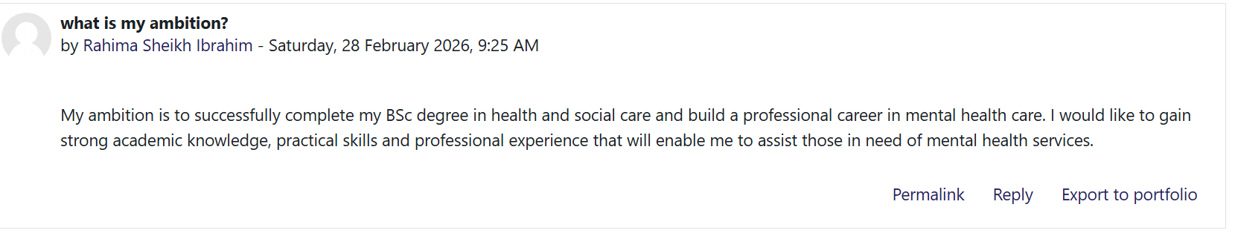

Reflection on Unit 2: Its a Small World
Unit 2, Its a Small World, helped me to change the focus toward the outside world, where I learned about world relationships, cultural competence, and diversity in health and social care. I knew the healthcare environment is becoming more and more diverse before this unit, but had not realised the depth of delivering culturally competent care in a globalised world. It was taught about the concepts of diverse cultural attitudes to health and illness, how to deal with health disparities in minority groups, and how to cross-culturally communicate (Dauvrin and Lorant, 2017).
I got to know that cultural competence goes beyond merely being aware of various cultural practises but a complete transformation in our outlook towards care provision. The lectures highlighted the fact that patients who belong to different cultural backgrounds might have different expectations of healthcare professionals, divergent interpretations of illness cause, and diversity in preferences of being involved in treatment. This insight informed my perception that I needed to provide effective care that is person-centred but also with a cultural sensitivity: For instance, improved communication results in higher treatment compliance. Patients are better able to comprehend their diagnosis and course of treatment when medical professionals employ interpreters or culturally appropriate language.
The discussions on the online forums especially played an important role in making these ideas come alive. During one of the discussions, we had to tell storeys of our experiences related to cultural encounters in healthcare environments, as well as what we thought worked out and what could have done better. Going through the work of my classmates of different backgrounds made me open my eyes to the views that I have not thought about before. To take a South Asian example, one of my classmates shared the reason family involvement in treatment decisions, which could be considered as an interference in certain Western settings, is a critical component of dignified care in their culture (Dauvrin and Lorant, 2017).
This learning is explainable by the application of the Cultural Dimensions theory which was developed by Hofstede (Hofstede, 2001) in understanding the way cultural values affect behaviour. The concept of individualism versus collectivism was especially applicable to health and social care because Hofstede has decoded why certain patients focus on the family inclusion and others are focused on personal autonomy. On the same note, his theory of power distance can be used to explain differences in expectations of the professional-patient relationship, based on cultural differences. Papadopoulos (2006) says that culturally competent healthcare demands that the health practitioners acquire culture awareness, cultural knowledge, cultural sensitivity, and cultural competence as developmental stages. This unit has shifted me up this scale.
Figure 2 Forum activity on Cultural Competence
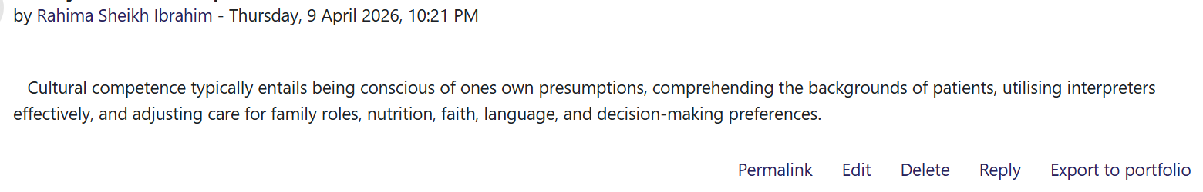

Reflection on Unit 3: Opportunity Knocks
Unit 3, Opportunity Knocks was about recognising and taking advantage of opportunities in personal and professional growth. The areas that were discussed were the identification of opportunities in day-to-day life, proper goal setting, and personal development plans c Prior to this unit, I was inclined to see opportunities as an uncommon, big occasion that would be evident. Now I realise that opportunities are in fact usually very subtle and have to be actively realised and made.
The lectures helped me to realise that the opportunity recognition is a skill that may be developed with the help of being interested, establishing networks, and having a proactive attitude. I got to know that health and social care scenarios have developmental opportunities which could be occasioned by difficult situations, co-worker feedback, or service delivery alterations. It is all a matter of coming to every situation with an open mind to learn.
The goal-setting workshop was one of the major realisations. I came to differentiate between empty dreams and realistic objectives that may be attained. In the activity, we needed to sketch our career objectives in the upcoming five years and pinpoint possible opportunities that would enable us to achieve the same. I found that my objective of becoming a specialist may be aided by opportunities including shadowing from more experienced practitioners, having the opportunity to attend the relevant training, and volunteering to work on projects that offer the relevant experience.
This learning also follows the SMART goals format that was initially credited to Doran (1981) which states that effective goals are supposed to be Specific, Measurable, Achievable, Relevant and Time-bound. Using this framework on my personal development plan has made me change my thinking of wishful thinking to action plans. I now realise that it is not sufficient to identify opportunities but also possess set standards to judge what opportunities are in line with the personal and professional objectives. , medium long term.
Developing my abilities and increasing my employability in the health and social care sectors are my short-term objectives. In order to engage with people and look into career chances, I updated my LinkedIn profile to match my current accomplishments and experience. In order to find chances for additional growth, I have also looked into pertinent courses on the website of my university.
Also, I related this learning with Dweck (2006) concept of growth mindset and fixed mindset. Growth mindset people perceive challenges as a chance to move ahead and the fixed mindset people cannot take risks because they are afraid of failures. I realised that I had been using a fixed mindset at some time especially when I was confronted with new circumstances. This unit taught me to be growth oriented, and I saw every obstacle presented in my healthcare practise as a chance to acquire new skills and knowledge.
Figure 3 Forum activity on Job opportunity
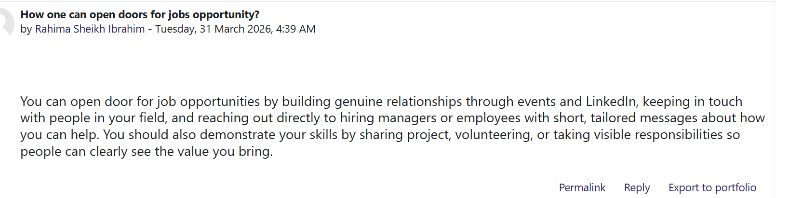

Reflection on Unit 4: The Pursuit of Happiness
Unit 4, The Pursuit of Happiness, covered the topics of wellbeing, resilience, and work-life balance in the challenging environment of health and social care careers. Among the issues discussed, there were learning the various wellbeing models, the aspects that lead to personal and professional resilience, and strategies to uphold wellbeing when working with others c
I also got to know that wellbeing is a multidimensional concept that is not limited to feeling happy or contented. The lectures have exposed me to the different theoretical approaches to the meaning of a good life and how they can be applied to the healthcare professional exposed to suffering and distress on a daily basis. I gained the realisation that my quality of wellbeing also affects my capacity to deliver high-quality care directly and that self-care is the only way to ensure that patient care is not impaired.
The online processes stimulated sincere consideration of my existing wellbeing practises. In one of the activities, we had to do a wellbeing audit where we had to rate ourselves on various aspects such as physical health, emotional wellbeing, social connexions, and purpose in life. My surprise was to find out that I had a high score on sense of purpose and dedication towards the job, but was lacking in physical exercise and good friends.
By concentrating on self-care, controlling my stress, and forming healthy habits, I have taken concrete measures to increase my happiness. In order to better develop myself, I intend to:
Develop more effective stress-reduction methods, such as relaxation and mindfulness. To prevent feeling overburdened, set reasonable goals.

This learning is related closely to the Perry Seligman model of wellbeing Positive Emotion, Engagement, Relationships, Meaning, and Accomplishment which is a cornerstone of wellbeing (Seligman 2011). Using this framework in my life allowed me to realise that I was certainly laying too much emphasis on accomplishment at the cost of other aspects. I also got to know that sustainable wellbeing involves considering all the five domains.
Maslach and Leiter (2016) also write about burnout; however, due to the lack of attention to wellbeing, health care providers are especially susceptible to feeling tired and detached.
Moreover, I researched on resilience theory which studies how human beings stay positive notwithstanding the challenges. Resilience in health and social care does not mean one is not vulnerable to stress but rather building resources and tactics to heal after such a difficult event. The unit also presented useful resilience-building skills such as mindfulness, reflective practise, setting clear work-personal life boundaries.
Figure 4 Forum activity on What does serendipity mindset mean?
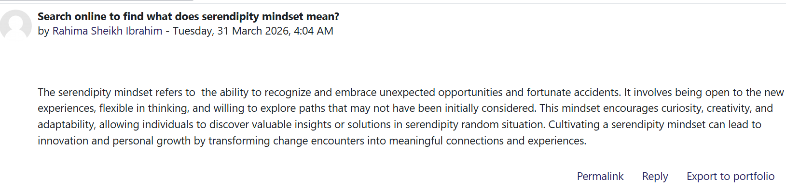

Conclusion
During this module, I have come to appreciate who I am and my role in the health and social care profession. In Unit 1, I learned that self-awareness as a basis of authentic personal branding through tools such as the Window of Johari is the basis of professional identity. Unit 2 broadened my understanding of the need to be culturally competent in our increasingly global system of healthcare and the dimensions provided by Hofstede are helpful in understanding cross-cultural interaction. Unit 3 provided me with the practical means of recognising and pursuing the opportunities, especially by setting SMART goals and adopting a growth mindset. Lastly, Unit 4 emphasised the essential role of wellbeing and resilience, and the PERMA model offers a model to balance and take care of other people.
The information and competencies that will be acquired during this module will be instrumental in my future practise in health and social care. I will be more conscious in my practise and realise how personal brand affects relationships in the workplace. I will be more culturally sensitive when interacting with patients and fellow co-workers with different backgrounds. Initially, I have implemented efficient time management techniques, encompassing the creation of organised study routines.

References
Cottrell, S. (2008) The Study Skills Handbook. 3rd edn. Basingstoke: Palgrave Macmillan.
Dauvrin, M. and Lorant, V., 2017. Cultural competence and social relationships: a social network analysis. International nursing review, 64(2), pp.195-204.
Doran, G.T. (1981) 'There's a S.M.A.R.T. way to write management's goals and objectives', Management Review, 70(11), pp. 35-36.
Duveau, C., Wets, C., Delaruelle, K., Demoulin, S., Dauvrin, M., Lepièce, B., Ceuterick, M., De Maesschalck, S., Bracke, P. and Lorant, V., 2023. Unintentional discrimination against patients with a migration background by general practitioners in mental health management: an experimental study. Administration and Policy in Mental Health and Mental Health Services Research, 50(3), pp.450-460.
Dweck, C.S. (2006) Mindset: The New Psychology of Success. New York: Random House.
Hofstede, G. (2001) Culture's Consequences: Comparing Values, Behaviors, Institutions, and Organizations Across Nations. 2nd edn. Thousand Oaks, CA: Sage Publications.
Luft, J. and Ingham, H. (1955) 'The Johari window: a graphic model of interpersonal awareness', Proceedings of the Western Training Laboratory in Group Development. Los Angeles: UCLA.
Maslach, C. and Leiter, M.P. (2016) 'Understanding the burnout experience: recent research and its implications for psychiatry', World Psychiatry, 15(2), pp. 103-111.
Medina Garrido, J.A., 2025. Steps to develop your professional personal brand.
Papadopoulos, I. (2006) Transcultural Health and Social Care: Development of Culturally Competent Practitioners. Edinburgh: Churchill Livingstone.
Seaward, B.L., 2020. Managing stress: skills for self-care, personal resiliency and work-life balance in a rapidly changing world: skills for self-care, personal resiliency and work-life balance in a rapidly changing world. Jones & Bartlett Learning.
Seligman, M.E.P. (2011) Flourish: A Visionary New Understanding of Happiness and Well-being. New York: Free Press.

