

BSc (Hons) Health and Social Care
Digital Transformation in the Health and Care Professions
BMHP6026
Component 1- Written Report

Student Name: Asho Hassan
Student ID: 2333642
Lecturer: Zakiyyah Ahmed

Table of Contents
Introduction 3
Overview of smart bandages and their implementation 4
Need of digital transformation 6
Impact on Service Delivery 7
Positive Impacts 7
Negative Impacts 7
Critical Analysis 8
Impact on Patients and Service Users 9
Positive impacts 9
Negative impacts 9
Future Opportunities and Challenges 11
Conclusion 12
References 13

Introduction
Digitalisation is the collaboration of technology in healthcare to enhance the quality, accessibility and delivery of care. In the healthcare sector, digital transformation, like electronic records, telemedicine, wearable sensors and remote systems of monitoring have shifted the traditional practices by allowing data-based and patient centred practices (Prakashan et al., 2024). The growing need for healthcare services, in addition to the shortage of workforce and costs of healthcare, has advanced the adoption of digital initiatives in the UK healthcare sector (Kumar et al., 2025). Management of wound care presents a substantial gap for the National Health Service (NHS). Chronic wounds involving diabetic foot ulcers and pressure ulcers are linked with long times of healing, raised risks of infection, decreased quality of patient life and significant healthcare expenses (Probst et al., 2026). One of the emerging innovations is in the form of smart bandages, also termed smart wound dressings. These have biosensors that monitor temperature, pH, levels of moisture, oxygen and infection (Gu et al.,2025). This report critically analyses smart bandage innovation in the context of UK healthcare. It evaluates their implementation and impact on the delivery of service and patient care. Specific focus is given to the merits and demerits of smart wound management technology in modern healthcare systems.

Overview of smart bandages and their implementation
Smart bandages are improved wound dressings that possess biosensors and responsive substances incorporated into traditionally used products for wound care. their propose is to enhance monitoring of the wound, support in decision making and provide interventions in a timely manner in case of complications. These are better than the traditional systems as they regularly collect and evaluate physiological data from the surroundings of the wound (Kumar et al., 2025).
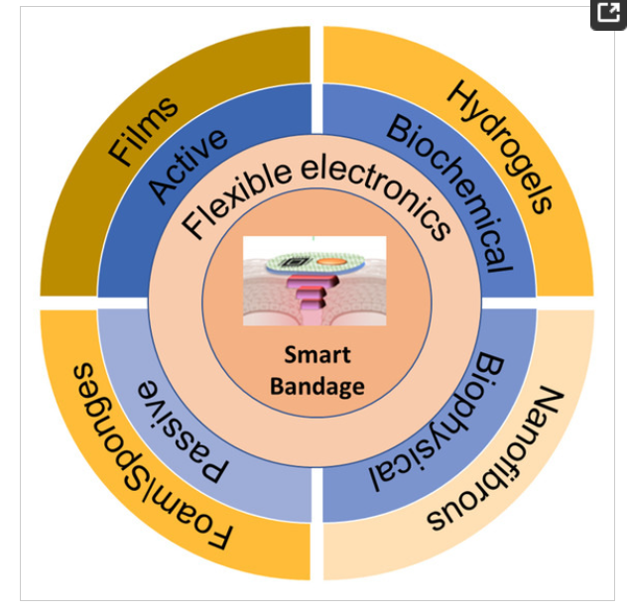
(Source : Levin et al., 2023)
The built-in sensors in smart bandages collect data about essential indicators of the healing of the wound. As per Probst et al (2026), pH, temperature and moisture, along with bacteria and matrix metalloproteinase-9 (MMP-9), are the usually controlled aspects in modern technologies of smart wound dressing.
Implementation in the UK
Smart bandages have not yet been adopted across the NHS; their development and analysis have been done through innovations in healthcare and research programmes. Various UK colleges, research universities and NHS collaborators have assessed the utilisation of biosensor-based wound bandages for chronic injury management, specifically in patients who have foot ulcers due to diabetes and other wounds that are not healed easily.
The necessity of these innovations is in terms of the burden of diabetic ulcers in feet. Over 120 diabetes associated amputations take place in the UK. Additionally, diabetic foot ulcers are estimated to cost about £1 billion annually for the NHS (NICE, 2019). Therefore, healthcare settings are expanding in technological advancements that may help in earlier diagnostics, decrease complications and enhance patients’ satisfaction.

Need of digital transformation
Smart bandages demonstrate a digital shift as they move care of wounds from reactive system to a proactive approach. Traditional management of wounds depends vastly on visual assessment, which may delay the evaluation of infection. In comparison, smart bandages give real-time control and monitoring, along with a feedback mechanism in real time that enables healthcare clinicians to identify complications fast and make decisions that are evidence-based (Wang et al., 2025).
Moreover, these digital technologies contribute to data-based decision-making by giving objective information in contrast to depending just on visual assessment. These smart bandages can also be integrated with wireless systems of communication and remote platforms for monitoring, which enables healthcare practitioners to evaluate the data without needing personal consultations.

Impact on Service Delivery

Positive Impacts
The smart bandages have the potential to change service delivery by focusing on continuous monitoring and earlier intervention when complications arise. One of the most important advantages is the early diagnosis of infection. It can reduce complications and improve a patient's health outcomes. The smart bandages regularly monitor temperature and pH and provide healthcare professionals with information so that they can indicate an Infection before visible symptoms develop (Farahan and Shafiee, 2021).
The other benefit is supporting isolated and community-based care. The NHS increasingly encourages home care and smart bandages, aligning with the objective by focusing on healthcare providers to observe a wound healing environment. This can decrease the travel needs of the patient and improve access to care in local areas.
Furthermore, the early diagnosis of difficulties can contribute to decreasing clinical admissions. In diabetic foot ulcers, the NHS invest around 1 million annually and contributes to over 150 diabetes in the UK (Cullen et al, 2023). Moreover, the technology promotes an earlier diagnosis, which may also reduce hospital problems and healthcare expenses.

Negative Impacts
The smart bandages also represent many barriers to service delivery. One of the main issues is technical credibility. Sensor malfunctions, improper readings, and connectivity issues could compromise patient safety if hospitals heavily depend on wrong data when making treatment decisions. The major issue is of data security concerns because the smart bandages produce large amount of data while monitoring the healing process of wound. This is because of virtual connection with hospitals which point the security concern. In this line some of individuals avoid the use of digital technology due to fear of data breaching. Further the maintainance cost of technology is also very high and lack of separate technological budget allocation limits the opportunity of promoting the use of virtual device like smart bandages.

Critical Analysis
The major differences between the traditional wound care and smart bandages could be understood as rapid changes in technology. In context of service delivery, the smart bandages offer and scope of effective virtual intervention to improve effectiveness, decrease complications and support preventative care. However, the questions remain related to their long-term cost efficiency and sustainability in the NHS, while decreasing clinical admissions and earlier diagnosis may create future savings, training and technological infrastructure are significant. Therefore, although smart bandages highlighted considerable NHS service pressure, further large-scale clinical evidence is needed to determine whether their benefits are reliable and compensate for the financial challenges linked with the widespread adoption.

Impact on Patients and Service Users

Positive impacts
Smart bandages are effective in enhance and promote positive patient results and experiences by allowing continous monitoring of the wound. One of the most key benefits is the early assessment of complications. Because, traditional wound identification is usually conducted through scheduled appointments for infections that may otherwise not be identified. Smart bandages regularly monitor parameters of the injury like temperature, pH and moisture, allowing clinicians to assess complications early on (Gu et al., 2025). Early diagnosis and treatment can results in reduced risk of major infection, reduce hospitalisation and enhance healing results. Moreover, smart bandages can enhance the empowerment of the patients by promoting better involvement in self-management and care practices. Through systems of digital monitoring and control, patients may obtain better access to information about their progress of healing, allowing them to enhance engagement in healthcare decisions and better evaluate their own condition. Similalry, these bandages may improve accessibility to healthcare, specifically for patients who have less mobility, disabilities or live in remote areas. This can enhance the delivery of services and decrease frequent travelling to healthcare settings.

Negative impacts
Smart bandages have certain barriers for patients and users of the service. Concerns related to privacy are the most substantial issue. Regular monitoring creates a huge amount of personal data that should be stored and evaluated safely. Moreover, digital literacy is also a significant challenge, as several patients, specifically the aged population and underserved groups, have less access to digital technologies, which causes disparities in interaction and monitoring systems utilisation. Accessibility problems also increase issues of equity. Smart bandages are presently rather expensive and not equally available across the UK and the NHS; therefore, some patients may benefit from the technological innovation while others face significant disparity in treatment access.
Overall, this technological innovation in healthcare can improve patient-centred care experiences by encouraging self-care and early assessment. Wound care is generally linked with emotional support and does not depend only on technology and treatment. Therefore, smart bandages should be observed as a tool that contributes to healthcare rather than replacing professionals.

Future Opportunities and Challenges
In the context of the future of smart bandages is closely linked to advancements in artificial intelligence. This is also related to embedding biosensor technology and remote technology in the healthcare intervention. The integration of artificial technology is effective and allows predictive analysis to prevent negative consequences and early diagnosis. The predictive analysis is related to early identification of patterns to assess deterioration before clinical symptoms emerge, supporting earlier and more targeted interventions. Moreover, the wider NHS adoption could improve the efficiency and quality of wound care delivery. However, some of the changes are already in place, such as increased implementation costs, maintaining regulatory operations, workforce training needs, and cyber-security complexities are existing.

Conclusion
In conclusion the key aim of this study was to examine the innovation in digital healthcare landscape. Smart bandages has discussed as the digital innovation which aim for potential transformation and wound recovery within the healthcare industry of the UK. This includes embedding biosensors into wound dressing and continuous monitoring the progress. To the comparison with traditional intervention the smart bandage offer effective care and allow early infection diagnosis. Moreover it is also helpful in supporting the person-centered care by reducing the need of frequent dressing and promoting effective monitoring. Although, some barriers are also existing such as digital exclusion, high implementation cost and major concern related to data-security which also questions on its long-term effectiveness. Overall it considered as the potential transformational device but the efficiency focused on addressing and reducing ethical and accessibility challenges.

References
Chaudhary, U., Ali, M.F., Kumar, A., Sharma, A. and Jayakody, D.N.K., 2025. Unleashing the power of wireless communication in healthcare by empowering patient care and connectivity: A comprehensive survey. IEEE Access. https://ieeexplore.ieee.org/iel8/6287639/6514899/11029189.pdf
Cullen, K., Jones, M., Sheehan, C., Game, F., Vedhara, K. and Fitzsimmons, D., 2023. Development of a resource-use measure to capture costs of diabetic foot ulcers to the United Kingdom National Health Service, patients and society. Journal of Research in Nursing, 28(8), pp.565-578. https://journals.sagepub.com/doi/pdf/10.1177/17449871231208108
Farahani, M. and Shafiee, A., 2021. Wound healing: from passive to smart dressings. Advanced Healthcare Materials, 10(16), p.2100477. https://espace.library.uq.edu.au/view/UQ:a210177/UQa210177_OA.pdf
Gu, H., Sun, X., Bao, H., Feng, X. and Chen, Y. (2025) ‘Optically pH-sensing in smart wound dressings towards real-time monitoring of wound states: A review’, Analytica Chimica Acta, 1350, p. 343808.https://www.sciencedirect.com/science/article/pii/S0003267025002028
Kumar, M., Sethi, P., Shiekmydeen, J., Rastogi, S., Mahmood, S., Chopra, S., Thomas, S., Kumar, D. and Bhatia, A., 2025. A recent review on smart sensor-integrated wound dressings: Real-time monitoring and on-demand therapeutic delivery. International Journal of Biological Macromolecules, 313, p.144251.https://www.sciencedirect.com/science/article/pii/S0141813025048032
Levin, A., Gong, S. and Cheng, W., 2023. Wearable smart bandage-based bio-sensors. Biosensors, 13(4), p.462.https://www.mdpi.com/2079-6374/13/4/462
Prakashan, D., Kaushik, A. and Gandhi, S., 2024. Smart sensors and wound dressings: Artificial intelligence-supported chronic skin monitoring–A review. Chemical Engineering Journal, 497, p.154371.Manchester Metropolitan University (2026) Could Smart Insoles Help Monitor and Improve Diabetic Foot Health? ISRCTN Registry.
Probst, S., Stefanelli, A., Groux, S., Bossi, N., Pugliese, M.T. and Pastor, D. (2026) ‘Smart wound dressings and the biological parameters they monitor: A scoping review’, International Wound Journal, 23(4), p. e70919.https://onlinelibrary.wiley.com/doi/pdf/10.1111/iwj.70919
Wang, J., Liu, Z. and Zhao, Y. (2025) ‘Smart biomaterials in wound healing: Advances, challenges and future directions in intelligent dressing design’, Bioengineering, 12(11), p. 1178.https://www.mdpi.com/2306-5354/12/11/1178

