
Assignment 1: E-Portfolio
Changemakers: Creativity and Value Creation

June 26, 2023
Owen Evans
2121421

Contents
E-portfolio screenshots 1
Links 4
Research Project Idea 4
Reference list (also included in E-portfolio) 5
Appendices 7
Appendix A – Unit 1 all sections evidence 7
Appendix B – Unit 2 all sections evidence 10

E-portfolio screenshots

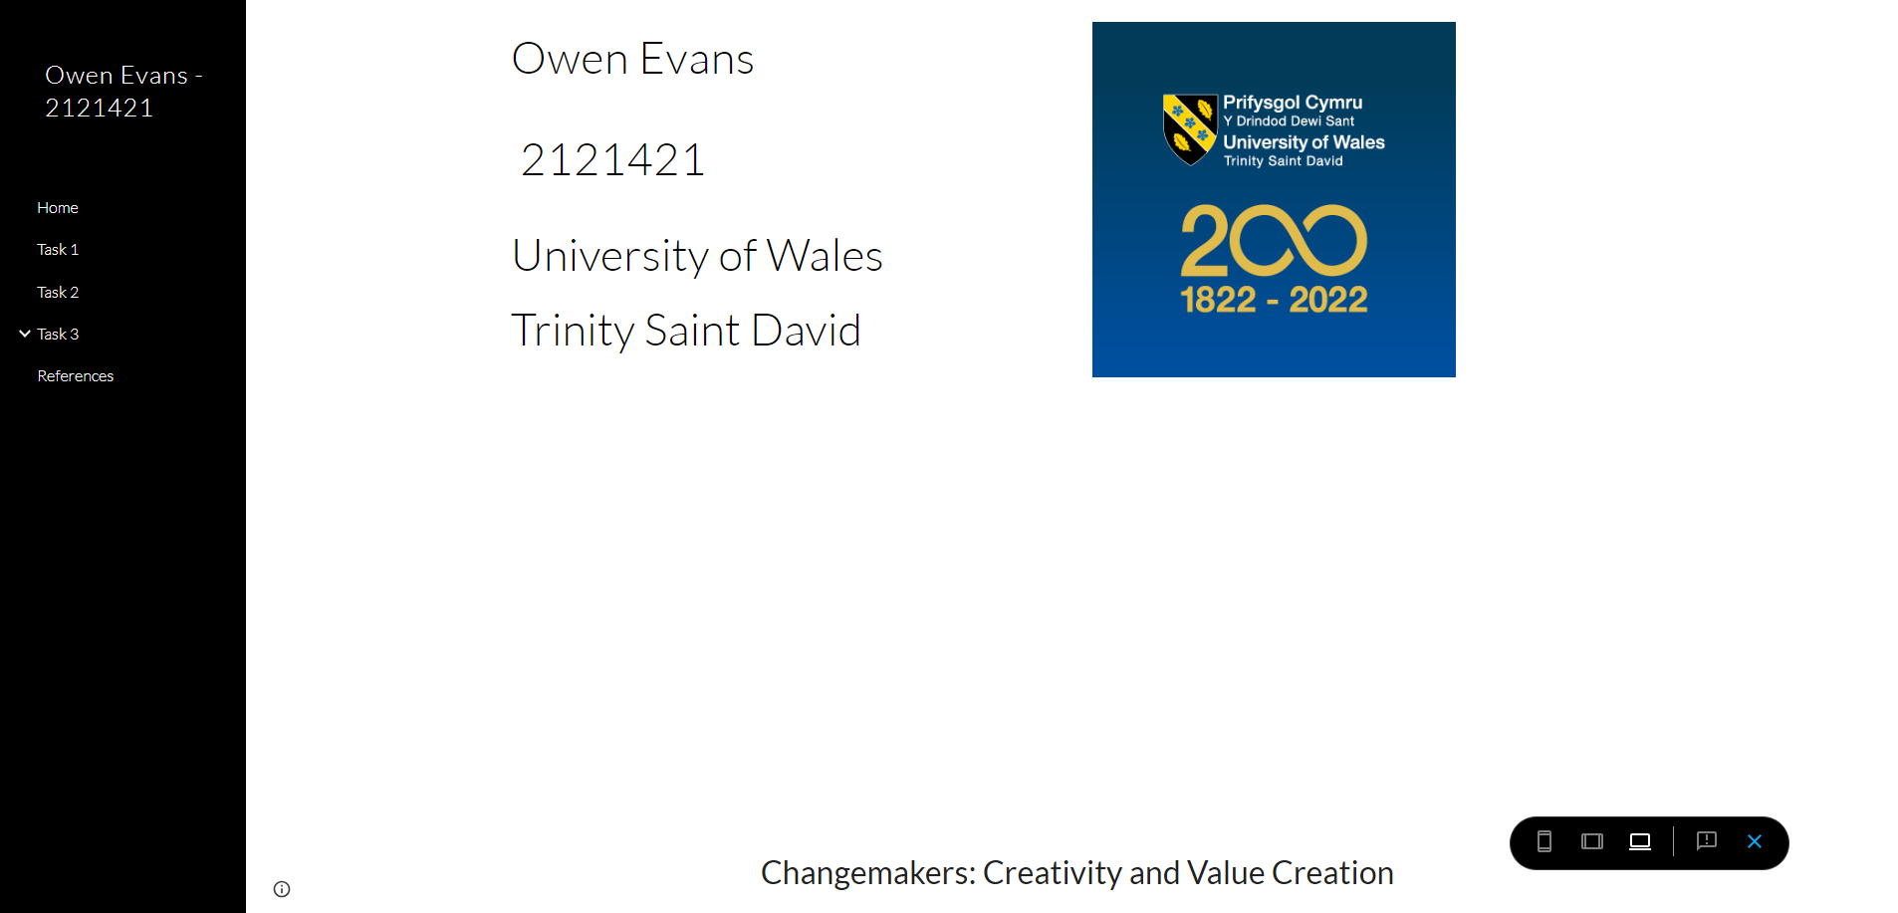
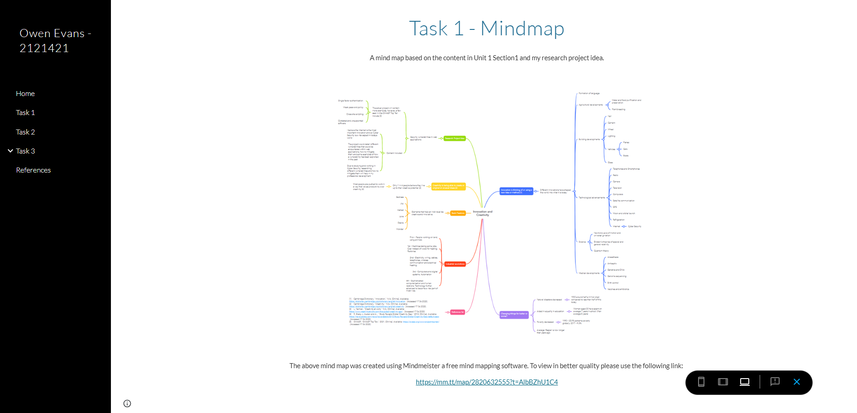
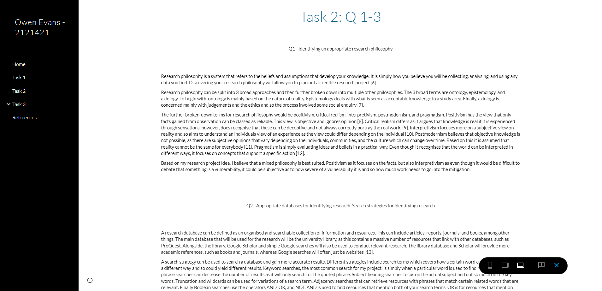
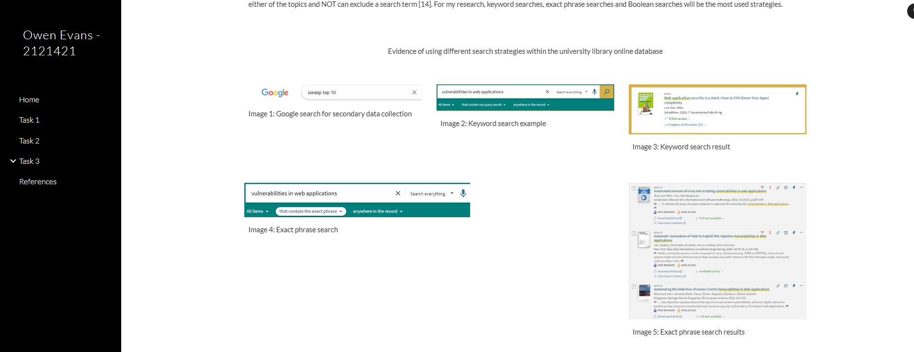
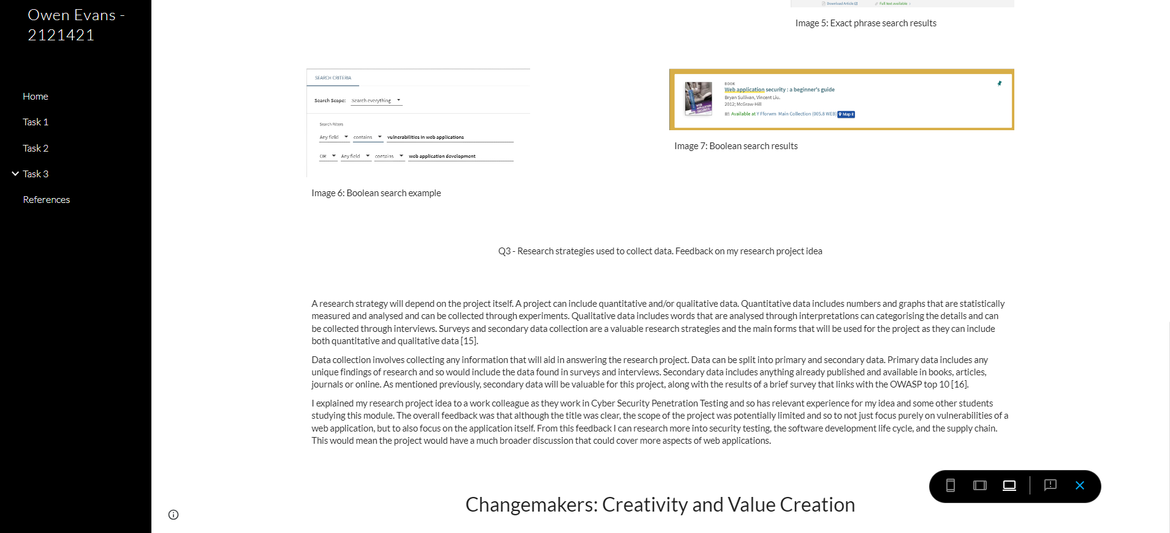
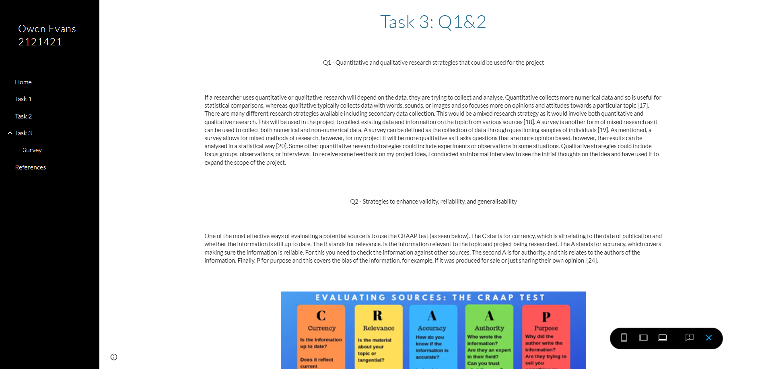
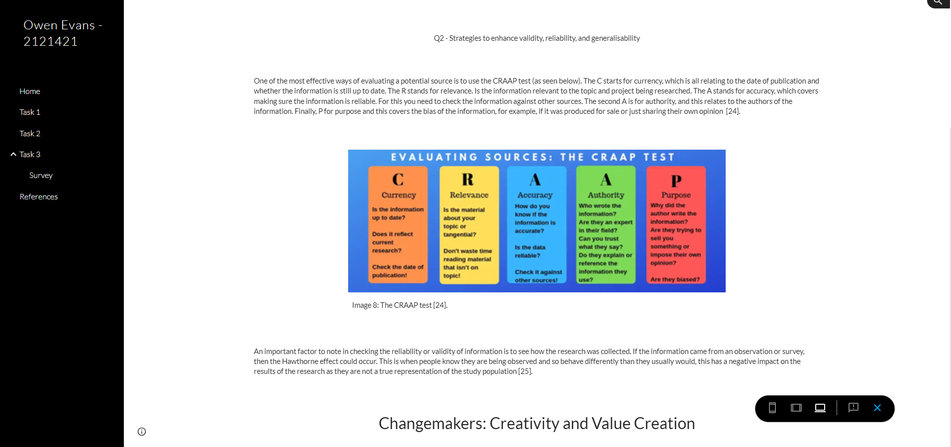
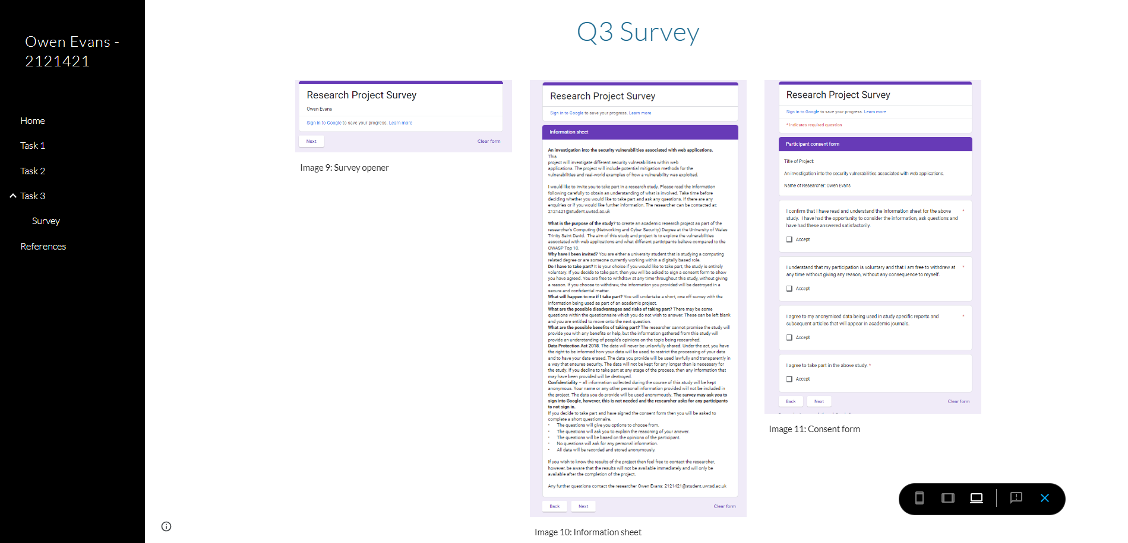
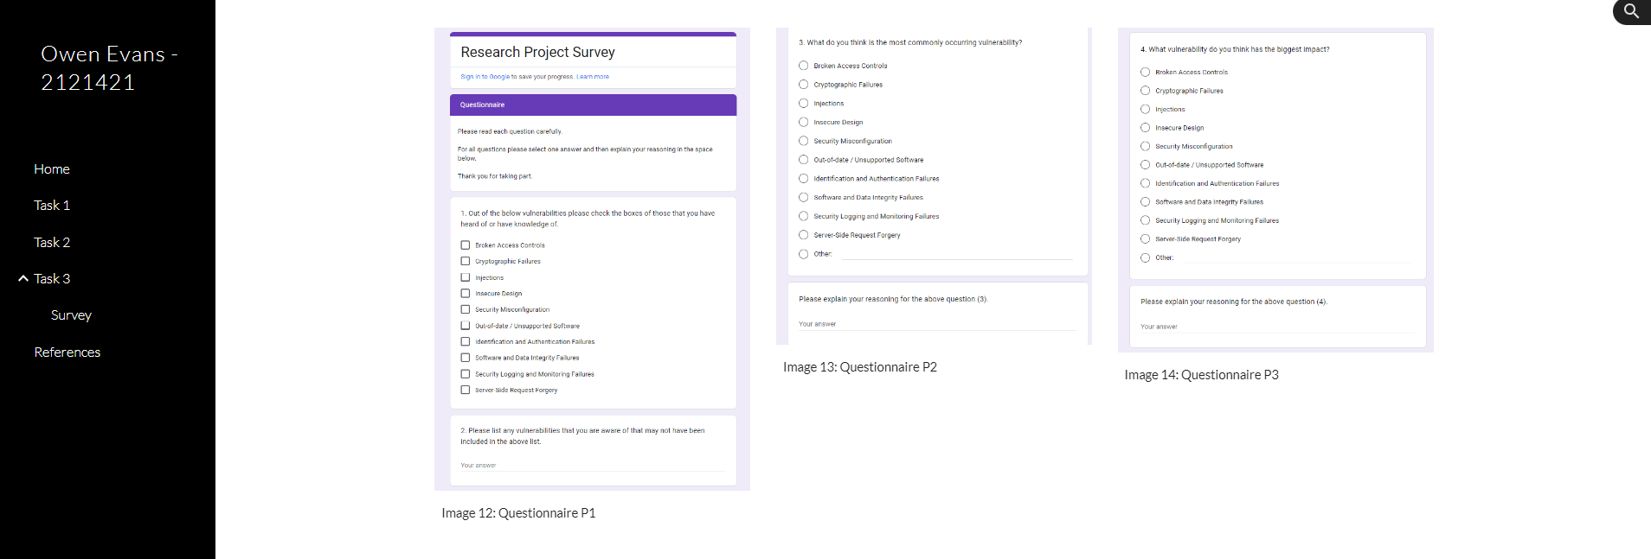
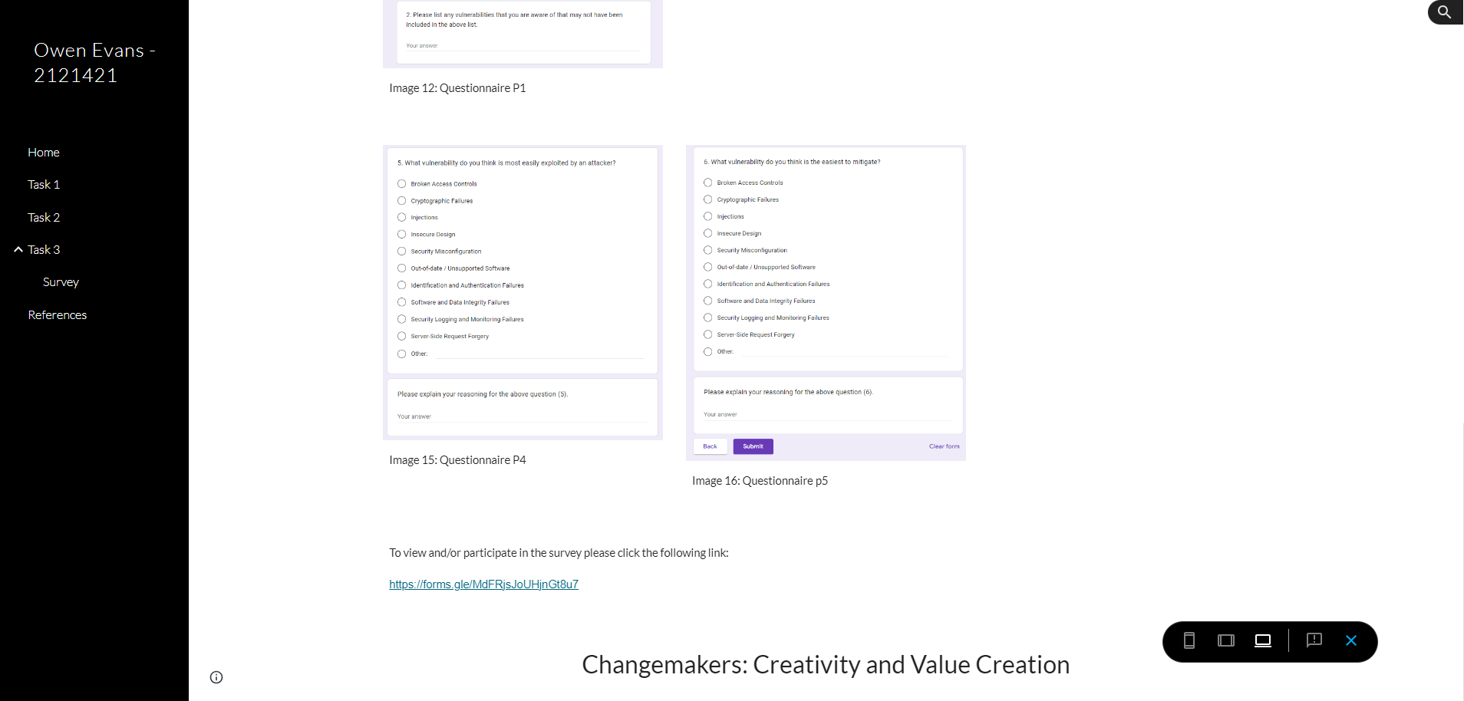

Links

Mind map - https://mm.tt/map/2820632555?t=AlbBZhU1C4
Survey - https://forms.gle/MdFRjsJoUHjnGt8u7
E-Portfolio - https://sites.google.com/view/owen-evans-2121421

Research Project Idea

Title: Security vulnerabilities in web applications
Description: This project will investigate different security vulnerabilities within web applications. The project will include potential mitigation methods for the vulnerabilities and real-world examples of how a vulnerability was exploited.

Reference list (also included in E-portfolio)

[1] | Cambridge Dictionary, "Innovation," N/A. [Online]. Available: https://dictionary.cambridge.org/dictionary/english/innovation. [Accessed 17 06 2023].
[2] | Cambridge Dictionary, "Creativity," N/A. [Online]. Available: https://dictionary.cambridge.org/dictionary/english/creativity. [Accessed 17 06 2023].
[3] | L. Naiman, "Creativity at work," N/A. [Online]. Available: https://www.creativityatwork.com/the-global-creativity-gap/. [Accessed 17 06 2023].
[4] | R. Brady, L. Auslen and A. , "Study Reveals Global Creativity Gap," 2012. [Online]. Available: https://news.adobe.com/news/news-details/2012/Study-Reveals-Global-Creativity-Gap/default.aspx. [Accessed 17 06 2023].
[5] | OWASP, "OWASP Top Ten," 2021. [Online]. Available: https://owasp.org/www-project-top-ten/. [Accessed 17 06 2023].
[6] | M. Saunders, P. Lewis and A. Thornhill, in Research Methods for Business Students, Pearson Education Limited, 2019, pp. 130-131.
[7] | P. Chetty and S. GuhaThakurta, "Understanding research philosophy," 2015. [Online]. Available: https://www.projectguru.in/research-philosophy/. [Accessed 21 06 2023].
[8] | H. Collins, in Creative Research: The Theory and Practice of Research for the Creative Industries, AVA Publications, 2010, p. 38.
[9] | A. Novikov and D. Novikov, in Research Methodology: From Philosophy of Science to Research Design, CRC Press, 2013.
[10] | N. University, "Understanding Pragmatic Rsearch: Two traditional research paradigms," N/a. [Online]. Available: https://www.nottingham.ac.uk/helmopen/rlos/research-evidence-based-practice/designing-research/types-of-study/understanding-pragmatic-research/section02.html#:~:text=Interpretivism%20is%20based%20on%20the,individuals'%20historical%20or%20social%20perspect. [Accessed 21 06 2023].
[11] | iNtgrty, "Research Paradigms: Postmodernism," 2016. [Online]. Available: https://www.intgrty.co.za/2016/09/20/research-paradigms-postmodernism/#:~:text=Postmodernism%20rejects%20the%20possibility%20that,voice%20of%20the%20expert%20researcher. [Accessed 21 06 2023].
[12] | Deakin University, "Research paradigm and why pragmatism worked for us," 2019. [Online]. Available: https://blogs.deakin.edu.au/devt-hum/2019/12/02/on-selecting-a-research-paradigm-and-why-pragmatism-worked-for-us/. [Accessed 21 06 2023].
[13] | University of Houston, "What’s the difference between a Research Database and Google?," N/A. [Online]. Available: https://guides.lib.uh.edu/c.php?g=1249066#:~:text=A%20research%20database%20is%20an,quickly%20search%20many%20resources%20simultaneously. [Accessed 21 06 2023].
[14] | University of Leeds Library , "Literature Searching Explained," N/A. [Online]. Available: https://library.leeds.ac.uk/info/1404/literature_searching/14/literature_searching_explained/4#:~:text=A%20search%20strategy%20is%20an,keywords%20and%20phrases. [Accessed 21 06 2023].
[15] | P. Bhandari, "Data Collection Methods | Step-by-Step Guide & Examples," 2022. [Online]. Available: https://www.scribbr.co.uk/research-methods/data-collection-guide/. [Accessed 21 06 2023].
[16] | J. Dudovskiy, "Data Collection Methods," 2022. [Online]. Available: https://research-methodology.net/research-methods/data-collection/. [Accessed 21 06 2023].
[17] | S. Mcleod and O. G. Evans, "Qualitative Vs Quantitative Research Methods & Data Analysis," 2023. [Online]. Available: https://www.simplypsychology.org/qualitative-quantitative.html. [Accessed 23 06 2023].
[18] | Benedictine University Library, "Public Health Research Guide: Primary & Secondary Data Definitions," 2023. [Online]. Available: https://researchguides.ben.edu/c.php?g=282050&p=4036581#:~:text=Secondary. [Accessed 2023 06 2023].
[19] | J. Check and R. Schutt, in Research Methods in Education, Sage Publications, 2012, pp. 159-185.
[20] | R. Singleton and B. Straits, in Approaches to social research, Oxford University Press, 2017.
[21] | S. Mcleod and O. G. Evans, "Sampling Methods In Reseach: Types, Techniques, & Examples," 2023. [Online]. Available: https://www.simplypsychology.org/sampling.html. [Accessed 23 06 2023].
[22] | Oregon State University, "Snowball Sampling," 2010. [Online]. Available: https://research.oregonstate.edu/irb/policies-and-guidance-investigators/guidance/snowball-sampling. [Accessed 23 06 2023].
[23] | H. Barratt and S. Shantikumar, "Methods of sampling from a population," 2018. [Online]. Available: https://www.healthknowledge.org.uk/public-health-textbook/research-methods/1a-epidemiology/methods-of-sampling-population. [Accessed 23 06 2023].
[24] | Canterbury Christ Church University, "Library Guide - Law.," N/A. [Online]. Available: https://www.canterbury.ac.uk/guides/library/library-guide-law. [Accessed 23 06 2023].
[25] | E. Spencer and K. Mahtani, "Hawthorne effect," Catalogue of Bias: University of Oxford, 2017. [Online]. Available: https://catalogofbias.org/biases/hawthorne-effect/. [Accessed 23 06 2023].

Appendices

Appendix A – Unit 1 all sections evidence

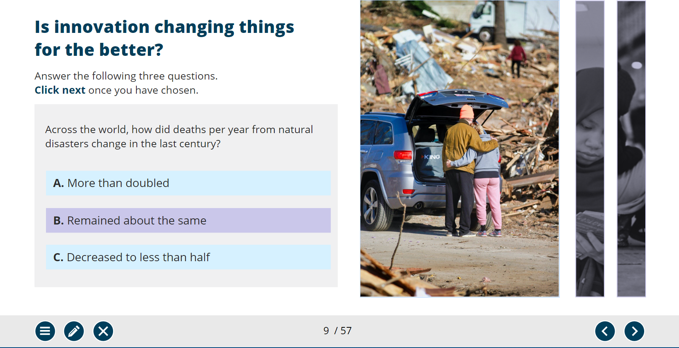
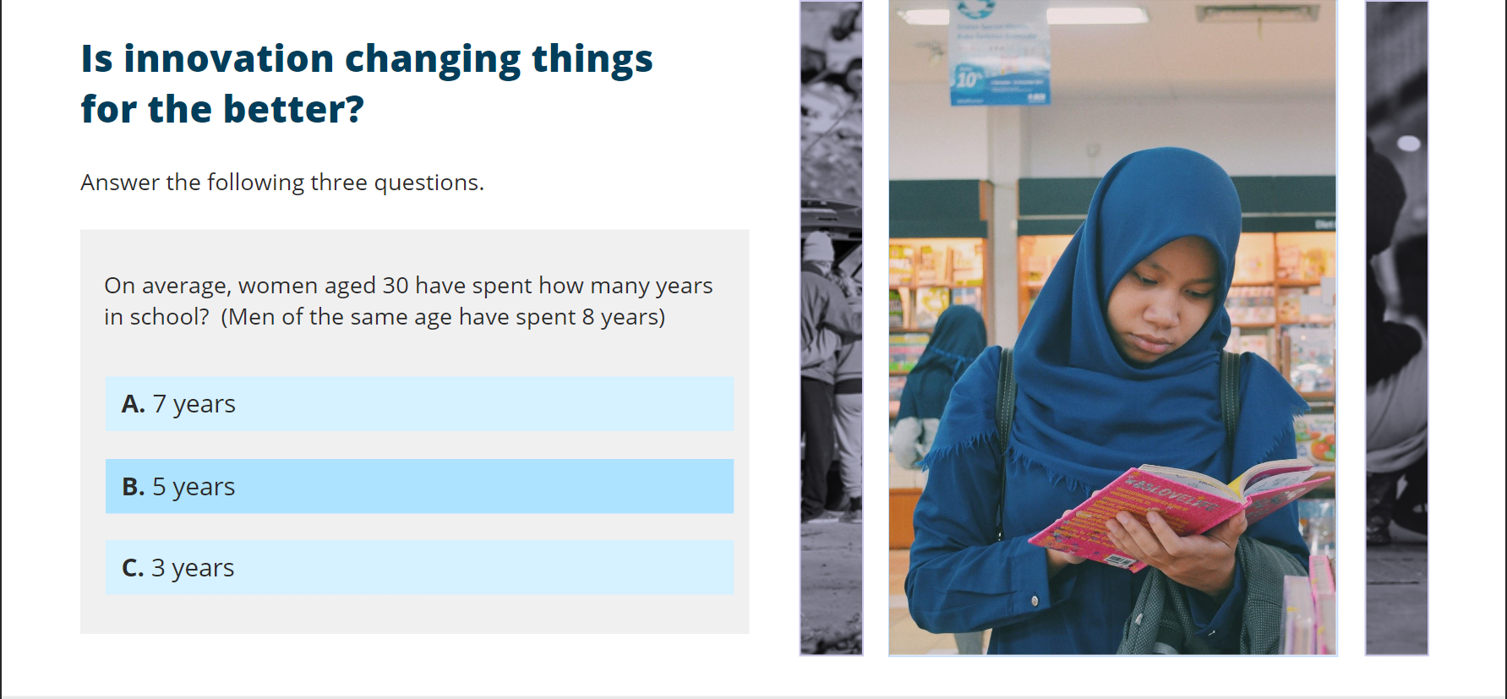
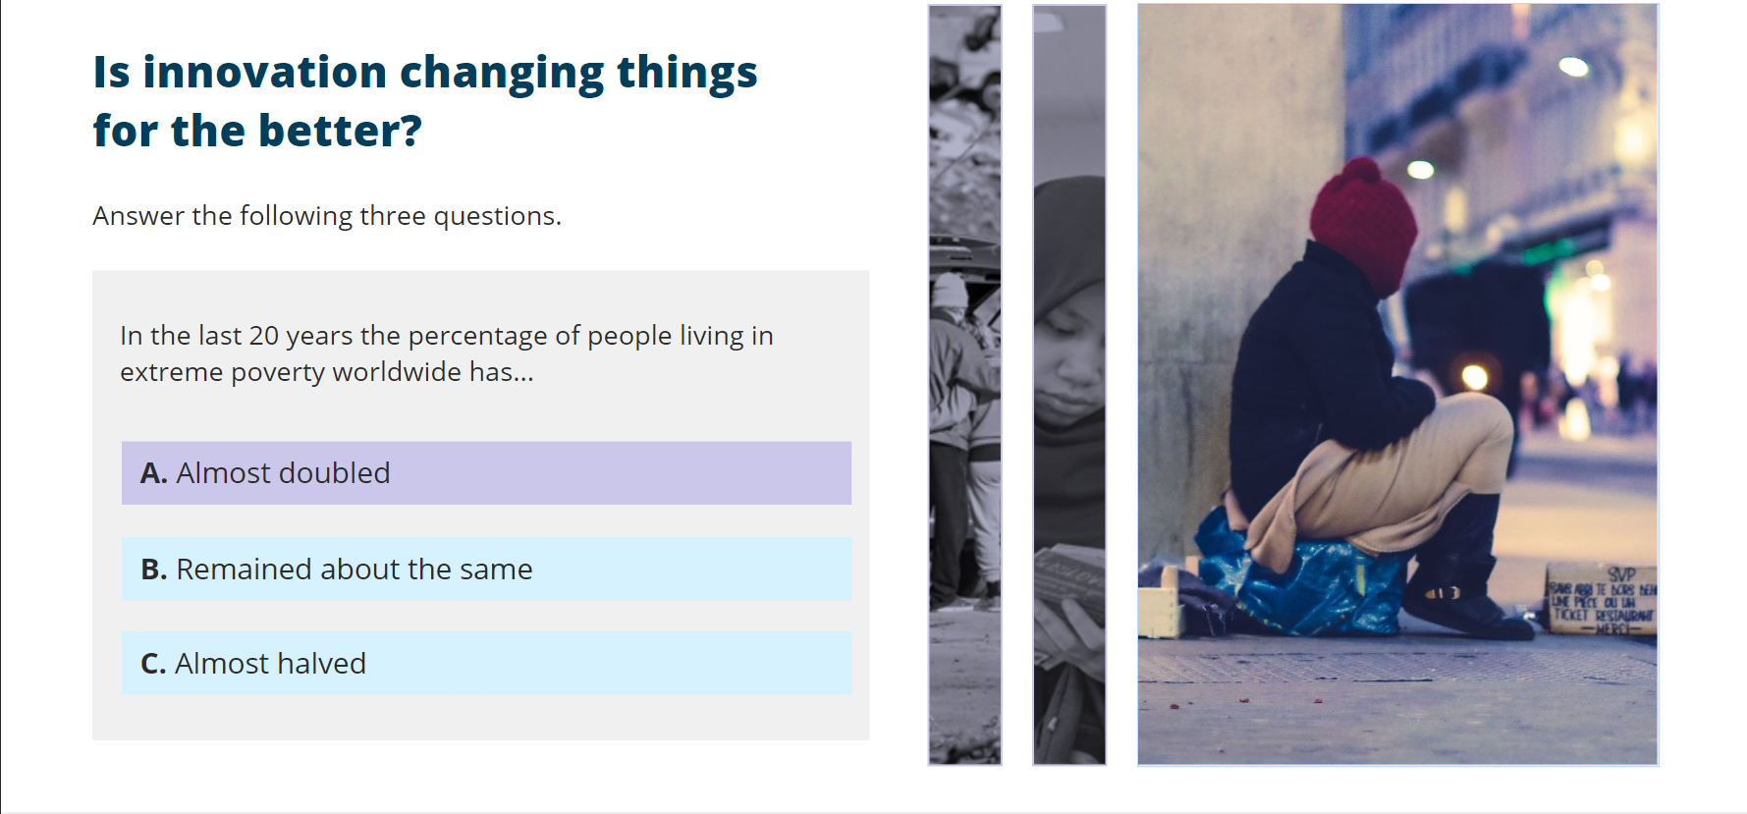
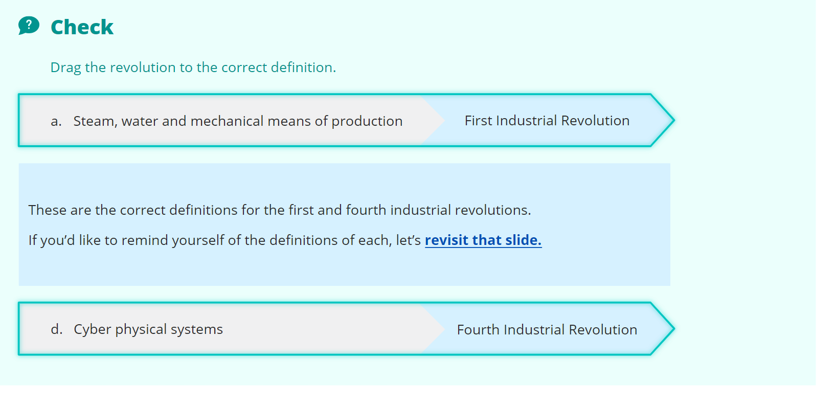
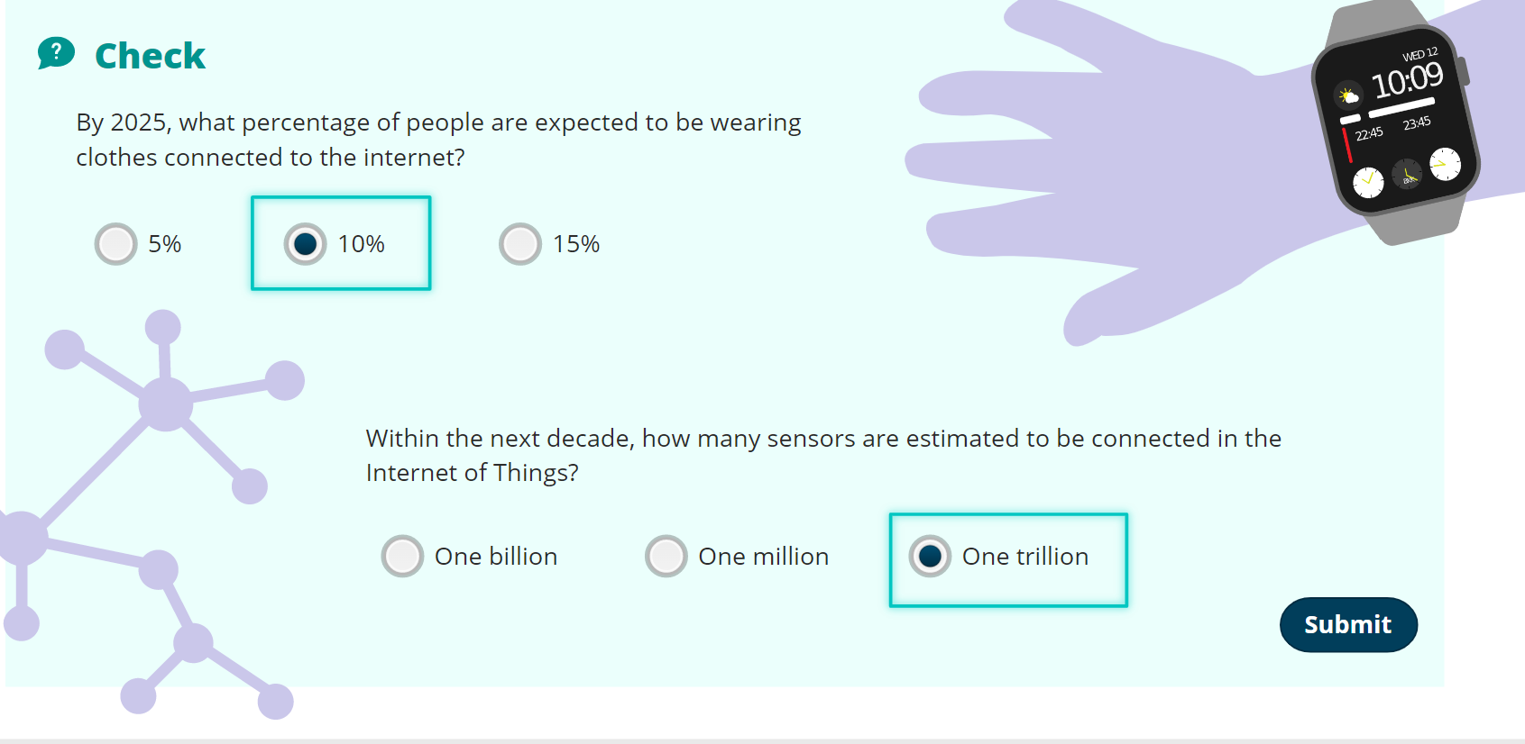
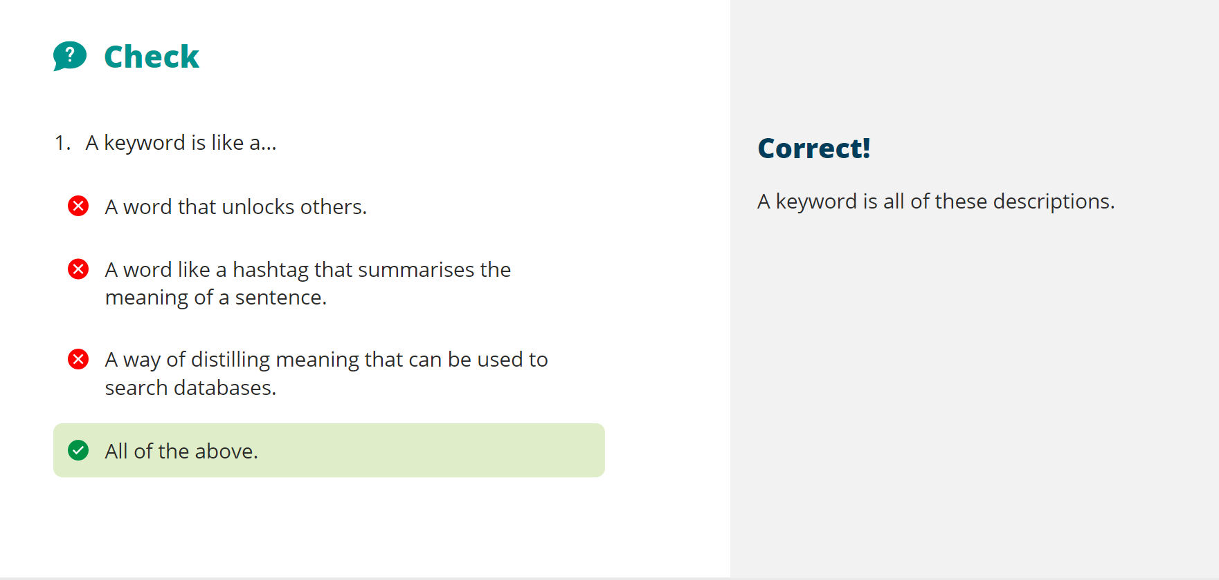
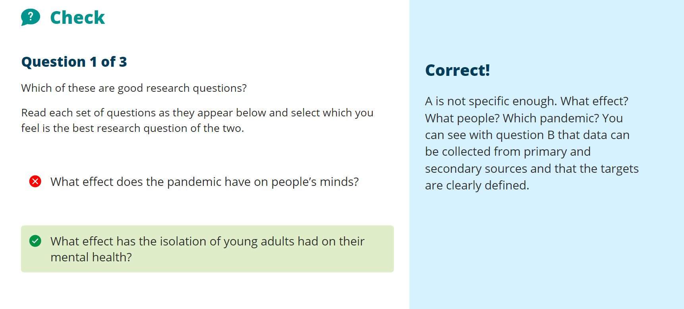
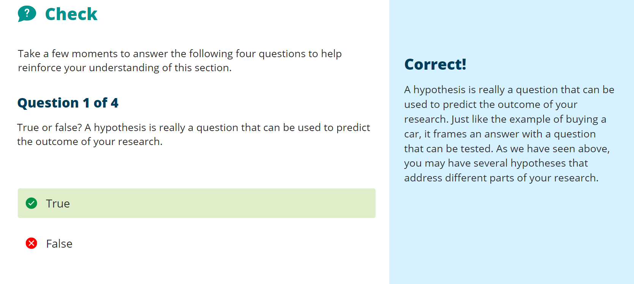
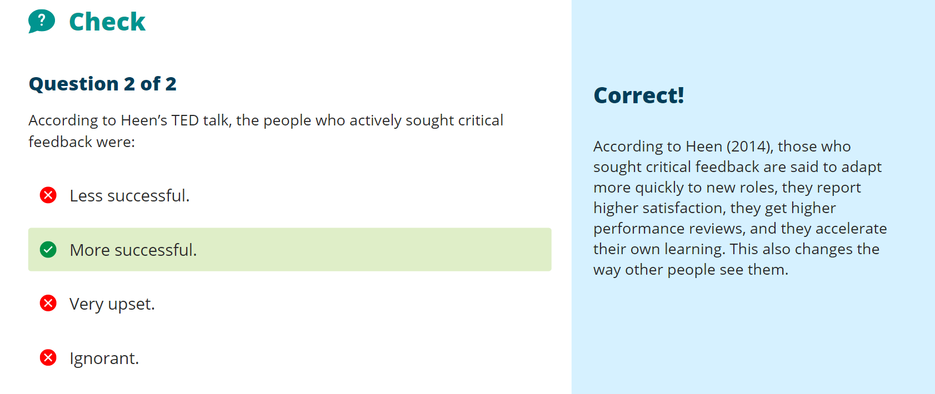

Appendix B – Unit 2 all sections evidence



