Title | Network Operating Systems and Services (NOSS)
Assignment | Worksheet 2
Lecturer | Nitheesh Kaliyamurthy
Student Number | 1802975
Course name | Cloud Computing

Table of Contents
Worksheet task 1 ------------------------------------------------------------------------------------------------------------3
Worksheet task 2 ----------------------------------------------------------------------------------------------------------11
Worksheet task 3: Individual Task -------------------------------------------------------------------------------------25 References-------------------------------------------------------------------------------------------------------------------29
Table of Figures:
Figure 3: Configuring the network shared folder. 5
Figure 4: Drive (Z:) mapped to the shared folder. 5
Figure 5: GPO 1: Restricting Access to the control panel. 6
Figure 6: GPO 1: Moderating Access to the Control Panel. 7
Figure 7: GPO 2: Removing Access to the Command Prompt. 8
Figure 8: GPO 3: Restricting Access to Removable Media Drives. 9
Figure 9: GPO 4: Restricting Software Installation (REMOVE?) 10
Figure 10: GPO 4: Restricting Software Installs 11
Figure 11: GPO 5: Enforcing Password Policy in the ‘accatask.msft’ domain 12
Figure 12: Address resolution protocol cache contents from arp -A command. 13
Figure 13: Arp cache contents from asp -A command after pings. 14
Figure 14: Route print output from Server 1. 15
Figure 15: Creation of FTP site on Server 2. 16
Figure 16: Configuring FTP welcome banner of Server 2. 16
Figure 18: Installing the remote access role. 17
Figure 19: Server 1 pinging Server 2 on its public IP address. 18
Figure 20: Client 1 pinging Client 2 on its private IP address 19
Figure 21: Client 2 pinging Client 1 on its private IP address 20
Figure 22: Configuring IP filter to block ping of router interface (Filter 1). 21
Figure 23: Ping of router interface blocked, other IP addresses respond. 22
Figure 24: FTP service connection. 23

Name of the Team: KSPT
Team Members
Student Name | Student ID
Samuel Jackson | 1802975
Kes Summer | 2015409
Pete holdstock | 2021952
Tim Day | 1909697

 | Kes Summer | Samuel Jackson | Pete Holdstock | Tim Day
Kes Summer | 5 | 4 | 4 | 4
Samuel Jackson | 5 | 4 | 4 | 4
Pete Holdstock | 5 | 4 | 4 | 4
Tim Day | 5 | 5 | 5 | 5

Worksheet task 1

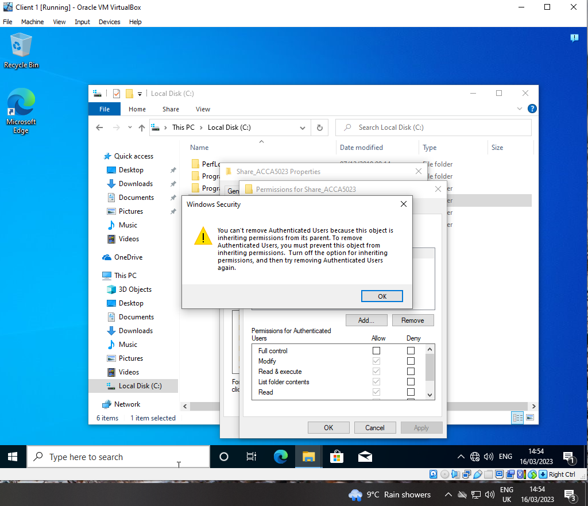

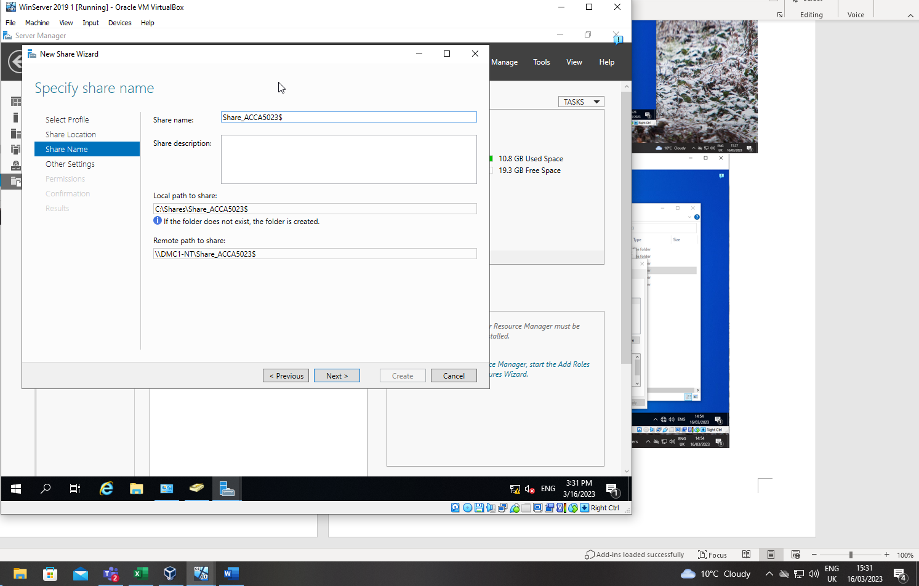
Figure 3: Configuring the network shared folder.
The folder was configured as a network share so that others can access the files within the folder. The ‘$’ at the end of the share name causes the share to be hidden so it cannot be browsed via the network and the name has to be known to be able to map to it.

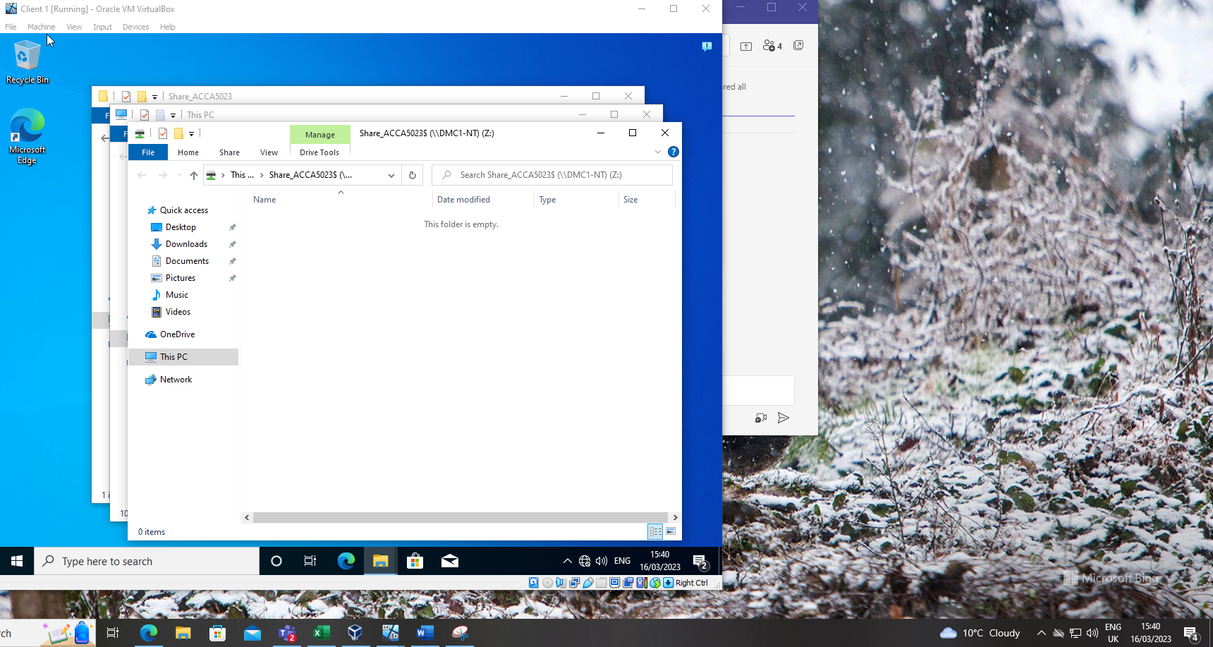
Figure 4: Drive (Z:) mapped to the shared folder.
Once the share was configured on the folder it was possible to map to the share using the full universal naming convention (UNC) path consisting on the name of the server and the name of the share, i.e. \\DMC1-NT\Share_ACCA5023$

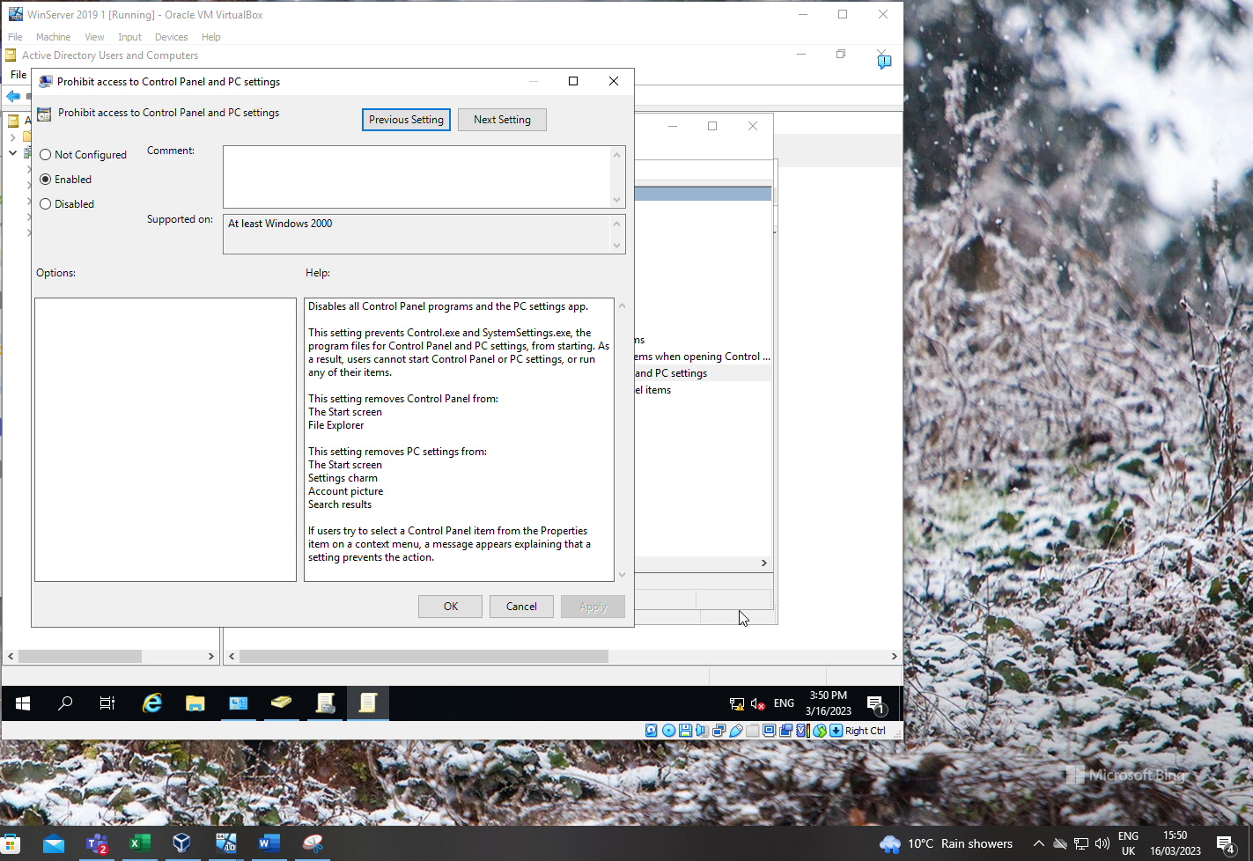
Figure 5: GPO 1: Restricting Access to the control panel.
Using the group policy management console (GPMC), a group policy was created to disable access for standard users to the control panel.

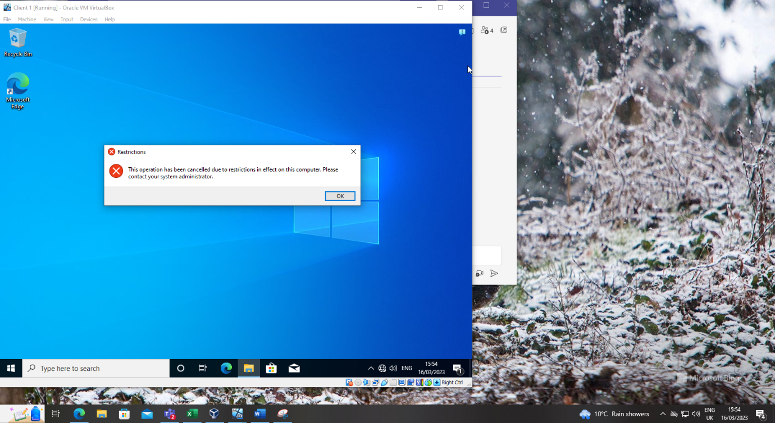
Figure 6: GPO 1: Moderating Access to the Control Panel.
Message displayed when a standard user attempts to open the control panel.

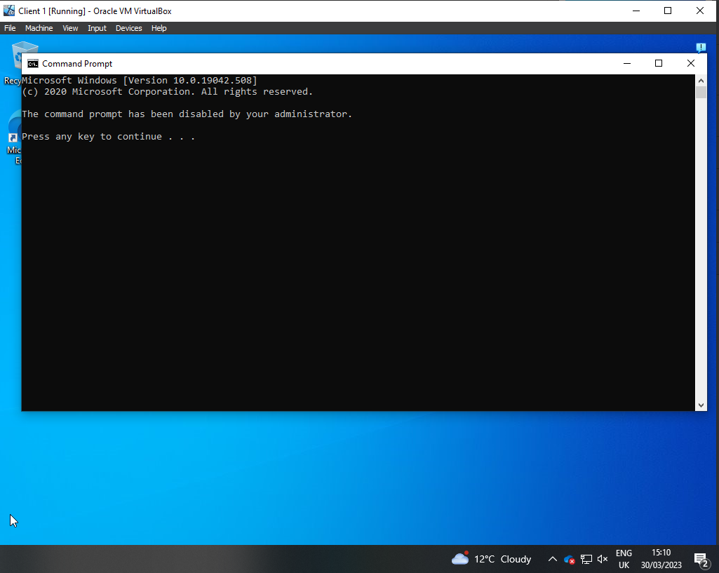
Figure 7: GPO 2: Removing Access to the Command Prompt.
Message displayed when a non-admin user attempts to access the command prompt after configuring a group policy to restrict access.

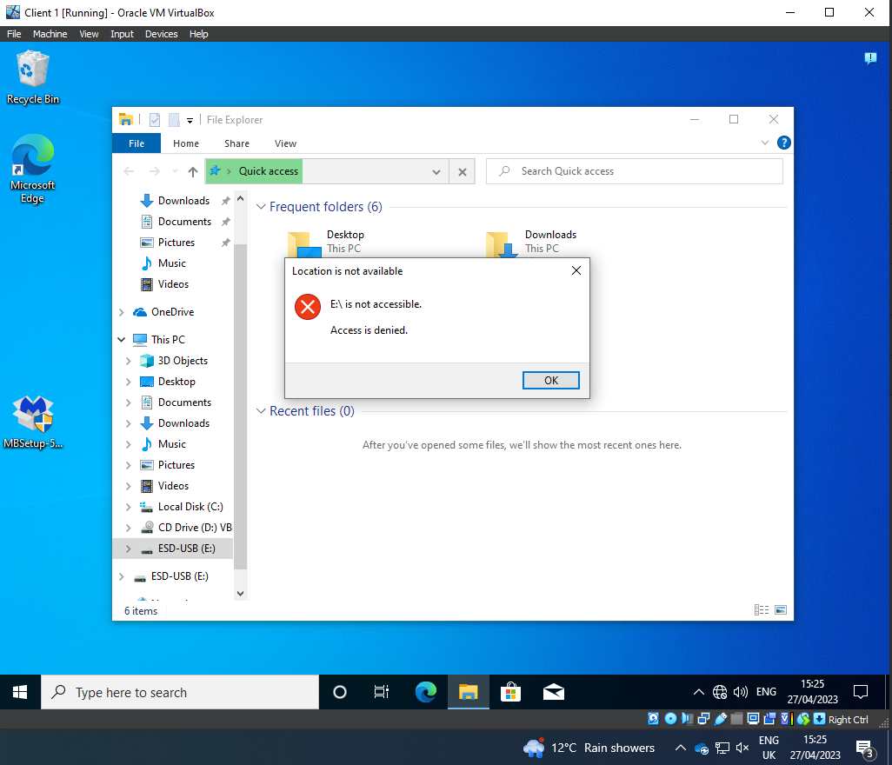
Figure 8: GPO 3: Restricting Access to Removable Media Drives.
Removable storage devices are a significant security risk due to virus and malicious code infection, Group policies can be utilised as a security control to restrict use of USB drives and other removable storage devices, as shown above.

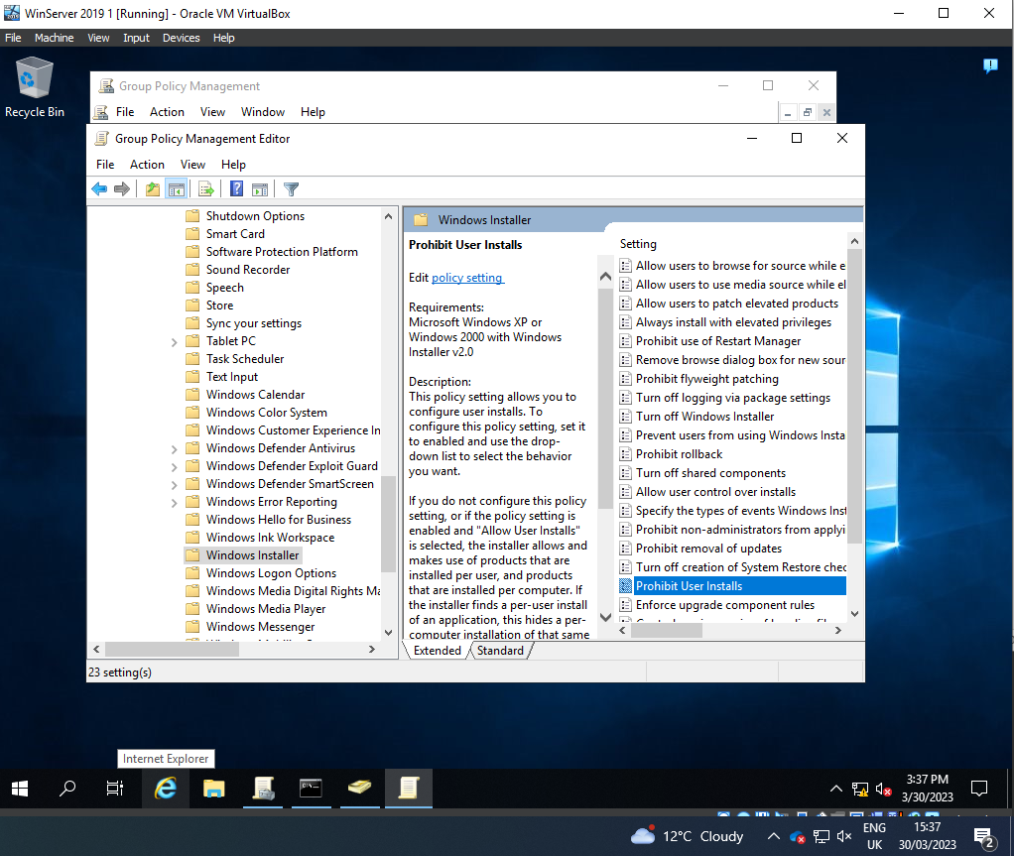
Figure 9: GPO 4: Restricting Software Installation (REMOVE?)

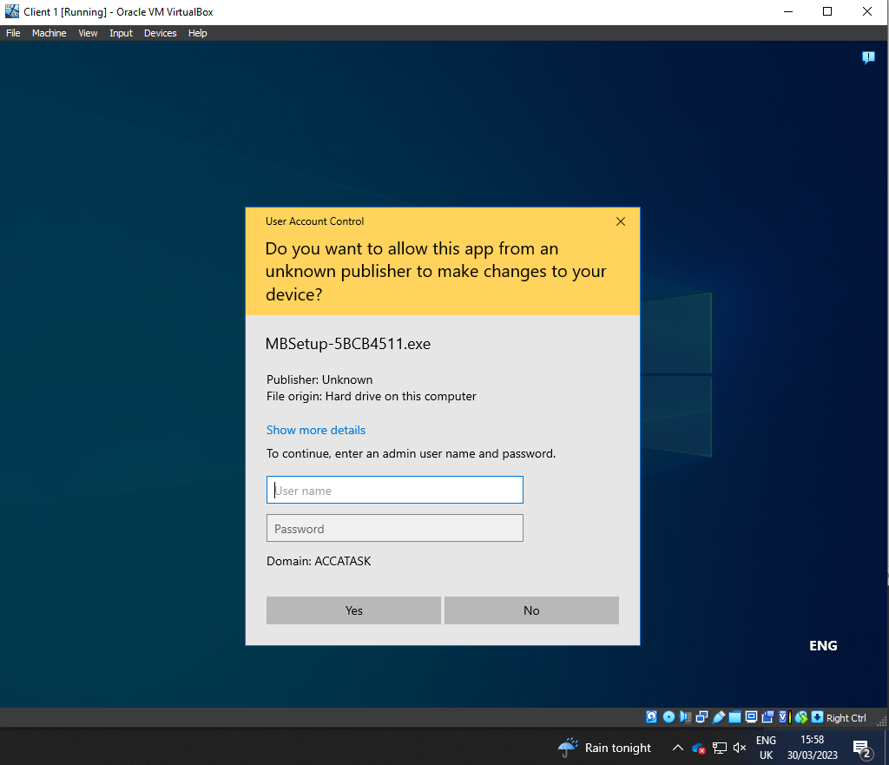
Figure 10: GPO 4: Restricting Software Installs
Installation of software by users can lead to infection of a system allowing lateral movement for hackers to gain access to business systems. Using group policy, it is possible to stop non-admin users from installing software. This helps prevent these types of cyber-attacks. This will also aid an organisation in software version control as standard users will not be able to install or update software without admin access. Allowing for software management tools to be utilised.

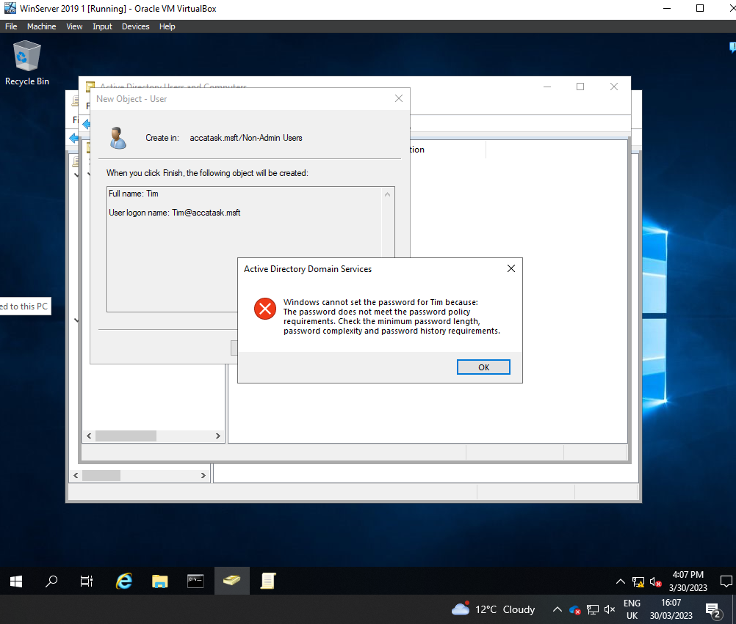
Figure 11: GPO 5: Enforcing Password Policy in the ‘accatask.msft’ domain
Enforcing an organisational password policy contributes to maintaining a good security posture. Using group policy complex password can be enforced on all domain users, both admin and non-admin users.

Worksheet task 2

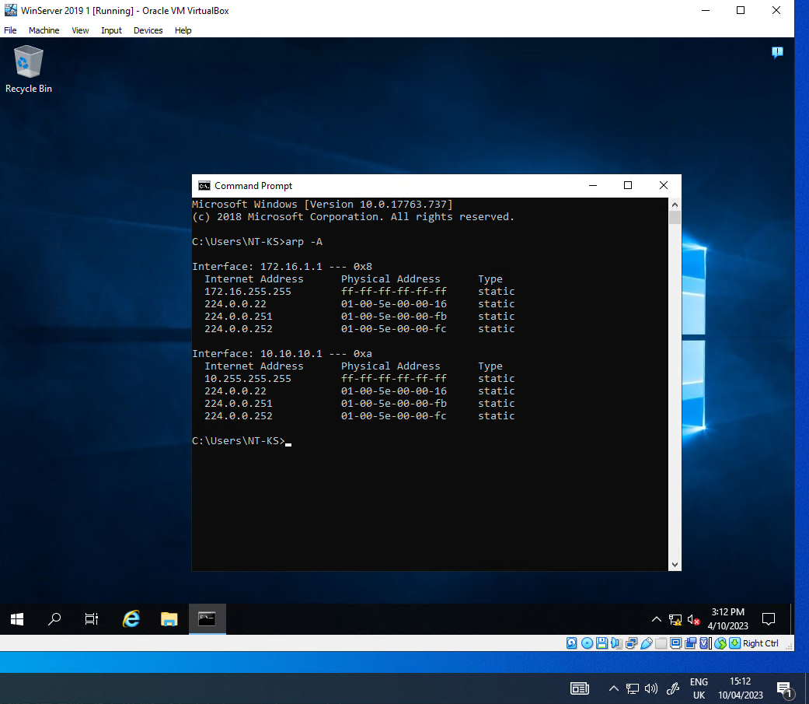
Figure 12: Address resolution protocol cache contents from arp -A command.
Contents of the server address resolution protocol (ARP) cache prior to any other network communication.

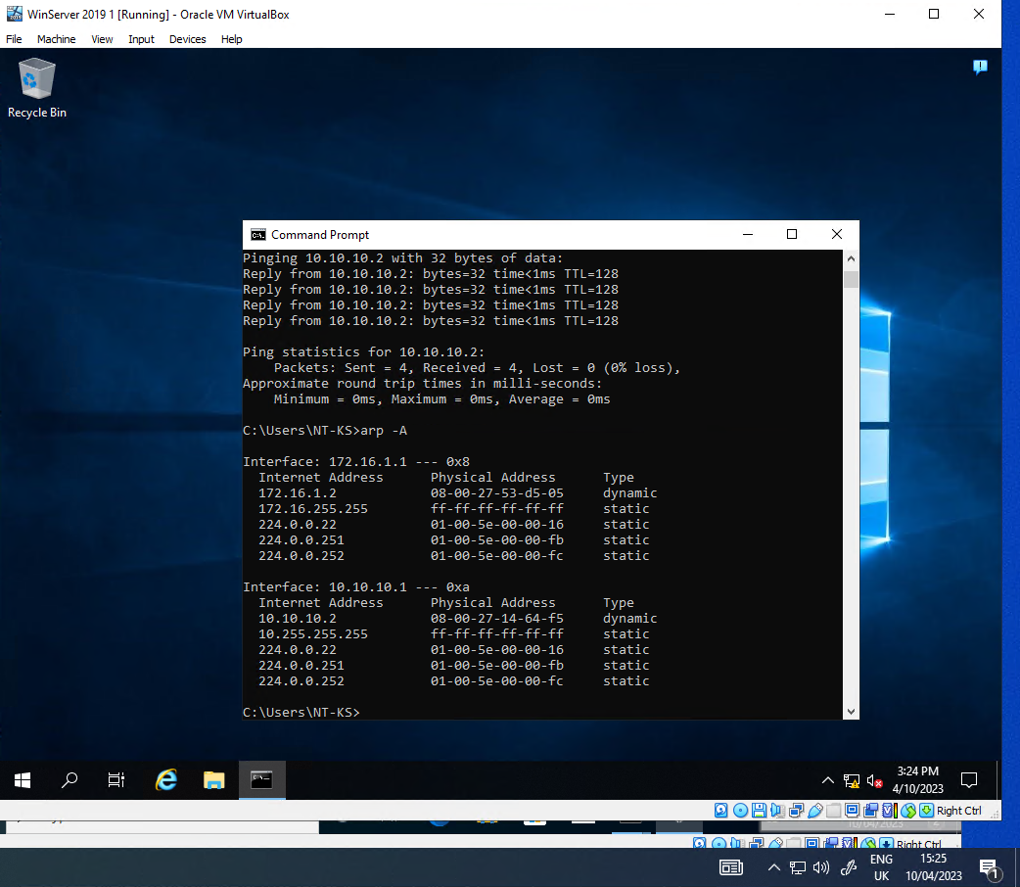
Figure 13: Arp cache contents from asp -A command after pings.
Contents of the server ARP cache after pinging other networked devices.

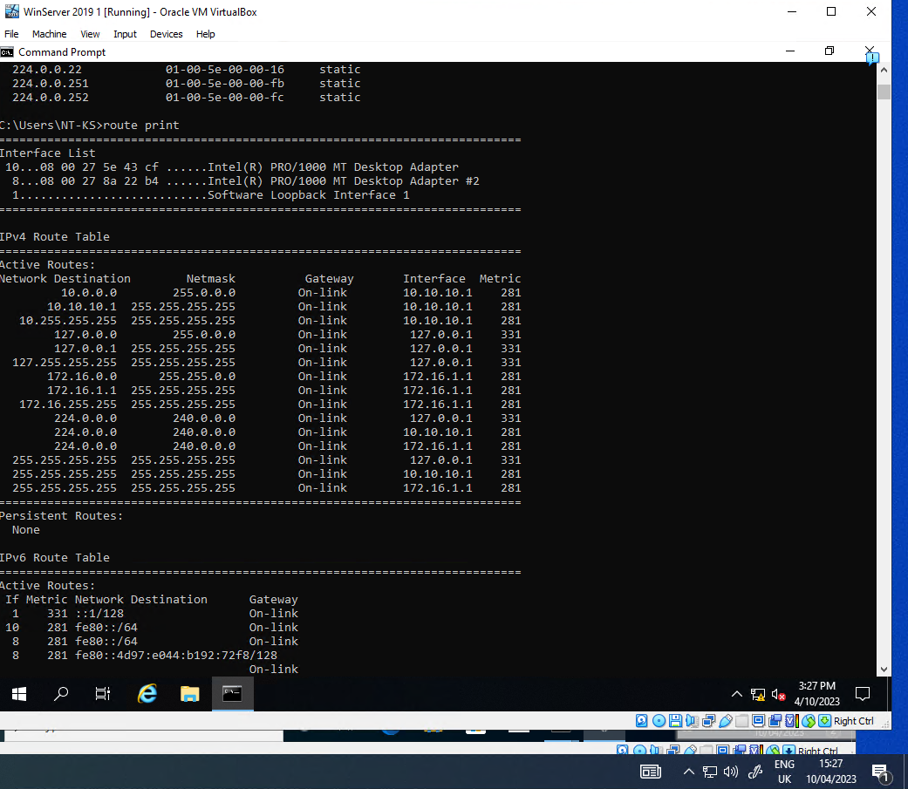
Figure 14: Route print output from Server 1.
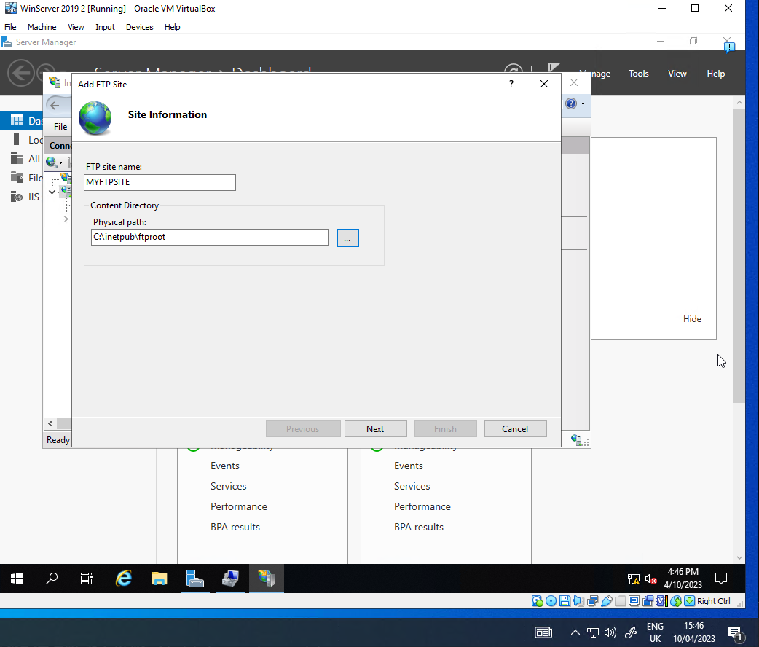
Figure 15: Creation of FTP site on Server 2.
File Transfer Protocol is a common server function used to transfer files between computer. Installation of the FTP role on a Windows 2019 server.

Figure 16: Configuring FTP welcome banner of Server 2.

Routing:

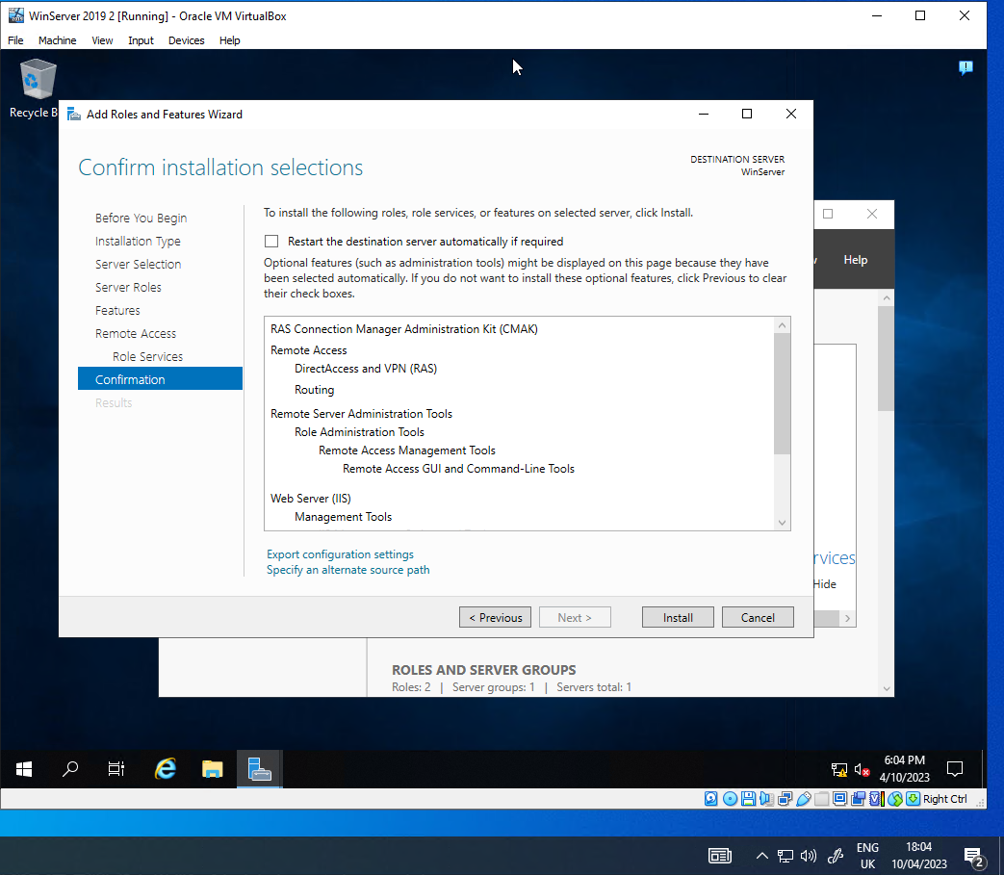
Figure 18: Installing the remote access role.
In order to be able to configure the two servers as routers, the Remote Access role had to be added to both servers. This would allow the clients in each of the private networks (172.16.0.0.) to communicate.
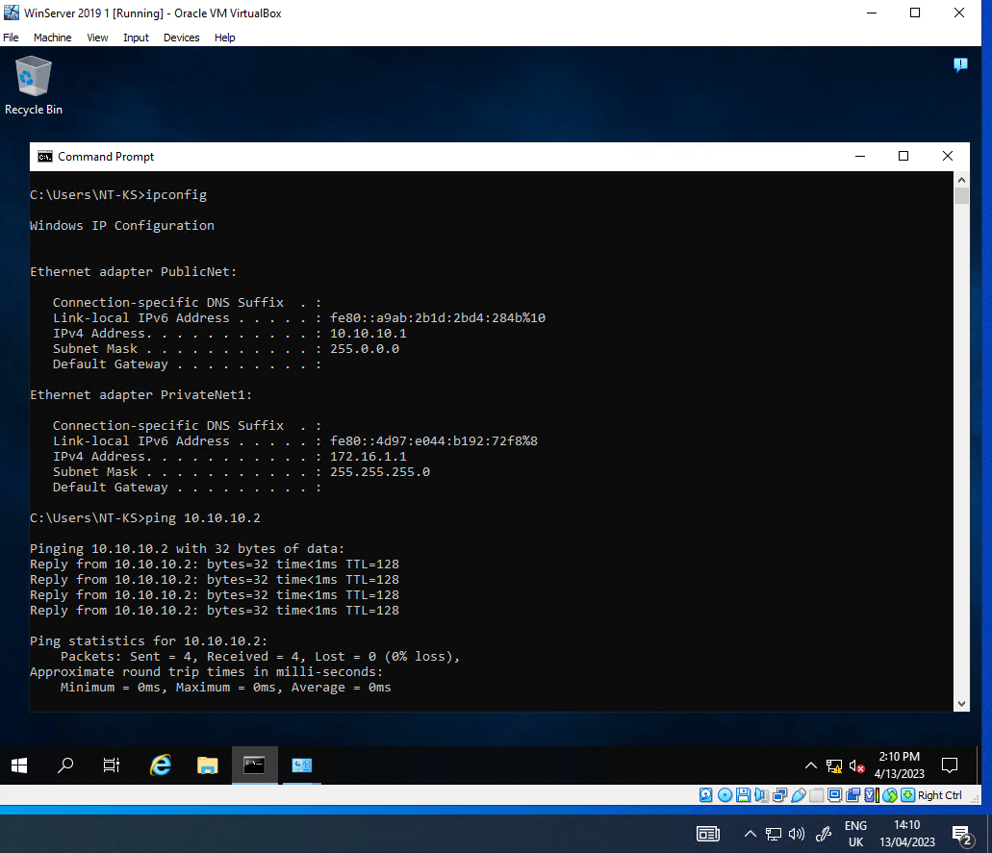
Figure 19: Server 1 pinging Server 2 on its public IP address.
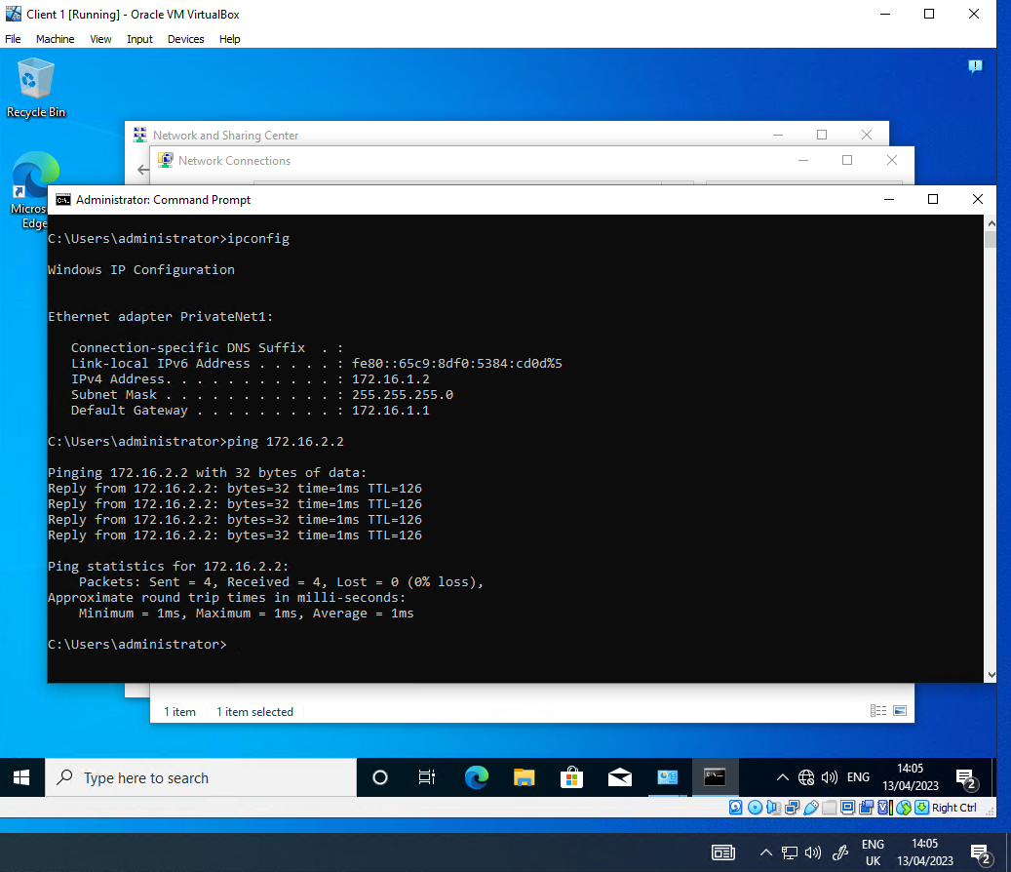
Figure 20: Client 1 pinging Client 2 on its private IP address
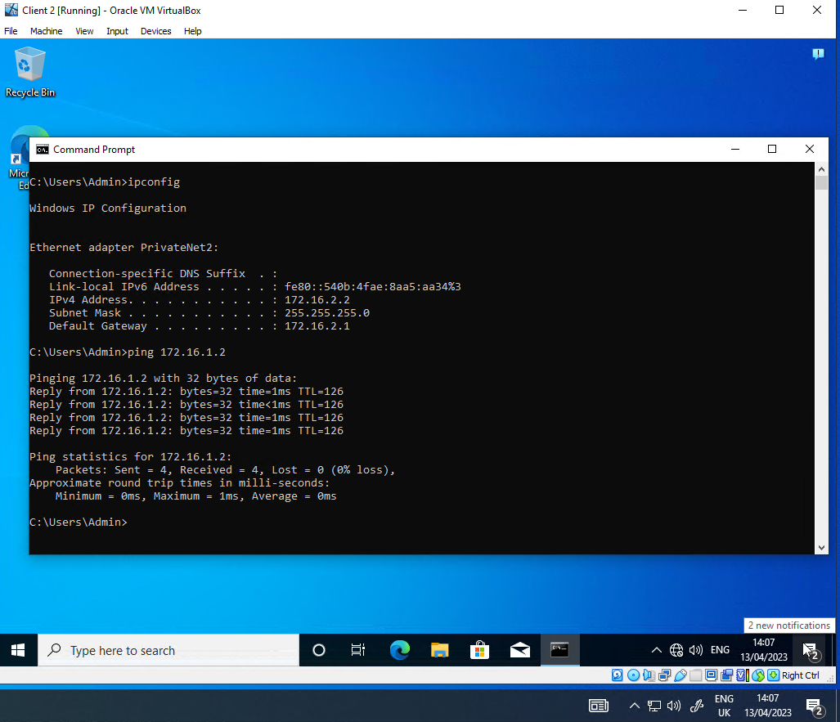
Figure 21: Client 2 pinging Client 1 on its private IP address
After both of the servers had the remote access role configured and RIP routing was configured the two clients on different networks could communicate, as demonstrated by the above screenshot.

Section 4: IP filtering
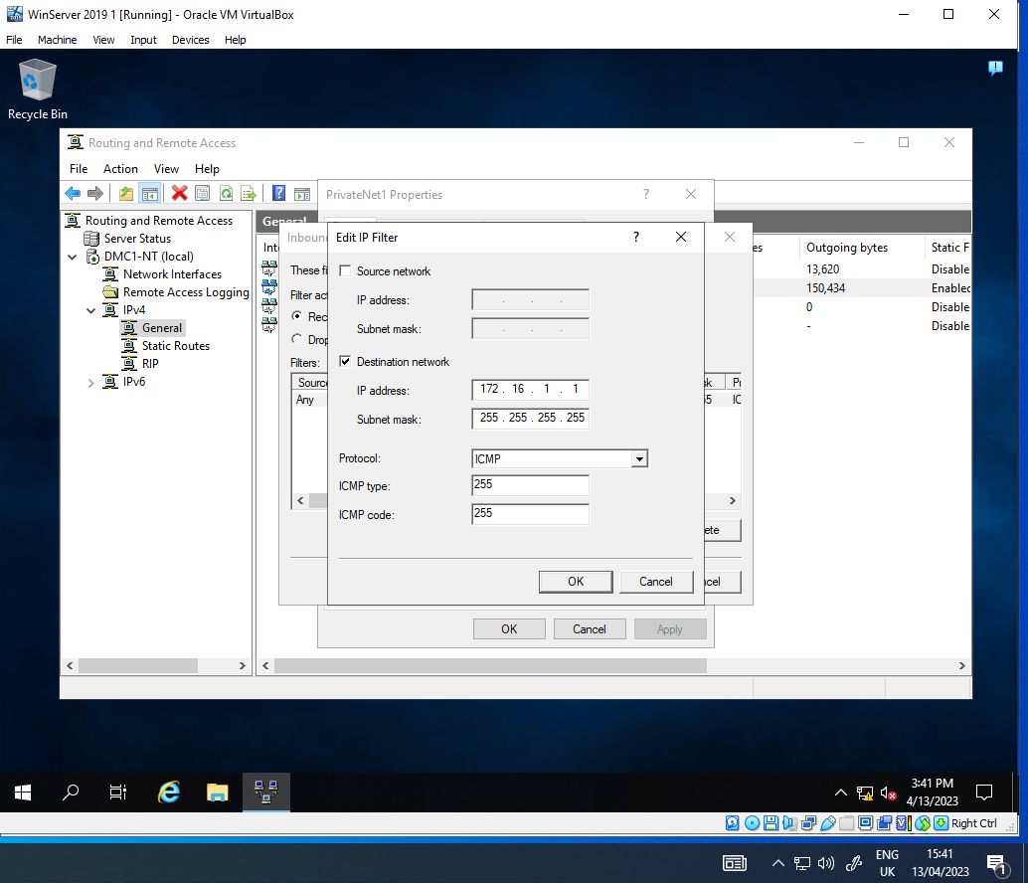
Figure 22: Configuring IP filter to block ping of router interface (Filter 1).

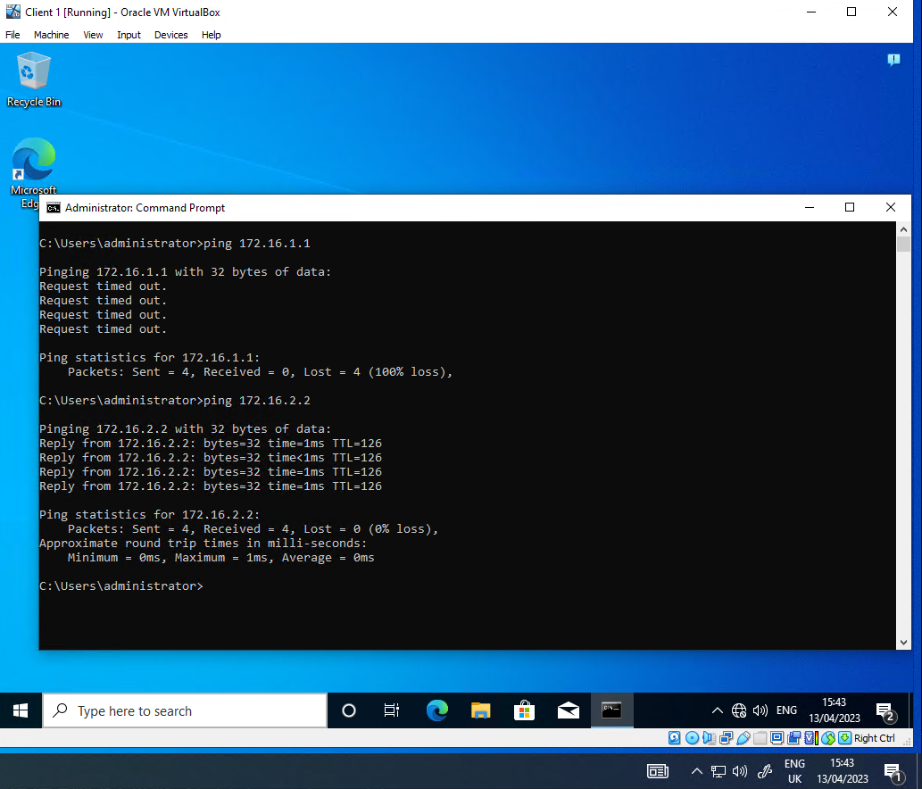
Figure 23: Ping of router interface blocked, other IP addresses respond.

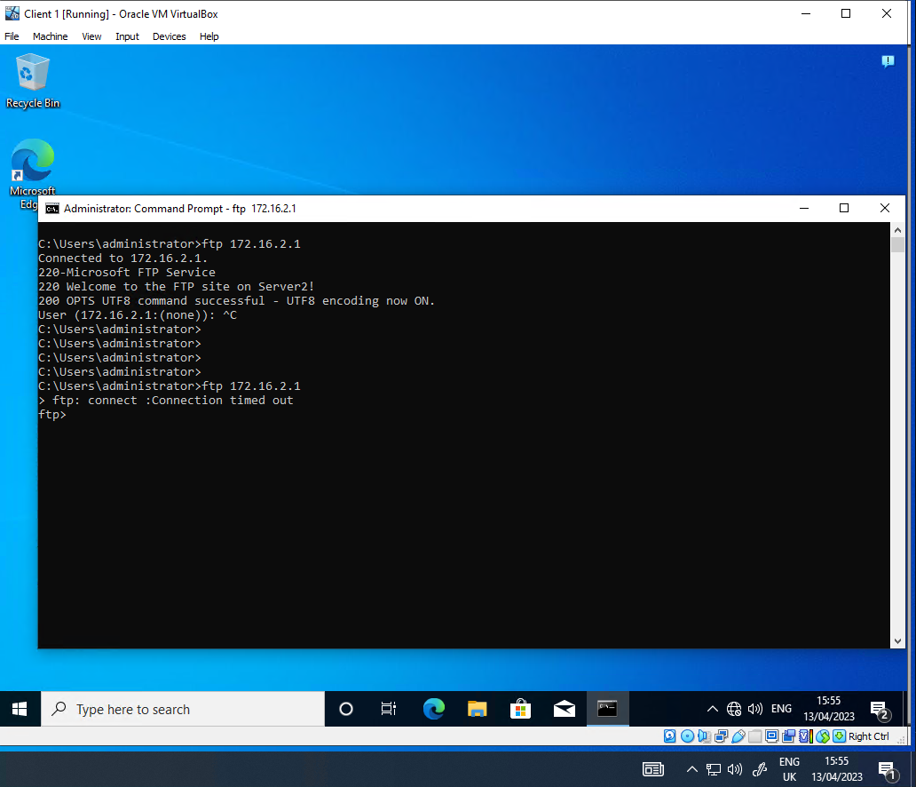
Figure 24: FTP service connection.
The above figure shows the FTP service connecting prior to applying the IP filter rule (Filter 2) and then failing to connect after the filter is applied on the router (Server 1). The filter worked as expected, stopping FTP connectivity to Server 2 from Client 1.

Filter 3:
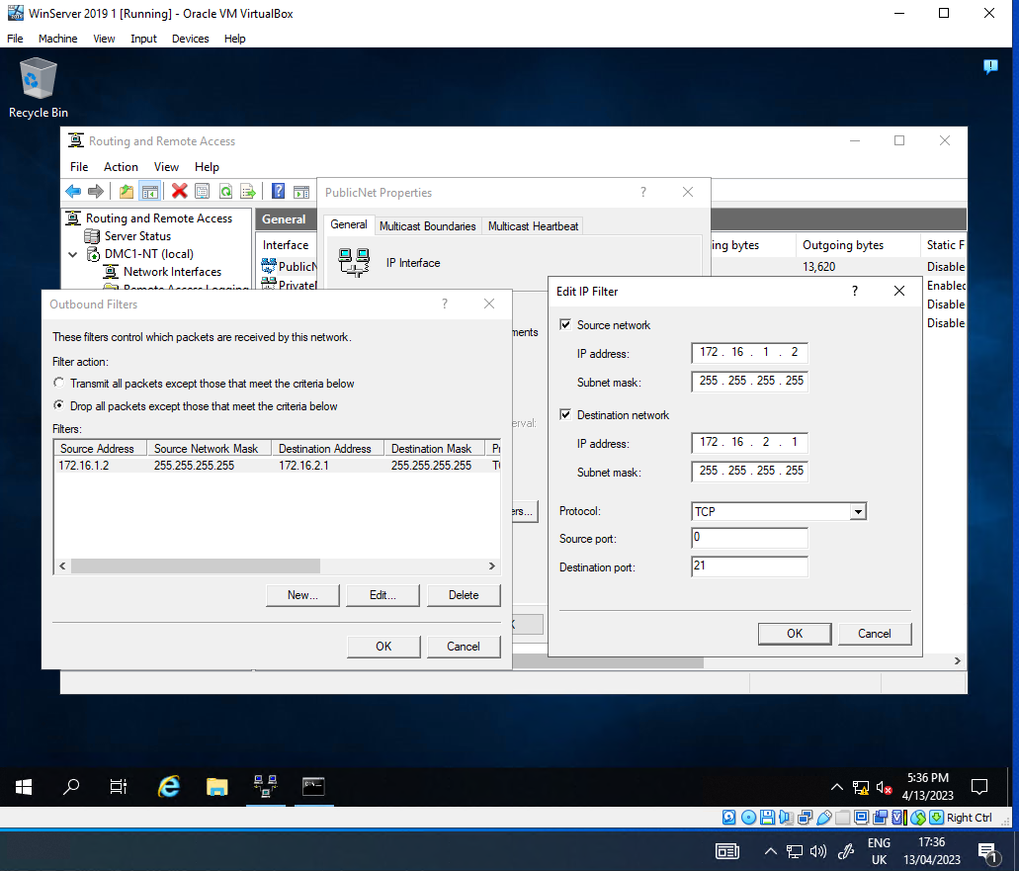

The filter to only allow FTP access to Server 2 from Client 1 in PrivateNet1 is based on the PublicNet interface of Server 1 with the following properties:
- It is an Outbound filter with a filter action of “Drop all packets except those that meet the criteria below”. This means that the filter can block access for any traffic that does not meet the filter.
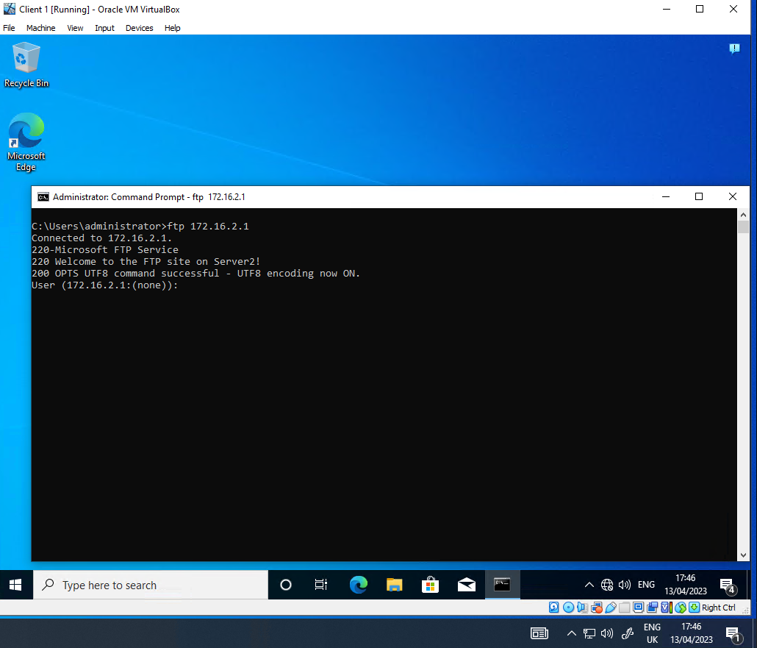

Prior to the filter being applied, Server 1 was used to test FTP connection to the FTP site, which worked. The filter was applied and then Server 1 was tested again. The connection failed after the filter was applied, as shown below.

TASK 3: Individual Task
i. Enhancing SOHO (Small office/ Home Office) network Security:
In order to increase the security of a SOHO (Small Office/ Home Office), I would set password policies that would enforce a more complex minimum standard of password. Demonstrated in the worksheet we used the standard minimum requirements set by Microsoft. To further enhance the security of user passwords a higher requirement would be applied. There are multiple studies around password security, that outline the best practices to follow when managing password requirements. NIST recommends [1] the these commonly used more complex requirements can be as followed:
- Not contain the user's account name or parts of the user's full name that exceed two consecutive characters.
- Be at least six characters in length.
- Non-alphabetic characters (for example, !, $, #, %)
- Password change after 90 days.

However security experts have conflicting views on password requirements for the most effective password, further research has shown that passwords that need to be reset frequently or require Non-alphabetic characters lead to users becoming ‘Lazy’ and use the bare minimum to comply with the rigid password requirements, using easily penetrable passwords known by cyber threats, for example users will use an easy to remember password ‘P@ssword1’ and when they are forced to change it will just increment the last number by 1. ‘P@ssword2, P@ssword3’ so on and so forth. This is evidenced by an investigation carried out by Microsoft [2].
Another action that would need to be taken involving passwords in ensuring that all default passwords on all network devices have been changed, Routers and switches. The default passwords can often be found via a quick and simple Google search based on only knowing the manufacture of the device.
Thankfully in a small office/ home office the number of users will be low, meaning that education of users will be an achievable goal, if everyone using the network has been trained on the dangers, risks and types of attaches the number of vulnerabilities will be reduced. To achieve this would be to hold Quarterly sessions for all members of the office/ home office to update them on both old and new risks.
Ensuring that all software and firmware that communicates either with or through the network is kept up to date with the manufacturer or suppliers’ patches. The outcome of investigation and research has shown that routes with outdated firmware are particularly vulnerable and it “t isn't until a vulnerability surfaces, usually accompanied by the words "critical" or "bypass" that hopefully they command our attention” [3]. These updates can either be available through the website or via the software packet itself. However, to best utilise the Active Directory services created in the workbook, the most effect way to deploy these updates would be via groups and policies created and enforced through Active Directory.

ii. Failover Clustering for high availability systems/ Services: Failover clustering is crucial for the capability to successfully run a high availability (HA) system/ Service. Failover clustering is the technique of providing an automatic failover in the event of one server failing, the secondary server will automatically step in taking over the primary server’s responsibilities ensuring the hosted application continues to run unaffected. Failover Clustering had many benefits to an organisation wanting to host a service, including “Highly available or continuously available” [4] When creating an effective failover cluster for a high availability system, the following concepts need to be carefully considered.
Redundancy, essentially all a failover system is, is having single or multiple spare systems built ready to jump in and take over, each system will recure all the same means as the primary server, like storage, network connectivity and hardware and software components to sure that the secondary serve will function as intended, until the primary server fails or is retired the secondary server will be sitting in standby, making it redundance.
Scalability, like any service failover clustering needs to be scalable to grow with demand and growth of an organisation’s services, without scalability the service could grind to a hold during increased traffic. This will result in none of the redundant servers being able to handle the load. Upgradability is also important for scalability, keeping all failover servers up to date with the most modern components is a must for a reliable high availability service.
Monitoring, closely related to scalability in many ways as monitoring is a vital way to measure performance of the service, enabling admins to plan maintenance, allocate more resources to the servers in order to keep up with demand, identifying high traffic times to ensure available recourse is applied. Monitoring the service will allow for foresight as to when a server within a cluster is lightly to fail, proving prepping time for a smooth transaction over to the secondary server. Furthermore, without a cluster monitoring service in place, server admins may never know when the failover has taken place. [5]

iii. Network Policy:
This policy is to sure the security and integrity of an enterprise network, underlining the rules for using, managing and operating at a high availability standard.
This policy applies to all users of the interpose network. Employees, visitors, contractors’ senior management and any devices and systems on the network.
Network setup and design:
The network will be designed and configured to offer a high availability service for critical business applications.
Using redundancy methods across the whole network will assist with maintaining the high availability and standard. Redundancy will be used in the forms of but not limited to failover clusters, multiple PSBN (Public Safety broadband network) [6] links in and out of each site to ensure constant network access.
The network will be segmented to mitigate any damaged in result of a cyber attach, this will be achieved through the use of Firewalls, VLANS and other network security tools.

Monitoring:
The network cross all sights will be monitored, monitoring will allow for the network to be managed successfully, though monitoring we will be able to identify, traffic spikes, faults, user trends, security breaches and cyber-attacks.
All hardware and software will be monitored to ensure that it has the most updated firmware and software versions and patches.

Accessing the network:
In order to access the network an individual user account and password will need to be created with MFA (Multifactor Authentication) enabled to ensure no unauthorised access is gained. MFA is a very highly recommended method to prevent brute force attacks. [7]
User access method of least privilege will be applied, meaning that users will be granted the very minimum access in order to carry out their job’s duties.
There will also be restrictions on internet browsing, safe search applied by policy.

In case of Incidents:
A separate document will be written up clearly outlining the actions that will e followed in the case of an incident, these will include, cyber-attacks, network outages, equipment failures, natural disaster recovery.

Enforcement:
Using the network monitoring tools and data protections policies, any breaches or failure to comply with this policy will result in an immediate lock and isolation of the suspected user account user account while an investigation is carried out to review the damage caused and rules broken. If found guilty of not following this policy the disciplinary process will begin.

In order to keep this policy up to date, and relevant this policy will be reviewed in detail annually. This will aid in the security of the network being achieved as it may need to be updated as threats and new methods of protection present.

Iv. Reflection:
When completing the tasks in this worksheet, I was able to apply myself and work constructively within a team. It allowed for research to be carried out, new skills developed, and professional relationships formed.
The only thing I would do differently would be to do more structed and regular meetings were scheduled with the whole team being available. This would improve the communicating and understanding of who’s doing what and avoid any work being completed twice.

References

[1] P. Grassi, J. Fenton, and E. Newton, "Digital Identity Guidelines: Authentication and Lifecycle Management - NIST Special Publication 800-63B," National Institute of Standards and Technology, Gaithersburg, MD, USA, NIST SP 800-63B, June 2017. [Online]. Available: https://nvlpubs.nist.gov/nistpubs/SpecialPublications/NIST.SP.800-63b.pdf
[2] R. Shay, C. Herley, P. C. van Oorschot, and A. S. Patrick, "Password Guidance: Simplify Your Approach," Microsoft Research, Redmond, WA, USA, Tech. Rep., May 2019. [Online]. Available: https://www.microsoft.com/en-us/research/wp-content/uploads/2016/06/Microsoft_Password_Guidance-1.pdf
[3] C. Brook, "Router Firmware Vulnerability Bypasses Authentication," Digital Guardian, November 2014. [Online]. Available: https://www.digitalguardian.com/blog/router-firmware-vulnerability-bypasses-authentication
[4] Microsoft, "Failover Clustering in Windows Server and Azure Stack HCI," Microsoft Corporation, Redmond, WA, USA, 2022. [Online]. Available: Failover Clustering | Microsoft Learn
[5] B. Posey, "Strategies for Monitoring Failover Clusters (Part 1)," TechGenix, March 2017. [Online]. Available: https://techgenix.com/strategies-monitoring-failover-clusters-part1/
[6] National Institute of Standards and Technology, "Public Safety Broadband Network," NIST, Gaithersburg, MD, USA, 2023. [Online]. Available: https://www.nist.gov/ctl/public-safety-broadband-network
[7] National Cyber Security Centre, "Multi-factor Authentication for Online Services," NCSC, London, UK, 2021. [Online]. Available: https://www.ncsc.gov.uk/guidance/multi-factor-authentication-online-services

