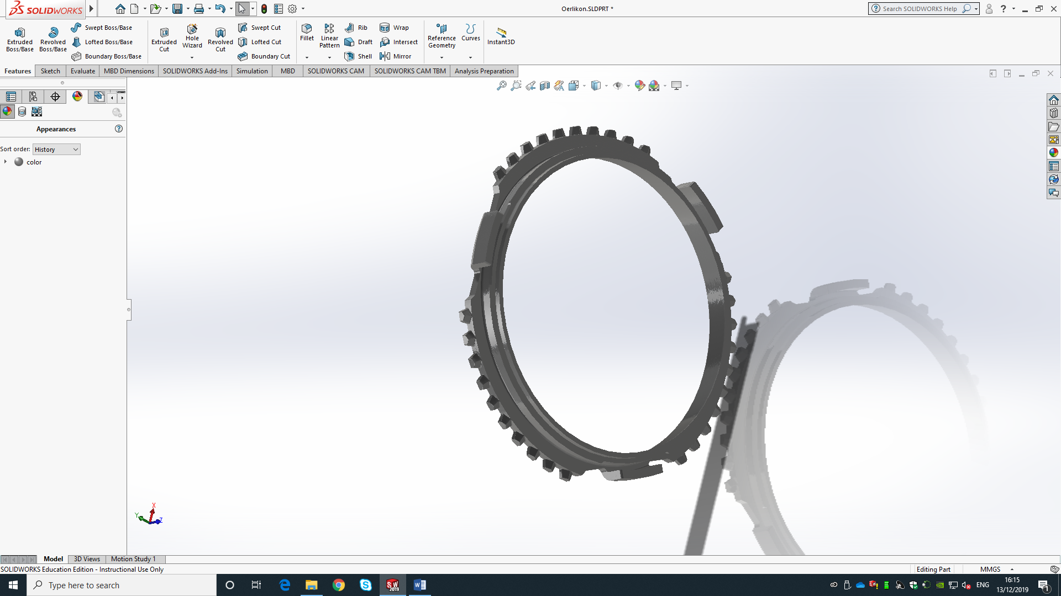
Manufacturing Process and Material Selection
Jack Williams (1811173)
Materials & Introduction to Manufacturing Technology (M4X01163)
[Date]

Contents
Task 1 2
Functional requirements 2
Material used 2
Oerlikon Synchronizer Manufacture Process 2
Task 2 3
Additive Machining Process Choice (3D Printing) 3
The benefits 3
Limitations and disadvantages 4
Material 4
Conclusion 4
Bibliography 4
References 4

Abstract
This report will be exploring a current prototype which is the Oerlikon synchroniser gear ring and how they gear ring is currently manufactured the paper then looks if additive machining can be used instead of the current process of manufacturing these parts. The report will firstly look at task one this is split into three main subjects these subjects are the functional requirements of the parts. This will show what they do and what they are being manufactured to be used as. The second subject of this report will look into the current material choice that is being used to manufacture the parts and why that material is currently being used. The last subject will be reviewing how these parts are currently manufactured and what current machining methods are being used to create the parts. Task two will be split into four subjects, the first subject is choice of additive machining method this will explore the choice of additive machining method chose that could replace the current manufacturing process being used. The second subject is the benefits of the additive machining method that is chosen. This will explore all the benefits of the additive machining method over the current manufacturing process. The third subject will look at the disadvantage and limitations of the chosen additive machining process that would limit you if you were to select the additive machining process. The last subject will be the material choice that would have to be selected for the chosen additive machining method that has been selected. This will look at the materials available to the additive machining process and which material is suitable to use.

Task 1
For my assignment I have chosen a gear ring prototype that my company currently manufacture for Oerlikon. These parts are used on a Suzuki moped. We currently manufacture the prototype parts to test and when the customer is happy with the design, they create a forging tool to create the gear rings for production.

Functional requirements
The functional requirements of the prototype Oerlikon gear rings are that they will be tested to the extreme conditions so they can finalise the design to make into a forging tool. The material will need to be hardened to emulate the strength of forging, also the dimensions and tolerances must be met to ensure the parts can be tested properly.

Material used
The material we use to manufacture is C35. The material then gets heat treated to a certain spec which is on the drawing. C35 is used for these parts as C35 has excellent forgeability. ("C35," n.d.). After the prototypes are completed and the deigns are finalised the parts then get forged this is why forgeability is important.

Oerlikon Synchronizer Manufacture Process
Currently our process for manufacturing the Oerlikon synchroniser components is to first get a Three-Dimensional (3D) Computer Aided Design (CAD) model of the part so we are able to create an electrode ready for the Electro Discharge Machining (EDM) stage of the manufacturing process. We will also need the 3D CAD model to use to use a programming software known as Computer Aided Machining (CAM) this will ensure the turning machine is able to machine the part after the billets have been stress relived.
When we receive the billet in from the material supplier, we pre machine the billets for a stress relieving stage where we put a hole in the middle of the billet and machine the rough edges, so they are all cleaned up and running true. The billets are then sent out to an external company to be stress relieved.
We then get the billets back ready for machining as many features as possible using the Computer Numerically Controlled (CNC) turning machines at this point we stage check every 5-10 parts in Quality Assurance (QA) to make sure there is consistency in the parts.
The parts then go onto the EDM section where they use the electrodes that have been designed earlier on in the manufacture process. The EDM process is where in electrode sparks away the material into the shape that the electrode has been designed in. This roughly take 4 hours per part. at this point we stage check every 5-10 parts in QA to make sure there is consistency in the parts.
The parts then move onto the milling section were a small portion of the part is machined on the backside of the part. This usually takes about 10-20 minutes per part.
The parts are then moved on to the grinding section where the parts are put on to the grinder and ground flat and parallel to a certain tolerance, the parts are also ground to certain dimensions that corresponds to the drawing. This operation roughly taking 30 minutes per part.
All Parts are then laser etched for identity purposes, this part of the process is done in the stores section and takes up to 2 minutes per part.
After having their identity number etched on all parts are put into QA for a final inspection where all the dimensions are checked and evaluated. If the parts pass the QA inspection, they are sent off to the customer.

Task 2

Additive Machining Process Choice (3D Printing)
My choice of the additive machining process is 3D printing. I think that 3D printing is ideal to improve the manufacture for the prototyping stage of the Oerlikon synchroniser components. I have chosen this process due to the fact that you are able to produce very highly detailed parts with just using the one machine and process which will hopefully cut down on production time of the Oerlikon synchroniser components.

The benefits
One of the benefits of 3D printing is that it can be extremely cost-effective to manufacture low volume batch work, even further it is good for prototyping as it can be economical to make minor or major adjustments to the design of the prototype. Easy to tweak. If you need to change the design, the process is simple and only requires a few buttons to be pressed rather than an expensive and lengthy re-design. ("3D Metal Printing | How Does a 3D Metal Printer Work? | SPI," 2019). An example of this would be having to change the Oerlikon design then having to create new electrodes to manufacture the prototypes again which will be very costly and time consuming.
Another benefit to 3D printing is less waste and raw materials will be used compared to CNC machining as the additive machining process only uses the material required to build the part and all excess powder can be re used. (Hye-Won Lim, Tracy Cassidy, 2014,). 3D printing also needs less stages so less people will need to be employed to create the prototypes compared to traditional subtractive machining. This will cut down on labour costs which will then cost the company less money to produce parts. ("10 Disadvantages of 3D Printing Technology," 2018).
Another benefit towards 3D printing is that you can create much more complicated geometries in parts that are impossible to CNC machine, even if you have a 5-axis CNC machine. This is due to the fact the tool will be unable to machine all surfaces of the complicated geometry on the part. To machine these geometries on the part you would have to do several set-ups to reach different faces which adds a bigger labour cost. You may also need to create custom jigs and fixtures to machine the difficult parts. ("3D Printing vs. CNC machining," n.d.)

Limitations and disadvantages
3D printing can often be a very slow process when it comes to manufacturing several parts, depending on the type of printer and the quality of the print needed. This can mean that prints can take up to several hours or even days to print. ("10 Disadvantages of 3D Printing Technology," 2018).
One of the biggest disadvantages to 3d printing is the ability for other companies to counterfeit your blueprints into their own designs and forge the work you have created as their own. This means that patent infringements will happen more often and become common and trying to identify counterfeited designs will become virtually an impossible. This means as 3D printing starts to develop patents, and copyright holders will have a harder time protecting their rights and companies will have an harder time protecting their designs. ("10 Disadvantages of 3D Printing Technology," 2018).

The biggest limitation of 3D printing is the dimensional accuracy that the 3D printers can achieve. Also, the warping and shrinking that will occur when 3D printing. The dimensional tolerance that 3d printing can achieve is ±0.1mm which is good enough for most features but there are features were a secondary operation will be needed after printing to gain the correct tolerance of the feature. As for the warping and shrinking of the part there will have to be supports and braces incorporated into the design to ensure the will be limited distortion to the part. ("Dimensional accuracy of 3D printed parts," n.d.)

Material
Choosing the material is difficult as the material originally used gets hardened and the properties change. This will have to be taken into consideration when selecting the material. The materials that can be 3D printed are Aluminium, Stainless Steel, Titanium and Brass. ("3D Printing vs. CNC machining," n.d.). If any of these materials were used they would need to be hardened like the original material and I believe that either stainless steel or titanium would be a suitable alternative to the material that is currently used.

Conclusion
In conclusion the report shows that 3D printing could be used in the process of making the prototypes of the Oerlikon gear ring I believe the parts could be 3D printed then machined to gain the tighter tolerances. By doing this you would save on several operations that are currently used in the process of creating them right now. This would save money on several operations and labour costs which would save a lot of money. This would also mean you would need less employees to make the Oerlikon gear ring.
The report also shows that 3D printing is much more effective method for low volume batch work like making prototypes to test. 3D printing is also a really cost-effective way to develop prototypes and make small tweaks to the designs without having the high cost of the manufacturing processes. This would also save a company a lot of time and money due to not having to spend out on an expensive manufacturing process.
For 3D printing to be used for the prototyping of the Oerlikon gear rings they will have to be hardened like they are in the original manufacturing process to replicate the conditions of the materials for the testing after the prototypes are made.

Bibliography

References
10 Disadvantages of 3D Printing Technology. (2018, January 24). Retrieved from https://3dinsider.com/3d-printing-disadvantages/
3D Metal Printing | How Does a 3D Metal Printer Work? | SPI. (2019, December 6). Retrieved from https://www.spilasers.com/case-study-printing/3d-metal-printing-an-overview/
3D Printing vs. CNC machining. (n.d.). Retrieved from https://www.3dhubs.com/knowledge-base/3d-printing-vs-cnc-machining/
3D Printing vs. CNC machining. (n.d.). Retrieved from https://www.3dhubs.com/knowledge-base/3d-printing-vs-cnc-machining/
C35. (n.d.). Retrieved from https://steelnavigator.ovako.com/steel-grades/c35/
Dimensional accuracy of 3D printed parts. (n.d.). Retrieved from https://www.3dhubs.com/knowledge-base/dimensional-accuracy-3d-printed-parts/#fdm
Hye-Won Lim, Tracy Cassidy. (2014). 3D Printing Technology Revolution in Future Sustainable Fashion. 3D Printing Technology Revolution in Future Sustainable Fashion.

