Marcos Vinicio Resende Soares Bruno (2512504)

Module Name: Introduction to web and
Database Concepts
Module Code: ACCA4023

Student Name: Marcos Bruno
Student ID: 2512504
Group: 1

Table of Contents
Introduction and Scenario 2
Database Desing 3
Query 6
Desing Decisions 9
Validation and Testing 9
Conclusion 10
References 10

Introduction and Scenario
Medilink Pharmacy is a growing pharmacy that needs to manually handle information about medications, supplies, medicines, customer prescriptions and sales transactions. Their current manual system leads to many errors and can be difficult to calculate supplements on, greatly hindering product handling. To improve their information system, they need to request the creation of a database system developed in Microsoft Access.
Access is a relational database management system that is not part of the Microsoft Office suit. It can combine data with a graphical interface, allowing the creation of tables, queries formas and much more (Davies & Paul, 2004). Access is commonly used by business to manage the data.
Using a developed database system will ensure that necessary information is organized and can be used to track stock and delivery. Price repots include medicines, suppliers, customer, prescriptions and sales transactions.
The Medicines entity allow you to store information about all medications available at the pharmacy, including details such as name, category, price, and quantity in stock. Medicines may be supplied by different providers.
The Suppliers entity may contain information about companies that supply medications to the pharmacy. This includes the supplier ID, name, contact number and address.
The Customer Prescriptions entity is used to store details about customers who purchase medications at the pharmacy. This can include customer ID, name, phone number, email and address.
The Prescriptions entity records prescriptions written by doctors for patients. All prescriptions contain patient details such as the prescription ID, associated patient, doctor’s name and the time the appointment was made.
The Sales Transactions entity is about sales recorded in the Pharmacy. It may include information such as the sales ID, medication sold, customer who purchased it, the quantity, the details of the sale and the price.

Database Desing
This section shows the database structure developed that I created for Medilink Pharmacy, to be implemented in their system. It was created in the ERD model format as requested and will ensure data integrity with primary kyes and the relationships.

The Customer Table stores information about each customer, where each one can be found by their customer ID, which is the primary key. Additional attributes include name, data and address. ↓
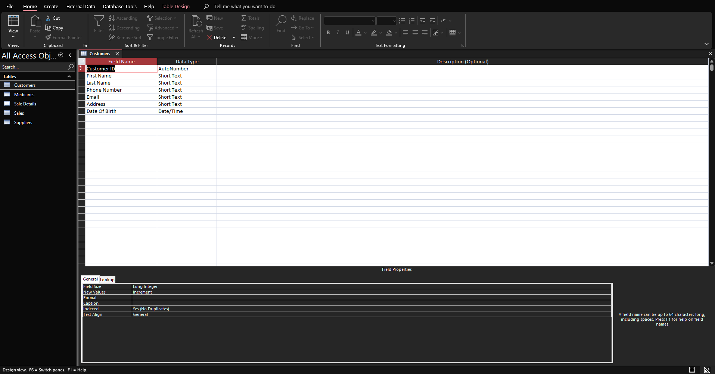
The Medicines Table contains details of all available medications including their name, categories, price and quantity in stock, among other things. Each Medication is linked to supplier via the Supplier ID. ↓
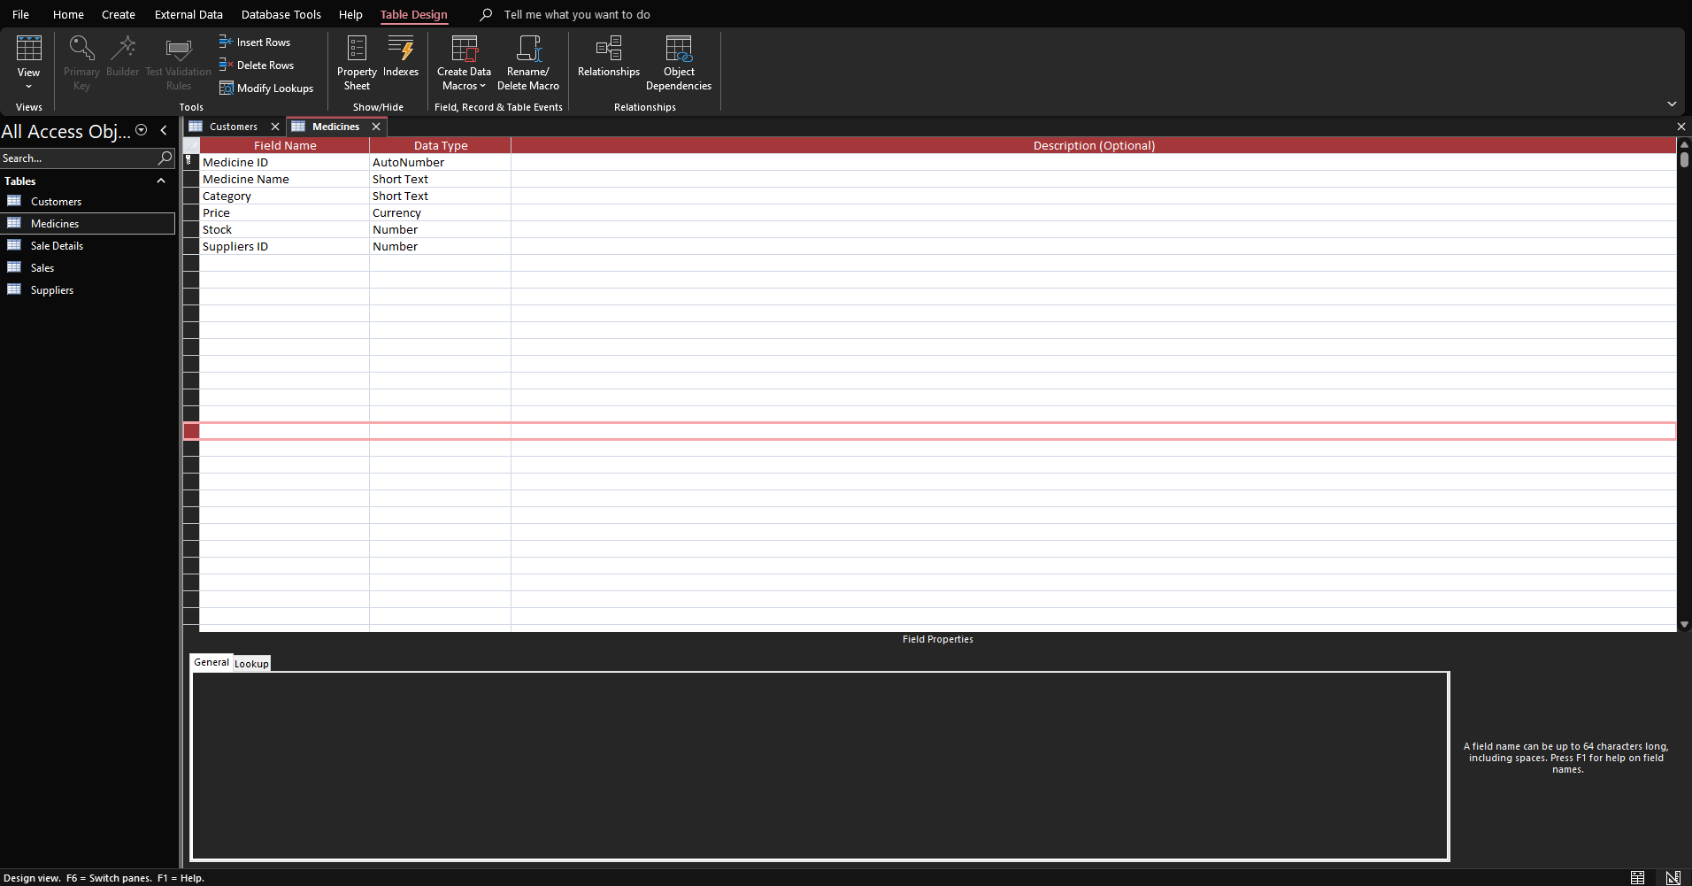

The Sales Table provides detailed information about each sale, including which medications were sold and n what quantity. This table makes product sales faster. ↓
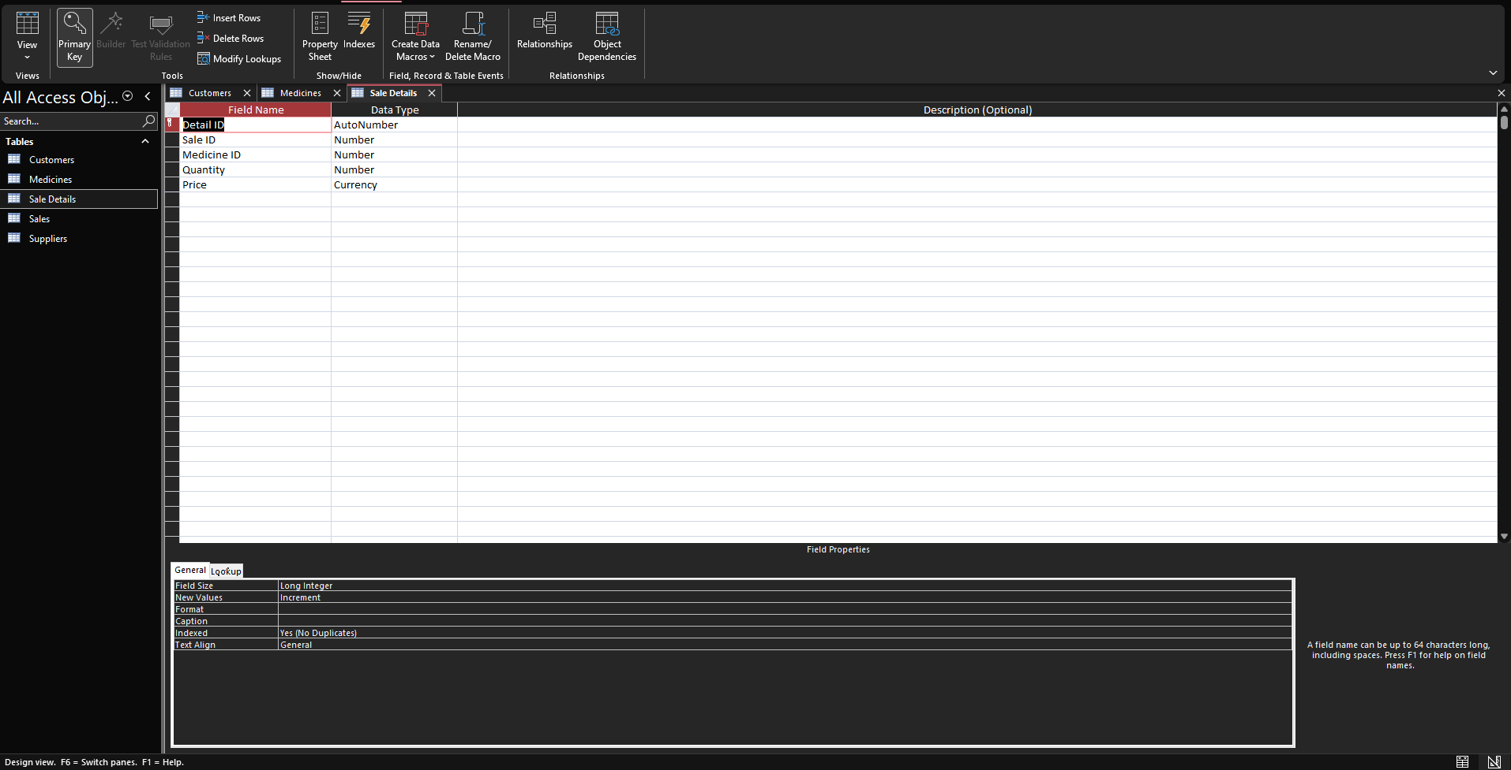
The Sales Table records transactions made by customers, including the date and the value of the product. The customer ID is used as a foreign key to link each sale to each customer. ↓
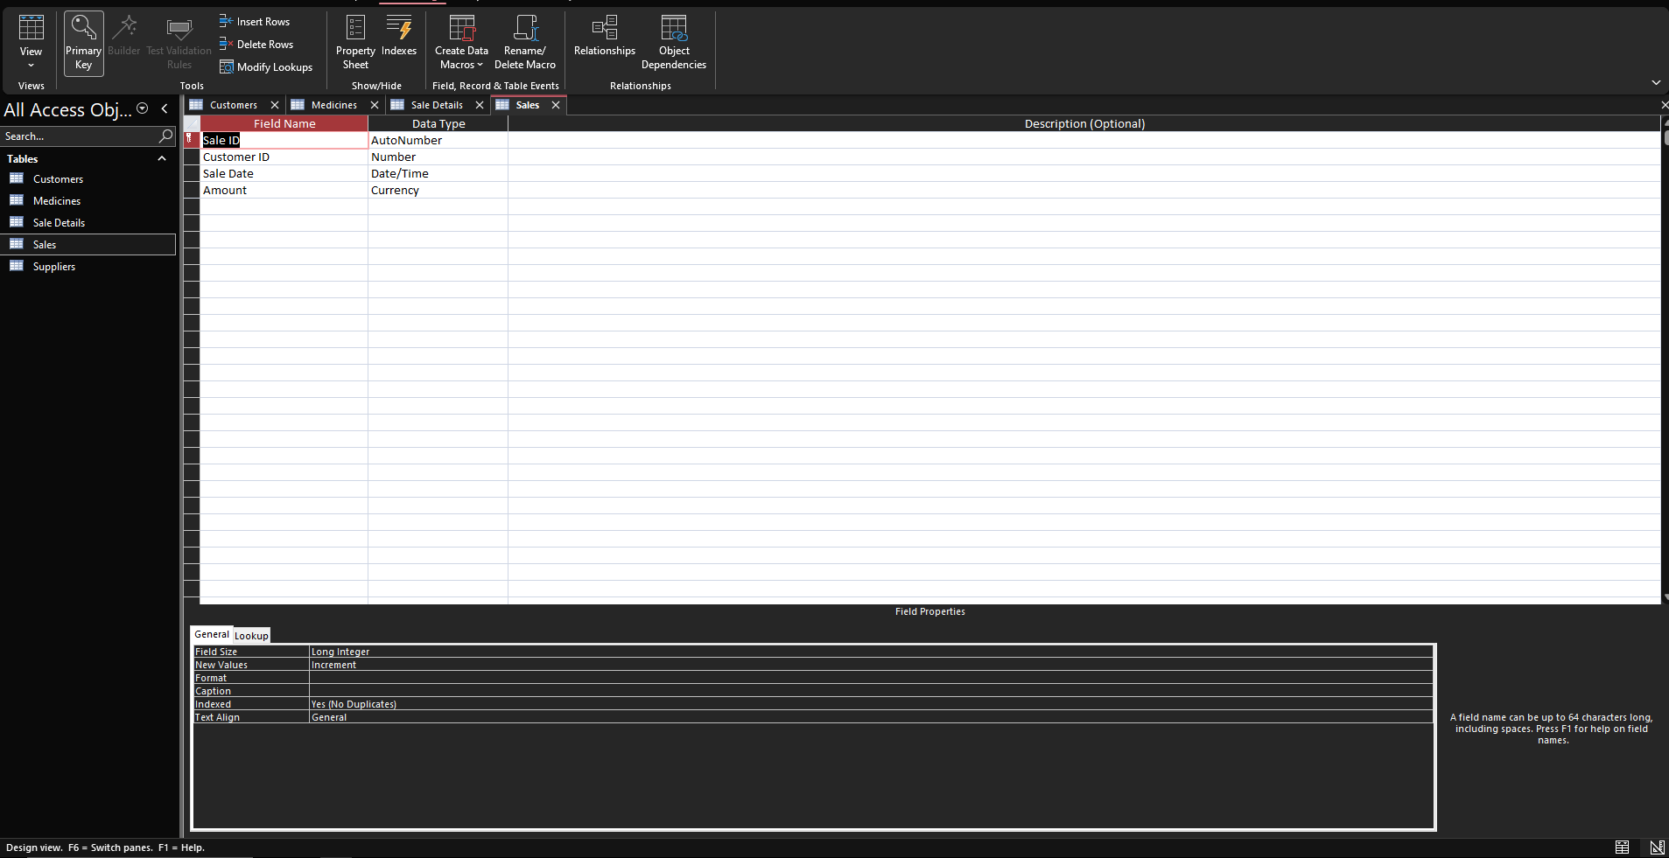

The Suppliers Table stores information about companies that supply medications. Every supplier is identified by their Supplier ID. ↓
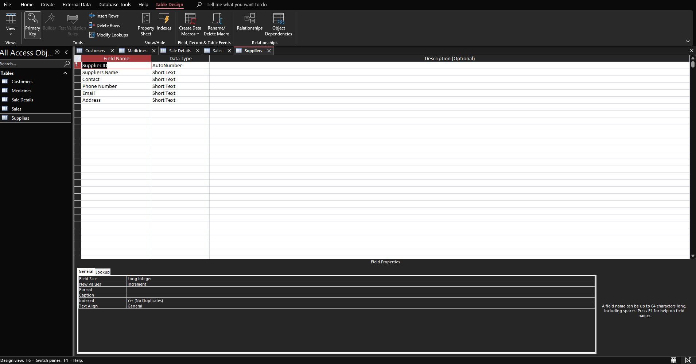

The basis for each data point includes one-to-many relationships, such as:
A customer can have multiple sales of various products.
A supplier can provide various medications.
A sale can have various details about the sale.
A medication can have various information or appear in multiples sales.
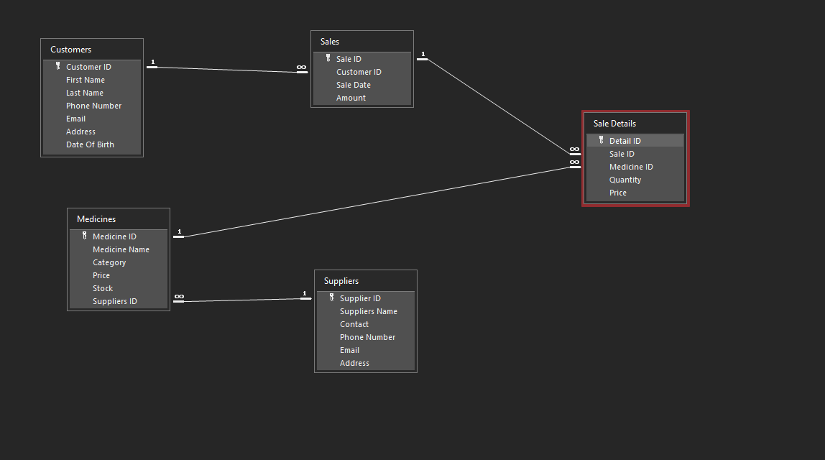

Query
A query is used to find specific categories of information. They are typically used to locate very specific information within the system’s data (Ron & McFadyen, 2016).
The first query was to show which medications are running low, such as supplements recently. Below these two screenshots, you can see the result. I set it to calculate the stock quantity of medications below 20 and coloured it to trigger the system to run it. Thus, indicating that the stock was running low. ↓
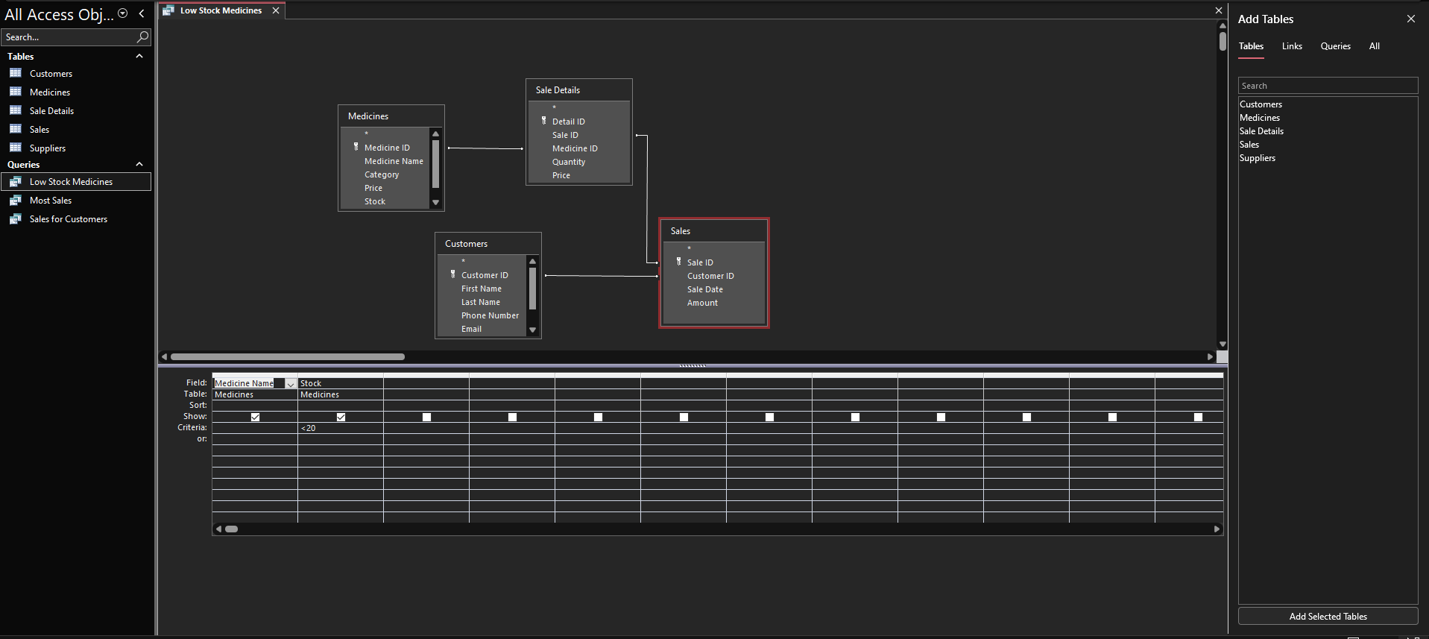
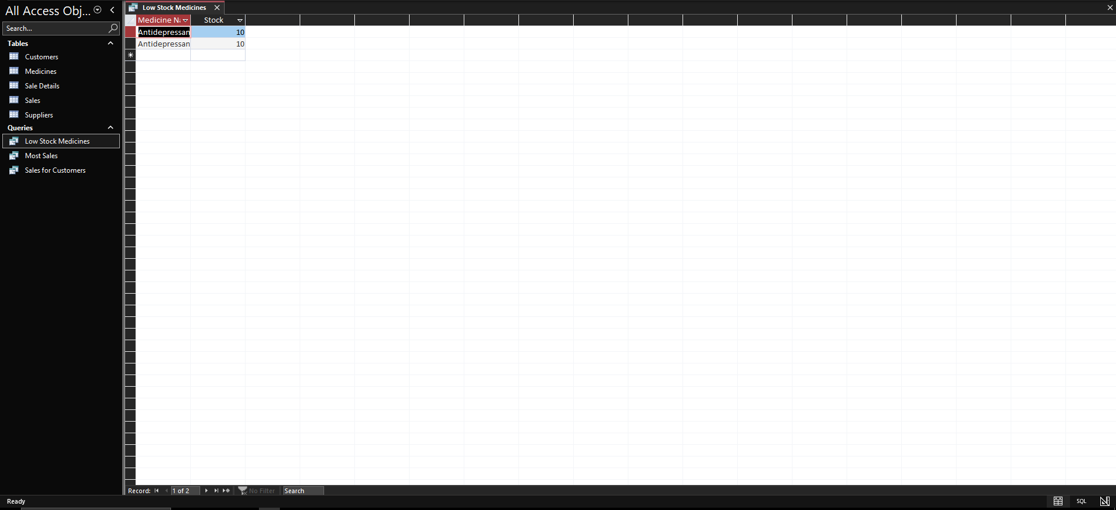
These other two screenshots were to demonstrate which of the medications was being purchased most by customers. Just like the two screenshots above, I only put in the information I wanted for this query, and them I had to add the (Total) and selected the (Group By) option for medicine, and in quantity I put (Sum), so the system could calculate which products were sold the most. ↓
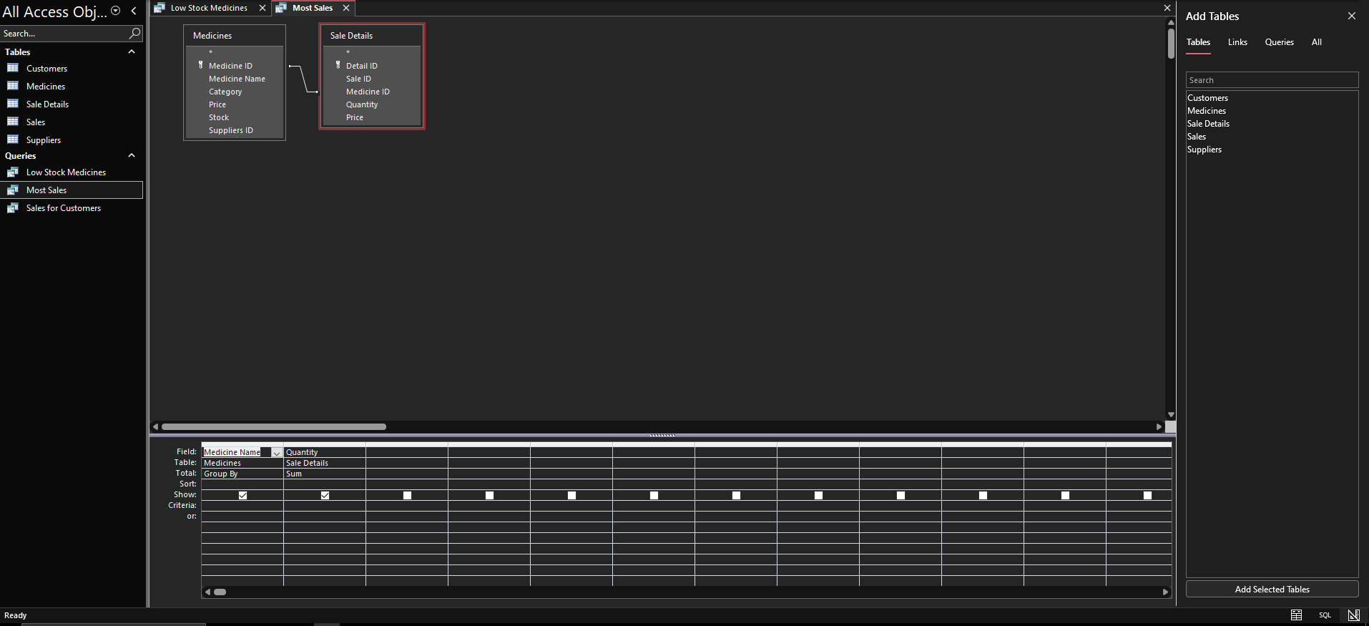
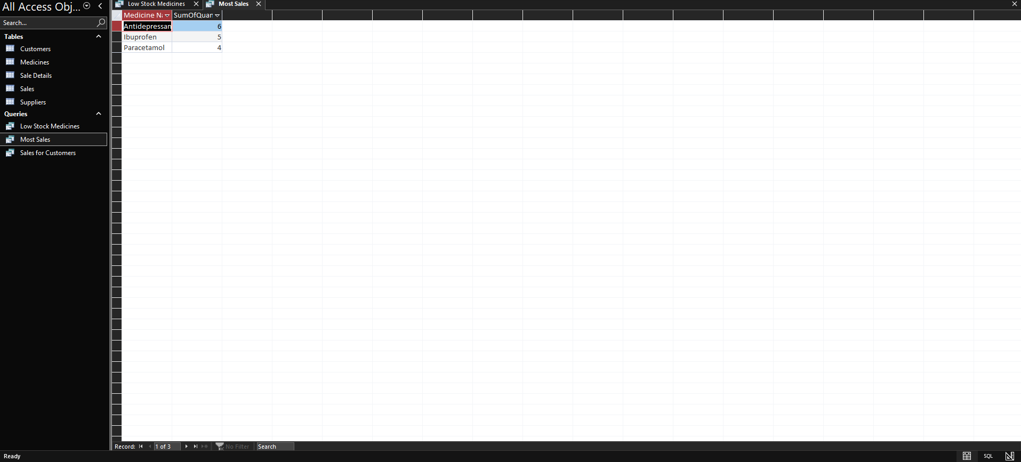
These are to show the purchases made by customers. For this part, I did almost the same thing as the others. I put the customer first and last name, them the quantity of sales, then did almost the same thing I had done to find out which medicines were the best-selling, using the (Total). After that, I just pressed the system to calculate. ↓
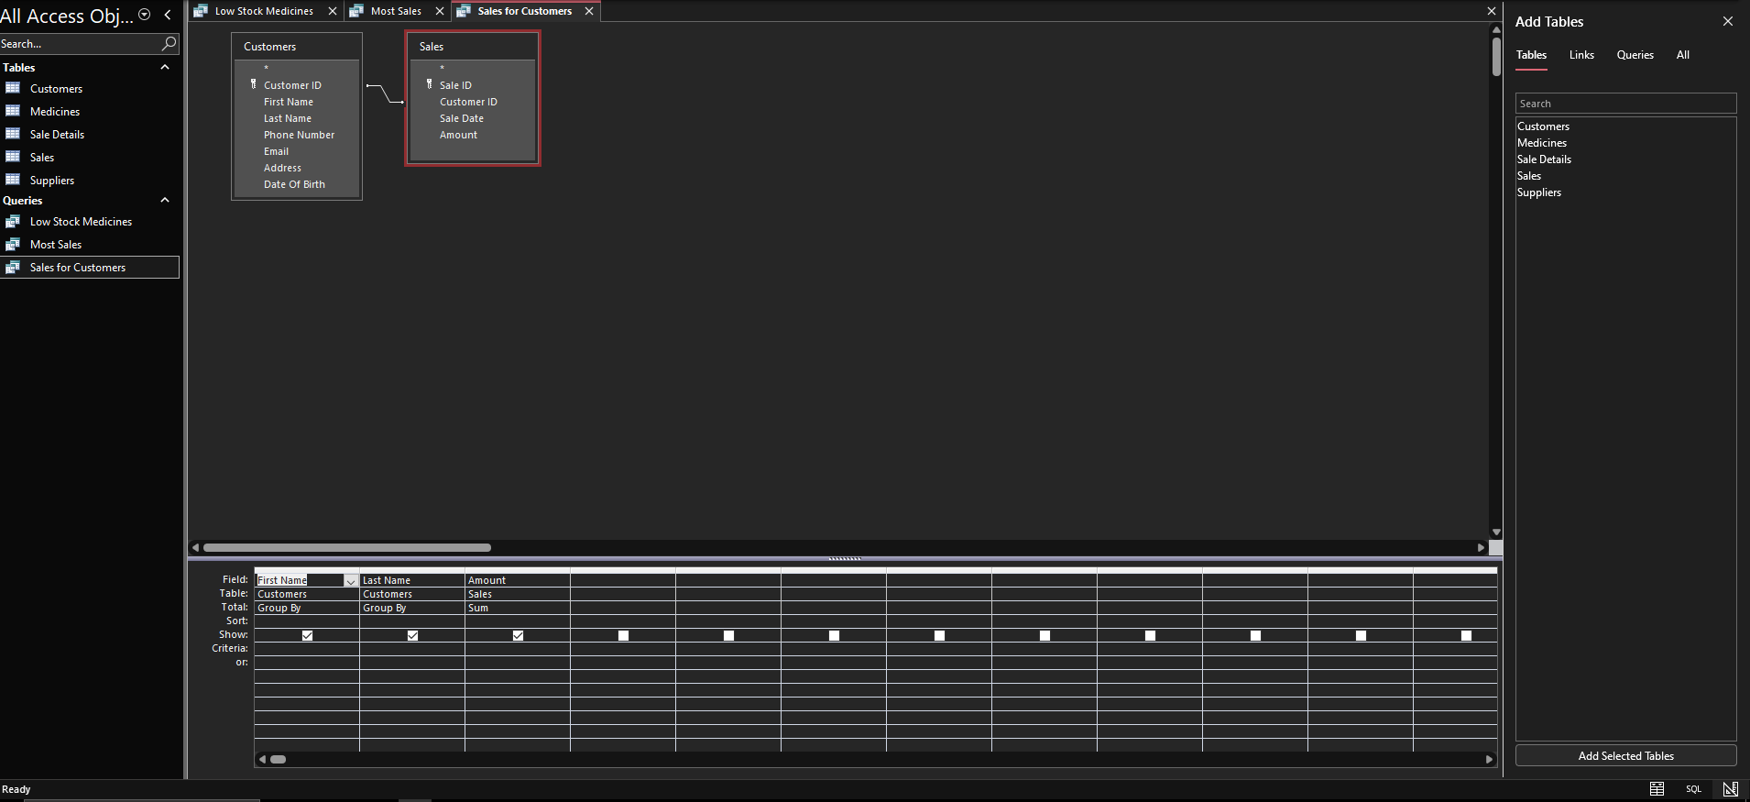
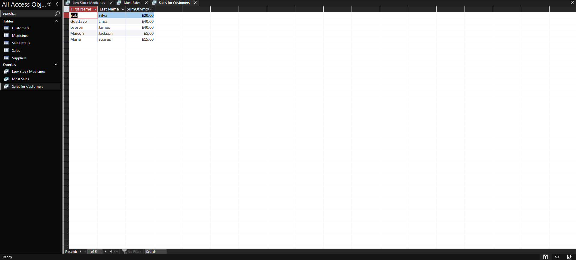

Desing Decisions
This was a demonstration of the system in operation. The company can use a system like this to understand what’s happening with the system’s database, thus avoiding manual errors. This is a very simple way to solve company problems. I would recommend using this system I created because it’s practical and easy to use, doesn’t make mistakes, and can be very useful for the company daily operations.

Validation and Testing
The demonstration of the database system developed for Medlink Pharmacy was conducted to ensure it met the requirements for operation and the user’s needs. Several tests were performed to determine if the system functioned correctly.
Many tests were performed during the creation process of this system:
The system accepts the insertion of records into all tables correctly, ensuring that it accepts and store the date properly.
The relationships tests were permanently, I verified that the key restrictions were in order and that there were no invalid data entries, thus ensuring referential integrity.
The query testing was performed by executing various queries, such as identifying low stock, calculation total sales, and accessing the customer’s purchase history.
Data consistency tests ensured that all related records in the tables were correct and properly linked.
The results of these tests confirmed that the database system was functioning very well. All relationships were successfully presented, preventing the entry of incorrect Tada. The queries produced results that were final enough to make this system work, thus demonstrating the system’s capabilities.
In summary, the system efficiently meets the functional requirements of Medlink Pharmacy, providing with greater accuracy and reliable trigger generation capabilities.

Conclusion
The hardest part of this work was remembered how to do some things, how to use Access and its tools, but with a little research on the subject I managed to do what Medlink Pharmacy asked for. What took me the most time in this work was organizing the relationships and putting them together. But to create this database, I had to find the relationships, and with that in hand, Hard to open Access and create 5 different tables for supplies, sales, customers, medications and stock. After that, I filled these tables with some information and I went on to create the relationships, putting everything together, after that it was just a matter of writing the queries.

References
Davies, B., & Paul. (2004). Microsoft Access. London: Database systems. Palgrave.
Ron, & McFadyen. (2016). Relational databases and microsoft access.

