  essay  Management Economics | Management economics Lcbb5003_birm  lecturer Vasilios tAVLARIDIS

Table of Contents

Introduction 2
Market of perfect competition 2
Imperfect competition 3
Monopolistic competition 4
Oligopoly 5
Monopoly 6
Duopoly 8
Conclusion 9
References 10

Introduction
This essay will examine the different market structures in the economy, besieging the different market structures in conditions of perfect and imperfect competition.
A market structure is a description of the behaviour of sellers and buyers in a given market. Behaviour depends on many characteristics, but mostly on the nature of goods and services and the number of market participants. Also, the lower the degree of impact of an individual company on the market, the more competitive the market structure.
There are various discussions about market structures in the economy and according to a study conducted by Hasan et al. (2017), it is analysed that market structures in the economy are categorized into four types
- Perfect competition
- Monopolistic competition
- Monopoly
- Oligopoly
It would be very convenient in cases where the competitive structure reaches zero degree of market influence, by all individual companies, then each of them perceives the price, depending on market supply and demand. This ideal situation is called a perfectly competitive market structure.

Market of perfect competition
Perfect competition is the first form of competition that has emerged objectively because of the natural development of the market economy, based on the complete economic freedom of all market participants (Griffiths and Wall, 2011). A large number of small and medium-sized companies compete with each other in the production and sale of homogeneous products, in conditions of free access to the market and information, mobility of production factors. Perfect competition is characterized by the following features:
- There are a large number of companies on the market, each of which has a small market share. The market share is less than 1%. Hence the conclusion that the individual company cannot change the market situation, to influence the market price level.
- The product produced is homogeneous, which makes it exchange. The goods do not differ in their quality characteristics, and this is one of the reasons for a single market price of the goods. Transactions can be concluded according to a standard (Griffiths and Wall, 2011).
- There are no barriers for companies to enter the industry and the market, neither economically nor legally, access is free.
- No secrets, free access to information. The information is symmetrical, and producers and consumers are aware of production and market conditions.
- Competition is conducted with price means
The advantages of this market structure are:
• In the long run, the company's behaviour leads to maximum economies of scale and minimize costs.
• With the entry of new competitors in the industry, the volume of production increases and the average total costs decrease.
• The pursuit of higher profits makes companies look for ways to reduce costs by implementing the achievements of technical progress (Sloman, and Garratt, 2019).
Disadvantages include:
• The relatively modest size of the companies, which do not allow to realize large savings.
• The implementation of active and intensive innovations.
• Smooth development of technical progress.
• The absence of massive accumulation of capital.
The advantages and disadvantages of perfect competition give reason to consider it as a model of theoretical rather than practical nature.
The demand curve of perfect competition can be analysed from the following figure (i.e., perfect elastic demand)
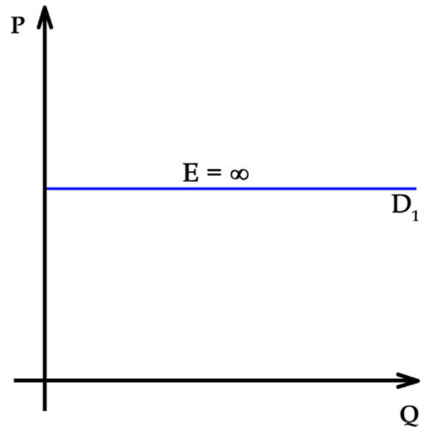
Figure 1: Demand Curve of Elastic Demand (Opentextbc.ca, 2019)
In the case of real examples, the markets of farmers are considered as one of the closest to real-life examples for perfect competition because identical products are being produced by farmers at an individual level. It is also observed that various brands are being offered in the supermarkets at different discounts rate. The main purpose of availability of these products at cheaper versions is mainly due to the reason of identical products and these are available almost every supermarket. To increase the revenue or sales of these products, the participants of market provide different discounts to attract their customers (Sloman, and Garratt, 2019)..

Imperfect competition
Perfect competition is an ideal model of the "classical market economy", non-existent in its pure form. In the real market economy there are various prerequisites that lead to permanent violation of basic market rules and requirements of perfect competition. the rules of free competition are permanently violated, as a result of which a buyer or seller may influence the supply and demand of a product and its market price.
Imperfect competition means a market in which individual producers can have some impact on price. In imperfect competition, all companies have something in common - they exercise market power, i.e.. ability to increase the price without losing all demand for your product.
A key feature of imperfectly competitive markets is market power. It can be bigger or smaller. Depending on this, the types of imperfect competition differ. In the model of perfect competition, the homogeneity of the product is placed. In most modern markets, the product is not homogeneous, but differentiated. This is achieved through differences in quality, functional characteristics, model, product packaging, renovation, advertising, etc. Product differentiation is a form of non-price competition between companies. Product differentiation is seen as a factor of market imperfection, it helps to limit competition and strengthen market power.
Types of imperfect competition
- monopolistic competition
- monopoly
- oligopoly
- Duopoly
A unifying feature of all these cases of imperfect competition is that in them the individual company faces a declining demand curve. Generally speaking, imperfect competition occurs when any (some) of the conditions of perfect competition are violated

Monopolistic competition
Monopolistic competition is another type of market structure in which there is perfect market competition along with the traits for both competitive as well as a monopoly market (Bertoletti and Etro, 2017).
Monopolistic competition is a market structure in which there is a variety of goods, and each company produces a product that is a close substitute for other companies. Demand follows exclusively the change in prices, and this is price competition. There are many commonalities between monopolistic and perfect competition - many sellers and buyers, the absence of significant barriers to entry in an industry, transparency, and complete information about the market in terms of prices, basic production technologies, etc. What distinguishes monopolistic from perfect competition is the lack of homogeneity, i.e. of homogeneity of production. In monopolistic competition, products are both differentiated and substitutable (Keat et al, 2014). Monopolistic competition is characterized by the following features:
- Product differentiation gives the seller a certain monopoly power over consumers.
- There are free entry and exit of competing companies in the industry. They enter it when profits are high and exit when they start to decrease.
- The goal of companies in monopolistic competition is to maximize their profits, equalizing marginal revenue with marginal cost.
- In monopolistic competition, production is carried out with less use of production capacity compared to perfect competition, and prices remain above the marginal cost (Keat et al, 2014).
The demand curve of monopolistic competition can be analysed from the following figure (i.e., elastic demand).
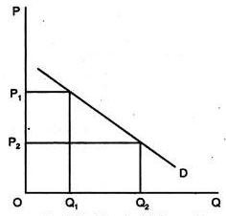
Figure 2: Demand Curve for Monopolistic Competition (Cliffsnotes.com, 2015)
In a market, there are a variety of grocery stores that provide products with distinct branding and marketing. These grocery stores have been considered as an example of monopolistic competition. Apart from this, hotels provide a variety of services also considered as a prime example of monopolistic competition because each service being offered by the management of hotels is identical with a slight variation in their quality mainly due to the reason of their price. Also, the books are an excellent example of monopolistic competition, as they differ in price, quality of workmanship, readability, quality of illustrations or lack thereof, and vary depending on the target audience and topics such as textbooks and college novels.

Oligopoly
The situation in which the market is dominated by a small number of companies is called an oligopoly. The oligopoly is one of the forms of imperfect competition that exists with a small number of relatively large sellers(LOERTSCHER, 2018). The few companies operating in the oligopolistic market are interdependent, given the quantity sold and the market price. The presence of several large companies creates barriers to new entrants into the oligopolistic market, and the trend in terms of competition is to keep it in line with non-price factors in order to maintain or increase market share. Both the monopoly and the oligopoly are characterized by the possibility of making economic profits in the short and long term. The oligopolistic market therefore has the following characteristics:
- A small number of companies, some of which control a significant part of the market.
- Interdependence of companies - decisions about the volume of production and prices of each company affect the profit opportunities of all others.
- Homogeneous or differentiated product - the product can be both homogeneous and heterogeneous;
- Presence or absence of barriers to entry is likely. The oligopolistic market is usually characterized by barriers to entry, especially economies of scale. It is possible that new companies will enter the oligopolistic markets and compete with existing ones(LOERTSCHER, 2018).
- Depending on the product offered by the companies, the oligopoly is homogeneous when, from the buyer's point of view, the products are identical and heterogeneous if the companies produce differentiated products. The oligopoly is considered to be the predominant form of the market in developed market economies under modern conditions.
A graph can be analysed as:
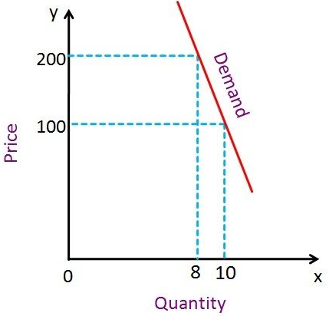
Figure 3: Demand Curve for Oligopoly (Breaking Down Finance, n.d.)
In case of real-time examples, car industry like Ford Motor company, General Motor company and theatre motor corporation is some of those largest car manufacturing companies that white a large number of cars around the globe. This can be an example of an oligopoly market structure. In further detail, the smartphone industry such as Samsung and Apple are the largest Smartphone brands market in the United States after China (Hayes, 2019). These are also considered as an example of oligopoly market structure

Monopoly
A monopoly is a market structure in which only one company is a producer and seller of a product that has no close substitute and sells all products at the same prices to all consumers. (Bertoletti and Etro, 2022).
A monopoly (pure monopoly) is a market structure in which there is only one producer in the industry, which means a single seller in the market. It produces a product for which there are no close substitutes and there are significant barriers to entry into the industry ( Marks, 2014). The word "monopoly" has Greek origins and consists of two parts "mono" - sole and "polist" - seller. But even in the past, pure monopoly was the exception rather than the rule. In modern conditions it is rare. Monopoly is more of an abstract theoretical model than a real market organization. However, it plays a key role in the theory of imperfect competition. By showing the maximum possible market power, the monopoly model reveals the essence of imperfect competition. Since the monopolist company is the only producer, the demand curve of production under the pure monopoly is the demand curve of the whole market and has a negative slope (Marks, 2014). This determines the main features of the market mechanism of the monopoly:
- The amount of production that can be sold on the market will increase depending on how the market price will fall.
- In this situation, the marginal product (MR) ceases to be a constant value and begins to decline, as the revenue generated from the sale of each additional unit of production is less than the market price. in search of pure monopoly.
Types of monopoly
Depending on the way the monopoly is established, there are two types: natural and artificial (institutional).
- The natural monopoly arises by virtue of objective circumstances. It is always based on economies of scale associated with the possession of unique or non-reproducible natural resources. This allows only one company to serve the entire market. Examples of this are railway transport, communications, and others.
- The institutional monopoly arises administratively or through the so-called "Entry barriers", such as customs duties, licenses, patents, etc., through which the state can consciously create a monopoly, as the main consideration is often the pursuit of efficient production(Marks, 2014).
- Consequences of the monopoly
Monopoly results in inefficiency
A condition and prerequisite for efficiency in the allocation of resources is that the marginal costs are equal to the price. In the case of a monopoly, however, this condition is not met (Keat et al, 2014). By establishing a price and volume different from those of perfect competition, the monopoly causes an irrational distribution and use of resources on a public scale. Another important consequence of replacing perfect competition with monopoly is the redistribution of income in society. When establishing a balance in the conditions of a monopoly by increasing the price and reducing the volume, part of the consumer surplus passes into the monopoly and forms its economic profit(Keat et al, 2014). The third significant consequence is related to the influence of market power on scientific and technological progress and renewal of production. Many economists believe that protected from competition by high barriers, monopolists are not under the same pressure to resume production and cut costs as competing firms. Various measures are used to combat the monopoly and its consequences:
- Taxes - taxes can be used to reduce the negative effects of the monopoly on the distribution of income. By taxing concentrated industries with high taxes, the state reduces monopoly profits,
- Price control - its essence comes down to establishing administrative regulation of prices
- State property - in some sectors such as water supply, gas, electrification, telephone services, etc. it is considered that efficient production can take place under the condition of a monopoly or approach to it.
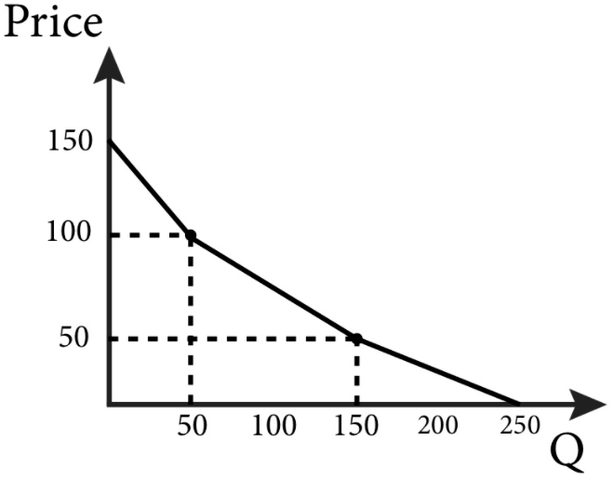
Figure 4: Demand Curve for Monopoly (Spaulding, 2019)

Duopoly
Duopoly is the simplest case of an oligopoly (from Latin duo - two and Greek poleo - for sale) - a special case of limited competition, when there are two independent sellers of the same product on the market, and the number of buyers is not limited. In general, duopolies have three options.
First, they compete - freely, regardless of each other, reduce prices in an effort to sell maximum products. In this case, the total sales volume will be the largest (limited only by effective demand), but the price and profit per unit of goods will be the smallest (Corporate Finance Institute, n.d.).
The second possibility is for each of the duopolies to strive to increase their profits to the maximum possible level (maximize it, believing that changes in its production do not affect the competitor's decisions about the volume of production of (the same) product (Sloman, and Garratt, 2019)... Due to its clarity, this example is often used in economic theory in modelling market processes. In the Cournot model, both companies have to decide how much to produce, and both make decisions at the same time. The final price depends on the total production of both companies.
Characteristic of the model:
- Each company makes a decision, considering that the production of its competitor is constant during a certain period. After some mutual adaptation, an equilibrium is established between them, called the Cournot equilibrium.
- In the end, the profits made by each company are higher than in perfect competition. More sophisticated methods of analysis take into account the likely reaction of a competitor to a change in the competitor's output. Such is Stackelberg's model of market equilibrium, which considers the possible reaction of competitors to decisions about production volumes, and one or both companies believe that the competitor will behave as a duopoly of Cournot.
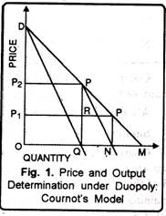
Figure 5: Demand Curve for Duopoly (Kumar, 2015)

Conclusion
From the above discussion, it has been concluded that there are four major market structures that exist in an economy. These economic structures are concluded as perfect market competition, monopolistic market competition, oligopoly, and monopoly. These market competitions significantly help the market participants to play their role to enter and exit from this market.
These are the main market structures. As you can see, there are many of them, and some of them are not found in pure form. Market and market structures are the main topics in the economy, so they need to be studied as well as possible.

References

Bertoletti, P. and Etro, F., 2017. Monopolistic competition when income matters. The Economic Journal, 127(603), pp.1217-1243.
Bertoletti, P. and Etro, F., 2022. Monopolistic competition, as you like it. Economic Inquiry, 60(1), pp.293-319.
Breaking Down Finance. (n.d.). Kinked Demand Curve Model. [online] Available at: https://breakingdownfinance.com/finance-topics/finance-basics/kinked-demand-curve-model/.
Cliffsnotes.com. (2015). Monopolistic Competition in the Long run. [online] Available at: https://www.cliffsnotes.com/study-guides/economics/monopolistic-competition-and-oligopoly/monopolistic-competition-in-the-long-run.
Corporate Finance Institute. (n.d.). Duopoly - Overview, Examples, and Types of Oligopolies. [online] Available at: https://corporatefinanceinstitute.com/resources/knowledge/economics/duopoly/.
Griffiths, A. and Wall, S. (2011) Economics for business and management. Third edition. Harlow, England: Pearson Education Limited.
Hasan, I., Jackowicz, K., Kowalewski, O. and Kozłowski, Ł., 2017. Do local banking market structures matter for SME financing and performance? New evidence from an emerging economy. Journal of Banking & Finance, 79, pp.142-158.
Hayes, A. (2019). What are Current Examples of Oligopolies? [online] Investopedia. Available at: https://www.investopedia.com/ask/answers/121514/what-are-some-current-examples-oligopolies.asp.
Hendren, N., 2016. The policy elasticity. Tax Policy and the Economy, 30(1), pp.51-89.
Keat, P.G., Young, P.K.Y. and Erfle, S.E. (2014) Managerial economics: economic tools for today’s decision makers.
Kumar, M. (2015). 4 Types of Duopoly Models (With Diagram). [online] Economics Discussion. Available at: https://www.economicsdiscussion.net/duopoly/4-types-of-duopoly-models-with-diagram/7364.
LOERTSCHER, S. (2018). MARKET MAKING OLIGOPOLY*. The Journal of Industrial Economics, 56(2), pp.263–289.
Marks, SG 2014, Managerial Economics, Wiley Textbooks, New York.
Opentextbc.ca. (2019). 5.2 Polar Cases of Elasticity and Constant Elasticity – Principles of Economics. [online] Available at: https://opentextbc.ca/principlesofeconomics/chapter/5-2-polar-cases-of-elasticity-and-constant-elasticity/.
Parenti, M., Ushchev, P. and Thisse, J.F., 2017. Toward a theory of monopolistic competition. Journal of Economic Theory, 167, pp.86-115.
Sloman, J. and Garratt, D. (2019) Essentials of economics. 8th ed. Harlow: Pearson.
Spaulding, W.C. (2019). Pure Monopoly: Demand, Revenue and Costs, Price Determination, Profit Maximization and Loss Minimization. [online] Thismatter.com. Available at: https://thismatter.com/economics/pure-monopoly-demand-revenue-costs-profits.htm.
Thisse, J.F. and Ushchev, P., 2018. Monopolistic competition without apology. In Handbook of Game Theory and Industrial Organization, Volume I. Edward Elgar Publishing.

