

Module Code: LCMB7035
Module Name: Dissertation

Title: Exploring the Impact of Artificial Intelligence on Human Resources

Student Name: HARSH DEEPSINGH
Student ID: 2436567
Submission Date: 17th July
Word Count: 2283

Contents
1
1. Introduction and Research Background 1
2. Problem Statement 2
3. Research Questions and Objectives 3
Research Objectives 3
Research Questions 3
4. Conceptual Framework 3
5. Literature Review (Selected Themes) 4
Recruitment and Predictive Sourcing 4
Staffing and the "Skills-Based" Organization 4
Training, Upskilling, and Hyper-Personalization 4
6. Proposed Research Methodology (Saunders' Research Onion) 4
Layer 1: Philosophy (Positivism) 5
Layer 2: Approach (Deductive) 5
Layer 3: Method Choice (Mono-Method Quantitative) 5
Layer 4: Strategy (Survey) 5
Layer 5: Data Collection (Primary Data) 6
Layer 6: Time Horizon (Cross-Sectional) 6
7. Gantt Chart & Research Implementation Schedule 6
References 6

1. Introduction and Research Background
The fast development and integration of artificial intelligence (AI) is causing an unprecedented paradigm shift in the corporate operations landscape. Modern AI systems have evolved from being thought of as specialized, back-office tools for mathematical computation to being key contributors to strategic commercial value. Human resource management (HRM) is going through some of the most significant structural transformations of any corporate industry. Highly automated, algorithmic, and data-driven systems are rapidly replacing traditional, paper-heavy, and intuition-driven HR processes. This shift marks a profound, fundamental change in how businesses identify, assign, manage, and develop their human capital; it goes beyond simply altering the tools that HR professionals use (Tambe et al., 2019; Malik et al., 2023).
Leading international professional services company Deloitte, which employs hundreds of thousands of highly skilled knowledge workers worldwide, is at the vanguard of this digital upheaval. Due to its distinct dual function in the market, Deloitte offers an incredibly rich backdrop for this study. On the one hand, Deloitte serves as a reliable outside strategic advisor, assisting large multinational companies in managing their own AI-driven workforce transitions (Deloitte, 2026a). Regarding the However, Deloitte uses its own sophisticated, fast-paced, and high-turnover consulting staff to test these very technologies internally (Deloitte, 2026b). Due to its dual stance, Deloitte is an ideal topic for examining how state-of-the-art HR technology operate in a knowledge-intensive, high-stakes setting where people are the main business product.
The three main pillars of Deloitte's talent cycle are the focus of this dissertation proposal, which evaluates the strategic and operational effects of AI:• Recruitment and Predictive Sourcing: Examining how sophisticated Natural Language Processing (NLP) search models, conversational screening bots, and algorithmic systems that forecast candidate fit and performance can replace laborious, manual resume screenings and localized sourcing channels (Albert, 2023). Skills-Based Staffing and Allocation: Analyzing the transition to real-time, skills-based AI matchmaking platforms from traditional, partner-network scheduling and strict job descriptions Deloitte HR-AI Dissertation Proposal (Expanded Edition) Page 1. Based on real-time skill profiles, availability, and professional development goals, these automated solutions dynamically assign consultants to international client projects (Deloitte, 2026b).
• Hyper-Personalized Learning & Development (L&D): Examining how customized, AI-guided learning ecosystems that continuously assess an employee's work tasks and performance gaps to suggest immediate, personalized learning paths are replacing conventional, mass-produced employee training programs (Pan et al., 2022).
The human side of this technology revolution is quite complicated, despite the obvious operational and financial benefits of HR automation, such as reduced administrative expenses, quicker hiring times, and optimal project utilization. Deep cultural conflict, algorithmic biases, and employee resistance are frequently brought about by integrating AI into HR operations; these issues are collectively referred to as "culture debt" (Deloitte, 2026b). This study aims to investigate these internal issues in further detail. By extensively examining Deloitte, we hope to get insight into how one of the top consulting networks in the world strikes a balance between the human-centric requirements of openness, fairness, and empathy and the clinical, data-driven efficiency of automated algorithms.

2. Problem Statement

The execution and trust gap in AI deployment, rather than the lack of AI competence, is the main issue facing contemporary enterprises. A startling paradox is revealed by Deloitte's own research: although 85% of corporate executives concur that workforce adaptation and AI integration are essential for competitive survival, just 7% think their companies are effectively assisting their employees in adjusting to new technologies (Deloitte, 2026b).

Algorithmic prejudice and inaccurate candidate data pose a threat to top talent in hiring and employment (Tambe et al., 2019; Malik et al., 2023). Static corporate learning systems are no longer practical in training and development due to the quick obsolescence of skills, yet businesses find it difficult to implement personalized learning that yields a quantifiable return on investment (Deloitte, 2026c).

Deloitte and other professional service companies run the risk of high employee turnover, skill mismatches, and a serious deterioration of organizational culture if they do not link their AI deployments with real human needs (Vrontis et al., 2022). By investigating how AI can be used in hiring, staffing, and training in a way that favors human talent rather than replacing it, this study fills this crucial vacuum.

3. Research Questions and Objectives

Research Objectives

• Goal 1: Assess the strategic and practical effects of AI technology on Deloitte's hiring, staffing, and training procedures.

• Goal 2: To determine the main ethical, cultural, and organizational obstacles to AI adoption in Deloitte's HR ecosystem.

• Goal 3: To provide a strategy framework for the professional services industry that strikes a balance between human-centric talent management and automated AI efficiency.

Research Questions

• RQ1: How does the incorporation of AI-driven technologies affect the effectiveness and applicant experience of Deloitte's hiring and staffing procedures?

• RQ2: How do AI-powered learning and development initiatives affect employees' career advancement and upskilling opportunities within the company?

• RQ3: What are the main operational, cultural, and ethical obstacles to Deloitte's successful HR-AI integration, and how may they be overcome?

4. Conceptual Framework
A conceptual framework is developed to map out the relational dynamics between the adoption of AI in fundamental HR procedures and the ensuing operational and human results in order to direct the investigation. This concept recognizes that the operational shift to AI does not happen in a vacuum and that organizational mediating and moderating factors play a major role in determining its success. 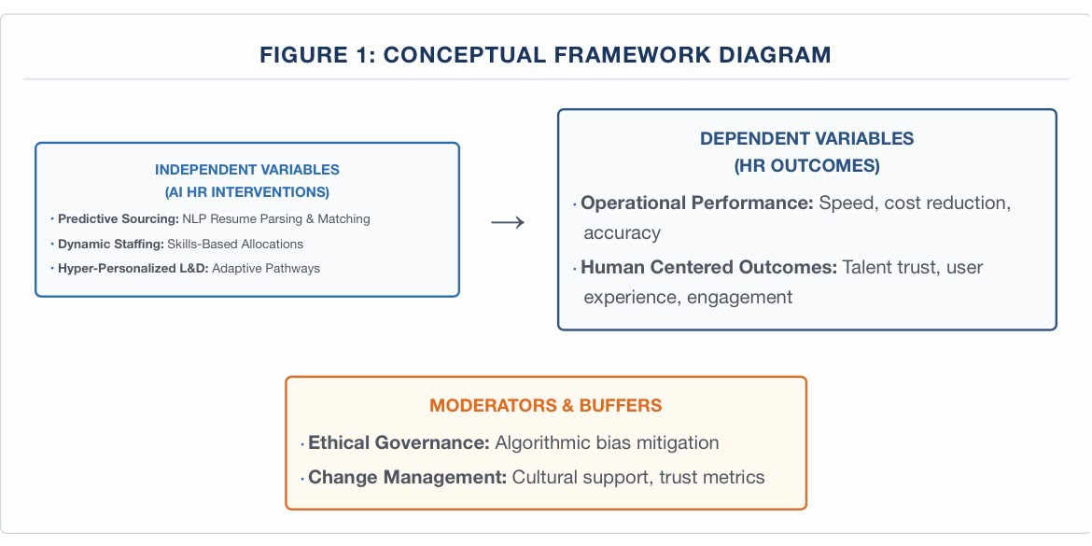

5. Literature Review (Selected Themes)
Techno-optimism, which emphasizes enormous efficiency advantages, and socio-technical skepticism, which emphasizes biases, loss of human agency, and cultural friction, are the two opposing schools of thought in the literature on AI in HRM.).

Recruitment and Predictive Sourcing

Human screening, which is particularly susceptible to subjective bias and cognitive fatigue, is a major component of traditional recruitment (Budhwar et al., 2022). By employing natural language processing (NLP) to analyze resumes and forecast a candidate's match based on past success data, AI systems simplify this procedure (Tambe et al., 2019). Critics counter that if these systems are trained on historical data, they run the risk of systematically ignoring underrepresented groups and codifying and replicating previous human prejudices (Malik et al., 2023; Albert, 2023).

Staffing and the "Skills-Based" Organization

In the past, local partner networks and strict job titles were the main factors influencing professional services staffing. Using AI to dynamically match consultants to projects based on real-time skills inventories rather than job titles, businesses are now moving toward "skills-based" staffing (Deloitte, 2026a). Although this optimizes the use of resources, it may result in algorithmic over-scheduling and employee alienation if workers perceive themselves as nothing more than data points (Vrontis et al., 2022; Charlwood and Guenole, 2022). Training, Upskilling, and Hyper-Personalization

The shelf life of talents in professional services is constantly decreasing. AI-driven, hyper-personalized learning pathways that adjust to an employee's daily duties, performance metrics, and career aspirations are replacing traditional, one-size-fits-all training methods (Deloitte, 2026c). Employee engagement rises when AI recommends hyper-targeted learning content, according to research by Pan et al. (2022). But keeping internal skills data accurate continues to be a major challenge for HR departments around the world (Deloitte, 2026b).

6. Proposed Research Methodology (Saunders' Research Onion)

The layers of **Saunders' Research Onion** are used to openly structure and justify the research methods of this study in order to guarantee complete academic rigor (Saunders et al., 2019). In order to assess systemic correlations with statistical precision, this dissertation uses a rigorous **mono-method quantitative methodology** driven solely by **primary data collection**. 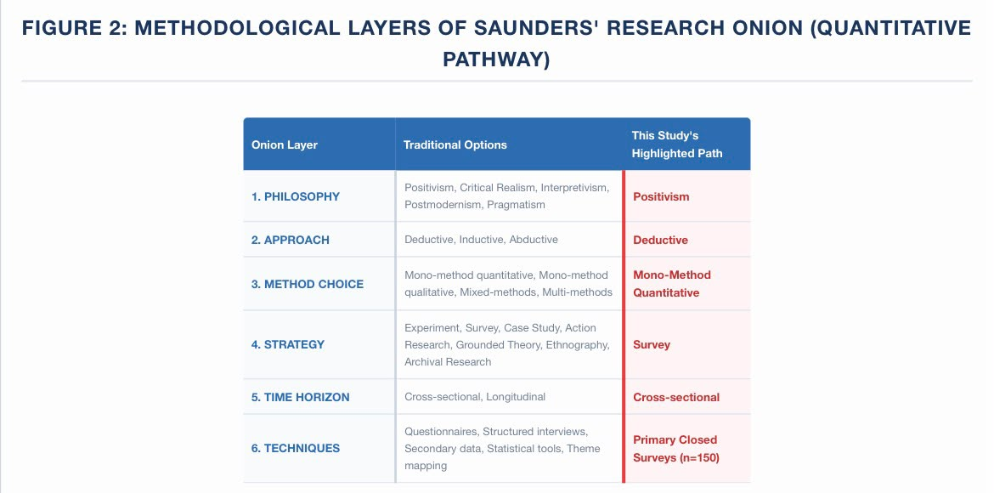Layer 1: Philosophy (Positivism)

The foundation of this study is a **Positivist Research Philosophy**. Put simply, positivism views the world as an organized environment that can be objectively measured using logic, facts, and statistics. This study makes the assumption that the genuine effects of AI on hiring, staffing, and training at Deloitte are a tangible fact that exists outside of our individual perspectives rather than depending on sentiments, subjective narratives, or personal judgments. The researcher takes on the role of an impartial observer when employing a positivist methodology. We collect hard numerical data using standardized scales, which enables us to generate objective, value-free results that are simple for other researchers to examine and validate (Saunders et al., 2019).

Adopting positivism in practice means that we are not attempting to comprehend the complex, unique life stories of a small number of people. Rather, we want to take a comprehensive view and find consistent, broad trends throughout the entire company. In the same way that physical sciences quantify natural occurrences, this philosophy assumes that human actions, decisions, and attitudes toward technology can be classified and measured using structured techniques. This guarantees the objectivity and dependability of our final outcomes.

Layer 2: Approach (Deductive)

The research employs a deductive methodology. Put simply, this means that we begin with a well-established theory regarding the impact of AI on human resources. Next, we develop particular hypotheses—predictions—about these connections. In order to verify or refute our initial hypotheses, we collect data to test those predictions (Saunders et al., 2019).

Layer 3: Method Choice (Mono-Method Quantitative)

A mono-method quantitative approach is used in this investigation. This implies that we will only use one kind of study instrument—numbers and statistical data. Focus groups and interviews will not be used. The study stays highly focused and consistent by concentrating only on numerical data, which enables us to identify specific patterns and do precise mathematical comparisons across many departments (Saunders et al., 2019).

Layer 4: Strategy (Survey)

A survey is the main method of research. Employees will receive highly organized, closed-ended questions. This enables us to swiftly and effectively collect data from a huge population. We can simply categorize, compare, and numerically evaluate each participant's responses because they all respond to the same questions in the same way (Saunders et al., 2019).

Layer 5: Data Collection (Primary Data)

Primary data collection will be used. This indicates that we are obtaining new, unique data for this topic directly from the source. We will send our own surveys to Deloitte workers directly rather than relying on historical data or reports that have already been gathered. This guarantees that our data is entirely correct, current, and relevant (Saunders et al., 2019).

Layer 6: Time Horizon (Cross-Sectional)

A cross-sectional time horizon is used in the investigation. This merely indicates that we are capturing a single "snapshot" in time. Instead of monitoring trends over a number of years, we are examining how Deloitte employees currently feel about AI. This is really useful, keeps the project on schedule, and gives a realistic picture of how AI is now being adopted (Saunders et al., 2019).

7. Gantt Chart & Research Implementation Schedule
A planned nine-month timeline has been set in order to guarantee the effective completion of this dissertation. From the original proposal clearance until the final thesis submission, the timeline below shows the overlapping operational phases.

Figure 3: Project Implementation Gantt Chart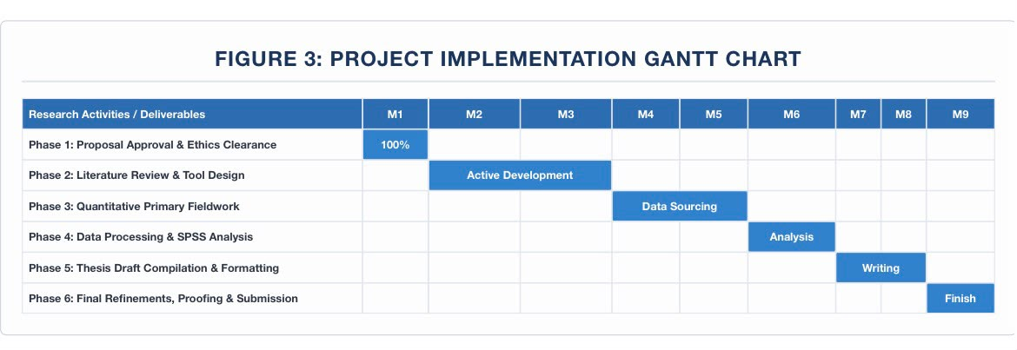

References
Albert, E.T., 2023. AI in talent acquisition: a review of current trends and future directions. Journal of Work-Applied Management, 15(1), pp.99-113.
Braun, V. and Clarke, V., 2012. Thematic analysis. APA Handbook of Research Methods in Psychology, 2, pp.57-71.
Budhwar, P., Malik, A., De Silva, M.T. and Thevisuthan, P., 2022. Artificial intelligence-challenges and opportunities for international HRM: a review and research agenda. The International Journal of Human Resource Management, 33(6), pp.1065-1097.
Charlwood, A. and Guenole, N., 2022. Poetry in motion? Or incremental progress? Explainable artificial intelligence and HRM. Human Resource Management Journal, 32(4), pp.729-745.
Deloitte, 2026a. 2026 Talent Acquisition Technology Trends: The new imperative. London: Deloitte Insights. Available at: <https://action.deloitte.com/insight/5005/2026-talent-acquisition-technology-trends-the-new-imperative> [Accessed 16 July 2026].
Deloitte, 2026b. 2026 Global Human Capital Trends: From tensions to tipping points: Choosing the human advantage. New York: Deloitte University Press. Available at: <https://www.deloitte.com/us/en/insights/topics/talent/human-capital-trends.html> [Accessed 16 July 2026].
Deloitte, 2026c. 2026 HR Tech Predictions: Human motivators will shape AI-driven learning journeys. London: Deloitte Insights. Available at: <https://action.deloitte.com/insight/4834/2026-hr-tech-predictions-human-motivators-will-shape-ai-driven-learning-journeys> [Accessed 16 July 2026].
Malik, A., Budhwar, P., Patel, C. and Srikanth, N.R., 2023. May the bots be with you! Delivering artificial intelligence in human resource management. Human Resource Management, 62(2), pp.211-232.
Pan, Y., Froese, F., Liu, L. and Zhang, L., 2022. The adoption of artificial intelligence in employee training: Benefits and barriers. Asia Pacific Business Review, 28(5), pp.762-781.
Saunders, M., Lewis, P. and Thornhill, A., 2019. Research Methods for Business Students. 8th ed. Harlow: Pearson Education.
Tambe, P., Cappelli, P. and Yakubovich, V., 2019. Artificial intelligence in human resources management: Challenges and a path forward. California Management Review, 61(4), pp.15-42.
Tyson, H., 2026. The 5i Model: A Strategic Framework for Talent Management. The Age of HR, [online] Available at: <https://www.theageofhr.com> [Accessed 16 July 2026].
Vrontis, D., Christofi, M., Pereira, V., Shubin, S. and Grandhi, B., 2022. Artificial intelligence, robotics, advanced technologies and human resource management: a systematic review. The International Journal of Human Resource Management, 33(6), pp.1237-1266.
Yorks, L., 2025. Your Talent Strategy Has to Keep Up with Your AI Transformation. Harvard Business Review Digital Articles.
Zhang, L., 2026. AI Adoption Is Overloading Your Middle Managers. Harvard Business Review, [online] Available at: <https://hbr.org> [Accessed 16 July 2026].

