INTELLECTUAL COMPETENCE REPORT FOR THE GENERAL MANAGER
HOTEL DIVERSITY FROM ITALY

Module title:Foreign Languages and Cultural Awareness
Module Code:BMIH5003
Student Number:2206483
Student Name:Constantin Alin Nanu
Lecturer Name:Giulia Chifari

Abstract
The study focuses on the analysis of the establishment of business operations in the market by obtaining market information. Further, the study also discusses the importance of analysing the country's external environmental to understand the perception of the people along with their behaviour to establish its business in the Italian market.

Table of Contents
Introduction 4
Main body 4
Cultural overview 4
Globe project country analysis 6
Conclusion 8
Recommendation 8

Introduction
The country analysis allows the business to address and assess the national environment with importance to gain relevant insights about the country's external situation. In addition, analysing the country's culture helps businesses to understand the attitudes and behaviour of the people which is essential to build a successful business organisation. The purpose of the report is to effectively analyse the cultural differences and external factors in Italy to manage workflow and customer satisfaction. The report has provided a suitable recommendation in order to increase the leadership quality to successfully managing tem while increasing profitability. in addition, Report has also analyse the suitable leadership style for managing the business effectively and successfully.

Main body

Cultural overview
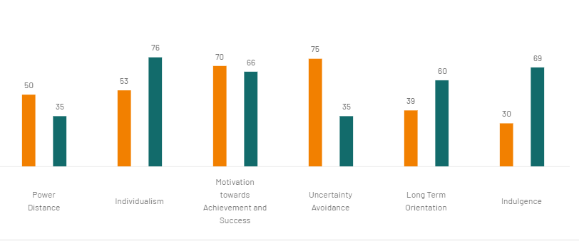
Figure 1: Cultural overview of Italy
(Source: Hofstede-insights.com, 2023)

Based on the power distance, Italy tends to prefer decentralisation and equality of decision-making. The younger age group in Italy dislikes manage and general management; they mainly prefer an open supervision style and teamwork. On the other hand, the UK has highly individualist and private people compared to Italy. In the UK people are very focused on their future. This can impact the leadership structure of Italy by effectively influencing them and encouraging them towards productive work because Italy has a team-oriented high Visualisation score such as 5.87. In this case, it has benefits for Diversity Hotel and Spa that people can easily rely on the organisation in case they provide a suitable and welcoming work culture. a successful leadership management is extremely important for the business organsiation to manage work flow and business stability. Therefore, Italy has a highly success-oriented and driven culture. Accordingly, the general managers have to provide future growth opportunities and upskilling training to the employees to retain them in the workplace for a long time because Italy has moderate institutional collectivism 3.58. In order to manage this general manager needs to follow democratic leadership style to manage the team successfully. [Refer to appendix 1]
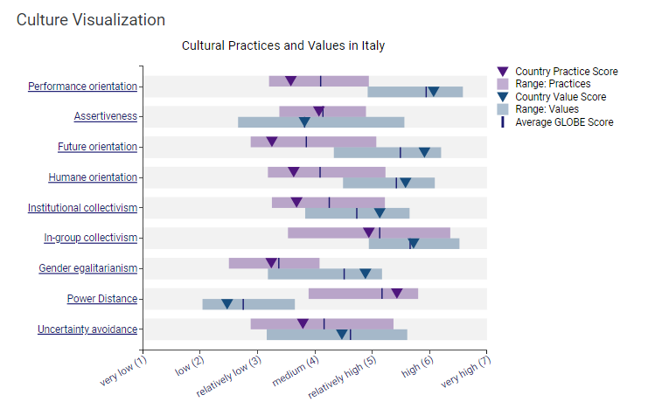
Figure 2: Culture Visualisation
(Source: Globeproject.com, 2023)
Based on the above figure, it can be stated that Italy has a less performance orientation culture because of less concern about the future. In Italy, the assortment of high Masculinity as well as high indecision evasion create life very hard and demanding for the Italian culture and the Gender egalitarianism score in Italy has 3.5. In this case, the general manager needs to provide proper job satisfaction and flexible shifts to the employees during the mid-breaks to maintain their satisfaction rate and well-being. Significantly, Italian people have shown great respect towards their cultures and traditions to preserve them for the future. In this case, the general manager needs to observe and adopt the culture and attitude in terms of making a successful connection with the employees and the customers. However, Italy tends to have pessimism and cynicism in contrast to lenient societies because of the moderate human orientation score as 3.63. Thus, managing cultural management in the expansion country helps to increase employee productivity and performance.

Globe project country analysis

Factors | Details | Impact on Diversity Hotel and Spa
Political | - The political stability score of Italy is 0.58 in 2021 ( theglobaleconomy.com, 2023)  - The cost of starting a business in Italy is 13.8% per capita ( theglobaleconomy.com, 2023)  - Italy has a parliamentary republic with a multi-party system | Can carry out business management without any political exposure
Economical | - The financial growth has been increased by almost 4.5% in 2021 (Statista.com, 2023)  - The inflation rate in Spain is estimated at 4.3% (Statista.com, 2023) | assist to manage price rate due to low inflation rate
Social | - The total population in Italy is estimated at 58.98 million (Statista.com, 2023)  - In Italy almost 22.9 million are employed in 2020 (Statista.com, 2023)  - The literacy rate in Italy is approximately 99.94% (Globaldata.com, 2023) | rising population increase business profitability
Technological | - The digital division in Italy grow from 68.7 billion Euros to 77.09 billion Euros (Statista.com, 2023)  - More than 47 million in Italy use Internet service daily (Statista.com, 2023) | allow to adopt innovative business strategies
Legal | - In Italy, Law no. 300/1970 determined that labourers are no longer liable to work more than 48 hours per week  - Law No. 125 of 10 April 1991 determined to reduce sexual discrimination to promote equality | permit to manage business operations ethically
Environmental | - Legislative Decree No. 152/2006 determines environmental stability and reduces pollution in Italy  - Italy also has climate crises such as landslides and floods | amplify business sustainability
Table 1: PESTLE analysis of Italy
(Source: Statista.com, 2023)
Analysis
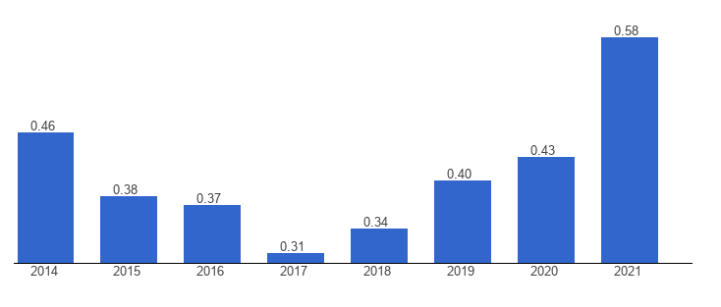
Figure 3: Political stability in Italy
(Source: Theglobaleconomy.com, 2023)
Based on Figure 2, it can be stated that Italy has a stable political situation which permits Diversity Hotel and Spa to conduct their business operation without any political negligence. In addition, Italy also has an effective financial structure which can allow the hotel institute to increase profitability and invest larger amounts. Therefore Italy has also a high technological advancement which is important for any business to increase business advancement and growth. Accordingly, Italy has a strong legal structure in order to managing the ethical business process and employee satisfaction. It is important for the business organisation to maintain proper sustainable business structure in order to maintain proper relationship with the government. thus, suitable business operation is helpful for the environment as ell as the company to increase customer awareness and employee morale.

Conclusion
Based on the above discussion it can be concluded that the cultural visualisation of Italy is effective for Diversity Hotel and Spa in order to expand successful business management. Political stability is also a significant part which determines that Italy has suitable circumstances to manage daily business management.

Recommendation
- General manager needs to follow transparency within the workplace in order to increase team collaboration as well as productivity because employees expect their managers to be honest, transparent and trustworthy in the workplace,
- Adopting the customers and attitudes of the employees by regularly conducting quality communication is essential in terms of determining successful team management

References
Eige.europa.eu, (2023). Gender Mainstreaming Approach - Italy. https://eige.europa.eu/gender-mainstreaming/countries/italy?language_content_entity=en#:~:text=Committee%20(EONC).-,Law%20No.,their%20professional%20advancement%20and%20careers. [Accessed on: 04.11.2023]
Globaldata.com, (2023). Literacy Rate in Italy (2010 - 2021, %) - GlobalData Available at: https://www.globaldata.com/data-insights/macroeconomic/literacy-rate-in-italy/#:~:text=As%20more%20people%20get%20a,of%20Italy%20grew%20by%200.1%25. [Accessed on: 04.11.2023]
Hofstede-insights.com, (2023). COUNTRY COMPARISON TOOL Available at: https://www.hofstede-insights.com/country-comparison-tool?countries=italy%2Cunited+kingdom
Iclg.com, (2023). Environment & Climate Change Laws and Regulations Italy. Available at: https://iclg.com/practice-areas/environment-and-climate-change-laws-and-regulations/italy#:~:text=Italy's%20environmental%20policy%20is%20based,figures%20as%20well%20as%20lawmakers. [Accessed on: 04.11.2023]
Statista.com, (2023). Demographics of Italy - Statistics & Facts | Statista Available at: https://www.statista.com/topics/5925/demographics-in-italy/#:~:text=In%202022%2C%20the%20total%20resident,sixth%20of%20the%20whole%20population. [Accessed on: 04.11.2023]
Statista.com, (2023). Digital market size in Italy 2017-2026 - Statista Avilable at: https://www.statista.com/statistics/1054874/digital-market-size-italy/#:~:text=Between%202017%20and%202022%2C%20the,Web%20Services%20and%20Mobile%20Business. [Accessed on: 04.11.2023]
Statista.com, (2023). Employment in Italy 2020, by economic sector - Statista Avilable at: https://www.statista.com/statistics/586899/employment-by-economic-sector-italy/#:~:text=The%20service%20sector%20employed%20the,employed%20in%20Italy%20in%202020. [Accessed on: 04.11.2023]
Statista.com, (2023). Inflation rate in Spain 2028 - Statista Available at: https://www.statista.com/statistics/271077/inflation-rate-in-spain/
Statista.com, (2023). Internet usage in Italy - Statistics & Facts - Statista Avilable at: https://www.statista.com/topics/4217/internet-usage-in-italy/#:~:text=Italians%20are%20embracing%20the%20internet,47%20million%20active%20internet%20users. [Accessed on: 04.11.2023]
Statista.com, (2023). Italy: GDP forecast 2021-2024 - Statista. Available at: https://www.statista.com/statistics/1112346/forecasted-gross-domestic-product-gdp-growth-in-italy/#:~:text=Forecasted%20Gross%20Domestic%20Product%20growth%20in%20Italy%202021%2D2024&text=A%20forecasted%20published%20in%20October,would%20grow%20by%204.8%20percent. [Accessed on: 04.11.2023]
Theglobaleconomy.com (2023), Italy: Cost of starting a business https://www.theglobaleconomy.com/Italy/Cost_of_starting_business/. [Accessed on: 04.11.2023]
Theguardian.com, (2023). Italy's disasters suggest the climate crisis is at the gates . Available at: https://www.theguardian.com/world/2023/may/18/italy-disasters-floods-europe-climate-crisis. [Accessed on: 04.11.2023]

Appendices
Appendix 1: Leadership visualisation


