
HPHE5006 Landscape archaeology and landscape: Gower
Alexander Savage

Introduction:
The Gower Peninsula is a short drive from the city of Swansea with grid reference SS4914190580. This site was visited on 24/01/19. The forecast was rain although it stayed mild but windy. There was a short walk to the site “Arthurs Stone” in the Gower Maen Ceti, Cefn Bryn near to the village of Reynoldston.

Method:
The location was reached on foot for a visual investigation, and a holistic approach was taken. Information about the site was gathered for recording. This was done by taking photos of the monument and also the landscape that surrounds it. Also, rough notes were taken about the history of the area, and the ancient monument was discussed within the group as to the age, what it was used for, and what materials it was made of.

Findings:
Site 1: The main data consisted of a very large stone balanced on much smaller stones that seem to be made of the same type of material. Very rough looking stone visually distinctive from other stones in the area. The area surrounding the ancient stone has much smaller stones laid out in a circular ring around the stone these could possibly be part of another structure that has either collapsed through thousands of years or even down to vandalism these are just two possibilities. The stone itself is made of quartz and weighs in at a hefty twenty-five tons, and is protected under the Ancient Monuments Act 1882. Even though it is called Arthurs stone, it has nothing to do with king Arthur but is a 2500 B.C burial tomb (Explore-Gower).

Photograph of the site Aerial photograph of the site

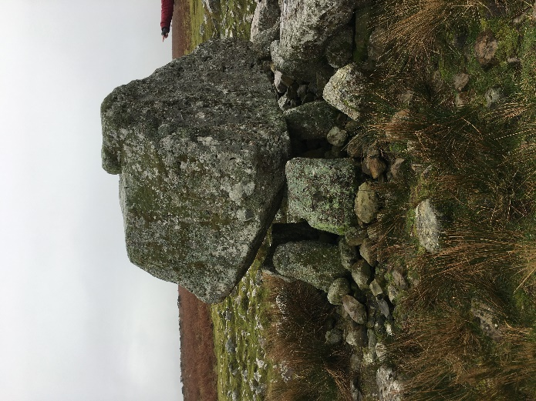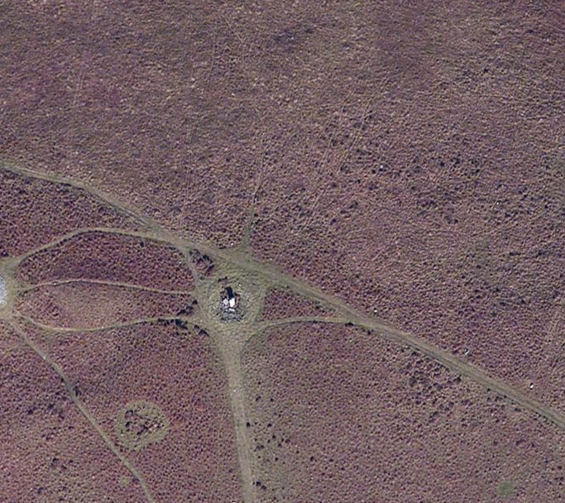
Savage (2019) National Library of Scotland (2018)

Discussion:
To interpret what was seen at the ancient monument of Arthurs stone a visual observation was used to understand how the structure was placed there, why it was placed, what it was made from and even how it became known as Arthurs stone. To understand the reliability of the evidence dating techniques and looking at other sites Called Arthurs stone would have to be looked at and compared in detail. Historical accounts and records will have to be looked at in detail to improve the data source. According to Fleming (2006) If you look beyond what evidence is in front of you, you can then potentially create problems of interpretation. Therefore, any aspect of precise assessment carried out can only improve the accuracy of any findings, as the environment changes over time the landscapes around it also changes through weathering and human activities. Comparing sites of similarity and age give us a better understanding of the monuments themselves. According to Tilley (2007) archaeologists seem to establish a great emotional closeness for different sites they have recorded and excavated in the past. Also working at these locations, they seem to get a heightened sense of self meaning and establish a great connection with these places they can identify with these ancient sites just like the past occupants who lived there would have done.

References:
Fleming, A. Post Processual Landscape Archaeology. A Critique, (2006), pp. 268-278
Savage, A. (2019)
Explore Gower, Arthurs Stone, <http://www.explore-gower.co.uk/arthur-s-stone> [Accessed on 26th January 2019]
The National Library of Scotland, 2018 https://maps.nls.uk/geo/explore/side-by-side/#zoom=17&lat=51.5934&lon=-4.1795&layers=1&right=BingHyb [accessed 26th January 2019]
Tilley, C. Stone Worlds, Narrative and Reflexivity in Landscape Archaeology, (2007), pp.280

