HUMAN RESOURCE MANAGEMENT

Table of Contents
Introduction 3
The current state of the labour market in the UK 3
Changes in the emerging human resource management in the post-Covid, post-Brexit 7
external environment 7
Conclusion 9
References 11

Introduction
Human resource management is a crucial function in any running organisation. Human resource management is involved in the process of recruiting and retaining employees in the organisation. Maintaining a healthy working atmosphere and work culture the human resource management focuses on. Human resource management involves the process of maintaining the right quality and quantity of the workforce in the organisation.

The current state of the labour market in the UK
The UK market has experienced a remarkable job boom in recent years which is recorded in the higher employment rate. The current state of the labour market in the UK is explained on the following grounds:

Economic factors affecting the labour market
The economic background data gives details of the everyday business of HR. The statistical data provided by the UK Office for National Statistics, where most of the statistics are forward-looking and many are backward as well, requires real-time insights into their processes and functions. With these reports, a clear vision of the economic indicators such as unemployment, inflation and GDP can be accessed well. With the current report, the UK employment rate has increased by 0.2 % (commons library.parliament.UK, 2022). With the UK's diverse work sectors, numerous employment opportunities and a good working culture the UK have successfully gained the masses' involvement in the workforce. The continued higher rate of inflation leads to falling in earnings in real terms. The UK has faced continued inflation for three months to June 2022. The changes in the demand and supply of goods and services, the size and composition of the population, and the minimum wage rate required have a substantial impact on the job and labour market.

Balanced demand and supply in the labour market
The labour market in the economy functions on the demand and supply of labour. The demand and supply of labour are dependent upon the bargaining power in the market. The UK has faced a higher inflation rate and a tight labour market, where the number of unemployed people has fallen below the number of job vacancies, and the organisation is retaining their employees with high salaries to retain their skilled staff to the organisation.
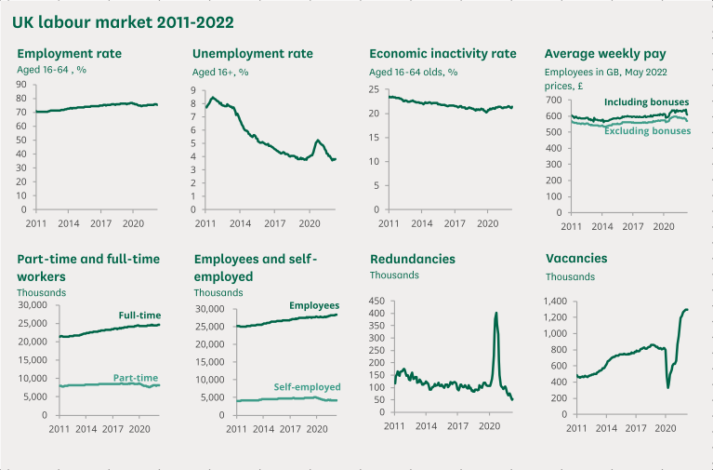

Figure 1: Trends of UK labour market from 2011-2022
(Source: commons library. parliament.UK, 2022)
Though the employment rate has increased from the last quarter, the growth rate of employment is slower. Unemployment and economic inactivity are still increasing at a faster rate. The UK employment rate was 3.8% approximately and 1.29 million people ages 16+ were unemployed. The unemployment level fell by 306,000 since the previous years (commons library.parliament.UK, 2022). Changes in the UK labour market were introduced in 1997 which affects the employment equilibrium of the UK. The equilibrium is hindered due to the underlying favourable aggregates in the labour market which affects the unskilled labour, their creative access and participation, and economic inactivity. Even though the changes in the policy have brought about a change in the youth labour market, the impact on youth employment has increased considerably and reduced child poverty in a way (researchgate.net, 2022). In the above diagram, the changes in the labour market from the year 2011-2022 has been analysed on the grounds of employment rate, the unemployment rate, economic inactivity rate, average weekly pay for the workers, the part-time full-time worker's participation and several vacancies present in this context. The latest labour market indicators show that employment levels have surpassed pre-pandemic levels and the rate of unemployment and economic inactivity show levels of improvement but it's not that much to return to the pre-pandemic position. The service sector has improved, and the number of employees in the service sector, manufacturing sector, and private sector has shown a considerable increase which is the highest on record.

The strong position of the UK labour market
The UK labour market performance was considerably strong with proper mobilisation of resources with a rate of decrease in the unemployment rate in the sector. The more human resources that contribute to the GDP, the greater the amount of labour force contributed to the market leads to an increase in the level of potential GDP. The UK has shown a balanced level in the demand and supply market of the labour force, the increase in the cost of employing people which in turn leads to a fall in the level of human resources. The increasing factor of inflation in the UK shows a constant decrease in the labour demand and supply forces. The demand for goods and services exceeds the amount of potential GDP, there is upward pressure on the prices and costs of the goods and services which ultimately leads to an increase in the level of inflation and the cycle continues. The UK has faced such high inflation due to the post-pandemic and the context of Brexit external environment, the economy’s output is constrained by consumer demand and inputs such as land, labour and capital as well (economy-ni.gov.uk, 2022). The causes of unemployment in the UK can be contributed to the factors such as major causes of cyclical recession demand deficient unemployment, a continuous fall in the GDP causing people to lose their jobs and so on.
The latest indicators such as unemployment
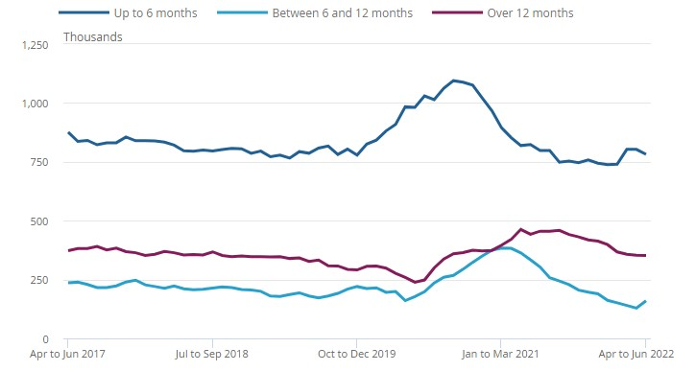

Figure 2: The unemployment rate from 2017 to 2022
(Source: ons.gov.uk, 2022)
Here in this graph, the unemployment rate for the year 2017 to 2022 is shown. The number of people unemployed for up to 12 months has increased over the last three months whereas the increase is offset by the decrease for the last 12 months. The cause behind such changes is the recession that continues over a larger period and structural unemployment that prevails in the UK.
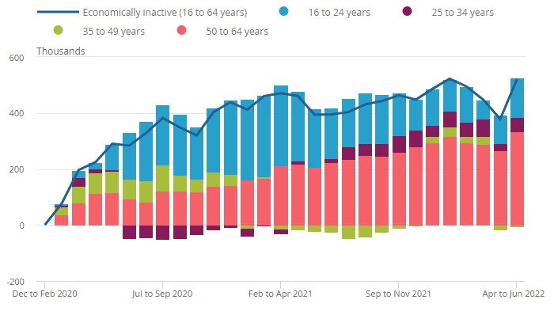

Figure 3: Compound bar graph showing Economic inactivity in the UK
(Source: ons.gov.uk, 2022)
The compound bar graph shows the economic inactivity by age in the UK, aged 16 to 64 years. According to the diagram during the first year of the pandemic Covid-19, the economic inactivity is largely driven by people aged between 16-24 years whereas recently the inactivity has risen to those of 50- 64 years with an increase of over 60% over the pandemic times. Furthermore, a positive effect was seen to decrease economic inactivity for the aged 35-49 years which shows the participation and involvement rate of the independent population in the economic activity. Hence, these data and information play a crucial role in discussing the situation and condition in the present labour market of the UK economy.
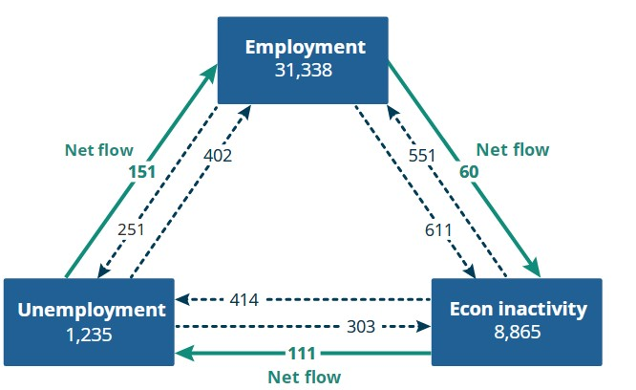

Figure 4: Net flows from economic inactivity to unemployment and from unemployment to employment
(Source: ons.gov.uk, 2022)
The UK flows between employment, unemployment and economic inactivity of people aged 16 to 64 years. The decrease in the employment rate in the latest three-month period was driven by both men and women whereas the decrease in the unemployment rate was mainly driven by women. Furthermore, the rate of unemployment for both men and women has now returned to the position of the pre-pandemic times which shows the improvement in the UK labour market.
The labour force is described as the human factor involved in producing the goods and services for an economy. Thereby finding several people with the right skills to initiate the process of production and services and the economic inactivity thus prevails acts as a barrier to this process of development. Therefore, involving a larger share of labour in the market forces leads to better production of goods and services and overall economic growth and development of the economy is a crucial factor. The pandemic caused enough shortage in the labour force of the UK’s economy as many of the workforce quit their jobs to find a better work-life balance. Furthermore, increased flexibility and compensation and a proper working culture and environment are the need of the workforce or participants involved in the production process. Hence, the UK market has a great presence in the labour market.

Changes in the emerging human resource management in the post-Covid, post-Brexit

external environment

Human resource management in the post-Covid
The HR leaders or the centre of the organisations have a rapid response to COVID -19, they are trying to maintain the workforce engaged and productive in their sphere of working. UK has seen a reduced job performance during COVID-19; human resource management tries to bring in the integration of all the activities in an organisation. The factors related to the HRM in shaping the organisation's performance by assessing the individual areas of performance such as marketing, operations and strategies as a contribution to organisational performance (Collings and Sheeran, 2020). The HR officials give out the trends on working of the human resources post-Covid. They focus on remote working as part of the business offering to the organisation to attract and retain new employees. The UK HR leaders reveal that 65% will be prioritising the recruitment and retention of employees to the organisation, 64% on the well-being and health initiatives. Moreover, 61% will be focussing on the engagement and experiences of the workforce or employees (capterra.co.uk, 2021).
HR also focuses on business flexibility and adaptability skills referring to the competencies and the new working environments they are adapting to. Human resource management also focuses on keeping in the employees, and businesses and retaining their upskilled labour forces in the post-pandemic situation.
The UK human resource management also focuses on training staff to develop skills which are needed for the new working environment and looking after the employee's career paths and keeping the infrastructure intact (Moradlou et al., 2020). The human resource management post- Covid also focuses on collaboration software to keep the business on and continuing with the help implementation software which allows the work from home to the concerned workforce and maintains the level of productivity as well. The HR manager's post- covid continues to combine the offline and online models of recruitment. Introducing video conferencing software thereby faces the digital transformation in the fields of production and services and sets in motion the changes that continue for the period post-pandemic (Jewell et al., 2021). Moreover, the changes brought in the field of human resource management post- covid led to a better talent pool, allowing candidates with better-suited skills to apply for the jobs available with increase the levels of development in an organisation. Maintaining the hybrid tools of the online and offline methods of recruitment post-pandemic will lead to better engagement of the workforce in their sphere of activity (Oseghale et al., 2022). In this regard, maintaining the process of hiring, employee development, digitalization, and better job designs are required strategies for human resource development. Furthermore, a collaboration between the various activities, maintaining corporate social responsibility and proper communication and well-being of the employees are taken into consideration through the changes in human resource management post covid.

The post-Brexit external environment on human resource management
Brexit changes the nature of the formal relationship that exists between the UK and EU. It creates new trade restrictions between the UK and the rest of Europe and limits the mobility of the citizens to move freely around Europe. The effect of Brexit has been anticipated for years and the business has faced certain challenges and issues which are to be solved strategically (Altena et al., 2020). The Brexit external environment has created certain economic volatility which has an indirect impact on the incentives, bonuses and financial pensions and many others (ashurst.com, 2021). The cost of doing business has increased in the Brexit period due to the new trade agreement where the UK is not following the rules and regulations on this ground the various changes are noticed to be altered on the financial grounds. Moreover, on this aspect, human resource management needs to focus, as the government is changing legislation and the organisation should keep their business parallel to the increased business and administrative costs. Brexit has also impacted the recruitment processes by controlling overseas recruitment to the UK where the HR officials should support the incoming talents by securing approval from the regulators regarding the appropriate qualifications before they arrived in the UK (Dupont et al., 2019). Every industry was affected by Brexit, on the grounds of economic constraints such as recession and reduced investment in businesses and other spheres of activity. Brexit has the following positive impact as well for example making more opportunities in the vibrant market as well, gathering a deeper talent pool of human resources as well.
The human resource management acknowledges the salary differences for instance if an employee is employed in the UK and is working overseas a negotiation is done based on the local market pay data which will gain an advantage for both the business and the employee as a whole. The human resource management after the post-Brexit external environment also focuses on transparency with the employees. Not only it is creating new regulations and rules for businesses it also affects the employee's mental health (lattice.com, 2021). Human resource management should aim at developing trust within the businesses and focussing on organisational leaders to navigate the information to the employees concerned. The post-Brexit external environment has an impact on HR as they will face challenges in coping with the legislative changes and thereby be involved in the process of engagement of the workforce by hiring and retaining it. The HR post-Brexit situation takes certain strategies such as conducting an audit of the workforce employed, where the employees residing in the UK for 6 years are eligible to get British citizenship and thereby comes under the obligations of paying tax by the employers and employees as well. Moreover looking into the various options for the overall improvement of the employees in the sphere of their activity is a concern for HR. HR even focuses on communicating with the employees; a lack of communication may lead to disagreement, the spread of rumours, and lower levels of engagement and morale value. Maintaining a longer lead time to include a larger skilled workforce in an organisation and increase productivity (Zawada et al., 2020). Hence, HR also focuses on creating a proper task force to integrate the activities and communicate well with their employees to maintain their operations effectively.

Conclusion
The responsibility of human resource management is hiring, providing employees compensation and benefits and defining and designing the working framework. Human resource management focuses on re-establishing the culture of the organisation, making a more flexible working environment and adaptability the employees to the new sphere of work. Human resource management focuses on digitalization and implementing new software in the sphere of activity to retain the workforce in the organisation. Human resource also focuses on hybrid working models where they can benefit from both offices working and remotely working cultures. Therefore, it can be concluded that the current situation of the labour force in the UK has shown a decrease in the participation rate post-pandemic and it is trying to recover the situation with proper management enforcement.

References
Altena, E., Baglioni, C., Espie, C.A., Ellis, J., Gavriloff, D., Holzinger, B., Schlarb, A., Frase, L., Jernelöv, S. and Riemann, D., (2020). Dealing with sleep problems during home confinement due to the COVID‐19 outbreak: Practical recommendations from a task force of the European CBT‐I Academy. Journal of sleep research, 29(4), p.e13052.
Ashurst.com (2021). “The impact of Brexit: top 10 HR issues”. Available
at:https://www.ashurst.com/en/news-and-insights/insights/the-impact-of-brexit---top-10-hrissues/ [Accessed on: 13th August 2022]
capterra.co.uk (2021).”5 key HR trends for UK businesses in 2021”. Available at: https://www.capterra.co.uk/blog/1846/5-hr-trends-for-uk-businesses-in-2021[Accessed on: 13th August 2022]
Collings, D.G. and Sheeran, R.,( 2020). Research insights: Global mobility in a post-covid world. The Irish Journal of Management, 39(2), pp.77-84.
Commons library. parliament.UK “UK Labour Market Statistics”.(2022). Available at: https://commonslibrary.parliament.uk/research-briefings/cbp-9366/[Accessed on: 13th
August 2022]
Dupont, Claire, and Brendan Moore. "Brexit and the EU in global climate governance." Politics and Governance 7, no. 3 (2019): 51-61.
economy-ni.gov.UK(2022).” Labour Market Statistics”.Available at: https://www.economyni.gov.uk/news/labour-market-statistics-43[Accessed on: 12th August 2022]
Jewell, P.D., Bramham, K., Galloway, J., Post, F., Norton, S., Teo, J., Fisher, R., Saha, R., Hutchings, S., Hopkins, P. and Smith, P., (2021). COVID-19-related acute kidney injury; incidence, risk factors and outcomes in a large UK cohort. BMC nephrology, 22(1), pp.1-12.
Lattice.com (2021).“4 Ways HR Can Navigate Brexit’s Impact on UK Business” .Available at: https://lattice.com/library/4-ways-hr-can-navigate-brexits-impact-on-uk-business [
Accessed on: 12th August 2022]
Moradlou, H., Fratocchi, L., Skipworth, H. and Ghadge, A., (2020). Post-Brexit back-shoring strategies: what did UK manufacturing companies could learn from the past? Production Planning & Control, pp.1-18.
Ons.gov.uk, (2022). ”Employment in the UK”. Available at:
https://www.ons.gov.uk/employmentandlabourmarket/peopleinwork/employmentandemploye types,[Accessed on: 12th August 2022]
Oseghale, R., Ochie, C., Dang, M., Nyuur, R. and Debrah, Y., (2022). Human Resource
Management Reconfiguration Post-COVID Crisis. In Organizational Management in Post-Pandemic Crisis (pp. 139-159). Springer, Cham.
researchgate. net(2022) .“The Recent Performance of the UK Labour Market”. Available at: https://www.researchgate.net/publication/5216164_The_Recent_Performance_of_the_UK_L abour_Market [ Accessed on: 13th August 2022]
Zawada, P., Okrasa, W. and Warchalowski, J., (2020). Flow management system for maximising business revenue and profitability. Statistics in Transition new series, 21(5), pp.193-206.

