University of Wales Trinity Saint David
Structure and Properties – Laboratory Report
BEng Materials Science – L5 M5X01185

Briony Morgan
Declaration: I declare that this assignment is all my own work and that I have acknowledged all material used from the published or unpublished works of other people. All references have been duly cited.
Due to the coronavirus pandemic some of the data collection procedures have been compromised and as a result some of the data referenced in the report have been obtained through research methods or historical studies.

An Investigation to Determine how the Percentage of Carbon in Steel Affects its Mechanical Properties and Crystalline Structure

Table of Contents
Introduction 3
Investigation Scope 3
Purpose of Findings 3
Literature Review 3
Manufacturing Methodology and Conditions 3
Iron and Steel Making 3
Casting and Cooling 4
Rolling 6
Defects 6
Phase Diagrams 6
Hypothesis 7
Investigation Predictions based on Research 7
Fair Testing 8
Experimental Procedure 8
Sample Selection Process 8
Tensile Testing and Mechanical Properties 9
Optical Microscope and Crystalline Structure 10
Results and Discussion 11
Raw Data 11
Metallurgical 11
Microscopic 14
Visual Aids and Trends 15
Observations 17
Stress-Strain Graphs 17
Grain Formations 17
Anomalies and Deviations 17
Conclusions 18
Findings 18
Successes 18
Errors 18
Recommendations 18
Works Cited 19

Introduction

Investigation Scope
An investigation was conducted to determine how the percentage of carbon in steel affects its mechanical properties and crystalline structure. A series of tensile tests were carried out to measure properties such as strength, hardness and ductility.
Additionally, corresponding steel specimens underwent microscopic analysis to observe grain structure patterns and chemical composition.

Purpose of Findings
Innovative steel manufacturing is fundamental in advancing transformational technology; new products rely on evolved steel grades that are stronger, lighter and more flexible to adapt to harsher environments, withstanding tougher conditions.
Studying how chemical compositions of steel alloys effect its product performance provides opportunities to manipulate manufacturing conditions to create more advanced steel and cater to new technological requirements, inspiring modernisation.
(Allwood, 2016)

Martin Brunnock, the UK Technical Director of Tata Steel: “Steel is playing an essential role in helping to solve major societal challenges such as the transition to sustainable energy and mobility, and it’s vital we can keep pace through the faster development of innovative steel products.”
(Scitech, 2018)

Literature Review

Manufacturing Methodology and Conditions

Iron and Steel Making
Steelmaking is the creation of steel from raw materials; Iron ore, sources of carbon and limestone are heated in a furnace to produce iron. This product is refined in a converter by removing tramp elements and excess carbon, adding various amounts of alloying elements to produce different grades of steel.
(Bell, 2020)
Figure 1 (Barrington, 2020)

Figure 2 (Jamie Short, 2018)

Casting and Cooling
Following the converter, the molten steel is solidified into a slab via a casting process. The nature of casting decides how much remaining impurities are left and where they are located;
(Louhenkilpi, 2014)

- Curved casting will allow impurities to rise up until blocked, more impurities will remain at the top surface. The Advantage to this method is reduced strain exerted on the slab during rolling.
- Straight casting enables all impurities to rise to the top and will not remain in the casted slab. Consequently, no horizontal stress is applied to the slab resulting in more stress during hot rolling.
Figure 3 (Louhenkilpi, 2014)

During cooling steel converts from a liquid to a solid phase, a new surface is created during phase separation. The energy required for this to occur is dependent on the liquid solid interface (grade boundary); the liquid must cool below its equilibrium freezing temperature. Excessive low temperatures will undercool the material to initiate the solidification process (figure 5). High degrees of undercooling will result in more spontaneous solidification, meaning less control over the final grain structure (figure 4). Longer cooling periods produce larger grains where rapid cooling (quenching) will form larger quantities of smaller grains, making the material harder and more brittle.
Figure 4 (Paramita, 2016) Figure 5 (Jayawardena, 2017)

Heat conducts from the liquid phase to the newly formed solid phase, the latent heat of solidification releases at the liquid/solid interface. Consequently, the heat is conducted away from the interface and a temperature gradient is established; a steeper gradient means the liquid/solid interface becomes unstable and protrusions can occur at a faster rate. The increased growth of protrusions at the liquid/solid interface will convert a flat interface to a dendritic structure (figures 6 and 7).
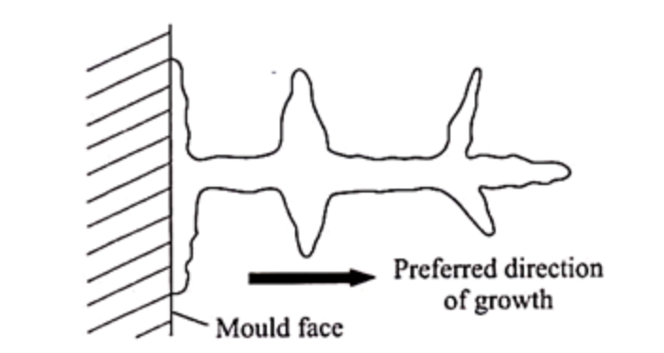
Figure 6 (University of Cambridge , 2007) Figure 7 (Paramita, 2016)

Rolling
Post casting, the slab is hot rolled at approximately 1200 degrees Celsius, the temperature must be high enough to recrystalise the steel, altering the microstructure and mechanical properties to change its thermochemical state.
The steel is work hardened as strain is exerted during rolling and dislocation density increases. Grains elongate during dynamic recrystallisation (figure 8).

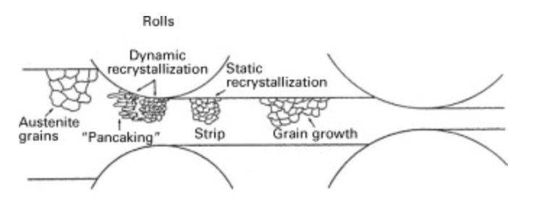
Figure 8 (K.H. Jürgen Buschow, 2001)

Recrystallisation occurs producing finer grains due to retained stress within the slab; finer grain austinite converts to ferrite during subsequent cooling, the material will have higher yield and tensile strength properties.
(K.H. Jürgen Buschow, 2001)

Defects
Defects can arise in solids and are categorised into the following;
Point
Planes of atoms are distorted by vacancies and/or self-interstitial atoms within the structures
Line
Dislocations in the structure are line defects, they cause slipping between crystal planes when moving. They produce permanent plastic deformation.
Area
Grain boundaries between crystals are produced by the solidification process. They have a change in orientation and impede dislocation motions.
(D.Rodney, 2009)

Phase Diagrams
Phase diagrams are based on homogenous properties and physically different compositions within a system – changes in phase.
The diagrams identify the phase of a material given the temperature and pressure environments. It demonstrates the point materials undergo phase transformation. This occurs when the current state of the alloy is unstable in relation to its final state.
(Clark, 2014)
The eutectic point (figure 9) illustrates where solid steel transitions immediately to liquid without a liquidous stage. The critical temperature must be exceeded to reach melting point.
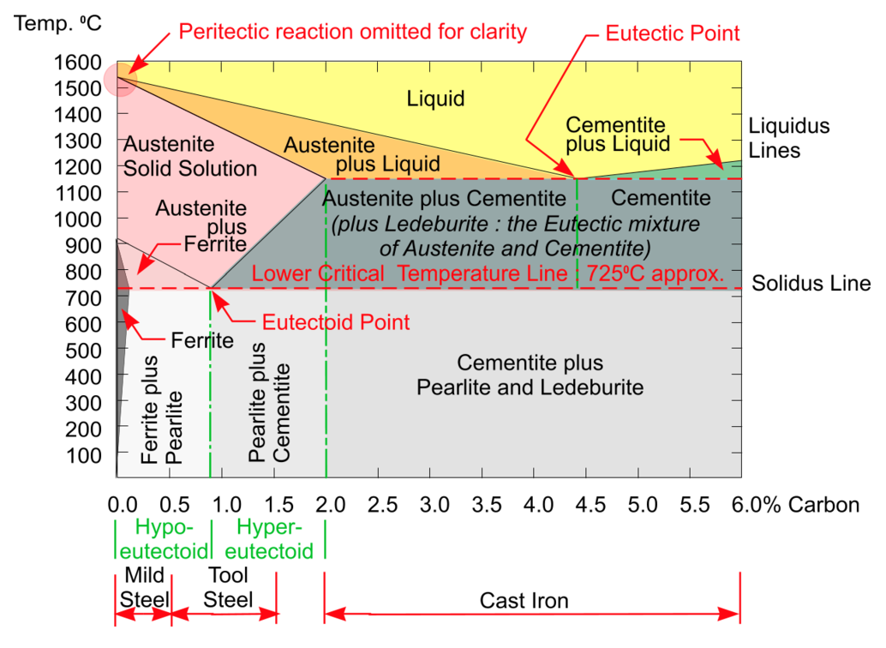
Figure 9 (DT Online, 2017)

Phase stability can be measured using thermodynamics; the relative stability of systems are determined by Gibbs free energy, a theory developed by Josiah Willard Gibb in 1870.
At its most stable, a system is in equilibrium with the lowest possible value for Gibbs free energy.

Hypothesis

Investigation Predictions based on Research
At the converter the chemical composition of steel is determined, the investigation will analyse how different quantities of carbon will affect the mechanical properties and crystalline structure. Steel manufacturing and material properties research provided a basis for following predictions.

- Higher quantities of carbon in steel result in harder, more brittle properties.
(Heikki Jalkanen, 2014)
- Steels containing less than 0.8% carbon (hypo-eutectic steel) solidify into a two-phase structure containing ferrite which is soft and ductile. It can also form layered ferrite and cementite (pearlite) which is hard and brittle.
- More cementite produces harder steels, whereas more ferrite produces softer steels.
- At 0.8% carbon (eutectoid steel) only perlite will form.
- More martensite will form in higher carbon concentrations.
(DT Online, 2017)

Despite chemical composition being established, further processing techniques can alter the mechanical properties in the following ways.
- Steel has higher ultimate tensile strength when cooled slowly due to added cementite, slower cooling will allow larger grains to form creating space for defects.
- Quenching austinite prevents the carbon atoms dissociating, the material will remain hard and brittle.
- Rolling steel can be customised to produce specific properties; work hardening the steel will strengthen, where tempering will increase elongation.

Fair Testing
To mitigate bias, the following control factors were implemented to isolate one dependent variable – carbon quantity.

- Selecting one grade of steel to analyse low, medium and high amounts of carbon.
Grades have specific tolerances for chemical variation which will eliminate other chemicals affecting properties while ensuring carbon content is relatively constant.
- Test specimens taken from the same location relative to the steel coil. Each sample will be taken from the quarter width position ensuring results are comparable.
- Using the same apparatus will eliminate machine variation and equipment error during testing.
(Jon T. Selvik, 2020)
- Taking samples that have undergone identical casting and rolling conditions guarantees the same processing temperatures and pressures.

Experimental Procedure

Sample Selection Process
The steel grades representing low, medium and high amounts of carbon are shown below (figure 10). Chemical compositions were predetermined for specimens using optical emission spectrometry (OES).
(Mengtian Li, 2018)

Category | Specification | Carbon Tolerance (%)
Low Carbon | Ultra-Low Carbon | 0-0.0035
Medium Carbon | Medium Carbon | 0.04-0.06
High Carbon | Advanced High Strength Steel – Duel Phase | 0.12-0.15
Figure 10

50 tensile tests were carried out on each grade, the nature of destructive testing does not allow retesting so to improve the repeatability of results and determine a more reliable conclusion a large sample pool was tested.
10 steel samples covering a wide range of carbon compositions will be prepared for microscopic analysis to assess the grain structure.
Anomalous test results will be omitted from final calculations.
To standardise testing and prioritise safety while testing, safe working procedures were adhered to and risk assessments considered.

Tensile Testing and Mechanical Properties
Full width steel samples were collected from production units. At the quarter width position standard 250mm by 38mm strips are sheared in preparation for machining.
Strip samples are milled into tensile specimens in accordance with testing standard BS EN ISO 6892-1:2016. Specimen dimensions were homogeneous throughout the investigation.

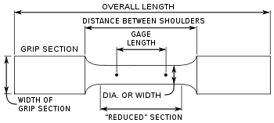
Figure 11 (Davies, 2010)

Machines are calibrated using UKAS standards prior to testing, certifying machine accuracy and reliability. Additional calibrations take place post testing, certifying no data drift. All testing took place in a lab at controlled room temperature.
Automated tensile machines tested the milled specimens. Robot arms selected specimens to measure the gauge and prior to placement between two hydraulic grips. A pulling force is applied to separate the grips and specimen, measuring how it responds to stress. The specimen’s parallel length will experience strain, reduce in width at an area of weakness (necking) until facture (figure 12).
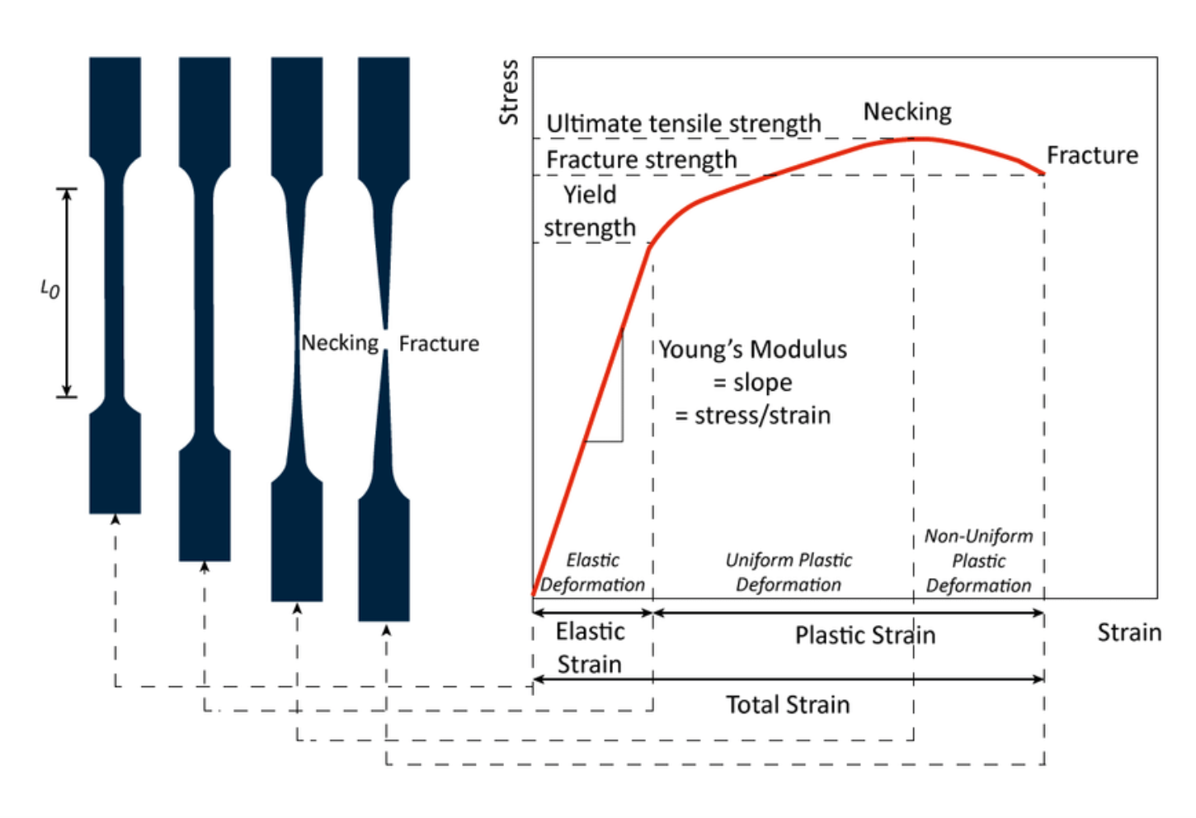
Figure 12 (Yalcin, 2017)

The standard states that if breakage occurs outside or at the parallel length, results are invalid and will not be included in calculations.
Automated testing systems ensure that human error will not affect data and standardise testing.
Stress and strain data were collected throughout testing, producing graphs for each specimen (example figure 12).
(Jörg Uhlemann, 2020)
The following mechanical properties were calculated individually and collated to analyse patterns and relationships:

- Ultimate tensile strength measures the maximum stress a specimen sustains.
(Satoshi Sumikawa, 2017)
- Hooke’s law is obeyed during the initial stages of testing where stress and strain is proportional, Young’s modulus was calculated, described as the modulus of elasticity. This measured the material’s stiffness.
(Kohout, 2001)
- Yield strength identifies at which applied stress the material reaches its proportional limit; before the yield point, materials show elastic deformation whereas this point materials demonstrate plastic deformation (will not to return back to its original shape).
- Gauge values are used in determining calculations, they will be recorded and considered relative to the mechanical data obtained.
(Instron, 2017)

Optical Microscope and Crystalline Structure
Full width steel samples were collected from production units; at quarter width position a 10mm by 10mm sample was sheared in readiness for preparation.
The metallographic specimens were cold mounted as high temperatures can affect the integrity of the sample. Clear resin is required to view embedded features, and excellent edge retention essential to accurate readings.
Samples were submerged into a hardener and resin combination and left to solidify in a vacuum.
Optical microscopes use light and magnified lenses to observations objects the naked eye can’t see, cameras capture these images for evaluation. Sample surfaces were polished, providing a clear microscopic image.
(Gianfrancesco, 2017)
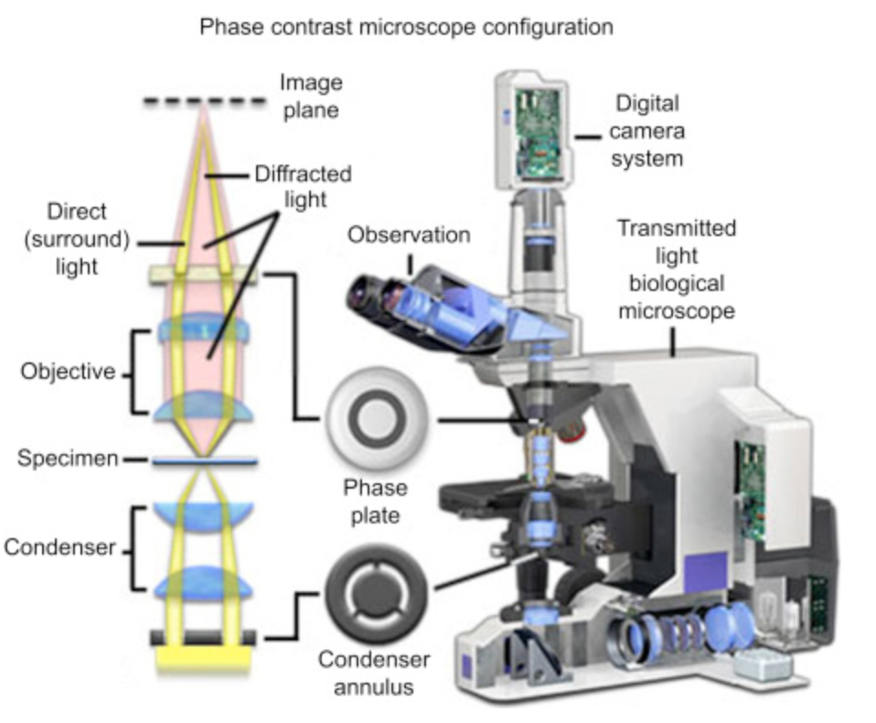
Figure 13 (Gianfrancesco, 2017)

Results and Discussion

Raw Data

Metallurgical
Figure 14

Figure 15

Figure 16

Microscopic
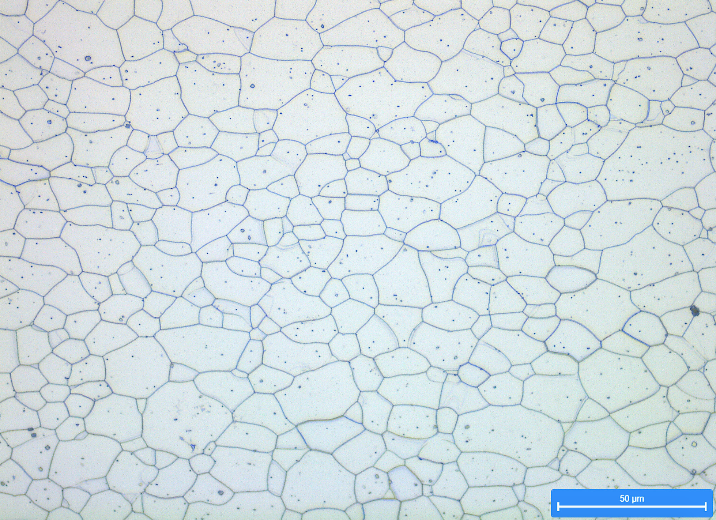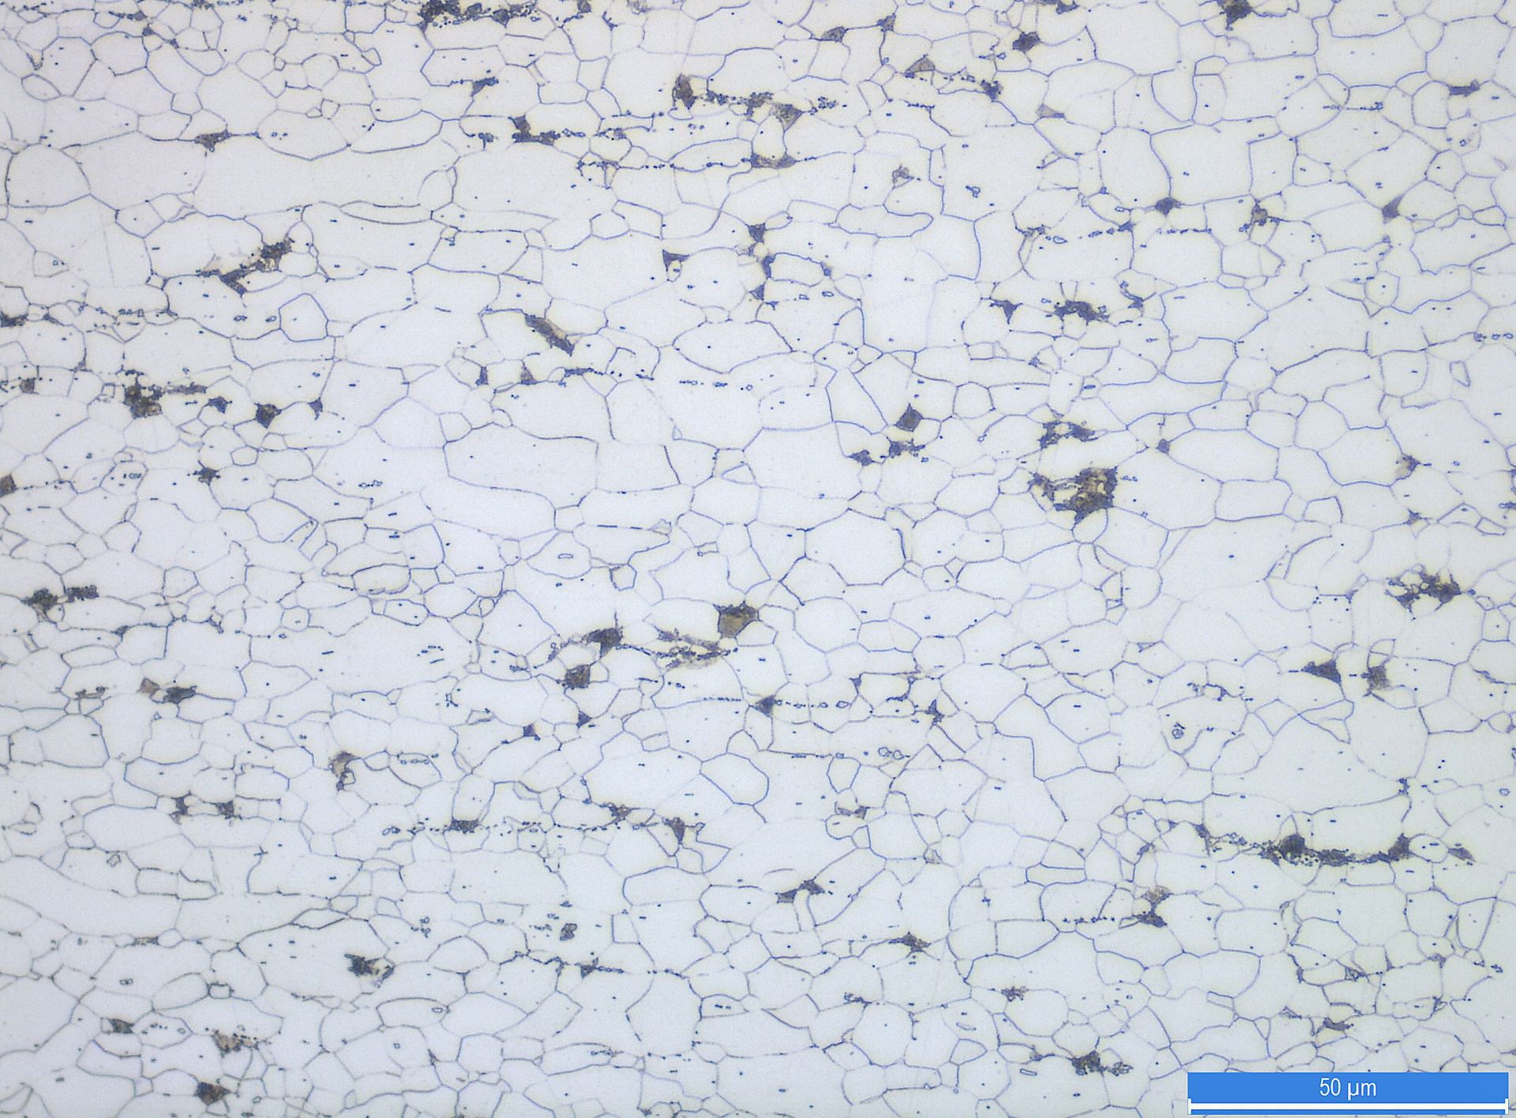
Figure 17 Ultra Low Carbon Figure 18 Low-Medium Carbon
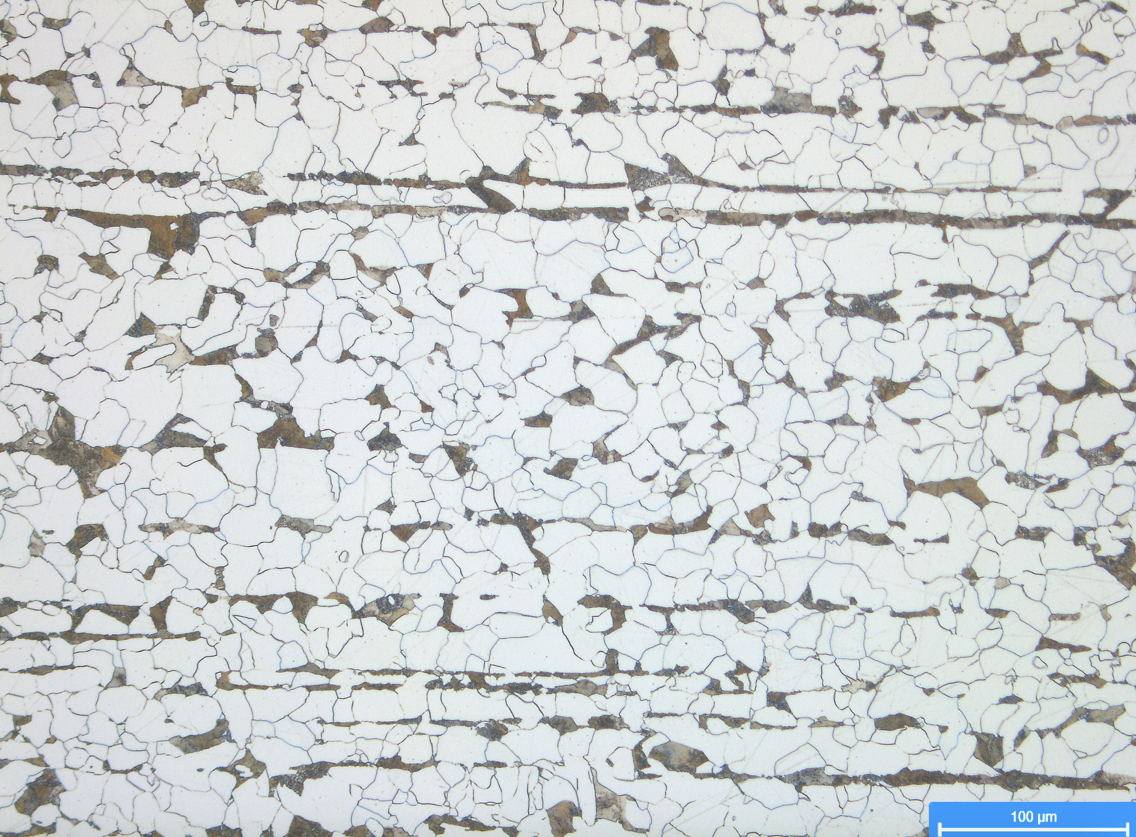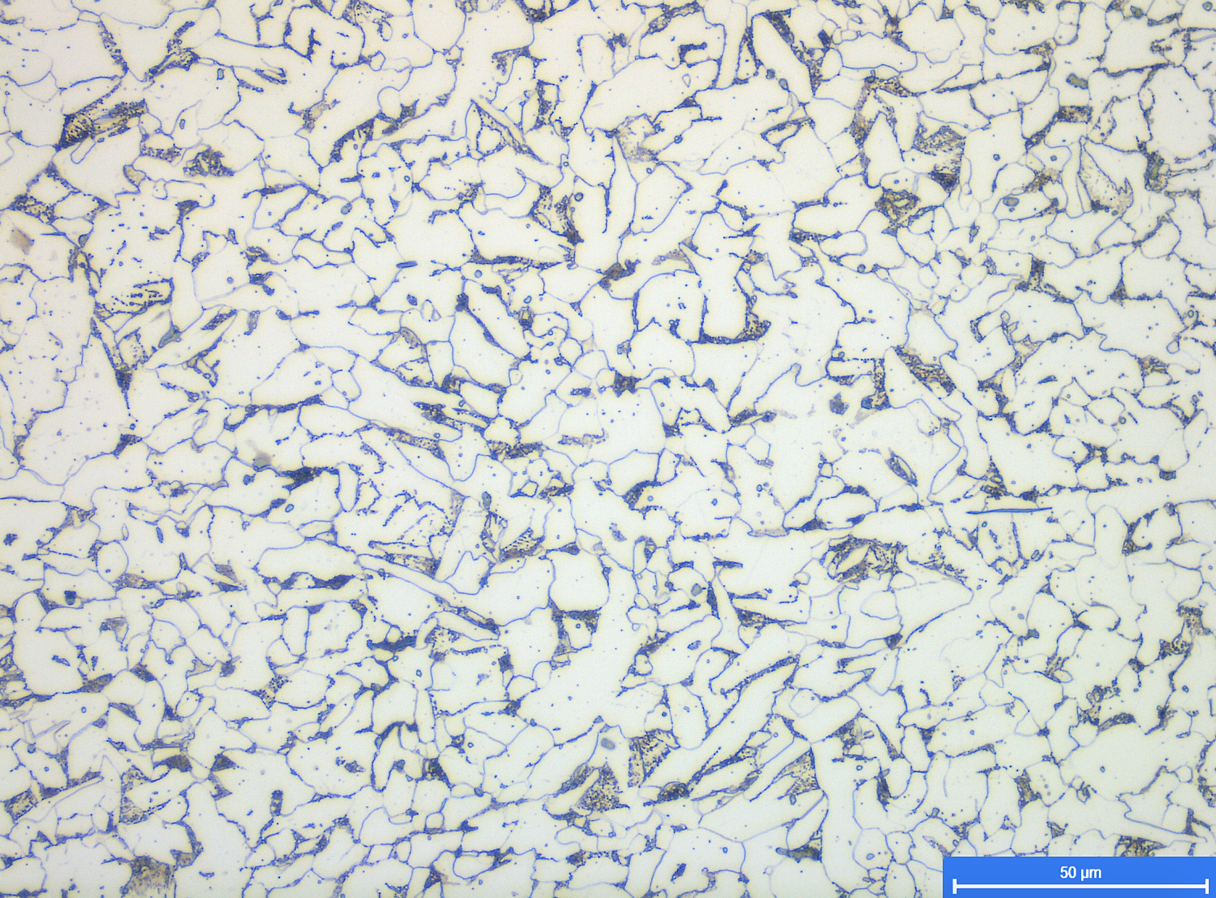
Figure 19 Medium Carbon Figure 20 Medium Carbon
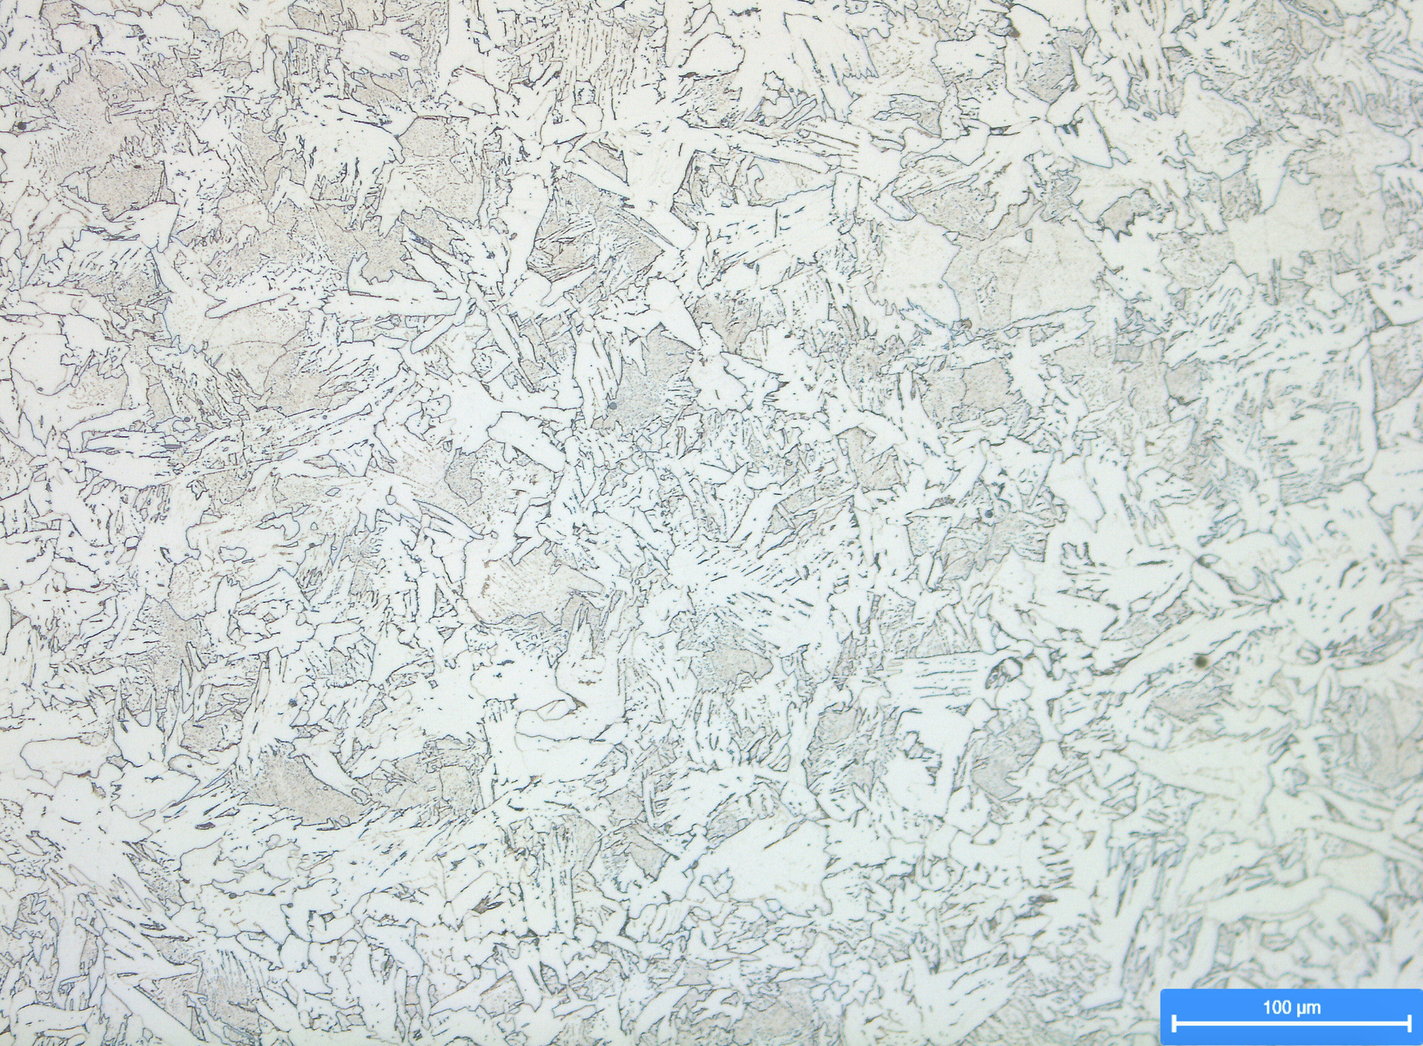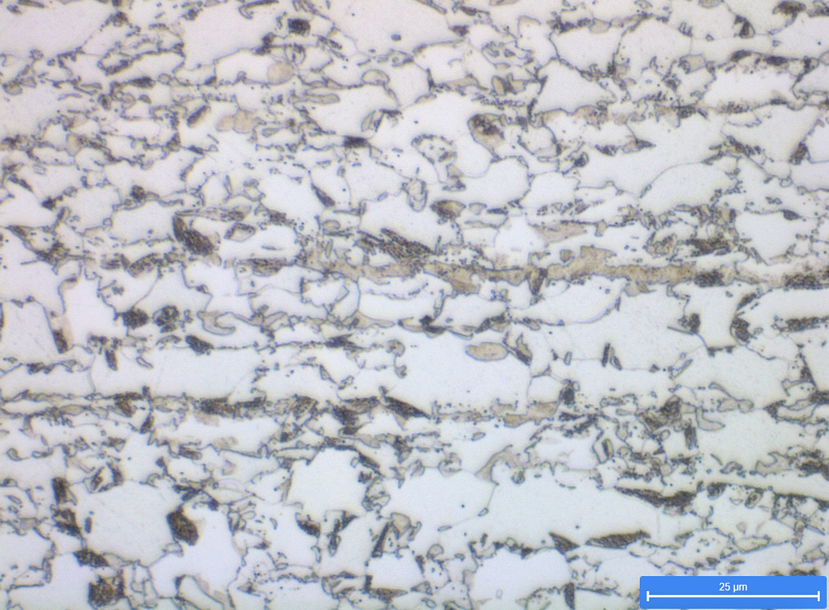
Figure 21 Medium Carbon Figure 22 Duel Phase High Carbon
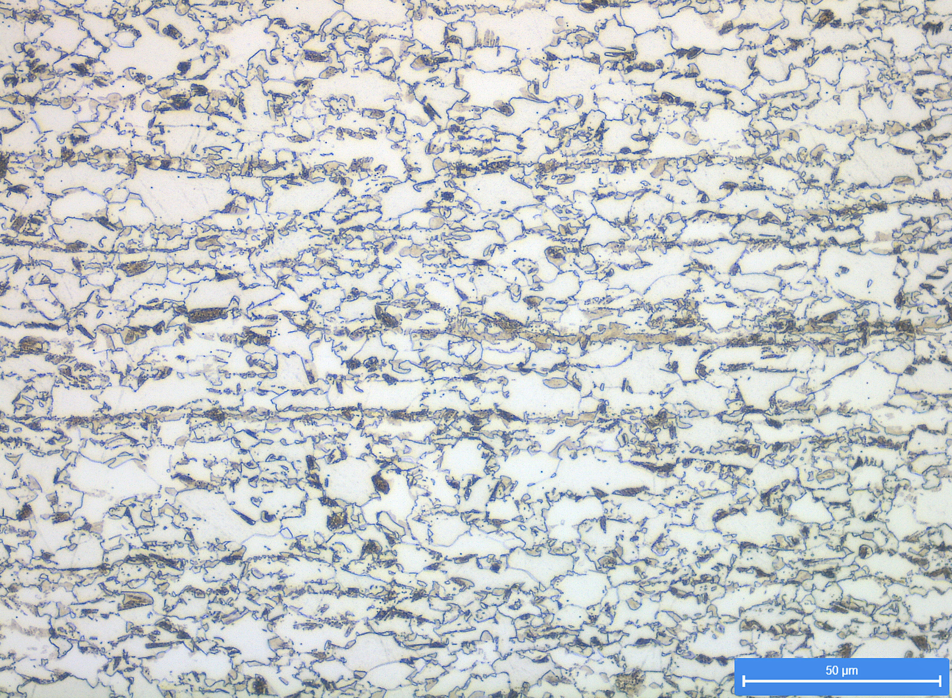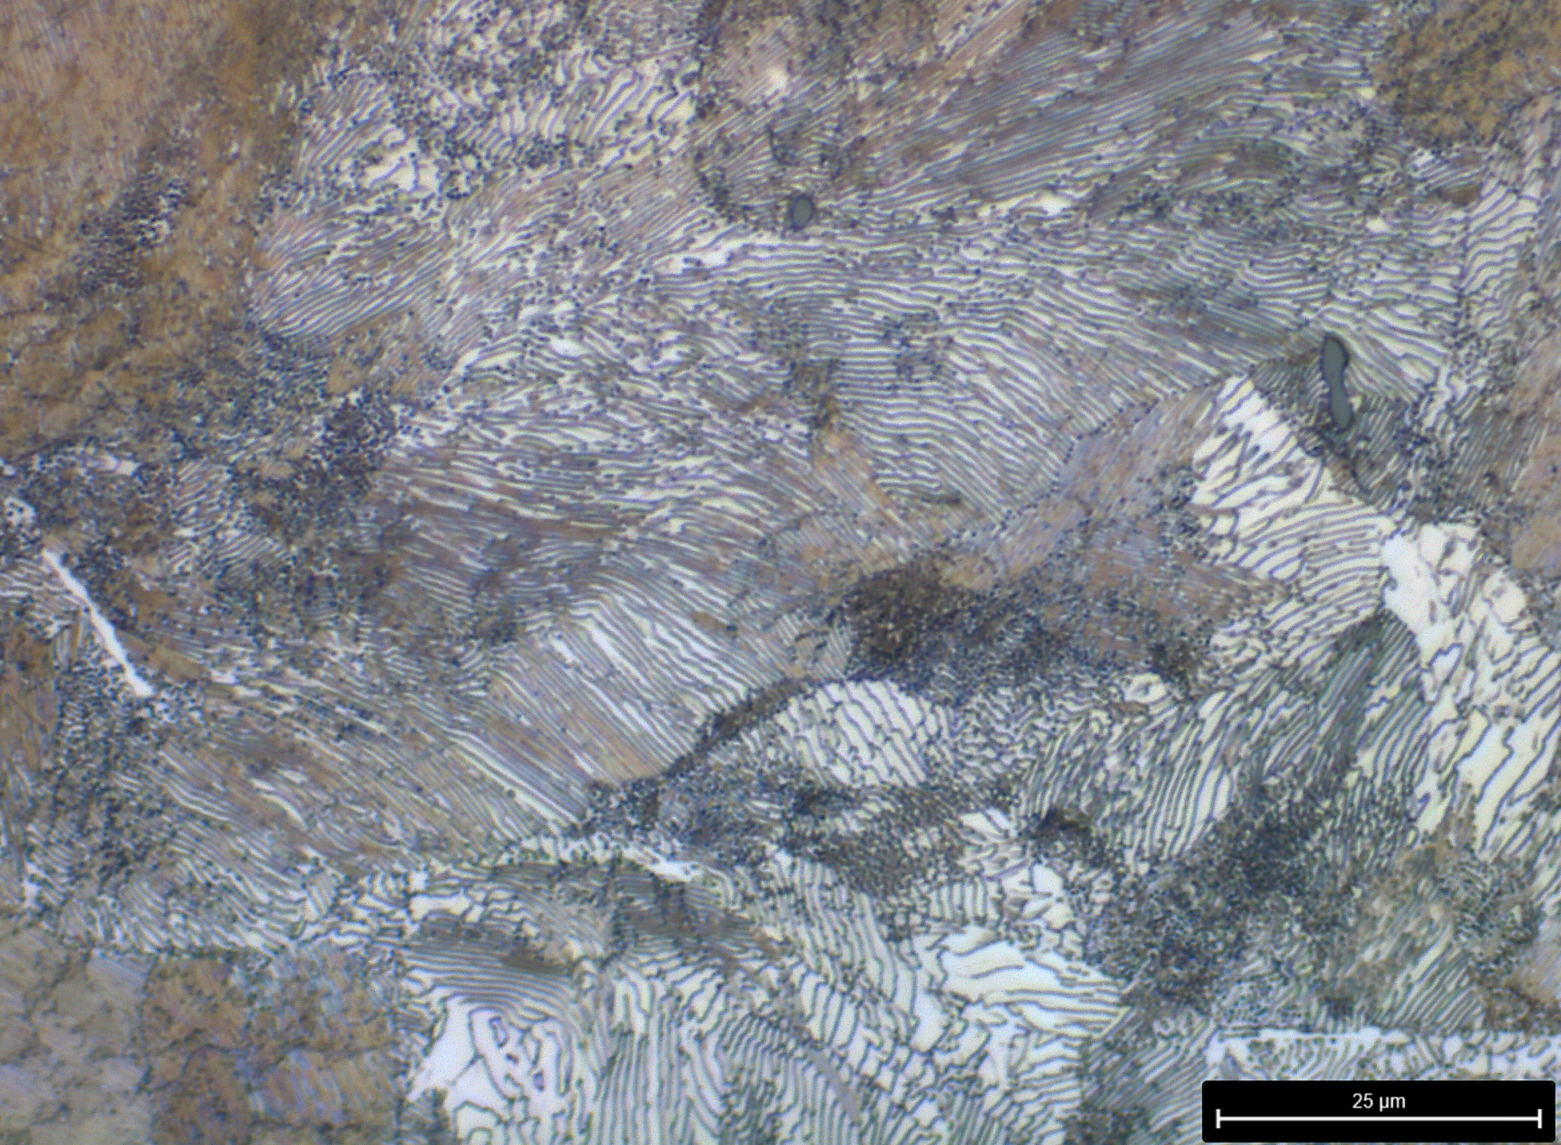
Figure 23 Duel Phase High Carbon. Figure 24 High Carbon
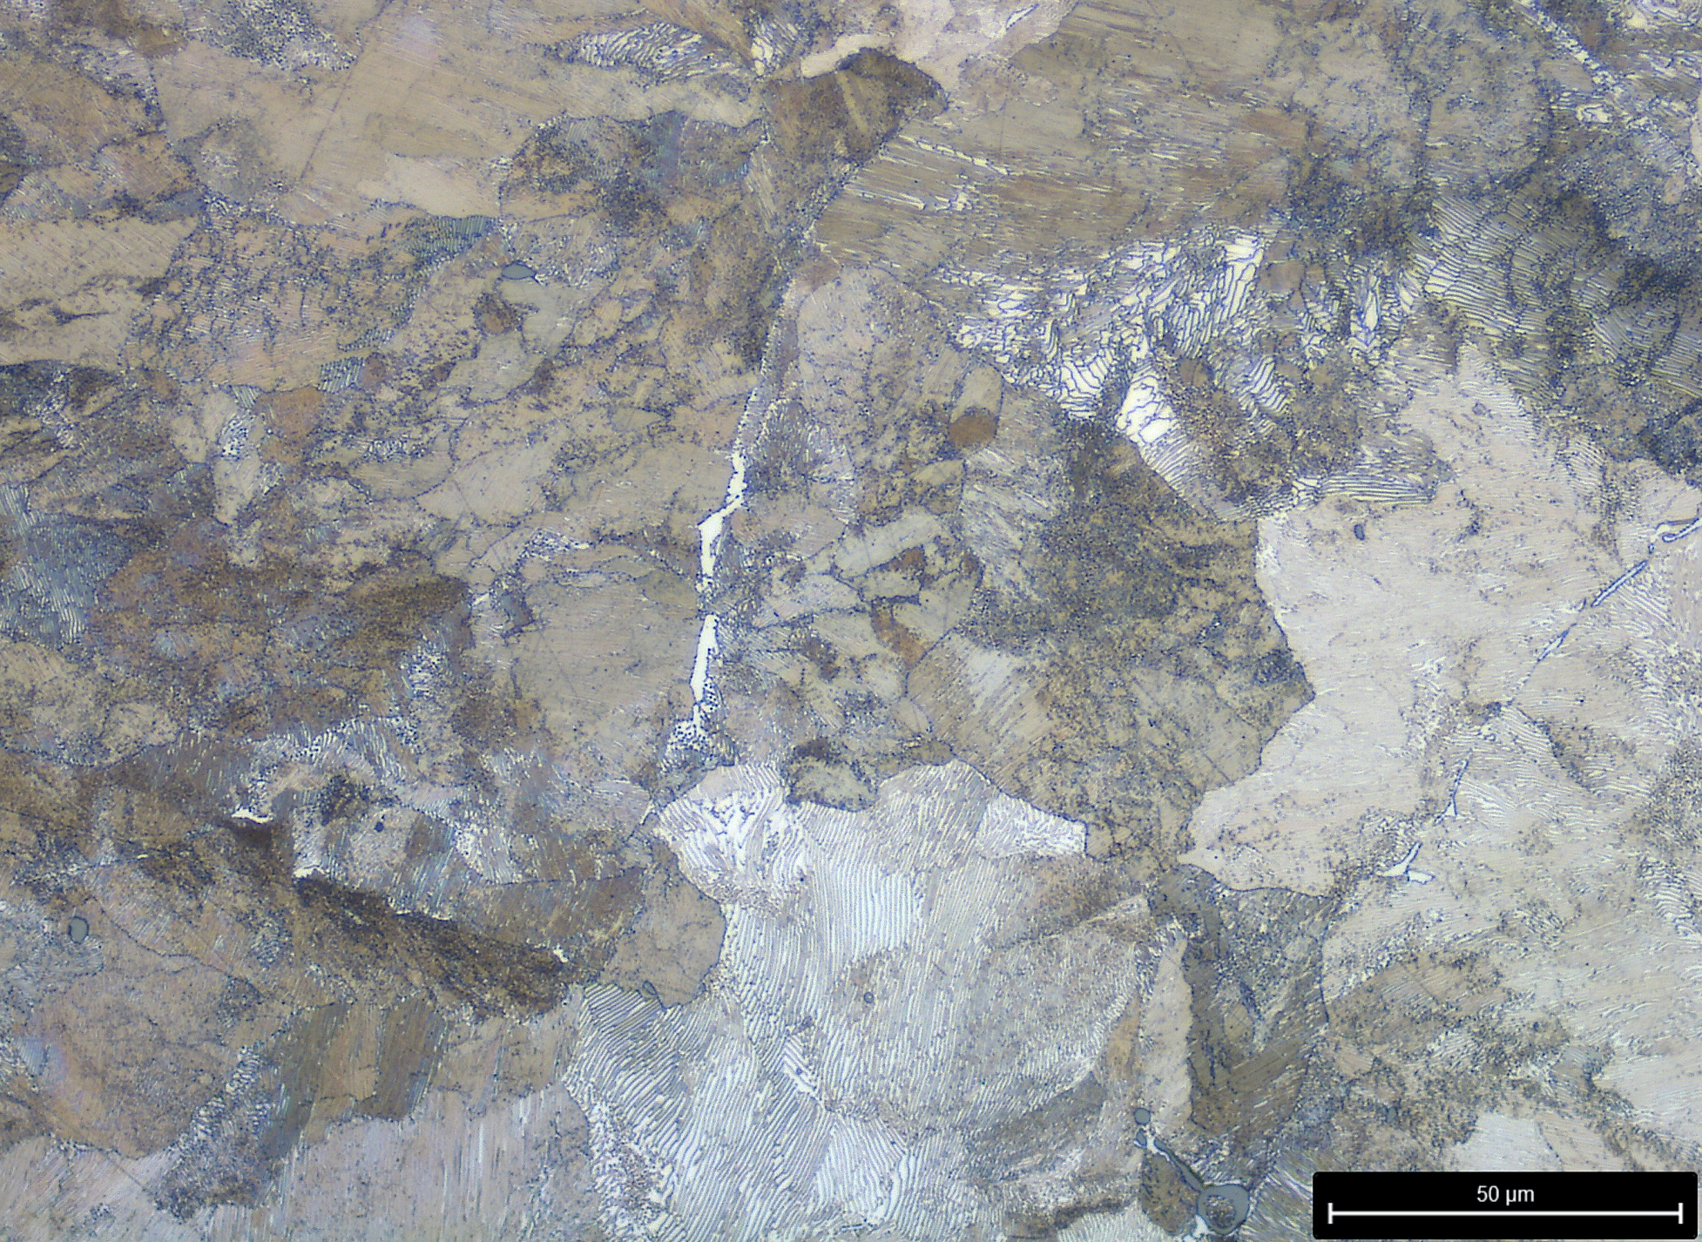
Figure 25 High Carbon

Visual Aids and Trends

Figure 26 Carbon against Elongation

Figure 27 Carbon against Ultimate Tensile Strength

Figure 28 Carbon against Yield

Variance (low C%) | 2.047937
Variance (medium C%) | 9.354551
Variance (high C%) | 9.617238
Figure 29 Variance in Data

Variance (gauge) | 0.447894
Average (gauge) | 1.677447

Figure 30 Variance in gauge values

Observations

Stress-Strain Graphs
- Figure 26 plots carbon content against total elongation, the trend line identifies that for every 0.01% increase in carbon, elongation will increase by 2.05% relative to original size.
- Figure 27 shows positive correlation between carbon content and ultimate tensile strength (UTS); for every increase of 0.01% of carbon, UTS increases by 41.75 MPa.
- The steels yield increases by 25.49MPa when the percentage of carbon increases by 0.01%, shown in figure 28.
- Calculations in figure 9 show the variance between mechanical results, it was determined that the lower carbon grade displayed four times less variance than the medium and high carbon grades.
- A determination co-efficient was calculated for each correlation, all values were higher than 0.8, representing significant statistical relationship.

Grain Formations
- Where low-medium amounts of carbon were present (figure 18), pearlite and ferrite grains form.
- Medium grade carbon steels demonstrated a combination of grain formation. Ferrite and banded pearlite (figure 19), ferrite/pearlite/bainite (figure 20), and ferrite/bainite (figure 21).
- Duel phase steels (figure 22 and 23) evidence black bainite, brown patches of martensite but mainly ferrite grains.
- Where high amounts of carbon were present (figure 24 and 25), a fully pearlite structure was formed.

Anomalies and Deviations
Three medium carbon test specimens displayed anomalous mechanical properties (circled in red). These outlier results were deemed invalid and excluded from all calculations.

Conclusions

Findings
The investigation led to conclusions regarding mechanical and microscopic properties.
(Patricia Martin-Rodilla, 2018), (Neimitz, 2014), (Nobuyuki Ishikawa, 2015)
The negative correlation shown in figure 26 exhibits lower elongation with increasing carbon, suggesting steels containing more carbon will be less ductile and malleable.
A positive relationship in figure 27 implies that steel is stronger and can withstand larger stress capacities before fracture when more carbon is present.
Figure 29 indicates that increasing carbon content increases yield, ultimately meaning the steel is harder.
Larger ferrite and pearlite grains form when steel is cooled slower whereas smaller ferrite and bainite grains form at quicker cooling rates.
Martensite grains form when high amounts of carbon are present giving steel it’s high strength properties.

Successes
Research was conducted to develop an understanding which led to the foundations of a successful hypothesis.
Large pools of data were collected to establish relationships between chemical composition and metallurgical properties in steel.
(Marta Fernandes, 2019)

Errors
A series of errors were considered during the initial stages of the investigation and were eliminated or minimised where possible. The following factors have been controlled to an extent but could have compromised the investigation;
- Varying specimen gauge can skew the data, the average gauge value was 1.67 with a variance of 0.45 (figure 30) which is relatively low. Gauge is used in strength and yield calculations; lower gauge values would increase these values.
- Despite samples undergoing consistent processing conditions, it’s impossible to accurately measure and regulate temperatures and pressures during large scale manufacturing. This can affect how and what grain structures form.
(Branko Štrbac, 2020)
- Grade tolerances control the chemical composition for all elements within the steel, although slight variances (within tolerance) can alter both mechanical and microscopic properties. Example shown in figure 19,20,21 where manganese is present.

Recommendations
Based on investigation outcomes the following recommendations have been outlined to improve accuracies and the validity of findings if repeated;
- To ensure results are repeatable and reliable, a larger quantity of data would be collected to identify outliers and provide clarity on correlations.
- Data clusters of low, medium and high carbon materials are identified in figures 26,27 and 28; to determine a more accurate line of best fit, samples would be tested representing all amounts of carbon, producing a continuous spectrum of data.

Works Cited
Allwood, J. M. (2016, April). A bright future for UK steel. Retrieved from University of Cambridge: https://www.cam.ac.uk/system/files/a_bright_future_for_uk_steel_2.pdf
Barrington, C. (2020, October 1st). Pig Iron Production - Blast Furnace Route. Retrieved from Iron Metallics Association: https://www.metallics.org/pig-iron-bf.html
Bell, T. (2020, January 14). Manufacturing Process. Retrieved from The Balance: https://www.thebalance.com/steel-production-2340173
Branko Štrbac, B. A. (2020). Investigation of the effect of temperature and other significant factors. Serbia: Elsevier.
Clark, J. (2014, January). Phase diagrams of pure substances. Retrieved from Chem Guide: https://www.chemguide.co.uk/physical/phaseeqia/phasediags.html
D.Rodney, D. Y. (2009). Chapter 88 Dislocation–Obstacle Interactions at the Atomic Level. Liverpool: Elsevier.
Davies, J. R. (2010, September 26th). Nomenclature of a tensiel test specimen .
DT Online. (2017, April 2nd). Phase Diagrams . Retrieved from d and t online: http://wiki.dtonline.org/index.php/Phase_Diagrams
Gianfrancesco, A. D. (2017). Technologies for chemical analyses, microstructural and inspection investigations. Elsevier.
Heikki Jalkanen, L. H. (2014). Treatise on Process Metallurgy: Industrial Processes Volume 3. Oxford: Elsevier.
Instron. (2017). What is tensile testing? Retrieved from Instron: https://www.instron.us/our-company/library/test-types/tensile-test
Jörg Uhlemann, F. S. (2020). Saturation of the stress-strain behaviour of architectural fabrics. Bochum, Germany: Elsevier.
Jamie Short, C. B. (2018). The development of a process charge expert system for a Basic Oxygen Steelmaking plant. Swansea: College of Engineering, Swansea University.
Jayawardena, E. (2017, May). ResearchGate. Retrieved from University of Sri Jayewardenepura: https://www.researchgate.net/figure/Schematic-diagram-of-freezing-curve_fig3_317248735
Jon T. Selvik, L. J. (2020). Addressing human error when collecting. Norway, Netherlands: Elsevier.
K.H. Jürgen Buschow, R. W. (2001). Encyclopedia of Materials: Science and Technology. Amsterdam, The Netherlands: Elsevier.
Kohout, J. (2001). A simple relation for deviation of grey and nodular cast irons from Hooke's law. Brno, Czech Republic: Elsevier.
Louhenkilpi, S. (2014). Treatise on Process Metallurgy: Industrial Processes. Oxford : Elsevier.
Marta Fernandes, A. C.-C. (2019). Data analysis and feature selection for predictive maintenance: A case-study in the metallurgic industry. Porto, Portugal: Elsevier.
Mengtian Li, S. H. (2018). Miniaturized point discharge-radical optical emission spectrometer. Sichuan, China: Elsevier.
Neimitz, A. (2014). Ductile Fracture Mechanisms in the High-strength Steel Hardox-400. Microscopic Observations and Numerical Stress-strain Analysis. Kielce, Poland: Elsevier.
Nobuyuki Ishikawa, K. Y. (2015). Microscopic deformation and strain hardening analysis of ferrite–bainite dual-phase steels using micro-grid method. Hiroshima, Japan: Elsevier.
Paramita, B. (2016). Solidification of Metals: Mechanism, Rate and Process | Casting | Manufacturing Science. Retrieved from Engineering Notes: https://www.engineeringenotes.com/manufacturing-science/solidification-of-metals/solidification-of-metals-mechanism-rate-and-process-casting-manufacturing-science/52493
Patricia Martin-Rodilla, J. I.-P. (2018). Assessing data analysis performance in research contexts: An experiment on accuracy, efficiency, productivity and researchers’ satisfaction. Valencia, Spain: Elsevier.
Satoshi Sumikawa, A. I. (2017). Stress state dependency of unloading behavior in high strength steels. Hiroshima, Japan: Elsevier.
Scitech. (2018, October 3rd). The virtual factory: the technology that will increase steel innovation. Retrieved from Scitech: https://www.scitecheuropa.eu/virtual-factory-steel-innovation/89585/
University of Cambridge . (2007). University of Cambridge . Retrieved from Solidification of Alloys: https://www.doitpoms.ac.uk/tlplib/solidification_alloys/index.php
Yalcin, D. (2017, July 26th). How do different specimen geometries affect tensile test results? Retrieved from ResearchGate: https://www.researchgate.net/publication/319773789_How_do_different_specimen_geometries_affect_tensile_test_results

