Programme: | Certificate in Higher Education Business Skills for the Workplace
Module Title: | Enterprise and Entrepreneurship
Module Code: | LCLM4006
Assignment Title: | Individual Written Business Plan
Student Name: | Zaire Arif
Student Number: | 2432765
Lecturer’s Name: | Fouziya Farheen



MOBILE TECH HIVE LTD

Executive Summary

Mobile Tech Hive Ltd a UK business located in Stratford, London aims to become a leading supplier of genuine Apple repair parts for devices such as, iPhones, iPads, and Apple Watches, in the UK. Growing online search trend indicate high demand for iPhone spare parts and repairs, particularly iPhone batteries (Bahrami, 2025). The companys target market is individual customers and professional repair businesses, supplying genuine parts for repairs and a repair service, right to repair allowing customers to fix their own devices with quality and reliable parts forming long-term partnerships with repair experts. (Hernandez et al., 2020). To address this gap in the market the company will source premium components from reputable manufacturers in China. Mobile Tech Hive USP is focusing on genuine high-quality parts rather than unreliable counterfeit parts. The company will use a digital-focused marketing strategy using social media SEO and e-commerce platforms bringing in revenue from online sales and B2B expanding brand awareness. Funding will be used from a bank loan of approximately £40,000 and personal funding of £20,000 to start up the business covering initial costs for stock, premises and operational expenses. The management team at Mobile Tech Hive bring technical knowledge and business understanding and practical experience in the mobile industry making it in a position to achieve steady, sustainable growth and establish a reliable reputation within the UK repair ecosystem (Joseph, 2024).
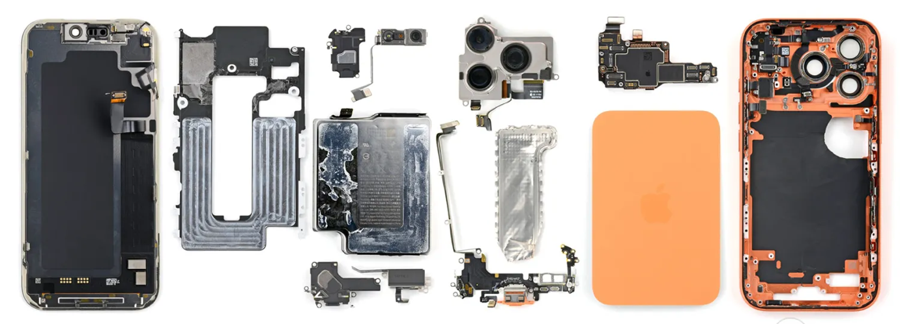(Chamberlain, 2026)
Contents
Executive Summary 2
Overview of the Business 4
Unique selling point 4
Legal – Format of Business 4
Management Team & Staff Structure 5
PESTEL – Analysis 6
SWOT - Analysis 7
Competition Overview 7
Marketing Plan 7
Funding Source 8
Cashflow 9
Reference list 10

Overview of the Business

Mobile Tech Hive Ltd a UK-based company situated in Stratford London is committed to providing only genuine Apple parts for devices such as iPhones, iPads, and Apple, there are many other suppliers and repair providers, but our business strategy centres on supplying genuine parts to companies and individual customers looking to fix their own devices, and repair businesses that specialise in Apple repairs. We aim to build a presence in the expanding market of genuine Apple parts through strategic connections with reliable Chinese manufacturers which dominate the supply of high-quality spare parts (Budiono and Ellitan, 2024). Mobile Tech Hive will be positioned as a preferred supplier thanks to our dedication to quality, outstanding customer service, and community involvement programs.
Short Term Goal: First year, start up with a user-friendly website, pushing towards a strong internet presence to aid in our marketing and reaching sales targets, hiring new staff, building relationships with local businesses and individual customers.
Long Term: Later expanding its customer base across the UK enhancing its distribution capabilities and partnership with other companies, building trust, recognition, supporting growth and profits. The demand for genuine, high-quality Apple parts is rising due to the rising cost of new devices and the growing demand for expert repair services, driven by DIY repair trend and the need for high-quality components (Soudachanh and Salhofer, 2025).

Unique selling point (USP): Providing genuine Apple parts sourced directly from Chinese manufacturers ensuring quality and reliability. The UK has the greatest number of Apple Stores in Europe and a sizable Apple user base, which reflects the brands widespread adoption and the continuous demand for repair-related services (Statista, 2025). This will enable Mobile Tech Hive to provide and fill the demand and gap in the market and supply genuine parts.

Legal – Format of Business

Mobile Tech Hive Ltd will be formed as a limited company rather than a Sole Trader because the benefits a far greater.
SOLE TRADER
Product claims, Legal Challenges, Personal assets, Long-Trem Growth, Future Investments

LIMITED COMPANY
Limited liability, Personal assets safe, Lower Financial Risk, Own legal identity, Tax Efficient, Supply Partnership

Limited Company:
In a commercial environment including imported goods, supply contracts, and any warranty or liability claims. Limited liability lowers personal financial risk and promotes entrepreneurial investment and expansion, claim (Deakins and Whittaker, 2020). Limited companies are more trusted by financial institutions, suppliers, and consumers. This is important when dealing with business clients and building international supply partnerships, incorporated businesses are more likely to obtain long-term contracts and external financing, according to research (Storey, 2016).
Sole Trader:
Unrestricted liability, debts and claims for defective products, or legal challenges resulting from imported electronic parts could jeopardise the owners personal assets (Burns, 2018). Additionally, a sole trader model cannot adequately support long-term growth goals, which call for a structure that permits scalability and future investment (Deakins and Whittaker, 2020).

Management Team & Staff Structure

Operations Manager
Technician Manager
Manging Director

Business management is the foundation to any organization, which gives its activities direction, structure, and purpose. To accomplish aims and objectives, it is essentially a combination of different organisational actions and resources (James, 2025). In the 1st year of business, we will require a structure of three staff members management team. To meet rising demand, the company may hire more operational or sales personnel as it expands.
Technician Repair Manager
Operations Manager

Managing Director


- Business strategy.
- Import product sourcing.
- Finance control.
- B2B relationship.
- Device repairs.
- Quality control.
- Authenticity check.
- Sales report.
- Client enquires.
- Packaging.
- Warehouse despatch.

The Two key personal will be the Managing Director and the Repair Technician. The Managing Director oversees finances, supplier connections, company strategy. The Repair Technician guarantees the authenticity and quality of the parts. When combined, they guarantee excellent leadership, high-quality products, and consumer confidence.

PESTEL – Analysis
Is used to identify, Political, economic, social, technological, and legal factors that may affect the businesses external threats which could have an impact on the performance and decision-making. It can help the companys objectives and the range of operations for new business entering the market used to evaluate risks and adapt tactics to new changes in the external environment (Johnson et al., 2020). Identifying external factors, we will be able to identify threats and the competition. Our competitors are repair shops that sell parts, generic mobile parts wholesalers, and online marketplaces like third-party sellers (Kotler et al., (2024).

PESTEL
Political
Trade Policies - changes could increase Import costs and custom delays
(Whittington, 2019).
Government regulations - strict changes on electronic components, raise cost
Social
Legal
Economic
Technological
Environmental
P
L
T
E
Rising Cost – Inflation increases operating cost and low profit (Spulbar et al., 2025).

Exchange rates - increase imported parts and component costs
Low Price Demand - Consumer will choose cheaper counterfeit parts
(Kotler et al., (2024).

Reduce customer Spending - low repair demand for genuine parts

New Products - Demand for new parts old parts go obsolete (Whittington, 2019).

E-commerce growth - Digital payments supports online sales & distributions
Eco - Friendly waste - landfill, add additional expenses
Strict Regulations - co- friendly packaging may increase costs (Wang, 2025).
Consumer Protection Law - require higher liability for faulty parts (Atrill, 2022).
Trading regulations restrictions - may limit certain component availability

S

E

SWOT - Analysis




- Limited to Apple product repairs.
- Reliance on Suppliers from abroad.
- Rising Rents

Strengths
Weaknesses
Opportunities
Threats
- Apple product repairs.
- Direct Sourcing.
- B2B repair shops.
- Genuine parts differentiate us from competitors (Wahyudi, 2024).

- Demands for repairs.
- Awareness of counterfeit parts.
- E-commerce can boost online sales.
- B2B partnerships increase visibility.

- Competition.
- Import delays.
- Trade restrictions.
- Rapid Technology changes.
- Price changes

Using management tools with SWOT to understand strengths, weaknesses, opportunities, threats, an analysis is used to assist company executives in creating such strategies (Didijer, 2023).
Competition Overview
A Business is not always considered a rival merely because they offer similar products or services. It is possible that the products they sell in the market are completely different quality. (Barrow et al., 2021). Mobile Tech Hive competitors are repair shops that sell non-genuine parts, wholesalers, and online marketplaces like third-party sellers (Kotler et al., 2024).

Marketing Plan
Using online digitally marketing strategy focusing on the product prices and the services and quality of the product which will be provided (Lopez, 2020). Using Ai marketing to speed up content production, and automate routine task, automate email marketing and social media management (Mariani, 2022). Setting up an online digital friendly website for shoppable components for retail and trade sales orders. Using various social media platforms such as TikTok, Instagram and Facebook will influence a large amount of online buying customers (Kotler et al., 2023). Use paid digital search advertising to reach businesses and DIY repair customers, using SEO. To promote repair content and the use of genuine parts we will use influencers (SMIs) who are increasingly used to promote products, called influencer marketing. (Audrezet et al., 2020).

Marketing strategy:
Geographic
Base

Technological
Social Media Platforms
Technological
Online Website, AI
Marketing Strategies

Psychographic
Lifestyle
Behavioural
SEO
Influencers

Content Education
Demographic

(Madzik, 2021).
Content marketing will focus on education, the risk of using counterfeit parts and the benefits of using genuine, building trust and technical credibility. The companys base will be in London, Stratford near the Westfield shopping centre, which has a lot of mobile phone repair businesses and a lot of foot traffic. We will look at our competition and use multiple- ways to market and build awareness and long-term customer relationship (Kotler et al., 2023).

Funding Source

Funding options when starting up a business, Mobile tech hive will use a bank loan and personal funding to start up, enabling the business to obtain the fundings required, then utilise that money to make investments in equipment, premises, inventory, and so forth to generate revenue (Atrill, 2022).
Bank loan
Personal Funding

Personal funding benefits are no debts or interest payments, disadvantages are financial risk, limited funds (FundsforNGOs, 2024).
Bank loan benefits, access to more capital, and improving credit, Disadvantages are, the duty to return loan regardless of profitability, high interest charges, very stringent approval processes, and the potential requirement for collateral. (Barrow et al., 2021).
FUNDING SOURCE

Cashflow
Initial first month startup funding to cover inventory purchase, premises setup, and early operating costs of £40,000. Personal funding of £20,000. The positive net cash flow of £34,350 implies short-term financial stability at launch. The cash flow prediction shows that Mobile Tech Hive has enough starting capital to pay all its initial expenses, making it financially ready for launch (Lewellen and Lewellen, 2016). The first-month net cash position is positive, demonstrating sound financial management and efficient planning.

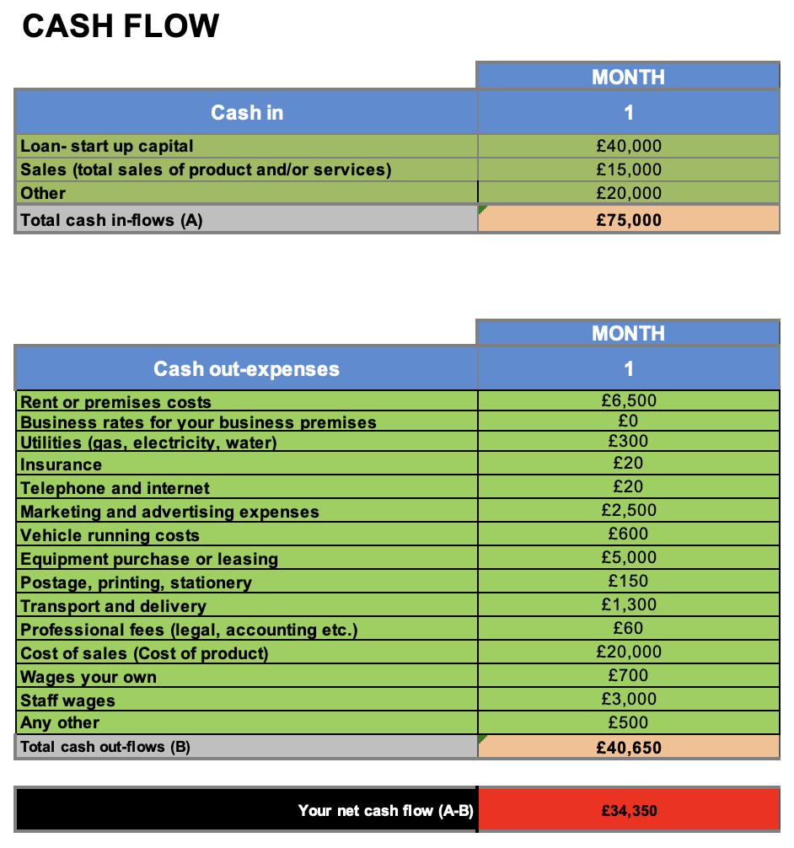

Reference list

Atrill, P. and McLaney, E.J. (2022) Accounting and finance for non-specialists. 12th edn, Hoboken, NJ: Pearson.
Audrezet, A., De Kerviler, G. and Moulard, J.G. (2020) ‘Authenticity under threat: When social media influencers need to go beyond self-presentation’, Journal of business research, 117, pp.557-569.
Barrow, C., Barrow, P. and Brown, R. (2018) The Business Plan Workbook: A Step-By-Step Guide to Creating and Developing a Successful Business. Kogan Page Publishers.

Bahrami, H. (2025) Evolution of Smartphone Design: Repairability and Material Use, pp 1- 48.
Budiono, K. and Ellitan, L. (2024) ‘The Efficiency and Performance of Apple’s Supply Chain Management’, ULIL ALBAB: Jurnal Ilmiah Multidisiplin, 3 (5), p7.
Chamberlain, E. (2026). The Science Behind Scratchgate and What It Means for Repairing the iPhone 17 Pro. iFixit. Available at: https://www.ifixit.com/News/113388/iphone-17-pro-teardown (Accessed: 20 January 2026).

Didijer, S. (2023) Journal of intelligence studies in business. Available at: https://research-ebsco-com.uwtsd.idm.oclc.org/c/onvpsy/viewer/pdf/a3am6igkcb?route=details (Accessed: 25 January 2026).
Hernandez, R.J., Miranda, C. and Goñi, J. (2020) Empowering Sustainable Consumption by Giving Back to Consumers the ‘Right to Repair’. Sustainability, 12(3), p.850.
James, S. (2025) Importance of Business Management: A Complete Overview. Available at: https://www.theknowledgeacademy.com/blog/importance-of-business-management/ (Accessed: 20 January 2026).
Johnson, G., Scholes, K. and Whittington, R. (2020) Exploring Strategy. 12th edn. Harlow: Pearson.
Joseph, G. (2024) Repairing is Easier Said Than Done: Apple’s Self-Service Repair Program. SAGE Publications: SAGE Business Cases Originals.
Kotler, P., Armstrong, G. and Balasubramanian, S. (2024) Principles of Marketing. 19th edn. Global edition: Pearson.
Kotler, P., Keller, L.K., Brady, M., Goodman, M., and Hansen, T. (2024) Marketing management. 5th European edn. Harlow: Pearson.
Lewellen, J. and Lewellen, K. (2016) ‘Investment and Cash Flow: New Evidence’, Journal of Financial and Quantitative Analysis, 51(4), pp.1135–1164.
Lopez, S. (2020) Value-based marketing strategy: pricing and costs for relationship marketing. Vernon Press
Madzík, P., Čarnogurský, K., Hrnčiar, M. and Zimon, D., (2021) Comparison of demographic, geographic, psychographic and behavioural approach to customer segmentation. International Journal of Services and Operations Management, 40(3), pp.346-371.
Mariani, M.M., Perez‐Vega, R. and Wirtz, J. (2022) ‘AI in marketing, consumer research and psychology: A systematic literature review and research agenda,’ Psychology & marketing, 39(4), pp. 755–776.
Soudachanh, S. and Salhofer, S. (2025) ‘Unveiling Environmental Potential in Smartphone Repair Practices in Vientiane Capital, Laos’, Sustainability, 17(2), p.711.
Statista (2024) Topic: Apple in the UK. Statista. Available at: https://www.statista.com/topics/8884/apple-in-the-uk/#topicOverview (Accessed: 20 January 2026).
Spulbar, C., Cinciulescu, D., Ene, C.C. and Spulbar, L.F. (2025) ‘Altman Z-Score Modeling and Financial Risk analysis: An Empirical Study on Companies Listed on the Bucharest Stock Exchange’, Studies in Business and Economics, 20(2), pp.314-340.
Utama, H. (2025) An Analysis of Business Loans on the Payment of Micro, Small and Medium Enterprises (MSME) Loans. Jurnal Multidisiplin Sahombu, 5(03), pp.273-285.
Wang, R. and Zhang, G. (2025) ‘Does optimising the business environment enhance enterprise resilience? The role of digital innovation and entrepreneurial spirit’, Humanities and Social Sciences Communications, 12(1), pp.1-15.
Wahyudi, D., Taryana, T., Tawil, M.R., Zulkifli, Z. and Sipayung, B., (2024) SWOT Analysis in Business Risk Awareness in MSMEs. TECHNOVATE: Journal of Information Technology and Strategic Innovation Management, 1(2), pp.56-61.
Whittington, R., Regner, P., Johnson, G., Angwin, D. and Scholes, K. (2019) Exploring strategy. 12 edn. Pearson: UK

