

WORK BASED PROJECT
Modifying a single-phase test console in order to test both single and three-phase appliances

Author: Oliver Kucyj
Student number: 1910808
Course: B.Eng Electrical and Electronic Engineering
Module Code: ACDA5016
Lecturer: Dr Stephen Mosey
Date: 4th July 2022

Consort Equipment Products Ltd | Thornton Industrial Estate, Milford Haven, Pembrokeshire SA73 2RT, United Kingdom

Contents
1 Abstract 3
2 Introduction 4
2.1 Project Brief 4
2.2 Success Criteria 4
2.3 Research Methodology 4
3 Research and Data Collection 6
3.1 Seaward Testing Setup 6
3.1.1 Testing explained 7
3.2 Light Guards 7
3.3 Contactor Monitoring 9
2.4 Choosing the Contactors 9
3.5 Muting 10
3.5.1 On-delay Timer Circuit 10
3.6 Emergency Stop 11
3.7 Interlock Function 12
3.8 Wireless Control 12
4 Design of the Testing Station 13
4.1 System Diagram 13
4.2 Circuit Diagram 13
5 Parts List 14
6 Mounting the system components onto the testing station casing 16
7 Testing the installation 17
7.1 Testing the Light Guards 17
7.2 Testing the Safety Circuit 18
8 Conclusion 20
9 References 21
Appendix A 23
Appendix B 24
Appendix C 25
Appendix D 26
Appendix E 30
Appendix F 32

1 Abstract

Throughout this project, the design, development, implementation, and testing of the 3-phase testing station is explained. The project was completed successfully. After a few small issues encountered during the testing stage were rectified, the 3-phase testing station was fully tested, calibrated, and issued for production use.

2 Introduction

2.1 Project Brief

This project will investigate upgrading a single-phase testing station into a three-phase testing station whilst also improving the safety of the station. To do this, research must be conducted on all aspects of the system, including research on both existing components and those which will be considered as part of the upgrade. Suitable planning is vital with this project as it will be governed by a strict timeframe, as described in the project proposal.

To assist with this, three main project objectives have been created. These are listed below.

- To design a safety circuit for the 3-phase testing station incorporating the existing light guard and safety relay.
- To create a full system wiring diagram, compile a parts/cost list and order all required parts.
- To build and test the 3-phase testing station in line with the timeline set out by the Gannt chart.

Completing this project will provide an important test of individual skills which have been developed over the previous 4 years working for Consort as an apprentice and studying electrical engineering. It is an opportunity to demonstrate that the training is paying off and that more responsibility can be assumed.

2.2 Success Criteria

This project can be considered a success if the testing station is modified to test 3-phase products accurately and safely. Worker safety is paramount and much of the research conducted throughout the report will focus on maximizing this.
The work should be completed independently with limited intervention from colleagues and must be completed within the timeframe set in the project proposal. The timeframe allows for the testing station to be used by production workers for 3 weeks before the report is submitted, providing the opportunity to confirm it operates correctly over that period.

2.3 Research Methodology

Throughout this project, an epistemological action research approach will be used. Much of the data which will be collected will be secondary, although some primary data will be collected on the electrical characteristics of Consorts products which will require testing. The secondary data will be collected from reliable sources such as books on electronics, HSE documents, standards, conference papers, datasheets, and reputable websites. User guides will also be consulted to develop a better understanding of the equipment being employed.

The reliability of all sources used will be determined using the CRAP (Currency, Reliability, Authority and Purpose) analysis system.

3 Research and Data Collection

3.1 Seaward Testing Setup

Consort use Seaward testing equipment to test all electrical products which are manufactured in the factory. Seaward testing equipment is used on all 5 testing stations.
The HAL104 and the three phase PowerSmart will be used on the upgraded version of this testing station. These devices are designed to communicate with each other and must be set-up in accordance with the user manuals [1, 2]. They can all be controlled via a computer using Seaward’s computer software Safety e-Base Pro. This software is used to test the appliances, and can log all test results, as well as commanding a printer to print labels when a test is passed. This is done using a system which is already in place.
This application allows the creation of test sequences. An example of one of these test sequences is shown in figure 1.

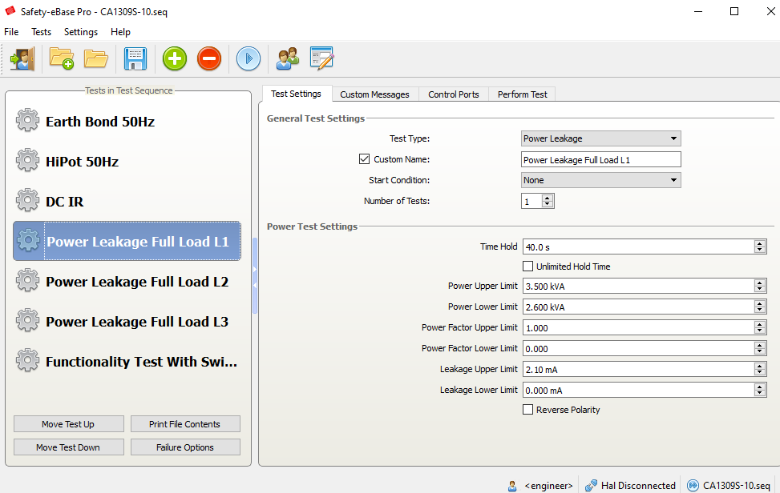
Figure 1 – Example of a test sequence for a 9kW, 3-phase appliance

These tests can only be set up or modified in engineering mode, which has restricted access. This allows total flexibility of the tests without the risk of anything being tampered with. This mode can also be used to enable or disable the Hal104 control ports. The Hal104 has 8 control ports. Of these 8 control ports, the first 5 are required for selecting different tests on the PowerSmart. They are configured by default using the cables provided by Seaward. The remaining three control ports can be used for implementing new features.

3.1.1 Testing explained

Each of the tests shown in figure 1 has its own purpose.

The earth bond test ensures that the earthing conductor is in suitable condition. It measures the resistance between the earth terminal on the product and the external casing. To do this, the earthing clamp must be attached to the heater casing.

HiPot (High Potential) testing checks the condition of the insulation and ensures there is no risk of arcing. 1500V AC is applied between Line and Neutral. The PowerSmart then measures the current leakage to earth, ensuring it is under the specified limit.

The DC IR test involves applying 500V DC to measure the insulation resistance.

The full load tests involve running the appliance and measuring the apparent power being drawn and the power leakage.

3.2 Light Guards

All testing stations use light guards to protect workers from the risk of electric shock. They are already installed on this testing station. When an object is in the detection zone, it will block the beam, preventing the receiver from receiving the signal. When this happens, the OSSD (Output Signal Switching Device) will be switched off. It is important that there are no gaps in this detection zone.
The light guard used is the Keyence GL-R series [3] in conjunction with the GL-T11R safety relay [4]. The circuit diagram shown in figure 2, taken from the GL-T11R user manual, highlights the communication between the GL-T11R and the GL-R. Figure 3 shows an example wiring diagram which utilizes the interlock, EDM and muting functions.

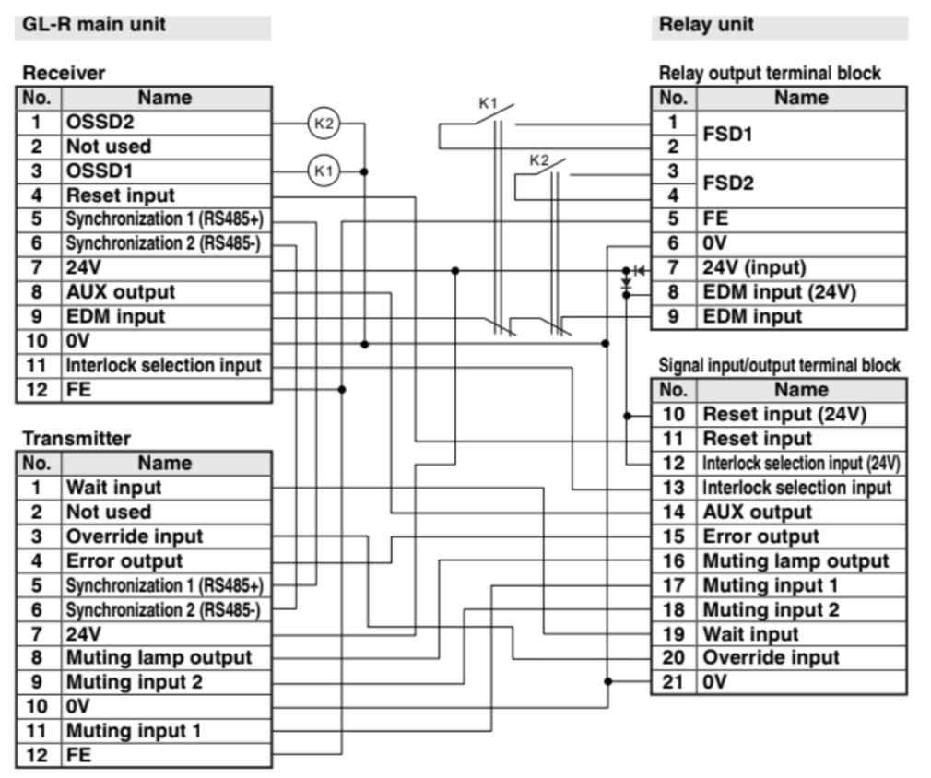
Figure 2 – GL-R and GL-T11R circuit diagram [op cit. 4]

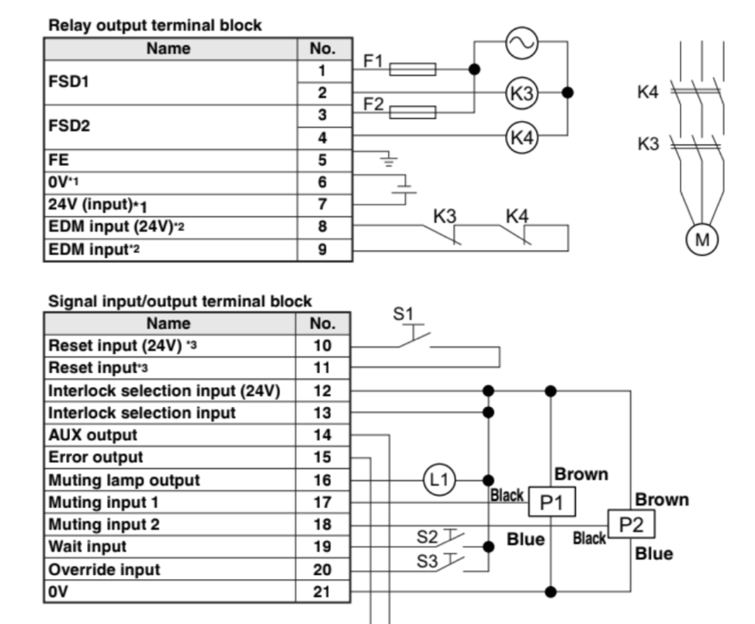
Figure 3 – Example circuit diagram utilizing the GL-T11R [op cit. 4]

The Gl-T11R will be used to control the contactors. The device is 24V, so a 24V power supply must be included in the circuit.
Under the current single-phase installation, the full functionality of this safety relay is not utilized. The FSD outputs are used to power the contactor coil, opening the contacts when the light guard is triggered. This does not provide the option to disable the light guards at all, making fault finding difficult. It also does not account for the fact that safety components, such as contactors, could fail.

3.3 Contactor Monitoring

The GL-T11R has an EDM function for monitoring external devices. As per BS EN 60947-4-1 [5], it cannot be assumed that contactors will not weld shut. If they did, the output would always be live. When dealing with high current electrical products, a fault like this could result in death, so it must be taken seriously.
As suggested in a HSE guide on the application of light guards [6], a recognized method of minimizing this risk is through contactor monitoring. This can be done using auxiliary contacts clipped onto the side of the contactor. They mechanically monitor the contactor position. By connecting EDM 1 from the GL-T11R in series with the Normally closed (NC) auxiliary contacts and EDM 2, the safety relay can detect a contactor not switching correctly. It will then disable the FSD output and activate an error LED. In these circumstances, the output would still be live since the contactor is welded shut. To eliminate this risk, two contactors can be used in series. This is known as a safety contactor arrangement and is shown in figure 3. This arrangement allows the GL-T11R to ensure that under these circumstances, the second contactor coil is not energized.
There is still the potential that both contactors could weld shut. The chance of this is low, but a power indicator light should be added as an extra safety feature. This will alert the user and colleagues around them whenever the testing station is live.
To implemented this, a 240V double pole relay will be used to control a 24V light beacon. The relay coil will be connected to the output of contactor 2. The COM port of the relay will be connected to 24V. The NC output should be connected to the green LED and the NO output should be connected to the red LED. This arrangement ensures that whenever the output is powered, the red LED will be on, and the green LED will be off.

2.4 Choosing the Contactors

The contactor rating must be decided by considering the maximum load which will be used on the test console. The largest heater sold at Consort is 24kW. This is a 3-phase unit, so there will be 8kW per phase. A 9kW single-phase appliance is also sold, so this will provide the maximum possible current in a single pole.

The product wattage has a tolerance of +/-5%, so 9000 x 105% = 9,450kW.

Therefore, the maximum current drawn is 9450/240 = 39.375A.

Based on this, a 45A contactor should be used. The contactors are the most important part of this safety circuit. If They fail, the consequences could be catastrophic. A colleague recommended using ABB contactors and stated they are very reliable. ABB have a compatible range of contactors and auxiliary contactors which can be used in conjunction with each other. These will be used for this project.

3.5 Muting

The option to disable the light guards must be included into this safety circuit. The HSE light guard document [op cit. 6] states that a muting function should only be available when it is essential to the process being used. Based on this recommendation, it is vital that production workers are not able to disable the light guards. This feature will only be available using engineering mode on the safety E-base software.
The feature can be implemented using a spare control port from the HAL104 to trigger the muting option on the GL-T11R. The GL-R datasheet [op cit. 3, p. 2-14] states that to disable the light guards, mute 2 must be triggered between 0.04 and 3 seconds after mute 1 is triggered. Once power is removed, the light guards will reactivate. This configuration is used to minimize the risk of the light guards being disabled through a fault.
To implement this, an on-delay timer circuit must be introduced. Control port 6 will be used to provide a signal. This is 12V, whilst the GL-T11R requires 24V. As a consequence, the on-delay circuit must allow 24V to be controlled by a 12V signal.

3.5.1 On-delay Timer Circuit

The on-delay timer circuit could be achieved using a 555-timer configured as shown in figure 4. In this configuration, the charging and discharging of an external RC network is used to define the on-delay [7].

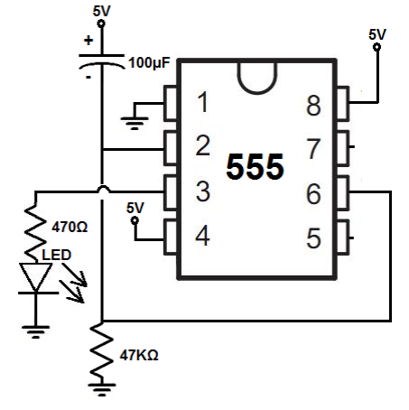
Figure 4 – 555 timer configured as an on-delay timer [8]

To switch 24V with a 12V signal, either a relay or an optocoupler may be used. Using a relay with a 12V coil would allow the 24V signal to be switched, however relays are large and bulky. An optocoupler would be a more space and cost-efficient method. A national power electronics conference stated that an optocoupler allows a lower voltage gate signal to be used to switch a higher voltage signal powered by an isolated power supply [9]. They also provide galvanic isolation which can help to protect delicate circuitry [10]. The Hal104 is an expensive piece of equipment, so it is important to electrically isolate control port 6 from the 24V power supply.
A 555-timer can only work up to 15V, so to implement the 555-timer circuit two optocouplers are required. One would be required to use the signal from control port 6 to switch 24V to mute 1, and the second would be required to use the 555-timer output to switch 24V to mute 2.

This can be simplified greatly by utilizing a purpose built on-delay timer. They are readily available DIN rail mounted components which provide a much more compact method of muting the light guards. One optocoupler will still be required to use control port 6 to switch 24V. 24V will be available from the 24V power supply.

3.6 Emergency Stop

An emergency stop must be included to allow the user to shut everything down instantly in the event of a fault. When the emergency stop is pressed, it must be impossible for the appliance to be powered. The power is switched in two separate places on the testing station, the PowerSmart, and the safety contactors. Two emergency stop circuits should be implemented, allowing the emergency stop to shut both control elements.
The emergency stop currently installed has two NC contacts.
To switch off the safety contactors, power must be removed from the contactor coils whenever the emergency stop is pressed. This will keep the contactors open regardless of what other elements of the testing station are set to.
The second circuit will utilize the purpose-built guard switch on the HAL104. When there is no continuity between the two wires on the guard switch, the HAL104 will ensure the PowerSmart output is off. It will immediately fail any test which is in progress. To utilize this, the second NC contact from the emergency stop should be connected between the two wires.
As an additional feature, the NO port on one of the auxiliary contacts should be connected in series with the emergency stop. This will inform the Hal104 that an error has occurred causing the contactors to switch off, so that any test in progress will be failed instantly. Without this, the user might not notice that the appliance is not powered when testing.

3.7 Interlock Function

The safety relay has an optional interlock function. When the light guards are triggered, the interlock function keeps the contactors open until a manual reset pulse is received. This is not necessary for this installation and would prove a nuisance since the light guards will be tripped regularly when the appliances are being wired into the testing station. To disable the feature, pins 10 and 11 must be linked [op cit. 4]. With this setup, the safety circuit will return to normal operation as soon as the obstructive object is removed from the light guard detection area.

3.8 Wireless Control

This testing station will incorporate a wireless control PCB. This PCB will serve two purposes. It will pair and switch on wireless heaters automatically. The second feature is more complicated. One of the products at Consort incorporates a special self-test carried out by the internal PCB. The product will not work until it has passed this self-test. The self-test can only be activated by a special test signal which is sent by this wireless control PCB inside the testing station.

The wireless control PCB has already been designed by another engineer at Consort. This project simply needs to implement the design by connecting control ports 7 & 8 from the Hal104 to the PCB. These control ports will be used to send the wireless signals when required.

This PCB also requires a 5V power supply to power it. A power supply used on the Consort CRXSL will be used.

4 Design of the Testing Station

4.1 System Diagram

The next for this project is to begin designing the system. By designing a system diagram, the connections between each different aspect of the circuit can be identified. Most of this basic system block diagram can be created based upon the seaward datasheets for the Hal104 and the 3-phase PowerSmart.
The system block diagram is shown in appendix A. This was created using Creo Elements Direct Drafting. Each of the important communications are described below.

- The interconnection lead is used for communication between the Hal104 and the PowerSmart. This is how the electrical parameters measured by the PowerSmart are communicated back to the Hal104.
- The control ports cable from the Hal104 is used to enable/disable features using the Safety e-Base application. It is connected to the PowerSmart, the safety circuit and to the wireless control PCB.
- Guard 1 will be wired as part of the safety circuit, as discussed in section 3.6.
- The earth probe is used to perform earth bond tests. This is a crocodile style attachment which clips to the metalwork of the heaters.
- The output test lead goes through the contactors and is then outputted to the appliance.
- The green and red power indicator LEDs are controlled by a relay within the safety circuit.

4.2 Circuit Diagram

Using the information from section 3 and the system diagram, the circuit diagram shown in Appendix B was created. This is the final design for all circuitry which will be included in addition to the Hal104 and the PowerSmart.

5 Parts List
The parts list for this work is in table 1. All parts have been specified based on the information stated in sections 3 and 4. The components will all be DIN rail mounted since the existing safety relay is also DIN rail mounted.

Part number | Quantity | Cost per unit | Width
Hal104 | 1 | Already Installed | -
3-Phase PowerSmart | 1 | £3,000 | -
ABB 45A 4-pole contactor 24V coil [11] | 2 | £107.23 | 45mm
ABB side mounted Auxiliary contact | 2 | £14.03 | 12mm
RS PRO Switch Mode Power Supply 230V AC input, 24V DC output [12] | 1 | £22.63 | 36mm
TE Connectivity DIN Rail Power Relay 230V Coil DPDT [13] | 1 | £18.71 | 15.5mm
RS PRO Signal Tower 24V [14] | 1 | £120.53 | -
RS PRO on-delay timer relay 24V SPDT. 0.3s-30h [15] | 1 | £28.69 | 17.5mm
GL-T11R | 1 | Already installed | 48mm
Wireless Control PCB with standoffs | 1 | £10 | 30mm
5V Power Supply from discontinued product | 1 | £5 estimated | 30mm
Miscellaneous parts from stock such as cables, ferrules, electronic components, steel and DIN rail | - | £20 estimated | -
Fibox Solid Polycarbonate Enclosure 278 x 188 x 180mm [16] | 1 | £63.44 | 278
Total |  | £3,540.12
Table 1 – Parts list

Now that all components which must be installed on a DIN rail as part of the additional circuit have been identified, a method of mounting must be decided. The existing test console casing does not have much room left , so the additional components must be installed inside an isolated box mounted externally on the test station casing. This is preferred over redesigning the testing station casing since this would be a time consuming and costly job.
The total width of all DIN rail components is 174mm. Room will also need to be allowed for mounting the PCB and the 5V power supply. Based on this, the Enclosure added to the end of the parts list will be required. This is 278mm Long. There is plenty of clearance in terms of height and depth.

6 Mounting the system components onto the testing station casing

The Hal104 and the 3-phase PowerSmart will both fit inside the existing testing station. The light beacon will be installed on top of the testing station casing in a visible position. The emergency stop and the light guards are already mounted in position from the single phase setup.
As described, the additional circuitry will need to be mounted externally. This can be done using a simple L-shaped bracket screwed to the bottom of the main enclosure. A drawing of the bracket design can be seen in Appendix C. All dimensions are in millimetres. This will be manufactured manually using metal salvaged from production builds. The guillotine and a manual bending machine will be used. The bracket will then be painted in the paint shop as it will be a visible part.
The material used will be 2mm steel, so the blank will be cut 2mm longer to account for bending tolerances. This is an estimate rather than a calculation as the bracket size is not critical.

7 Testing the installation
By following the planning and design work completed over the course of this project, along with the RAMS (Risk Assessment Method Statement) shown in appendix D, the test console modification has been completed. Images of the completed testing station can be found in appendix E.
Section 7 will cover the testing of the system.

7.1 Testing the Light Guards

Keyence provide a ‘finger’ probe for ensuring full functionality of the light guards. The finger must be placed in the detection area of the light guards and moved along the path shown in figure 11. This path covers a large area of the detection zone to help ensure they are fully functional.

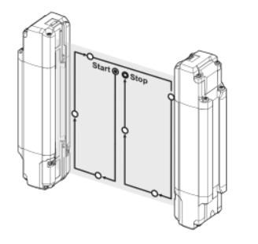
Figure 11 – Light guard probe test [op cit 3]

Throughout this movement, the indicator on the light guard must remain red to show that the probe has been detected. Any gap in the detection zone will cause the indicator to switch to green.
The datasheet for the light guard also states that once the system is live, the probe should be placed in 3 separate locations, near the transmitter, near the receiver and in the centre of the detection zone. Placing the probe in each of these 3 locations should result in the power being removed from the appliance and the Hal104 failing the test.

The muting function also required testing. This was done by ensuring when control port 6 is active the light guards will not switch anything off. It must also be ensured that once control port 6 is deactivated, the light guards become fully functional. This testing found that the light guards were not disabling. Upon investigation, it was discovered that an off- delay timer was ordered rather than an on-delay timer. This was a simple fix but caused a delay as a new part required ordering. Upon replacing the timer, the muting function operated as expected.

7.2 Testing the Safety Circuit

A second issue was encountered during the initial testing phase. The light guards would not allow the contactors to switch on. A red LED was flashing, indicating a fault with the EDM. This was caused by a mistake with the wiring. The normally open and normally closed connections on the auxiliary contacts were mixed up. Whilst this is a quick rectification, time was spent fault finding to identify the problem.
Once this was rectified, the logic table from table 2 was followed. This ensured all circumstances were tested. Each test was carried out 3 times to ensure reliability.

Is a test in progress? | Is the light guard detection area clear? | Is the emergency stop already activated? | What happens when the emergency stop is activated | What happens when the emergency stop is deactivated | Light guard detection area cleared
No | No | No | Power remains disconnected | Power remains disconnected | Power remains disconnected
No | No | Yes | - | Power remains disconnected | Power remains disconnected
No | Yes | No | Power remains disconnected | Power remains disconnected | -
No | Yes | Yes | - | Power remains disconnected | -
Yes | No | No | Power disconnected | Power remains disconnected | Power remains disconnected
Yes | No | Yes | - | Power remains disconnected | Power remains disconnected
Yes | Yes | No | Power disconnected | Power remains disconnected | -
Yes | Yes | Yes | - | Power remains disconnected | -
Table 2 – Testing logic table

This testing, along with the probe testing recommended by Keyence, confirms that this safety circuit is adequately protecting the staff at Consort and all features are working correctly in accordance with the original specification.
In addition to this, the EDM function must be tested. To do this, EDM 2 was disconnected. This will simulate the contactors being closed since the NC auxiliary contact is used. As expected, both contactors were de-energized immediately and an EDM fault was indicated by the GL-T11R.
The functionality of the wireless control PCB also required testing. This was done by testing three heaters which require the special signal. If the wireless control PCB was not functioning, the heaters would not have begun heating.
The testing station can safely and accurately test 3-phase appliances. This was confirmed by Seaward during the calibration/commissioning they carried out on the testing station.

8 Conclusion

Overall, this project was a success. All points stated in the success criteria were achieved. The work was completed independently, and multiple safety features have been introduced to the testing station.
The schedule shown in the Gantt chart from the project proposal was followed although the testing console was not fully tested ready for calibration until lunchtime on 13/06/22. This was in part due to the issues discussed in section 7. In addition to these issues, the job did take longer than expected. Crimping the control port cables was more time consuming than expected, and the interconnection cable also required shortening to allow it to fit inside the testing station, which required more time. Based on this, more time should have been allowed to complete this project. The time-schedule was tight, which added unnecessary pressure and lead to mistakes being made. With hindsight, an extra day should have been allowed to complete the work. This is a learning opportunity, and in future, when planning a job, more time will be allocated to allow for mistakes, faults, or any other unforeseen circumstances.
Despite this, the testing station is now in full working order. At the time of writing this report, the testing station has been in use for 3 weeks with no issues.
Completing this project independently has provided an important learning opportunity. Existing knowledge and skills were both tested and developed.

9 References

[1] Clare Instruments, “Your HAL Tester,” Seaward Group. [Online] Available: https://www.seaward.com/gb/support/download/331 [Accessed: May. 23, 2022].

[2] Clare Instruments, “PowerSmart Three Phase Automation and Leakage Test Module,” Seaward Group.

[3] Keyence, “Safety Light Curtain,” Keyence, 2017.

[4] Keyence, “Dedicated Safety Relay for the GL-R series,” Keyence.

[5] Low-voltage switchgear and control gear – Contactors and motor-starters. Electromechanical contactors and motor-starters, BS EN IEC 60947-4-1:2019.

[6] Application of electro-sensitive protective equipment using light curtains and light beam devices to machinery, ISBN 978 0 7176 1550 6, 1999. [Online] Available: https://studylib.net/doc/18846041/application-of-electro-sensitive-protective-equipment-using [Accessed: May. 24, 2022].

[7] T. F. Schubert and E. M. Kim, Fundamentals of electronics. Book 4, Oscillators and advanced electronics topics. San Rafael, California: Morgan & Claypool Publishers, 2016. doi: 10.2200/S00715ED1V04Y201604DCS050.

[8] Learning about Electronics, “How to Build a Delay Before Turn On Circuit with a 555 Timer,” Learning about Electronics. [Online] Available: http://www.learningaboutelectronics.com/Articles/555-timer-delay-before-turn-on-circuit.php [Accessed: May. 25, 2022].

[9] N. Anurag and S. Nath, "Effect of Optocoupler Gate Drivers on SiC MOSFET," 2021 National Power Electronics Conference (NPEC), 2021, pp. 01-06, doi: 10.1109/NPEC52100.2021.9672531.

[10] P. Horowitz and W. Hill, The art of electronics, Third edition. Cambridge: Cambridge University Press, 2015.

[11] ABB, “4-pole Contactors,” AF26-40-00-11 and CAL4-11 datasheet. [Online] Available: https://docs.rs-online.com/c115/0900766b810f8cb7.pdf [Accessed: Jun. 02, 2022].

[12] RS Pro, “RS PRO DIN Rail Power Supply,” 136-8308 datasheet. [Online] Available: https://docs.rs-online.com/dc0a/A700000007349978.pdf [Accessed: Jun. 02, 2022].

[13] Tyco Electronics, “Relay Package RT,” RT4S5T30 datasheet. [Online] Available: https://docs.rs-online.com/6fab/0900766b805c9d26.pdf [Accessed: Jun. 02, 2022].

[14] RS Pro, “Baby TWS 2 Colori,” 199-9758 datasheet. [Online] Available: https://docs.rs-online.com/71a8/A700000006773814.pdf [Accessed: Jun. 02, 2022].

[15] RS Pro, “RS PRO SPDT Timer Relay,” 896-6810 datasheet. [Online] Available: https://docs.rs-online.com/9670/A700000008000872.pdf [Accessed: Jun. 02, 2022].

[16] Fibox Enclosing Innovations, “Solid PC 2819 18 T,” PC 2819 18 T datasheet. [Online] Available: https://docs.rs-online.com/fab2/0900766b80643c67.pdf [Accessed: Jun. 02, 2022].

[17] HSE, “Working safely with display screen equipment,” HSE. [Online] Available: https://www.hse.gov.uk/msd/dse/work-routine.htm#:~:text=Take%20short%20breaks%20often%2C%20rather,meetings%20or%20making%20phone%20calls [Accessed: Jun. 04, 2022].

Appendix A
System diagram

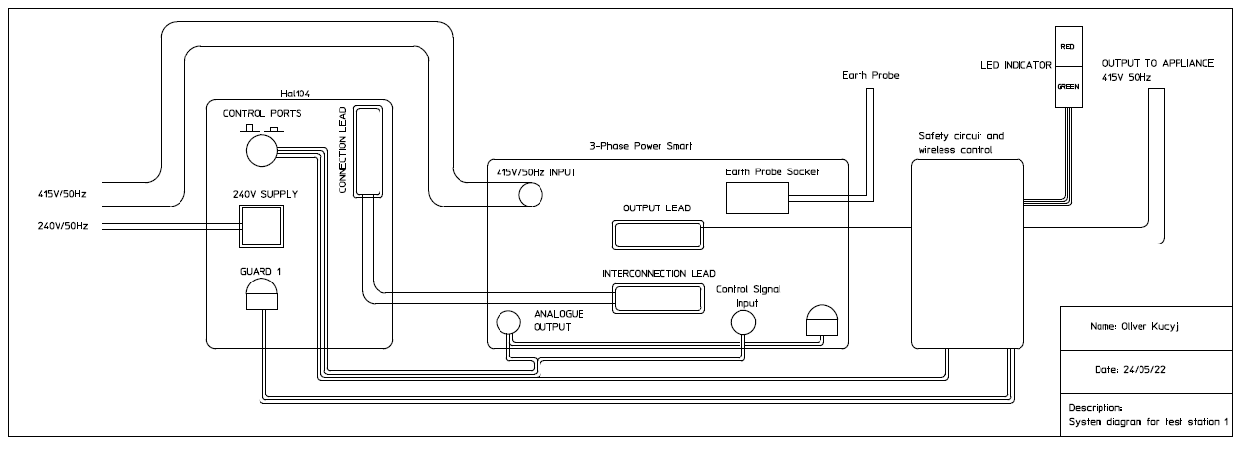

Appendix B
Circuit Diagram

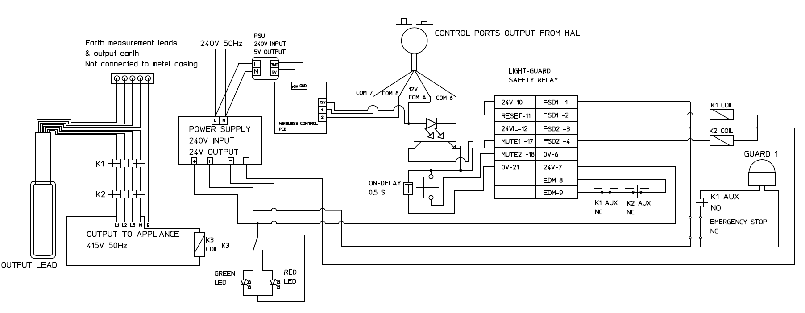

Appendix C
L-shaped bracket drawing

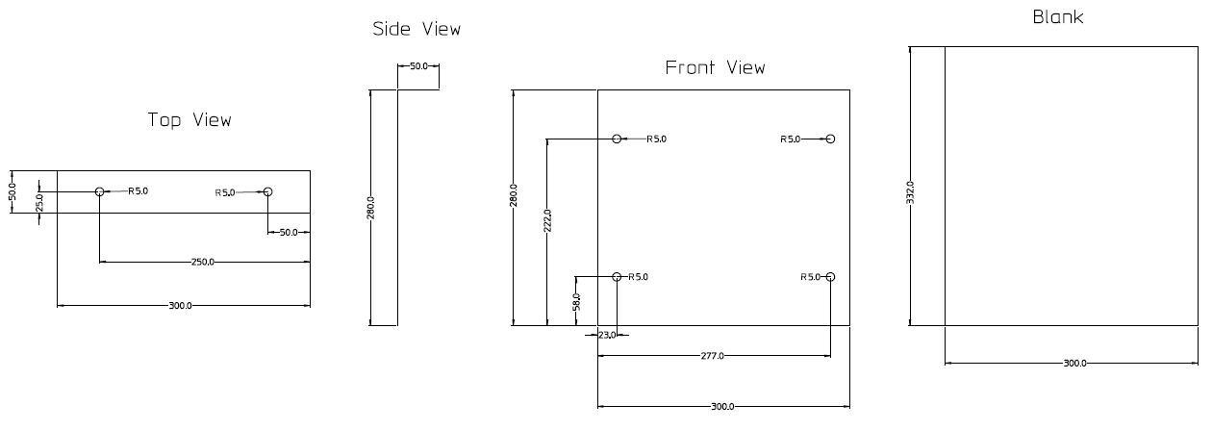

Appendix D
RAMS

Project: Modifying a single-phase test console in order to test both single and three-phase appliances.

Date of works: 27/05/22 – 10/06/22

Task: Working at a computer desk for project planning
Hazard | Control measures | Who is at risk?
Repetitive Strain Injury and eye strain | Computer desk must be set up in a tidy and comfortable manor. Short, regular breaks must be taken. The HSE recommendation is to take 5-10 minute breaks every hour when working with Display Screen Equipment (DSE) [17]. | Operative

Task: Stripping down the old testing station
Hazard | Control measures | Who is at risk?
Electric shock | Ensure all electrical sources are disconnected and safely isolated using lock out tag out. | Operative and colleagues
Cuts to hands due to sharp surfaces and cutters | Wear gloves when using cutters and working with potentially sharp surfaces  Ensure any cuts are cleaned and covered correctly by on site first aid staff member. | Operative

Task: Soldering new cables onto the control ports connector and creating a PCB with the opto-isolator.
Hazard | Control measures | Who is at risk?
Inhaling dangerous fumes | Ensure lead free solder is used  Ensure the room is well ventilated and that the extraction fan is used | Operative and colleagues
Burns | Do not touch the soldering iron tip whilst it is on or whilst it may still be hot  Do not touch any items which have just been soldered. They may still be hot. | Operative

Task: Creating the mounting bracket for the plastic enclosure
Hazard | Control measures | Who is at risk?
Sharp edges on metal | Wear gloves when working with sharp metal | Operative
Fingers getting caught by the guillotine | Ensure hands are behind the safety barrier at all times. | Operative
Hands caught in the bending machine | Ensure hands are behind the safety barrier at all times | Operative
Drilling into hands/fingers | Wear gloves and hold the bracket a safe distance from the drill. Ensure the safety guard is in place | Operative
Drill catches on the metal, causing it to spin in the clockwise direction | Hold the bracket in a position so that if it does catch, it does not spin towards the operative | Operative
Shrapnel getting into eyes | Wear safety glasses | Operative
Sharp edges on the finalized product | File down all sharp edges. Wear gloves whilst filing. Send to painting area for painting. | Operative

Task: cut and strip all wires required to complete the job. Estimate the required length by measuring the distances they must travel. Use ferrules on all wires which must go to a terminal.
Hazard | Control measures | Who is at risk?
Cuts to hands using cutters | Wear gloves when using cutters | Operative

Task: Install all components into the plastic enclosure and complete wiring in accordance with appendix B
Hazard | Control measures | Who is at risk?
Cuts to hands using cutters | Wear gloves when using cutters | Operative

Task: Drill holes into testing station for mounting plastic enclosure and light beacon. Install them both
Hazard | Control measures | Who is at risk?
Drilling into hands/fingers | Wear gloves and hold the bracket a safe distance from the drill. Ensure the safety guard is in place | Operative
Drill catches on the metal, causing it to spin in the clockwise direction | Hold the bracket in a position so that if it does catch, it does not spin towards the operative | Operative
Shrapnel getting into eyes | Wear safety glasses | Operative

Task: Swap the single-phase power outlet for a three-phase power outlet
Hazard | Control measures | Who is at risk?
None identified | - | -

Task: Install the three-phase PowerSmart and Hal104
Hazard | Control measures | Who is at risk?
Injury due to carrying heavy loads | Use a stack truck to bring the devices to the testing station, being aware of other members of staff whilst doing so.  Ask a colleague to help to lift the PowerSmart and Hal104 with proper lifting technique to minimize the risk of injury. | Operative and colleagues

Task: Complete the wiring of the full system in accordance with appendix A
Hazard | Control measures | Who is at risk?
Cuts to hands using cutters | Wear gloves when using cutters | Operative

Task: Testing stage. Visually inspect the whole system. Ensure everything is mounted securely. Close enclosure. Connect power and test functionality in accordance with section 7
Hazard | Control measures | Who is at risk?
Electric shock | Ensure unit is not powered until everything is fully assembled.  Do not touch live parts | Operative and colleagues

Appendix E
Images of the completed testing station

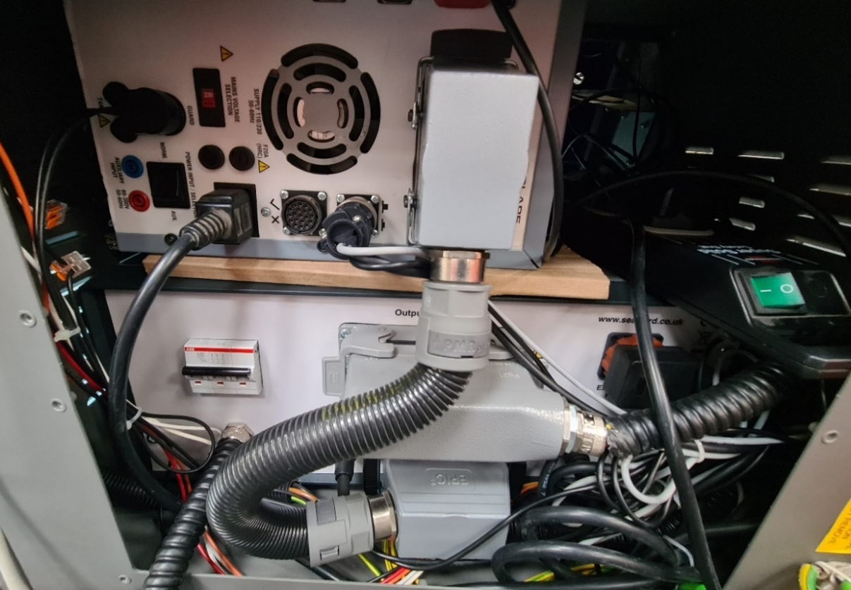
The back of the Hal104 and the 3-phase PowerSmart

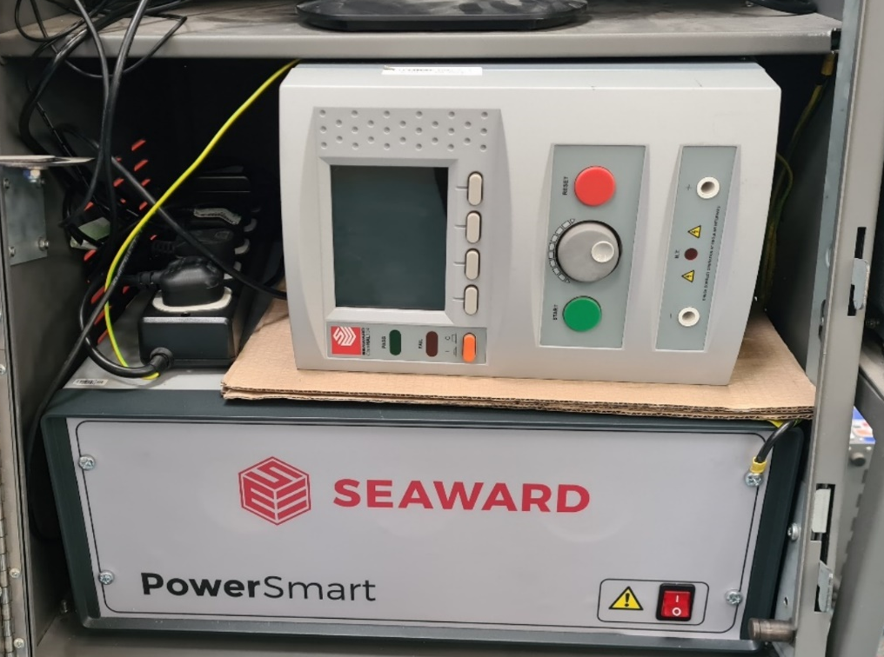
The Hal104 and 3-phase PowerSmart from the front

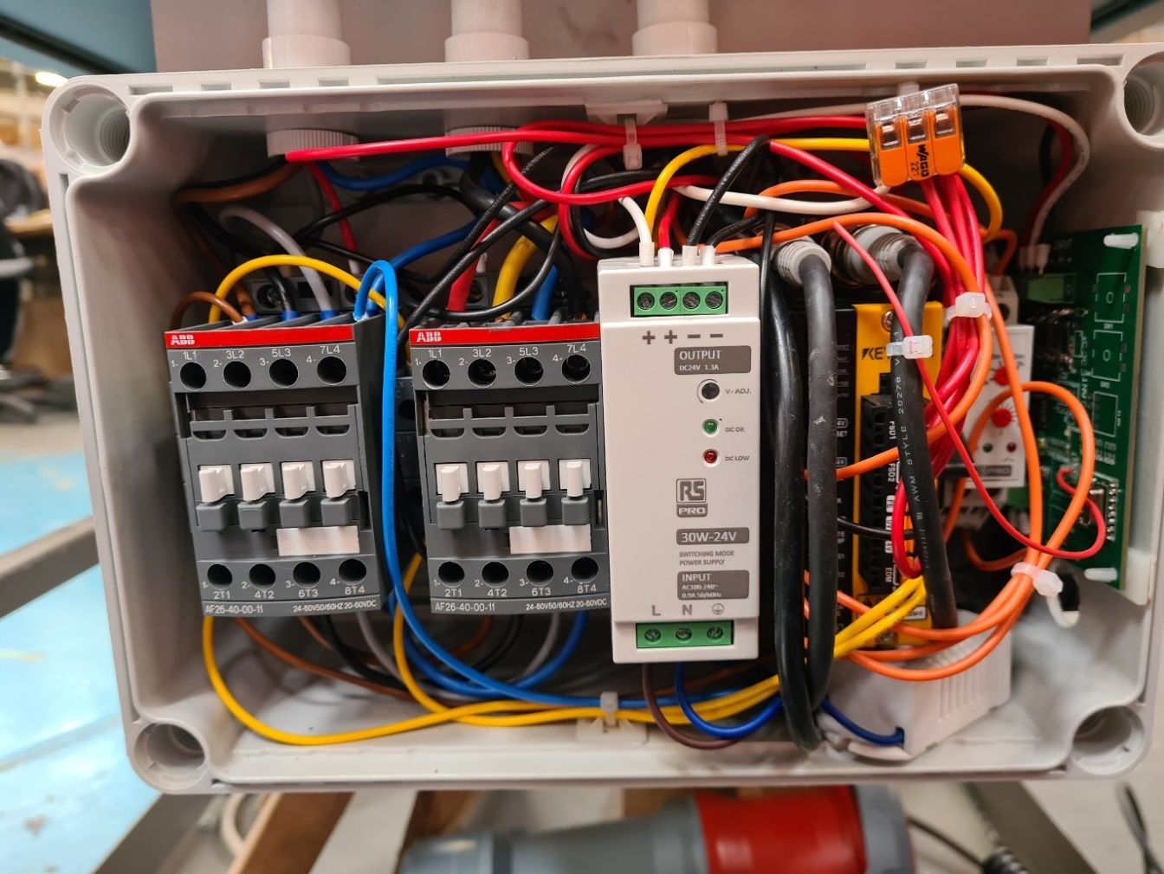
The safety circuit and wireless control PCB fully assembled

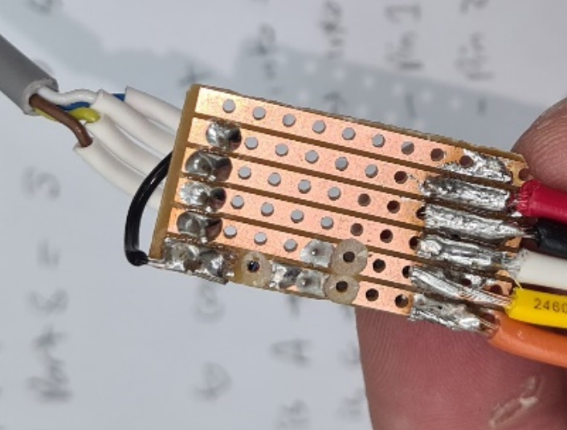
PCB with opto-isolator. This was also used to extend cables from the control ports

Appendix F
Gannt Chart



