

MASTER OF BUSINESS ADMINISTRATION

Strategic Management

LCMB7003

Assessment component: Individual report- Primark

Lecturer’s name;Dr Andry Rakotovololona
Student name:JAVAD KHOSHDAREGI
Student ID:2030121

Date:22/12/2025
Executive Summary
The report provides an analytical business expansion plan in light of the contemporary global business environment, which is characterised by quick change, fierce competition, and strategic ambiguity. The study will focus on Primark's planned entry into the Australian market, using a strategic framework to evaluate its market appeal, competitive dynamics, and strategic compatibility. The company's global expansion strategy has been evaluated by looking at Primark's organisational capabilities, performance measurement methods, and target market selection. Analytical tools such as PESTLE, Porter's Five Forces, and Porter's Diamond model are used to assess Australia's macroenvironment and competitive landscape. The competitive landscape and macro-environment of the Australian fashion sector are observed to be beneficial for the expansion of Primark. Additionally, strategy formulation has been shaped by the notion of Porter’s generic strategy along with internationalisation theory, resource-based view model and others to ensure a competitive base to Primark. Moreover, the report incorporates KPIs related to finances, operations, society, and the environment while notably utilising a balanced scorecard and TBL framework to assess the effectiveness and progress of expansion.

Table of Contents
Introduction 4
1. Selection of Organisation and Target Market 4
1.1 Identification of the organisation 4
1.2 Proposing a new international market for expansion 7
2. Comprehensive Strategic Analysis 9
2.1 Macro-environmental analysis 9
2.2 Analysis of competitive landscape 12
2.3 Critical evaluation of the effectiveness and limitations of the analytical tools employed 16
3. Strategy Development and Formulation 16
4. Performance Evaluation Framework 19
4.1 Balanced Scorecard 19
4.2 Analysing performance measurement system with TBL (Triple Bottom Line) theory 23
Conclusion 25
References 27
Appendices 33
Appendix 1: Porter's generic strategy framework 33
Appendix 2: OLI framework 34
Appendix 3: Inflation rate in Australia 35

Introduction
Organisational expansion is essential for boosting revenue, gaining economies of scale, diversifying markets to reduce risk, and building a stronger brand. Therefore, the report presents an analytical organisation expansion plan within the context of the contemporary international business environment, which is characterised by rapid change, global competition, and strategic uncertainty. In this regard, the report will focus on Primark’s proposed expansion into the Australian market while applying a strategic framework to evaluate market attractiveness, competitive dynamics, and strategic fit. Besides this, the following report has been structured, undertaking four core sections of organisational and market selection along with comprehensive strategic analysis, strategic formulation, and performance evaluation. Moreover, while integrating theory with real-world information, the report will demonstrate the ways strategic agility and evidence-based decision-making can significantly support sustainable international growth with long-term competitive advantage.

1. Selection of Organisation and Target Market

1.1 Identification of the organisation
The organisation selected for this international expansion plan is Primark, which is a multinational value-fashion retail company significantly owned by ABF (Associated British Foods), headquartered in the UK (ABF, 2025). Primark operates as a retail firm with significant divisions due to its scale, international reach, and revenue contribution. According to ABF, Primark operates over 470 stores across 17 countries, predominantly in the UK, Ireland, the US, and Europe (ABF, 2025). The organisational business model is significantly centred on cost leadership while offering fashionable apparel, accessories, footwear and homeware at consistently low prices. Unlike its competitors, such as H&M and Zara, Primark does not rely heavily on advertising expenditure or e-commerce-driven growth. Despite this, it leverages economies of scale, high volume sourcing, and store-led strategy to maintain price competitiveness while preserving margin discipline (Lu, 2023).
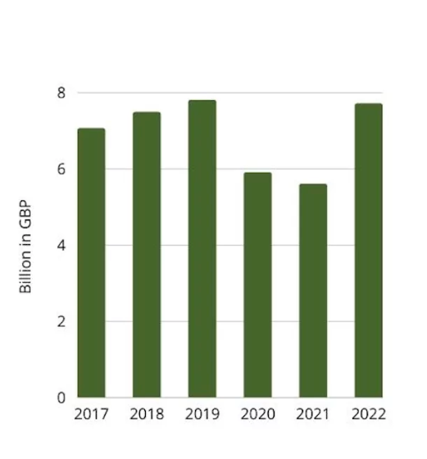
Figure 1: Revenue of Primark
(Source: Hegart, 2023)
From a financial perspective, it is said that there are 10.2 million visits on Primark’s website, along with £7,697 billion in revenue in the year 2022 (Hegart, 2023). Moreover, Primark UK has significantly increased its revenue by 18% between the years 2021-2022, and it is expected to reach approximately 530 stores by the end of 2026 (Hegart, 2023). In this regard, Primark is a major contributor to ABF's overall performance; regarding this, it has generated revenue of approximately £9 billion, reflecting growth despite challenging macroeconomic conditions, such as in terms of reduced discretionary consumer spending in some markets (ABF, 2024). Apart from this, it has been noted that the organisation has received 22.24 million visits in its average website traffic with a bounce rate of 47.62% (SemRush, 2025).
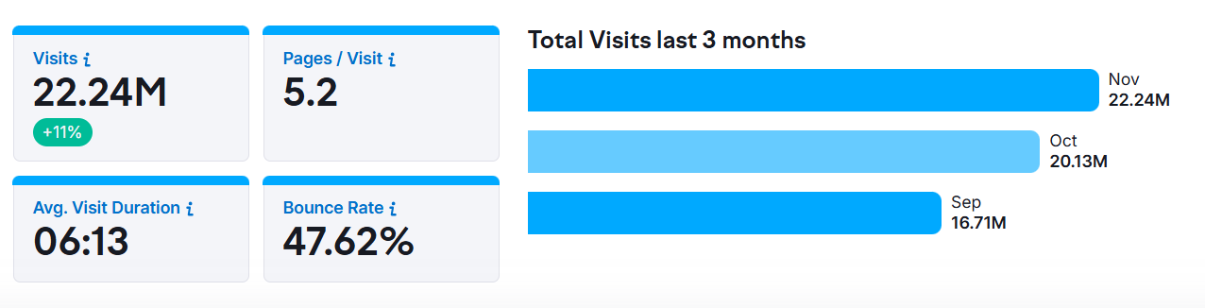
Figure 2: Website visitor engagement of Primark
(Source: SemRush, 2025)
The resilience of Primark’s value-driven proposition has been significantly highlighted by business analysts, particularly during the period of economic uncertainty. It has been reported that Primark has benefited from consumer trading down from mid-range brands to lower price retailers, which reinforces the strategic relevance of cost leadership in a volatile economic environment (Virdi, 2025). From a strategic management perspective, Primark's position is significantly aligned with Porter's generic strategy framework, specifically in terms of cost leadership, which allows the firm to achieve a competitive advantage while offering compatible products at lower prices than competitors. This framework refers businesses to obtain a competitive edge (Kuijk, 2024) [Refer to Appendix 1]. This significantly allows the organisation to have effective market positioning with price sensitivity and high competition, which are prevalent in global fashion retailing.
Primark’s internationalisation strategy has historically favoured organic expansion through wholly-owned subsidiaries rather than franchising or joint ventures. This significantly allowed the organisation to retain operational control, protecting brand consistency, along with enforcing standardised supply chain practices across the market. This approach aligns with the OLI framework, which is also termed as Dunning’s eclectic paradigm, which states that Primark possesses strong ownership advantages with internationalisation advantages and selective target locations with favourable demand conditions [Refer to Appendix 2]. The organisation has also responded to growing stakeholder and regulatory pressure while enhancing its sustainability agenda through the Primark Care program (Primark, 2025). This initiative focuses on improving supply chain transparency, along with reducing textile wastage, and increasing the use of recycled and sustainably sourced materials.
Connecting to this, the selection of Primark for this organisation expansion plan is strategically justified as the company combines strong financial performance and a scalable business model, which can allow the organisation to have an international operation experience and clearly define a competitive strategy. However, it has unlimited geographic presence outside Europe and North America, which suggests a significant growth potential in other developed markets, making it a suitable business for international expansion analysis.

1.2 Proposing a new international market for expansion
The proposed target market for Primark’s international expansion is considered to be Australia, which is a developed economy with a mature retail sector, a high level of consumer spending, and a sizable fashion market. Regarding this, in the year 2022, the market has significantly gained a revenue of $56,701, which is forecasted to grow to approximately $125,546 in the next 5 years with a growth rate of 10.4% (Grand View Research, 2025).
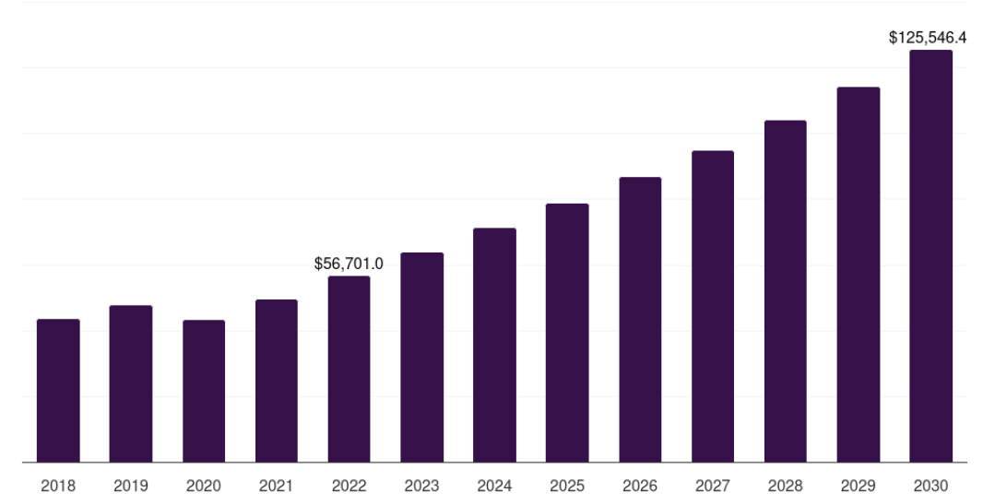
Figure 3: Australia’s fashion market growth
(Source: Grand View Research, 2025)
Moreover, despite cultural and institutional similarities with the UK, Australia is noted as having a notable gap in Primark’s international store portfolio, presenting an opportunity for strategic market development. It has been determined that the Australian clothing retail industry is substantial in scale and economic importance, and this is identified to be improving and having a continuous growth in terms of affordable fashion, increasing urbanisation, and evolving consumer lifestyle (Lewin, 2023). From an economic standpoint, Australia is acknowledged to have strong fundamentals for retail expansion, as the country maintains a high GDP, which represents 1.65% of the world economy (Trading Economics, 2025). On the contrary, the inflation rate of Australia has significantly increased to 3.53% which significantly affects the household spending (Clark, 2025) [Refer to Appendix 3]. However, value-oriented retailers have significantly shown resilience, as consumers in Australia increasingly prioritise affordability. For evidence, it is noted that 84% of Australians are prioritising affordability in terms of their purchasing decisions (Lewin, 2023). This strength can significantly be consistent with Primark’s core value proposition, which will be advantageous for the organisation.
Apart from this, Australia has been identified to have a shared language, similar legal system, and compatible consumer behaviour with the UK, which significantly aligns with the corporate governance standards and operation adaptation. While geographic distance is considerable, Primark is required to establish a global sourcing network, particularly in Asia, which can allow the organisation to mitigate logistical challenges. Apart from this, from an industry competition perspective, Australia's apparel market is dominated by domestic and international players, such as Kmart, H&M, and Zara (Brydges et al. 2021). Regarding this, the competition is intense; however, the market remains fragmented with no single retailer holding a dominant market share which suggests room for a new entrant with a differentiated value proposition. In this regard, Primark’s low pricing strategy will position itself competitively against organisations while offering a broad fashion variety and international brand appeal. This strategic position prominently allowed the organisation to target price-sensitive consumers seeking trend-led fashion without premium pricing.
As referred to by Brydges et al. (2021), Australian consumers are highly fashion aware and influenced by European and global trends, particularly in urban centres such as Sydney and Melbourne. Findings reveal that the younger consumer is in developed markets and increasingly value-conscious while still seeking style and variety that reinforces the relevance of Primark’s offering (McKinsey, 2025). However, Australia presents challenges in terms of labour cost and consumers demonstrating increasing concern for sustainability and ethical sourcing (Murdock et al. 2021). These factors indicate that Primark is required to consider operational efficiency with transparent communication strategies.
Undertaking the challenges and positive perspective, Australia represents a strategically coherent and attractive expansion market for Primark. The country has strong consumer demand for value fashion, a stable institutional environment, and cultural alignment with the existing Primark market, supporting the feasibility of entering. Moreover, expansion into Australia will also strengthen the organisational global footprint while providing a platform for future growth within the wider Asia-specific region.

2. Comprehensive Strategic Analysis

2.1 Macro-environmental analysis
Factors | Justification | Impact
Political | - The political stability of Australia stood at 0.92 points (The Global Economy, 2025)  - Stable democratic governance and trade agreements  - Minimal import tariffs on clothing due to free trade patterns (GOV, 2025) | Positive
Economical | - Current GDP stood at $1,771.68 billion (Clark, 2025)  - Inflation declined to 2.55% in 2025 (Clark, 2025)  - The cost-of-living crisis affected purchasing behaviour (Liu, 2025) | Positive
Social | - The increasing demand for fashion and clothing leads to the growth of the Australian fashion textile market at an 18.4% rate (Grandview Research, 2025)  - Customers are style-conscious and investing more in their fashion and appearance (Liu, 2025)  - Consumer behaviour emphasises fashion diversity, sustainability, and value for money | Positive
Technological | - Rapid e-commerce expansion (Fibre2Fashion, 2025)  - Around 97.063% of the population uses the Internet (Trading Economics, 2025)  - AI is leveraged for inventory management, and digital marketing integration is vital to retail success (Fibre2Fashion, 2025) | Positive
Legal | - Need to comply with the ACL (Australian Consumer Law) (GOV, 2025)  - Workplace management must comply with the “Fair Work Act 2009” and the “Fair Work Regulations 2009” (GOV, 2025)  - Product safety regulations are mandatory (ACCC, 2025) | Negative
Environmental | - Sustainability is increasingly prioritised by consumers  - Government committed to reaching net zero by 2050 (GOV, 2022)  - Waste reduction, eco-friendly materials, and responsible sourcing are prioritised | Negative
Table 1: PESTLE analysis
Political
Based on the macro environment analysis, the political factors are noted to be positive for Primark’s expansion in Australia. This is because, despite a decline in political stability, stable demographic governance and minimal import tariffs are beneficial (The Global Economy, 2025; GOV, 2025). A minimal tariff on imports would be favourable for the organisation for ensuring profitability in this new foreign market.
Economic
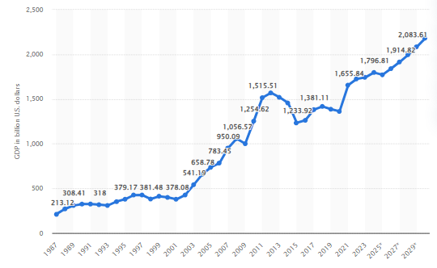
Figure 4: GDP of Australia
(Source: Clark, 2025)
The economic scenario also indicates a positive environment for the expansion of Primark in Australia. This is because, alongside a notable growth in GDP, inflation is declining. Specifically, why the GDP is predicted to reach $2181.79 billion in 2030, inflation is predicted to reduce to 2.5%, after a slight rise in 2026 (Clark, 2025; Clark, 2025) [Refer to Appendix 3].
Social
There is an increasing demand for fashion products, which is contributing to the growth of clothing retailing and the fashion textile market in Australia (Grandview Research, 2025; Liu, 2025). Customers are increasingly becoming style-conscious and investing heavily in fashion and appearance. Consumers' behaviour also emphasises value for money, sustainability, and fashion diversity. This also indicates a positive scenario for Primark to enter and sustain growth in Australia.
Technological
In Australia, there is extensive use of the internet, as well as e-commerce market has been growing rapidly (Fibre2Fashion, 2025; Trading Economics, 2025). This indicates the possibility for the company to successfully interact with customers through online channels and ensure sales. Additionally, the rapid use of advanced technology like AI in this sector is beneficial in terms of successful inventory management and digital marketing.
Legal
Legal scenario indicates that the organisation may have complexities related to legal compliance. This is because there are strict legislative guidelines regarding customer service, people management, and product safety that are mandatory to adhere to within organisational practices (GOV, 2025; ACCC, 2025). Thus, a lack of focus in this regard may lead the organisation to legal consequences that can affect its reputation and financial performance.
Environmental
Alongside increasing concern over sustainability, the government of Australia is committed to reaching carbon neutrality by 2050 (GOV, 2022). There is a need for the organisation to use eco-friendly materials, reduce waste, and prioritise responsible sourcing to ensure sustainability, which may increase cost concerns.

2.2 Analysis of competitive landscape
Porter's Five Forces analysis
Force | Impact | Analysis
Threat of New Entrants | Moderate | - Australia’s fashion market growth attracts investment (Liu, 2025)  - However, high upfront capital for retail space, supply chain setup, and brand recognition needs create barriers
Bargaining Power of Suppliers | Moderate | - Pressure for ethical sourcing and sustainability increases supplier compliance costs  - Primark has a strong supplier base in several countries (Watty, 2025)
Bargaining Power of Buyers | High | - Australian consumers have wide choices, including local, global, and online retailers  - Price sensitivity, under cost-of-living pressures, and no switching cost, which heightens buyer power (Liu, 2025)
Threat of Substitutes | High | - Substitute fashion sources, like online platforms, are widely available (Youl et al. 2024)  - Availability of cheaper products
Competitive Rivalry | High | - Australia has dense competition from established brands  - Competitors are Myer, Farfetch, SSENSE, Net-A-Porter, The ICONIC, and others (Youl and Hockey, 2024)
Table 2: Porter's Five Forces analysis
The above-conducted Porter's Five Forces analysis clearly indicates the competitive landscape of the Australian fashion industry. Specifically, while this market has attractiveness due to remarkable growth, the high requirement of investment for supply chain setup, retail space, and brand recognition is a notable barrier. Additionally, pressure for sustainability and ethical sourcing is notable in increasing suppliers' bargaining power. However, Primark has a robust supplier network in Asia, as in countries like China, Bangladesh, India, Turkey, Pakistan, Cambodia, Sri Lanka, Vietnam, and the UK, it has around 407, 132, 100, 60, 22, 18, 17, 15, and 19 supplier factories respectively (Watty, 2025).
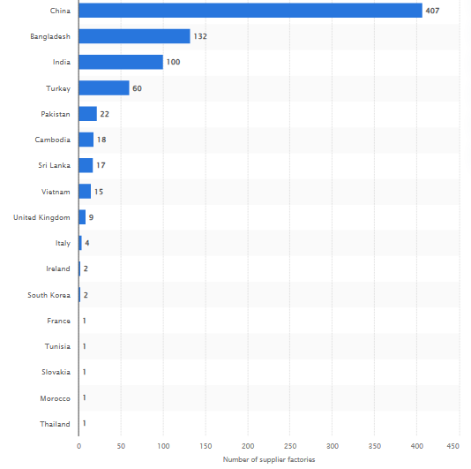
Figure 5: Number of Primark’s supplier factories, by country
(Source: Watty, 2025)
However, customers have high bargaining power due to the increased cost of crisis, no switching cost, and availability of a variety of choices (Liu, 2025). Moreover, this market has a high competitive rivalry with the existence of brands such as Myer, Farfetch, SSENSE, Net-A-Porter, The ICONIC, and others (Youl and Hockey, 2024). Henceforth, despite some concerning factors like competitive rivalry and high bargaining power of customers, the competitive landscape of Australia is observed to be favourable for the expansion of Primark, as there is a moderate rate of entry and the company has a robust supplier network, which can be beneficial in satisfying the needs of customers for affordable fashion.
Analysis of the landscape with Porter's Diamond Model
Dimension | Relevance to Primark
Factor Conditions | - Australia offers a strong retail infrastructure, reliable logistics and skilled workforce, essential for fashion retailing (KPMG, 2025)  - Digital adoption, AI, and data analytics also support omnichannel retailing (KPMG, 2025; Fibre2Fashion, 2025)
Demand Conditions | - Diverse consumers with high expectations around value and sustainability present opportunities for brands (Tapsuwan et al. 2024)  - However, increased customer expectations also raise the entry challenge
Related and Supporting Industries | - Established local brands, supply chain service providers, e-commerce platforms like The ICONIC (KPMG, 2025; Youl and Hockey, 2024)  - Logistics partners aid in creating a supportive ecosystem for retail entrants
Firm Strategy, Structure and Rivalry | - Intense rivalry among domestic and global players drives innovation but raises competition costs  - Primark needs clear value differentiation in terms of sustainability commitments and digital experience
Table 3: Porter's diamond model analysis
Based on the above analysis of the Australian fashion industry with Porter's diamond model, this industry is observed to present a favourable landscape for the organisation. Specifically, the nation has been offering a robust retail infrastructure, which is supported by a skilled workforce and logistics that are required for fashion retailing (KPMG, 2025). Additionally, the increasing use of data analytics, alongside digital adoption, indicates a favourable landscape for the expansion of Primark, as it can successfully leverage the retail infrastructure and digital technologies to smoothly conduct operational activities. Besides, the diverse consumer base has expectations related to sustainability, which present opportunities; however, increased expectations can increase complexities. Despite that, as Primark has a substantial focus on sustainability along with offering sustainable clothing ranges, it can sustain growth in this market (Primark, 2025). Moreover, there are related and supporting industries, including e-commerce platforms, third-party service providers for supply chain and technology and local brands (KPMG, 2025; Youl and Hockey, 2024). However, as there is an extensive competitive rivalry, it will be beneficial for Primark to emphasise differentiation by enhancing focus on elevating digital experience and sustainability-related commitment.

2.3 Critical evaluation of the effectiveness and limitations of the analytical tools employed
For evaluating the macro environment and competitive landscape of Australia, analytical tools like PESTLE, Porter's Five Forces, and Porter's Diamond model are used. In particular, the PESTLE framework provided a clear structure for comprehensively scanning the external environment with respect to political, economic, social, technological, legal, and environmental factors (Korkmaz and Topcu, 2021). However, despite supporting long-term development of understanding development this analytical tool has limitations, as it only emphasises external market conditions.
Besides, the use of Porter’s Five Forces assisted in developing a comprehensive idea regarding the competitive landscape by emphasising forces such as competitive rivalry, bargaining power of customers and suppliers, threats of new entrants and substitutes. However, this tool is industry-focused and ignores complementors. Likewise, to overcome this limitation Porter's Diamond model has been leveraged. Despite having a limitation like oversimplifying the complex country competitiveness, this analytical tool has positively aided in successfully comprehending the competitive landscape with respect to factor and demand conditions. The use of these analytical tools ensured a thorough analysis of the macro environment and competitive landscape of the Australian fashion industry.

3. Strategy Development and Formulation
In this section, strategic frameworks that have been tested and proven are utilised to generate a feasible market entry strategy that will enable Primark to establish a sustainable competitive advantage as it attempts to minimise the risks posed by geographical distance, high operational costs, and growing sustainability pressures. Nevertheless, the greatest strategic priority of Primark in Australia is to create a profitable and scalable market presence at a time when it maintains its low-cost value proposition. Based on the primary focus of attaining a competitive edge through the lowest operating cost structure in the industry, the growth strategy of Primark should be based on the Cost Leadership paradigm developed by Porter (Ali and Anwar, 2021) [Refer to Appendix 1]. This involves taking advantage of the economies of scale, mass purchase and low advertising expenses in order to meet the high structural costs of paying, renting and legal compliance in the Australian setting.
Unlike competitors such as Zara, which focus on differentiation and competitiveness in terms of speed and design, the strategic positioning of Primark focuses on affordability of prices and reasonable quality of fashion apparel (Primark, 2025). However, the cost leadership will also enable Primark to appeal to both cost-sensitive and value shoppers, down to the local value stores like Kmart and Target. Nevertheless, such variables as high minimum wages and logistics on the long way limit the use of absolute cost leadership in the Australian market. In order to meet these challenges and guarantee value creation, maintaining the ethical standards and good consumer service, the strategy of Primark should ensure that cost efficiency comes first before a price reduction has priority. Based on the Dunning framework, the best course of action that Primark would choose to take to establish a presence in Australia is to do it by means of totally owned subsidiaries in a strategic way (Ren, 2024) [Refer to Appendix 2].
The advantages of ownership are strong brand equity, a distinct chain of supply relations, and the successful capacity to operate in a large-format business. High consumer expenditure, political and legal stability and demand for low-priced clothes can enable Australia to cash in on its location. Moreover, Primark has internalisation benefits because of the necessity to manage prices, sourcing standards and efficiency in operations. Primark needs to start with major stores in key cities like Melbourne and Sydney as part of a strategic organic expansion strategy. The cities have a large number of feet, fashionable consumers and a retail base. As a result, the incremental strategy ensures risk is minimised, learning and adaptation are developed, and before the company goes national with its activities, it gets time to perfect its supply chain and operations. Regarding the global strategy perspective, the growth of Primark is closer to a global approach than a multidomestic or multinational approach (Fernandes et al. 2023). There is an increased amount of similarities that should be maintained between products, prices and store layout to retain brand consistency and economies of scale.
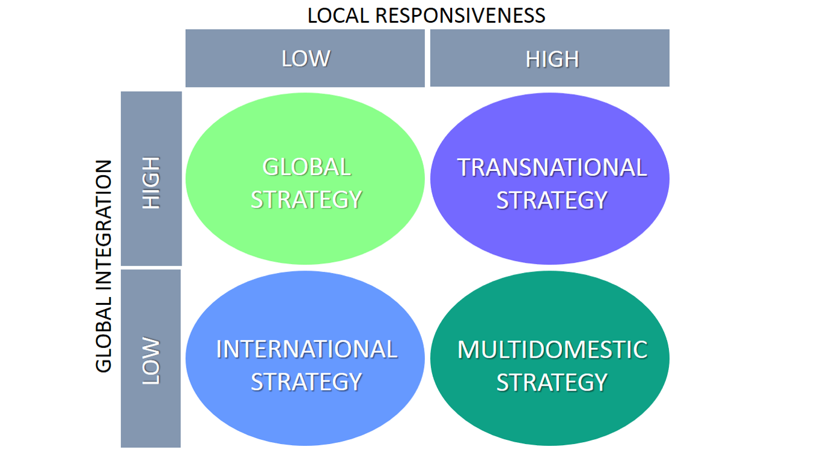
Figure 6: Internationalisation theory
(Source: Fernandes et al. 2023)
Nevertheless, in such categories as fit, seasonal mix of products, and clothes out of temperature, a lesser level of local response is required to reflect the warmer climate and lifestyle of Australia. Primark focuses on global effectiveness but is selectively responsive to the local market circumstances, thus it is reminiscent of Bartlett and Ghoshal's integration-responsivity model (Fernandes et al. 2023). Value chain optimisation will enhance the competitiveness of Primark in Australia, especially in inbound logistics, operations and store management (Du et al. 2022). Due to the geographical separation between Australia and the European markets, Primark can leverage its existing network of Asian suppliers to cut down on the transit time and reduce transportation costs. More efficiency would be produced by strategic alliances with the logistics companies and investment in the inventory planning systems. On the retail level, the stores should be of large format, high density of products, and few in-store services to promote cost effectiveness. Small visual merchandising and low staff-to-customer ratios by Primark facilitate its low price policy without negating the availability of its products.
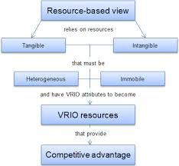
Figure 7: RBV
(Source: Ferreira and Ferreira, 2025)
Although cost leadership may still be essential, sustainability should be considered as a strategic facilitator and not a constraint. Australian consumers and authorities are better acquainted with ethical sourcing, environmental impacts, and labour practices (Stringer et al. 2022). Primark Care programme offers a platform to decrease the reputational risks and increase credibility without significantly changing its low-cost approach. Tactically, sustainability should aim at ensuring the supply chain is transparent, using more recycled materials and observing the existing anti-slavery laws. Those actions are suitable for the Resource-Based View (RBV) that argues that sustainable competitive advantages are a feature of intangible resources such as moral legitimacy and reputation through the preservation of brand trust, reduced regulatory risk, and conformity to the expectations of stakeholders (Ferreira and Ferreira, 2025). Such strategic risks associated with the entry of Primark into Australia consist of brand misdirection, failure to supply, and an increase in cost. In order to minimise such risks, Primark should use strong performance monitoring tools. Besides, redistributing locally earned profits into the slow growth increases financial risk and strategic flexibility.

4. Performance Evaluation Framework

4.1 Balanced Scorecard
Perspective | Strategic Objectives | Key Performance Indicators (KPIs) | Strategic Rationale
Financial | To achieve profitable market entry while maintaining Primark’s cost-leadership model | - Revenue growth in Australia  - Operating margin per store  - Cost per unit sold Return on investment (ROI) within 3–5 years | - Financial objectives focus on ensuring that expansion into Australia delivers sustainable profitability despite high labour and rental costs.  - Maintaining low operating margins is essential to preserving Primark’s value proposition (McKinsey, 2025).  - Monitoring ROI ensures that capital investment in large-format stores delivers long-term shareholder value while mitigating risks associated with geographic distance and market entry costs.
Customer | To build brand awareness and deliver superior value to Australian consumers | - Footfall per store  - Customer satisfaction score (CSAT)  - Repeat purchase rate  - Price perception index | - Customer metrics emphasise Primark’s need to establish brand recognition in a new market where competition is intense.  - Footfall and repeat purchases indicate acceptance of the value-fashion proposition.  - Price perception is critical in Australia, where consumers are cost-conscious but fashion-aware, aligning with Primark’s strategic positioning against domestic value retailers (Hegart, 2023).
Internal Business Processes | To optimise supply chain efficiency and in-store operations | - Stock turnover rate  - Inventory shrinkage  - On-time delivery rate  - Store operating cost ratio | - Efficient internal processes are vital given Australia’s high operational costs and long supply chains.  - High stock turnover supports Primark’s fast-fashion model and minimises markdown risk.  - Strong logistics performance ensures product availability and supports customer satisfaction, while cost control safeguards competitiveness in a price-sensitive market (McKinsey, 2025).
Learning and Growth | To develop local capabilities and support long-term strategic agility | - Employee training hours per FTE  - Staff turnover rate  - Internal promotion ratio  - Sustainability compliance score | - Learning and growth objectives ensure that Primark builds a skilled local workforce capable of delivering consistent service standards.  - Investment in training reduces employee turnover in a high-wage labour market (Al-Azzam and Obeidat, 2025).  - Sustainability metrics support alignment with Australian consumer expectations and reinforce Primark’s corporate responsibility commitments, enhancing long-term brand legitimacy.
Table 1: Balance Scorecard
The balanced scorecard provides an integrated mechanism for translating organisation's Australian expansion strategy into measurable and actionable objectives. Regarding this, financial indicators can prominently ensure that cost leadership is preserved despite Australia's high operating expenses, while consumer metrics assess brand acceptance and value perception in the competitive retail environment. Moreover, internal process measure focuses and supply chain efficiency, which is critically driven by geographic distance and logistics complexities. In addition, learning and growth indicators prominently support long-term sustainability by developing local capabilities and reinforcing ethical and environmental standards. Regarding this, with the support of the balanced scorecard, Primark would be able to have a strategic intent with operational control while monitoring performance historically and adapting effectively during the market entry in Australia.

4.2 Analysing performance measurement system with TBL (Triple Bottom Line) theory
In order to complement the balanced scorecard, along with providing a holistic assessment of Primark's expansion into the Australian market, the TBL model is applied as an overarching performance measurement system. The TBL approach prominently evaluates organisational performance across three interrelated dimensions that are people, profit, and planet, thereby extending beyond the traditional financial metrics to capture broader stakeholder value and long-term sustainability (Nogueira et al. 2023).
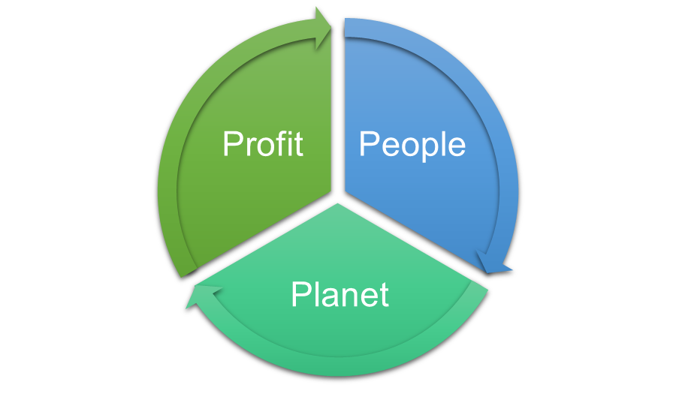
Figure 8: TBL model
(Source: Self-created)
In terms of the profit aspect of the model, while aligning with the financial and customer perspective of the balanced scorecard, the KPI indicators include Australian market revenue growth, store-level operating margin, and cost per unit sold. These metrics assess whether Primark’s cost duration strategy remains viable in Australia's high-cost retail environment. The success is measured not only by the revenue generation but also by the firm's ability to achieve acceptable investment, payback periods, while maintaining competitiveness. By integrating economic KPIs with customer focus metrics, such as footfall and repeated purchase rates, the TBL model can prominently ensure that financial success is evaluated alongside market acceptance and brand loyalty (Agu et al. 2024).
In terms of the social context of Primark's impact on employees, suppliers, and consumers, which directly corresponds with the learning and growth perspective of the balanced scorecard. The key KPIs include employee turnover rates, average training hours for employee health and safety, and supplier compliance with ethical labour standards. In the Australian context, where labour regulations are stringent and wage expectations are high, workforce stability and engagement are critical success factors (Flanagan and Clibborn, 2023). Regarding this, the success metrics in this dimension prominently emphasise employee retention, internal promotion ratios and compliance with modern slavery and fair work legislation through satisfaction and complaint rates.
Referring to the environmental dimension, which complements the internal process and sustainability objectives, it refers to the KPIs regarding the percentage of sustainable source material, carbon emission per store, waste division rates and supply chain environmental audit passed. Given Australia's high environmental awareness among consumers and regulators, success in this dimension requires demonstrable reduction in environmental impact and transport reporting (Khatter et al. 2021). Environmental KPI supports Primark’s broader corporate responsibility commitment while enhancing legitimacy in a new market where sustainability increasingly influences purchasing behaviour.
In this regard, integrating with the balanced scorecard and TBL model provides a multi-dimensional performance measurement system that balances short-term financial outcomes with long-term social and environmental responsibilities. This integrated approach enables the organisation to monitor expansion progress comprehensively while managing stakeholder expectations along with its growth in Australia (Flanagan and Clibborn, 2023). Complementing these, the TBL significantly captures the wider impact of the expansion while assessing economic viability, environmental sustainability, and social responsibility (Nogueira et al. 2023). Economic KPIs deliver long-term financial values while social metrics assess workforce stability and ethical sourcing, along with customer trust (Malarvizhi and Raji, 2024). In addition, environmental indicators prominently measure organisation ability to minimise ecological impact in a market with strong sustainability expectations. With this, the combination of these frameworks provides a comprehensive and balanced approach for Primark while having a forward-looking performance measurement system with informed decision-making in sustainable international growth. This would foster long-term viability by providing Primark with access to international talent, new customer bases, and a competitive edge against market stagnation.

Conclusion
Based on the analysis, Primark’s international expansion strategy has been evaluated while analysing its organisational capabilities, performance measurement frameworks, and target market selection. The organisation's cost leadership models, strong financial performance, and scalable operations position are identified to be advantages for international growth. Regarding this, Australia has been identified as an attractive expansion market due to its improving fashion industry, value-conscious consumer, along with a stable economic environment that significantly has a cultural alignment with the UK. Besides, Primark has an acceptable but competitive environment in Australia to grow internationally, as per the detailed strategic analysis. A macro-environmental review provides a clear view of a robust economy, digital preparedness and increased consumer demand for value clothes; however, unlike the concepts of regulatory and environmental challenges. The presence of a competitive analysis with a strong rivalry in the market and relatively high power of buyers serves as an additional reason to support the necessity of a robust cost-leadership strategy. The proposed strategy thus aligns the fundamental operation capacities of Primark with a gradual yet fully owned entry into the market, coupled with global efficiency, localisation, value chain efficiency and sustainability embedded to establish a long-term competitive advantage in the Australian market. In this regard, to assess expansion progress and impact, the report prominently applies a balanced scorecard and TBL framework while integrating financial, operational, social, and environmental KPIs. This framework has enabled Primark’s performance monitoring and strategic control that can lead to sustainable international expansion.

References
ABF, (2024). Investing for tomorrow Delivering today. [Online]. Available at: https://www.abf.co.uk/investors/annual-report-2024 [Accessed on 28 December 2025]
ABF, (2025). Retail. [Online]. Available at: https://www.abf.co.uk/our-businesses/retail [Accessed on 28 December 2025]
ACCC, (2025). Search mandatory standards. [Online]. Available at: https://www.productsafety.gov.au/business/search-mandatory-standards?layout=grid [Accessed on 28 December 2025]
Agu, E.E., Iyelolu, T.V., Idemudia, C. and Ijomah, T.I., (2024). Exploring the relationship between sustainable business practices and increased brand loyalty. International Journal of Management & Entrepreneurship Research, 6(8), pp.2463-2475.
Al-Azzam, M.D. and Obeidat, S.M., (2025). Global insights on wage and employee turnover in microfinance. International Review of Economics & Finance, 100, p.104117.
Ali, B.J. and Anwar, G., (2021). Porter’s Generic Competitive Strategies and its influence on the Competitive Advantage. International Journal of Advanced Engineering, Management and Science, 7(6), pp.42-51.
Brydges, T., Heinze, L. and Retamal, M., (2021). Changing geographies of fashion during Covid‐19: The Australian case. Geographical Research, 59(2), pp.206-216.
CFI, (2025). Eclectic Paradigm. [Online]. Available at: https://corporatefinanceinstitute.com/resources/management/eclectic-paradigm/#:~:text=Based%20on%20the%20internalization%20theory,model%20follows%20the%20OLI%20framework [Accessed on 28 December 2025]
Clark, D., (2025). Australia: Gross domestic product (GDP) in current prices from 1987 to 2030 n billion U.S. dollars). [Online]. Available at: https://www.statista.com/statistics/263573/gross-domestic-product-gdp-of-australia/?srsltid=AfmBOoq0OzeKXCEXSoF3e-MH9tydeOykb2m1A1mvikm7tsBeq6sZK8WZ [Accessed on 28 December 2025]
Clark, D., (2025). Australia: Inflation rate from 1987 to 2030. [Online]. Available at: https://www.statista.com/statistics/271845/inflation-rate-in-australia/?srsltid=AfmBOoq2KizHG6W-JONwHxfDCknNKmFOnOevajIYRaJxqSN7QwhHZ8Hi [Accessed on 28 December 2025]
Du, G., Meng, S., Zhou, K. and Wu, R.Y., (2022). Value chain design through synergistic optimisation of configuration and operation of value activities: an application case of cold chain logistics. Journal of Engineering Design, 33(8-9), pp.607-634.
Fibre2Fashion, (2025). Impact of AI & e-commerce on Australia's fashion sector. [Online]. Available at: https://www.fibre2fashion.com/news/textile-news/impact-of-ai-e-commerce-on-australia-s-fashion-sector-303208-newsdetails.htm [Accessed on 28 December 2025]
Fernandes, C., Veiga, P.M. and Gerschewski, S., (2023). SME internationalisation: past, present and future trends. Journal of Organizational Change Management, 36(1), pp.144-161.
Ferreira, N.C. and Ferreira, J.J., (2025). The field of resource-based view research: mapping past, present and future trends. Management Decision, 63(4), pp.1124-1153.
Flanagan, F. and Clibborn, S., (2023). Non-enforcement of minimum wage laws and the shifting protective subject of labour law in Australia: A new province for law and order?. Sydney L. Rev., 45, p.337.
GOV, (2022). Government Commitments to Climate Change. [Online]. Available at: https://www.aofm.gov.au/sites/default/files/2022-11-28/Aust%20Govt%20CC%20Actions%20Update%20November%202022_1.pdf [Accessed on 28 December 2025]
GOV, (2025). Australian commitments on tariffs Overall. [Online]. Available at: https://www.dfat.gov.au/trade/agreements/in-force/tafta/fta-information/Pages/australian-commitments-on-tariffs [Accessed on 28 December 2025]
GOV, (2025). Current legislation. [Online]. Available at: https://consumer.gov.au/legislation/current-legislation [Accessed on 28 December 2025]
GOV, (2025). Legislation. [Online]. Available at: https://www.fairwork.gov.au/about-us/legislation [Accessed on 28 December 2025]
Grand View Research, (2025). Australia Fashion Textile Market Size & Outlook, 2022-2030. [Online]. Available at: https://www.grandviewresearch.com/horizon/outlook/fashion-textile-market/australia [Accessed on 28 December 2025]
Grandview Research, (2025). Australia Fashion Textile Market Size & Outlook, 2022-2030. [Online]. Available at: https://www.grandviewresearch.com/horizon/outlook/fashion-textile-market/australia [Accessed on 28 December 2025]
Hegart, S., (2023). Primark Statistics: The Facts You Need To Know. [Online]. Available at: https://huuray.com/inspiration/gift-cards/primark-statistics/ [Accessed on 28 December 2025]
Khatter, A., White, L., Pyke, J. and McGrath, M., (2021). Barriers and drivers of environmental sustainability: Australian hotels. International Journal of Contemporary Hospitality Management, 33(5), pp.1830-1849.
Korkmaz, G. and Topcu, M.K., (2021). PORTER'S DIAMOND MODEL AND THE COMPETITIVENESS OF THE TURKISH DEFENSE INDUSTRY. Journal of Defense Resources Management, 12(1).
KPMG, (2025). Australian Retail Outlook 2025. [Online]. Available at: https://assets.kpmg.com/content/dam/kpmgsites/au/pdf/2025/australian-retail-outlook-2025.pdf.coredownload.inline.pdf [Accessed on 28 December 2025]
Kuijk, A., (2024). Porter's generic strategy framework. [Online]. Available at: https://www.toolshero.com/strategy/porters-generic-strategies/ [Accessed on 28 December 2025]
Lewin, A., (2023). Do consumers really shop their values? Here’s what the data says, and why. [Online]. Available at: https://insideretail.asia/2023/11/15/do-consumers-really-shop-their-values-heres-what-the-data-says-and-why/ [Accessed on 28 December 2025]
Liu, Y., (2025). Clothing Retailing in Australia - Market Research Report (2015-2030). [Online]. Available at: https://www.ibisworld.com/australia/industry/clothing-retailing/407/ [Accessed on 28 December 2025]
Lu, S. (2023). Primark’s Global Sourcing for Apparel. [Online]. Available at: https://shenglufashion.com/2023/09/11/primarks-global-sourcing-for-apparel-updated-september-2023/ [Accessed on 28 December 2025]
Malarvizhi, S. and Raji, V., (2024), February. Reviewing the landscape: A literature-based exploration of sustainable HR practices and Key performance indicators (KPIs) in green HRM for assessing organizational sustainability. In 3rd International Conference on Reinventing Business Practices, Start-Ups and Sustainability (ICRBSS 2023) (pp. 580-588). Atlantis Press.
McKinsey, (2025). The State of Fashion 2026: When the rules change. [Online]. Available at: https://www.mckinsey.com/industries/retail/our-insights/state-of-fashion [Accessed on 28 December 2025]
Murdock, B.E., Toghill, K.E. and Tapia‐Ruiz, N., (2021). A perspective on the sustainability of cathode materials used in lithium‐ion batteries. Advanced Energy Materials, 11(39), p.2102028.
Nogueira, E., Gomes, S. and Lopes, J.M., (2023). Triple bottom line, sustainability, and economic development: What binds them together? A bibliometric approach. Sustainability, 15(8), p.6706.
Primark, (2025). Our Primark Cares Commitments. [Online]. Available at: https://corporate.primark.com/en-gb/a/our-approach/our-primark-cares-commitments [Accessed on 28 December 2025]
Primark, (2025). Sustainability and Ethics Progress Report. [Online]. Available at: https://corporate.primark.com/en-gb/primark-cares/sustainability-report [Accessed on 28 December 2025]
Ren, Y., (2024). A Review of the Determinants of Outward Foreign Direct Investment (FDI): From the Perspective of the Eclectic Paradigm. Academic Journal of Business & Management, 6(11), pp.128-132.
SemRush, (2025). Primark. [Online]. Available at: https://www.semrush.com/website/primark.com/overview/ [Accessed on 28 December 2025]
Stringer, T., Payne, A.R. and Mortimer, G., (2022). As cheap as humanly possible: why consumers care less about worker welfare. Journal of Fashion Marketing and Management: An International Journal, 26(4), pp.717-737.
Tapsuwan, S., MacMillan, C., Moglia, M., and Gordon, S., (2024). Consumer preferences for sustainable clothing. [Online]. Available at: https://australiancottonconference.com.au/wp-content/uploads/TAPSUWAN-Sorada.pdf [Accessed on 28 December 2025]
The Global Economy (2025). Australia: Political stability. [Online]. Available at: https://www.theglobaleconomy.com/Australia/wb_political_stability/ [Accessed on 28 December 2025]
Trading Economics, (2025). Australia - Individuals Using The Internet. [Online]. Available at: https://tradingeconomics.com/australia/individuals-using-the-internet-percent-of-population-wb-data.html [Accessed on 28 December 2025]
Trading Economics, (2025). Australia GDP. [Online]. Available at: https://tradingeconomics.com/australia/gdp [Accessed on 28 December 2025]
Virdi, A., (2025). Primark to shift focus from fashion to price to help people ‘rediscover’ its ‘value disruptor edge’. [Online]. Available at: https://www.marketingweek.com/primark-value-disruptor-marketing/ [Accessed on 28 December 2025]
Watty, F., (2025). Number of supplier factories of Primark as of October 2024, by country. [Online]. Available at: https://www.statista.com/statistics/1102388/number-of-suppliers-of-primark-by-region/?srsltid=AfmBOoqh4TOJ62zTkQX1XnJYasZyT3rVV5o5Ec76hlCmHcgVVgJvOxHB [Accessed on 28 December 2025]
Youl, P., and Hockey, M., (2024). The Best Online Shopping Sites In Australia, According To marie claire. [Online]. Available at: https://www.marieclaire.com.au/shopping/best-online-shopping-sites-australia/ [Accessed on 28 December 2025]

Appendices

Appendix 1: Porter's generic strategy framework
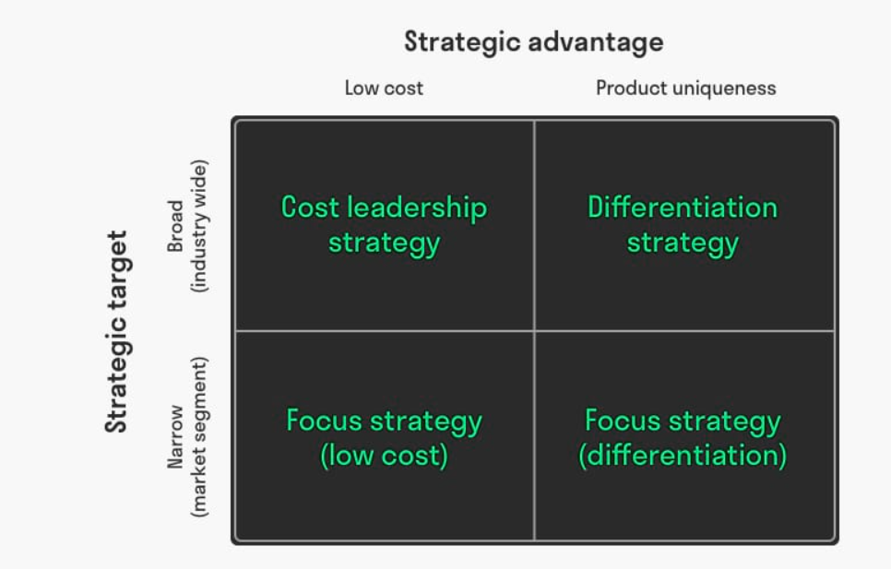
(Source: Kuijk, 2024)

Appendix 2: OLI framework
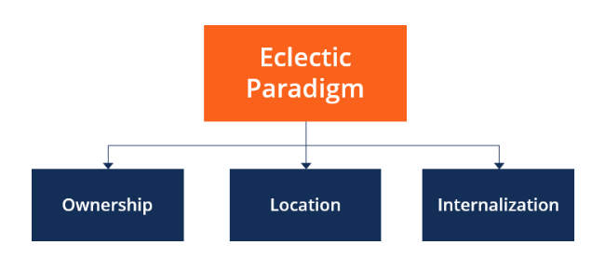
(Source: CFI, 2025)

Appendix 3: Inflation rate in Australia
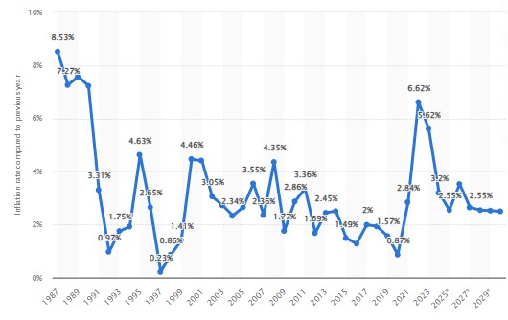
(Source: Clark, 2025)

