Strategic Management for SMEs
BMSW6104

Strategic Development and Implementation for SMEs

Land Chocolate LTD



By

Laszlo Peter Molnar

Student ID: 2113314
Lecturer: Faizu Edu

Executive summary

It is well known that the efficiency and profitability of multi-enterprises (large enterprises) are much higher than that of micro, small, and medium-sized enterprises due to more favourable conditions. Small and medium-sized enterprises (SMEs) are enterprises that maintain their revenues, assets, liabilities, and employees up to a certain limit. SMEs play a very important role in the country's economic growth, they provide job opportunities and bring innovation to the country. Governments also help encourage SMEs with incentives, favourable tax breaks, and better credit options. These SMEs can be part of any industry, they have come up with new and innovative ideas that require less labour, less capital, etc. (Rizos, et al., 2016)

Following the same path is London-based chocolate company SME Land Chocolate, which was founded in 2016 by Phil Landers, whose vision was to produce quality chocolate from the bean to the chocolate bar that is a tribute to the world's finest cocoa and the people. The Land has won numerous awards since its humble beginnings. It's still made in London's East End and enjoyed around the world - from Paris to Tokyo and, of course, Bethnal Green, where it all began. (Land, 2022)
Business aspect:
- Award-winning chocolate of unique origin
- Discovery of natural flavours, unique to each origin
- Paying 2-3x the Fairtrade price for cocoa.
The 5 principles of Fair Trade for the Reduction of inequalities and Sustainable Development
- Fair price – producers receive a fair price that covers the costs of production, and ensures a decent living and a reasonable profit.
- Prohibition of child labour - all forms of child labour are prohibited.
- Fair working conditions - workers employed on plantations, farms, processing plants, and other facilities are safe and legal. They work in healthy working conditions, a maximum of 48 hours a week, and are paid a living wage. All forms of discrimination, coercion, and harassment are prohibited.
- Development of local communities - a significant part of the Fairtrade surcharge (Fairtrade premium) is used by the producer communities for such developments as drinking water supply and road construction. But it also finances the establishment of educational and health institutions, training costs, micro-loans, and health insurance.
- Environmental sustainability - the use of harmful chemicals and genetically modified plants is excluded from the fair trade system. Supported production technologies protect the valuable ecosystem and protect the health of both the producer and the consumer.

Fairtrade-certified products can only come from countries where freedom of association is a given. In exchange for a higher price, the producer must comply with the basic principles of the organization. (Organisation, 2023)
Phil Landers 2019 Land has built a reputation for quality, winning a handful of awards over the years and supplying chocolate to some of the most esteemed companies, including Selfridges and Michelin-starred restaurants. The mission has been the same since day one. Make the highest quality chocolate, but not at the expense of the environment or the supply chain. (Land, 2022)

Table of content
Executive summary 2
Introduction 4
Task 1. 4
The current strategic direction of the organization 4
Land Chocolate Ltd: 5
The Land Chocolate Ltd revenue: 5
Analysis of the external and internal environment of your organization 6
Land Chocolate LTD. Strategy: 6
Land Chocolate LTD SWOT Analysis 6
Land Chocolate LTD PESTEL analysis 7
RBV-VRIO Framework 9
Land Chocolate Ltd VRIO analysis 10
Task 2 11
Strategic growth opportunities available to SMEs in the markets 11
Land Chocolate Ltd Porter’s Generic Strategies 11
Land Chocolate Ltd Ansoff Matrix 13
Stakeholder analysis and critical evaluation of the expectations of the various stakeholders 15
Stakeholders have a fundamental influence on sustainability performance. 15
Strategies for increasing the value and profitability of the Land chocolate factory. 16
The different methods through which Land Chocolate can get financing are the reality of the developers. 19
Recommendation for choosing the best source of financing for Land chocolate bar 20
Conclusion 20
References 20

Introduction

There are over 5.7 million small and medium-sized businesses in the UK. They are the engine of growth in our economy, they encourage innovation and higher productivity, and they find solutions, and create jobs.
In 2023, there were approximately 5.55 million SMEs in the UK. Micro businesses employing up to nine people make up the majority of SMEs in the UK, with over 5.28 million people. Businesses with 10-49 employees are considered small businesses and makeup around 222,800 in the UK, while medium-sized businesses number 36,900. (Clark, 2023)

This report discusses the various factors that need to be considered for SMEs.
The report is divided into two parts, in which the first part deals with the organization's current strategy and the analysis of the organization's external and internal environment. The second part covers the strategic growth opportunities available to SMEs in the markets, as well as the consideration of new strategic opportunities that can bring long-term results in the future.
To illustrate the points mentioned above, this report considers Land Chocolate LTD as a case company, an SME based in London, United Kingdom.

Task 1.

The current strategic direction of the organization

Retail sales of chocolate confectionery are set to fall by 3% in 2023, in line with the UK's declining frequency of chocolate consumption. It also contributes to the fact that restrictions on the placement of HFSS (Caines, 2022) products have reduced the visibility of chocolate in stores and reduced purchases of chocolate in supermarkets.

Land Chocolate Ltd:

Is a live company located in London, Bethnal Green. It operates in the manufacture of cocoa and chocolate confectionery sectors. Founded in September 2016, its largest shareholder is Phillip Jeremy John Landers with a 100% stake. Land Chocolate Ltd is a young, micro-sized company that has 4 employees. It offers chocolate in various shapes and forms. Big slices, small slices, drinking chocolate, coverture.
By 2019, Land has built a reputation for quality, winning a handful of awards over the years and supplying chocolate to some highly regarded companies, including Selfridges and Michelin-starred restaurants.
The mission has been the same since day one. Make the highest quality chocolate, but not at the expense of the environment or the supply chain. (Land, 2022).

The Land Chocolate Ltd revenue:

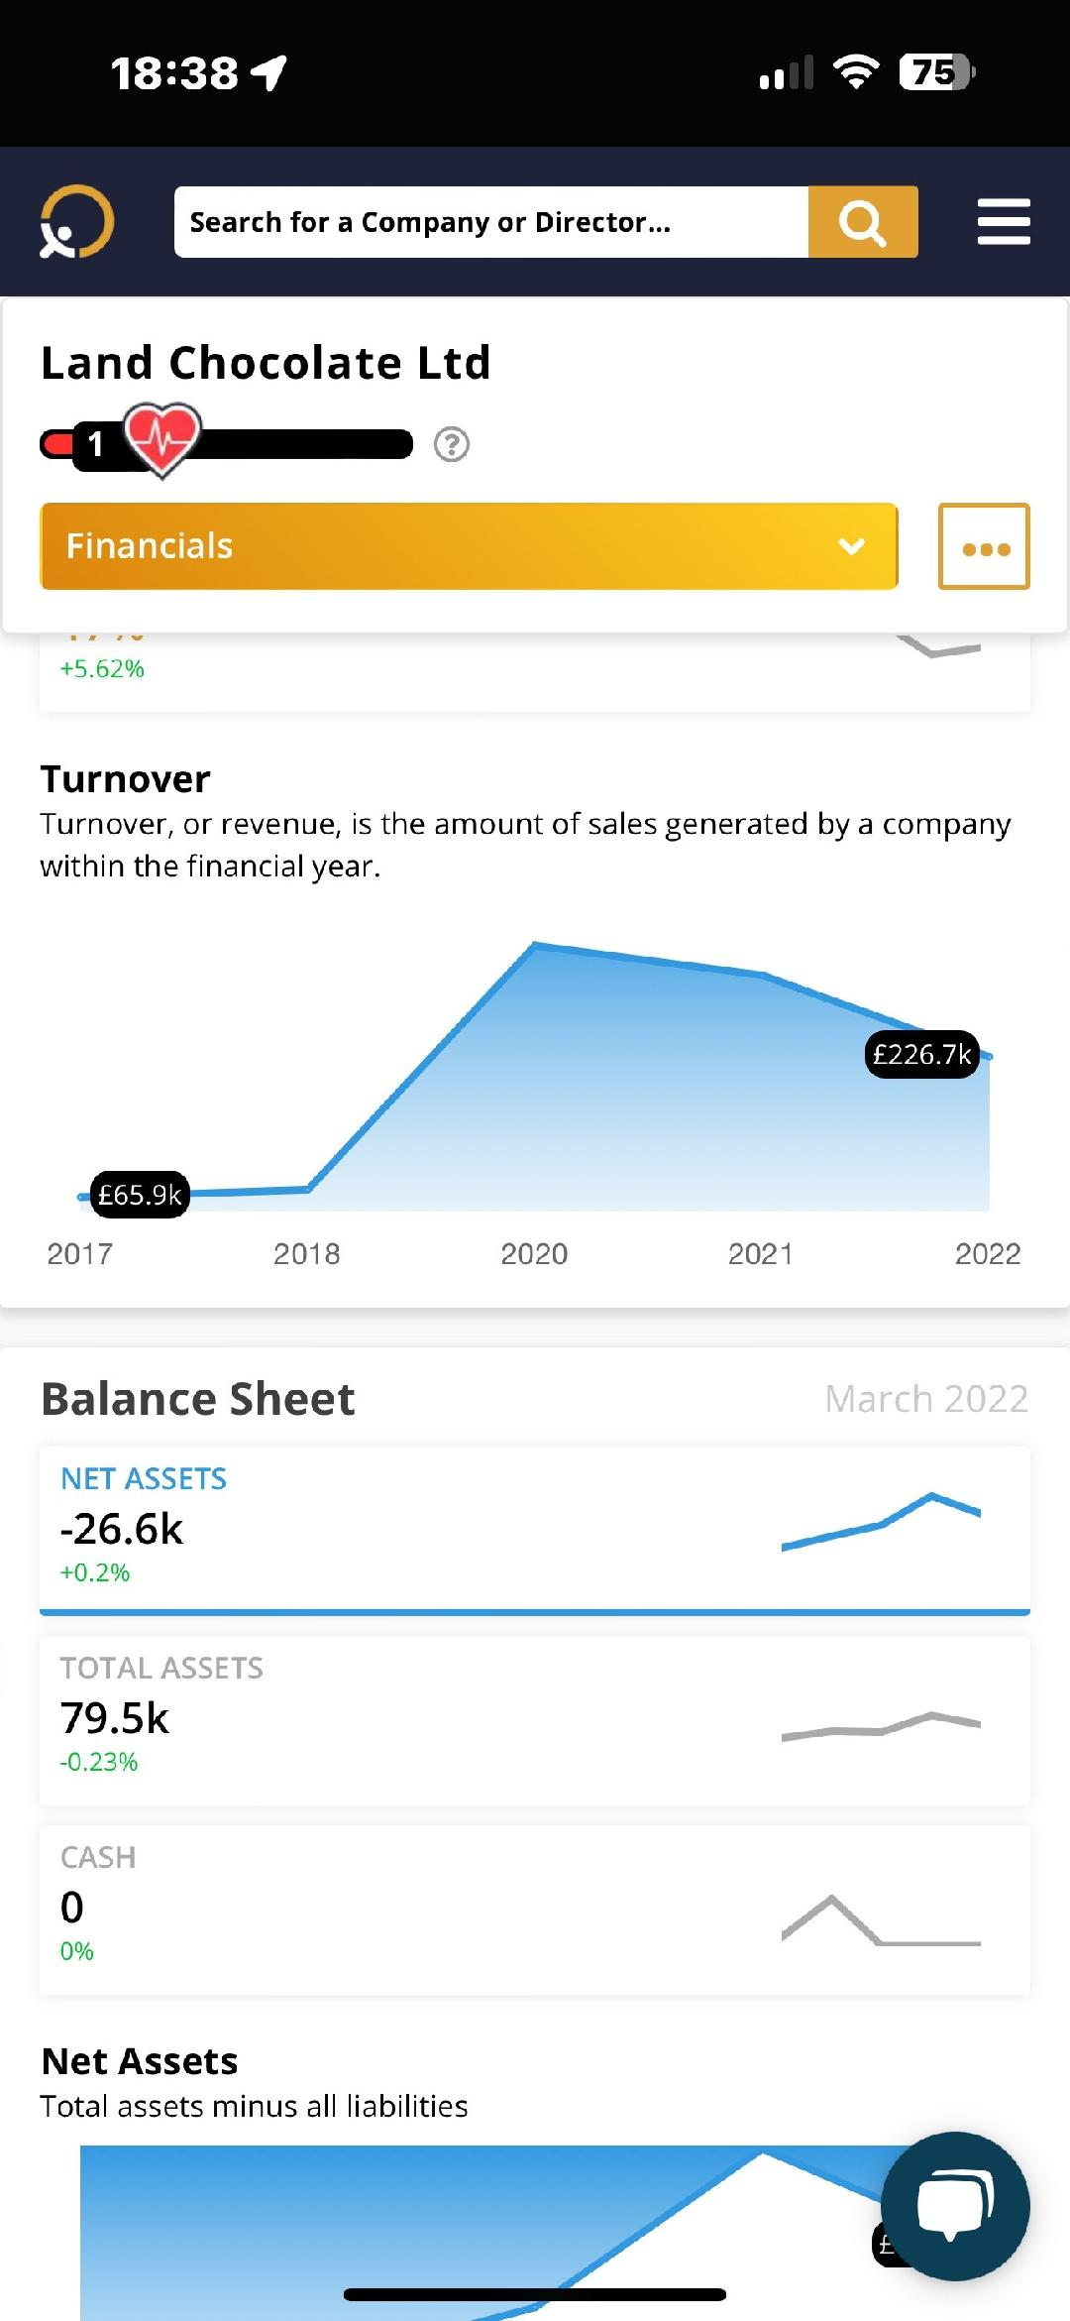Figure 1 Land Chocolate turnover

The sales revenue of Land Chocolate Kft. in March 2022 is estimated at 226.7 thousand pounds and the net assets of the company at -26.6 thousand pounds. According to their 2022 financial statements, Land Chocolate Ltd has 2 employees and maintains 0 cash reserves on the balance sheet. According to the financial statements, the company has 4 employees and based on the statements, in March 2023, the company net assets were 254,000 pounds. (10390931_aa_2023-12-14, 2023)
According to the statements, the company increased its income from 2016 to 2021. In the past two years, its turnover and income have fallen.

Analysis of the external and internal environment of your organization

In the modern market economy, entrepreneurs compete with each other. Due to the supply exceeding the market demand and the rapidly changing and uncertain environmental conditions, they are forced to win the trust of the consumers of the market and to maintain and increase their market presence, ahead of their competitors. The strong market competition, the uncertainty of their environment, and the prevention of dangerous situations, prompt and force businesses to - face their problems - organize their knowledge and prepare for the conscious planning of their future. They can develop their strategy as a tool and method for this. Strategy is nothing more than the long-term planning of actions to achieve certain goals. Strategy as a business concept
The concept of a small business is based on three essential prerequisites
• Existence of an identity (vision, mission, value),
• Employees are willing to think,
• Employees have a sense of responsibility if the prerequisites are met, the small business will be able to
• finds the right direction,
• create order around you,
• create a method for the previous two.
Based on the aspects of this concept, the strategy, system, and method are based on pillars, of which the system is a static element while the strategy is a dynamic element. Thus, when defining the strategy, we can mark the value creation and business goals as a direction.

Land Chocolate LTD. Strategy:

Going back to the basics of chocolate, Land treats the cocoa bean with meticulous detail at every stage of the process. This process begins with the procurement of cocoa. It works with like-minded producers like Ingemann and Uncommon Cacao to buy the best quality cocoa while providing a living for farmers who pay 2-3 times the fair trade price. (Land, 2022)

Land Chocolate LTD SWOT Analysis

With the help of the SWOT analysis, we can determine the business portfolio of the company, and the strengths, weaknesses, opportunities, and threats of some of its projects.
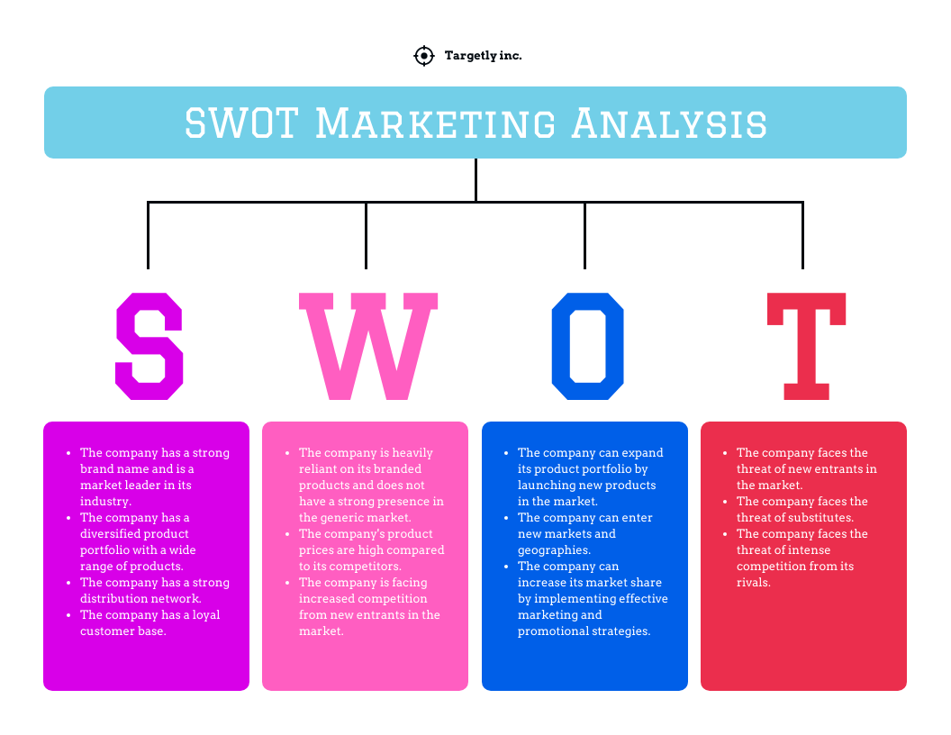Figure 2 Swot template

Strength: the characteristics of the business that give it an advantage over others.
- Quality raw materials,
- Popular trends such as gluten-free, dairy-free, vegan, and soy-free chocolate.
Weaknesses: the characteristics of the business that put the business at a disadvantage compared to others
- Competition is increasing and the market is becoming saturated.
- The profit margins
- Lack marketing knowledge.
Opportunities: the elements of the environment that the business can use to its advantage.
- New B2B opportunities are available.
- More distributors want artisanal chocolate
Threats: external factors that may present a challenge or risk.
- The marketing staff of the big chocolate companies refer to handmade chocolate
- The production of fine-tasting and better-quality cocoa may decrease in the coming years. (Hill, 2007)

Land Chocolate LTD PESTEL analysis

PESTEL examines the large-scale environment outside the company and industry.

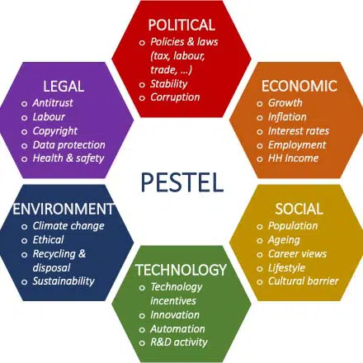Figure 3 PESTEL template

Political factor: How and to what extent a government intervenes in economies or businesses are political factors. The economy can be influenced by the government. It is implemented through laws and regulations. This includes political stability and its relationship with other countries.
The UK's stable political environment is a supporting factor for the company. It offers all SMEs various incentives and benefits, and provides them with tax breaks, which support the company and make it possible for the companies.

Economic factor: These elements determine the efficiency of the economy.
The developing economy of the United Kingdom supports small businesses, which provides opportunities for the growth of the Land Chocolate company. The growth of the Land Company helps the development of the country's economy, this small business helps create jobs by introducing new products.

Social factors: As new generations, Millennial and Generation Z interpret workplace ethics and work culture differently, these societal factors must be taken into account by companies.
Land Chocolate Company should focus on things that will attract a new generation of customers, which will increase the demand for the product in the market. The Land Chocolate company should also focus on the latest trends in society like lifestyle, growing urban population, and trends.

Technological factors: Technological progress has made the production process simpler for several companies. But these new technologies can also represent potential competition for certain businesses.
It includes aspects such as research and development activity, the rate of technological change within the company, and the technology life cycle. These changes can also be implemented in the products offered by the company on the market, the products sold by the company must be unique and innovative.

Environmental factors:
Recently, environmental factors, such as concerns about climate change, have brought a variety of new regulations into the lives of companies. Although not all of the regulations are legal requirements, companies that can perfectly meet these expectations are likely to be able to generate more traffic. It is important to focus on organic farming and waste management and the use of sustainable products, which at the same time protect the environment and provide a healthy product to your customers.

Legal factors: Legal factors are extremely important. Not only do the regulations maintain a negative perception among the public, but they can also have unfavourable legal consequences.
These factors affect the company's profitability and business operations. Land Chocolate must ensure that labour law is effectively implemented, including employee engagement programs. (Pan, et al., 2019)
To create the company's strategy, analyse the current situation, and prepare plans, it is essential to assess and evaluate the company's internal capabilities and resources, and to estimate the impact of future processes on the company.

RBV-VRIO Framework

One method of assessing internal resources is the "resource-based view" (RBV), i.e. the resource-based approach. The method analyses resources as the key to company processes, which are the means of achieving comparative advantages. The theory starts from the need to find those resources within the company (instead of, or rather in addition to, the analysis of the external environment) that can give the company a competitive advantage over its competitors. The method divides resources into two basic groups:
1. Tangible resources: physical, visible (e.g. capital, land, buildings, plantations, equipment, stocks)
2. Intangible resources: non-physical, invisible (e.g. culture, knowledge, brand value, reputation, intellectual property, such as copyright, patent, trademark, production, business secret).

The comparative advantage can come more from intangible resources, which are much more difficult to generate and create. The tools are evaluated in the VRIO framework (Barney, 1986):
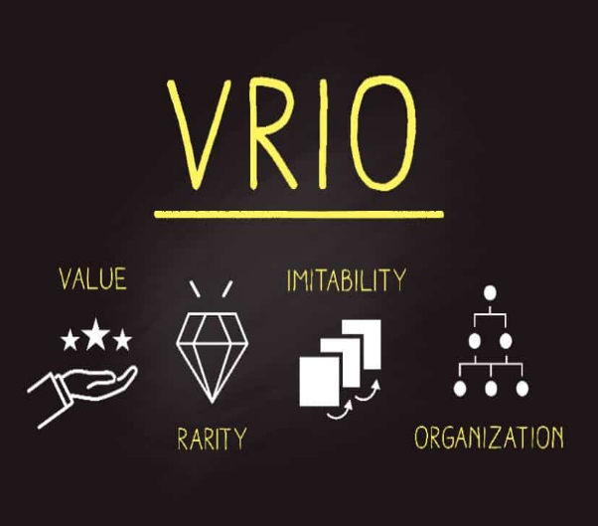Figure 4 VRIO

Land Chocolate Ltd VRIO analysis

V – Can be evaluated – yes; making quality chocolate, with a special process
R – Rare, unique- yes; about the utilization of chocolate and its incorporation into various food and beverage areas
I – it is costly to copy- no; easily copied or replaced.
O – The value of the resource can be captured (organizationally embedded). – No; since the organization has only 1 person, the company does not have the background of large companies.

Task 2

Strategic growth opportunities available to SMEs in the markets

Land Chocolate Ltd Porter’s Generic Strategies

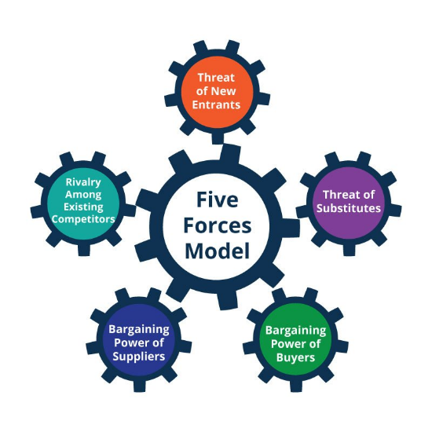Figure 5 Porter’s 5 forces model

Treats of new entrants -
In the case of Land Chocolate Limited, the risk of new entrants is high. SMEs only need limited investments to start a business, anyone can start a venture at any time. Therefore, the barriers to market entrants are very low. By producing different and innovative products, the handmade chocolate company can enjoy the possibility of pricing and market share. Based on the quality and versatility of your product, you can access new markets.

The threat of substitution -

The risk is high with Land chocolate bars, as there are many different companies selling chocolate on the market. Both handmade and factory quality. In the chocolate industry, the availability of substitutes is very easy. The company that gains customer satisfaction gains a greater competitive advantage.

Bargaining power of buyers -

The bargaining power of buyers is very low since each buyer is an individual who buys a small number of products. In the case of the Land Chocolate Company, customers have no influence, as consumers find the best quality at the most favourable price on the market.

Bargaining power of suppliers -

The bargaining power of suppliers is moderate because the company depends on the best quality raw material to produce the best quality chocolate beans. The bargaining position of suppliers is influenced by the number of suppliers, how different and unique their products are, and how much it will cost the company to switch to new suppliers.

Competitive Rivalry -

There are many companies in the market that sell leading artisan and factory chocolates like Duffy's, Aphrodite Chocolate, Milka, etc. and they have a large market to cover. Various SMEs also produce chocolate and offer quality products on the market, which is why Land Chocolate has many competitors. (HAX, 1984)

Land Chocolate Ltd Ansoff Matrix

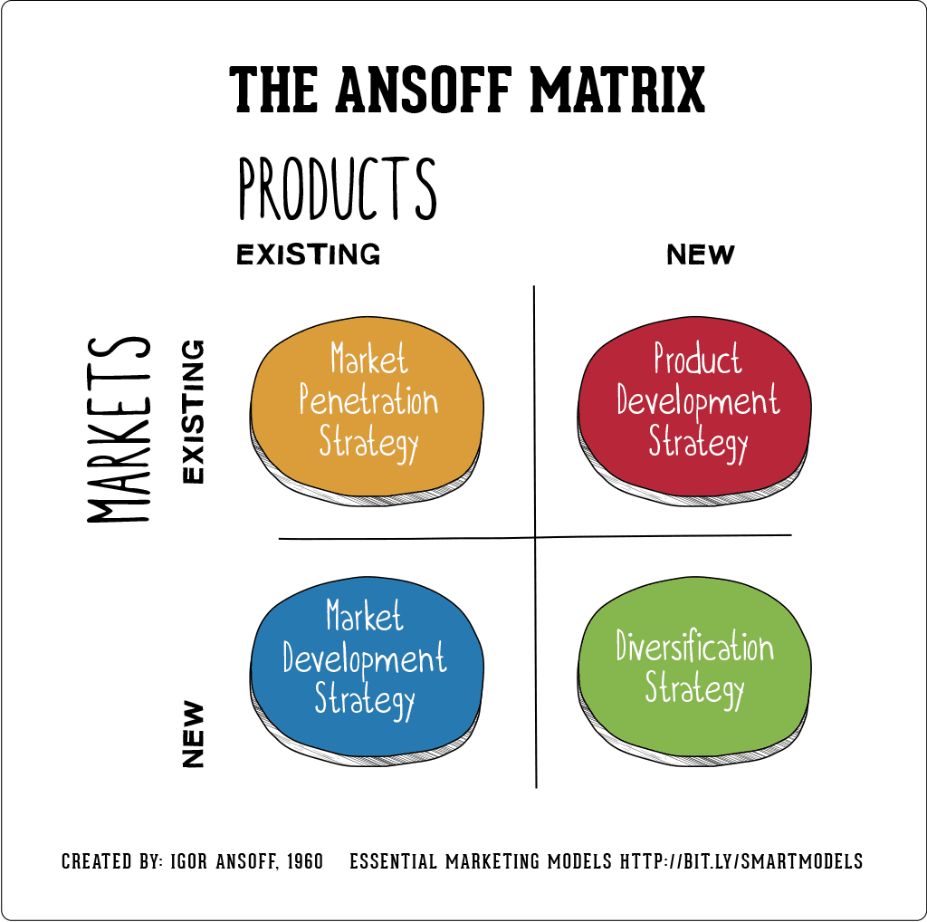Figure 6 Ansoff matrix template

Mathematician and business executive H. Igor Ansoff (Hussain, et al., 2013) created the matrix to help businesses define their strategies by varying what product to sell and to whom.
Ansoff's matrix encourages marketers to consider the four P's or "marketing mix":

• Product: what do they sell?
• Location: where is it sold?
• Price: how much does the product cost?
• Promotion: how is the product sold to the target audience?

Whether a marketer can accurately define the four Ps for their marketing efforts depends on the growth strategy they are using and the political and economic outlook of the market.

Market penetration:

A market penetration strategy is a growth approach that focuses on selling existing products in existing markets. Among the growth opportunities in the Ansoff matrix, market penetration is generally considered to be the least risky. This is because this strategy works across existing products and markets, and does not specifically involve new product development or market mapping.

Market Development -
A market development strategy takes an existing product to new markets. Similar to a product development strategy, a market development strategy is considered riskier than a market penetration strategy because it involves introducing a familiar product to an unfamiliar market. Although the product remains the same, the new point of sale may require new pricing and promotional efforts.

Product development -
Product development strategy involves developing a new product for an existing market. It is typically considered riskier than a market penetration strategy because it requires the creation of an entirely new product. To be successful, product development strategies typically require innovation and further research into the existing market, including the profile and needs of the target audience.

Diversification –

A diversification strategy involves developing a new product for a new market. The novelty expected from the diversification strategy also means that it is the riskiest of the four strategies of the Ansoff matrix. Diversification strategies require full attention to all four Ps—product, price, place, and promotion—but the biggest risks can also lead to the biggest rewards. (Hussain, et al., 2013)

Stakeholder analysis and critical evaluation of the expectations of the various stakeholders

Stakeholders have a fundamental influence on sustainability performance.

Understanding the environment of the organization creates a new perspective because the business no longer revolves around the customer who pays for our service and who buys our products. This focus extends to the stakeholders, i.e. those who can significantly risk the sustainability of the organization.
Who are they? An interested party is the customer, the supplier, any service organization, authority, municipality, society, parent company, sister company, employees, etc.
In the case of the Land Chocolate Company, e.g. the customers, the chocolate bean producers, the employees. (Krishna, 2023)
Many groups and organizations are involved in the business activities of Land Chocolate. These stakeholders, in turn, have a fundamental impact on your sustainability performance. We group stakeholders based on their impact and influence on business practices.
Contacting different groups and identifying and responding to needs is different. One way of identifying and summarizing issues affecting stakeholders is materiality assessment. With the help of the results of the evaluation, it determines its strategy, goals, and metrics for the company and other interested parties in the important topics.

The most important stakeholders:

- Clients
- Employees
- Investors/shareholders
- Suppliers
- Local communities
- Government, authorities.

Customer dialogue: To learn about market needs and stimulate value creation

Customers help us understand and explore the possibilities of innovation. Relying on a direct and frequent exchange of ideas, products that customers want must be developed and marketed. .
Suppliers: common, proactive measures must be taken for sustainability at all points of value creation
Activity related to the supply chain is an important element of sustainability performance. Actively collaborates with suppliers to ensure they also meet Land's responsible operating standards for chocolate.
Land Chocolate are also in direct dialogue with our suppliers in some key focus areas such as:
- Financial stability and operational efficiency
- Environmental responsibility,
- Social responsibility, such as the fair supplier price/ratio.
Community commitment: To improve the quality of life of its employees and those affected by its operations

Land chocolate seriously cares about the communities in which it lives and works. The company cares about the cocoa bean producers so that they get quality sugarcane and adequate money. (Hill, 2007)

Strategies for increasing the value and profitability of the Land chocolate factory.

Chocolate companies are taking significant steps to improve the conditions of cocoa cultivation and to promote the sustainability of the industry, and so is Land Chocolate LTD.
Major chocolate companies such as Nestle support responsible farming practices, invest in farmer training and community development, partner with organizations to manage deforestation risks and empower cocoa farmers to create a flexible and equitable supply. A chain that meets the needs of conscious consumers. (Grewal, 2023)
But smaller micro companies cannot do everything for this. What can they do to improve their income and have a more sustainable business?

New businesses are the basis for the growth of an economy. The effectiveness and efficiency of already operating micro, small and medium enterprises determines the economic performance of a country.
Even before the economic crisis, it was difficult for some small companies to get the financing necessary for their growth or innovation. Whether they needed a car loan to start a transportation business or equity capital for a biotech venture, SMEs often found it hard to get money.

The Strategy for increasing the value and profitability of the Land chocolate factory is given by the Ansoff Matrix.
Market penetration:
- Production capacity:
If Land Chocolate Factory increases its total production capacity, it will allow the company to reach a wider audience in an existing market and thus benefit from lower costs. For this, however, the number of employees must be increased and equipment must also be invested.

- Marketing investment
More investments in marketing and sales activities. It helps the Land Chocolate company to be in contact with its customers more effectively, and this leads to more potential customers.

- Distribution channels
Land Chocolate Factory can explore innovative and unique sales channels. For example, you can break into the market of hotel chains with the special chocolates you sell.

Market development
- Research and development
Land Chocolate Factory must invest in its R&D department to be able to identify the changing trends of the market. This helps you target the right market at the right time. (Darmawan & Wiguna, 2014)

- Territorial expansion
The Land chocolate factory can enter a new market if it expands its activities. This includes various cities across the country.

- New segments
New segments of the current market can be discovered. The Land Chocolate Factory can add new functions and ways of using the product to its existing products, among which there are still many special products, for example, the chocolate drink or the bagged chocolate in the ass of the food products, which also satisfy the needs of another customer segment. Hotels or restaurant chains.

Product development
- Amendments
Land Chocolate Factory may modify an existing product by improving its features to expand its product offering. (Darmawan & Wiguna, 2014)

- Introducing more products
Land Chocolate Factory should invest in its R&D department to come up with new and innovative products that attract and satisfy the needs of the target audience. This will increase your sales and increase your profitability.

Diversification

- Vertical integration
Develop and launch new products that are similar to your existing product category.
- Horizontal integration
Land Chocolate Factory can diversify its business through horizontal integration. This means entirely that your new products and services are unrelated to your current products. (Darmawan & Wiguna, 2014)

The different methods through which Land Chocolate can get financing are the reality of the developers.

The majority of SMEs are made up of private individuals, who are the driving force behind job creation and economic development. These SMEs provide essential goods and services to small and middle-class communities. Financing small and medium-sized enterprises is a big challenge for all financial institutions for various reasons.

In this changing and emerging economy, most SMEs are financed by various sources outside the formal financial sectors, which are quite expensive for businesses. To expand the business, the company needs more resources. There are various financing methods available from which Land Chocolate Tooth can choose the best way to obtain funds.
The methods of financing are as follows:

Bank loans

– This is the simplest way of financing. The company can choose from various loan options, which, according to the agreement, will pay a fixed interest rate together with the principal amount in the future at a pre-agreed date.

Venture capitalists

– In this method, funds are obtained from venture capitalists in exchange for interest on their investments. This is a very common way of financing, in the market, different investors are always looking for opportunities to invest in companies and earn profits in return for their investments. The venture capitalist only invests if the project is worth investing in and provides the expected return.

Government funding
- The United Kingdom Government always initiates the financing of this type of SME, because the development of SMEs helps the economic development of the country. The government is launching several programs that provide resources and growth opportunities for small businesses. The government offers resources such as real estate, loans, tax credits, etc. However, this method of financing has a major drawback, obtaining funds from the government is a very difficult task, requiring a lot of legal formalities and eligibility for state support.

Recommendation for choosing the best source of financing for Land chocolate bar

Choosing the right funding source for an SME like Land Chocolate Company is a very important task. As mentioned in the report above, there are different ways of financing and the company should choose the best option for its future development. In the case of Land chocolate bars, it is recommended that the company consider the possibility of various governments or think about venture capital investment. Its main aim is to cover a large market area and also attract rich people, which further helps the company to get investments from venture capitalists as they are members of high-income groups.

The Land Chocolate Ltd has everything it takes to expand its scope and offer a product that will impress consumers looking for quality food. But to survive and thrive, you need to promote yourself more and better online and offline, and develop more strategic plans of action to seize opportunities and avoid threats.

Conclusion

This report discussed the various factors that need to be considered for SMEs.
The report is divided into two parts, in which the first part deals with the organization's current strategy and the analysis of the organization's external and internal environment. SWOT, PESTEL, Porter's 5 forces analysis, and Ansoff Matrix analysis.
The second part covered the strategic growth opportunities available in the markets for SMEs and Land Chocolate Company, as well as the consideration of new strategic opportunities that will bring long-term results in the future.

References

10390931_aa_2023-12-14, C. r. n., 2023. GOV.uk. [Online]
Available at: https://find-and-update.company-information.service.gov.uk/company/10390931/filing-history
[Accessed 30 12 2023].
Barney, J. B., 1986. Strategic Factor Markets: Expectations, Luck, and Business Strategy. Mangement Science, 32(10), pp. 1231-1241.
Caines, R., 2022. Mintel Sore. [Online]
Available at: https://store.mintel.com/report/uk-attitudes-towards-hfss-food-drink-market-report
[Hozzáférés dátuma: 10 12 2023].
Clark, D., 2023. Statista.com. [Online]
Available at: https://www.statista.com/statistics/880155/number-of-smes-in-united-kingdom-uk/
[Accessed 10 12 2023].
Darmawan, M. A. & Wiguna, B., 2014. Value chain analysis for green productivity improvement in the natural rubber supply chain: a case study. Journal of Cleaner Production, pp. 201-211.
Grewal, K., 2023. Kennedyes Confection. [Online]
Available at: https://kennedysconfection.co.uk/building-a-sustainable-future-for-chocolate-through-empowerment-and-environmental-stewardship/
[Accessed 25 12 2023].
HAX, A. C. −. M. N. S., 1984. Strategic Management: An Integrative Perspective. New York: Englewood Cliffs.
Hill, W. &. J. R., 2007. Strategic management: An integrated approach. 7 edn. ed. Boston: Houghton Mifflin Company.
Hussain, S., Khattak, J., Rizwan, A. & Latif, M., 2013. ANSOFF matrix, environment, and growth-an interactive triangle.. Management and Administrative Sciences Review, Volume 2, pp. 196-206.
Krishna, S., 2023. Linkedin. [Online]
Available at: https://www.linkedin.com/pulse/what-stakeholder-analysis-sai-krishna
[Accessed 20 12 2023].
Land, 2022. Land Chocolate. [Online]
Available at: https://landchocolate.com/pages/about
[Accessed: 10 12 2023].
Organisation, W. F. T., 2023. WTFO. [Online]
Available at: https://wfto.com/
[Accessed: 20 12 2023].
Organization, W. F. T., 2014. WFTO. [Online]
Available at: http://www.wfto.com/
[Accessed: 20.12.2023].
Pan, W., Chen, L. & Zhan, W., 2019. PESTEL analysis of construction productivity enhancement strategies: A case study of three economies.. Journal of Management in Engineering, p. 35.
Rasmussen, D., 2017. Michael Porter’s Competitive Strategy., US: Harvard Business School.
Rizos, V. et al., 2016. Implementation of circular economy business models by small and medium-sized enterprises (SMEs): Barriers and enablers. s.l.:Sustainability.

