

Student Name: Jowher Ahmed
Student ID: 2437456

Programme: Master of Business Administration
Module Name & Code: International Marketing: Principles and Practices (LCMB7026)
Assignment Title: Assessment component 1: Individual report
Lecturer: Tushara Balendran
Word Count: 5500

Contents
1. Introduction 1
2. Background Information About the Company 2
2.1 Home Country and Host Country of IKEA 2
2.2 Mission Statement 2
2.3 Vision Statement 3
3. Comparison of the macro environment (PESTLE) of Germany vs United States 3
3.1 Definition of PESTLE 3
3.2 PESTLE Analysis of IKEA in Germany vs United States 3
3.8 Similarities and Differences 12
4. Comparison of Brand’s STP Strategies in Germany and the United States 13
4.1 Segmentation 13
VALS MODEL 14
4.2 Targeting Strategy 15
4.3 Positioning Explanation 16
4.4 STP Comparison 17
5. Comparison of International Marketing Mix (7Ps) Strategies in Germany and the United States 17
5.1 Definition of Marketing Mix 17
5.2 Product Strategy 17
5.2 Pricing Strategy 20
5.3 Promotion Strategy 21
5.4 Place (Distribution) 22
5.5 Physical Evidence, People and Process. 23
6. Directional Development Strategy (Germany) 25
6.1 Definition of Directional Development Strategy 25
6.2 Application of Ansoff Matrix to IKEA in Germany 25
7. Ethical Marketing Evaluation (Germany) 26
7.1 Ethical Marketing Examples (Germany) 26
7.2 Unethical Marketing Examples (Germany) 27
7.3 Overall Ethical Evaluation 27
8. Recommendations and Conclusion 27
8.1 Recommendations: 28
8.2 Conclusion: 29
Section 2: 30
Reflective Account of Research and Analysis Process 30
1. Description 30
2. Feelings 31
3. Evaluation 31
4. Analysis 32
5. Conclusion 32
6. Action Plan 33
References 34

List of Table
Table 2-Product Adaptation Table 19
Table 3-Pricing Comparison Table 21
Table 4-Marketing Mix (7Ps) Comparison Table 24

List of Figure
Figure 1. Diagram of PESTLE. Adapted from Johnson, Scholes, & Whittington (2023). 3
Figure 2: Hofstede Cultural Dimensions Comparison – Germany vs United States 8
Figure 3. VALS Model classifying consumers by motivations and resources. Adapted from SRI International (1989). 14
Figure 4: Perceptual Map of IKEA Positioning in the U.S. Market 16
Figure 5.-IKEA product images 18
Figure 6. Gibbs’ Reflective Cycle applied to research on IKEA’s international marketing strategies in Germany and the United States. Adapted from Gibbs (1988). 30

1. Introduction
IKEA is a global home-furnishing retailer that has been known to have a cost leadership approach and a unique Scandinavian style, as well as being highly sustainable (Kotler and Keller, 2016; IKEA, 2023). The company operates in various global markets but assumes a strategic balance between standardisation and adaptation to suit the different needs of consumers and cultural expectations (Levitt, 1983). The report is a critical analysis of the international marketing strategies used by IKEA in Germany and United States, two of its most important global markets. The objective is to assess the effectiveness of the way IKEA changes its marketing strategies based on the varying macro-environmental factors, cultural aspects, and consumer behavioural trends in these nations (Hollensen, 2020). The report starts with a comparative macro-environment analysis with the PESTLE framework, and a specific cultural analysis by Hofstede, the Cultural Dimensions Theory (Hofstede, 2011). It then analyses the Segmentation, Targeting and Positioning (STP) strategy of IKEA that involves the use of psychographic information using the VALS Framework (Mitchell, 1983). This is followed by the analysis of the international marketing mix of IKEA based on the 7ps framework (Booms and Bitner, 1981). Moreover, the report examines the directional development strategy of IKEA and how it approaches its ethical marketing in one of the chosen markets (Ansoff, 1957). Strategic recommendations are offered based on the findings to improve the competitiveness of IKEA and provide the long-term sustainable development. Lastly, the Gibbs Reflective Cycle (Gibbs, 1988) is used to reflectively describe the research and analysis process, and through this method, it is possible to critically reflect upon the process of the research, the challenges faced, the main learning outcomes, and personal growth of the completion of this assignment.

2. Background Information About the Company

2.1 Home Country and Host Country of IKEA
IKEA is a Swedish firm that was started in 1943 by Ingvar Kamprad. The company began as a small mail-order company and grew into one of the largest furniture retailers in the world with a flat-pack design, reasonable price and a functional Scandinavian style (IKEA, 2023; Kotler and Keller, 2016).
IKEA initially ventured into other countries in 1960s when it entered Germany in 1974 and subsequently came across as one of its most successful and strategic markets in Europe. Germany was instrumental in enhancing the brand presence of IKEA in Europe because it has a high need of functional, high-quality and sustainable furniture (Hollensen, 2020).
In the year 1985, IKEA ventured into large and highly competitive non-European market when it entered the USA. The market in the U.S. needed major adjustments in the form of product sizing, store formats, and consumer preferences as the spaces in the household were larger, and the desire to buy things with a high level of convenience and online purchasing (Johansson, 2009).
In this report, Germany and the United States were taken as the most important host countries where IKEA employs both global standardisation and local adaptation strategies to suit the needs of the diverse consumers (Levitt, 1983; Hollensen, 2020).

2.2 Mission Statement
The mission of IKEA is “to create a better everyday life for the many people” (IKEA, 2023).
Explanation: This mission reflects IKEA’s focus on affordability, accessibility, and functional design. It emphasises delivering value to a broad customer base rather than targeting only premium segments, which aligns with its global expansion strategy in both Germany and the United States.

2.3 Vision Statement
The vision of IKEA is to become a leading global home furnishing company by offering well-designed, functional, and sustainable products at low prices (IKEA, 2023).
Explanation: The vision highlights IKEA’s long-term strategic direction, focusing on sustainability, innovation, and global market leadership. This unified vision supports consistent brand positioning across different international markets, including Germany and the United States.

3. Comparison of the macro environment (PESTLE) of Germany vs United States

3.1 Definition of PESTLE

PESTLE analysis is a strategic framework used to evaluate the macro-environmental factors affecting an organisation, including political, economic, social, technological, legal, and environmental influences (Johnson et al., 2017).

3.2 PESTLE Analysis of IKEA in Germany vs United States

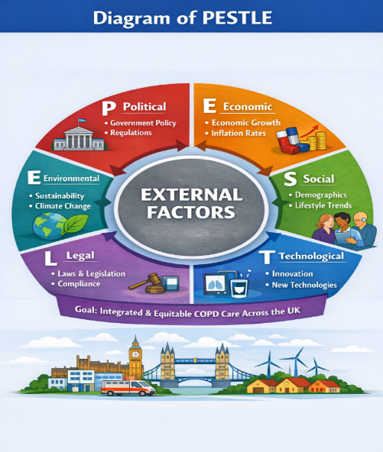
Figure 1. Diagram of PESTLE. Adapted from Johnson, Scholes, & Whittington (2023).

1. Political Factors
Germany
Germany has a good political framework and EU trade laws. The government favour’s sustainable business and severe labour regulations.
- Implications for IKEA: This poses opportunities and challenges to IKEA. On the one hand, political stability minimizes the risk of doing business and promotes the long-term investment. Conversely, stringent labour and environmental policies make the cost of operation higher and IKEA has to invest more in sustainability of production and compliances (Hollensen, 2020).
United States
United States has a favourable regulatory environment in business, yet the trade policies and tariffs are subject to change based on the ruling of the government.
- Implications for IKEA: The market is open and big hence presenting huge growth potential. Nevertheless, the tariffs on imported furniture or raw materials can also lead to higher expenses of IKEA as the company has a significant part of its furniture channel supply mess that is located worldwide (Hollensen, 2020).
Judgement:
- Germany → Favourable (stable, predictable policies)
- USA → Favourable (business-friendly but policy fluctuations)
2. Economic Factors
Economic factors are defined as the macroeconomic factors that can affect the consumer purchasing power, business performance, pricing strategies and the overall demand in the market. These are measures like the Gross Domestic Product (GDP), Gross National Product (GNP), inflation levels, income levels and consumer spending trends (Mankiw, 2021).
Germany
Germany is among the most powerful economies in Europe with a high GDP/capita of about €46,000 and a stable economic condition due to low unemployment and robust industrial growth (World Bank, 2023). The relatively stable GNP of the country is also an indicator of the stability in the national income levels that are also contributing to the high consumer purchasing power.
Nevertheless, in Germany, the inflation rate in 2023 was approximately 3-4% and this has had a moderately positive impact on discretionary expenditure, especially on commodities that are non-essential like home furnishings (Eurostat, 2023).
In terms of performance, IKEA made about €5.3 billion in Germany in 2023, which is one of its most critical markets in Europe. Such a good performance in sales indicates that the IKEA pricing strategy and brand positioning is effective enough to work in a highly competitive yet stable economic environment (IKEA Annual Report, 2023).
United States
America is the biggest consumer economy on earth, having a GDP per capita of about 70,000. The suburban and urban housing markets have a high demand of home furnishings due to high household disposable income. Nonetheless, market segmentation strategies are affected by income inequality and adjusting consumer spending patterns.
Inflation rates of approximately 4-5 percent also affected the U.S. economy in 2023 and this has affected consumer buying behaviour especially on non-essential items. Nevertheless, the market is very appealing because of its size and expenditure on home improvement and lifestyle products (U.S. Bureau of Labor Statistics, 2023).
Here, IKEA has reached a sales level of about 6.5 billion in the United States in 2023, which is impressive considering the growth in a growing and very competitive market.

Comparative Insight
Generally, Germany and the United States are both good economic prospects to IKEA, although with varying forces. Germany is a stable and quality-conscious market with high sustainability rates, whereas the United States is a bigger and growth-oriented market with higher consumption rates and online shopping growth (Kotler et al., 2022).
Judgement:
- Germany → Favourable (stable economy, strong middle class)
- USA → Favourable (high consumption, large market size)
3. Social Factors
Germany
The German consumers are very sensitive to sustainability, quality of products and environmental responsibility.
- Implications for IKEA: This is very much in line with the brand strategy of IKEA which is centred on recycled materials and production that is environmentally friendly. Marketing environmentally friendly furniture, IKEA will be able to build its brand image in Germany (Kotler et al., 2022).
United States
The United States consumers appreciate convenience, affordability and contemporary design. There are also a number of young consumers who like DIY furniture.
- Implications for IKEA: The flat-pack furniture idea of IKEA is aligned to the lifestyle of most American consumers, especially the students and young professionals. Nonetheless, there are consumers who like fully assembled furniture and this implies that IKEA should also offer such services (IKEA Annual Report, 2023).
Judgement:
- Germany → Favourable (demand for durable furniture)
- USA → Favourable (trend-driven consumption)
4 Cultural Factors
Cultural factors are the set of common values, beliefs, attitudes and behaviours that affect consumer preferences and purchasing behaviour in various countries. When marketing to a different culture, one has to know the differences in culture in order to adjust accordingly.
One of the major models that are applied to study the differences in culture is the Cultural Dimensions Model by Hofstede that ranks countries on the basis of six dimensions: Power Distance, Individualism, Masculinity, Uncertainty Avoidance, Long-Term Orientation, and Indulgence.
4.1 Hofstede Model
Definition of Hofstede Model
The Hofstede Cultural Dimensions Model, developed by Geert Hofstede, is a framework used in international marketing to analyse and compare cultural differences between countries. It explains how national culture influences consumer behaviour, communication styles, decision-making, and workplace values. The model is based on six key dimensions: Power Distance, Individualism vs Collectivism, Masculinity vs Femininity, Uncertainty Avoidance, Long-Term Orientation, and Indulgence (Hofstede, 1980; Hofstede Insights, 2024).

Hofstede Cultural Dimensions Comparison
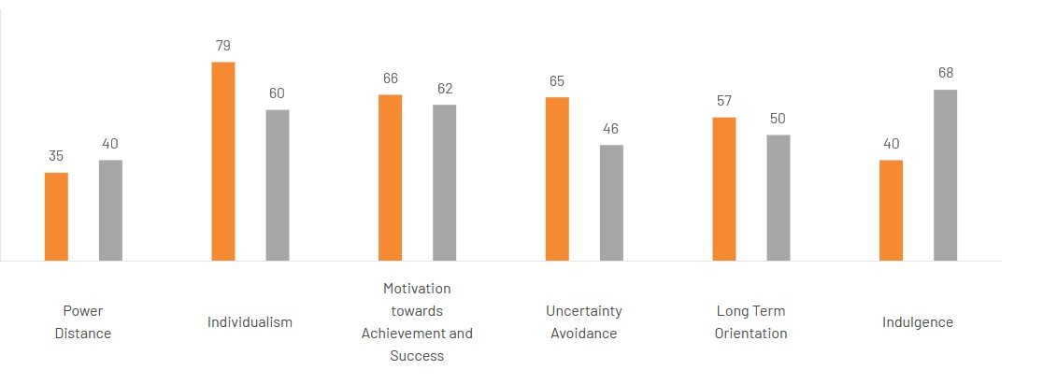
Figure 2: Hofstede Cultural Dimensions Comparison – Germany vs United States

4.2 Cultural Dimension Comparison
Power Distance
The power distance in Germany is relatively low implying that the society appreciates equality and participative decision-making. The power distance in the United States is low to moderate, with hierarchical disparities that are not as strict in business and social arenas (Hofstede Insights, 2024).
Individualism
Both the United States and Germany are very individualistic societies. People place emphasis on individual ambitions, self-reliance and self-expression. Nevertheless, the United States is a little more individualistic, as it is characterized by a greater emphasis on personal success and way of life (Hofstede Insights, 2024).
Masculinity
Germany is moderate in terms of masculinity and there is moderation in competition and quality of life. The US is more masculine, achievement-oriented, success-oriented and performance-oriented behaviour (Hofstede Insights, 2024).
Uncertainty Avoidance
Germany is characterized by high uncertainty avoidance culture that is, consumers like order, information and minimization of risks. Uncertainty avoidance is low in the United States, which means that it is more open to innovation, risk-taking, and flexibility.
Long-Term Orientation
Germany has a high long-term orientation, which deals with sustainability, planning and future value. The US is more short-to-medium term oriented, and has more focus on fast outcomes and immediate gains.
Indulgence
Germany is characterized by low-moderate indulgence where the consumers are more conservative and practical in consumption behaviour. Indulgence in the United States is high, and consumers are oriented towards enjoying, lifestyle, and leisure consumption.
4.3 Impact of Culture on the Consumer
Cultural differences of Germany and the United States have a great impact on consumer behaviour and purchasing habits.
In Germany, the consumers are highly organized, quality conscious and eco-friendly. They like in-depth product details, eco-friendly merchandise, and sustainable value. Purchasing decisions are usually logical and thought through.
Conversely, consumers in the United States are more convenience-oriented, expressive and experience-oriented. They are better placed to be experimentative with new products, react well to promotional activities as well as are lifestyle and comfort conscious about what they purchase. Emotional and impulse buying behaviour is also promoted by the higher indulgence culture.
4.4 Cultural Favourable / Unfavourable
For IKEA:
- Germany → Favourable (alignment with quality, functionality, long-term orientation)
- USA → Favourable (alignment with affordability, convenience, and lifestyle branding).
4.5 Advantages and Disadvantages of Hofstede Model
Advantages:
- Helps understand cross-cultural differences
- Supports international marketing strategy
- Provides measurable cultural insights
Disadvantages:
- Overgeneralises national cultures
- Ignores individual differences
- May be outdated in rapidly changing societies.
4. Technological Factors
Germany
The digital infrastructure and internet use in Germany is high.
- Implications for IKEA: This will enable IKEA to increase online shopping, mobile applications, and online marketing. The efficiency of the supply chain can also be enhanced with the help of advanced logistics technology.
United States
The USA boasts of one of the most advanced e-commerce markets in the world.
- Implications for IKEA: IKEA will have to spend a lot of money on online channels, online delivery, and delivery of goods to homes to compete efficiently with e-commerce stores.

5. Legal Factors
Germany
Germany is under stringent EU consumer protection laws and labour laws.
- Implications for IKEA: These rules not only make compliance more expensive, but also provide a level of fair competition in the market, as well as consumer protection which promotes confidence in the well-established brands such as IKEA.
United States
The US has product safety and consumer protection laws, yet labour regulations are not as strict as in Germany.
- Implications for IKEA: This offers an additional level of operational freedom yet governmental rigorous adherence to safety requirements concerning furniture goods.
Judgement:
- Germany → Moderately favourable (strict regulations)
- USA → Favourable (flexibility for businesses)
6. Environmental Factors
Germany
In Germany, there are good environmental policies and awareness of the climate change.
- Implications for IKEA: IKEA has to be more concerned with sourcing sustainably, recycling, and energy-efficient stores. This compliments the global sustainability strategy of IKEA and enhances its brand image to other consumers who are environmentally friendly.
United States
There is the growing awareness of the environment, and the rules differ in states.
- Implications for IKEA: This opens a chance through which IKEA can make itself a sustainable furniture leader by marketing environmentally friendly products and renewable resources.
Judgement:
- Germany → Favourable (supports sustainable business models)
- USA → Moderately favourable

3.8 Similarities and Differences
Similarities
- Both countries have stable political environments
- Strong economies with high purchasing power
- Advanced technological infrastructure
- Increasing focus on sustainability
Differences
- Germany has stricter regulations compared to the USA
- USA shows higher individualism and indulgence
- Germany consumers prefer durability, USA prefers convenience
- Environmental policies are stricter in Germany

4. Comparison of Brand’s STP Strategies in Germany and the United States

4.1 Segmentation
In Germany and the United States IKEA employs a multi-variable segmentation approach, which involves the combination of demographic, geographic and psychographic variables to locate and target appropriate customers.
Demographic Segmentation
The main target of the middle-income consumers in the two markets include young professionals, students, young families, and first-time homeowners who prefer affordable and functional home furnishings.
- Germany vs USA Insight: Both countries target similar income groups; however, the USA has a larger young consumer base, increasing demand for affordable and flexible furniture.
Geographic Segmentation
In Germany, IKEA targets urban and suburban residents who are highly accessible by physical stores and have a high awareness of sustainability. Segmentation in the United States is more varied as it includes the population that lives in apartments in the city as well as households that live in suburbs and have bigger areas of residence.
- Insight: The USA market is geographically larger, requiring more distribution coverage compared to Germany.
Psychographic Segmentation
Psychographic segmentation is founded on lifestyle, personality and values. German consumers are more inclined to sustainability, quality, and minimalism, whereas the U.S. consumers focus on convenience and self-expression and lifestyle-oriented consumption.

VALS MODEL
The VALS (Values, Attitudes, and Lifestyles) classification divides consumers into psychological characteristics and resources to enable business to know the motivators of behaviour.
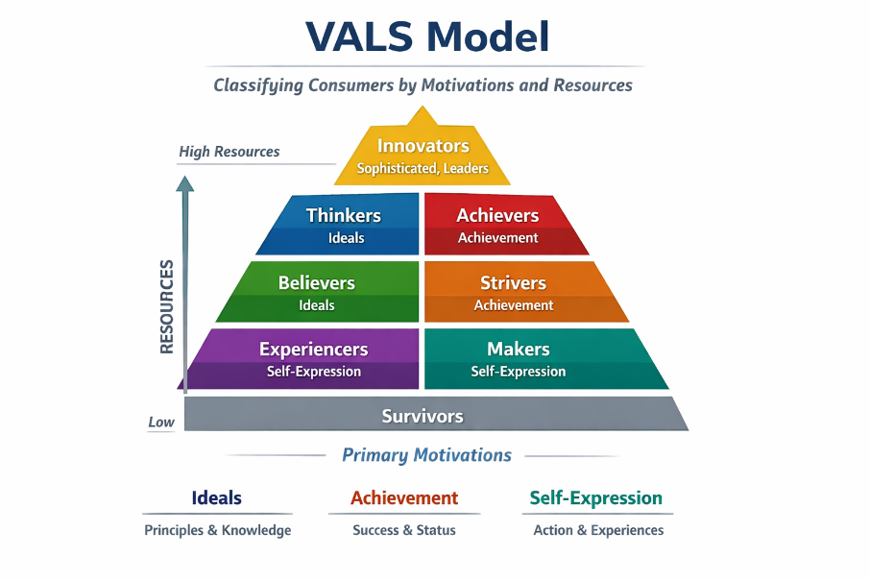
Figure 3. VALS Model classifying consumers by motivations and resources. Adapted from SRI International (1989).
Germany VALS Profile
The German consumers can be mostly categorized as:
- Thinkers → Logical, place value on quality, information based decision-making.
- Believers → Traditional, brand-loyal, favour traditional and reliable brands.
- Achievers → value money, prefer high quality functional products, goal-oriented.
This goes in line with the emphasis that IKEA has on durability, sustainability and systematic product information in Germany.
United States VALS Profile
The U.S. consumers are primarily categorized as:
- Achievers - success driven, like high quality but realistic products.
- Experiencers Trend-driven, like new, lifestyle consumption.
- Striders → Price-sensitive yet want to live a glamorous and contemporary life.
This helps in the emphasis on affordability, design appeal, and convenience that IKEA has on the U.S. market.

4.2 Targeting Strategy
IKEA uses a differentiated targeting strategy in both Germany and the United States.
The company does not focus on a particular market segment and targets a variety of customers. These include:
- Middle-income families
- Young professionals
- Students
- First-time homeowners
Differentiated Targeting Strategy
- In Germany, the accent is on the consumers with a more environmental and quality-oriented mind-set.
- The focus in the United States is on convenience-oriented, fashionable, and bigger household buyers.
Such differentiation enables IKEA to be consistent globally and be responsive to the needs of the local market (Kotler et al., 2021).
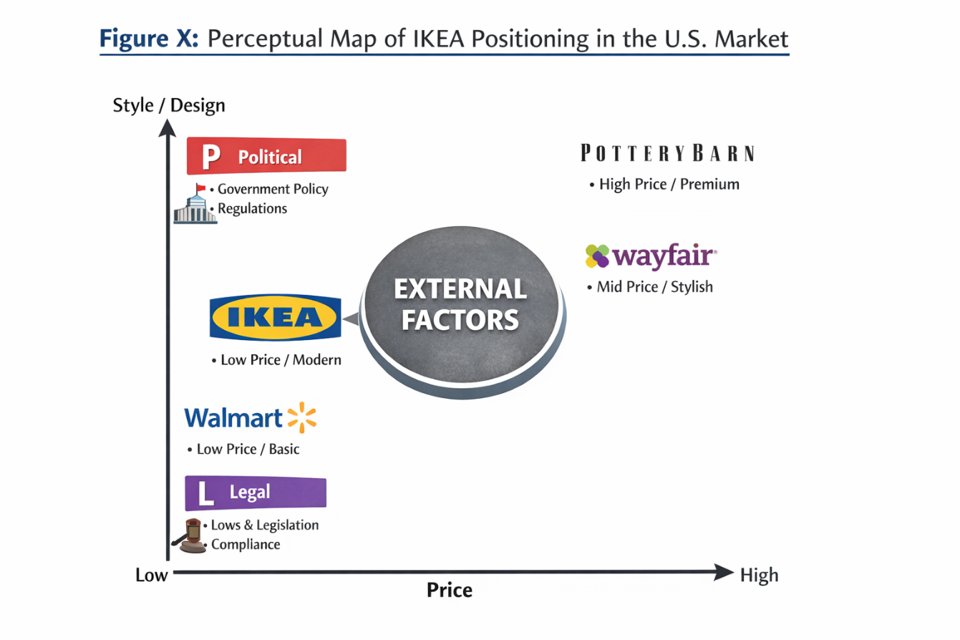
Figure 4: Perceptual Map of IKEA Positioning in the U.S. Market
In the United States, IKEA is positioned as a cost-effective yet stylish furniture brand, offering modern designs at affordable prices (Kotler and Keller, 2016). This positioning appeals to younger consumers and budget-conscious households seeking both functionality and aesthetics.

4.3 Positioning Explanation
IKEA is positioned in a good low-cost, modern design, and they are differentiated by low cost, flat-pack efficiency, and Scandinavian design appeal. This positioning enables IKEA to be a competitive firm in the very competitive furniture market of the U.S. by appealing to both value-conscious and style-conscious customers at the same time (Kotler and Keller, 2021; IKEA, 2023).

4.4 STP Comparison
Similarities
- Both countries target middle-income consumers
- Strong focus on urban populations
- Emphasis on affordability and functionality
- Use of differentiated targeting strategy
Differences
- Germany consumers prioritise quality and durability
- USA consumers prioritise style and convenience
- VALS types differ:
  - Germany → Thinkers, Believers
  - USA → Experiencers, Strives
USA market is more trend-driven compared to Germany

5. Comparison of International Marketing Mix (7Ps) Strategies in Germany and the United States
The foundation of one such framework is the marketing mix (7Ps), which is important in analysing the manner in which companies adopt marketing in the global market.

5.1 Definition of Marketing Mix
The marketing mix refers to a set of controllable marketing tools that organisations use to achieve their marketing objectives, traditionally expanded to the 7Ps: product, price, place, promotion, people, process, and physical evidence (Kotler and Keller, 2016).

5.2 Product Strategy
The product strategy of IKEA is based on the provision of affordable, modern Scandinavian-designed furniture that is functional. Although the basic product is the same worldwide, IKEA makes minor adjustments to its product range to suit the local consumer tastes in Germany and the United States.
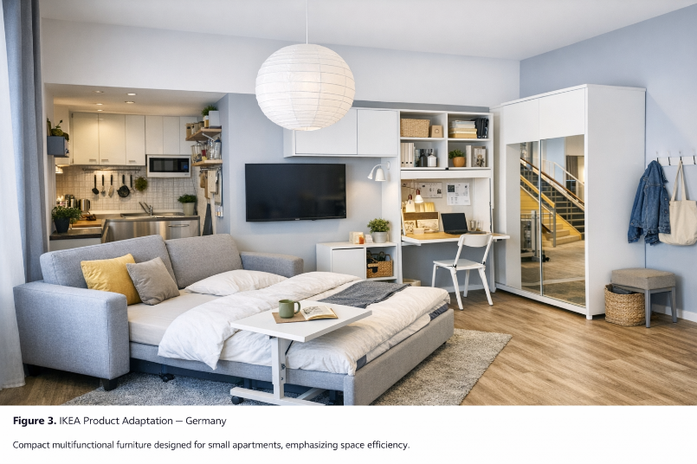
Figure 5.-IKEA product images
Product Depth (Product Range Differences)
Product depth is the diversity of products in a category.
- IKEA has a great variety of small, energy-efficient, and sustainable furniture in Germany including space-saving storage units, eco-certified materials and minimalist designs. German customers are interested in quality, sustainability, and sustainability.
- In the United States, IKEA puts more emphasis on bigger furniture like big sofas, king beds, and large storage solutions because of larger household sizes, and suburban lifestyle.
Germany: Focus on durable, functional, and high-quality furniture aligned with long-term usage
USA: Wider variety of stylish, space-saving, and trend-based furniture

Product Width (Brand Extensions)
IKEA has gone beyond furniture and products to offer other services and products:
- IKEA Restaurants
- Food assortment (Swedish meatballs, snacks, beverages)
- Customer services (delivery, assembly support, planning tools, click-and-collect)
Germany vs United States comparison.
Comparison:
- Germany → Traditional menu, standardised offerings
- USA → More localised menu options and convenience-focused services
IKEA restaurants in Germany focus on sustainability, healthier food choices, and sourcing products that are environmentally friendly. The food service experience is incorporated into the store visit and serves the eco-conscious brand identity.
Table 2-Product Adaptation Table
Feature | Germany | United States
Product Lines | Sustainable furniture, smaller modular units | Larger furniture, home storage solutions
Packaging | Eco-friendly, minimal, informative | Larger packaging, protective, branded visuals
Labeling | German language, eco-labels | English, compliance with U.S. safety standards

5.2 Pricing Strategy
IKEA is a cost leadership pricing company, which strives to provide relatively cheap goods without compromising on quality due to effective production and supply chain management.
Nonetheless, the prices in Germany and in the United States differ because there are a number of factors that impact it:
Factors Affecting Price
- Taxation: Various VAT and state tax regimes influence end prices.
- Transport Costs: In certain areas, longer supply chains and import logistics raises costs.
- Inflation: Economic factors determine the consumer buying power.
- Exchange Rates: Exchange rates between the Euro and US Dollar influence the pricing levels.
Pricing Strategy Application
Cost-based pricing in Germany is predominantly applied by IKEA, which keeps its prices competitive with the high intensity of competition and price-sensitive buyers.
In America, IKEA employs a mix of:
Cost leadership pricing
- Psychological pricing (e.g. 199 USD rather than 200 USD to make consumers think it is cheaper)
- This strategy assists IKEA to stay competitive in a large-scale retail sector, where pricing is very sensitive (Kotler et al., 2021; IKEA, 2023).

Table 3-Pricing Comparison Table
Product | Germany Price (€) | Competitor Price (€) | U.S. Price ($) | Competitor Price ($)
IKEA BILLY Bookcase | 59 | 65 (Wayfair) | 69 | 75 (Target)
IKEA MALM Bed | 199 | 220 (Home Depot) | 229 | 250 (Walmart)
IKEA POÄNG Chair | 79 | 85 (Wayfair) | 89 | 95 (Target)

5.3 Promotion Strategy
IKEA employs the concept of integrated promotion involving both the traditional and digital marketing tools to create brand awareness and deliver its value proposition of low-quality and stylish furniture.
IMC Definition: Integrated Marketing Communications (IMC) refers to the coordination of different promotional tools to deliver a consistent message across multiple channels (Kotler and Keller, 2016).
Germany – Promotion Strategy
IKEA employs:
- Social Media Marketing (Instagram, YouTube) with the emphasis on sustainability and minimalist life.
- Email Marketing to advertise seasonal deals and loyalty offers.
- TV Advertising with emphasis on environmentally friendly lifestyle and functionality.
- Catalogue Marketing (powerful traditional instrument still popular in Germany)
- SEO & Website Campaigns on sustainability searches.
- Influencer Marketing and eco-lifestyle and home-design influencers.
ALL German promotion is highly geared towards sustainability, quality, and long-term worth messages.

United States- Promotion Strategy.
IKEA employs:
- Social Media Marketing (Instagram, Tik Tok, Facebook) with a lifestyle, home design, and DIY culture focus.
- Email Marketing and personalised offers and product recommendations.
- TV Advertising that encourages convenience, cheapness and contemporary living.
- Online shopping development with the help of Digital Catalogue and Website SEO campaigns.
- Lifestyle, home decor, and family-oriented influencers.
U.S. advertising is more emotional, lifestyle-and-convenience-based than in Germany.
Key Comparison Insight
In general, IKEA has its globalised marketing policy but modifies messages on a regional level:
- Germany → responsibility, quality, sustainability.
- United States → convenience, lifestyle, affordability.
Such balance enables IKEA to have a robust global brand image and attract consumer demands at the local level (Kotler & Keller, 2021).

5.4 Place (Distribution)
IKEA employs selective distribution approach where the company sells its products mostly using big IKEA retail stores and its official online shops. In the United States and Germany, the stores are usually situated in the suburbs where they have large retail areas.
The length of the distribution channel is not very long as IKEA markets itself directly to consumers via online platforms and its own stores. This would minimize reliance on middle men, and the firm would have good control over the price and the brand experience.
Distribution Channels
- Physical IKEA stores
- Online website and e-commerce
Comparison:
- Germany → Dense store network, efficient logistics
- USA → Wider distribution due to geographic size

5.5 Physical Evidence, People and Process.
The store layout and inside store experiences, coupled with customer service personnel, are the major components of IKEA service strategy. The employees are also trained to serve the customers during product selection, and self-service shopping. The store layout and the showroom concept are quite standardised across the world, which enables customers to have experience of the furniture setups before making a purchase.
Both countries have similar physical aspects of their stores including store design, signage as well as product displays, which helps support the global brand image and uniform shopping experience of IKEA (Deloitte, 2023).
Comparison:
- Germany → Highly trained staff, strong focus on efficiency
- USA → Customer-oriented service, flexible approach
Process refers to how services are delivered.
- Self-service model (both countries)
- Online ordering and delivery systems
- Customer complaint system:
- Returns policy
- Customer service support
Comparison:
- Germany → Structured and efficient process
- USA → More flexible and customer-friendly
Table 4-Marketing Mix (7Ps) Comparison Table
7P Element | Germany | United States
Product | Focus on durability, sustainability, modularity | Focus on larger furniture, style, convenience
Price | Competitive pricing, cost-leadership | Competitive pricing, psychological pricing
Place | 53 large-format stores, strong logistics | 52 stores, urban mini-stores, strong e-commerce
Promotion | Sustainability-focused campaigns, digital ads | Style-focused campaigns, omnichannel promotions
People | Trained staff, focus on service and sustainability | Staff trained for larger homes, customer service emphasis
Process | Efficient in-store flow, online ordering | Omnichannel process, click-and-collect, home delivery
Physical Evidence | Eco-friendly store design, product displays | Modern store design, showroom layouts
On the whole, IKEA uses a relatively uniform marketing mix approach in Germany and the United States to preserve the coherent global brand image.

6. Directional Development Strategy (Germany)

6.1 Definition of Directional Development Strategy
A directional development strategy refers to the strategic growth decisions a firm makes to expand, maintain, or restructure its position within a market. It focuses on how a company moves forward in terms of market penetration, product development, market development, or diversification in order to achieve long-term competitive advantage. One of the most widely used tools to analyse directional development is the Ansoff Matrix, which helps firms evaluate growth strategies based on existing and new products and markets.

6.2 Application of Ansoff Matrix to IKEA in Germany
IKEA in Germany mainly follows a Market Penetration and Product Development strategy.
1. Market Penetration
IKEA increases its market share in Germany by strengthening existing products in the existing market. This is achieved through:
- Competitive pricing strategy
- Strong brand loyalty
- Expansion of online and offline channels
- Promotional campaigns focused on sustainability and affordability
2. Product Development
IKEA also introduces improved and sustainable product lines in Germany such as:
- Eco-friendly furniture collections
- Circular economy products (recycling and reuse programs)
- Smart home and space-saving solutions
This reflects Germany’s strong sustainability-oriented consumer base.
6.3 Evaluation of Directional Strategy in Germany
IKEA’s directional strategy in Germany is highly effective because it aligns with strong consumer demand for sustainability, affordability, and quality. The combination of market penetration and product development allows IKEA to maintain strong brand loyalty while continuously innovating within a mature market. However, limited diversification means IKEA relies heavily on existing market structures, which may restrict long-term growth if consumer preferences shift significantly.

7. Ethical Marketing Evaluation (Germany)
Overview of Ethical Issues in Marketing Mix (7Ps)
Ethical marketing refers to the application of fairness, transparency, sustainability, and social responsibility within a company’s marketing activities. In Germany, ethical expectations are particularly high due to strict environmental laws and strong consumer awareness.
IKEA integrates ethical considerations across its 7Ps marketing mix, but both positive and negative ethical issues can still be identified.

7.1 Ethical Marketing Examples (Germany)
Example 1: Sustainable Product Design (Product)
IKEA uses responsibly sourced materials such as recycled wood and sustainable cotton in its furniture products. This supports Germany’s strong environmental culture and reduces environmental impact.
Example 2: Circular Economy Initiatives (Place / Process)
IKEA offers furniture take-back, repair, and recycling programs in Germany. This encourages product reuse and reduces waste, aligning with ethical sustainability principles.

7.2 Unethical Marketing Examples (Germany)
Example 1: Greenwashing Concerns (Promotion)
Some critics argue that IKEA’s sustainability advertising may exaggerate environmental benefits, creating perceptions of “greenwashing,” where environmental claims are not fully transparent or measurable.
Example 2: Supply Chain Transparency Issues (People / Process)
Despite improvements, IKEA has faced criticism in the past regarding limited visibility in its global supply chain, raising ethical concerns about labour conditions in outsourced production facilities.

7.3 Overall Ethical Evaluation
Overall, IKEA demonstrates a strong commitment to ethical marketing in Germany through sustainability-driven product innovation and circular economy practices. However, challenges remain in ensuring full transparency across global supply chains and maintaining consistent ethical communication in marketing campaigns.

8. Recommendations and Conclusion
According to the discussion of the international marketing practices of IKEA in Germany and the United States, there are some strengths and weaknesses that can be identified. The STP strategy has mostly worked: in Germany, IKEA is able to cater to the needs of consumers who are environmental conscious and focused on quality with functional products that are sustainable, whereas in the U.S. the company targets bigger households and urban populations, that are interested in affordable, stylish, and useful furniture (Kotler et al., 2021).
The strategies of marketing mix (7Ps) portray standardization and adaptation. Design and core products are universal, whereas the sizing of products, packaging and online distribution channels are localized to fit the local requirements. Both countries have effective pricing strategies that can support the cost-leadership strategy of IKEA but would better pricing in the high-cost urban regions of the U.S. to eliminate local competition (Hellenes, 2024).

8.1 Recommendations:
- Digitise and Omni -Channel in Germany - Although online sales are on the rise, younger, more technology-centric customers can be captured by investing in local e-commerce platforms and app functionality.
- Urban store format in the U.S. – Keep on expanding the smaller urban stores to reach the apartment dwellers and busy consumers who find it appealing with either click-and-collect
- Empower the sustainability communication in advertising campaigns -It has been proved that German consumers place sustainability very high in their value system, and consumers in the U.S. are becoming more environmentally conscious; mentioning activities of circular economy and energy-efficient products in advertisements can increase brand loyalty.
- U.S. urban adaptation- The pricing or promotion campaigns slightly cheaper in New York, Los Angeles, and Chicago can be adopted in the effort to help IKEA position itself competitively against the local furniture stores, such as New York, Los Angeles, and Chicago.
- Supply chain visibility and ethicality- In both countries, communicate ethical sourcing and labor practices to strengthen the credibility and attractiveness of IKEA to socially responsible consumers (IKEA, 2023).

8.2 Conclusion:
The international marketing strategy adopted by IKEA has mostly succeeded in Germany and the U.S., with high market penetration, brand popularity, and sales. IKEA is able to respond to consumer expectations by ensuring that it provides a combination of both global uniformity and local adaptation. Further investments into digital channels, urban format, sustainability communication, and ethical supply chain will contribute to the competitiveness of IKEA, and guarantee growth in both markets in the long-term. Altogether, IKEA shows that the main success in global operations is formed by well-thought-out strategies, rooted in ethical and sustainable activities.

Section 2:

Reflective Account of Research and Analysis Process
In conducting this reflective account, I have used Gibbs Reflective Cycle (1988), which consists of six stages namely Description, Feelings, Evaluation, Analysis, Conclusion and Action Plan. The cycle has enabled me to critically review the process that I undertook in completing the research, analysis and writing of the report about international marketing strategies that IKEA adopted in Germany and the United States.
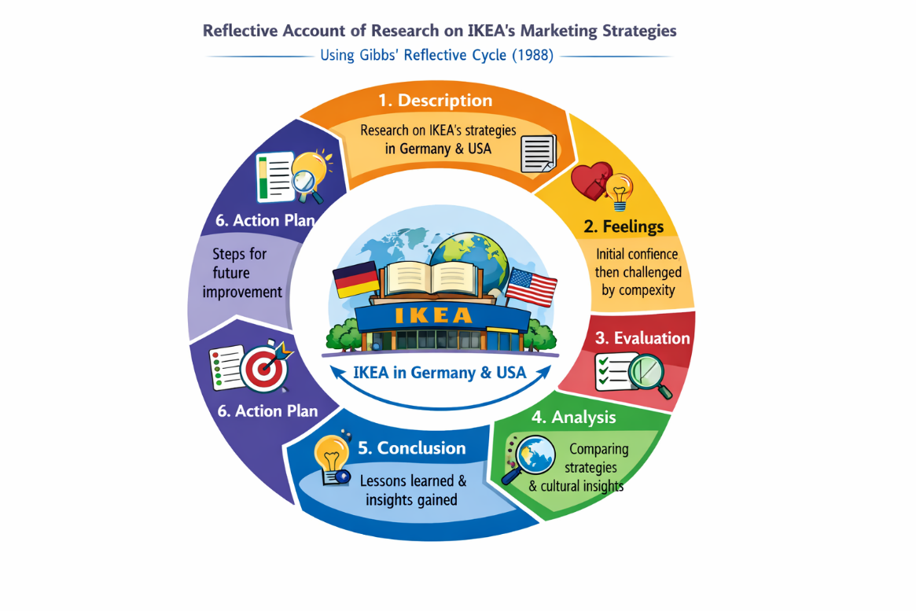
Figure 6. Gibbs’ Reflective Cycle applied to research on IKEA’s international marketing strategies in Germany and the United States. Adapted from Gibbs (1988).

1. Description
It was a comparative analysis of IKEA business in Germany and the United States, with regard to PESTEL macro-environment, STP strategies, marketing mix (7s), directional development, and ethical marketing practices. To do that, first I had to review the literature with the help of the latest academic sources, reports in industry and IKEA official documents. I gathered information about the performance of IKEA in the market, the consumer behaviour, sustainability and positioning of IKEA in the two countries.
Then, I applied a comparative analysis in the form of assessment of how IKEA operates in changing its products, prices, promotion, channels of distribution, and sustainability practices to the local market conditions to preserve its international brand image. As an example, I contrasted the size and style of available furniture, online and cross-channel approach, and sustainability communication. I also looked at market statistics, sales performance, and number of stores and brand recognition to evaluate the directional growth of IKEA in every country.

2. Feelings
At first, I was drowned by the number of information that is available about IKEA in the world. The difficulty was to narrow down on the most pertinent data concerning Germany and the United States and keep a critical eye on it. I was also becoming more confident as I went on, specifically when I started to arrange the report with the help of the frameworks assigned during the classes, including PESTEL, STP, and 7Ps.
There was also a sense of frustration that I felt when trying to find similar evidences between the two markets especially with specific prices, package and digital marketing information. However, I found the process thought-provoking as it involved thorough consideration and critical analysis of information as opposed to summarising descriptive data.

3. Evaluation
My research process had a number of strengths. In the first place, the analysis was evidence-based due to the utilization of scholarly journals and industry reports. I had a chance to connect the theory with the practice, including the implementation of Kotler principles of marketing to the IKEA pricing and marketing strategies. Second, the juxtaposition of two culturally and institutionally different markets helped me to gain insights into how global brands alter the strategies, preserving the same identity.
Nevertheless, it had certain flaws. Others did not have granular information on local preferences of the consumer or regional price variations, which constrained the depth of comparison. Also, my first drafts were overly descriptive, and I needed to revise it several times to critically relate the strategies employed by IKEA to such concepts as market segmentation, brand positioning, and marketing based on sustainability.

4. Analysis
Gibbs framework made me critically think as to why some of the strategies applied in different countries prove to be different. As an illustration, the reason why France is more sustainable in the environment and highly regulated is why IKEA focuses on sourcing sustainably and commitment to the circular economy instead of the U.S. market, where convenience, bigger furniture, and the Omni channel are more important.
The theory to practice connection process allowed me to realize why adaptation is more important than standardization in international marketing. I have also seen that, although IKEA has a core product identity, it needs local products in terms of dimensions, packaging, prices and promotions in response to the cultural, economic and consumer specific requirements.
In addition, the consideration of marketing ethics has also shown that the global policies of IKEA in sustainability and ethical sourcing are strategic in boosting brand trust especially in socially aware markets. The consideration of such practices enabled me to understand the ethical aspects that transcend profitability, and puts them directly into connection with the marketing strategy.

5. Conclusion
The process of reflection allowed me to conclude that my study and analysis were detailed but iterative as they had to be verified and linked to the theory several times. The major learning points are:
- The usefulness of the structured frameworks (PESTEL, STP, 7Ps) to structure the data and critically evaluate the international strategies.
- The significance of evidence-based critical analysis, instead of descriptive reporting.
- The need to compare similar factors in different countries to be sure that there are valid conclusions about the market adaptation and global strategy.
- The awareness that ethical and sustainability activities are part of international marketing that affect the perception of consumers and operational strategy.

6. Action Plan
In case I were to undertake a similar research study in future, the following enhancements would be made:
- Early sensitivity of similar metrics– Prior to gathering data, I would establish a table of important indicators (e.g. pricing, product lines, digital engagement) to guarantee country comparability.
- Improved primary source utilization - Conduct surveys or interviews on the consumers in target countries to gain up-to-date and accurate information on preferences and perceptions.
- Time management - Use more time in analysis than collecting the data as description as to establish better connections with the theory and concepts.
- Visual evidence- Use more visual comparisons like product pictures, packaging and store layout to prove the analysis of the adaptation and standardization.
- Reflective practice - Keep on making reflections throughout the research to see gaps, narrow arguments, and to avoid not meeting the academic standards.
To conclude, applying the Reflective Cycle by Gibbs has been a systematic way to assess my research, locate the strengths and weakness, as well as develop the plan that will help to keep improving. This reflection has increased the depth of my knowledge on international marketing strategies as well as the skill of being able to critically apply theoretical frameworks to real business problems.

References
1. Ansoff, H.I., 1957. Strategies for Diversification. Harvard Business Review. Available at: https://hbr.org/1957/09/strategies-for-diversification
2. Armstrong, G., Adam, S., Denize, S. and Kotler, P., 2020. Principles of Marketing. 8th ed. Harlow: Pearson. Available at: https://www.pearson.com/uk/
3. Business Model Analyst, 2025. IKEA Target Market & Consumer Behaviour Analysis. Available at: https://businessmodelanalyst.com/ikea-target-market-analysis/
4. Chen, J., 2023. Market Entry Strategy: IKEA in China & the USA. Journal of International Business Studies, 54(2), pp.142–159. Available at: https://www.jibs.net/article/market-entry-strategy-ikea
5. Deloitte, 2024. Consumer Trends & Ethical Marketing. Deloitte Insights. Available at: https://www2.deloitte.com/global/en/insights/consumer-trends.html
6. Dibb, S. and Simkin, L., 2021. Marketing Essentials. London: Cengage Learning. Available at: https://www.cengage.com
7. Euromonitor International, 2024. Furniture Retail in Germany & the United States. Available at: https://www.euromonitor.com/furniture
8. Forbes, 2022. IKEA’s Digital & Omnichannel Strategy. Available at: https://www.forbes.com/sites/forbestechcouncil/2022/06/10/ikea-omnichannel-strategy
9. GfK Consumer Insights, 2023. Brand Awareness & Consumer Trust in Germany. Available at: https://www.gfk.com/insights
10. Hollensen, S., 2024. Global Marketing. 9th ed. London: Pearson. Available at: https://www.pearson.com/uk/
11. IKEA, 2023. IKEA Sustainability & Corporate Responsibility Report 2023. Available at: https://www.ikea.com/gb/en/this-is-ikea/sustainable-everyday
12. IKEA, 2024. IKEA Annual Report 2023. Available at: https://www.inter-ikea.com/annual-report
13. IKEA, 2023. IKEA Strategy & Sustainability Initiatives. Available at: https://about.ikea.com/en/sustainability
14. Johnson, G., Scholes, K. and Whittington, R., 2021. Exploring Corporate Strategy. 12th ed. Harlow: Pearson. Available at: https://www.pearson.com/uk/
15. Keller, K.L., 2022. Brand Management: Research, Theory & Practice. 3rd ed. London: Routledge. Available at: https://www.routledge.com/
16. Kotler, P. and Keller, K.L., 2021. Marketing Management. 16th ed. Harlow: Pearson. Available at: https://www.pearson.com/uk/
17. Kotler, P., Keller, K., Chernev, A., 2021. Marketing Management: European Edition. Harlow: Pearson. Available at: https://www.pearson.com/uk/
18. Kotler, P., Kartajaya, H. and Setiawan, I., 2021. Marketing 5.0: Technology for Humanity. Hoboken, NJ: Wiley. Available at: https://www.wiley.com/
19. MarketLine, 2024. IKEA Market Profile and Competitive Analysis. MarketLine Industry Profile. Available at: https://www.marketline.com/
20. McDonald, M. and Wilson, H., 2021. Marketing Plans: How to Prepare Them, How to Use Them. 9th ed. Chichester: Wiley. Available at: https://www.wiley.com/
21. Mintel, 2023. Retailing in Germany & US Home Goods. Available at: https://www.mintel.com/
22. Osterwalder, A. and Pigneur, Y., 2021. Business Model Generation. Hoboken, NJ: Wiley. Available at: https://www.wiley.com/
23. PESTLE Analysis, 2024. Germany Retail Sector PESTLE. Available at: https://pestleanalysis.com/germany-retail-sector-pestle
24. Porter, M.E., 2021. Competitive Strategy. New York: Free Press. Available at: https://www.simonandschuster.com/
25. Prahalad, C.K. and Ramaswamy, V., 2023. The Future of Competition. Boston, MA: Harvard Business School Press. Available at: https://hbsp.harvard.edu/
26. Statista, 2024. Furniture Retail Market Share – Germany & US. Available at: https://www.statista.com/
27. UNCTAD, 2023. World Investment Report – Retail FDI Trends. Available at: https://unctad.org/publication/world-investment-report-2023
28. World Bank, 2024. Country Data – GDP, Disposable Income, Retail Trends. Available at: https://data.worldbank.org/
29. Yankelovich, D. and Meer, D., 2022. Rediscovering Market Segmentation. Harvard Business Review. Available at: https://hbr.org/2022/03/rediscovering-market-segmentation
30. Zeithaml, V.A., Bitner, M.J. and Gremler, D.D., 2022. Services Marketing: Integrating Customer Focus Across the Firm. 7th ed. New York: McGraw‑Hill. Available at: https://www.mheducation.com/
31. Chen, L. and Lee, J., 2023. Cross‑Cultural Consumer Behaviour in International Retail. Journal of Retailing and Consumer Services, 68, p.102932. Available at: https://www.sciencedirect.com/
32. Tran, Q. and Nguyen, P., 2025. Digital Adoption & E‑Commerce Growth in Global Retail. International Journal of Retail & Distribution Management. Available at: https://www.emerald.com/

