UNIVERSITY OF WALES TRINITY SAINT DAVID

REPORT

PROBLEM SOLVING AND DECISION MAKING

BMSW4004_LON

STUDENT: IONUT FLORIN DEMIAN ( 2125129 )

LECTURER: BALENDRAN K.

Table of Contents
INTRODUCTION 3
The workplace problem 3
Analysing Information 4
Root Cause Analysis ( RCA ) 4
APPLYING SITUATIONAL ANALYSIS MODEL 4
RANGE OF ALTERNATIVE SOLUTIONS 5
EVALUATION OF ALTERNATIVE SOLUTIONS 6
IMPLEMENTING THE SOLUTION 7
Communication plan with stakeholders 8
MONITORING AND REVIEW TECHNIQUES 9
CONCLUSION 10
REFERENCES 10
APPEDIX 11

INTRODUCTION

The purpose of this report is to define a complex problem in the workplace in a care home, including the scope and impact, to analyse information on the identified problem, to help inform the decision-making process, to propose a range of alternative solution to the problem. I will use one of the decision-making techniques I have learned in the class to evaluate a range of solutions to identify the most appropriate option, to develop a plan for implementing the solution, to communicate the plan to stakeholders and to assess appropriate monitoring and review techniques to ensure successful implementation of the solution.
It is important to solve the problems in a company no avoid unsatisfied staff, staff leaving, low performance, poor quality.
Working in a care home it is more sensible because between staff and management, are vulnerable people that can suffer because of the problems that can cause unsatisfied staff.
The NHS sector faced a lack of staff in the past years and seems to be difficult to find enough staff and to keep everyone happy. Most of the staff is leaving because of the amount of overtime they must do, low payrates and the stress caused by working short staff most of the time.

The workplace problem

The problem I have found at my workplace is that the staff was unhappy and unsatisfied about their workplace. Having meeting with a few members of staff, I have found that they are unhappy because of the stress level, overtime they must do and the amount of agency we have to use to replace missing staff. Also, agency cannot provide same staff all the time, which means that our permanent staff have to train every new agency staff that is coming for the first time in the care home.
After all the meetings I had with the staff, I have found that the main problem for the unsatisfied staff, it is the shortage of staff.
This is a complex problem in a care home because it can cause multiple problems and can have a negative impact on our staff and residents also. The care home can lose the experienced and hardworking staff, the quality of services can demand, the residents will be unhappy, and the complaints rate will increase, the Care Quality Commission can even close the gates of the care home.

Analysing Information

Root Cause Analysis ( RCA )

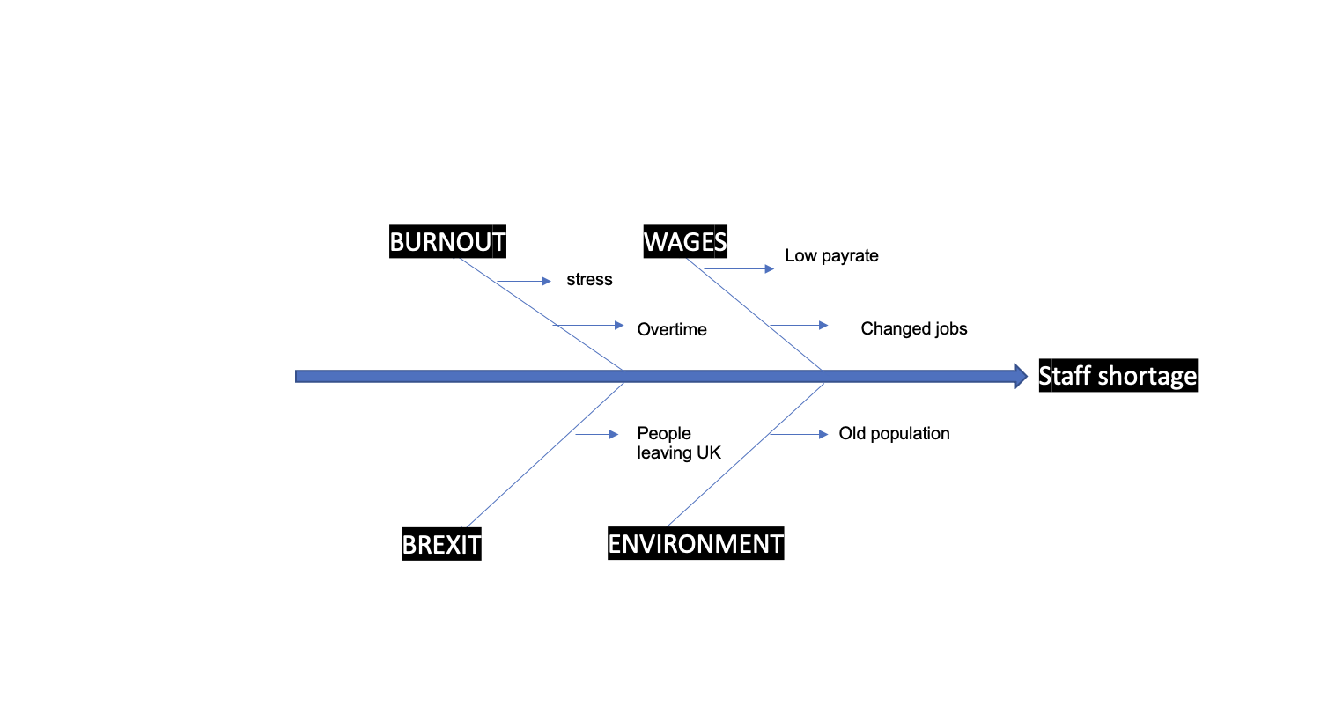
After the brainstorm with all the management, seniors, and nurses, I have identified the root cause of the unsatisfied staff. After all the possible root causes, I have put it on the list and after all the meeting I had with the staff, I found that the main root cause of the unsatisfied staff is the staff shortage.

APPLYING SITUATIONAL ANALYSIS MODEL

To make sure I will keep the staff I have now, I will use the SWOT analysis tool to find out the strengths, weaknesses, opportunities, and threats of the care home and to find out solutions that I can implement for a better future.

STRENGHTS:
- Strong brand image.
- New management
- Well-established with 20 years of experience of working with older people.
- Free paid training and induction
- Well trainer staff - knows residents, builds relationships and ensure the best services are provided.
- Embraces diversity.
- Pet friendly policy.

WEAKNESSES:
- Limited focus on expanding beyond UK.
- Lack of staff.
- Using agency to cover over 50% off the staff.
- Location.

OPPORTUNITIES:
- Working with best agency staff provider in South-west.
- Sponsoring qualified staff outside of the UK for working visa.

THREATHS:
- High competition
- Previous owner bad reputation

RANGE OF ALTERNATIVE SOLUTIONS

After analysing and having chat with all the management team, I am bringing on the table 3 alternative solutions to complete the team and to keep the business with a GOOD rate from Care Quality Commission (CQC).
First solution is to increase the wage per hour above minimum wage and to offer to the staff a package of benefits for relating (SPA tickets, hairdresser/barber vouchers).
The second solution is to keep using agency staff with a block booking contact and working on a rota basis.
The third solution is to sponsor qualified staff from outside UK for a working visa.

EVALUATION OF ALTERNATIVE SOLUTIONS

 | Increase wage | Block booking agency | Working visa non uk qualified staff
Cost | 4 | 4 | 4
Implementation time | 4 | 4 | 4
Flexibility | 2 | 3 | 1
Duration | 4 | 4 | 4

 | Weight | Increase wage | Block booking agency | Working visa non uk qualified staff
Cost | 4 | 4 x 4 = 16 | 4 x 4 = 16 | 4 x 4 = 16
Implementation time | 4 | 4 x 4 = 16 | 4 x 4 = 16 | 4 x 4 = 16
Flexibility | 2 | 2 x 2 = 4 | 3 x 2 = 6 | 1 x 2 = 2
Duration | 3 | 4 x 3 = 12 | 4 x 3 = 12 | 4 x 3 = 12
Total |  | 48 | 50 | 46

After the evaluation of the alternatives chosen, the highest score has showed me that the best solution for the care home it is to use the agency staff as block booking until the shortage of the staff will be solved.
The agency staff will be able to help the care home to have same staff and to help permanent staff on the floor.

IMPLEMENTING THE SOLUTION

To implement the solution, I will use ADKAR model and present to all the staff.
ADKAR model is coming from awareness of the change, desire to participate and support the change, knowledge on how to chance, ability to implement required skills and behaviours and reinforcement to sustain the change.
The care home will need 10 agency staff for block booking, starting in the 3 weeks.

Awareness

The nature of the chance it is that the care home will work with block booking agency staff supply the lack of staff.
This change is happening to help the permanent staff to be able to have days off, to keep our residents safe and to be able to provide the highest quality of services we can.
it is necessary to implement this solution to avoid that a higher number of staff to leave, burnout, increasing the number of complaints from residents and even the risk to be shut by the Care Quality Commission (CQC).

Desire

For the wellbeing of our staff and residents, I am dedicated spending more time to find the best implementation plan and to make sure that together with all the management team, nurses, and seniors, will offer all the support for this change.

Knowledge

To make sure that the agency staff will fit in the team, management will provide induction and mandatory trainings for all the staff, will check that every member of staff have the skills that the care sector are require from care homes.
All the agency staff will start with a period of 7 days of training and another 3 days of induction at the workplace. Also, we will provide shadowing days if any of the staff is not confident after the training and induction.

Ability

To implement the new changes, I am working on a 2-week rota, booking the trainer for the 7 days training, and informing the residents about the changes that are coming.
Also, I will contact the agency we work with to make sure they have enough staff that want to work with us as a block booking contract.

Reinforcement

To sustain the change, there will be weekly meetings with the seniors and nurses and every 2 weeks staff meeting with all members of staff and agency to make sure that everyone is happy and to give everyone the chance to expose their opinion and to propose their ideas.
The employee of the month will be voted by the residents and will be rewarded with SPA vouchers and shopping discounts.

Communication plan with stakeholders

Stakeholders:
- Residents
- Resident’s family
- Nurses
- Seniors
- Staff
- Regional manager
- Owner

STAKEHOLDER COMMUNICATION PLAN

STAKEHOLDER | INTEREST | KEY INTEREST&ISSUE | COMMUNICATION VEHICLE | FREQUENCY | COMMENTS
RESIDENTS | BENEFICIAL OF SERVICES | QUALITY OF SERVICES | VERBALY | WEEKLY | N/A
RESIDENT’S FAMILY | QUALITY OF SERVICES | RELATIVE’S WELLBEING | LETTER | MONTHLY | N/A
NURSES | SHIFT COVER | WELLBEING OF STAFF AND RESIDENTS | MEETINGS | WEEKLY | N/A
SENIORS | SHIFT COVERED | ENOUGH STAFF, STANDARDS RESPECTED | MEETINGS | WEEKLY | N/A
STAFF | NO LACK OF STAFF | WELLBIENG OF RESIDENTS AND TEAM | MEETING | MONTHLY | N/A
REGIONAL MANAGER | QUALITY OF CARE | PROGRESS OF THE BUSINESS | MEETING | WEEKLY | N/A
OWNER | PROFIT OF THE BUSINESS | EXPENSES/ KEEP THE COSTS LOW | MEETING | WEEKLY | N/A

MONITORING AND REVIEW TECHNIQUES

To avoid any inconvenience between staff, management and residents, every month, every member of staff and every resident will have to complete a questionnaire regarding the new change.
The questionnaire will be forwarded to the management team, regional manager, and the owner in according to a good monitoring and to be able to make decisions in case of any inconvenience.

CONCLUSION
After discovering the potential impact to the organisation, I was able to find the root cause and to analyse the cause-and-effect using a fishbone diagram, I was able to find a range of alternative solutions, to evaluate them and to implement the most beneficial one for the business. I have created a communication plan with the stakeholders and made a plan of monitoring and review the techniques to make sure that the process of implementation can be achieved.

REFERENCES

- ‘Moodle” classroom by BALENDRAN K.
- Deno, S.L. (2005). Problem-Solving Assessment. In Brown-Chidsey, R. (Ed). Assessment for intervention: A problem-solving approach. (10-40). New York, NY, US: Guilford Press
- ‘’Decision-Making and Problem Solving: What’s the Difference?’’ By: Jamie Birt, published May 11, 2021, Updated December 22,2022, [Online] Available at: https://www.indeed.com/career-advice/career-development/problem-solving-and-decision-making (Accessed at: 27/12/2022)

APPEDIX



