Name: Saima Kausar
Student number:2407682
Component- 1
Module Number: BMHP 6026
Name of the lecturer: Tomy Adattu Chacko

Table of Contents
Contents
Introduction 3
Uses of mobile health 4
Workforce skills and responsibilities 5
Delivery service changes 5
Patients and experiences of care 6
Digital inequality 8
Privacy, security, and emerging technologies 9
Recommendations 11
Conclusion 12
References 13

Digital transformation in health and social care

Introduction
Mobile health, often called mHealth, uses mobile phones and other wireless devices to support health and healthcare. It includes applications, text messages, and monitoring devices (World Health Organization [WHO], 2011). It is part of digital transformation, which involves changes in how technology, information, and staff skills are used. Electronic records, remote consultations, and artificial intelligence are further examples. These developments affect health and social care professionals, patients, families, and communities.

.

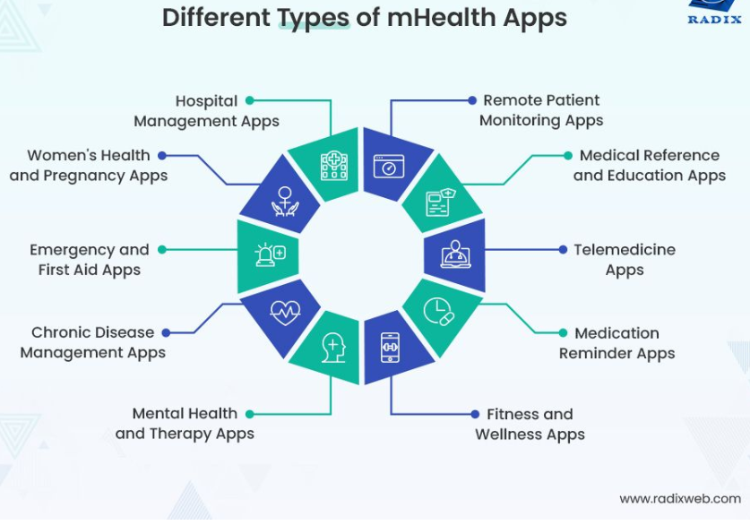

Fig.1 Mobile App Development ,(2026)
Digital technology can make some services easier to access and help people manage their health. However, buying new equipment does not automatically improve care. Services also need trained staff, reliable systems and support for people who find technology difficult. This essay considers the uses of mHealth and examines the benefits and challenges of wider digital transformation. It argues that technology should improve care while protecting personal information, patient choice, and equal access.

Uses of mobile health
Health applications have different purposes. Some health apps provide health information, medication reminders, or activity tracking. Others support communication with professionals or monitoring outside a clinic. WHO (2011) describes uses like health education, patient monitoring, and data collection. However, mobile applications are only one part of the wider digital system. Hospital records, laboratory systems, and pharmacy information are not automatically related to every application.

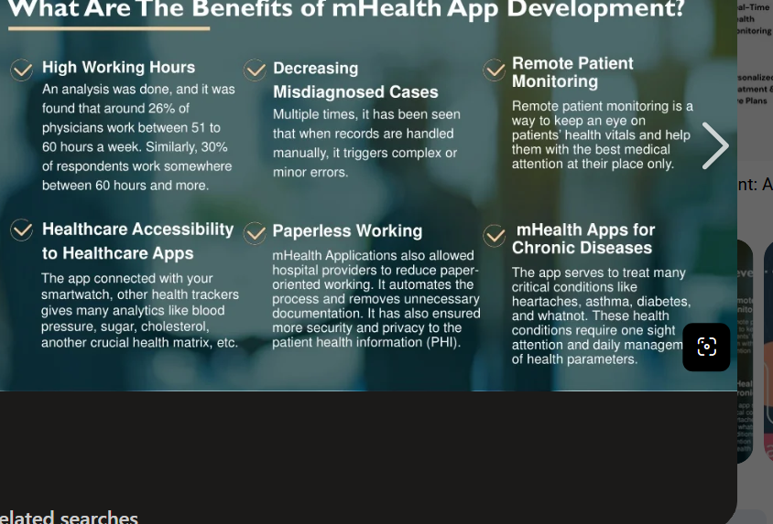
Fig. 2 : MHealth App Development Benefit The Healthcare Industry,(2026)

A reminder service offers a practical example. Staff first confirm the patient's contact details, preferred language, and suitable communication method. The system can then send an appointment reminder by text message or application notification. Patients should understand the service and be able to change their preferences. WHO (2019) supports targeted mobile communication in specific health contexts and protects sensitive content.
Reminders may be useful, but their wording matters. Someone might share a phone with relatives or have notifications visible on a locked screen. A detailed message could reveal confidential information. Services should therefore agree on what can safely be included and check whether the person receives the messages. A reminder also cannot solve every attendance problem. Transport costs, illness, or caring responsibilities may still prevent someone from attending.
Monitoring can involve recording blood pressure, blood glucose or physical activity using suitable connected equipment. Patients may review patterns and discuss changes with a professional. This supports someone with a long-term condition who finds regular travel difficult. However, reading need to be accurate and interpreted in context. A device cannot explain every symptom, and an application should not encourage someone to delay necessary assessment. Health education and mental wellbeing tools may offer additional support but should be learned before use. (WHO, 2011).

Workforce skills and responsibilities
Digital transformation changes everyday professional work. Nurses, doctors, social workers, and care staff may need to record information electronically, use video consultations and respond to monitoring results. The Care Quality Commission (CQC, 2024) stresses that digital records should support safe, effective care. Staff need to understand both how systems work and how to record information accurately.
For example, a community nurse could check an electronic care record before visiting a patient. Information about medication, recent concerns and previous care may help with planning. However, an incorrect entry could be copied into later decisions. Staff must check information rather than assume that a digital record is always correct.
New systems can also create work. Staff may have to enter the same details in various places, deal with technical problems or check large numbers of alerts. Organisations should consider these tasks when planning staffing. Training needs to be practical and ongoing, with time and support. WHO's digital health strategy explains that technology requires organisational, financial, and human resources as well as equipment (WHO, 2021b).

Delivery service changes
Digital services can change where and how care is provided. A virtual ward allows suitable patients to receive hospital-level care at home, supported by a clinical team. NHS England (2024) describes arrangements that can include monitoring technology, professional reviews, and clear routes for further assessment. This is different from simply giving someone an application and expecting them to manage alone.
For selected patients, home care may avoid admission or support earlier discharge. It may also reduce journeys and help people remain in familiar surroundings. However, suitability must be assessed individually. The home environment, clinical needs, and available support all matter. The plan should be clear.
Telephone and video consultations offer another way to deliver care for routine discussions but cannot replace every examination or conversation. A poor connection can interrupt communication, while limited privacy at home may make sensitive discussions difficult. Services should offer an appropriate alternative when remote contact does not meet the person's needs.
Digital records can improve access to information, but organisations must plan for system failure. CQC (2024) explains protection against cyber-attacks. Staff still need to provide safe care when information systems are unavailable.
Information sharing also needs attention. If professionals cannot access records held by another service, patients may have to repeat their history. A useful digital system should support relevant communication between teams while limiting access to those who need it. Clear responsibilities matter because collecting more information does not necessarily improve coordination. Staff need to know which record is current and how to correct mistakes. These are practical service issues, which can be solved by purchasing equipment alone (CQC, 2024).

Patients and experiences of care
Patients may welcome digital services because they offer convenience and greater involvement. The NHS App allows access to health information, repeat prescriptions and appointment management, although available functions vary (NHS, n.d.). Someone with limited mobility may find these options easier than travelling or waiting on the telephone.
However, convenience does not mean that every patient feels supported. A person may struggle to describe symptoms on a video call or feel uncomfortable discussing distress without meeting a professional. Others may prefer remote contact because they feel more relaxed at home. Services should ask about preferences rather than assume one method suits everyone.
A systematic review by Leonardsen et al. (2020) found that experiences of technology-enabled care related to usability, independence, empowerment, and security. This suggests that patients value both useful equipment and reassurance. However, the review included different technologies and settings, so its findings should not be treated as a guarantee of satisfaction with every service.
Patients also need clear information about monitoring. They should know who checks their readings, when these are reviewed and what to do if symptoms worsen. Without this explanation, a patient might wrongly believe that someone is watching their information continuously.

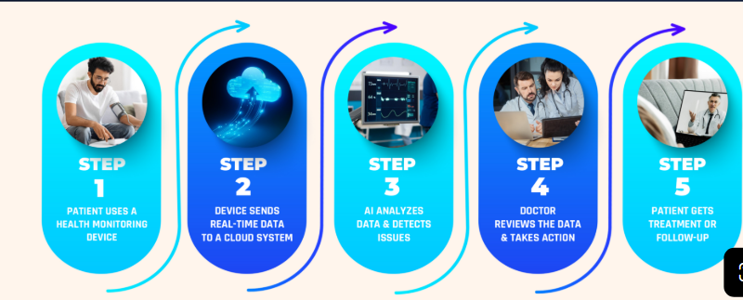

Fig 3 :How Remote Patient Monitoring Works: Saha, N.(2026)

Community and public health

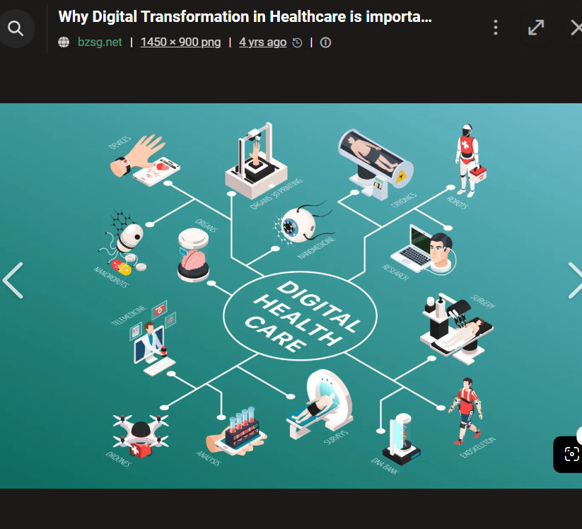
Why digital transformation in health care is important ,(2026)

Moving care into the home also affects relatives and unpaid carers. Families may help someone take readings, charge equipment, or contact professionals. This can support care, but it can also add responsibilities to an already demanding role. NHS England (2024) states that carers' needs should be assessed. Their willingness, time and confidence should not be taken for granted.
Community involvement is also important when developing services. Co-production means professionals and service users working together to shape care. For example, a patient group could test an appointment system and explain which instructions are confusing. Involving people early may reveal problems that designers have missed. WHO (2021b) places people at the centre of digital health development.
Digital information can support public health planning by helping services understand patterns of need. However, information only helps when it is accurate and used responsibly. Online surveys may miss people without internet access, so their findings may not represent the whole community. Services should combine digital feedback with conversations, community meetings, and other ways of listening. Otherwise, decisions intended to improve access could overlook the people who need additional support.

Digital inequality
Digital inequality means differences in access to technology and in people's ability to use it. NHS England (2023) identifies barriers involving devices, internet access, skills, accessibility, and trust. Some older people, people with disabilities and people on low incomes may face difficulties, although experiences vary within every group. Limited English or poor internet coverage can create further problems.

\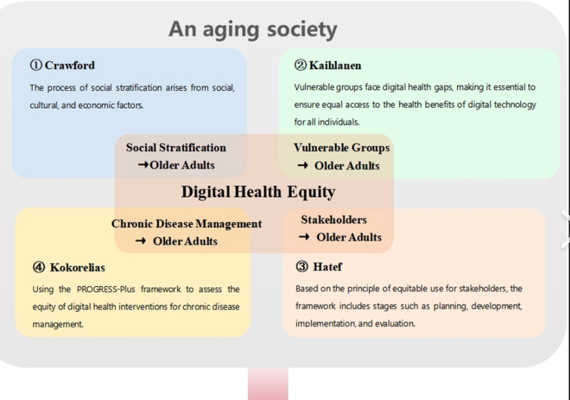
Guo X, Cao J, Huang M, Tan T, Quan H, Li C and Shen X (2026) Digital health equity among older adult(s): a conceptual analysis. Front. Public Health 14:1891578. doi: 10.3389/fpubh.2026.1891578

For example, an online appointment system may save time for someone with a smartphone and reliable internet. The same system may be difficult for someone who cannot afford mobile data or needs help reading instructions. Offering everyone the same website does not necessarily give everyone an equal opportunity to obtain care.
Crawford and Serhal (2020) argue that digital services can reinforce existing inequalities if they ignore social circumstances. Their paper presents a framework and discussion, rather than proving the size of these effects through a clinical trial. Nevertheless, it provides a useful reminder that access involves more than owning
Services can respond through accessible design, language support and help with digital skills. Telephone and face-to-face routes should remain available. Organisations should also examine who misses appointments or does not complete digital processes. This can show whether a new service is creating barriers for groups.

Privacy, security, and emerging technologies
Health information is sensitive, and people need confidence that it is managed responsibly. Tangari et al. (2021) identified privacy concerns in health applications, including data collection and sharing practices. Their findings show why an application should not be considered trustworthy simply because it appears in an application store.
Security requires several measures. Encryption can help protect information during transmission, but it does not prevent every privacy problem. Organisations also need suitable access controls, staff training, and clear explanations about how information is used. Patients should understand what they are sharing and who may access it. Artificial intelligence can help professionals analyse information and identify patterns. Connected devices can also provide measurements outside clinical appointments. However, these tools require evidence of accuracy and appropriate use. A fitness tracker should not automatically be treated as a medical diagnostic device. WHO (2021a) emphasises human rights, accountability, and ethical oversight in healthcare AI.
Bias is another concern. If the information used to develop a system does not represent different populations, its performance may vary between groups. Professionals need to understand limitations and remain able to question results. NICE (2022) provides evidence standards for digital health technologies. These support assessment of effectiveness and value, alongside the separate safety and regulatory requirements that may apply.

Recommendations
Organisations should introduce technology in response to a clear care need. Staff should receive practical training, reliable equipment, and time to learn new responsibilities. Patients and carers should help design services, with particular attention to people who are less confident using technology.
Digital access should be offered alongside suitable telephone and face-to-face care.

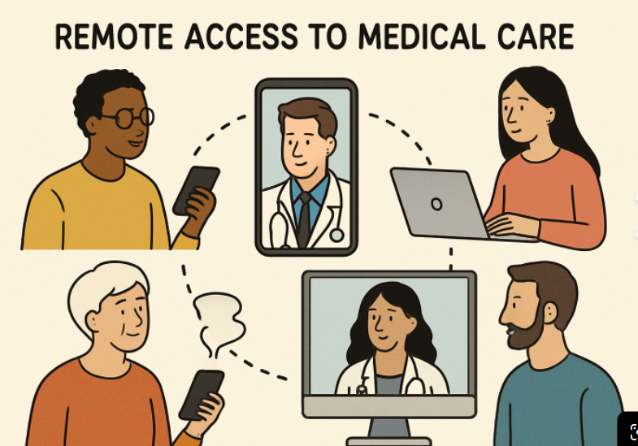
Fig.Innovative Strategies for Enhancing Healthcare Accessibility,(2026)

Information should use plain language and accessible formats. Services should protect confidentiality, agree on responsibility for monitoring, and prepare for technical failures. Finally, evaluation should examine patient experience, staff workload, safety, costs, and differences in access. These priorities reflect guidance on inclusion, digital records, and evidence assessment (NHS England, 2023; CQC, 2024; NICE, 2022).
Evaluation should begin before implementation so that services can compare experiences and outcomes afterwards. For example, organisations could examine missed appointments, time spent completing records and complaints about access. They should also ask whether savings for the organisation create extra costs for patients or families. A small trial may help identify difficulties before wider use. However, positive feedback alone is not enough to demonstrate clinical effectiveness. Evidence should match the technology's purpose and risks (NICE, 2022).

Conclusion
Digital transformation offers useful opportunities for health and social care. Mobile applications, electronic records, and remote services can improve communication and help some people receive care at home. However, benefits depend on how services are organised and whether people can use them. Staff training, privacy, patient preferences, and family responsibilities all need attention. Successful change requires careful planning, continued evaluation and accessible alternatives for people who need them.

References
Care Quality Commission (2024) Digital record systems: achieving good outcomes for people using adult social care services. Available at: https://www.cqc.org.uk/guidance-regulation/adult-social-care/digital-record-systems-adult-social-care (Accessed: 15 October 2026).
Crawford, A. and Serhal, E. (2020) Digital health equity and COVID-19: the innovation curve cannot reinforce the social gradient of health’, Journal of Medical Internet Research, 22(6), e19361. Available at: https://doi.org/10.2196/19361
Leonardsen, A.C.L., Hardeland, C., Helgesen, A.K. and Grøndahl, V.A. (2020) ‘Patient experiences with technology enabled care across healthcare settings– a systematic review’, BMC Health Services Research, 20, article 779. Available at: https://doi.org/10.1186/s12913-020-05633-4
National Institute for Health and Care Excellence (NICE) (2022) Evidence standards framework for digital health technologies. ECD7. Available at: https://www.nice.org.uk/corporate/ecd7 (Accessed: 15 October 2026).
NHS (n.d.) Access your NHS account. Available at: https://www.nhs.uk/nhs-app/account/ (Accessed: 15 October 2026).
NHS England (2023) Inclusive digital healthcare: a framework for NHS action on digital inclusion. Available at: https://www.england.nhs.uk/long-read/inclusive-digital-healthcare-a-framework-for-nhs-action-on-digital-inclusion/ (Accessed: 15 October 2026).
NHS England (2024) Virtual wards operational framework. Available at: https://www.england.nhs.uk/long-read/virtual-wards-operational-framework/ (Accessed: 15 October 2026).
Tangari, G., Ikram, M., Ijaz, K., Kaafar, M.A. and Berkovsky, S. (2021) Mobile health and privacy: cross sectional study’, BMJ, 373, n1248. Available at: https://doi.org/10.1136/bmj.n1248
World Health Organization (2011) MHealth: new horizons for health through mobile technologies. Geneva: World Health Organization. Available at: https://iris.who.int/handle/10665/44607 (Accessed: 15 October 2026).
World Health Organization (2019) WHO guideline: recommendations on digital interventions for health system strengthening. Geneva: World Health Organization. Available at: https://www.who.int/publications/i/item/9789241550505 (Accessed: 15 October 2026).
World Health Organization (2021a) Ethics and governance of artificial intelligence for health. Geneva: World Health Organization. Available at: https://www.who.int/publications/i/item/9789240029200 (Accessed: 15 October 2026).
World Health Organization (2021b) Global strategy on digital health 2020–2025. Geneva: World Health Organization. Available at: https://www.who.int/publications/i/item/9789240020924 (Accessed: 15 October 2026).
Radixweb (n.d.) Everything You Need to Know About mHealth Apps. Available at: https://radixweb.com/blog/everything-need-know-about-mhealth-apps (Accessed: 18 October 2026).
SlideServe (n.d.) MHealth App Development. Available at: https://www.slideserve.com/dreamsoft4u/mhealth-app-devel (Accessed: 18 October 2026).
PatientCalls (n.d.) Protected Health Information. Available at: https://www.patientcalls.com/wp-content/uploads/protected-health- information(Accessed:18October2026)
Guo X, Cao J, Huang M, Tan T, Quan H, Li C and Shen X (2026) Digital health equity among older adult(s): a conceptual analysis. Front. Public Health 14:1891578. doi: 10.3389/fpubh.2026.1891578
(Accessed:18 October 2026
Innovative Strategies for Enhancing Healthcare Accessibility Available at: Home - Hope Town Lodge.(Accessed:18 October2026)

