MSc Digital Skills for the Health and Care Professions
Digital Technology in Health and Social Care BMDS7006
System Improvement Programme – COHORT 2, 2022-2023
Student ID: 2212656 Total Word Count: Date of Submission: 16.12.2022

Introduction

Describe the nature of the organisation and the operational context
The Welsh Ambulance Service Trust (WAST) was established in 1998 and serves a population of over three million people and covers an area of over 20,640 km (WAST, 2022). The WAST employs almost 3,500 people with approximately 70% of the workforce within Emergency Medical Services (EMS), including Clinical Contact Centres (CCC) (WAST, 2022).
Wales consists of not only urban but rural and remote areas which require a more dynamic approach to the way the WAST responds to patients’ varying needs. The service answers and responds to non-urgent, urgent, and emergency calls within the community that require some form of clinical triage and intervention.
The organisational structure contains many directorates beneath the Chief Executive Officer, the below identifies the hierarchical structure with a detailed view of the Digital Directorate:

Figure 1. WAST / Directorate / Digital Directorate / ePCR
Furthermore, the service works closely with key stakeholders both internally and externally to meet targets set by Welsh Government (WG) that include financial constraints, Research and Development, succession planning to include the Integrated Medium Term Plan (IMTP), which is a long term strategic framework to move forward to deliver an excellent service and aim to ensure that patients receive the right advice and care in the right place at the right time, a continual cycle of striving to better the patient experience (WAST, 2022)

Identify the BUSINESS Problem
WAST is on a journey of embracing digital technology to support the development of our clinical offering as an ambulance service within the wider National Health Service (NHS) Wales (WAST, 2020). One agreed and funded priority was to procure an electronic Patient Clinical Records (ePCR) solution with the application being operational on all clinicians’ WAST iPads.
WAST (2020) identified 4 key investment objectives for the ePCR business case:

Figure 2. WAST 4 key investment objectives
1 | To use better data and access to information to improve the quality of patient care
2 | To increase data sharing in a collaborative whole system approach
3 | To improve efficiency by using high quality data to reduce waste
4 | To increase the value of our clinical data through quality and timeliness

By implementing the electronic record, the above key objectives should be achieved. Porter et al. (2018) state that electronic patient records are clinically safer and more robust to scrutiny than traditional paper records. They go on to say that access to patient health records through the digital medium is preferable in all instances.
The current handover to clear process involves both a WAST clinician and ED staff communicating the formal handover whilst physically with the patient, however, once the verbal handover is complete, both the ED staff and WAST clinician must leave the patient to attend a fixed Hospital Arrival Screen (HAS) to enter their individual Personal Identification Number (PIN) to complete the handover process. Unfortunately, this is challenging due to the location of the HAS, with other contributing factors including, distractions on the way that may separate them which will delay the process resulting in added time away from caring for the patient. Handover pressed prematurely by another member of ED staff where patients would be classified as handover complete whilst the formal physical handover was still taking place. Data isn’t accurate due to the many discrepancies in the process whilst this further delays the WAST clinician clearing resulting in lost hours with reduced ambulance availability to respond to waiting emergency calls.
Possible root cause and effects of a business problem can be brainstormed and visually documented, which is recognised as the Fishbone diagram, also known as Ishikawa Fishbone Diagram:
Figure 3. Ishikawa Fishbone Diagram
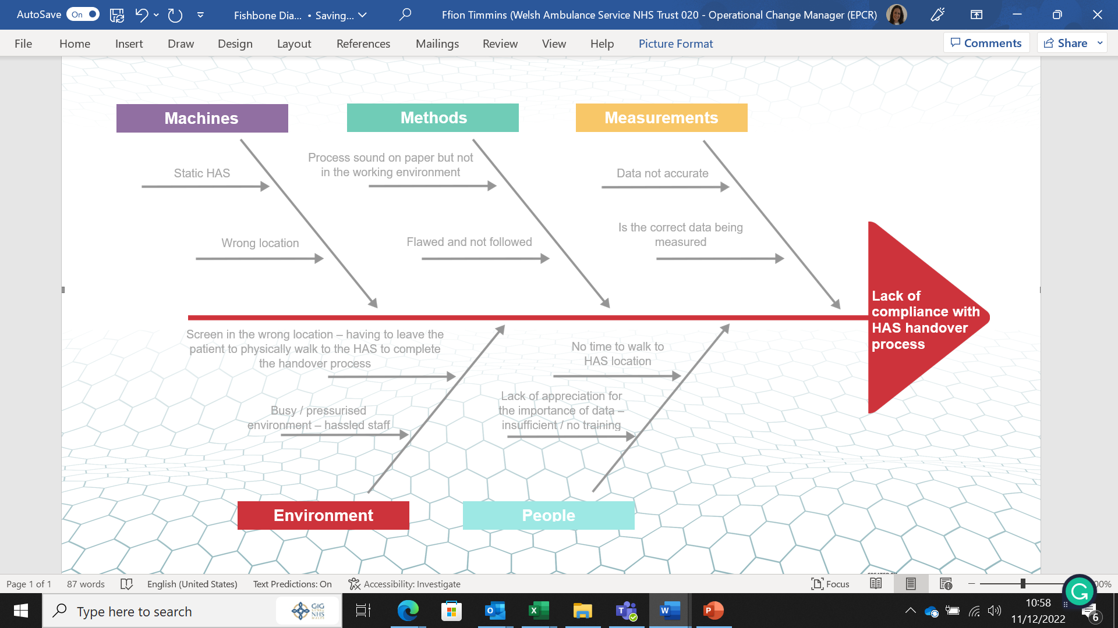
(TemplateLab, 2017)
This allows a business to truly diagnose problems rather than focusing on the symptoms and allows to separate the content of the problem from its history and get a team consensus on the problem and its root cause.

Explain how it can be improved using an Information System:
An Information System (IS) is recognised as critical in improving the efficiency, cost-effectiveness, quality, and safety of healthcare (Gomes and Romão, 2018).
Projects, regardless of their size, contain information and data that will need to be managed and organised throughout. As the project progresses, so does the amount of information surrounding the project, therefore a system that helps project managers manage and deliver project information becomes essential. A Project Management Information System (PMIS) allows for easy planning and tracking of progress through all stages.

Figure 4. 6 Key PMIS Functions
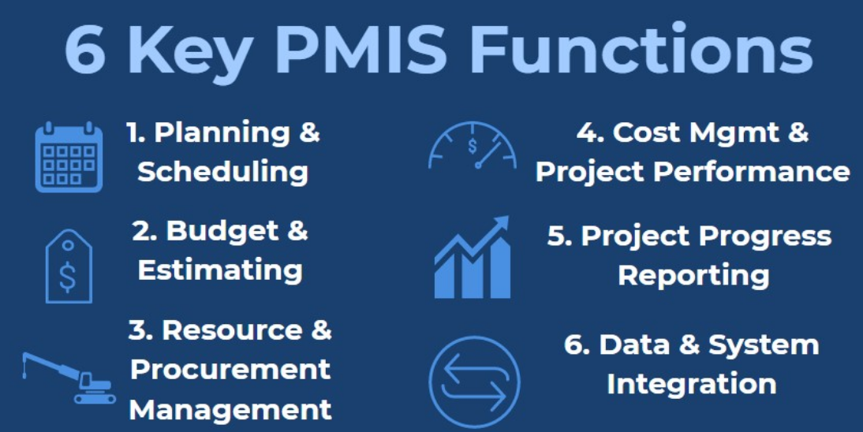
(ARES PRISM, 2021)
- Planning & Scheduling: utilising a scheduling application will enable a project to create a specific schedule and scope.
- Budget & Estimating: a quality PMIS can allocate project costs to individual tasks or items to create more accurate budget estimates.
- Resource & Procurement Management: resources and procurement items make up the majority of project costs.
- Cost Management & Project Performance: PMIS assists PM to manage costs and performance, allows to update existing plans, tracking and manage the whole project.
- Progress Reporting: project progress reporting is essential for PM by providing the tools needed to create and send project reports to team members and stakeholders.
- Data & System Integration – to bring all project data together, should be able to be integrated into other applications or software systems.

The role of IS is characterised by the evolution of IT - the expansion of IS, digital platforms, and the development of IT across organisations (Delmond et al., 2016).
The lack of compliance and process would be improved using an Information System, the below diagram indicates the required work breakdown structure which highlights all key deliverables of the business problem project:
Figure 5. Key Deliverables

Justification
Explain the change you will be introducing
The ePCR application on WAST clinician’s iPad is a mobile device, therefore, capturing live data which will result in an improvement in the process. Currently, the ePCR functionality does not support the dual PIN handover process. A dedicated screen on the ePCR application could act in lieu of the existing HAS screen and can be designed to include dual PIN handover when a physical handover has occurred. The system would need to be designed so that both WAST and ED staff would enter their PIN to allow the handover “stamp” to be recorded accurately before the closure of the ePCR record.

Justify why you think these changes are important
The issue of inaccurate handover recordings identified a need to improve the use of data by adding a robust process, that is measurable and that will enhance patient care and safety. A recent Health Inspectorate Wales (HIW) report has indicated that the current patient handover process is not adequately used across HAS sites in Wales and is not compliant with the hospital handover guidance issued by the WG in 2016. The guidance stipulates the need for a timely patient handover to clear within 15 minutes (WAST, 2021).
A key element to the above is that the HAS is not available in every cubicle or corridor as they are static units located in a couple of places in ED. Furthermore, the process isn’t compliant due to a busy ED with staff having no time to leave their area of work, a lack of energy, and no understanding of the importance of the data. The expectation from HIW and WG is to capture accurate data, by using a technology system incorporating the handover recording into the ePCR application would improve the process and allow for a safer handover process with minimal distractions which would provide a timely flow of live, tangible, and accurate data with no room for errors. This will also result in a timelier release of WAST resources to respond to other 999 calls waiting in the community.

Aims and Objectives
Aim
Implementing the handover to clear process using the ePCR Dual PIN instead of the current HAS will result in accurate handover data and improve patient safety, furthermore, it will enable WAST resources to clear in a timelier manner. By the end of September 2023, a 10% improvement is anticipated, which will positively increase with ongoing training, support, and monitoring moving forward.
Objectives (SMART)
By the end of July 2023, we will have worked closely with operational colleagues and key stakeholders to ensure the following SMART (Specific, Measurable, Achievable, Realistic, Time-Bound) objectives:
Constant liaison with the supplier to ensure the solution is configured as desired. The training needs of all users will be identified, planned, and delivered. Testing and deploying the new process will be carried out with continual review through the Plan, Do, Study Act (PDSA) cycle. The launch of the new data collection from the point of handover.
Accomplishing the objectives should achieve the overall aim as planned. The above objectives are not only SMART but follow Leavitt’s Diamond Model which is based on four major interdependent components of People, Task, Technology, and Structure. A change in any component will also affect the other three.
Literature Review (based on the business problem)
Define your search strategy
A literature review gives readers the opportunity to learn more about a particular topic. The initial searches were as extensive as possible to try and identify relevant literature about the business problem, the search was undertaken using multiple specific keywords to base the research on Google Scholar which were ‘lack of compliance in hospital handover’ which produced over 26,000 results. To ensure studies were relevant and not outdated the search criteria were narrowed to a time frame set to 10 years with anything written from 2012 onwards and published in English. However, the search still produced over 18,000 results, which indicates that the search criteria needed to be narrowed down.
Another systematic review of the literature was performed by searching multiple databases, including Pubmed, Medline, and MIDRIS. Some of the search terms used were ‘handover data’, ‘timely handover’, ‘ambulance handover’, and ‘accurate data’. Once the search results were populated, further sub-headings and synonyms were added along with utilising the Boolean operators (AND, OR, NOT or AND NOT) to combine and exclude keywords and to increase the specifics of the search.
Reading the search results in full would be impossible due to the vast number of studies populated as the subject is quite broad. Reading the title and abstract of the studies determined their suitability or relevance to the identified problem which would then necessitate reading the full article.
PRISMA is an evidence-based item for reporting in systemic reviews and meta-analyses and is primarily focused on reporting reviews that assess the impact of interventions, additionally, it can be used as a basis for reporting systemic reviews for purposes other than assessing interventions. Provides a checklist that authors, editors, and reviewers can use to verify that each component of the search is fully reported and therefore reproducible (Rethlefsen et al., 2021).
Present your results and discuss the emerging themes
Whilst carrying out this literature review the author has been drawn to the lack of information on systems currently in use to support a digital handover process. Moreover, it is apparent that this sphere of work has not presented a problem for other United Kingdom based ambulance services that rely upon a HAS to track the ambulance hospital handover process and has therefore not developed or introduced an electronic mobile solution.
Studies conducted by Tan et al., (2021) stipulated that patient safety could be improved during the handover process by implementing an electronic handover process, furthermore, the findings from surveys are consistent with previous studies indicating that combining both a verbal and electronic handover together would improve the overall patient care. However, a systematic review of the literature on hospital handover concluded there is no reliable evidence to state that standardising handover procedure leads to sustained patient improvements (Sujan et al., 2015).
Fitzpatrick et al., (2018) postulated that a digital handover is not always possible due to the patient’s condition being time-critical and requiring immediate ED care. Clinicians have found a way around the issue with observations being written on their gloves or on a random piece of paper, resulting in the need to complete the ePCR following the physical handover which delays the handover to clear process. They strengthen their statement by adding that clinical information written on a glove is inherently dangerous towards a robust clinical handover, yet they concede that it is necessary for the clinician to do this to ensure that all pertinent clinical information is presented at handover. However, they acknowledge that these practices do not comply with the traditionally held view of a handover process due to there being no physical data capture as to the physical point of patient handover, thereby transference of clinical care between originations is somewhat clouded furthermore, these practices inevitably lead to delays in the availability of the clinicians to respond to the next waiting 999 incident.
Limited evidence of the digital handover process contained within the conducted surveys undertaken on this area identified that ambulance clinicians are reporting several factors contributing to the delay in the ePCR completion following the point of physical handover, these being technical in nature, consisting of inadequate system architecture and poor user interface design (Altuwaijri et al., 2018).
Hovenkamp et al., (2018) reported that the clinician’s satisfaction with the quality of the patient handover is determined by different factors, one being the use of handover interfaces. Therefore, both studies contribute to evidence that inadequate digital systems do have a negative impact on the patient handover experience.
However, JENSEN et al., (2013) went on to state that the patient handover needs to be improved by addressing cultural issues among multidisciplinary staff and that a lack of professional awareness and knowledge plays a key role in identified failures. Staff training combined with structured tools has the potential to change the culture and improve the handover process.
Dawson et al., (2013) concur somewhat with the above views, that Ambulance Clinicians and ED staff are lacking awareness of the importance of each other’s required duties, and education and training would improve the handover process. However, they clearly maintain that the responsibility for accurately demonstrating the point of formal patient handover resides with the first attending clinician, interestingly they discuss the merits of capturing a signature on a piece of paper. Whilst this is less time-consuming, having to physically attend a static HAS to be an onerous part of the handover process, utilising paper is clearly outside of the modern held view of carbon footprint reduction by the limitation of paper use.
The writings of Wells et al., (2012) conclude that an electronic solution is best placed to limit carbon footprint impact and to robustly strengthen the clinician-to-clinician transference of data to ensure maximum clinical safety is always maintained.
Identify a suitable Project management methodology with justification
When selecting a project management methodology, there are numerous theories around, each with its own individual strengths and weaknesses. Whilst many are effective long-standing methodologies, Kerzner (2017) stated that traditional methodologies are somewhat predictable and that due to various factors projects have been unsuccessful. Due to their rigid policies and procedures, they are becoming less popular.
A traditional methodology is Waterfall which consists of five stages that need to be completed singularly before moving to the next stage, it lacks flexibility as the process is rigid with an added risk of having nothing to show the customer until the very end of the project (TemplateLab, 2017).
Kerzner (2017) further added that Agile is now becoming the preferred methodology, with different types being Scrum, Lean, and Kanban. Reduced rules, practices, and documentation mean it is lightweight with the ability to be flexible in process, in comparison to the traditional method.
“Agile development models are currently the rage, for product development, agile methodology is truly amazing” (Ahmed 2012), but also goes on to say that one of Agile’s limitations is that it doesn’t suit a project where staff work in varying time zones, as communication is constantly required and a key to the project’s success. Agile has a lack of associated documentation that could potentially cause issues further down the line when most of the original project staff have dispersed to other roles.
Nevertheless, PRINCE2 is the preferred and recognised methodology within the NHS and WAST, however, there are limitations with PRINCE2 as it is document-heavy with a need for constant senior management involvement, which can delay timelines due to other work commitments. However, as the ePCR project team is already established, limitations are known and understood and can be worked around. Adding the dual PIN handover process interface would be a relatively small part of the project in comparison to the implementation of the full ePCR application, therefore the PRINCE 2 methodology will be applied as it will allow following the same structure and method of the overall ePCR project and the need for the required documentation.
Describe the selected Project management methodology
Projects IN Controlled Environments (PRINCE) was developed by the Central Computer Telecommunications Agency (CCTA) in 1989. Due to the need to develop the methodology, in 1996, PRINCE2 was developed following extensive consultation with European organisations (Anon, 2021).
The PRINCE2 methodology provides a structured framework to be followed through a project’s entity, pertinent objectives are set at the very start where management mechanisms are in place to allow for monitoring and tracking. The objectives are continually reviewed and analysed at the end of the project to identify if they were achieved (Hinde, 2018).
Hinde (2018) illustrates the PRINCE2 four integrated elements, which are, principles, themes, processes, and project environment. Additionally, the below diagram (addresses the planning, delegation, management, and control of the six aspects of project performance – time, cost, quality, risk, scope, and benefits.

Figure 6. PRINCE2 Principles, Themes and Processes
PRINCE 2 | 7 Principles | 7 Themes | 7 Processes
1 | Continued Business Justification | Business Case Theme | Start a Project
2 | Learn From Experience | Organisation Theme | Initiating a Project
3 | Roles and Responsibilities defined | Quality Theme | Directing a Project
4 | Manages by Stages | Plans Theme | Controlling a Stage
5 | Manages by Exception | Risk Theme | Managing Product Delivery
6 | Focus on products | Change Theme | Managing Stage Boundaries
7 | Tailor to Suit Project Environment | Progress Theme | Close a Project

As stated, PRINCE2 is the preferred methodology to be used by WAST, this ensures a consistent project management approach that the PM can keep monitor and control all aspects.
Figure 7. PRINCE2 Methodology
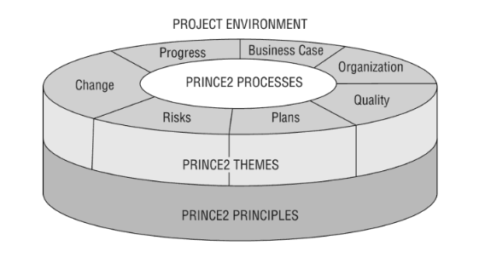
Hinde (2018)
The ePCR team is already established due to the implementation of the initial project start, the Digital Director is heavily involved in the progress and development of the project. Internal and external stakeholders have a vested interest as the ePCR application has an array of positive benefits to provide the service with advanced digital technology that can be interfaced to produce reliable and accurate data.
Continual interaction with the supplier allows for further progress and development ensuring a constructive and positive relationship of trust for both parties.
Figure 8. Digital Directorate ePCR Team:
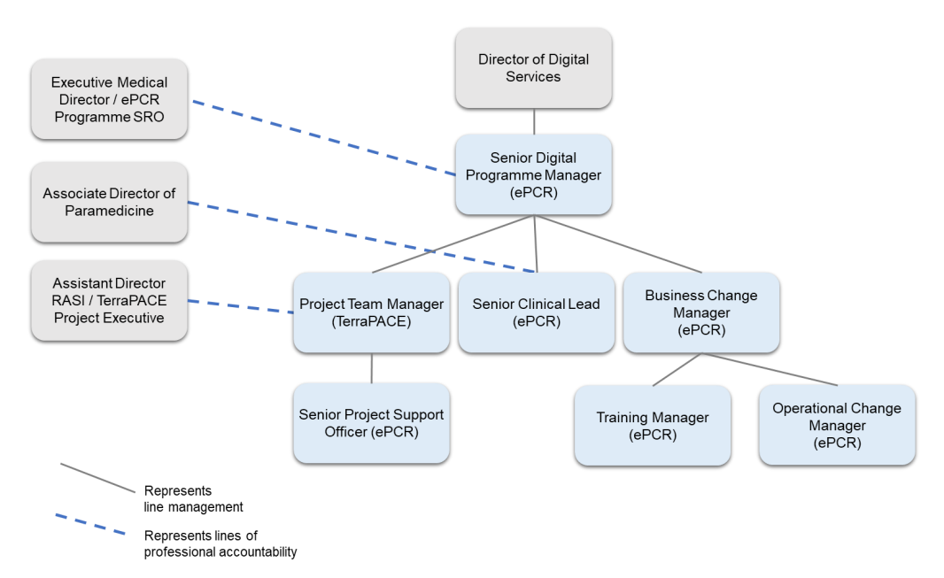

Discuss how you will implement the project management methodology
A project management methodology is defined as a set of methods, techniques, procedure, rules, templates, and best practices used in a project. It is generally based on a specific project management approach that defines a set of principles and guidelines that define how a project should be managed (Špundak, 2014).
Figure 9. Project Management Guidelines
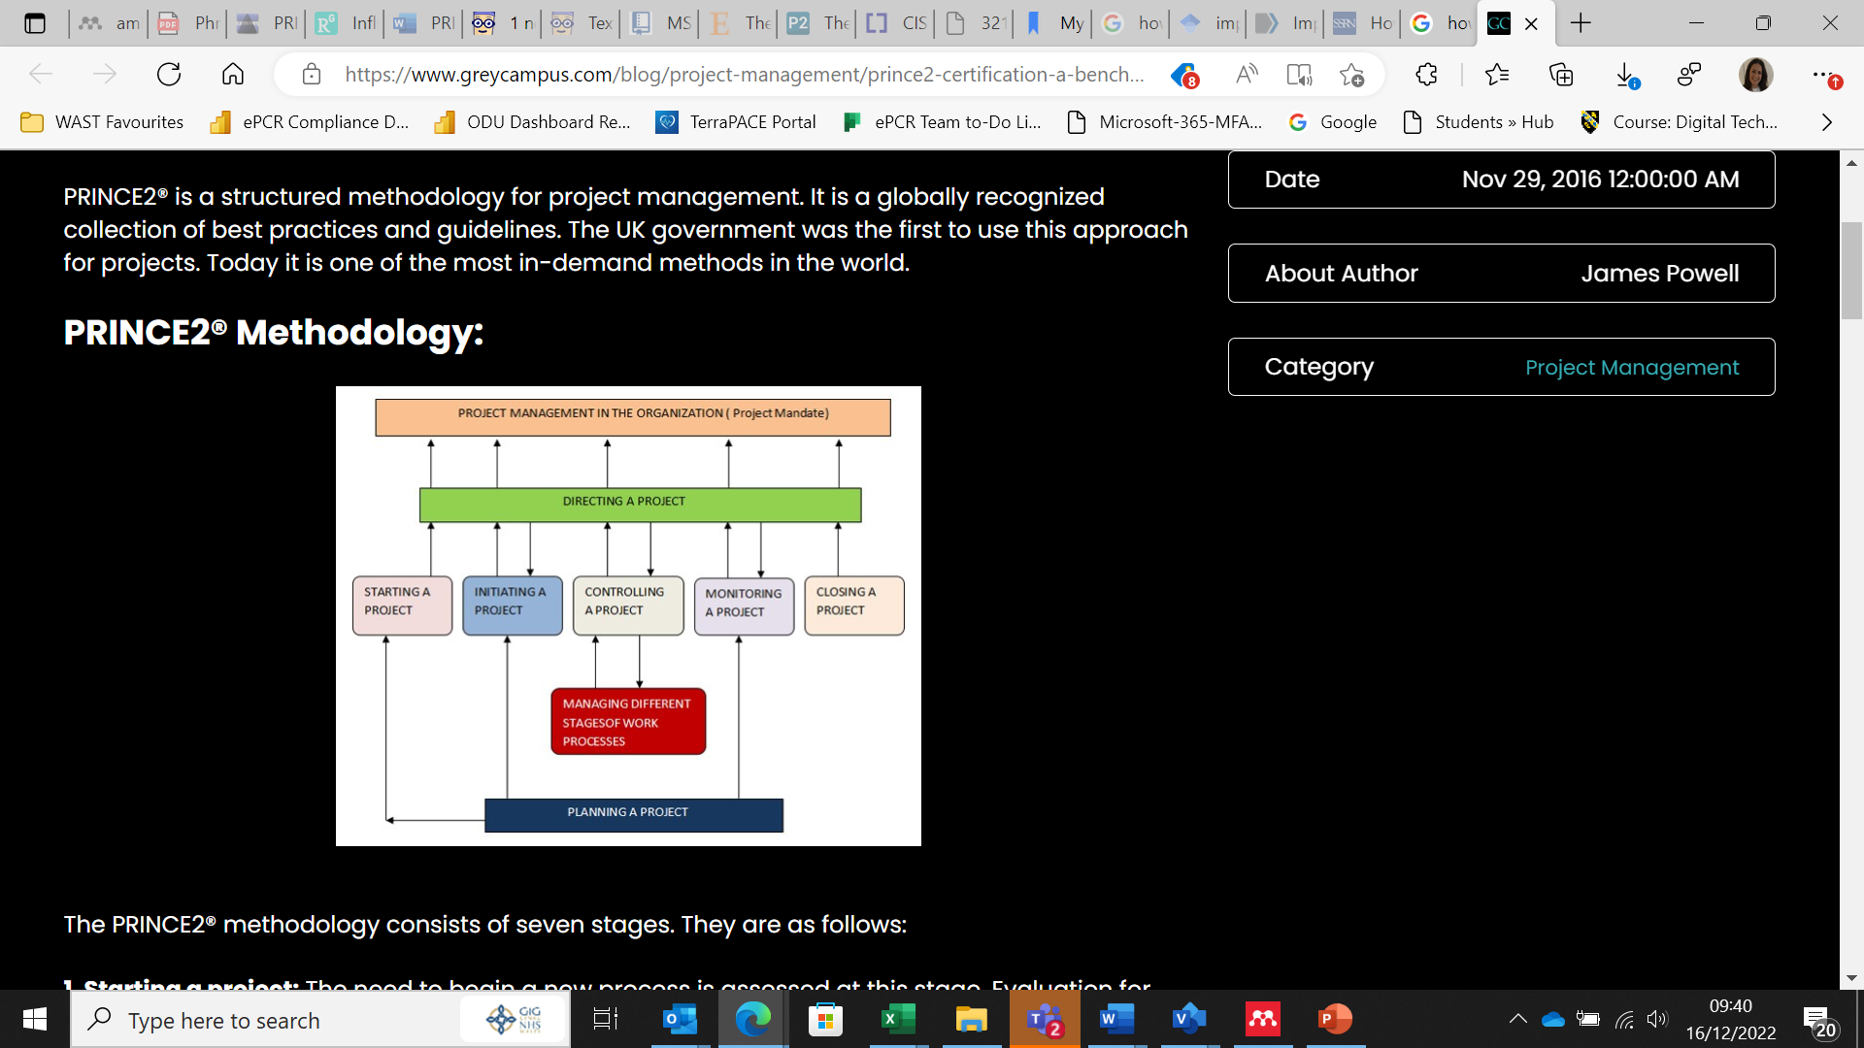
(www.greycampus.com, n.d.)
PRINCE2 is a structured methodology for PM, which is described below and consists of seven stages:
- Starting a project: the need to initiate a new process is assessed, during this phase, process evaluation and validation of the new application begins.
- Directing a project: appointing someone to oversee the project on the project board level, they are responsible for directing the project. This runs through the entirety of the project and involves one or two people from the project board.
- Initiating a project: the project scope and project initiation document (PID) are created and include a project plan along with performance targets. Benefits realization are created and presented to the project board.
- Planning a project: in this phase, the project workflow is set along with a time-bound process. The service delivery cycle includes providing ongoing support to the customers.
- Controlling a project: work is divided into smaller tasks, which are work processes, which include change and quality control methods.
- Monitoring a project: the progress of a process along with any issues along the way are analysed.
- Closing a project: once the project is complete all work should be documented. A full review of the process with any changes will be recorded for future reference. Once all the reporting work has been completed, the project can be closed.
Discuss how you will evaluate the impact of your project
All aspects of a project, including cost, scope, risk and return investment will require rigorous evaluation for maximum benefit of the project. Effective assessment paves the way for further development and improvement of health information systems. Eslami Andargoli et al., (2017) studied whether evaluation frameworks are sufficient to answer the who, what, how, when, and why questions in the evaluation process. Lack of consideration in addressing the questions for the evaluation became evident, although these frameworks complement each other, care should be taken when applying them as they have limitations.
Questionnaires would be distributed pre-project and post-project implementation; user feedback is invaluable in any change process as appropriate feedback can be reported on both positive and negative experiences which can allow further change to be considered. An added reporting tool that can be utilised is the established WAST Improvement and Innovation Network (WiiN) portal (WAST, 2021). Improvement ideas or change request recommendations are submitted for consideration and approval with feedback on the recommendation outcome provided to each user. Users are continually encouraged to submit improvement ideas, without user input and feedback the service cannot develop further to meet the differing demands and challenges of an ever changing health care system.
Discussion
Reflect on how you envisage your change will influence wider system improvements
Implementing the proposed change process will enhance the analysis of accurate data reporting, however, studies are evident that subsequent processes leading up to the physical handover play an integral part in improving the process. Factors thought to be influencing the handover process have been explored in several studies and it is recognised that cultural differences within the work setting were a decisive factor, nevertheless, knowledge, education, and training should improve the overall understanding and allow for a wider appreciation of individual requirements.
Other studies identified that the hardware infrastructure utilised for handover purposes was also an unfavorable consideration when evaluating the handover to clear data, this is consequently completed having to leave the patient to attend to the static HAS which is not completed in a unified manner between the WAST clinician and ED staff. Implementing the dual PIN handover proposal onto the ePCR application would allow for live, accurate data to be produced. Therefore, handover data shared with BCU and WG would be accurate and allow factual reporting of the handover to clear data that WAST can analyse for the identification of any WAST internal discrepancies.

Relate this to other relevant domain knowledge from the literature
Other wider system improvements that may benefit from the business change include a safer and more robust journey as the patient transitions through the wider healthcare system, furthermore, allowing for a comprehensive safe handover between other departments within the hospital due to the ePCR application itself reducing ambiguous generated patient data. Moreover, as the Trust endeavor towards a more positive and structured carbon footprint, aiming to generate a 95% reduction in paper copies will support the Trust to achieve their goal.
Should the implementation of the business problem be approved, possible further interfaces could be introduced to improve service delivery. The current Recognition of Life Extinct process has also identified to be another business problem as paperwork isn’t reliable and instantly accessible. Furthermore, the WAST clinicians presently complete an electronic version on the ePCR but also having to duplicate the information to leave a paper copy to the Police who must attend the scene of any unexpected death as they act in the capacity of the Coroner’s office out of hours. Inevitably the duplication increased administration errors along with increased data protection compliance due to the risk of paperwork being misplaced, moreover, the whole process increased the carbon copy by having to utilise paper which is going against the WAST aims and objectives to reduce waste.

Discuss possible extension or downstream benefits of your intervention
Qualitative and quantitative benefits realisations were implemented to evaluate the ePCR programme delivery and progress. Qualitative benefits generally cannot be measured in monetary or other objective ways. Quantitative profit, on the other hand, is measured in currency units or percentage change. The benefits are measurable, but the fundamental evaluation will be received from the users of the proposed application. The benefits would be matched to each integral stakeholder in how the business problem would benefit their area of work.
Furthermore, the biggest benefit of the intervention would be a robust clinical handover, providing reliable and tangible data which will in turn better the patient experience. The Dual PIN handover process would closely monitor the reasons and obstacles to WAST resources clearing following the physical handover to the clear point. Studies conducted indicate there is a lack of human knowledge and understanding of the importance of complying with the correct handover process. Moreover, having to leave the patient to physically attend the static HAS to complete the handover process has implications as already discussed, implementing the proposed solution would provide a mobile HAS which will produce live data with no room for error as will be completed at the end of the physical handover whilst with the patient. Patient safety and patient experience will be enhanced with a more comprehensive detailed handover without distractions.
Reference list
Ahmed, I. (2022). Clinical Hand Over: A neglected domain in our Health Care. Isra Medical Journal, 14(2), pp.48–49. doi:10.55282/imj.ed60.
Altuwaijri, E.A., Budgen, D. and Maxwell, S. (2018). Factors impeding the effective utilisation of an electronic patient report form during handover from an ambulance to an emergency department. Health Informatics Journal, 25(4), pp.1705–1721. doi:10.1177/1460458218797984.
Anon, (2021). What is PRINCE2 | Project Management| Xebrio. [online] Available at: https://www.xebrio.com/project-management-methodology/prince2-project-management/ [Accessed 15 Dec. 2022].
ARES PRISM. (2021). PMIS Overview: A Guide to Choosing a Project Management Information System. [online] Available at: https://www.aresprism.com/blog/pmis-overview-guide-choosing-pmis-project-management-information-system/.
Bjerke, M.B. and Renger, R. (2017). Being smart about writing SMART objectives. Evaluation and Program Planning, [online] 61(1), pp.125–127. doi:https://doi.org/10.1016/j.evalprogplan.2016.12.009.
Dawson, S., King, L. and Grantham, H. (2013). Review article: Improving the hospital clinical handover between paramedics and emergency department staff in the deteriorating patient. Emergency Medicine Australasia, 25(5), pp.393–405. doi:10.1111/1742-6723.12120.
Delmond, M.-H., Coelho, F., Keravel, A. and Mahl, R. (2016). How Information Systems Enable Digital Transformation: A Focus on Business Models and Value CooProduction. SSRN Electronic Journal. doi:10.2139/ssrn.2806887.
Eslami Andargoli, A., Scheepers, H., Rajendran, D. and Sohal, A. (2017). Health information systems evaluation frameworks: A systematic review. International Journal of Medical Informatics, 97, pp.195–209. doi:10.1016/j.ijmedinf.2016.10.008.
Fitzpatrick, D., Maxwell, D. and Craigie, A. (2018). The feasibility, acceptability and preliminary testing of a novel, low-tech intervention to improve pre-hospital data recording for pre-alert and handover to the Emergency Department. BMC Emergency Medicine, 18(1). doi:10.1186/s12873-018-0168-3.
Gomes, J. and Romão, M. (2018). Information System Maturity Models in Healthcare. Journal of Medical Systems, 42(12). doi:10.1007/s10916-018-1097-0.
Hinde, D. (2018). PRINCE2 study guide : 2017 update. Indianapolis, Ind.: John Wiley & Sons, Inc.
Hovenkamp, G.T., Olgers, T.J., Wortel, R.R., Noltes, M.E., Dercksen, B. and ter Maaten, J.C. (2018). The satisfaction regarding handovers between ambulance and emergency department nurses: an observational study. Scandinavian Journal of Trauma, Resuscitation and Emergency Medicine, 26(1). doi:10.1186/s13049-018-0545-7.
JENSEN, S.M., LIPPERT, A. and ØSTERGAARD, D. (2013). Handover of patients: a topical review of ambulance crew to emergency department handover. Acta Anaesthesiologica Scandinavica, 57(8), pp.964–970. doi:10.1111/aas.12125.
Kerzner, H. (2020). Innovation Project Management. PROJECT MANAGER (IL), (43), pp.5–6. doi:10.3280/pm2020-043002.
McHale, P., Wood, S., Hughes, K., Bellis, M.A., Demnitz, U. and Wyke, S. (2013). Who uses emergency departments inappropriately and when - a national cross-sectional study using a monitoring data system. BMC Medicine, [online] 11(1). doi:10.1186/1741-7015-11-258.
Muhammad (2012). Release Process on Quality Improvement in Open Source Software Project Management. Journal of Computer Science, 8(6), pp.1008–1011. doi:10.3844/jcssp.2012.1008.1011.
Ogbeiwi, O. (2017). Why written objectives need to be really SMART. British Journal of Healthcare Management, [online] 23(7), pp.324–336. doi:10.12968/bjhc.2017.23.7.324.
Rethlefsen, M.L., Kirtley, S., Waffenschmidt, S., Ayala, A.P., Moher, D., Page, M.J. and Koffel, J.B. (2021). PRISMA-S: an extension to the PRISMA Statement for Reporting Literature Searches in Systematic Reviews. Systematic Reviews, 10(1). doi:10.1186/s13643-020-01542-z.
Špundak, M. (2014). Mixed Agile/Traditional Project Management Methodology – Reality or Illusion? Procedia - Social and Behavioral Sciences, [online] 119, pp.939–948. doi:10.1016/j.sbspro.2014.03.105.
Sujan, M., Spurgeon, P. and Cooke, M. (2015). The role of dynamic trade-offs in creating safety—A qualitative study of handover across care boundaries in emergency care. Reliability Engineering & System Safety, 141, pp.54–62. doi:10.1016/j.ress.2015.03.006.
Tan, X.L., Park, H., Patel, J. and Murden, M. (2021). Improving Clinical Handover on an Electronic Communication Platform: A Quality Improvement Project. Cureus. doi:10.7759/cureus.19156.
TemplateLab (2017). 47 Great Fishbone Diagram Templates & Examples [Word, Excel]. [online] TemplateLab. Available at: https://templatelab.com/fishbone-diagram-templates/.
Wells, J.-R., Boucher, J.-F., Laurent, A.-B. and Villeneuve, C. (2012). Carbon Footprint Assessment of a Paperback Book. Journal of Industrial Ecology, 16(2), pp.212–222. doi:10.1111/j.1530-9290.2011.00414.x.
www.greycampus.com. (n.d.). PRINCE2 Certification A Benchmark For Excellence In Project Management. [online] Available at: https://www.greycampus.com/blog/project-management/prince2-certification-a-benchmark-for-excellence-in-project-management [Accessed 16 Dec. 2022].

