Group Project

Reflective Project Report

Date: 22/05/2024

Assessor: Richard Sutton

Student: Ryan Lewis (2318511)

Executive Summary

This report provides a reflective analysis of a project carried out over the past 17 months, using Gibbs’ Reflective Cycle as the primary method of evaluation. The project demonstrated strong team collaboration, clear communication, and effective leadership, leading to significant improvements in stock management and productivity.
Key successes included an 87.13% decrease in unaccounted stock, recovery of 77.2% from unused items, and substantial cost savings. The project also led to the development of a new stock policy and more accessible stock locations.
However, the project faced challenges such as time management, transitioning to a new Computerised Maintenance Management System (CMMS), stock relocation, extensive audit checks, processing new items, and incorrect booking-out by engineers. These issues initially caused frustration and stress among the team but were mitigated through consistent meetings and efficient communication.
The report suggests several strategies for future improvement, including improved and more frequent communication, broader idea generation, proactive conflict resolution, improved organisation through planning tools like Gantt charts and critical path analysis, continuous improvement, employee recognition, leadership development, and the evaluation of new technology options early in the project.
In conclusion, the project’s transformation process was successful, highlighting the importance of managing change with urgency, leadership, employee involvement, and strategic planning. The key to successful change lies in effective communication, inclusive decision-making, proactive conflict resolution, comprehensive planning, and continuous improvement. The insights gained from this project can guide future initiatives, potentially leading to even better results.

Conclusion

Executive Summary 1
Conclusion 2
Introduction 3
Project Plan 4
Project timeline 5
Aims of Project 6
Description: 7
Feelings: 7
Evaluation: 9
Analysis: 10
Conclusion: 11
Action plan 12
Bibliography 18

Introduction

One of the main operational challenges faced by Renishaw, a prestigious engineering company, was managing stock across several locations. During a strategic group meeting, it was discovered that the current stock management system was considerably slowing down processes and leading to underperformance. Two examples of the inefficiencies were the long process (requiring the engineers to climb five flights of stairs) to access the storeroom and the discrepancies in stock levels (considerably large amounts of inventory missing or unaccounted for).
Given the urgency of the situation, management decided to conduct a force field analysis to aid in decision-making about the appropriate course of action to address this issue. This decision-making tool was created in 1951 by Kurt Lewin to assist individuals in determining whether to accept or reject a proposed change. It facilitates comprehension of the dynamics at work, analysis of the forces propelling change, and comparison of those forces with the barriers to change (Lewin, 1951).
The management made the decision to adhere to Kotter's model, which outlines eight guidelines for the process to follow, in order to guarantee the success of the change process. These steps include creating a sense of urgency, building a guiding coalition, forming strategic vision and initiatives, enlisting volunteers, enabling action by removing barriers, generating short-term wins, sustaining acceleration, and instituting change. (Kotter 2012). Each of these actions helps to achieve the desired result and makes it possible to manage the change successfully.
This report offers a thoughtful examination of the project's execution and outcomes, outlining the benefits and drawbacks of each stage of the procedure. It takes inspiration from a number of sources, such as Gibbs (1988), Lewin (1951), and Kotter (2024), to give a thorough understanding of the change process and its effects on the organisation. Additionally, the report contains data and figures that show the project's progress and results.
With an emphasis on the tactics used, the difficulties faced, and the solutions put in place, this report aims to present a thorough and expert analysis of the project. It also seeks to assess the change process's efficacy and how it has affected the organisation's operations.

Project Plan

In the initial planning phase of the project, a forcefield analysis was conducted.
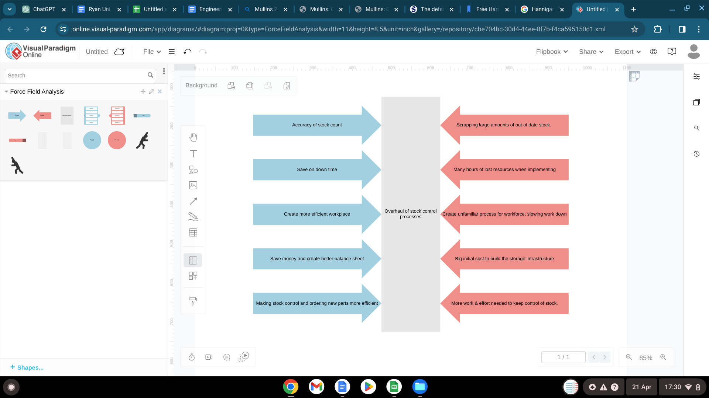
Source, visual-paradigm.com, (2024).
The framework was designed to help with decision-making when dealing with the current issue. It gives decision-makers the ability to evaluate suggested changes and decide whether to accept or reject them. This framework provides insight by dissecting the underlying dynamics, looking at what drives behaviour, and contrasting it with barriers to change (Lewin, 1951).
To help the project manager at every stage, a project timeline was also carefully created. It provides accurate time estimates for the beginning and ending of crucial project stages. This timeline's visual aid promotes timely execution and improves project oversight.

Project timeline
December 2022
- Week 1: Strategic group meeting to identify stock control challenges.
- Week 2: Decision to use force field analysis and Kotter’s model.
- Week 3: Creation of force field analysis.
- Week 4: Initial planning and preparation for implementing Kotter’s model and creation of a Gantt chart.
January 2023
- Week 1: Step 1 - Create a sense of urgency. Recognise the need for change and develop initial plans.
- Week 2: Completion of initial stock audit.
- Week 3: Step 2 - Build a guiding coalition/ form a working group, assign roles.
- Week 4: First team meeting to establish targets and address challenges.
February 2023
- Week 1: Step 3 - Form a strategic vision and initiatives. Develop a detailed five-year plan.
- Week 2: Presentation of phase 1 plan to maintenance and production management teams.
- Week 3: Step 4 - Enlist a volunteer army. Workers participate in assigned working groups.
- Week 4: Monthly meeting to review set goals and address key obstacles.
March 2023
- Week 1: Step 5 - Enable action by removing barriers. Address key obstacles identified in the previous meeting.
- Week 2: Continue addressing barriers. Provide additional training on CMMS.
- Week 3: Step 6 - Generate short-term wins. Begin implementing changes such as recognising missing inventory and organising stock rooms.
- Week 4: Monthly meeting to review progress and set new goals.
April 2023 - December 2023
- Ongoing: Continue with steps 6 and 7 - Generate short-term wins and sustain acceleration. Regular monthly meetings are held to review progress, set new goals, and address any new challenges. Implement changes as per the phased plan.
January 2024
- Week 1: Completion of stock audit and presentation of results in a meeting.
- Week 2: Step 8 - Institute Change. Implement changes to stock management and adjust processes, policies, and structures.
- Week 4: Development of a new stock policy and establishment of more accessible stock locations.
February 2024 onwards
- Ongoing: Continue with Step 8 - Institute Change. Monitor the effectiveness of the new system and make necessary adjustments. Plan for future improvements, such as the new lean lift in the workshop.

Aims of Project

The purpose of this report is to provide a thorough understanding of the project's accomplishments and difficulties to date. This will be carried out utilising various techniques of reflective analysis.
Reflective analysis is a method of examining and interpreting experiences to gain new understanding (Delivering Results, 2024). In the context of this project, the aim of reflective analysis is to critically evaluate the process, identify successes and challenges, derive insights for future improvement, and understand how the project could have run smoother over the past 17 months.
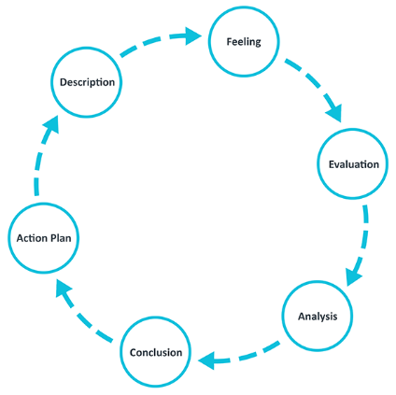
[Fig. 1]
The main method that has been used for the analysis is Gibbs’ Reflective Cycle. Developed by Graham Gibbs in 1988, this cyclical model leads through six stages exploring an experience: description, feelings, evaluation, analysis, conclusion, and action plan. It provides a structured approach to learning from experiences and is particularly useful for repeated experiences (Gibbs, 1988).

[Fig 1] (The University of Edinburgh, 2020).

Description:
It is possible to comprehend the change process more fully by thinking back on the project. The project involved addressing stock control challenges across multiple sites within Renishaw. This move was made in response to years of inadequate stock control and numerous stock moves brought on by ongoing factory work, which resulted in disorganised stock control procedures and numerous instances of needless downtime.
A force field analysis was used to guide decision-making, and Kotter’s model wasfollowed to manage the change process. Kotter’s 8-step model for change provides a structured approach to managing change. Reflecting on each step can help identify what worked well and what could be improved. For instance, the project successfully created a sense of urgency (Step 1) and built a guiding coalition (Step 2). However, there were challenges in enabling action by removing barriers (Step 5) particularly with the transition to a new CMMS system, and the period during the actual stock movement. Each of these steps contributed to the overall outcome and allowed the management of the change to be successful (Kotter, 2012). Reflecting on these experiences can provide valuable insights for managing similar changes in the future. The forcefield analysis was used at the onset to decide what the following steps were going to be.

Feelings:

The report demonstrates how well the team members worked together. There was a strong collaborative environment evident in the creation of a working group comprising representatives from each site, the division of the group into smaller groups that each focused on a particular area, and the active involvement of employees in the groups to which they were assigned (Kotter, 2012). The team members developed a feeling of cohesion and common goal as a result. The team's perception that achieving the ultimate goal would substantially benefit them was the cause of this (Mullins, 2019).

Everyone remained on the same page regarding the progress of the project. There was clear and regular communication. Team meetings and in-person meetings were planned on a regular basis to set goals and discuss obstacles or failures. Mullins (2019) suggests that this may promote transparency.

The team's level of trust was demonstrated by the senior engineers' delegation of stock management responsibilities and the group leader's selection based on his organisational and leadership skills. According to Maxwell (2013), the team's willingness to adjust to the new changes and their dedication to the project were probably influenced by their trust in leadership, particularly in those who have the ability to affect others' behaviour and actions.

Time management, switching to a new CMMS, moving stock, carrying out extensive audit checks, processing new items, and incorrect booking-out by engineers were among the difficulties the team had to overcome. When the group leader and a few team members realised how much work they had on their hands, these difficulties may have initially caused them to become frustrated and stressed. The managementfaced a daunting task when they discovered that £334,00 worth of stock was missing from the original audit. This resulted in emotions such as stress, disappointment, and mild rage at how out of control the situation had become. Frustration was felt amongst the engineers and technicians when searching for stock that was in the process of being removed and allocated to the new location. Because the stock was dispersed among several boxes in the new locations, employees had to physically go through each box in search of the specific part they were looking for. This resulted in conflicts between managers and maintenance employees as well as delays in finishing the work.
But the group's ability to overcome these obstacles through consistent meetings and efficient communication probably lessened these bad emotions and promoted a sense of success (Mullins, 2019).
Motivation and engagement were increased through the project's phased approach, the setting of realistic, personal goals, and the annual review that acknowledged each team member's contributions. Seeing the tangible results of their efforts and the significant cost reduction achieved instilled a sense of pride and satisfaction among the team members (Mullins, 2019).
The group leader's leadership style, which was characterised as being helpful, modest, and putting the needs of the group before his own, probably encouraged team cohesion and inspired the members to give the project their all (Big Think, 2023; YouTube, 2018). His leadership was probably a major factor in the changes' successful execution.

Evaluation:
Renishaw used a variety of management techniques in their change process, which was in line with Kotters' change management model. Regular, in-person team meetings helped to foster communication and were essential for exchanging ideas, establishing objectives, and resolving problems. However, if some team members were unable to participate fully, the efficacy of these strategies might have been
jeopardised (Mullins, 2019).
According to Kim et al. (2014), the group leader had a major influence in steering the change process, and the decision-making process was essentially top-down. This strategy preserved process control and gave clear direction, but it may have limited bottom-up input, which could have resulted in resistance from those who felt their ideas were not given enough weight.
One of the most important parts of the change process was dealing with employee resistance to the new system. One useful tactic for handling this resistance was to provide a quick introduction to the CMMS system and to stress its long-term advantages (Indeed, 2023). The procedure could have been more successful, though, if it had taken more proactive steps to identify and resolve possible points of contention.
Further contributing to the change process's success were the volunteer army's recruitment, the formation of a guiding coalition, and the implementation of a phased approach (Indeed 2023; Mullins, 2019). Nonetheless, extra focus was needed on the problem of time management and the switch to a new computerised maintenance management system (CMMS). The implementation of additional planning and organisation tools could have resulted in a faster and more seamless process.
The project employed a number of management strategies, such as phased planning, Lewins' force field analysis, and Kotters' eight-step model. Examining these methods after reflection can help determine how effective they are and how to make them even better for projects in the future. For example, the initial decision-making process was greatly aided by the force field analysis (Lewin, 1951). Nonetheless, there might be chances to improve its application, like including more stakeholders in the study. More planning tools, such as a Gantt chart and critical path analysis, could have been used at the onset of the project to help with timekeeping and the structure of the project.
In summary, even though Renishaw's change process was generally successful, there were certain things that could have been done better. Lessons learned from this process can offer insightful guidance for future change management initiatives, highlighting the significance of inclusive decision-making, proactive conflict resolution, efficient communication, thorough planning, and organisation (Taylor, 2023).

Analysis:
Significant improvements in stock management were achieved as a result of the project, including a drop in unaccounted stock and increased productivity. Senior engineers are now in charge of managing the stock, and they are all tasked with running reports and doing weekly stock analyses. The way in which these tasks are distributed has enhanced supervision and responsibility, preserving the efficacy of the stock management procedure.
With an 87.13% decrease in unaccounted stock and a recovery of 77.2% from
unused items, these changes have optimised stock management and produced significant cost savings. Analysing these outcomes can assist in gauging the effect of the modifications and identifying areas in need of additional improvement. It resulted in significant cost savings, enhanced productivity, and better stock management. Additionally, the modification led to the creation of a new stock policy and more accessible stock locations. Even with the project's notable advancements, more stock holding resources are still required.
Engineers' and technicians' feedback highlighted the urgency of the situation and the
importance of employee input at all levels in identifying areas that need improvement. It is anticipated that this feedback mechanism will enhance system monitoring in the future, allowing for proactive issue management.
Mullins (2019) asserts that the group leader's attributes, including assertiveness and humility, as well as their prioritisation of the group's needs, were instrumental in fostering group unity and enabling change. It was a first for the organisation when a worker who was not part of the management team successfully managed a project this size.
In order to implement the change and gain the support of the workforce, employee participation was crucial, which reduced resistance. Although the updates were mainly discussed during monthly meetings, this strategy made sure that everyone was aware of any developments that were happening (Mullins, 2019).
The change process was guided by Lewin's three-step change model and Kotter's eight-step process, two examples of strategic planning tools. These models provided an organised method for managing change, guaranteeing that all required procedures were carried out. At the beginning of the project, other methods could have been used to help with time management and project structuring, such as a Gantt chart and critical path analysis.

Conclusion:
Many insights for prospective future projects can be gained from Renishaw's transformation. As per the report, the team exhibited strong leadership, cooperation, and communication, and overall team dynamics were positive. As problems were solved and their efforts were acknowledged, the team's motivation and engagement increased, which was encouraging. After the modifications were successfully implemented and notable advancements were made, the team members experienced a sense of fulfilment and success (Mullins, 2019).
The outcome was enhanced by the application of several management techniques. However, there were areas, such as decision-making, training, and conflict resolution, that could be improved to enhance the effectiveness of the transformation process. More inclusive decision-making and proactive dispute resolution techniques could be advantageous for upcoming projects (Mullins, 2019).
The organisation was significantly impacted by the transformation process, which was influenced by a number of factors. The transformation was successful, which emphasises how crucial it is to manage change with urgency, leadership, employee involvement, and strategic planning. Additionally, it draws attention to the possible advantages of change, such as increased effectiveness and cost savings (Mullins, 2019). It is imperative to acknowledge that change is a continuous process, and maintaining these advantages and resolving any outstanding issues will require ongoing improvement.
The process emphasised how crucial it is to establish a feeling of urgency prior to implementing any changes (Kotter, 2012). It is feasible to stop problems from getting worse and having a detrimental effect on operations by quickly recognising and resolving them (Mullins, 2019). Hopefully, this prolonged period of poor stock management will lead to future actions being taken more quickly.
The process of transformation emphasised how important leadership is in bringing about change. According to Kotter (2012), proficient leaders not only spearhead transformational projects but also cultivate cohesiveness within the team and inspire team members.
Volunteers and other staff members played a crucial role in the transformation process. By ensuring their buy-in and facilitating the change's implementation, their participation helped to lessen resistance (Kotter, 2012).
The transformation process was guided by strategic planning tools, which made sure that all required steps were completed. This demonstrates how critical it is to manage change using an organised method.
Continuous Improvement: There is still opportunity for improvement in the transformation process, especially with regard to stock holding resources. This underscores the importance of continuous improvement and informed decision-making.
Reflecting on the successes, the transformation process led to improved stock management, increased efficiency, and substantial cost savings. It also resulted in more accessible stock locations and the development of a new stock policy.

Action plan
A number of tactics and practical adjustments are developed by utilising the knowledge acquired from the Renishaw project. The report's thorough examination and analysis point out areas that could use improvement. These insightful lessons can easily guide future initiatives, possibly producing even better results.
Improved and more frequent communication: Although monthly meetings were beneficial, there should have been more updates in between, particularly if actions were made that affected the workforce. This was evident during the stock transfer, when many of the items were in transitional storage—they had been moved from their previous locations but had not yet been assigned to their new ones. An email indicating the location of each item could have been distributed to all pertinent staff members at the end of the shift when the stock movement stopped (Mullins, 2019).
Broader ideas: Since the team members are the primary users of the stock system, it would have been beneficial to involve them all in the decision-making process from the beginning to avoid any resistance. This could be accomplished by having suggestion boxes or brainstorming sessions where anyone can share their ideas (Kanter, 2012).
Limit resistance and frustration: Anticipation of issues should have been talked through and better, comprehensive training should have been given to all employees. To facilitate the users' lives, a brief instruction manual could have been included with this. Users had to figure out a lot of the material on their own because the training was too short, which led to delays (Kanter, 2012).
Improved organisation: When the project first starts, make greater use of planning tools like Gantt charts and critical path analysis. This can help with time management and structuring the project, making the process run smoother. Using a critical path analysis is a project planning technique that breaks down large projects into smaller, easier-to-manage tasks. It simplifies the process of managing complex projects. This method allows for the creation of an extensive and efficient action plan by identifying the necessary tasks, their duration, and their interdependencies. The major objective of critical path analysis is to identify the critical path, or the optimal sequence of actions that must be taken in a particular order to achieve the intended outcome (tutor2u, 2017). Project managers find that a Gantt chart is an invaluable tool for organising and tracking the status of their work. In addition to helping team members understand their roles and responsibilities, it gives a visual representation of the key tasks and deadlines involved in a project, ensuring that milestones are met on time (APM, 2021). With the use of these tools, the project's flow could have been substantially enhanced, and management could have seen exactly where the project stood in relation to its timeline and all of its phases. A Gantt chart has been developed, meticulously aligning with the project’s timeline. Each task is represented by blue squares, signifying the anticipated completion period. These squares can be dynamically color-coded to reflect task status—whether completed on time, delayed, or still in progress. Additionally, a real-time percentage indicator accompanies each task, providing an insightful view of progress. This visual tool empowers all stakeholders to identify bottlenecks and encourages proactive efforts to meet project deadlines.

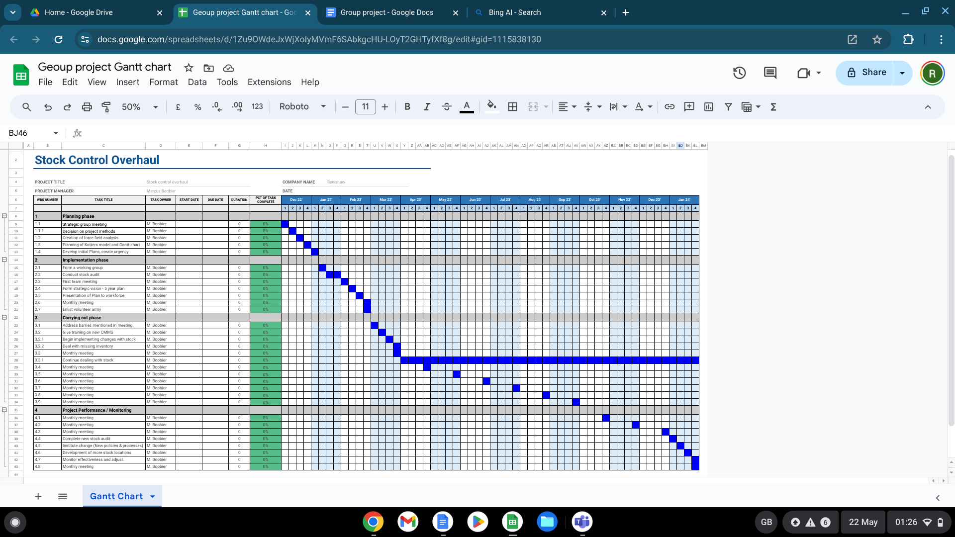
Continuous Improvement: Examine and evaluate the changes that have been put into place on a regular basis. In addition to ensuring that the advantages of the modifications are sustained, this will assist in identifying areas for additional improvement (Mullins of 2019). Furthermore, it will ensure that employees are doing their share of accurately booking out stock. As long as the team stays together to maintain the structure and follow the right procedures, there should not be any problems once a new lean lift has been installed in the workshop to house all of the stock that is still without a permanent location. It would have been faster to implement the lean lift much earlier. When starting other projects, it would be crucial to consider the big picture and make an effort to anticipate these problems before they become a barrier.
Employee Recognition: Continue recognising the efforts of team members. This not only raises their spirits but also motivates them to give the project their all (Mullins, 2019). This method should be applied right away in subsequent projects to bring out the best in people and, hopefully, motivate them to work as hard as they can to accomplish the objective.
Leadership Development: Despite the group leader's excellent performance during the project, it would be advantageous to have a different department member take charge of the operation. This will help to encourage the development of the leadership skills of others within the team. This can lessen the reliance on a single group leader by ensuring that there are several individuals qualified to oversee a project in the future (Graniello, 2024).
New technology: Early in the project, options for new technology could be evaluated and assessed for cost. Staff members would save a huge amount of time and effort with the use of new technology, such as barcode scanners that would automatically update the system when stock was scanned in and out (theaccessgroup, 2024). To ensure that it was both feasible and appropriate for the circumstances, this would need to be priced out and feasibility studies carried out beforehand. In those first meetings, every possibility ought to be at least considered.
These strategies and changes, tailored to the specific context and needs of future projects, can help ensure successful change management and continuous improvement. Remember, the key to successful change lies in effective communication, inclusive decision-making, proactive conflict resolution, comprehensive planning, and continuous improvement (Rowland et.al. 2023). ‌

‌

Bibliography

 |  | Bibliography
1 |  | APM (2021). What is a Gantt chart? | APM. [online] Apm.org.uk. Available at: https://www.apm.org.uk/resources/find-a-resource/gantt-chart/. [Accessed 15 May 2024]
2 |  | Big Think. (2023). Why the myth of the ‘alpha leader’ should be debunked. [online] Available at: https://bigthink.com/business/alpha-leader-myth/ [Accessed 15 Apr. 2024].
3 |  | deliveringresults.leeds.ac.uk. (2024). Reflective Analysis : A Practical Guide To Delivering Results. [online] Available at: https://deliveringresults.leeds.ac.uk/delivering-results-themes/quality-management/reflective-analysis/.[Accessed 15 May 2024]
4 |  | Eliza Taylor, 2023. TheKnowledgeAcademy. What Is Effective Communication: Key Principles and Strategies. [online] www.theknowledgeacademy.com. Available at: https://www.theknowledgeacademy.com/blog/what-is-effective-communication/. [Accessed 15 May 2024]
5 |  | Gibbs, G. (1988). Learning by doing: A guide to teaching and learning methods. Further Education Unit.
6 |  | Graniello, S. (2024). Why Should you Consider Implementing a Shared Leadership model? Holaspirit blog. Available at: https://www.holaspirit.com/blog/why-should-you-consider-implementing-a-shared-leadership-model#:~:text=Shared%20leadership%20can%20contribute%20to [Accessed 16 May 2024].
7 |  | Indeed Editorial Team. (2023). 15 Time-Management Techniques To Improve Productivity Available at: https://www.indeed.com/career-advice/career-development/techniques-of-management [Accessed 16 May 2024].
8 |  | Kanter, (2012). Ten reasons people resist change. [online] Harvard Business Review. Available at: https://hbr.org/2012/09/ten-reasons-people-resist-chang. [Accessed May 03 2024]]
9 |  | Kim, Y.H., Sting, F.J. and Loch, C.H. (2014). Top-down, bottom-up, or both? Toward an integrative perspective on operations strategy formation. Journal of Operations Management, [online] 32(7-8), pp.462–474. doi:https://doi.org/10.1016/j.jom.2014.09.005. [Accessed 15 May 2024]
10 |  | Kotter, J.P. (2012). Leading Change. [online] Google Books. Harvard Business Press. Available at: https://books.google.co.uk/books/about/Leading_Change.html?id=xpGX1EWL_EMC&redir_esc=y. [Accessed 21 Apr 2024]
11 |  | Kotter, J.P. (2012). Leading Change. [online] Google Books. Harvard Business Press. Available at: https://books.google.co.uk/books/about/Leading_Change.html?id=xpGX1EWL_EMC&redir_esc=y. [Accessed 21 Apr 2024]
12 |  | Lewin, K. (1951). Field theory in social science. Harper and Row.
13 |  | ‌Maxwell, J.C., 2013. The 5 levels to leadership: Proven steps to maximize your potential. New York: Center Street [Accessed 15 Apr 2024]
14 |  | ‌Mullins, L.J. and McLean, J. (2019). Organisational behaviour in the workplace. Twelth Edition ed. Harlow, England..
15 |  | Rowland, D., Thorley, M. and Brauckmann, N. (2023). The Most Successful Approaches to Leading Organizational Change. [online] Harvard Business Review. Available at: https://hbr.org/2023/04/the-most-successful-approaches-to-leading-organizational-change. [Accessed 15 May 2024]
16 |  | ‌The University of Edinburgh (2020). Gibbs’ Reflective Cycle. [online] The University of Edinburgh. Available at: https://www.ed.ac.uk/reflection/reflectors-toolkit/reflecting-on-experience/gibbs-reflective-cycle. [Accessed 15 May 2024]
17 |  | theaccessgroup. (2024). Stock Control Software | The Access Group. [online] Available at: https://www.theaccessgroup.com/en-gb/stock-control/#:~:text=Stock%20management%20systems%20typically%20use [Accessed 16 May 2024].
18 |  | ‌tutor2u (2017). tutor2u. [online] tutor2u. Available at: https://www.tutor2u.net/business/reference/critical-path-analysis.[Accessed 15 May 2024]
19 |  | ‌visual-paradigm.com, (2024). Force Field Analysis Template | Force Field Analysis Template. [online] Available at: https://online.visual-paradigm.com/diagrams/templates/force-field-analysis/force-field-analysis-template/. [Accessed April 21 2024].
20 |  | YouTube. (2018). The surprising science of alpha males | Frans de Waal. [online] Available at: https://youtu.be/BPsSKKL8N0s. [Accessed 15 May 2024]

‌

