LEVEL 5 ASSESSMENT SPECIFICATION

Module: | Business Inquiry & Research
Module code: | BMSP5007 | Contribution to Overall Module Assessment (%): | 30%
Lecturer: | Dr Roisin Mullins | Internal Verifier: | Dr Alex Bell
Assignment Title: | Assessment 2: Quantitative Study | Word count (or equivalent): | 1500
Submission deadline: | April 23rd, 2021 | Return date of provisional marks & written feedback: | 21/05/2021
Submission method: | All written assessments, where practical and possible, must be submitted via Turnitin unless otherwise instructed by the Lecturer. (Please DO NOT put this assessment specification into Turnitin or it will match many similarities with other students’ submissions.)  Alternative submission method (if applicable): Late submission of the assessment will result in a late penalty mark. Penalties for late submission: Up to one week late, maximum mark of 40%. Over one week late, 0%. Only the Extenuating Circumstances Panel may approve a change to submission dates.
Academic honesty / referencing: | Academic honesty is required. In the main body of your submission you must give credit to authors on whose research and ideas your work is based. Append to your submission a reference list that indicates the books, articles, etc. that you have used, cited or quoted in order to complete this assessment.

Name: Jordan Thomas

Student number: 1906033

Programme of Study: BA Outdoor Adventure Education

Module: Business Inquiry and Research

Tutor: Dr Roisin Mullins

Date: 23-04-2021, by 3pm

Introduction
This report presents the study of the Geographical Dispersement of Litter and its socioeconomic perception. The main focus of this study are the disparities between litter levels in different areas, from towns to cities, village’s to country side. This and the opinions of people spread across multiple generations on the litter problem in their areas. There were many factors leading up to this study. It started because according to the Well-Being of Future Generations Act (2015) the second goal is to be a “Resilient Wales”. A Resilient Wales is

“A nation which maintains and enhances a biodiverse natural environment with healthy functioning ecosystems that support social, economic and ecological resilience and the capacity to adapt to change.”

This inspired me to do a qualitative study on littering and whether or not the pandemic changed littering habits. During this study it was mentioned frequently that litter levels were not the same in all areas and in-fact some areas had littering problems and others didn’t. This inspired me to research the geographical spread of litter. For this, I will be collecting my data in quantitative form, by means of a 7 question opinion poll on Microsoft Forms. For participant selection I decided to post my questionnaire on multiple social media platforms and forums in order to get a wider and more varied spread of the British population as possible. To make the results as fair as possible it was justified that the sample be no less than 20 Participants. Once the data is collected a statistical analysis was performed. The questions included Several Categorical Variables and several Numerical Variables. For this reason both cross tabulation and correlation approaches were used in the analysis (open university, 2021)

Brief Overview of current literature
According to Melissa J. Goertzen (2017), quantitative research is “collecting and analysing data that is structured and can be represented numerically. This means that questions must be “direct” and “quantifiable” such as ‘how much?’ And ‘how many?’. Some of the advantages of quantitative research procedures include Comparability and replication, meaning that “The study can be reproduced in other cultural settings or with different groups of participants. Results can be compared statistically with a high external reliability (Kimura, 2006) The research paradigm I am following for this study is Positivism. Positivism is a philosophical theory stating that information about reality is obtained from observation and experience of a particular phenomenon (Jupp, 2006). The ontology of positivism is that there is a single reality or truth. What is Ontology? Ontology is the researchers beliefs about reality (Davies, Hands and Maki, 1998). I believe there is a definite correlation between urbanisation and litter levels and I intend to find it. Because of this I will be taking an objective stance on the data gathering to find the facts. The epistemology of positivism is that reality can be measured (Oluwagbamila, Polycarp and Kasimu, 2019) so I intend to capture reliable and measurable data that will produce a picture of the reality of littering in our communities. What is epistemology? Epistemology is the study of knowledge and how it is ascertained (Hetherington, 2019). In this case it will be measured. The methodology I will use to achieve this will be survey research to obtain quantitative results that can be analysed.

The research procedure
Following the positivism paradigm for this research is to do a statistical analysis on the data gathered. I will gather this data from a structured questionnaire with 7 questions.
The seven questions are as follows;

- What age bracket do you fit in?
(<18, 19-29, 30-39, 40-49, 50-59, 60+)
- Which of these applies to you most?
“I live in a city”, “I live in a town”, “I live in a village”, “I live in or close to the countryside”
- Before COVID-19 how bad was the littering problem in your area?
1 (not a problem), 2, 3 (noticeable), 4, 5 (a big problem)
- How would you rate your local councils effort to combat littering?
- During COVID-19 do you think littering became...
A) a bigger issue, B) didn’t really change, C) less of an issue
- In the effort to combat littering what would be the best policy?
Educating children from a young age not to litter, Cutting out disposable plastic at the source, Bigger fines for littering, More cameras
- Do you think that littering is a solvable problem?
Yes with the correct policies, No its always going to be around

These Questions where inputed into microsoft forms to make filling them out as user friendly as possible. Once the questionnaire was created the next steps were to identify the target population. At first wales as a nation was considered, however over 80% of land in wales is farm land. For this reason I decided to include England in the population to improve the chances of finding correlations between land development and litter. Next is to distribute the questions to as many people as possible. Facebook was chosen for this due to its capability for groups and forums filled with people from local communities. This lack of targeting, although limited to tech capable people, limited the bias that could have occurred should I have specifically selected the participants. Once the minimum of 20 people was met the data was gathered in tables and put into SPSS for analysis. For analysis I will be exploring any relationships between the data by performing a Correlation analysis. (MacIntosh and Gorman, 2015)

Findings and data analysis
The majority of the participants where aged Between 19 and 29 at 70% of the participant pool. This is not as even a spread as I’d have liked. Most of the participants also lived in towns and although unrelated to the study it is evident that most young people are living in towns. The participant pool isn’t as varied as I would like, however it is enough to pull some correlations and cross-tabulations.

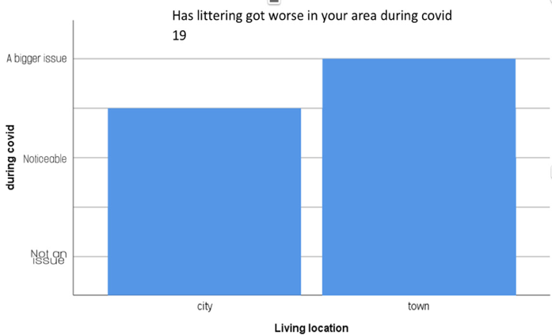
Figure 2

Figure 1

50%
100%

For the question “Before COVID-19 how bad was the littering problem in your area?” 50% of all participants answered “noticeable” (figure 1). This shows that littering is a problem that people are aware of. However, of this 50% that answered “noticeable”, 100% of these said they lived in towns. This shows that the littering problem is worse in the towns, possibly because funding is funnelled into cities. You can see this in Figure 2.
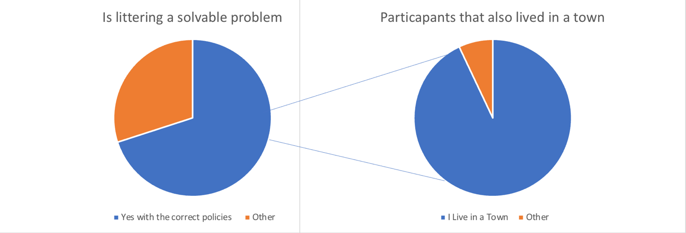
93%

70%

Figure 3

There is a lot of faith that littering is a solvable problem. In fact, 70% of participants voted this option, and of these 93% lived in towns (figure 3). This shows that although littering is worse in the towns the locals have faith in the council to improve the situation. This could also indicate that the faith in the local councils in the cities is lacking.

age * Living location * solvable problem? Crosstabulation
Count
solvable problem? |  |  | Living location |  | Total
 |  |  | city | town | Total
yes | age | 19-29 | 1 | 10 | 11
yes | age | 30-39 | 0 | 1 | 1
yes | age | 40-49 | 0 | 2 | 2
yes | Total |  | 1 | 13 | 14
no | age | 19-29 | 1 | 2 | 3
no | age | 40-49 | 0 | 1 | 1
no | age | 50-59 | 0 | 1 | 1
no | age | 60 plus | 0 | 1 | 1
no | Total |  | 1 | 5 | 6
Total | age | 19-29 | 2 | 12 | 14
Total | age | 30-39 | 0 | 1 | 1
Total | age | 40-49 | 0 | 3 | 3
Total | age | 50-59 | 0 | 1 | 1
Total | age | 60 plus | 0 | 1 | 1
Total | Total |  | 2 | 18 | 20

Figure 4

As you can see in this cross tabulation (figure 4) most of the participants who believed that the littering problem is solvable are in the age bracket 19-29. Maybe this is because the older people have been around long enough to see it not change or maybe councils are actually doing more to combat the problem now.

Conclusion
Although more concentrated, quantitative research has a smaller scope than qualitative research and has less opportunity to stumble upon information that could significantly benefit the study. However, this form of data gathering provides less space for bias to creep into the research. This being because the candidates are not specifically targeted and there is a more wide spread candidate population. It is much harder (but not impossible) to influence the results with your bias. The biggest influence on results being the design of the questions (Jovancic, 2019). For this reason if I was to do it again I would possibly use Triangulation with other studies with similar parameters in order to further solidify the validity and lack of bias of my questions and results (Wilson, 2016). One mistake I made when creating the survey was to use questions that resulted in both categorical variables and numerical variables. This made it difficult for some comparisons between the data and If I was to do this study again I would use one type of Variable to make analysis easier and more concise. The timing also had an effect on the results. Being in the midst of a pandemic, people are venturing out of the city more often. This possibly makes the results invalid for a pre and current pandemic world. If I was to do the research again I would make sure it is after restrictions are lifted to get a better look into the normal littering patterns. Over all this type of data collection is good for getting the results you want, but that in itself is a bias, as long as you ask the right questions the answers will be what you want them to be. For this reason Qualitative research is my preferred method.

(1569)

References

Davies, J., Hands, D. and Maki, U. (1998). The hand book of economic methodology. 1st ed. Cheltenham: Edward Elgar Publishing, pp.343-346. Available at: https://core.ac.uk/reader/213081231. (Accessed: 18th April 2021)

Future Generations. (2015) Well-being of Future Generations (Wales) Act 2015. Available at: https://www.futuregenerations.wales/about-us/future-generations-act/ (Accessed: 15 March 2021
Goertzen, M. (2017) ‘Applying Quantitative Methods to E-book Collections’, Library Technology Reports, 53(04), Available at: https://www.journals.ala.org/index.php/ltr/issue/viewFile/640/401. (Accessed: 17th April 2021)
Hetherington, S. (2019) What is Epistemology? New Jersey: Wiley
Jovancic, N. (2019) 4 Types of Bias in Research and How to Make Your Surveys Bias-Free. [online] LeadQuizzes. Available at: <https://www.leadquizzes.com/blog/types-of-bias-in-research/> [Accessed 21 April 2021].

Jupp, V. (2006). The SAGE dictionary of social research methods (Vols. 1-0). London, : SAGE Publications, Ltd DOI: 10.4135/9780857020116

Kimura, N. (2006) A Study of Qualitative Research and Quantitative Research, Otsuma Women’s University Repository, pp.257-262. Available at: https://otsuma.repo.nii.ac.jp/?action=repository_action_common_download&item_id=759&item_no=1&attribute_id=18&file_no=1. (Accessed: 21st April 2021)
MacIntosh, R. Gorman, K. (2015). Mapping Research Methods. P.50-57. DOI: 10.13140/RG.2.1.1419.3126

Oluwagbamila, E., Polycarp, U. and Kasimu, S. (2019). Facts and Fiction in Positivism and Neo Positivism. Research on Humanities and Social Sciences, 9(4), pp.21-22. DOI: 10.7176/RHSS

Open University (2021). 6 Methods of data collection. Save the children, pp. 17-20. Available at: https://www.open.edu/openlearncreate/pluginfile.php/74604/mod_resource/content/3/6%20methods%20of%20data%20collection.pdf?forcedownload=1. (Accessed: 16th April 2021)

Oluwagbamila, E., Polycarp, U. and Kasimu, S. (2019). Facts and Fiction in Positivism and Neo Positivism. Research on Humanities and Social Sciences, 9(4), pp.21-22. DOI: 10.7176/RHSS

Wilson, V. (2016) Research Methods: Triangulation. Evidence Based Library and Information Practice, 11(1(S), p.66. DOI: 10.18438/b86s5f

