
University of Wales Trinity Saint David
School of Computing
10/05/2023/ACCA7005
Web Services
By Kieran John Ayres

Table of Contents
Table of Contents
Table of Contents 2
Table of Figures 3
1. Introduction 4
2. Reflecting on the Design and Implementation 5
References 9
Appendix 10

Table of Figures
Figure 1 - CarOwner.Java 5
Figure 2 - One-to-One Relationship 6
Figure 3 - Request Mapping 6
Figure 4 - Specific Get Mapping 7

Introduction
The primary focus of this assessment is to design and implement a RESTful Web Service to represent the backend of a road tax management system. This implementation will be completed in Java, using the Spring Boot framework. This will also be implemented with documentation, integrated security, automated testing, and a Dockerfile, so the application can be containerised. This will be expanded upon through this report to outline and emphasise the design and implementation decisions that were made during the process.

Reflecting on the Design and Implementation
The following report discusses the design and implementation completed as part of the system. The brief was overall met; however, this is not to say that it was perfect. This report will reflect upon the process taken to understand what practices were good, while also reflecting upon what was learnt. This is vitally important as it enables the developer to understand where they can improve their practice, when they implement a Web Service in the future. Some components of the implementation couldn’t reach their full potential due to a variety of factors, for example, a time constraint on the developer.
implementation was completed using a variety of techniques. The first iteration of development began by designing and implementing the entities. The entities are Spring Boot based representations of Database tables. JPA later enables these to become a Database. The entities were divided into tables which were identified in the brief. The following example shows an entity class, representing the Car Owner table in the database.
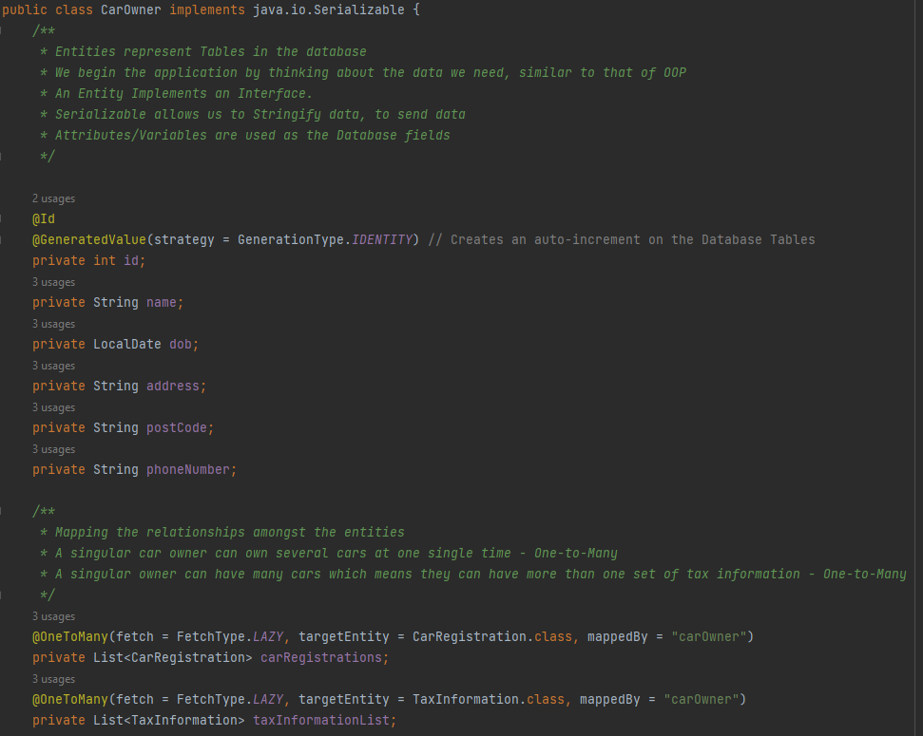
Figure 1 - CarOwner.Java
Customer would have been a better name, to represent this table, which would be more understandable for new users of the codebase. One part of this file which is important to expand upon is the annotations which specify the database relationships. Although One-to-One relationships are simpler to map, as can be seen in the following example. However, these relationships were decided to be mapped in the way that they were due to retaining a higher, more realistic representation of a real implementation. The Car Owner tabled, was mapped to Car Registrations with a One-to-Many, as one person can own many cars, and vice versa. While the Tax Information table has a One-to-One relationship with Car Registrations, as cars only have a singular record regarding their tax details. While Tax Information was mapped with a Many-to-One with the Car Owner table, as people can own more than one car, they would have more than one set of Tax Information.
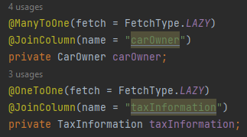
Figure 2 - One-to-One Relationship
Aside from occasional mistakes, the codebase can generally be considered clean. For example, the Entity classes followed the standard structure, while Methods were detailed, and assigned descriptive names. This promotes a clean, and readable codebase. While the files were divided accordingly to retain a simplistic, Object-Oriented approach. One other design choice that was made was to add the Request Mapping annotation. The following example illustrates this.
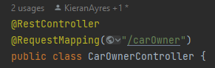
Figure 3 - Request Mapping
The reason for this implementation was so that, when mapping relationships into the Controller classes, using Get Mapping. The first part isn’t needed to be specified. This is cleaner, more minimalistic, while also being more maintainable and readable. The implementation included the use of Controllers, these were Autowired to the respective repositories to extend their functionality and implement methods that can be mapped to specific endpoints. An example can be seen below.
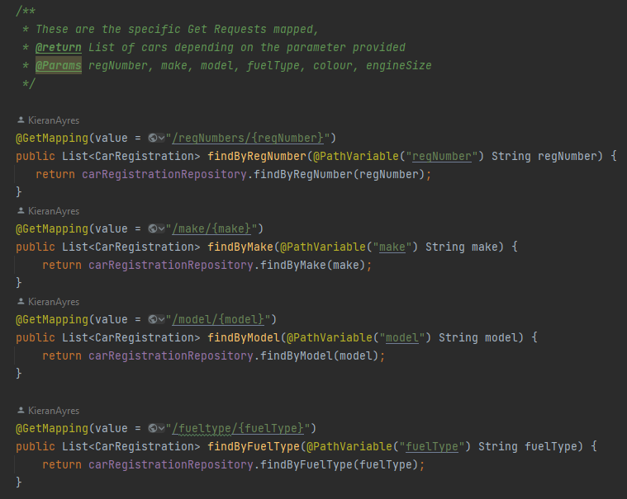
Figure 4 - Specific Get Mapping
These enabled functionalities to be built, such as filters to search for records in the database based on parameters, such as by the car’s registration number. This also mitigates the risk of the complexity of the endpoints that would need specifying when implementing the features on the frontend. Another good part of the implementation was adding DTOs, as specified by the brief. These are Data Transfer Objects. At a high level, these offer custom views on data. The two that were implemented offered a custom view on the endpoints by the DTO Controller. These were to join views such as Car Owners, with their Car Registrations and to join Car Registration with its relative Tax Information. The problem identified within this was that the DTO controllers weren’t developed further beyond a basic level, but these could have been enhanced to have filtered results, searches that aren’t case sensitive. Case sensitivity was one identified area of improvement overall. This limits the endpoint to needing the exact data to search in the endpoint, particularly when searching for a specific entry of data. The DTOs weren’t tested in Junit, due to the incorporated methods that were used in there were previously tested in the entity specific Junit test classes.
Overall. The brief was achieved. However, there were several areas which weren’t to the standard that was initially intended. This was due to time constraints. The first identified area was the idea that Polymorphism could have been implemented, by making a general interface in Spring Boot for the Controller methods, these could have been overridden to suit the particular entity and data that they were corresponding to in the code. This would make the code, so that it is DRY – the idea that code doesn’t repeat itself, a prominent, and important Software Engineering practice. This would have mitigated repetitive code being written. As mentioned previously, naming conventions weren’t enforced rigidly enough. This ensures that code has higher readability, which would help new developers understand what is happening within certain classes, by the names of attributes, and methods being descriptive enough to understand what they are used for. These would be amended in future practice. Another area which should have been improved, was the Controllers. Firstly, although repositories matched what was required, the endpoints can become complex and therefore, difficult to write. Therefore, explicit mapped requests would have been more suitable and easier to understand and would enhance the application. Secondly, all HTTP verbs weren’t explicitly mapped, PUT/PATCH wasn’t seen as needed in this particular use case but in the hypothetical case of an admin and normal user, this would have been better as admins could amend database entries using this. DELETE was implemented, but it wasn’t locked to a specific user which also enhances the vulnerability of the system, as the data hasn’t got a protective mechanism. Finally, the methods weren’t case insensitive, if this was attached to the frontend, the frontend would need to enforce validation checks through a technology like Regex, to ensure the searches are exact matches. In future practice, this would be improved to enhance simplicity, and maintainability, while also minimising work for the frontend, decreasing development time, ensuring faster production. The codebase wasn’t consistent, the Controllers were Autowired to the Repositories, this is suitable but specific Service classes, like what was done for the DTO would have been better and would have made the codebase more consistent. If there was more time, the codebase would have been refactored to use this technique instead of the blend of techniques. Testing had reasonable coverage, but the Constructors weren’t explicitly tested, or there was some functionality, such as DELETE methods, which weren’t tested. In future practice, time to test further will be allocated to improve test coverage of the code files. The last issue with the system, was the authorisation technique, due to time constraints, the developer only added basic Spring authorisation mechanisms. They would have preferred to implement OAuth, so they could lock specific roles to specific users, using a technology, such as Keycloak. This would enable admins to be able to delete records, while stopping basic users being able to.

- Conclusion
In conclusion, a web service has been built for this assessment. In theory, it could function as the backend of a Road Tax Management System. The design and implementation were expanded upon to further emphasise why it was implemented in the way that it was. Finally, there was a reflection to understand what went well about the implementation, and what could have been improved upon. During this, there has been clear areas of improvement which, if time permitted, would have been added to improve the standard and functionality of the system.

References

[1] | L. Gupta, “Test a Spring Boot REST Controller with JUnit 5,” N/A, 4 December 2022. [Online]. Available: https://howtodoinjava.com/spring-boot2/testing/rest-controller-unit-test-example/#2-unit-testing-using-spring-boot-webmvctest. [Accessed 10 May 2023].

Appendix
The sources that were mainly used were the in-class lectures, aside from the source specified to learn about unit testing the mapped endpoints.

