
Skills for the Workplace
Module Assignment Submission
Student Name: | Fellipe Arnold Fernandes
Student Number: | 1706379
Module No: | BMSK4002
Module Title: | Effective Team Working and Communication

Statement of Confirmation of Authenticity
By the act of making this submission, the student declares that this is the work of the student named above. The work has not, in whole or in part, been knowingly presented elsewhere for assessment, or where assessment has been built on a previous assessment, this has been identified. Where materials have been used from other sources it has been properly acknowledged. If this statement is untrue, the student acknowledges that an assessment offence has been committed.
Attention is drawn to the plagiarism and unfair practice policies of both the University and of ILM.

Table of Contents
1. Introduction 3
2. Literature Review 3
3. Communication and Teamwork models. 5
4. Barriers to Effective Teamwork 11
5. Barriers to Communication 11
6. Conclusion 12
7. Bibilography 13

1. Introduction
The focus of this report is on effective teamwork and communication. First of all if we define the term Communication it is the news, information, ideas, messages etc are exchanged between two or more persons. Everywhere in our lives we need to communicate, whether at home, class or at work etc. Effective communication is one of the keys to achieving success in any particular field. No one can deny the importance of Communication in our day to day lives. The start of a communication is with its language this unique ability has made the evolution of human society possible. As a result of language a message can easily be passed over a certain range no matter how complex it is. The world record of transferring message within a short range is less than 100 metres. In history of mankind people searched for ways to improve upon shouting. They used many forms of communication in the past carved message on stone pillars, smoke signals used by American Indians, lit bonfires consistently in a line of hillocks. But those were able to communicate very little pre-arranged signals such as danger or victory. Many strategies were used for Communication sending written messages, imperial communications, speeding up messenger, pigeon post, Gutenberg and western printing, spread of printing, incubala to mass communication, improving post, use of optical signals to modern day use of high technology etc. So we can clearly see that throughout the course of time people emphasized more and more on improving communication. Now if we speak of Teamwork it is when group of people work together for achieving a common goal. Teamwork is very important for any business and also in many other places which requires collective effort. So proper Communication is essential for smooth operation of any business. If Communication within a team is not smooth than there is a high chance that it will hamper the smooth flow of business.

2. Literature Review
As per Sierra 2011 by Teamwork we mean a group of people who are engaged in achieving a specific purpose. The main requirements of teamwork are co-operation, co-ordination and communication between the team members for achieving a specific purpose. In high-risk industries if we take example of healthcare effective teamwork has resulted in enormous success whereas ineffective teamwork has resulted in failure. (Walker 2008, Donohue and Endacott 2010, Lee et al 2012, Lyons and Popejoy 2014). Communication is necessary with every skill involved for members to contribute to an effective team. If we look at the following table

Skill | Required Behaviour
Leadership | Communicating awareness, understanding of beahvior ,roles and responsibilities etc
Mutual support | Providing feedback, support when needed or asked for, Have trust and faith.
Situation Monitoring | Review of current team performance. Be flexible and adapt as per need.
Communication | Sharing information with other team members, properly communicate the terminology, tools to the members. Acknowledge the communication and correctly interpret it.(loop communication)

(Miller et al 2009, Baker et al 2012, Gluyas and Morrison 2013)
Communication might be a basis for effective teamwork it might consist of spoken communication, non-verbal communication like gestures, facial expression etc. There is involvement of one person initiating a message, the recipient of the message by a specific person or other persons. (St Pierre et al 2011). The skills contributing to successful teamwork are leadership, mutual support, teamwork and effective communication. (Baker et al 2012). If a team wants to perform successfully than each of its members must be able to share understanding of things needed to achieve a common goal. (Endsley 2012). The individual activities are to be carried out by employees on their own with a sense of awareness about collective effort of other members. (Gluyas and Morrison 2013).

3. Communication and Teamwork models.
Communication models

Shannon and Weaver Model of Communication

Source: https://www.businesstopia.net/sites/default/files/shannon.jpg
An article known as ‘A mathematical theory of Communication’ was written by Claud Elwood Shannon. It was written in Bell system with support from Warren Weaver. Professionally Weaver as a mathematician whereas Shannon was scientist. It is referred to as mother of all models by many people.
Sender (information source)
The sender is the person involved in 3 different functions making the message, selecting appropriate channel and sending the message.
Encoder (Transmitter)
By using machine, message sent by sender is converted into binary data or signals.
Channel
The medium through which the message is sent.

Decoder (receiver)
The machine with the help of which signals or binary data are converted into specific message. Later the message is converted into a specific receiver.
Receiver (destination)
The person or place to whom message must reach is known as the receiver.
Noise
Physical disturbances that does not let the message reach exactly as it is intended to be reached.
Practical example of Shannon and Weaver Model of Communication
A CEO of a Company sends text message from his mobile phone to his Marketing Manager the message is to be present on launch of the Company new soft drink. This is how the whole process works
This is how it goes
CEO: Please be present at inauguration of our new soft drink at( 6pm.).Here 6pm goes missing.
Marketing Manager (feedback):At what time?
Here due to noise or disruption of network the 6pm goes on missing.
Sender | CEO
Encoder | Telecommunications Operator
Channel | Mobile Network
Decoder | Mobile phone
Noise | Missing part of text as a result of disruption
Receiver | Marketing Manager.

So here we can clearly see the flow of Communication from sender to receiver and how noise is created with a practical illustration.
BERLOS SMCR model of Communication
In 1960 Sender Messenger Channel Receiver model was postulated from Shannon Weavers Model of Communication in 1949. Here more focus is given on encoding and decoding which occurs before the message is sent from send from sender and before receiver receives the message. There are 4 main components source, message, channel, receiver etc

Component of BERLOS SMCR model of Communication
S-Sender
So here the sender must have proper communication skills like reading, writing, listening etc so that the message is communicated properly. The sender must have proper attitude towards himself as well as the receiver can have an impact on the message. Sound knowledge and an overall idea about the social system and culture is needed to make the message more ffective.
M-Message
The content of the message must be proper. It should clearly state the direct meaning. Beides the elements such as gesture smiles etc are to be properly communicated. Some other key elements of the message like treat(the way of conveying message to the receiver),the structure of message and coe(what form text, image or video etc).
C-Channel
For mass communication we use television, newspapers, internet for personal communication to human beings sixth sense is the channel.
R-Receiver
The receiver is the person who gets the message or to whom the message is intended. The receiver must have same set of skills like the sender.
Though it is a modified version of Shannon and Weavers model of communication where there is much thought process involved before sending a message. There is no feedback here which is the major drawback.

Schramms Model of Communication
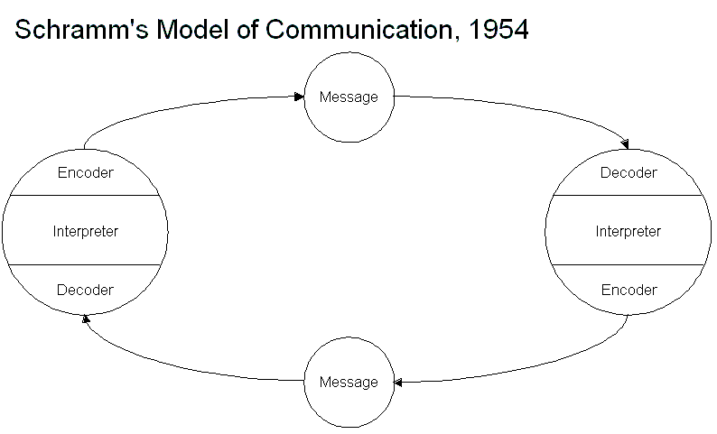
Source: https://www.businesstopia.net/sites/default/files/Schramm%27s%20Model%202_0.gif

This model was made by Wilbur Shramms in 1984 where Sender encodes the message before encoding and receives decodes the message under receipt by decoder. The main inspiration behind this model was Osgrood and Schram model of Communication or Encode Decode model of communication. We have discussed the key terms before let us explain how it works.
Process
This model mostly emphasizes on encoding and decoding. Data is encoded by sender (transmitter) and sent to receiver. Encoding is the process of converting data into information. The receiver receives data after which it is decoded and interpreted. This data is then transmitted through a medium. There is scope of feedback here.
Practical example
A person may not understand English. He/she writes the language he knows and encodes it. If the receiver can’t understand the language he/she immediately sends feedback.
Since there is scope for instant feedback it gives a chance for both parties to express their opinions. However this model is not suited for places where there are multiple levels of Communication.
Tuckmans teamwork Theory:
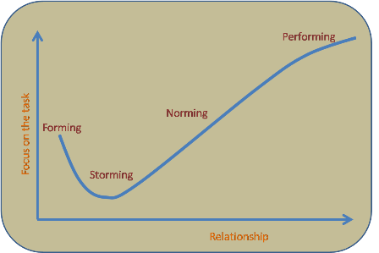
Source: http://the-happy-manager.com/wp-content/uploads/tuckmangroupstagesmodel1.png
Tuckmans theory was developed in the year 1965 and it is considered as one of the basis for effective team building. The four stages are discussed as follows
i. Forming
The initial stage where people within the teams don’t know each other properly, haven’t gelled together. So it’s the initial phase of building a team.
ii. Storming
This stage is most important when members start to feel as a part of the team. They deeply dicuss and brainstorm about new ideas and it results in conflicts at times.
iii. Norming
This stage is characterized by a term togetherness. They slowly start to develop new framework, modules etc. In this stage harmony starts developing among the members.
iv. Performing
All competencies here are combined to form a synergy. When people work effectively together they perform well for the Company.
So we see here for forming a team proper and effective communication is very important.

4. Barriers to Effective Teamwork
i. Poor Communication
Poor Communication is always termed liable for hampering productivity of employees. It creates misunderstandings, conflicts and hampers overall work progress. Ex,Culturul differences
ii. Unclear goals
If goals are not clear than it is very tough for team members to head in the right direction. They will just wander clueless.
iii. Personality or Ego clash
Different minds have different thoughts. If there is no unity among team members so it will result in miscommunication ad hamper the overall progress.
Besides other factors such as lack of proper leadership, poor decision making process, lack of understanding among team members etc is responsible.

5. Barriers to Communication
i. Cultural differences
When people from different cultures work or interact then there is a barrier in Communication.
ii. Physical barriers
So physical barriers are barriers which occurs when the equipment’s used is backdated or not up to date with the latest technology.
iii. Physiological barriers
The barriers which are related to sixth sense such as listening, hearing etc.
Besides other barriers to Communication are problems with structural design, lack of experience which are common in nature.

6. Conclusion
Finally from our research we can summarize some key points
i. Communication is involved in each of the skills(leadership, mutual support, situation monitoring needed etc) needed for building an effective team.
ii. If we look at the 3 models of Communication they have 3 different view points
Shannon and Weaver Model of Communication showed how message is to be transmitted from sender to receiver. Berlos model further focused on skills, knowledge, attitudes needed for sending and receiving message. Schramms Model of Communication put more emphasis on providing instant feedback when a receiver can’t properly receive a message.
iii. Tuckmans theory of Teamwork focused on 4 stages where team members get to know each other, form an understanding and slowly begin to start performing. For each of these stages effective communication is must.
iv. Some barriers to effective teamwork are unclear poor communication goals, personality or ego clash lack of proper leadership, poor decision making process etc
v. Some barriers to communication are cultural differences, physical barriers, physiological barriers etc
Finally we can say since dawn of civilization humans have always tried to improve Communication from sending written messages, imperial communications, speeding up messenger, pigeon post, Gutenberg and western printing. For effective teamwork proper communication is a must. No team can perform smoothly without effective Communication.

7. Bibilography
i. St Pierre M, Hofinger G,Buerschaper C, Simon R (2011) CrisisManagement in Acute Care Settings:Human Factors, Team Psychology,and Patient Safety in a High StakesEnvironment. Spinger-Verlag, Berlin
ii. Walker C (2008) A fatal lack of communication. Nursing Standard.23, 11, 62-63.
iii. Baker DP, Salas E, Battles JB,King HB (2012) The relation between teamwork and patientsafety.In Carayon (Ed) P Handbook of Human Factors and Ergonomicsin Health Care and Patient Safety.Second edition. CRC Press, Boca
iv. Endsley M (2012) Situation awareness. In Salvendy G (Ed) Handbook of Human Factors
and Ergonomics. Fourth edition.John Wiley and Sons, Hoboken NJ, 553-568.
v.Gluyas H, Morrison P (2013) PatientSafety: An Essential Guide. Palgrave
Macmillan, London.
vi. Shannon and Weaver Model of Communication. (n.d.). Retrieved December 21, 2017, from https://www.businesstopia.net/communication/shannon-and-weaver-model-communication
vii. Teamwork Theory. (n.d.). Retrieved December 21, 2017, from http://the-happy-manager.com/articles/teamwork-theory/

